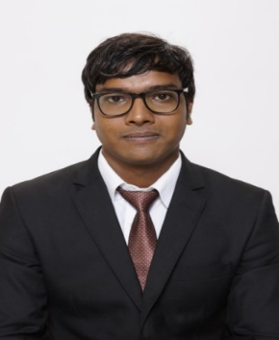

Mumbai

**Sunny Sharma**

**Career Objective:**To secure an entry level position where my skills and expertise are utilized in a way that contributes in a progressive manner that enhances the overall growth of the organization.

**Summer Training Project Details:** Declining interest rate, less paper work, fast processing time, rebate on income tax, flexibility to repay, attractive schemes have led for the significant growth of Indian Loan Market. To study the Current marketing scenario, with increased competition, Demanding buyers and customer satisfaction.

**Company :** Way2Wealth Brokers Ltd.

**Location :** Vikhroli

**Project Title:** Markets on Home Loan

**Additional Projects Undertaken:**

1. **Title:** Manual Sprayer cum Herbicide, Cum Pesticide, Cum Urea (Agriculture Oriented Project)

* Preventing, Destroying, Repelling or Mitigating Any Pest.
* Specially Meant to Work in Row Crops.
* Besides can be used to Apply Organic Fertilizer (Powder).

1. I have done internship during my graduation for six months in two MNCs in Eaton Fluid Power Ltd. And Indorama Synthetics Ltd. The project Included Team handling, Inspection of components, Reducing the failure of pumps.

The Project in Indorama Synthetics Ltd. Included the study of power plant.

**Academic Credential**

|  |  |  |  |  |
| --- | --- | --- | --- | --- |
| **Name of the Course** | **Name of the Institute** | **Name of the University/Board** | **Percentage/ CGPA** | **Year** |
| PGPM | IBS Mumbai | ICFAI | 6.53 | 2016 |
| B.E | Raisoni College of Egg. | RTMNU | 7.36 | 2014 |
| HSC | N.S High Secondary School | GUJARAT  BOARD | 50.6 | 2009 |
| SSC | N.S High Secondary School | GUJARAT  BOARD | 59.3 | 2007 |

**Additional Qualifications:** Diploma in Soft Skills and Personal Development.

**Awards and Achievements:** Achieved 1st Position in Best Innovation Award Competition in Hardware Category, Nagpur.

**Co-curricular Activities**

* Successfully Coordinated Sports Activity at College Level.
* Participated and Won in Various Cultural and Technical Events held at School and College Level.

**Languages known:** English, Hindi, Gujarati.

**Hobbies & Interests:** Gym, Photography, Music, Travelling, Gaming.

**Personal Details:**

**Date of Birth :** 09/Oct/1990

**Current Address :** C-36 Sur Sagar Tower,Near SattaDhar Bus Stand,Sola-Road

Ahmedabad (Gujarat)Pin code: 380061

**Phone Number :** +91 9766130250

**Email :** sunnyssharma9@yahoo.in