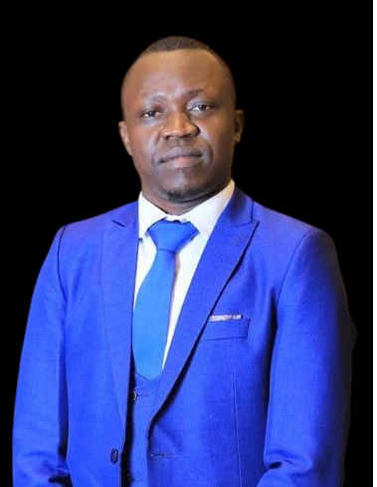s

· **Nationality:** Republic of South Sudan

· **Date of Birth:** January 1, 1989

· **Place of Birth:** Kaya

· **Current Employment:** [Not specified]

·

Personal information

·Basic Education Certificate from YMCA School, Juba – Score: 175 – Year: 2004

·Sudanese Certificate from Supiri Secondary School, Bibor-Juba Administration – Score: 65% – March 2010

·Bachelor’s Degree in Managerial Accounting, Faculty of Commerce, Cairo University, Egypt – Grade: 58.29% – May 2021

·Diploma in Human Resources, Emirates Academy, Egypt – 2023

· Diploma in Personal Skills, Emirates Academy, Egypt – 2023

· Diploma in International Computer Driving License (ICDL), Russian Cultural Center Academy, Egypt

·

Education

Volunteer work as a club member (active in the club)

· Party membership: [Not specified]

· First Aid Training – Egypt

· Espresso Coffee Basics – Dancing Bean, Egypt

·

EXPERIENCE

To obtain a position that supports my experience and skills, which span over 10 years in sales, management, and as a certified accountant with extensive experience in reviewing financial records. I aim to apply my four years of accounting experience to help **ACE CLUB** develop its accounting techniques in my new role as an Administrative Accountant.

SUMMARY

Contact information

Phone: 01122797275

Email:emaj2019@gmail.com

Address:Nyokuron west

City: Juba/SouthSudan

Languages

Arabic speaking&writing&listeniing 95%

English speaking&writing&listening 80%

Ability to express ideas clearly and listen to others

Team collaboration to achieve shared goals

Task organization and priority setting to complete work efficiently

Motivating others and making appropriate decisions

Quick response to new developments in the work environment

Analytical thinking to find practical solutions to various challenges

Skills

EMMANUEL KHAMIS

Computer Skills

Software Proficiency

Access 60%

PowerPoint 65%

Excel 70%

Word 75%

Windows 70%

Personal Skill