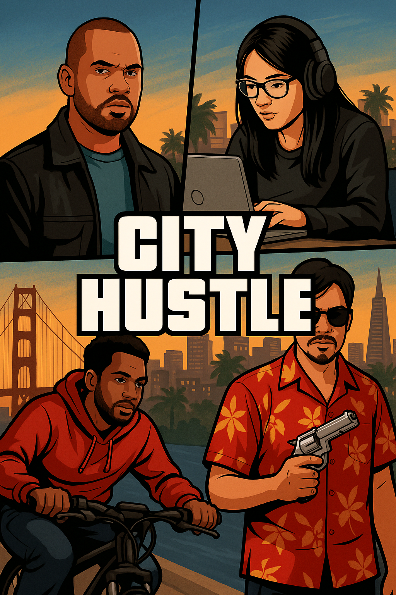

GTA: Bay City Hustle – SQL Training Missions

# MISSION 1: Suspect Scanner

Objective: Practice using WHERE to filter data

Story:

Claudia “Codewitch” Trejo has tapped into the Bay City suspect registry. She’s looking for known troublemakers with a Wanted Level of 2 or higher to flag for further investigation.

Assignment:

Write a SQL query to return all suspects with a WantedLevel of 2 or more. Include the suspect's name, alias, and wanted level.

# MISSION 2: Vehicle Watchlist

Objective: Use JOIN and WHERE to combine tables and filter stolen data

Story:

Jakeyl “Beardstorm” Millan is tasked with locating all stolen vehicles. He needs a list that matches each stolen vehicle to its owner.

Assignment:

Write a query that returns the name of the suspect, the vehicle type, and the brand of all stolen vehicles (where IsStolen = 1).

# MISSION 3: Reward Tracker

Objective: Use GROUP BY, SUM, and ORDER BY to calculate totals

Story:

Frederick “Freddie Finesse” is reviewing his crew’s earnings. He wants to know who completed the most valuable missions so he can pay out bonuses.

Assignment:

Write a SQL query that shows:  
- The name of each suspect  
- The total money earned from completed missions  
Group by name and order by earnings from highest to lowest.

# MISSION 4: Mission Speed Metrics

Objective: Use GROUP BY with MIN, MAX, and aggregate logic

Story:

Kevin “Sunset Sniper” Gagante wants a speed report. Some agents move like lightning, others crawl. He wants to know who’s fastest, who’s slowest, and how many missions each agent has completed.

Assignment:

For each suspect who completed missions, return:  
- Their name  
- The number of missions completed  
- Their fastest time  
- Their slowest time

# MISSION 5: Elite Agent Filter

Objective: Combine aggregates and use HAVING

Story:

Emilya “E-Mage” Illeeva is assembling a secret elite unit. She needs agents who completed at least 2 missions and earned $4000 or more in total rewards.

Assignment:

Write a query that returns the names of suspects who:  
- Completed at least 2 missions  
- Earned $4000 or more total  
Only show those who meet both conditions.

**Solutions**

**MISSION 1: Suspect Scanner**

**Expected Result:  
A list of suspects who have a WantedLevel of 2 or higher. Example values:**

* **Chi-neme-rem Agana (Ghostface) – 2**
* **Marq Alejandro (Firewall) – 2**
* **Frederick Canning (Freddie Finesse) – 3**
* **Jakeyl Millan (Beardstorm) – 2**
* **J Torres (Midnight Mapper) – 2**

**Total rows expected: 5**

**MISSION 2: Vehicle Watchlist**

**Expected Result:  
A list showing which suspects have a stolen vehicle, including:**

* **Remsey Mailjard – Motorcycle, ShadowRider**
* **Jakeyl Millan – Scooter, Zoomie**
* **J Torres – Van, StealthWagon**

**Total rows expected: 3**

**MISSION 3: Reward Tracker**

**Expected Result:  
Names and total earnings of suspects who completed at least one mission, ordered from highest to lowest earnings. Top examples:**

* **Marq Alejandro – $5000**
* **Claudia Trejo – $6000**
* **Remsey Mailjard – $3000**
* **Cricelia Prado – $1500**
* **Chi-neme-rem Agana – $1500**

**Total rows expected: 5**

**MISSION 4: Mission Speed Metrics**

**Expected Result:  
Each agent’s name, how many missions they completed, and the fastest and slowest time. Example rows:**

* **Remsey Mailjard – 1 mission – Fastest: 40 min – Slowest: 40 min**
* **Marq Alejandro – 1 mission – Fastest/Slowest: 60 min**
* **Cricelia Prado – 1 mission – Fastest/Slowest: 25 min**
* **Chi-neme-rem Agana – 1 mission – Fastest/Slowest: 20 min**
* **Claudia Trejo – 1 mission – Fastest/Slowest: 55 min**

**Total rows expected: 5**

**MISSION 5: Elite Agent Filter**

**Expected Result:  
Only the suspects who completed at least 2 missions and earned $4000 or more total.  
Expected output:**

* **Claudia Trejo**

**Total rows expected: 1**