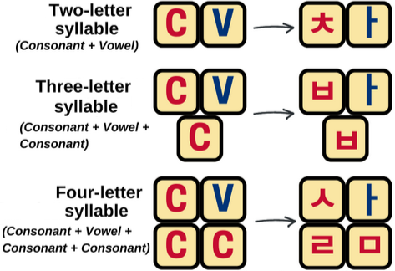ㅂ≈ (b)ed - *🔉P(eer)* - ㅍ≈ P(piπ) | ㅃ*🔉* ^*P(eer)*

ㄷ≈ (d)oor - *🔉T(eegrad)* - ㅌ≈ T(eeth) | ㄸ *🔉 ^T(eegrad)*

ㄱ≈ (g)un - *🔉K(eyle)* - ㅋ≈ K(ey) |ㄲ *🔉 ^K(eyle)*

ㅎ≈ (h)at

ㅈ≈ (j)ug with a spout at the top - *🔉Ch(eer)* -ㅊ≈ Ch(urch) | ㅉ *🔉* ^*Ch(eer)*

ㄹ≈ (l)adder

ㅁ≈ (m)outh

ㄴ≈ (n)ortheast like compass

ㅅ≈ (s)eashell | ㅆ*🔉* ^shell

ㅇ≈ placeholder ≈ !(p) ≈ ng (≈ing English if ends in a particular syllable)/silent if start

ㅛ

(+y)

*🔉* ‘yoh’

ㅕ(+y) *🔉*’yoh’ *🔉* ‘yaw’ (+y) ㅑ

🔉 ‘you~’

(+y)

ㅠ

ㅗ

(old)

*🔉* ‘oh(/我)’

ㅓ(ipod) *🔉*’oh’ *🔉* ‘aw’ (ipad)ㅏ

🔉 ‘ou~’

(new)

ㅜ

ㅣ≈ (tree) *🔉yee / E*

ㅐ≈ ㅏ+ㅣ*🔉(哎~)ae~*

ㅒ≈ ㅑ+ㅣ*🔉(耶~)yae~*

ㅔ≈ ㅓ+ㅣ*🔉e~*

ㅖ≈ ㅕ+ㅣ*🔉ye~*

ㅢ≈ ㅡ+ㅣ*🔉ui(/we)*

ㅡ ≈ (brook) *🔉eu(wer)*