insert into Employee values(NEWID(),'Karl Kats','karl@gmail.com','21345678','Roosikrantsi tn 2-4')

insert into Employee values(NEWID(),'Henri Kala','henri@gmail.com','1298412','Roosikrantsi tn 2-4')

insert into Employee values(NEWID(),'Darren Aas','ktamm@gmail.com','6345','Süda tn 9')

insert into Employee values(NEWID(),'Kana Kukk','kana@gmail.com','2142123','Tööstuse tn 20')

insert into Employee values(NEWID(),'Khabib Eestist','khabib@gmail.com','123125','Mere puiestee 7')

insert into Employee values(NEWID(),'Rock Kivi','Kivi@gmail.com','421412','Pargi tn 15')

insert into Employee values(NEWID(),'Eugneesius II','eugneesius@gmail.com','21341241','Teateri tn 5')

insert into Employee values(NEWID(),'Cenneth G','Cenneth@gmail.com','5124123','Tatari 28')

insert into Employee values(NEWID(),'Umps Puu','umps@gmail.com','124213','Öö 21')

insert into Employee values(NEWID(),'Öö Päev','oopaev@gmail.com','4124214','Teateri tn 412')

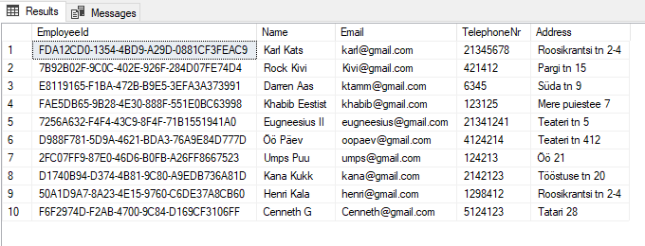

—

insert into Customer values(NEWID(),'Logan Paul','logan@gmail.com')

insert into Customer values(NEWID(),'Jake Paul','jake@gmail.com')

insert into Customer values(NEWID(),'KSI','ksi@gmail.com')

insert into Customer values(NEWID(),'Kalkun Külast','kalkun@gmail.com')

insert into Customer values(NEWID(),'Batman','batman@gmail.com')

insert into Customer values(NEWID(),'Spiderman','spiderman@gmail.com')

insert into Customer values(NEWID(),'Superman','superman@gmail.com')

insert into Customer values(NEWID(),'Antman','antman@gmail.com')

insert into Customer values(NEWID(),'Thor','thor@gmail.com')

insert into Customer values(NEWID(),'Garfield','[garfield@gmail.com](mailto:garfield@gmail.com)')

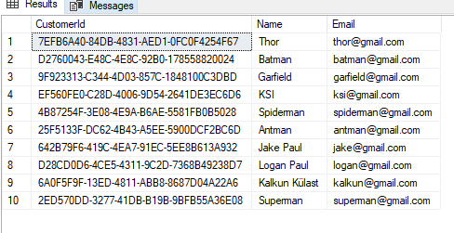

—

INSERT INTO PurchaseHistory VALUES (NEWID(), '7EFB6A40-84DB-4831-AED1-0FC0F4254F67', 'C09EC249-C557-40AC-93CC-29D174582D83', 4);

INSERT INTO PurchaseHistory VALUES (NEWID(), 'D2760043-E48C-4E8C-92B0-178558820024', 'EF1CBB71-7783-4D0A-ADB5-418DF980DFA5', 10);

INSERT INTO PurchaseHistory VALUES (NEWID(), '9F923313-C344-4D03-857C-1848100C3DBD', 'DD54B930-427E-4ADA-A02C-4B0B7B4F7D87', 1);

INSERT INTO PurchaseHistory VALUES (NEWID(), 'EF560FE0-C28D-4006-9D54-2641DE3EC6D6', 'B39DED5F-4804-4BF8-AAF2-59C03AE092BE', 3);

INSERT INTO PurchaseHistory VALUES (NEWID(), '4B87254F-3E08-4E9A-B6AE-5581FB0B5028', '538A958D-4056-4546-81DC-710BAA9033D4', 41);

INSERT INTO PurchaseHistory VALUES (NEWID(), '25F5133F-DC62-4B43-A5EE-5900DCF2BC6D', '452A9389-9040-4E1E-A9C7-781B8329B018', 51);

INSERT INTO PurchaseHistory VALUES (NEWID(), '642B79F6-419C-4EA7-91EC-5EE8B613A932', '9F3276D3-36DB-4BE4-947A-79A0B0905182', 21);

INSERT INTO PurchaseHistory VALUES (NEWID(), 'D28CD0D6-4CE5-4311-9C2D-7368B49238D7', '0852A2EC-2D60-41CC-B6F3-9631FA97CE74', 8);

INSERT INTO PurchaseHistory VALUES (NEWID(), '6A0F5F9F-13ED-4811-ABB8-8687D04A22A6', '28F3CA55-CB14-469E-AD5C-A53164B3A605', 11);

INSERT INTO PurchaseHistory VALUES (NEWID(), '2ED570DD-3277-41DB-B19B-9BFB55A36E08', '9DE5DCD2-76E8-4ABB-9463-BADD2F2D0B50', 61);

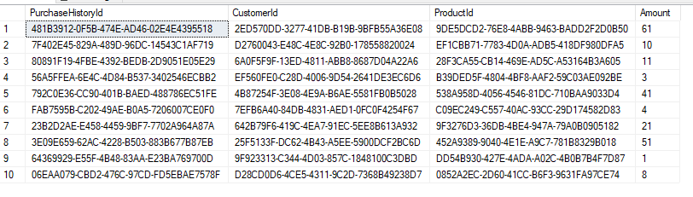

—

insert into Product values(NEWID(),'Smartphone',500)

insert into Product values(NEWID(),'Laptop',600)

insert into Product values(NEWID(),'Tablet',300)

insert into Product values(NEWID(),'Watch',1000)

insert into Product values(NEWID(),'Headphones',100)

insert into Product values(NEWID(),'Xbox',350)

insert into Product values(NEWID(),'Camera',150)

insert into Product values(NEWID(),'PC',1500)

insert into Product values(NEWID(),'Wii',50)

insert into Product values(NEWID(),'Playstation',500)

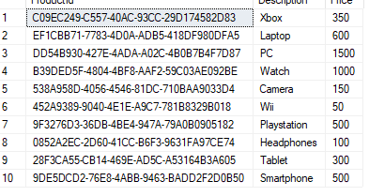

3 Joini

—

SELECT Product.Description, Product.Price, PurchaseHistory.Amount

FROM Product

INNER JOIN PurchaseHistory

ON Product.ProductId = PurchaseHistory.ProductId;

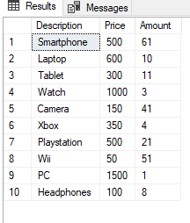

SELECT Product.Description, Customer.Name, PurchaseHistory.Amount

FROM Product

RIGHT JOIN PurchaseHistory

ON Product.ProductId = PurchaseHistory.ProductId

RIGHT JOIN Customer

ON Customer.CustomerId = PurchaseHistory.CustomerId;

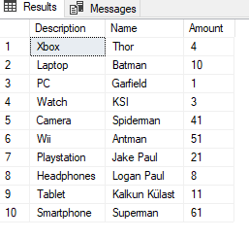

SELECT Product.Price, Customer.Name, PurchaseHistory.Amount

FROM Product

LEFT JOIN PurchaseHistory

ON Product.ProductId = PurchaseHistory.ProductId

LEFT JOIN Customer

ON Customer.CustomerId = PurchaseHistory.CustomerId;

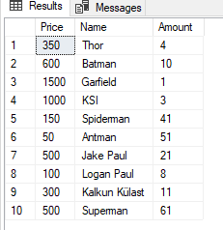

Stored proc

—

CREATE PROCEDURE GetPurchaseHistory

AS

BEGIN

SELECT \* FROM PurchaseHistory

END

EXEC GetPurchaseHistory

