Floreant POS Inventory Plugin 1.1.2

User manual



[www.orocube.com](http://www.orocube.com) | 800-844-6603 | sales@orocube.com

**Disclaimer:**

Our intent is to provide accurate and up to date content on this document; however, that is not always possible. THEREFORE, ALL CONTENT, SERVICES AND FUNCTIONS ON THIS DOCUMENT ARE PROVIDED "AS IS" AND "AS AVAILABLE" WITHOUT WARRANTY OF ANY KIND, EITHER EXPRESS OR IMPLIED, INCLUDING, BUT NOT LIMITED TO, ANY IMPLIED WARRANTIES OF MERCHANTABILITY, FITNESS FOR A PARTICULAR PURPOSE, OR NONINFRINGEMENT. Some jurisdictions do not allow the exclusion of certain implied warranties in which event any required warranty applies to the minimum extent legally required. Content is provided for informational purposes only and should not be relied on. Although the information on this Document may include statements on various life events and financial, legal or tax concerns, it is provided for informational purposes only, and is not intended and should not be relied upon as legal, tax or personalized advice. Floreant POS is a venture of OROCUBE LLC. However OROCUBE does not warrant or make any representations regarding the suitability, usefulness or expected results of the Content. You should not rely solely upon this information in making any decisions, including any decision to buy a product or service from OROCUBE LLC or any other company. You should consult your financial professional and legal and/or tax advisor for advice about the appropriateness of products and services for you, and the effect of state and federal law on the products, services or issues discussed on this document, or of federal income taxes or any other taxes on amounts held or paid out under any financial products described. Content may contain inaccuracies or errors and may change. No warranty or representation is made that the information on this Site is complete, accurate, up-to-date or error-free or that known defects will be corrected. Contents, services, products or functions available at this document may be changed or updated at any time without notice; but neither Floreant POS Team nor OROCUBE LLC has any obligation to update this document, so information may be out-of-date at any given time.  
  
Revision & Copyright Notice

This manual is released under CC license attribute 4. It lets others remix, tweak, and build upon our work even for commercial purposes, as long as they credit us and license their new creations under the identical terms.

|  |  |  |
| --- | --- | --- |
| Version | Author | Date |
| 1.0 | Chris Hays | 12/1/2016 |
| 1.1.0 | Chris Hays | 01/15/2017 |
| 1.1.1 | Chris Hays | 05/11/2017 |
| 1.1.2 | Chris Hays | 09/04/2017 |

Table of Contents

1. Installation 4

1.1 Overview 4

1.2 Version Compatibility 4

1.3 License 4

1.3.1 Before getting the license 5

1.3.2 After getting the license 5

2. Back Office Configuration 5

2.1 Inventory Items 5

2.1.1 Inventory Units 6

2.1.2 Reorder and Replenish Level 7

2.1.3 Package Purchase and Selling Price 7

2.1.4 Inventory Group 7

2.1.5 Inventory Vendors and Locations 7

2.2 Recipe 8

2.3 Inventory Transaction 9

3. Inventory Workflow 10

4. Inventory Reports 10

4.1 Inventory On Hand Report 10

4.2 Inventory Transaction Report 11

# 1. Installation

## 1.1 Overview

Inventory Plugin is a java extension file for Floreant POS to extend Inventory Management features. Like other plugins this plugin is packed as jar file. When you have received this plugin

Screen Capture 1

* Place the plugin file into the floreantpos/plugins folder.

Figure : Plugin License Activation

* 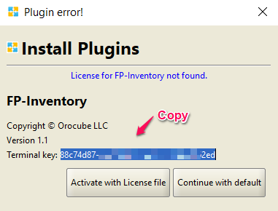Restart Floreant POS which will ask you to Activate with License file, Ctrl+ c to copy the 32 digit Terminal key and send it to an Orocube Agent in order to get license file. Once you receive license file follow steps from section 1.3.2

|  |  |
| --- | --- |
|  | **Plugin Naming convention**  Plugin is an executable jar file named after product - ‘major version#’. Often minor versions are not recorded. |
|  | **Terminal Key Issues**  Terminal keys are auto generated by Floreant POS. If you ever reinstall the system it may change the key and you have to request OROCUBE for replacement license. |

* If you have not received a license file yet, press on Continue with Default which will allow you to use the POS without plugin features, later once you have the license file follow steps from section 1.3.1 and then 1.3.2

## 1.2 Version Compatibility

Plugins are released for specific version of Floreant POS. You must get sure you have correct version of plugin. OROCUBE LLC will provide free update of plugins that you have purchased.

## 1.3 License

A license file is needed to activate the inventory plugin working with Floreant POS system. Each license file is unique per terminal and user basis and has its designated usage period. No license will work on a terminal other than the terminal that it is originally developed for. Below are the steps for activating a license file to a POS terminal working with its working POS software copy.

### 1.3.1 Before getting the license

* 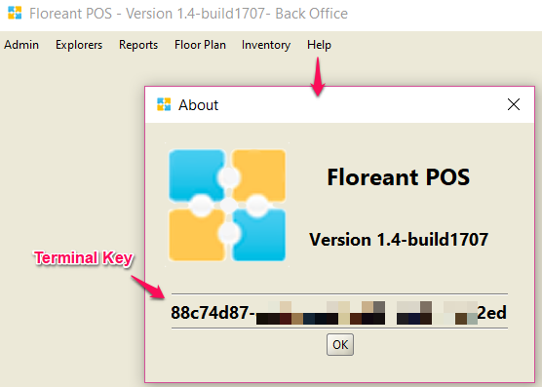Log into Back Office, press on the help tab and select About

Figure : Terminal Key at Back Office

* A new window will pop-up, copy the 32 digit Terminal key located right above the Ok button; this is a unique terminal key for the specific terminal that you are working on
* Paste and send your terminal key to an Orocube agent along with your Full name, email address and contact information once you have purchased this plugin license.

### 1.3.2 After getting the license

* Place the license file anywhere in your terminal/ pc safely.
* Try to restart Floreant POS this time and press on Activate plugin with License once it prompts
* Navigate to the place where you put your license file and import it.
* Now your Floreant POS system should acknowledge the license and you should be able to use all features of this inventory plugin.

# 2. Back Office Configuration

## 2.1 Inventory Items

Back Office🡪 Inventory🡪 Inventory Items

Inventory Items are the Raw Materials for Menu Items. Oil, Cheese, Tomato, Cucumber, Burger Buns are the Inventory Items, these can be purchased and also can be used as Recipe for one or several Menu Item. Once added as Recipe, Inventory Recipe Balance will be deducted after each sales transaction of Menu Item.

Before creating Inventory Items🡪 Inventory Units, Vendors and Locations should be created.

Barcode and Description fields are extra information of an Inventory Items to identify this Inventory Item than others easily; however these fields are optional to add.

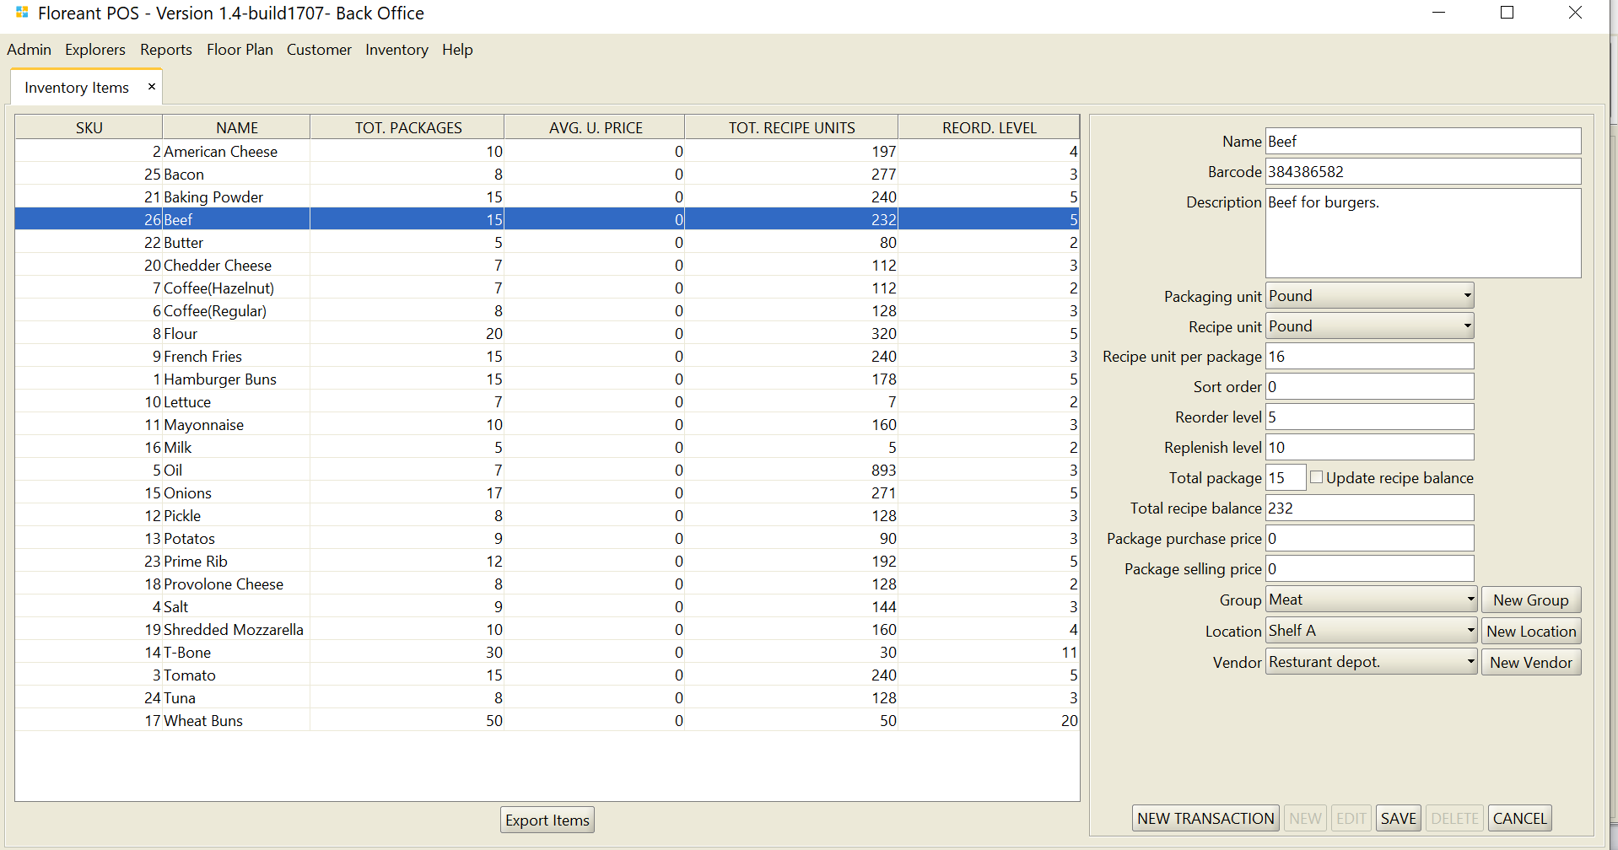

### 2.1.1 Inventory Units

Inventory Units are Piece, Dozen, Ounces, Pounds, etc. As we know 1 Dozen= 12 pieces, once creating the Unit Dozen, the Factor should be 12 and Dimension is Quantity. For Piece the factor would be 1 as this is the Base Unit. Similar way for Ounce and Pound the Dimension will be Weight.

Packaging Units show how Inventory Materials are packaged. Those could be packaged as Boxes, Packs, and Cases etc.

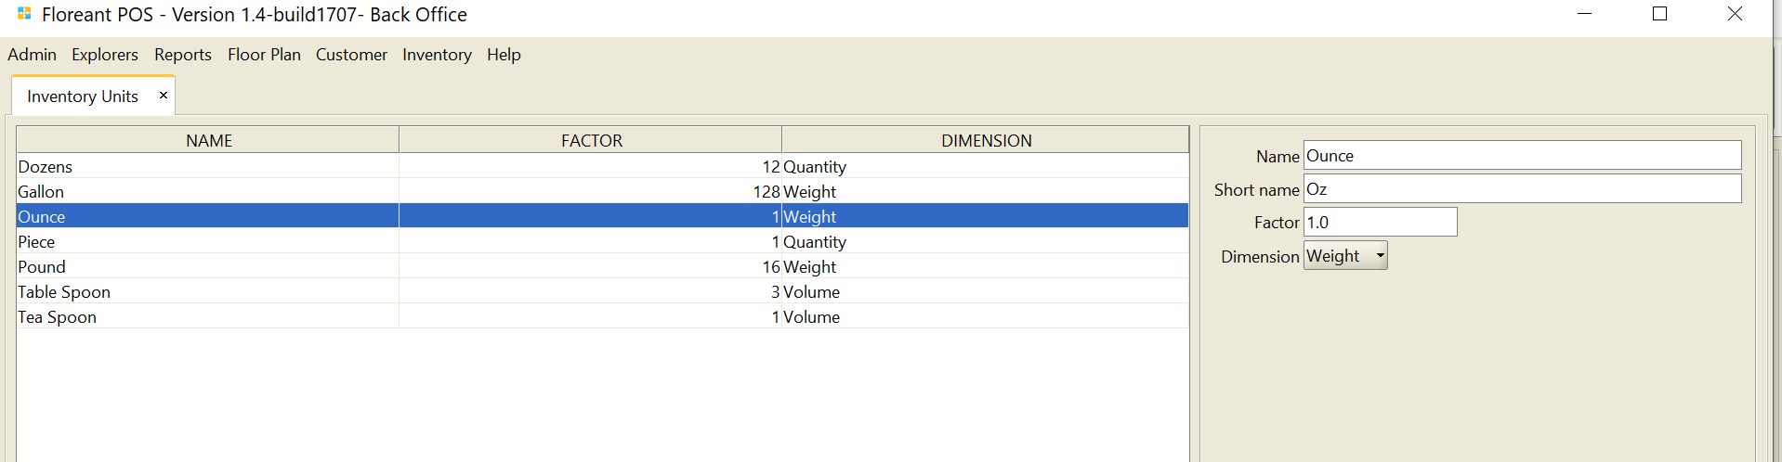

Not to be confused Recipe Units with Packaging Units, Recipe Units are not packaged anywhere, those are just counts. With certain count of pieces make a dozen and with certain count of ounces make a pound. But Packaging units are exactly with how many of those you are packaging. If a Package is added as Volume for a Box, it can contain 50 pieces or can contain 50 dozens of Inventory Items. In certain cases, Recipe Unit and Packaging Unit can be the same such as Pound (Short name: lb) for both.

Recipe Unit per package denotes how many of a Recipe Unit exists in 1 Package of Inventory Stock. Once Total Package of Existing stock is entered and the box for Update Recipe Balance is checked, the Total Recipe Balance will auto-calculate. Even after sales transaction and recipe balance deduction, you may update recipe balance by un-checking the Update Recipe Balance box and then re-checking this box.

 A store purchases 1 Container of Oil having 5 Galon of Oil in it. This 5 galon oil is equivalent to 250 table spoon of oil. 1 table spoon oil is needed to fry 1 Beef Petty, so the Oil container should be empty after selling 250 Beef Burgers. However, if the store manager finds out that it empties out after selling 240 Beef Burgers, he can adjust this missing 10 table spoon of oil because there is always 1-5% of wastage at the time of cooking.

### 2.1.2 Reorder and Replenish Level

Reorder Level denotes the quantity below which an item has to be ordered immediately.

When Inventory Item amount goes below Reorder Level it tends to refill by the amount of Replenish Level. Replenish Level specifies an Inventory Item to re-stock by how much.

### 2.1.3 Package Purchase and Selling Price

Package purchase price is the amount by how much this Inventory Item is purchased from a vendor like Walmart or Publix. Package selling price is only needed if an Inventory Item is sold directly in the store without adding it as recipe for a Menu Item.

### 2.1.4 Inventory Group

Inventory Items can be organized in Groups to find and locate those easily; Inventory Group must be created to assign an Inventory Item under that group. Dairy products group can hold Milk, Egg, Cheese Inventory Items, similar way Meat Group can hold Chicken Petty, Beef Petty, etc. [It is optional to add Inventory Group, Inventory Items can just stay by themselves]

### 2.1.5 Inventory Vendors and Locations

Inventory Vendors are the places from where Inventory Items are purchased like Walmart, Bi-Low, Aldi, Publix Supermarket etc. Each Inventory Item should be specified by its vendor indicating that it has been purchase from that Vendor.

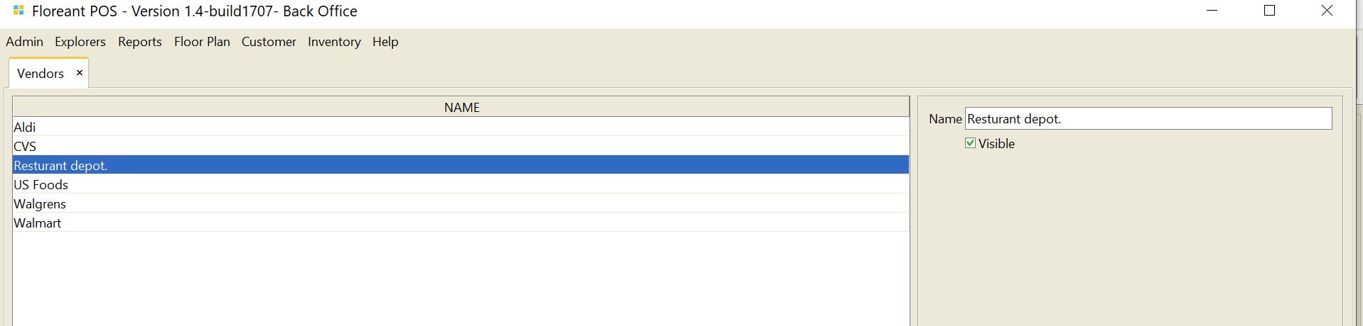

Locations are where Inventory Items are placed after purchase and receive. Locations may be Building Numbers, specific locations like Kitchen, Back Room or Stock room, shelf numbers or rack numbers, aisle numbers or such.

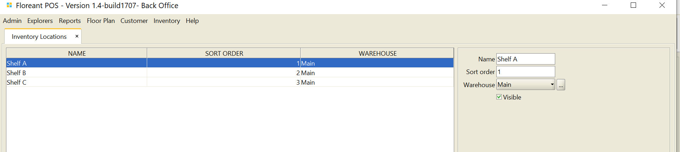

## 2.2 Recipe

Explorers🡪 Menu Items🡪 Select and Edit Menu Item🡪 Click on Recipe Tab

Recipe is the important function which relates Inventory Items to the Menu Items. Recipe defines which Inventory Item will be deducted for a Menu Item by how much after sale. Cheese, Tomato, Pickles, Mayonnaise, Beef patties, Buns are the recipe of a Beef Burger Item. Basically raw Inventory Items are the recipe of menu items. Inventory Items must be created as Raw Material first and then can be added as Recipe.

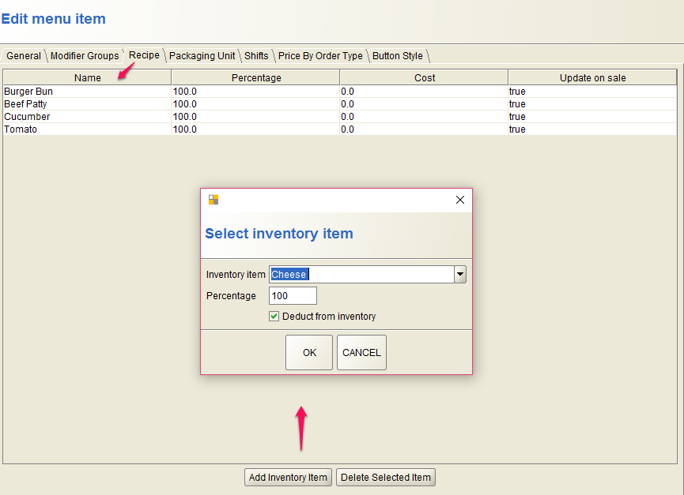

## 2.3 Inventory Transaction

Click on New Transaction while editing an Inventory Item to perform Inventory Transaction. First enter a reference number for this transaction. Inventory Transaction can be of 3 types, Purchase In, Purchase Out or Unchanged. Once you are buying Inventory Raw Materials, choose Transaction Type In, once selling choose Out, once moving one location of your store to another location choose Unchanged. Fill out all other fields as necessary to complete the transaction.

## 

# 3. Inventory Workflow

Below is an overall workflow for the total Inventory process

Inventory plays a vital role for all business. Entering Inventory Items the proper way saves lot of time and headache for store owner. Perform Inventory Transactions such as Inventory Item purchase or update Inventory/ Recipe Balance manually by the amount those are purchased.

Inventory/ recipe deduction after sales transaction is the main feature of this plugin. Once all Recipes are added for a Menu Item, it will always deduct Inventory/ recipe after each sales transaction automatically.

# 4. Inventory Reports

## 4.1 Inventory On Hand Report

Inventory On Hand Report will show current stock for each Inventory Item. It will continuously add Inventory Item purchases to the Stock and deduct Inventory Item after each Sales Transaction.

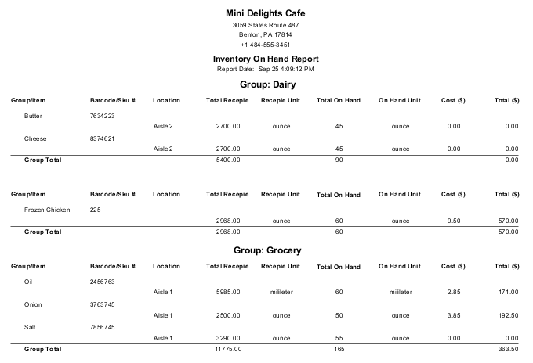

## 4.2 Inventory Transaction Report

This will show all Transactions been processed for all Inventory Items. The Status will show “In” for purchasing Inventory Items. Status will show “Out” when Inventory Items are sold, basically it happens when Menu Items are sold and Inventory Items are used as Recipe.

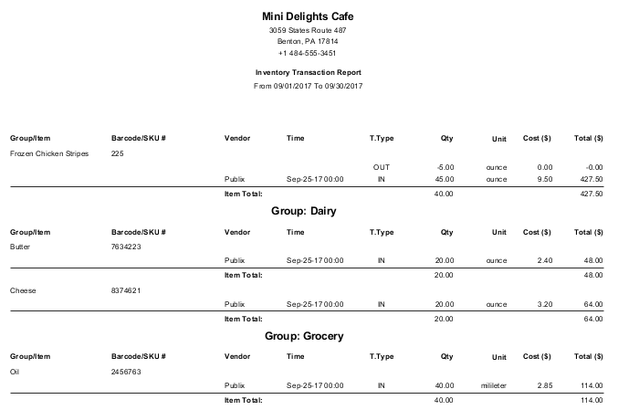

Inventory On Hand Report helps to decide the quantity to buy Inventory Items. As it shows current stock amount, store owner can easily make a shopping list and purchase Raw materials accordingly. Inventory Transaction Report keeps record of all Inventory Item purchases as well as keeping record of all Inventory Item deduction after Item Sales.