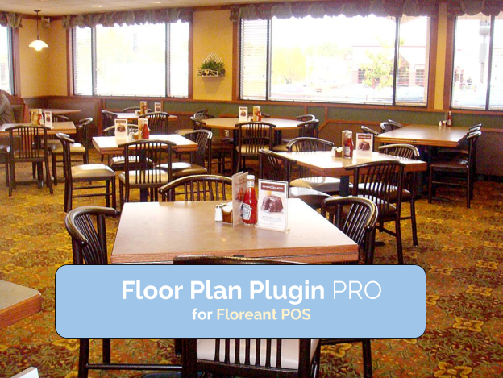

User manual v 1.22

Compatible with Floreant POS version 1.4 build 1600+



[www.orocube.com](http://www.orocube.com)

**Disclaimer:**

Our intent is to provide accurate and up to date content on this document; however, that is not always possible. THEREFORE, ALL CONTENT, SERVICES AND FUNCTIONS ON THIS DOCUMENT ARE PROVIDED "AS IS" AND "AS AVAILABLE" WITHOUT WARRANTY OF ANY KIND, EITHER EXPRESS OR IMPLIED, INCLUDING, BUT NOT LIMITED TO, ANY IMPLIED WARRANTIES OF MERCHANTABILITY, FITNESS FOR A PARTICULAR PURPOSE, OR NONINFRINGEMENT. Some jurisdictions do not allow the exclusion of certain implied warranties in which event any required warranty applies to the minimum extent legally required. Content is provided for informational purposes only and should not be relied on. Although the information on this Document may include statements on various life events and financial, legal or tax concerns, it is provided for informational purposes only, and is not intended and should not be relied upon as legal, tax or personalized advice. Floreant POS is a venture of OROCUBE LLC. However OROCUBE does not warrant or make any representations regarding the suitability, usefulness or expected results of the Content. You should not rely solely upon this information in making any decisions, including any decision to buy a product or service from OROCUBE LLC or any other company. You should consult your financial professional and legal and/or tax advisor for advice about the appropriateness of products and services for you, and the effect of state and federal law on the products, services or issues discussed on this document, or of federal income taxes or any other taxes on amounts held or paid out under any financial products described. Content may contain inaccuracies or errors and may change. No warranty or representation is made that the information on this Site is complete, accurate, up-to-date or error-free or that known defects will be corrected. Contents, services, products or functions available at this document may be changed or updated at any time without notice; but neither Floreant POS Team nor OROCUBE LLC has any obligation to update this document, so information may be out-of-date at any given time.

**Copyright Notice:**

This manual is released under CC license attribute 4. It lets others remix, tweak, and build upon our work even for commercial purposes, as long as they credit us and license their new creations under the identical terms.

Table of Contents

Installation 4

Overview 4

Version Compatibility 4

License 4

Back Office Configuration 6

Adding/ Creating Tables 6

Adding Muliple floors 8

FloorPlan- Table Booking 8

Search/ Edit Booked Table 10

Update booking status 11

Front End 12

Extra features in the new version of this plugin 14

Selecting Floor 15

Group / Ungroup 15

Hold Fire 16

Guest Check 16

Split Check 16

Settle 16

Authorize 16

Glossary 16

# Installation

## Overview

Floorplan Plugin is an executable jar file named fp-floorplan- ‘version#’. To install FloorPlan Plugin

1. Place the fp-floorplan plugin file into the floreantpos-plugins folder
2. Restart Floreant POS which will ask you to activate with license, copy the 32 digit Terminal key and send it to an orocube Agent in order to get license file
3. If you cannot get to step 2 you may follow steps from the License section below; otherwise only follow steps for ‘After getting the License’ from the License section

Once License is acknowledged by your Floreant POS system you may Login to Dine In mode and press ‘ok’ for creating default floor, it will ask you to enter number of tables for your desired floor; you may also perform this from the Back Office later on.

Note: If you are having trouble creating tables or Logging Into Dine In mode follow steps below:

1. Restart Floreant POS, press on Configure Database, CREATE DATABASE SCHEMA; please note: this step will remove all data including menu item setup from your Floreant POS application, if you have previously configured database skip steps 1-4 so that you do not lose any of your existing data
2. Select ‘yes’ once it prompts for removing existing database schemas
3. Choose if you want to generate sample data or not; pressing ‘yes’ will provide you sample menu item setup, pressing ‘no’ will provide you empty menu item setup with empty menu groups and category
4. Press ‘ok’ for restart and repeat steps 1-4 after it restarts; repeating steps 1-4 is necessary for floorplan plugin installation

## Version Compatibility

fp-floorplan-1.3 is not compatible with Floreant POS version 1.4 build 705, it is compatible with latest versions of Floreant POS for example 1.4 build 1600+

## License

A license file is needed to activate the fp-floorplan plugin working with Floreant POS system. Each license file is unique per terminal and user basis and has its designated usage period. No license will work on a terminal other than the terminal that it is originally developed for. Below are the steps for activating a license file to a POS terminal working with its working POS software copy.

Before getting the license:

1. Log into Back Office, press on the help tab and select About
2. A new window will pop-up, copy the 32 digit Terminal key located right above the Ok button; this is a unique terminal key for the specific terminal that you are working on

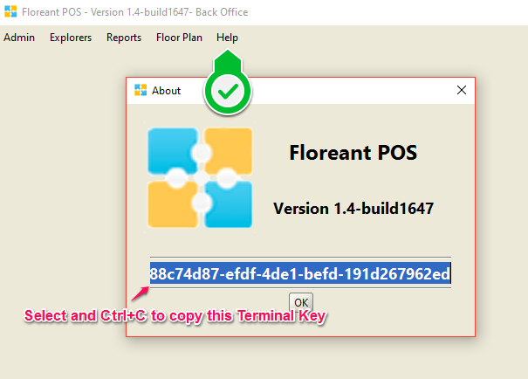

1. Paste and send your terminal key to an Orocube agent along with your Full name, email address and contact information once you have purchased this plugin license.

After getting the license:

1. Place the license file anywhere in your terminal/ pc safely.
2. Try to restart Floreant POS this time and press on Activate plugin with License once it prompts
3. Navigate to the place where you put your license file and import it.
4. Now your Floreant POS system should acknowledge the license and you should be able to use all features of this floorplan plugin.

# Back Office Configuration

## Adding/ Creating Tables

1. Go to Back Office- FloorPlan- Tables
2. Press ‘new’ at the bottom of the window, provide table number, brief description and guest capacity
3. Click on Create Table Type and enter table name and add a description
4. You can select any table and duplicate it pressing the DUP button with all its properties which will add more tables to the floor easily on your choice
5. Save it and add as many tables as expected in the floor, specify different table type and add description about that table; Table types can be named as Party Table, VIP table, Guest Table, Family Table etc.
6. You may create different table types also by using the FloorPlan- Table Type Tab
7. Next you will be able to select any specific table type while adding new table

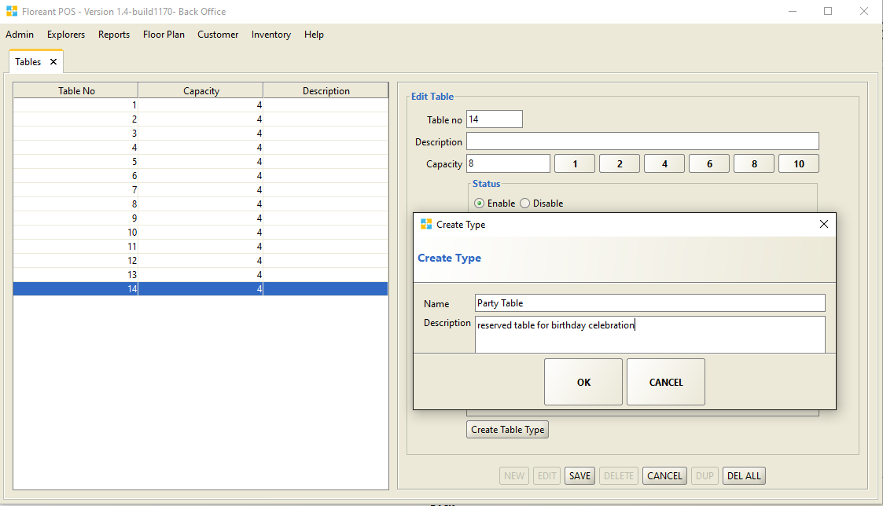

##### Adding Floor Image

1. Select floor plan- Floors and choose SET FLOOR IMAGE
2. Browse for saved floor images in your pc and import here; you should have floor map image file created in your pc/ terminal for your restaurant floor prior to this step, if you do not have your floor image create one or download floor image from google images for testing

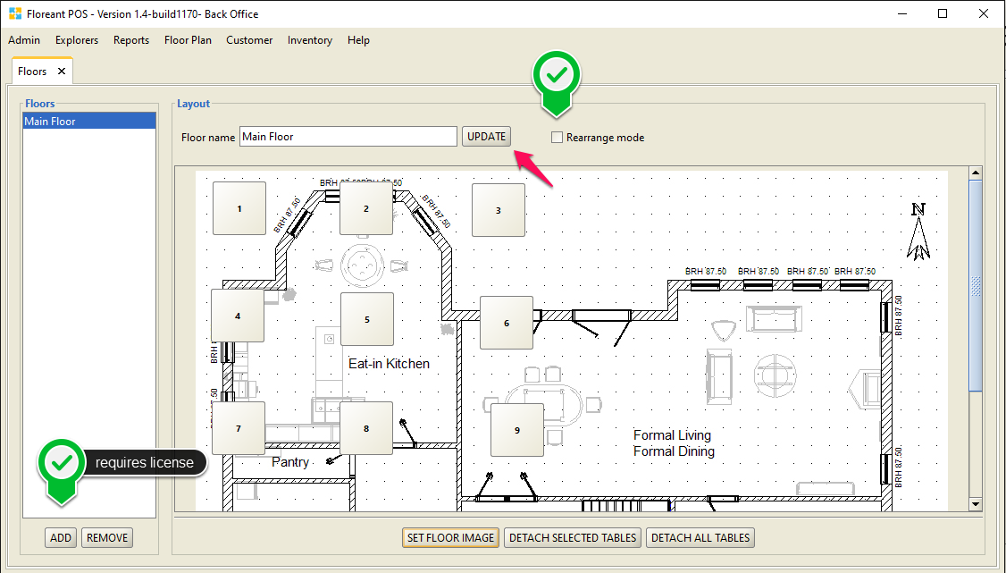

##### Adjust Table size and location

1. Check the box for rearrange mode and move tables as needed
2. Adjust button size by changing button width, height and font size if needed and save it; keep a ratio for the button width and height so that it shapes nicely, do not make the font size too big so that the number does not exceed out of the button, if it does reduce the button font and save it once you are satisfied
3. Click anywhere on the image to add additional tables
4. Select a table and click on ‘Detach Selected Table’ if you wish to remove a table from the floor, Detach all tables button will remove all the tables from the existing floor
5. Press ‘update’ to confirm final editing or continue editing and update later; in the newer version of this plugin ‘update button is to save button properties for tables and save button is to save your floor name such as main floor, additional floor, 2nd floor, party floor, VIP floor etc.

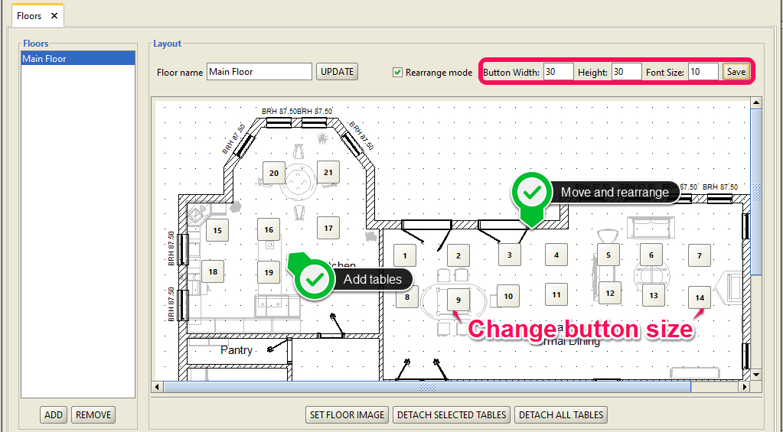

## Adding Muliple floors

You may have different floor map setup in your restaurant for different room or for multifloors.

1. Go to Floors from the Floor Plan tab, click Add button located at the bottom of the Floors Panel at the left hand side of the screen
2. Click on SET FLOOR IMAGE, import new floor image/ map, follow the same procedure as you did in the ‘adding floor image’ section above.
3. Repeat step 1 and 2 of this section for adding as many floor maps as you need for your restaurant, you must save each floor before adding a new one
4. Now you should have list of floors in the Floors panel at the left hand side, you may navigate to any specific floor map by clicking on that floor from the list and rearrange tables as you wish

## FloorPlan- Table Booking

Any specific table type can be booked for any specific customer.

1. Enter guest count which should be equal or less than the intended table guest capacity
2. Select booking date and time which must be later than the present time
3. Choose table type or search for desired table number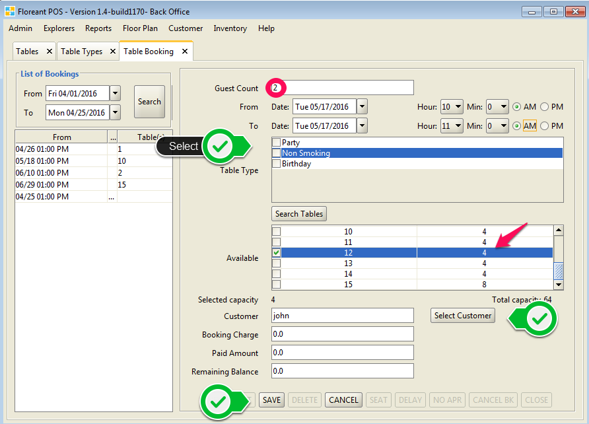
4. Select customer which will pop up another window to select intended customer searching by phone#, loyalty# or name of the customer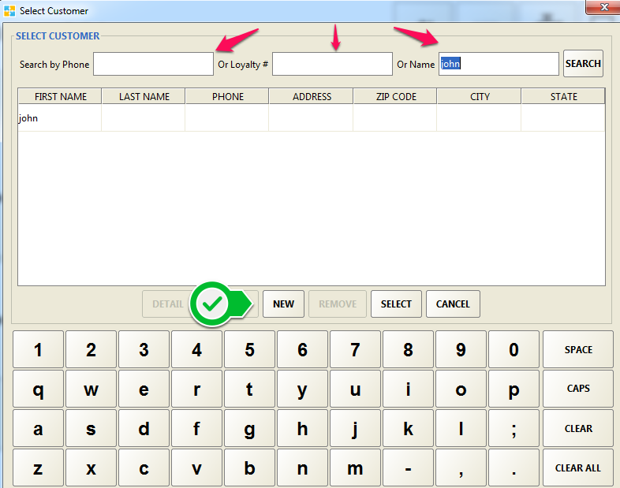
5. If the customer is not previously added click NEW and add customer information
6. Choosing the customer and pressing SELECT will take to the previous screen to complete booking
7. Save the booking to be appeared at the left booking list panel

## Search/ Edit Booked Table

To look for a booked table select the date or range of date at the left panel for List of Bookings

1. Press on Search button and select the desired booked table
2. Edit the table or any other information if needed
3. Enter Booking Charge, Paid Amount and Remaining Balance if required
4. Save to record the changes made

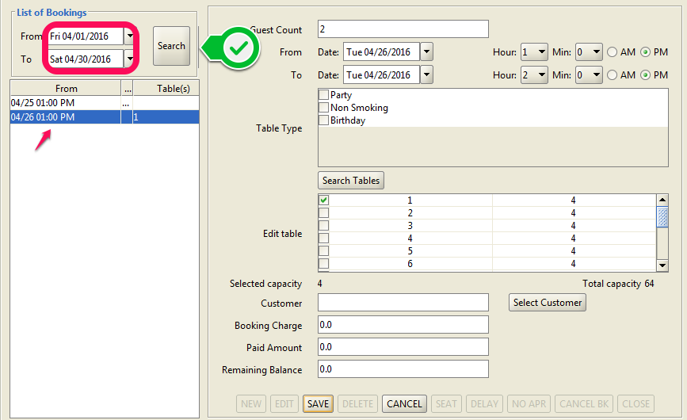

## Update booking status

Once a booked table selected press SEAT to activate the booking. This table will now appear in the Booked panel at the middle.

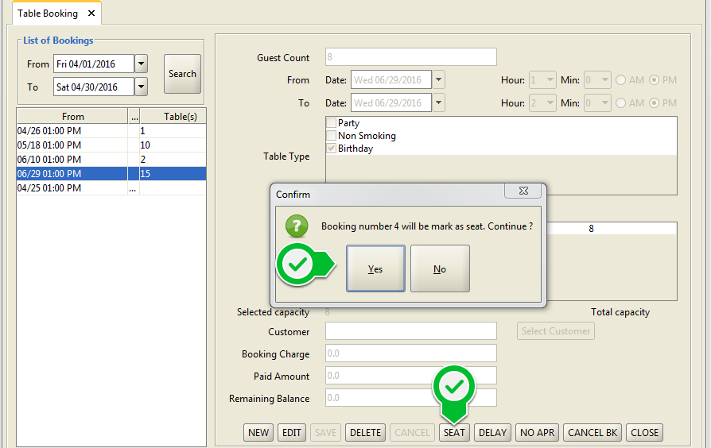

There are other options such as DELAY, NO APPEARANCE (of customer) AND CANCEL BOOKING.

1. If a customer makes Delay to arrive in the restaurant and makes a phone call prior to the booking time, his booking can still be kept on hold by pressing the DELAY button
2. If the customer does not show up at all the table booking can be marked as NO APR and might be given to another customer once it exceeds 15 minutes of non-appearance
3. If a customer requests to cancel the booking by making phone call, the booking can be cancelled by pressing CANCEL BK button

# Front End

Once everything is properly configured in the Back Office you are ready to take orders by selecting tables while in Dine In mode. Group/ Ungroup Tables as intended.

1. Press on Group in the Dine In mode and Select the tables need to be grouped altogether
2. Pressing Done will take to the Order Taking Screen
3. For single table simply pressing on the Table will take to the Order Taking Screen

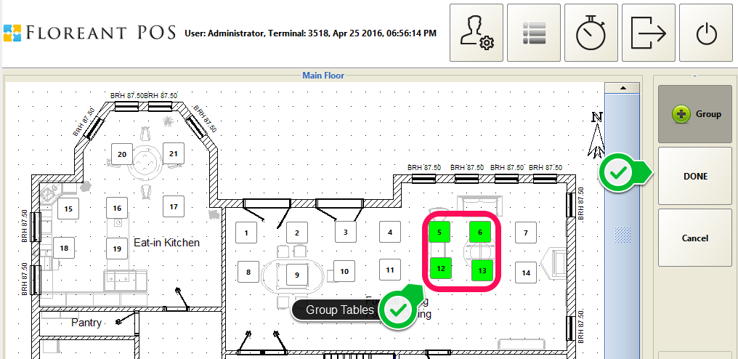

1. Add Customer information if required
2. Tables that are grouped are shown altogether separated by comma, press this button for editing
3. Press on Guest button and select total guest number for the group
4. Now you will be prompted to take Order for food at the main order taking screen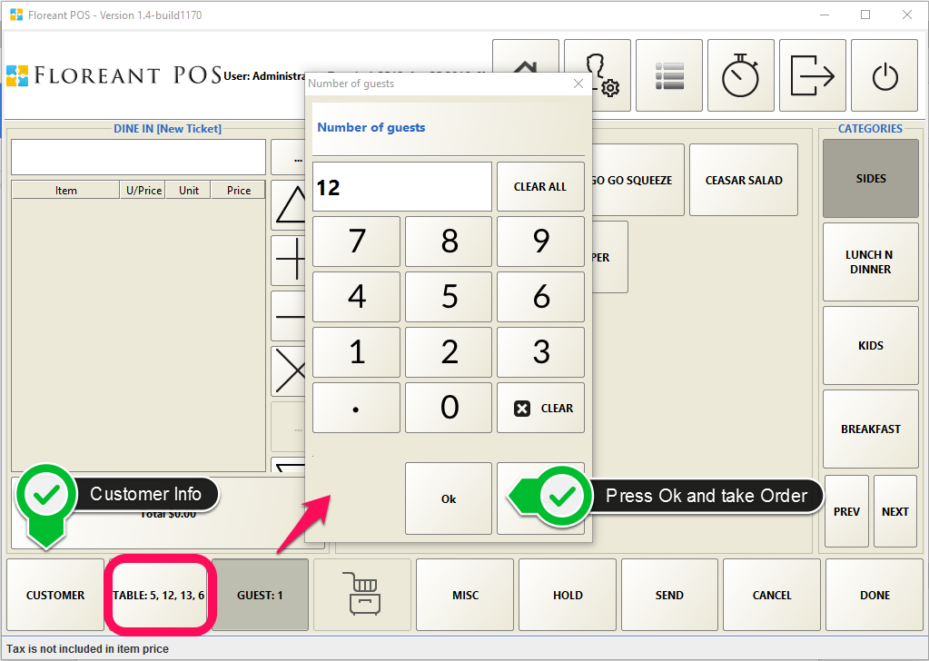
5. Later on, pressing the guest button will prompt to select specific guest from the list and take food order for that specific guest, if there 12 guests they will all appear in the list and pressing any number for example 8 will allow to take food order for the 8th guest in the group
6. Pressing Hold button will hold the table and the Order to be edited at any later time
7. Once food items are ordered and added to the ticket, Pressing Send button will send the order to the kitchen
8. Any orders can be edited for adding more items at any later time until the ticket is closed/ paid.

# Extra features in the new version of this plugin

There is an extra panel added once logged in as Dine In mode. Located at the right hand side of the screen this panel has different buttons to perform all essential functions for Dine In orders from one place. Now there is no need to go back and forth to different screens any more.

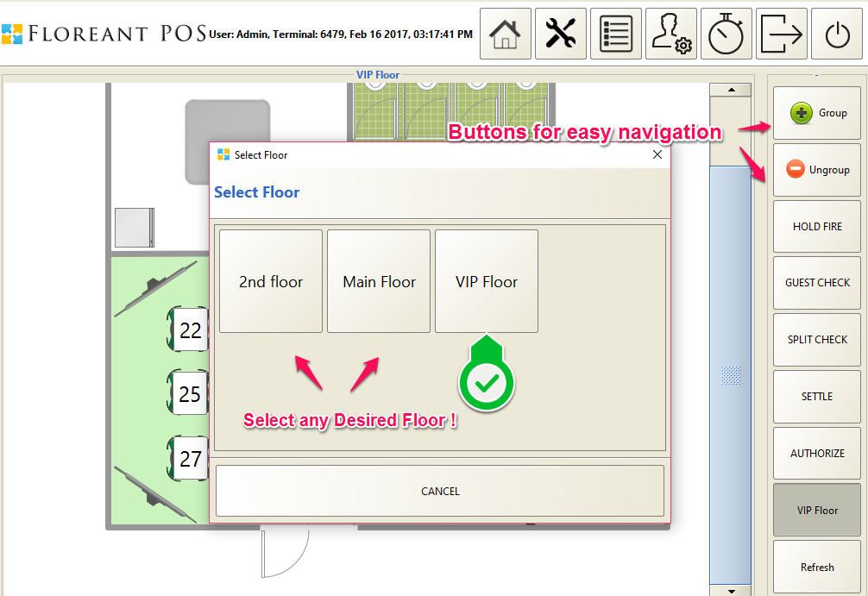

## Selecting Floor

At the bottom of the panel at the right hand side, there is a button to choose intended floor, the floormap of the current floor will be indicated at that button as well as at the top of the screen, pressing on that button will show additional floors that were added at the Back Office previously. Selecting any floor will take to the floormap of that designated floor and allow to take food order for the guests sitting/ to be seated on that floor.

## Group / Ungroup

Press Group button if you want to group more than one table to take order for a large group of people who require more than one table to sit. You may select as many tables to be in the same group as you need. After selecting tables, pressing Done will take to the order taking screen, pressing Cancel will undo the grouping of the tables. Previously grouped tables can be ungrouped using the Ungroup button.

If there is only one table needed, simply pressing to that table will take to the order taking screen.

## Hold Fire

Customer food order that is not ready to send to the kitchen can put on Hold after the order has been taken from the order taking screen. At any later time pressing ‘Hold Fire’ button and selecting the table will send the order for that table to the kitchen.

Usually any order taken for any specific table are send to kitchen immediately using the ‘Send’ button at the order taking screen.

## Guest Check

Pressing the ‘Guest Check’ button and selecting a table will show all ticket information for that specific table.

## Split Check

This button will allow splitting a check for food order of a specific table. Initially an order may be split up to 4 times, later split checks may be re-split and this way one original order can be split infinitely.

## Settle

A ticket for a specific table/ group of tables can be settled using the ‘Settle’ button followed by pressing that specific table.

## Authorize

Tickets that are paid by credit cards may be authorized directly pressing the ‘Authorize’ button. Tips may be edited at the time of authorizing or before.

## Refresh

Pressing Refresh button will adjust any ticket taken from a different terminal that is connected at the same network under the same server machine.