

OPEN SOURCE POINT OF SALE FOR RESTAURANTS

**User and Installation Manual**

Version 1.4



[www.orocube.com](http://www.orocube.com)

**Disclaimer:**

Our intent is to provide accurate and up to date content on this document; however, that is not always possible. THEREFORE, ALL CONTENT, SERVICES AND FUNCTIONS ON THIS DOCUMENT ARE PROVIDED "AS IS" AND "AS AVAILABLE" WITHOUT WARRANTY OF ANY KIND, EITHER EXPRESS OR IMPLIED, INCLUDING, BUT NOT LIMITED TO, ANY IMPLIED WARRANTIES OF MERCHANTABILITY, FITNESS FOR A PARTICULAR PURPOSE, OR NONINFRINGEMENT. Some jurisdictions do not allow the exclusion of certain implied warranties in which event any required warranty applies to the minimum extent legally required. Content is provided for informational purposes only and should not be relied on. Although the information on this Document may include statements on various life events and financial, legal or tax concerns, it is provided for informational purposes only, and is not intended and should not be relied upon as legal, tax or personalized advice. Floreant POS is a venture of OROCUBE LLC. However OROCUBE does not warrant or make any representations regarding the suitability, usefulness or expected results of the Content. You should not rely solely upon this information in making any decisions, including any decision to buy a product or service from OROCUBE LLC or any other company. You should consult your financial professional and legal and/or tax advisor for advice about the appropriateness of products and services for you, and the effect of state and federal law on the products, services or issues discussed on this document, or of federal income taxes or any other taxes on amounts held or paid out under any financial products described. Content may contain inaccuracies or errors and may change. No warranty or representation is made that the information on this Site is complete, accurate, up-to-date or error-free or that known defects will be corrected. Contents, services, products or functions available at this document may be changed or updated at any time without notice; but neither Floreant POS Team nor OROCUBE LLC has any obligation to update this document, so information may be out-of-date at any given time.

**Table of Changes**

|  |  |  |  |
| --- | --- | --- | --- |
| **Release Date** | **Description** | **Version** | **Updated By** |
| 4/22/2015 | Initial User Manual based on software version 1.4.596 | 1.0 | N. Leonard |
| 6/29/2015 | User Manual based on software version 1.4.638 | 1.1 | N. Leonard |
| 7/26/2015 | Updated formatting and minor tweaking | 1.2 | A. Bhuiyan |
| 4/08/2016 | User Manual based on software version 1.4.1169 | 1.3 | A. Bhuiyan |
| 5/08/2017 | User Manual based on FP Beta version 1.4 build 1702 | 1.4 | A. Bhuiyan |
|  |  |  |  |
|  |  |  |  |
|  |  |  |  |
|  |  |  |  |
|  |  |  |  |
|  |  |  |  |
|  |  |  |  |
|  |  |  |  |
|  |  |  |  |
|  |  |  |  |
|  |  |  |  |

The Floreant POS software is updated with new features and functionalities on a regular basis; therefore, it is important to make sure that the manual version is consistent with the software version being used. The Table of Changes will reference which software version correlates to which manual version. The Floreant POS software version is displayed on the top left portion of all terminal screens.

**Copyright Notice:**

This manual is released under CC license attribute 4. It lets others remix, tweak, and build upon our work even for commercial purposes, as long as they credit us and license their new creations under the identical terms.

Table of Contents

[Introduction 6](#_Toc482027491)

[Overview 6](#_Toc482027492)

[Background 6](#_Toc482027493)

[The Terminal 7](#_Toc482027494)

[Features and Overview 7](#_Toc482027495)

[User and Installation Manual 8](#_Toc482027496)

[Backup/Restore 8](#_Toc482027497)

[Remote Access 8](#_Toc482027498)

[Initial Login 9](#_Toc482027499)

[Orders Mode 10](#_Toc482027500)

[Kitchen Display Mode 11](#_Toc482027501)

[Clock-In/Out 11](#_Toc482027502)

[Log-In/Out 12](#_Toc482027503)

[System Shutdown 13](#_Toc482027504)

[Order Entry for Quick Service Take-Out and Dine-In 13](#_Toc482027505)

[Home Delivery/ Pick Up Orders 19](#_Toc482027506)

[Bar Tab Orders 19](#_Toc482027507)

[Voids/ Refunds 20](#_Toc482027508)

[Order Payment 20](#_Toc482027509)

[Quick Inventory 21](#_Toc482027510)

[Splitting and Grouping Tickets 22](#_Toc482027511)

[Coupons/ Discounts 23](#_Toc482027512)

[The Back Office 25](#_Toc482027513)

[Overview 25](#_Toc482027514)

[Admin 25](#_Toc482027515)

[Configuration 25](#_Toc482027516)

[User Types 31](#_Toc482027517)

[Users 32](#_Toc482027518)

[Gratuity Administration 33](#_Toc482027519)

[Import/Export Menu Items 33](#_Toc482027520)

[Menu Setup 33](#_Toc482027521)

[Reports 34](#_Toc482027522)

[Overview 34](#_Toc482027523)

[Inventory 36](#_Toc482027524)

[Hardware 36](#_Toc482027525)

[Overview 36](#_Toc482027526)

[Hardware Installation 37](#_Toc482027527)

[Service/Support 37](#_Toc482027528)

[Latest Features/ Updates 37](#_Toc482027529)

[Group by Categories in Kitchen Receipt 37](#_Toc482027530)

[Multi-currency 38](#_Toc482027531)

[Allow to Delete Printed Ticket Item 38](#_Toc482027532)

[Allow Quick Maintenance 38](#_Toc482027533)

[Select Language 38](#_Toc482027534)

[Pizza Builder and other Features 38](#_Toc482027535)

[Receipt Customization 38](#_Toc482027536)

[Resources 39](#_Toc482027537)

[Glossary 39](#_Toc482027538)

# Introduction

## Overview

Floreant POS is a fully featured, simple to use Restaurant Operating System. This Point of Sale (POS) system is designed for retail establishments and adapted for use in restaurants with their special requirements. Besides dealing with the tracking and sale of inventory items, the Floreant POS system is focused on the creation and the timely management of individual orders and improving the customer dining experience.

Depending on the store’s needs, the system can be configured with a single standalone register[[1]](#footnote-1)or with multiple registers. All information is maintained in a single, secure database, which is backed up off-site on a daily basis. When more than one register is required, the database is separated into a stand-alone Back Office Server. This allows for the addition of an unlimited number of registers or display terminals to be added to the system.

This manual is divided into two primary sections: The Terminal and The Back Office. The Terminal section addresses how staff uses the system on a daily basis to clock in/out, log in/out, operate a register, as well as operate other types of display terminals.

The Back Office section explains how to properly install, configure and manage the system, as well as how to take advantage of the reports to improve restaurant operations. At the end of this manual are resources to assist with the setup process and for properly maintaining the system.

## Background

Floreant POS is an Open source point of sale project that started in 2008 based on requirements of famous restaurant chain, Denny’s. It follows client server architecture and standard touch screen friendly user interface. Floreant POS started from the scratch with Dine In and it considered user friendliness and complex reports as major components. Floreant POS has been hosted in sf.net where anyone can download source code and tailor their project. According to the license agreement changes must be published to the end user. This is how open source grows.

In Latin "Floreant" means to flourish - to grow or develop in a healthy or vigorous way. In 2010 v 1.0\_2 was release with kitchen control and shift based pricing schema. In 2014 it was refactored and optimized to embrace many more features including support for commercial plugins for inventory and table map.

Floreant is more than just a POS. Rather Its a total hospitality solution that facilitates small cafes where simplicity matters, dine-ins where table operation is essential and in big chains where multiuser and multi-hosted operations is important. It has been used successfully in retails and groceries. It has helped many social welfare projects like fire halls. Universities use it for research projects, loyalty companies customize it as training system and Floreant is known for innovation. It has been used for venue management, food delivery and also used in Java tablets for mobile operation. Floreant UI supports Unicode and i18n locales. It has been translated to Chinese, Indic, and left-to-right languages such as Hebrew and Arabic. Floreant ships with sample database so that user can learn from existing database.

# The Terminal

## Features and Overview

This manual does not detail each button click required in order to complete a task. Instead, each operation is addressed in detail as to what it does (or does not do) in order to effectively use the feature, function or button. The actual method for data entry (button clicks) is so intuitive that detailing the actual button clicks is unnecessary.

* **Robust:** Enterprise grade POS followed Java code standard. Portable, application runs from even Pen drive, tested in Linux distros, Mac 10.4+ and Windows XP to 8.1. (Requires Java 7+).
* **Modular:** Can use as single cash terminal with embedded database or multiple terminal in client server model. Supports wide range of Databases (Compiled with MySQL, Derby) and ready to connect with Oracle and MSSQL.
* **Versatile:** Dine In, Take Out, Home delivery, Phone based Order and Pick up & Drive thru. Table management, scheduling order and driver database.
* **Bar tab:** Create new tab, edit tab and per-authorization of credit card.
* **Modifiers based Price:** Dynamic Pricing on Modifier Group, Max/Min Forced modifiers, Ala-carte, Happy hour, fixed, percent discounted price.
* **Kitchen control:** Route instructions to Kitchen receipt printer. Track wastage and assign dedicated Kitchen printers for different terminals.
* **Back-office:** Friendly interface for managing Food Menu, Mods, Prices, Beverages, Cooking instruction. Forced beverage by Guest count.
* **Cash terminals:** Magnetic card, Partial payment and multiple automatically calculate Discounts by percent and fixed amounts and accepts Gift cards and Coupons.
* **Tax:** Multiple tax, per item tax, Tax exemption. Included Vat/Tax sales system for UK and European restaurants.
* **MIS Reports:** Ships with standard set of financial reports including Sales summary and detail report, Hourly income report, Gratuity (Tips) report, drawer pull and Credit card reports.
* **i18n:** Supports 20+ languages. No need to wait for language pack all translated texts can be modified in Notepad++.
* **Manager facilities:** Credit card tips, Drawer Pull, Drawer bleed, Void, Split & reports in Receipt printer.
* **Architecture:** Plug-in based architecture.
* **Most Active project**, Real time source code access. Live chat support & Remote installation.
* **Zero Installer App**. Unzip it and it starts working in 2 minutes. It does not mess your computer.

The setup and configuration of the various terminal modes is detailed in the Back Office section of this manual. This Terminal section addresses the operation and use of a terminal when configured as a register. For additional information about the use of a feature or function, consult the Help function found in the Back Office or contact your service and support provider.

### User and Installation Manual

* Install Latest version of Java SDK
* Download latest version of Floreant POS
* Unzip and give write permission to the database folder

Terminal Modes:

When a small business wants to replace Cash terminal with a Standalone POS, their best choice is to run Floreant POS with embedded database. We call it Single mode, and such setup boots with Derby database. What you need is add hardware as necessary. Street food sellers using Floreant POS in Java supported tablets like Dell Venue Pro and they used battery operated Receipt printer for the best experience. On the other hand large restaurants have to deploy a back office server and then connect many terminals over Wi-Fi or Ethernet. Floreant ships with Derby Database server and has option for MySQL connection.

Single terminal Installation:

1. In windows 7, 8 or 10 installing JDK will make Jar files clickable. So try double clicking on floreantpos.jar
2. In case it does not start, setup Java environment and from command line write java -jar floreantpos.jar

Multi terminal Installation

1. Go to Terminal / Command prompt
2. Type cd database/derby-server
3. Type java -cp ./lib/derbynet.jar org.apache.derby.drda.NetworkServerControl start -h localhost -p 51527, Instead of localhost try with ip address. If you run Bat file change port number to 51527
4. Start Floreant pos terminal by java -jar floreantpos.jar
5. In login screen click on “Configure Database” database server IP and Port should be same as the server.
6. Create database schema and add sample data. Repeat this step for Dine In Option.

## Backup/Restore

If your PC is running slow for having huge load of data you may keep back-up of the Database folder in a safe place and Create Database Schema to start fresh.

## Remote Access

Running in Derby Server, double click on batch file start-server from database\derby-server folder and server should start running in cmd. Make sure you have port # as –p 51527 and ip address as –h ‘your server pc ip’ instaed of –h 0.0.0.0 while editing by Notepad++.

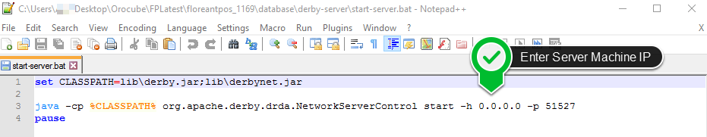

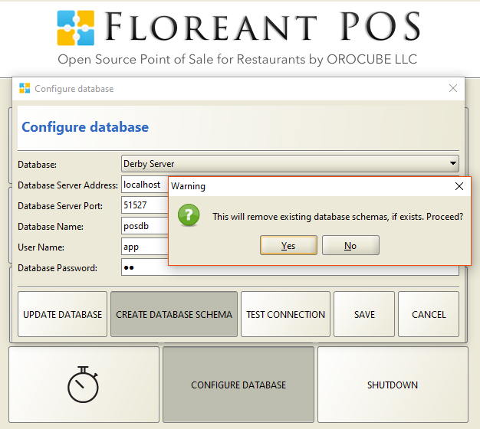Double click on Batch file of floreantpos. At the initial screen CONFIGURE DATABASE- CREATE DATABASE SCHEMA once entered same ip address as just set-up. In all the Client PC do the same procedure for CREATE DATABASE SCHEMA with providing the server ip address, no need to do the prior step of running a server. As long there is an internet or wifi connection they should all get connected with the server and share same information. Refresh button in the Order View screen updates all current tickets in all Server/ Client networked terminals. Make sure you have the server running in the cmd all the time in server machine to maintain the network.

## Initial Login

The Initial Login screen shown below is divided into several sections for different Order Types and also there is Orders button to see all open orders regardless of Order Types. This screen is used for login followed by clock in for the desired Order Type or Kitchen view; and Shut down the terminal. It also shows a CONFIGURE DATABASE button which is shown when the system is first installed and can/should be hidden by using the Back Office/Admin/Configuration/Terminal/Show Configure Database button on login screen.

Log out will always return the user back to this initial screen:

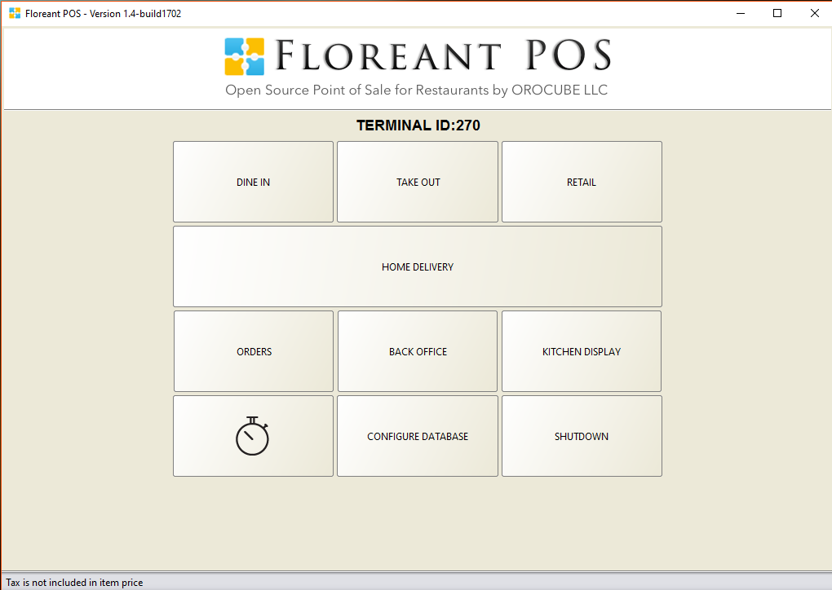

The top portion of the screen displays the software version.

Login ID entry can be configured to enter a specific number of digits to help facilitate faster logging in. Let’s say that all User IDs have been set to four digits (Back Office Admin/Configuration/Terminal/default password length=4). When the fourth digit has been entered in the ID Entry field, the system will perform the equivalent of pressing the “OK” button.

Although this feature adds a level of convenience, for added security the default password length can be set for more than 4 digits and a magnetic swipe card reader may also be integrated to facilitate user login.

## Orders Mode

order_filter.pngOrders option is specifically for managerial access to view all kind of activities and all orders for all Order Types. Select the mode before logging in entering the User ID and it will take the user in what is referred to as the Dashboard, where existing orders are displayed. Depending on the users’ Access Rights, they might see just their own orders or all open orders. Settle down an order, split or void an order are some functions that can be performed from this Order View Screen. Tickets and Activity panel columns can be filtered out by pressing the button. Also there is Order Filter button to view all open/ closed orders as well as viewing orders from all type or specific Order Type.

## Kitchen Display Mode

The Kitchen Display Mode configures the screen to show all open tickets. This is a display of all tickets rather than or in addition to printing the tickets on a kitchen printer. Tickets on the display can be sorted by kitchen printer (when there is more than one) or by order type (dine-in, take out, etc.). Kitchen Display Mode can be run as a separate terminal with login and logout access from it.

The display will list each item on a ticket and allow it to be marked as “Void” (cancelled order) or “Bump” (cooked and done). Different colors such as yellow and red indicates the elapsed time of the order being taken and helps the cook to decide which orders to cook first. Just ordered items will stay as they are and after specific time they will become yellow, for more time elapsed will finally turn to red.

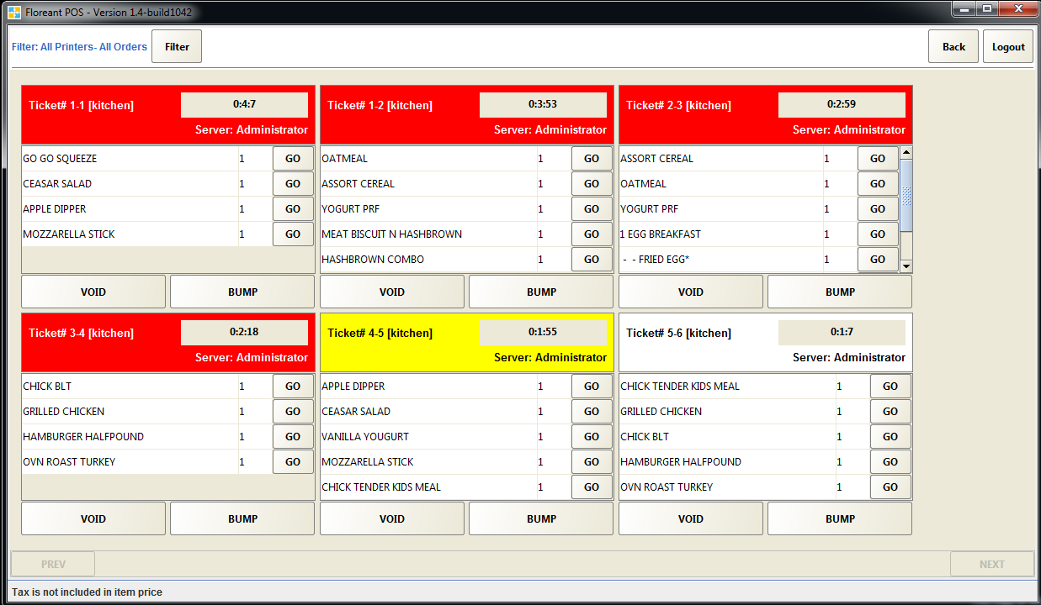

## Clock-In/Out

Terminals are used by staff to clock in and out of their work shifts. The system will track and report on staff work time from clock-in to clock-out. A Clock In/Out icon can be found at the top-right area of all terminal screens other than the Initial Log-in screen and Kitchen Display screen. 

If a user forgets to Clock-Out, the user will be automatically clocked out at midnight or the next time they try to Clock-in and will see the following notice:

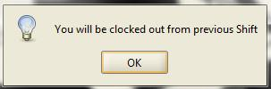

If the user forgot to clock-out of their previous shift, they should select the OK button. Otherwise if they didn’t intend to clock-out, they should select the red cancel icon on the top right of this warning screen (not shown). Selecting the OK button will clock the user out from the previous shift and restart the clock-in timer.

Several users can clock-in/out to one terminal at the same time. If one store has 6 employees and only one terminal, there should be 6 different set of password for each user to clock in and out for his shift. Once prompted to enter password for clock-in/out the designated user need to provide his own password and choose to clock in/out.

## Log-In/Out

Because of terminals can be used to access all parts of the Floreant POS system (and the cash drawer), they should never be left in an unprotected mode. When the terminal user leaves the terminal unattended, even for a short period of time, the user should always logout of the terminal. This will effectively lock the terminal until an appropriate User ID is re-entered. Terminals can also be programmed to automatically logout after a preset period of inactivity. This is managed in the Back Office under Admin/Configuration/Terminal/Enable Auto Log Off. The timer is set in seconds. A display of the remaining time (seconds) before logging off is displayed in the top center of each screen below the User Name, Terminal Number, System Date and Time. Pressing any key/button will reset the Auto Logoff timer.



Terminals can also be configured to use various types of ID cards (including a driver’s license) in addition to assigning an ID number. ID cards provide faster, more secure identification when logging in.[[2]](#footnote-2)

A Logout icon can be found at the top/right area of all terminal screens. Use of this button will logout (but not clock out) the current user and will return the user to the Initial Login Screen (See Figure 1 – Login Screen). 

When users clocks in, they are automatically logged into that terminal. However, they may have limited or no rights to perform further actions. See Users and User Types in the Back Office section of this manual for further information about access rights.

A User can Clock-out from any terminal.

## System Shutdown

The SHUTDOWN button will close the terminal entirely and return the screen to the operating system screen. This button requires sufficient Access Rights associated with the user’s login. The SHUTDOWN icon is also found at the top right of all Terminal Mode screens and serves the same function.

## Order Entry for Quick Service Take-Out and Dine-In

Orders (tickets) are created in three simple steps in Orders Mode:

1) Select the Order Type

2) Add Items

3) Settle/Close the order

1. Select the Order Type (Or Login From Initial Screen)-
   1. Dine In
   2. Take-Out
   3. Pickup (On-line or Phone Orders)
   4. Home Delivery
   5. Drive Thru
   6. Bar Tab
   7. Retail

Note that not all of the Order Types may be available (displayed or selectable) on a terminal, depending on the setup of the individual terminal. In addition, the name of each order type can be changed in the system configuration, such as To Go instead of Pick Up.

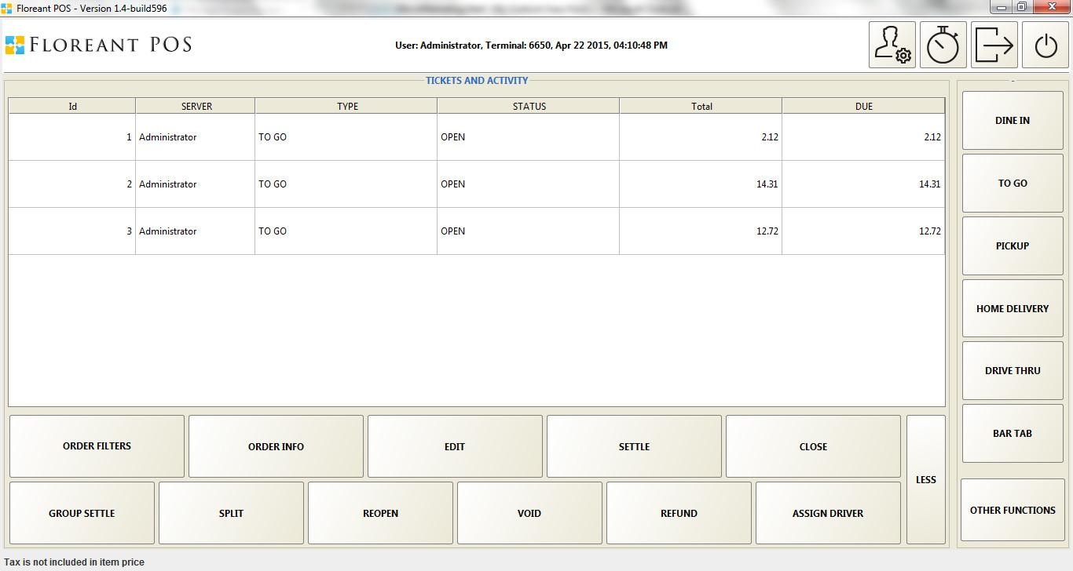

The latest version gives the opportunity to add Custom Order Types from the Back Office. From the Admin/ Explores tab any intended Order Type can be created. For each new/ existing Order Type boxes can be checked from the list as necessary.

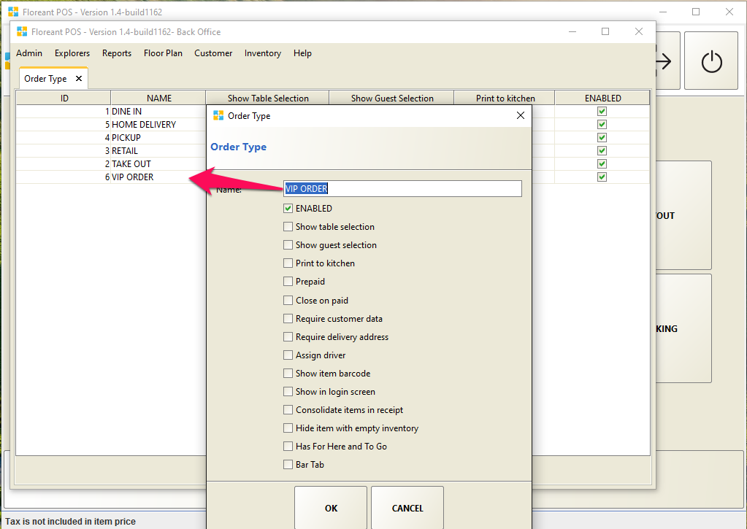

1. Select the items to be added to the order -

This screen has three sections:

* 1. Categories (right side of screen)

A Category is first selected to provide a list of Menu Items and/or Modifiers. Categories are the sub-sections of a menu used to help organize the selections; such as Breakfast, Lunch and Dinner or Appetizers, Entrees, Salads, Desserts, etc. They provide quick access to different parts of a menu.

* 1. Items, Groups and Modifiers

The individual menu Items may be displayed either with or without an Item picture. A further sub-grouping of menu items may be displayed as a Group. Groups allow organizing groups of menu items that are not large enough to warrant a separate Category or would otherwise be best placed with other items, such as Sides as a Group of the Category Entrees.

Note that Modifier Groups are different from Item Modifiers. Item Modifiers allow for the common preparation selection of individual Items, such as Eggs. The Item Modifiers for Eggs might display selections for Poached, Scrambled, Over Easy, Over Medium, Sunny-side Up, etc. Item Modifiers can be programmed to be either optional or a required selection. Modifier Groups group different type of modifiers in different groups, such as different types of eggs mentioned above in Eggs modifier group and different types of cheese such as Cheddar, Blue or Pepper jack in Cheese modifier group for an egg sandwich.

A category must exist for an item entry in the back office. The item must also be under specific group to be recognized easily while creating ticket. Minimum and maximum amount of Modifier settings allow food servers to help the customer better with their needs and reduce the chance of making mistakes.

Pricing is an important factor for items and modifiers. It can be chosen in lot of different ways how the user wants it to be.

* Items can be priced and included modifiers can be priceless.
* Items can be priceless and included different modifiers can have different price to give that item dynamic pricing.
* Items can be priced plus modifiers can be priced as well.
* Items can be priced and modifiers can be priceless but only priced when added over the maximum amount. If a modifier has maximum number set to 2, for selecting 3 or more of that modifier will start charging for each in this case. This price for modifier needs to be set in the Extra Price option. Besides charging extra the color will become red for that modifier when added to the ticket.
  1. Ticket

As a Ticket (order) is created, each Item (with Modifiers) is displayed in the Ticket section of the screen with the total of the ticket included. When all items have been added to the ticket, the user can DONE to save the ticket for payment later or can TOTAL to settle the ticket. The MORE button offers a variety of additional options including adding a discount, cooking instructions, voiding the ticket, among several other options.



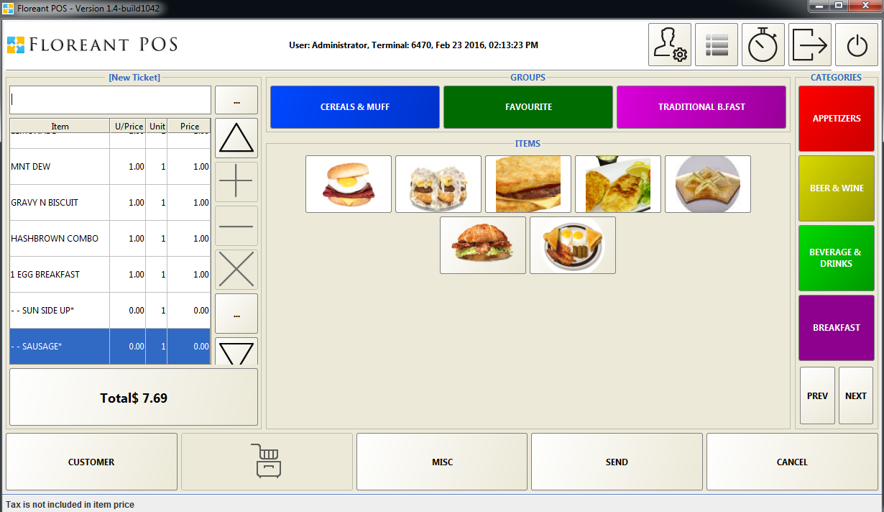

An Item can be added instantly if it does not exist/ have not entered in the Back Office Menu Item. Press on MISC button, Enter Item Name, Price and press Ok, this Item will be added to the ticket with or without other Items been added to the ticket. Setting up a barcode at the Back Office Menu Item entry will allow adding that item to the ticket by scanning the barcode.

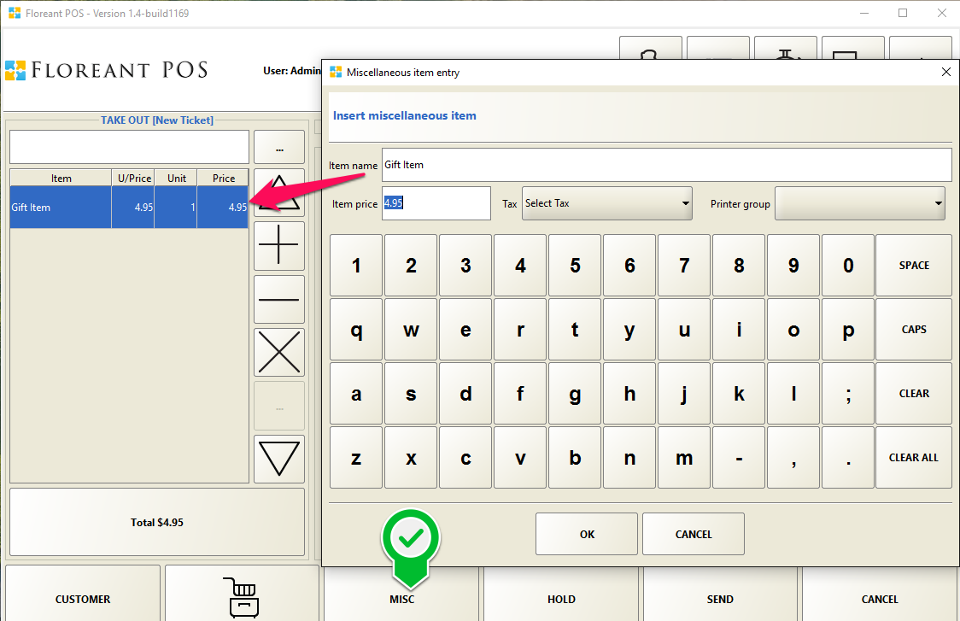

1. Completing the order:

If an order is final and ready to take payment hitting Total will take to the payment screen. For Take Out orders another window will pop up asking to choose either FOR HERE or TO GO. Making the 1st transaction of the day/ shift of employee will ask to assign drawer in behalf of the intended user with access permission. After selecting user will have to enter drawer initial balance. Then it will allow to settle specific ticket(s) ad take to the payment screen.

If an order is not ready to be settled and more items need to be added press the order view  tab and EDIT any specific ticket. Order Filters button at the bottom right of the panel will give many options to see all tickets/ open tickets/ closed tickets/ tickets by order types/ even filtering more by pressing the icon  at the upper right corner of the panel. More/ Less button at the bottom right of the panel gives more options.

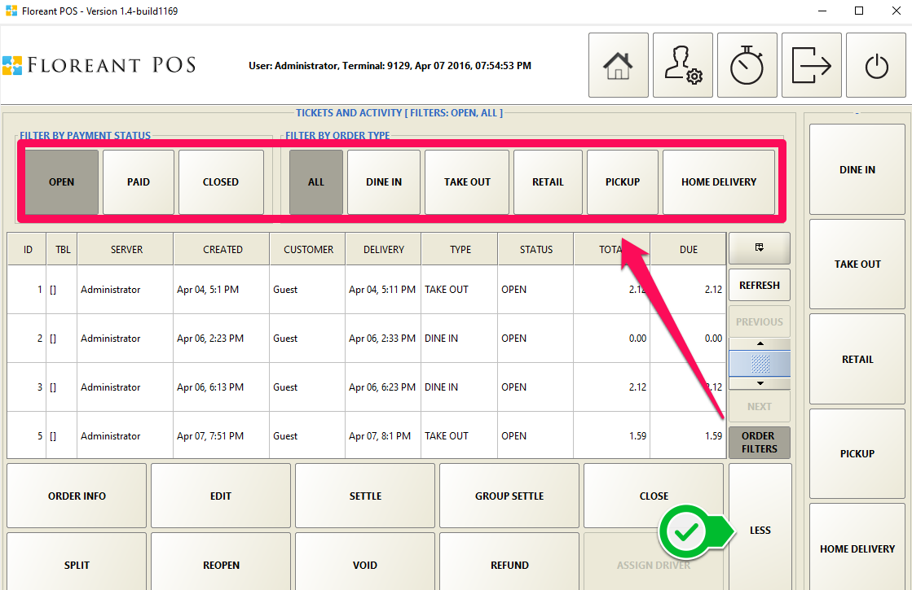

## Home Delivery/ Pick Up Orders

Extra information needed for Home Delivery is Customer Name, Phone number and Delivery Address. Delivery time can be scheduled for a later time if not needed in an hour or so. Google Mapping Integration facilitates viewing driving directions from the Store/ Terminal location to the desired Delivery Address. Zone mapping divides different areas for delivery in respect of zip code or driving distance and charged by zone. Delivery Driver can be assigned for food delivery and Driver can view his orders to deliver, take payment with tips and declare him as Driver IN once come back to store and ready for next delivery. Caller ID system can be integrated with this plugin but it is optional to use. For more details please visit Home Delivery plugin from the plugin link from the Resources section and download manual for Home Delivery.

Pick Up orders will be of same concept, only will not require any Delivery Address.

## Bar Tab Orders

Creating a tab is now easier. It can per-authorize certain amount, name a tab by customer and show standee in separate bar tab.

* To activate it check Bartab in order type in Back Office🡪 Explorers🡪Order Types🡪 Dine In
* You may also create a new Order Type and name it Bar Tab and enable bar Tab function the same way
* If it is a DINE IN then go to Dine in tab and Click on Group🡪 Select tables🡪 New Tab.
* Go to Bartab tab and add press new Tab.
* You can add a name to the tab now.

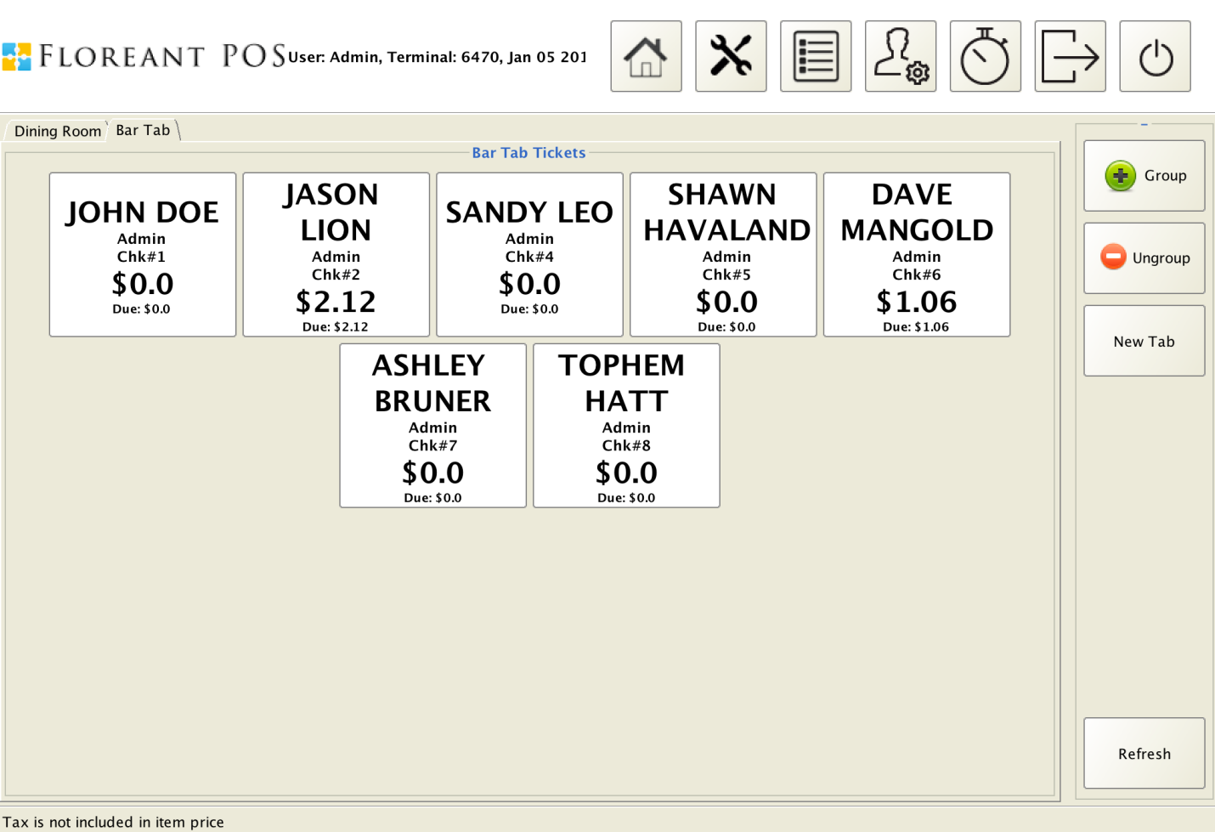

## Voids/ Refunds

Voids or Refunds can be done from the Order View screen. However a food server may need access permission from the Admin or the Store Manager to perform these tasks. Highlighting a particular ticket and clicking Void button brings up the details of the invoice for reviewing. The manager then selects the reason for voiding the ticket. If the item is wasted, he can check the wasted checkbox and hit the Void button in the bottom of the screen to confirm his action. Cancel button is available to back out of the voiding operation. Please note voiding an order will not void the transaction if paid already. Payment transaction must be voided from the Orders view🡪Admin button🡪Authorize option.

## Order Payment

In the payment screen choose intended payment type from the right panel and complete transaction. For Cash payment, hitting EXACT in the below screenshot would take the payment of exact amount $7.69, hitting NEXT AMOUNT would take the payment of $8.00 and calculate the change to be returned. All numbers button take payment for that specific amount and calculate change or remaining balance to be paid. Tendered amount also can be entered manually. Any remaining balance can be paid using different Payment Type and this way a ticket can be settled using Cash & Card/ Card & Gift card/ any other combination.

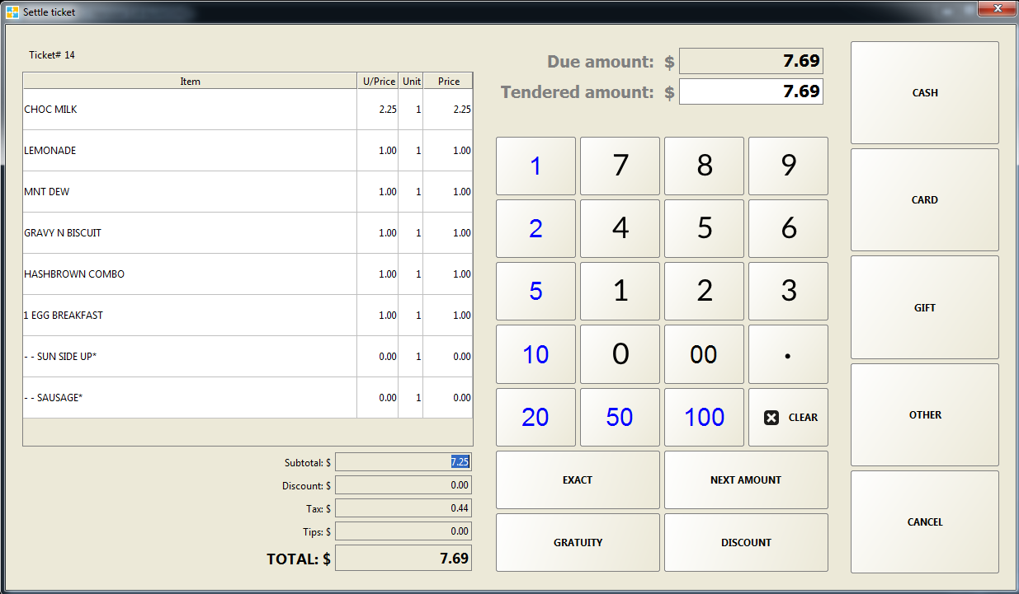

### Quick Inventory

This is a useful tool for Quick Service stores. The stock amount can be entered in the Back Office Item Explorer for each Item. After selling that item close the Menu Item Explorer and reopen it, you will see the stock amount has been updated. Press on Update Stock Amount to give new stock amount been received.

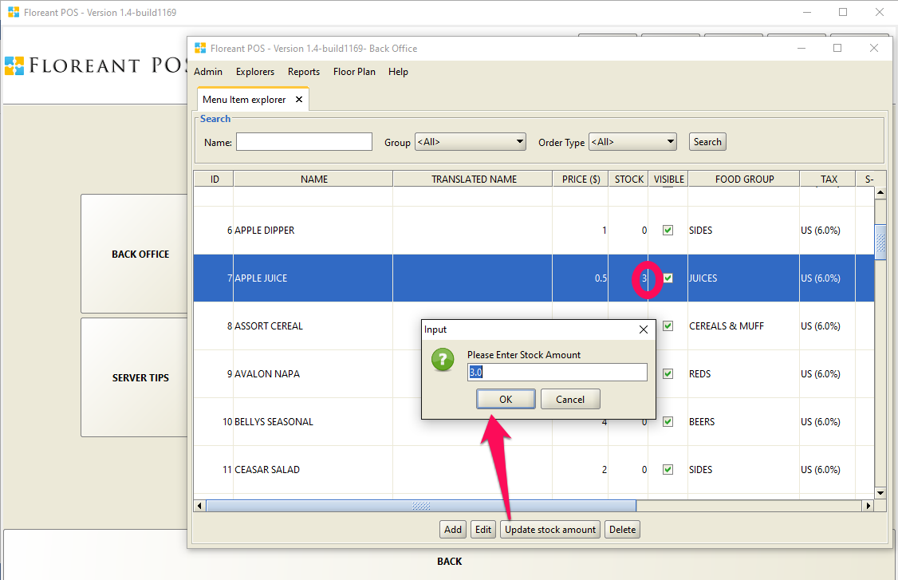

### Splitting and Grouping Tickets

Pressing the MORE button at the Order View Screen will give option to Split a Ticket/ Group Settle of specific tickets.

Split: A ticket can be split into 4 ticket in one go. If more split is required, one of the split tickets can be further split to maximum 4. Click the Split button and a new window will appear showing the ticket’s detailed information on the left hand side of the screen. On the top click on ‘the number of split’ button. If 2, one more blank panel will be shown on the left. If 3 another 2 more panels will appear. If 4, 3 new panels will appear. Now select the item that needs to be move to the 2nd ticket and hit ‘2’ button. If an item needs to be moved to the 3rd ticket, click button ‘3’. If numbers of splits are defined as 2, the 3 and 4 buttons will not work. Up and down arrow keys are for navigating through the menu items of the order. Once done, hit Ok Button and the new tickets will be displayed.

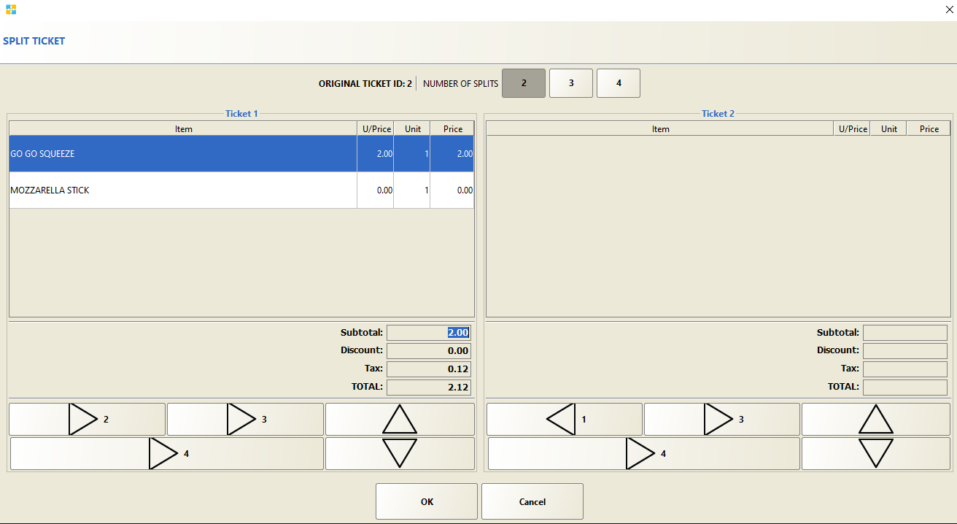

For Grouping Select the Tickets from Tickets and Activity Screen and select Group Settle.

### Coupons/ Discounts

Provide discount on specific Item or Order and even can scan coupons to automatically deduct the discounted price. Once the dedicated coupon is scanned the number will be entered in the Coupon Barcode box. Set an expiration date or leave it blank and check the box Never Expire if there is no specific date for discount offer ending. Choose coupon type if Percentage or Amount. Decide where the discount will go if to an item or to an order. For items select them from the right Panel using the Add button.

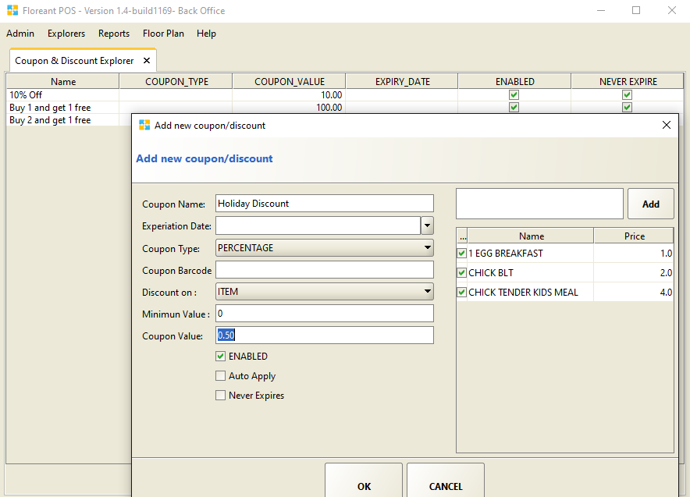

# The Back Office

## Overview

Back Office is the vital place where everything is controlled and managed from. Starting with adding Menu Items to the POS system, Terminal Configuration with Store and Printer information, Report, Inventory and a root for overall management of the POS.

## Admin

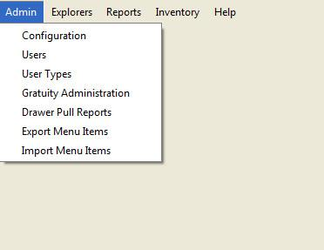

### Configuration

Configuration has all kind of set-ups using different Tabs:

Restaurant: This tab is to enter Restaurant/ Company information to be printed in the payment receipt. Restaurant/ Store Name, Physical Address, Phone Number and Ticket footer message such as “Thank you” or “See you Again” are the necessary information that the store wants to view in the receipt.

Terminal: Terminal numbers are obtained by the system automatically, if intended the terminal number can be changed at initial set up and should not be changed at any later time after transaction(s) been processed to that terminal. Default password length can be set more than 4 to have more secured access to the terminal. Enable auto log-off within a time interval is a security feature for food servers if they forget to login after that period of time no one else can fraudulently access the terminal. Group by Categories in Kitchen Receipt view option is intended for showing different courses of food items in different categories list. If Kiosk Mode is enabled, maximize/minimize/shutdown of application windows are not allowed. Shutdown is allowed by users who have proper authority for this mode.

Print: Different printers need to be added for different purposes such as Report/ Receipt/ Kitchen/ Packing. Multiple printers can be added in one printer group to satisfy special needs. For example if one item needs to be printed in 2 kitchen printer and 1 packing printer at the same time all these 3 printers needs to be added in a same printer group and this group has to be assigned by Editing the Menu Item from Explorers Tab.

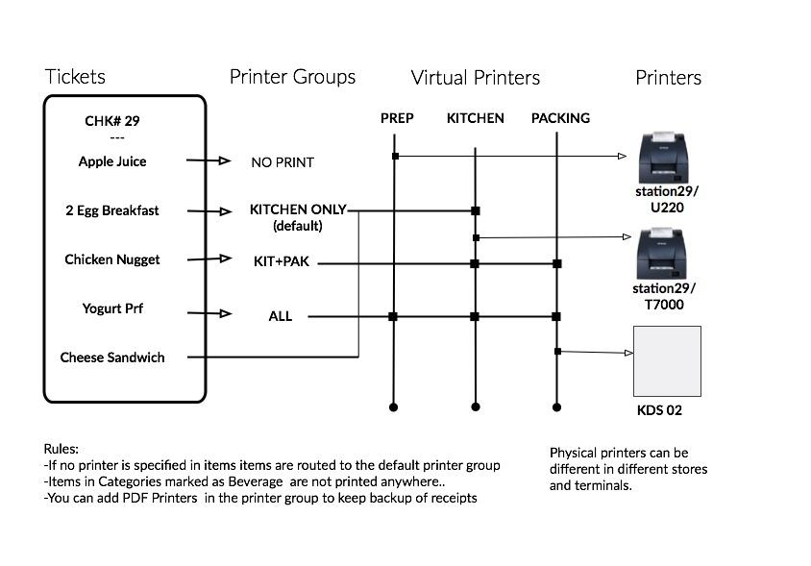

In the above case, for Order Check# 29, Apple Juice will not be printed anywhere. 2 Egg Breakfast and Cheese Sandwich will be printed in only T700 printer. Chicken Nugget will be printed in both T700 and KDS 02 printers. Yogurt Prf will be printed in all printers: U220, T700 and KDS 02. However, you are free to choose any printer group with any Printer combination. Report and Ticket Receipt Printers are usually not been grouped.

You can also set the timer for when you want an item to turn into yellow and respectively to red in the Kitchen Display Screen.

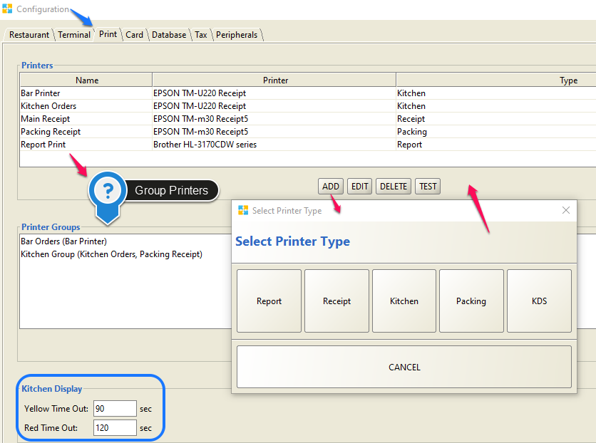

Card: Choose intended Merchant Gateway and complete processing including account set up in order to accept credit card transactions.

If you do not already have an authorize.net account [click here](http://reseller.authorize.net/application/?resellerId=27144) and set up your account, for only testing create a sandbox account [click here](https://developer.authorize.net/hello_world/sandbox/).

* Login to your account and click on ACCOUNT tab at the top right of the page below LOG OUT button.
* Under Security Settings click on API Login ID and Transaction Key.
* Copy API Login ID and paste it into Merchant Account at Back Office- Admin- Configuration- Card Tab in Floreant POS.
* Type simon as the secret answer for creating new transaction key.
* Copy new transaction key and paste it into Secret Code at the same screen in Floreant Back Office.
* Press Ok and create a ticket, take payment with any credit card and it should be working.

Try to keep the same setup as in the screenshot. You may change the Bar Tab Limit to any amount you want.

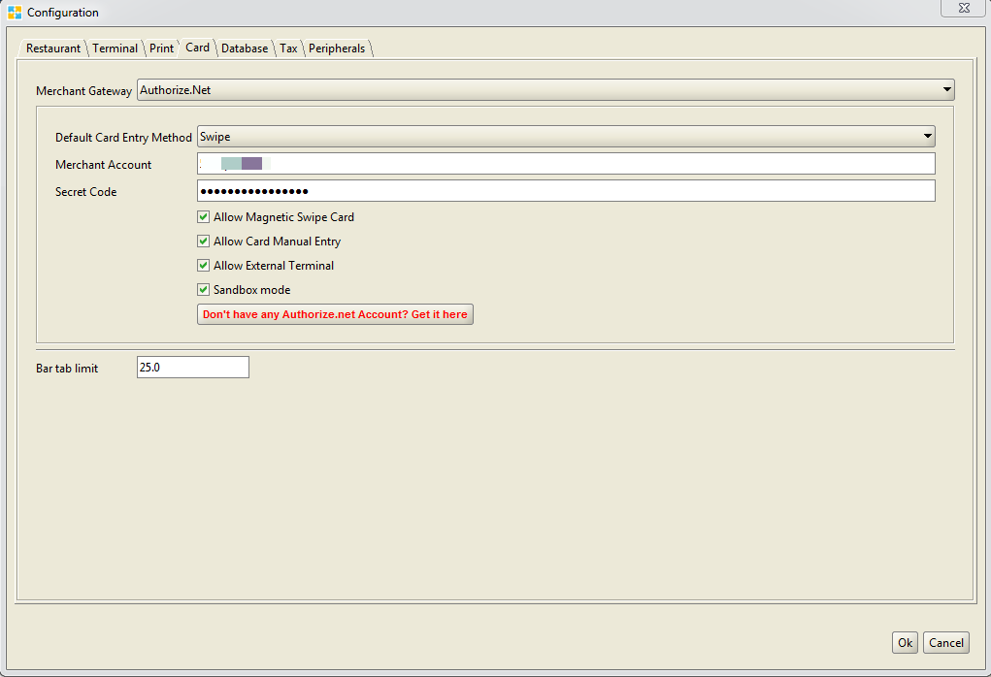

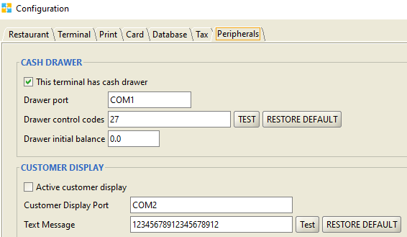Peripherals: Cash Drawer and Customer Display settings with com port and test for work-abilities. You may check com port by opening up Device Manger and set up com port number at Back Office🡪 Admin🡪 Configuration🡪 Peripherals Tab. Pressing Test button of Cash Drawer should kick open the drawer and show LED lights for the Customer Display. A major concern is when users fail to perform Test for Cash Drawer is they might have the Cash Drawer connected through a printer and not directly to the POS terminal. For this they are not able to perform Cash Drawer functions separately such as pressing “No Sale” button does not kick open the drawer. To solve this, users may connect the Cash Drawer directly to the POS terminal using an extra Drawer trigger, find put com port and test.

For using a Caller ID device, Caller ID driver will bring option to add Caller ID at the Peripherals tab. Choose the Caller ID device from the drop down list and enable the device to activate.

**Floreant POS Access Control List (ACL)**

The Access Control List (ACL) provides management the ability to allow/disallow individuals or groups of individuals (with similar job functions) to gain access to different parts of the Floreant POS system.

The general method for providing access control is to setup categories/permissions (i.e., Administrator, Manager, Cashier, Servers, Staff, etc.) and then assign each employee to the appropriate category based on the need to access various functions of the Floreant POS system. The highest level of access control is the Administrator category and this is assigned to just one or two individuals *that both understand the programming of the system and have the authority to assign all other employees to their appropriate categories*.

The following are common categories that are used (in addition to the Administrator) in most restaurants but the system is very flexible in the names of the categories and the number that can be used. Smaller restaurants will often combine these job functions into just a couple of categories.

Common ACL Categories:

Manager – Has the same abilities as the Administrator except does not have access to the Back Office -Admin tab functions. These functions include adding new employees (Users), assigning ACL permissions (User Types), setting up terminals/registers, etc. The Manager can also have the ability to handle payouts, add discounts, refunds, shut down a terminals and void tickets, as individual capabilities.

There are a separate set of managers functions that include:

* Managing Server Tips (Gratuity Administration)
* Drawer Pulls
* Ticket Management, including voids and transferring to other servers
* Drawer Bleeds (removing cash from a drawer)

These are listed in the ACL as Perform Manager Tasks.

**Back Office - Admin Tab List of Functions**

Ass’t Manager – Ass’t Manager access would be similar to the Manager’s but would not normally have the ability to the Back Office Admin or Explorer tabs.

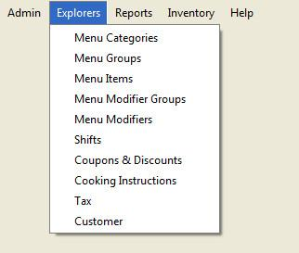

**Back Office - Explorer Tab List of Functions**

Cashier – When a restaurant has a dedicated cashier responsible for a specific register, the Cashier ACL permission is assigned, which only allows the ability to closeout tickets. In this scenario, the cashier cannot create or edit a ticket. However, this function varies greatly in smaller restaurants. See the Setup Scenarios list below for other options.

Servers – Servers (wait staff) normally have the ability to create new tickets and manage them until they are ready to close out.

Chef – When a Kitchen Display System (KDS) is used for ticket/order management, various kitchen staff may be given the ability to turn on and off the Kitchen Order Status display, which is then used instead of the kitchen (chit) printer.

Staff – This category is used exclusively as a time clock feature, allowing staff to clock in and out each day with a unique identifier (code). Any register can be used for this function. The system can be set up to use employee ID cards or even driver’s licenses for logging in and out instead of assigning ID codes.

Setup Scenarios:

Common Cashiering: This scenario is generally found in family operated restaurants where wait staff all share a single register. The wait staff all share in the cashiering responsibilities from a common till. There is no accountability for register overages or shortages in this scenario.

Dedicated Cashier: In this scenario, the wait staff can create and edit tickets but not void or close tickets. Generally, this is done from dedicated terminals that do not have cash drawers. Wait staff log in and out of the terminal with each order. Although the Cashier’s register can be used for order entry, it is normally dedicated to just closing tickets.

**The Floreant POS Access Control List Worksheet**

This worksheet will assist in the setup of Floreant POS Back Office. Fill out the worksheet with the appropriate access controls and list the pertinent employee information. The hourly rate information is used in different reports to show profitability from various perspectives.

### User Types

Create User Types before inputting User information.

Creating an Access Control List

|  |  |  |  |  |  |  |  |
| --- | --- | --- | --- | --- | --- | --- | --- |
| **ACL Name** | Administrator (Admin) | Manager (Mgr) | Assistant Manager (Ass't Mgr) | Chef | Cashier | Waiter/Server | Staff (Time Clock Only) |
| Reopen Ticket | \* | \* | \* |  | \* |  |  |
| Edit Ticket | \* | \* | \* |  | \* | \* |  |
| View Explorers | \* | \* |  |  |  |  |  |
| Take Out | \* | \* | \* |  | \* | \* |  |
| View Reports | \* | \* | \* |  |  |  |  |
| Perform Admin Tasks | \* |  |  |  |  |  |  |
| Split Ticket | \* | \* | \* |  | \* | \* |  |
| Authorize Tickets | \* | \* | \* |  | \* |  |  |
| Create New Ticket | \* | \* | \* |  | \* | \* |  |
| Pay Out | \* | \* | \* |  |  |  |  |
| View All Open Tickets | \* | \* | \* |  | \* | \* |  |
| Settle Tickets | \* | \* | \* |  | \* |  |  |
| Void Tickets | \* | \* | \* |  |  |  |  |
| Perform Manager Tasks | \* | \* | \* |  |  |  |  |
| Shut Down | \* | \* | \* |  |  |  |  |
| Refund | \* | \* | \* |  |  |  |  |
| View Back Office | \* |  |  |  |  |  |  |
| Add Discount | \* | \* |  |  |  |  |  |
| Kitchen Mode | \* | \* | \* | \* |  |  |  |

The ACL Name assignments in the above table are typical assignments used for identifying who has access to what register/terminal functionalities. The above assignments are only suggestions and can be modified as necessary or new ACL Names can also be added. These assignments are then applied to individual employees/staff, as needed. There is no limit to the number of ACL Names that can be used.

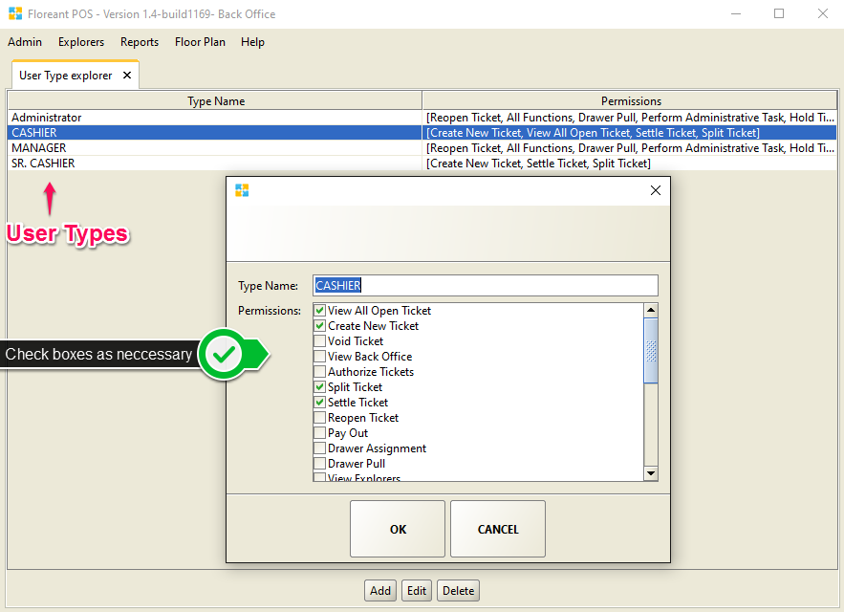

### Users

Anybody using the system has to be recorded in the system as a user through this window. The system ships with one built in user-id of type Administrator with authority to create further users with various combinations of permissions which again are pre-determined and recorded in the system through user type maintenance window. Each user will have a unique Id and a secret key and the secret key is used to logon to the system. Access to different functionalities is controlled through the user type associated with the user.

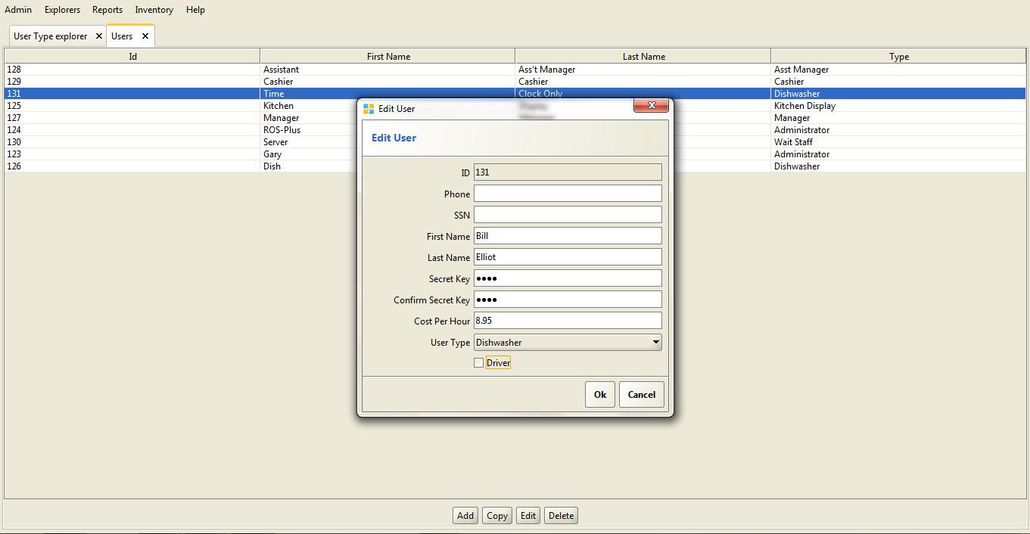

### Gratuity Administration

Any food server that logs in to the system is being recorded for the gratuity earned for the period been worked. Gratuity Administration can be accessed from the Back Office🡪 Admin button. It can also be accessed from Orders View🡪 Admin Button🡪 Server Tips Button. Choose the User/ Employee from the drop down box and tips amount for specific tickets will be listed.

### Import/Export Menu Items

Menu Items can be imported or exported from/ to outside sources of documents containing list of Items. Import / Export of menu items needed to proceed as .csv file extension.

## Menu Setup

Floreant POS is a java based system and in order to keep data integrity, Menu Programming sequence should be followed as🡪 Creating Menu Modifier Groups🡪 Creating Menu Modifiers🡪 Creating Menu Categories🡪 Creating Menu Groups🡪 Creating Menu Items🡪Adding Modifier Groups and Shifts (If Any)

**Follow Sequence**

Menu Items can be manually set up by name, price, and stock amount and also by fractional unit for grocery items by weight. Modifier Groups satisfies the need of combo items such as 2 Egg Breakfast or Burger combo with Fries and Drinks. Shifts can be created for offering the item in specific hours. Price by Order Type gives enhanced ability to adjust the price for an item, for example Dine In price should be higher than Take Out price and this could be done by giving the item a different price or even only setting different tax amount.

*Menu* *Modifiers are the ingredients for a Menu Item such as Egg and Cheese for an Egg Sandwich. If you have fixed modifiers and never intend to show them in your POS system you can skip adding Modifiers. You may also do so if you do not allow your customers to have flexibility in adding modifiers in their own choice. Candy stores or retail stores may never need to use Menu Modifier section at all for the Store Items.*

## Reports

### Overview

Many reports are available to management from the Back Office - Reports menu. There is also a Drawer Pull Report and a Gratuity Administration Report found in the Admin menu. Each of these reports is defined by user selectable beginning and ending dates.

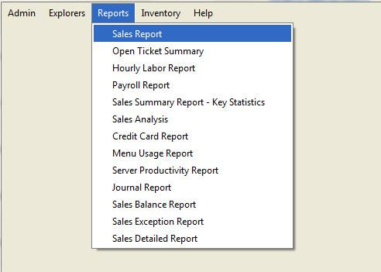

These reports provide the ability to review and manage the critical areas of operation. These reports can be divided into the following management areas:

Employee Management

* Hourly Labor Report: This report shows hourly efficiency of all employees or group of employees and/or per terminal/all terminals for a 24 hour period.
* Payroll Report: This report shows wage of employees between a date range of each employee in the system.
* Server Productivity Report: This report shows hourly efficiency of all employees or group of employees or per terminal.
* Journal Report: This is a vital report for the management to monitor activities of the employees. It records activities of all employees sorted by time along with some vital info for the restaurant owner to be on top of what is happening in the restaurant.

Sales Management

* Sales Report: This can be Current Sales Report, which is after the drawer has been reset or the previous sales report which is before the last drawer reset event.
* Sales Summary Report: shows detail performance statistics for a user type or terminal. Also this report has a profit center wise breakdown of number of guest, tickets numbers, Sales and average ticket, average Guests and %.
* Credit Card Report: Credit card detail by individual transaction
* Sales Exception Report: This report gives the detail information of voids recorded and discount coupons honored within a time range. Voids are shown with reasons and also summary is given for those that has food wasted and those not.
* Sales Detail Report: This report gives the topmost level visibility to the earning of the business within a certain amount of time in two parts - cash and credit. Also shows the discrepancy between the actual cash in the register amount as entered in the system. For the credit card portion, it shows the summary of total sales, returns, net, net tips and percentage of the tips to actual sales for all types of credit cards used.

Inventory Management

* Menu Usage Report: shows sale, cost and profit per menu category.

Bookkeeping/Accounting

* Journal Report: This is a vital report for the management to monitor activities of the employees. It records activities of all employees sorted by time along with some vital info for the restaurant owner to be on top of what is happening in the restaurant.
* Sales Balance Report: This report is another vital report for the restaurant manager match and balance cash register. This report can also be printed at the time of a drawer reset.

## Inventory

This feature will work with Plugin installed. Items that are entered for inventory will get updated as the sales occurrence. It also provides Inventory Control, Transactions including Purchase, Move, Wastage, restocking levels, Warehouse for Raw materials.

## Hardware

Printers: Supports any receipt thermal printer that has native printer driver.

Recommended Ticket Receipt Printer List:

* Epson TM T88 Series
* Epson TM m30

Kitchen Receipt Printer List:

* Star Micronics TSP100
* Epson U220

Cash drawer, Customer Display Pole: regular setup, refer to the vendor’s user manual

Barcode & Magnetic scanners – Standard USB (refer to vendor’s user manual)

### Overview

The first question will be, is the installation a single or multiple terminal application. The system is designed to be simple to install, setup, configure and maintain. Orocube will deliver the system with a customized system installation manual. The system will also be pre-configured and programmed with the information that has been provided to Orocube prior to delivery.

#### Architecture

Java app on either Linux or Microsoft OS with automatic on-site and off-site nightly backup and secure remote access for troubleshooting, system software upgrades and programming/configuration support.

### Hardware Installation

This is a planning exercise because it requires that multiple components be properly brought together in a timely manner before the system can be used effectively. These components include, but may not be limited to, Internet access, network hardware and wiring, dedicated power outlets, as well as terminals, printers and other hardware.

# Service/Support

What is covered and not covered. How is service and support provided and how to contact:

For any questions, concerns or services about Floreant POS please Email [sales@orocube.com](mailto:sales@orocube.com) or [support@floreant.org](mailto:support@floreant.org), Call 1-800-844-6603 or Chat with one of our agents in our website.

Services provided by Orocube are as listed:

* Commercial Subscription to Support Services with monthly paid
  + Bug fixing in existing POS software
  + Technical support with known issues by certified technicians
  + Online Helpdesk Ticket and Remote access support
  + Does not include Plugin/ Customization/ Other Services
* Hourly paid Support Services for Installation/ Configuration/ Technical Issues
* Customization Services: <https://orocube.com/request-customization-quote/>
* Plugin requests/ customizations
* Partnership/ Reselling and Rebranding options

For any inquiries please provide your business contact information and business details which will help our agents to assist you better.

# Latest Features/ Updates

## Group by Categories in Kitchen Receipt

Orders that are sent to kitchen may be categorized and viewed by Category. This way appetizers, meals/ kids meals or side items can be viewed under different categories which will make the cook to choose cooking priority and order. To enable this go to Back Office🡪Admin🡪Configuration🡪Terminal🡪 Check box for Group by Categories in Kitchen Receipt

## Multi-currency

This feature enables payment transactions in different currencies in many different locations in the world. Add your preferred currencies from Back Office🡪 Admin🡪 Currency Tab. Provide Currency name and symbol, Pay rate and tolerance. There must be one currency set as default. If US$ is your main currency set this currency as default and all other pay rate will be dependent on US$. Tolerence will allow ignore small difference, i.e: 0.2 tolerance will accept payment of $99.8 for the due amount $100.00. To enable multicurrency go to Back Office🡪Admin🡪Configuration🡪Terminal🡪 Check box for Enable Multi Currency.

## Allow to Delete Printed Ticket Item

Paid tickets that are printed on receipts cannot be deleted from the database and all the reports by default. If needed check the box for ‘Allow to Delete Printed Ticket Item’ from Back Office🡪Admin🡪Configuration🡪Terminal tab. After checking this box printed tickets can be deleted from Back Office🡪 Explorers🡪 Closed Tickets Tab.

## Allow Quick Maintenance

Quick Maintenance feature gives comfort of editing or adding Menu Items. If the button for Allow Quick Maintenance is checked at Back Office🡪Admin🡪Configuration🡪Terminal tab, Menu Categories/ Groups/ Items can be instantly added/ edited from the Order Taking screen. No more Back Office access will be required if this feature is enabled. Select this quick_maintenance.pngbutton and press on Select/ Edit/ Copy/ Del to perform actions. Pressing on + will allow to add new.

## Select Language

Language selection in 5 more languages other than English got easier now. Select your language from the drop down box from Back Office🡪 Admin🡪 Language, Save and you are ready to go. Available languages are Arabic, Egypt, German, Spanish, Dutch. You may need customization for full translation.

## Pizza Builder and other Features

Pizza Building capability with different size, crust and toppings with multiplier facility gave a module to add in the Floreant POS system. Please download and check the Pizza Designer Manual to understand all its functionality and proper usage.

Additional features such as Floor-plan and table booking facility, Caller ID and Home Delivery System integrated with Google Mapping, total Inventory System and Online Ordering please refer to the orocube.com webpage or follow the link for Plugin features below. You may download and read manual from the site, plugin licenses are sold per terminal and each plugin license is unique for specific terminal.

# Receipt Customization

Floreant POS ticket receipts/ kitchen receipts can be customized to print well with the designated printers in use. Most of the time the issue is receipt cut at the sides or font or layout issue. With jasper report formatting you can change receipt layout however you want to. You can even remove or add sections based on necessary or unnecessary information to be oriented in the receipt.

The compatible version of jasper report is ireport version 4.0.1 and you need to have jdk 1.7.67 active in the environment variables. Jasper Reports will not function well with JDK 8 or any other versions, changes made to receipt layout will not be active in that case.

Using iReport software open ticket receipt/ kitchen receipt .jrxml file.

* Make necessary changes that you need, you can click on the sections, use arrow keys to move them, click on the text and change font type/ size, adjust size of each section dragging to the left or right.
* For receipt cut problems, check the width of the page, if it is 80mm/ 76mm/ 58 mm. Setting up the page width will re-adjust all sections automatically and then you need to fix them back.
* It is recommended that you make page setup changes first and then change internal formatting.
* Once you are done with making changes compile it or simply press Preview button to view a preview and compile the same time.
* Make sure you have Empty Datasource selected prior to making a preview. Regardless what you see at the preview window your changes should be active and available to be reflected in the receipt print.
* Restart Floreant POS and al your changes should be available now to reflect on printing. If you do not get expected result, go back to iReport and fix how you like.

# Resources

[Open Source Floreant POS Website](http://floreant.org)

[Latest Feature Updates and Releases](https://floreant.xyz)

[Plugin based Additional Features and Support Services](https://orocube.com)

[Download Pizza Designer Manual](https://www.dropbox.com/s/qb2y9m3b0vlzxqw/Pizza_Designer.docx?dl=0)

# Glossary

**Administrator account:** The software ships with an account with default password 1111. This account is called Administrator account and is used to configure the software through back office. The password of this account can be changed as well as this account can be used to create other users account with administrator capabilities. Typically an administrator account will have the full authority to the back-office. Auto Log-off if a terminal is not used for certain amount of time, it can be configured to log off automatically. This is to avoid exposure of the system to potential unauthorized intrusion into the system. E.g. if Auto log off is active and set to 120 sec and if a food server forgets to logout and leaves the terminal unattended, it will logout itself after 2 minutes.

**Back Office:** Back office is the area of the software that is used to setup and control the functioning of the software system. Computer Hard wares, default/standard values of various elements of the software, users, security info, menus, inventory items, reports etc are maintained and accessed from back office Normally the Administrator account has access to this part of the software.

**Capacity info**: For this system, it refers to the maximum number of people that a food serving business can sit in its business premises at a given time.

**Clock out:** An employee or staff when logs off finally for the day, it is called Clocking out as opposed to Logout, which he does every time he leave the terminal unattended. Clocking out info is used by the system to determine the hours worked by the employee and is used in calculating pays, or generating payroll reports etc.

**Close Order:** Closing an Order /ticket is when the business doesn’t expect any further activity with that ticket. Important to understand that ticket is not closed when the payment is received in full. E.g. a delivery can be paid at the time of ordering, but an order cannot be closed until the customer has received the order and signed the receipt.

**Cooking instructions:** These are instructions given by the customer to the cooking staff regarding the orders they place. Typical examples could be – very mild or don’t add salt or use sweetener instead of sugar etc.

**Dine-In:** When customer enjoys the food and service in the premises of the restaurant business, they are called Dine-In customers

**Drawer Bleed:** This term refers to authorized removing of cash from the register system for valid business purposes.

**Drawer pull:** This term refers to the periodical removal of cash from the register.

**Explorer:** Explorer refers to a display style where you can see a set of information on a particular topic in table or list form and then add, change or delete one row at a time. The explorer menu show info on menu categories, items, modifiers etc.

**Export Menu Items:** Exporting refers to transferring list of menu items to a file in xml format.

**Gratuity:** This refers to amount of money paid by the customer on top of the billed amount as a token of appreciation for the service provided by the staff. This can be a percentage value of the total amount due or a lump sum amount paid at the discretion of the customer.

**Import Menu Items:** This refers to entering menu data directly from a file in xml format into system files instead of typing through key board.

**Inventory:** This refers to the raw material/ finished or intermediate products that are stored in the business premises for purpose of business that need to be tracked by the operation or managers.

**Kiosk Mode:** Kiosk mode is when the software operates in full screen mode. In this mode you cannot close or minimize the screen to work with any other window or software. You have to get out of application before you can access or use any other window or application.

**Light retail:** A retail business with simpler scope of operation is called a light retail. Examples are mom & pop shops.

**Logout:** This means exiting from the application. Any user should logout from the application when he is not attending the terminal.

**Menu categories:** The broadest grouping of the food items served in food business is termed as Menu categories in this system. It is the 1st level of grouping e.g. breakfast menu, Lunch menu and Dinner Menu. Each of the categories will have further grouping.

**Merchant Account:** Any business accepting credit card from its customers, has to register with a card service providers who gives them a unique identification number and account to access their service. This is called Merchant account

**Modifiers:** Modifiers in food business refer to variation of a food item that won’t result in change in price of the item. For example, a menu item called 2-Egg breakfast can have modifiers like following 4 modifiers – omelette, scrambled, poached, sunny side up.

**Open source:** Open source software are those that can be used and shared free of cost. They are distributed under licenses that comply with open source definition

**Open Tickets:** Orders that have placed but not paid, or paid but not delivered are termed as open ticket.

**PCI Compliant:** The Payment Card Industry Data Security Standard (PCI DSS) is a set of requirements designed to ensure that all companies that process, store or transmit credit card information maintain a secure environment. Any business, merchant, device, system or process that follows those requirement set is called PCI-Compliant

**POS:** Point of Sale - This is the place where a retail transaction by a customer is completed. In modern days it refers to the software and hardware system combination where customers can pays to the merchant in-exchange for the goods or service and gets the receipt. The computerized system is also called EPOS – Electronic Point of Sale.

**QWERTY:** This is most common modern day keyboard layout for English words. The 1st 6 words of the upper left corner of the keyboard

**Re-order Level:** This denotes the quantity below which an item has to be ordered immediately

**Replenish Level:** This is maximum capacity of the stock for an inventory item

**Restaurant Tab Sandbox mode:** It’s a mechanism to separate the testing environment from live or production environment of software system. For example testing a credit card transaction in sand box mode will not incur any real exchange of money but serve as test if the process is working correctly

**Secret Code:** This is actually the password to log-in into the system. Allowed length is 4, can be character or numbers.

**Settle ticket**: Once payment transaction is successfully completed for the amount in the ticket by the customer, it is called a settled ticket.

**Split ticket:** When group of people orders meal together and then want to pay separately at the end of food service, that one ticket can be separated into as many ticket as required. This is

**Tax Included Price:** When the price entered and saved in the system includes the VAT or any other form of tax, it is tax included as opposed to the one that doesn’t include Tax amount.

**Terminal:** Each workstation in the system that runs Floreant POS is a terminal

**Ticket:** A single unit of order for a food serving business is called a ticket

**Transferring Tickets:** Each ticket is assigned a server. Situation may arise where the tickets needs to be reassigned to a different staff when the ticket is still active. This is called transferring a ticket

**User interface:** Any hardware/software combination that can be used by an user to interact with the software system is called an User Interface or UI – the touch screens with input buttons or the menu are example of UI

**User type:** User type is used to determine which functions of the software a particular user will have access to. This is required for security purpose. For example a food server doesn’t need to have access to the screen where his wage is entered and saved. So, user types are defined in the system and each user is assigned to a type. All users belonging that particular type have access to part of the software which that particular type authorizes.

**Void a ticket:** This refers to cancelling a ticket. It might or might not result in waste of the material. Normally a cause is attached to a voiding operation to be reported and analyzed.

1. The terms Register and Terminal are often used interchangeably in this manual. The term Register denotes a terminal with a cash drawer. All display devices are Terminals, which can be configured in one of several different modes including as a Register. [↑](#footnote-ref-1)
2. The use of a driver’s license for an ID is especially important for employees that are involved with delivery, as this will ensure that the driver has a driver’s license in their possession when they check-in for work. [↑](#footnote-ref-2)