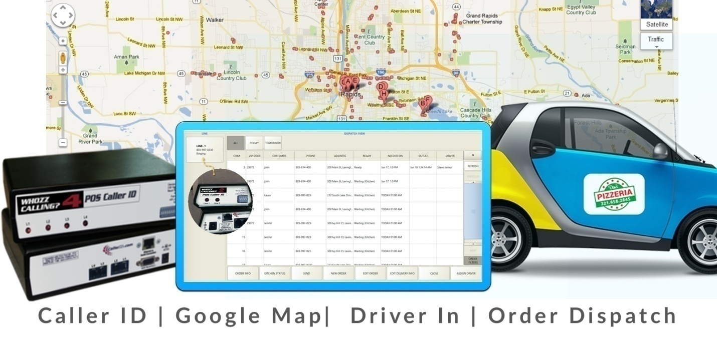

Orocust Pro Plugin 1.0 User manual

Compatible with Floreant POS 1.4 build 1600+



[www.orocube.com](http://www.orocube.com) | 800-844-6603 | sales@orocube.com

**Disclaimer:**

Our intent is to provide accurate and up to date content on this document; however, that is not always possible. THEREFORE, ALL CONTENT, SERVICES AND FUNCTIONS ON THIS DOCUMENT ARE PROVIDED "AS IS" AND "AS AVAILABLE" WITHOUT WARRANTY OF ANY KIND, EITHER EXPRESS OR IMPLIED, INCLUDING, BUT NOT LIMITED TO, ANY IMPLIED WARRANTIES OF MERCHANTABILITY, FITNESS FOR A PARTICULAR PURPOSE, OR NONINFRINGEMENT. Some jurisdictions do not allow the exclusion of certain implied warranties in which event any required warranty applies to the minimum extent legally required. Content is provided for informational purposes only and should not be relied on. Although the information on this Document may include statements on various life events and financial, legal or tax concerns, it is provided for informational purposes only, and is not intended and should not be relied upon as legal, tax or personalized advice. Floreant POS is a venture of OROCUBE LLC. However OROCUBE does not warrant or make any representations regarding the suitability, usefulness or expected results of the Content. You should not rely solely upon this information in making any decisions, including any decision to buy a product or service from OROCUBE LLC or any other company. You should consult your financial professional and legal and/or tax advisor for advice about the appropriateness of products and services for you, and the effect of state and federal law on the products, services or issues discussed on this document, or of federal income taxes or any other taxes on amounts held or paid out under any financial products described. Content may contain inaccuracies or errors and may change. No warranty or representation is made that the information on this Site is complete, accurate, up-to-date or error-free or that known defects will be corrected. Contents, services, products or functions available at this document may be changed or updated at any time without notice; but neither Floreant POS Team nor OROCUBE LLC has any obligation to update this document, so information may be out-of-date at any given time.  
  
Revision & Copyright Notice

This manual is released under CC license attribute 4. It lets others remix, tweak, and build upon our work even for commercial purposes, as long as they credit us and license their new creations under the identical terms.

|  |  |  |
| --- | --- | --- |
| Version | Author | Date |
| 1.0 | Chris Hays | 12/1/2016 |
| 1.2 | Chris Hays | 01/15/2017 |

Table of Contents

1. Installation 4

1.1 Overview 4

1.2 Version Compatibility 5

1.3 License 5

1.3.1 Before getting the license 5

1.3.2 After getting the license 5

2. Back Office Configuration 5

2.1 Creating Zones 5

2.2 Enable Driver Permission 6

2.3 Update License 7

2.4 Caller ID Device 8

2.4.1 How Caller ID Device Works 9

2.4.2 Certified Caller ID devices 10

3. Front End 11

3.1 Take new Order 11

3.1.1 Select Customer 12

3.1.2 Add Delivery address & time 12

3.2 Pizza Order 13

3.3 Delivery Dispatch 15

3.4 Reorder 16

4. Driver View 16

5. Table of Figures 17

# 1. Installation

## 1.1 Overview

Orocust Plugin is a java extension file for Floreant POS to extend home delivery, customer and driver management features. Like other plugins this plugin is packed as jar file. When you have received this plugin

Screen Capture 1

* 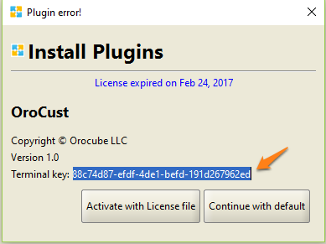Place the plugin file into the floreantpos-plugins folder.

Figure : Plugin License Activation

* Restart Floreant POS which will ask you to Activate with License file, Ctrl+ c to copy the 32 digit Terminal key and send it to an Orocube Agent in order to get license file. Once you receive license file follow steps from section 1.3.2

|  |  |
| --- | --- |
|  | **Plugin Naming convention**  Plugin is an executable jar file named after product - ‘major version#’. Often minor versions are not recorded. |
|  | **Terminal Key Issues**  Terminal keys are auto generated by Floreant POS. If you ever reinstall the system it may change the key and you have to request OROCUBE for replacement license. |

* If you have not received a license file yet, press on Continue with Default which will allow you to use the POS without plugin features, later once you have the license file follow steps from section 1.3.1 and then 1.3.2

## 1.2 Version Compatibility

Plugins are released for specific version of Floreant POS. You must get sure you have correct version of plugin. OROCUBE LLC will provide free update of plugins you have purchase.

## 1.3 License

A license file is needed to activate the fp-floorplan plugin working with Floreant POS system. Each license file is unique per terminal and user basis and has its designated usage period. No license will work on a terminal other than the terminal that it is originally developed for. Below are the steps for activating a license file to a POS terminal working with its working POS software copy.

### 1.3.1 Before getting the license

* 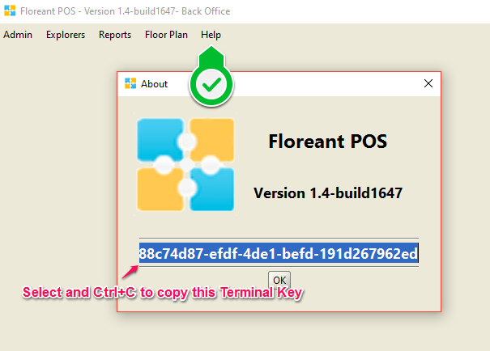Log into Back Office, press on the help tab and select About

Figure : Terminal Key at Back Office

* A new window will pop-up, copy the 32 digit Terminal key located right above the Ok button; this is a unique terminal key for the specific terminal that you are working on
* Paste and send your terminal key to an Orocube agent along with your Full name, email address and contact information once you have purchased this plugin license.

### 1.3.2 After getting the license

* Place the license file anywhere in your terminal/ pc safely.
* Try to restart Floreant POS this time and press on Activate plugin with License once it prompts
* Navigate to the place where you put your license file and import it.
* Now your Floreant POS system should acknowledge the license and you should be able to use all features of this orocust plugin.

# 2. Back Office Configuration

## 2.1 Creating Zones

Food delivery i.e. pizza delivery is usually charged by the distance between the delivery address and the Pizza store. This section will allow making different delivery zones in order to create different pricing charges depending on the distance.

|  |  |
| --- | --- |
|  | **Google API key for MAP**  The Google MAP key provided with the plugin is for test only. This is strongly recommended that users create their own MAP Key. We also take no responsibility for correctness of information of Google MAP API. Visit Google |

* Go to Back Office- Customer- Delivery Configuration
* Choose the Length measuring unit km/ mile for the distance
* Specify the terminal location, i.e: physical address of the pizza store where the pizza will be delivered from; this address may be saved pressing the save button to be used for distance from the delivery address.
* Check the box for charging by zipcode such as $2 for zipcode 29072, $3 for zipcode 29073, if not leave the box unchecked and you will require to enter start range and end range at the right hand side panel

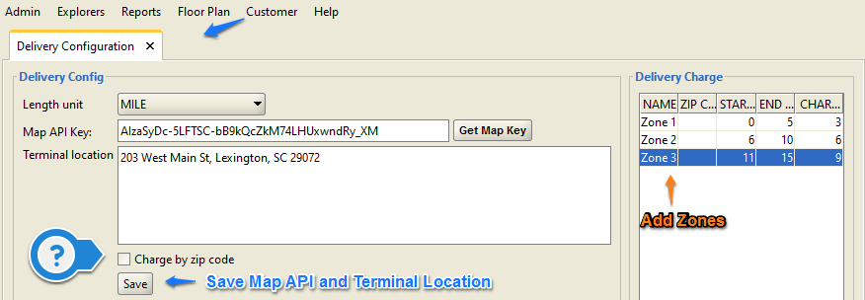

Figure : Setting Up Terminal Location and Delivery Zones

* At the Delivery charge section, press add button and create zones as zone1, zone 2 etc.
* For zip code based pricing enter zipcode and specify charge amount for the corresponding zipcode
* Otherwise provide the start range and end range for the distance between the terminal address and the delivery address, i.e: 0mile upto 5 mile: $3, 6mile upto 10 mile: $10 and so on. Entering zip code is not necessary here.

## 2.2 Enable Driver Permission

Delivery driver must be selected from the store employee list in order to assign driver for food delivery orders

* Go to Back Office- Admin- Users
* Select the employee(s) from the list who will go for the Home Delivery
* Press edit for the specific employee and check the box at the bottom of the screen where it says Driver.
* You should have other fields for this employee filled out and also the secret key which this employee/ driver may login to the Driver View mode from Login screen
* If you are the admin/ manager and do not know the secret key for this employee/ driver, use backspace and enter new secret key/ login password; if you are connected to a Database, check user password there
* Press Ok and close the Users tab to activate the functions performed

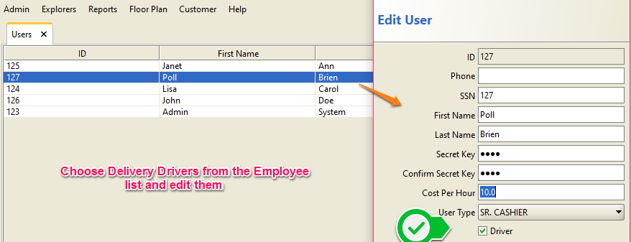

Figure : Enabling Driver Permission for Home Delivery

## 2.3 Update License

If you have received an evaluation copy of this plugin or if your license is expiring soon, you may get another copy of this plugin with extended expiration period.

* Once you receive new license file save it in a safe place.
* Go to back Office- Customer- About
* The screen will pop up with the purchase information with expiration date of this license
* Press on the Update button and navigate to the place where you placed the new license file and import it
* Your license expiration date should be updated; a restart of the POS system may be necessary

## 2.4 Caller ID Device

Caller ID device allows you to connect customer database with phone no. It only works with certified products. To enable caller Id features

* Go to Back Office- Admin- Configuration- Peripherals
* At the bottom of the window check the box for enabling Caller ID Device
* Choose the Caller ID device that you are using, options are AD101/ Whozz Calling; check their features below to decide which one to get if you do not have one yet

|  |  |
| --- | --- |
|  | **Caller ID device is not mandatory**  You can operate full system without any caller ID device. You can also anytime turn off caller Id device or extend more lines more devices. |

* Press Ok, the POS system may need a restart to activate the Caller ID system

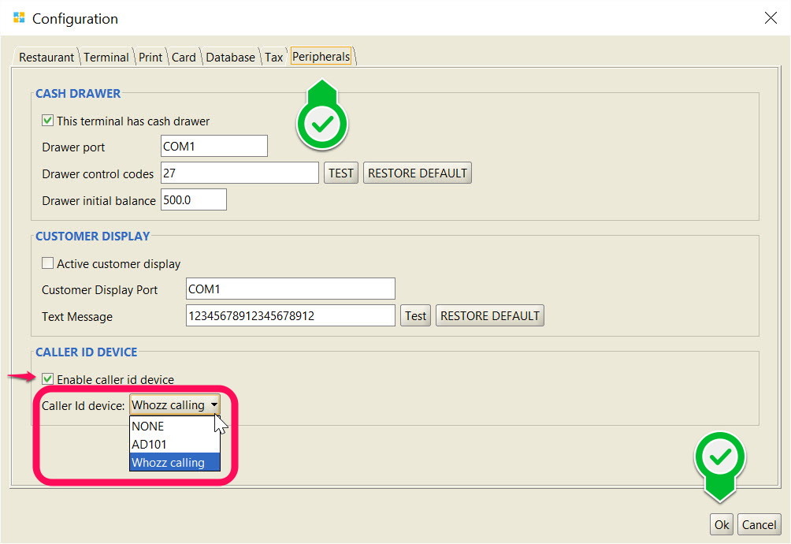

Figure : Enabling Caller ID Device

### 2.4.1 How Caller ID Device Works

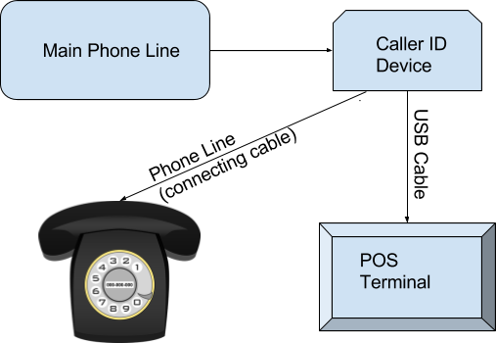This is a diagram of how to connect the Caller ID device in between the phone line and the POS Terminal

Figure : Caller ID Setup

* Main phone line may need to disconnect from the phone that was connected and then connect directly to the Caller ID device.
* Caller ID device will have 2 outputs, 1 output will go to the Phone and the other one

Once the Caller ID device is set up properly and configured at the Back Office, any incoming phone call from outside will pop up at the top left hand side of the Dispatch View screen in the Home Delivery mode.

### http://cdn.p-os.com/team/2_1E679088.png

Figure : Caller ID Map

### 2.4.2 Certified Caller ID devices

Floreant POS currently supports 2 types of Caller ID devices, Whozz Calling Deluxe and Artech CIT AD 101.

* 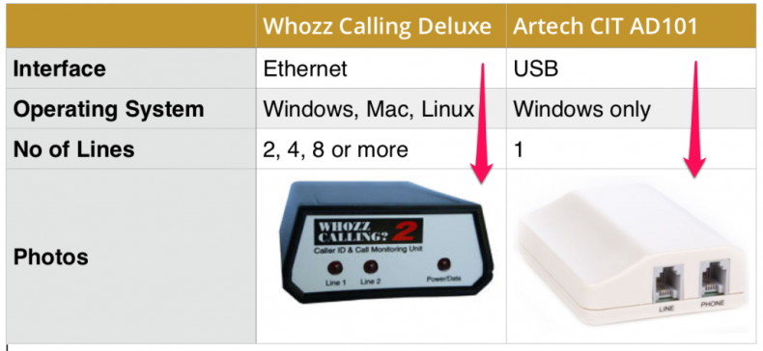Whozz Calling device needs to have Ethernet connection and will operate on Windows, Mac or Linux. It can handle 2,4 or 8 phone lines at a time

Figure : Caller ID Device Features

* AD 101 device can be connected through USB cable and will operate only on Windows Terminals/ PCs. It can handle only 1 phone line at once.

# 3. Front End

## 3.1 Take new Order

Once everything is properly configured in the Back Office you are ready to take orders by logging into the Home Delivery followed by the Dispatch View screen. This Diagram shows a full Home Delivery Order cycle.

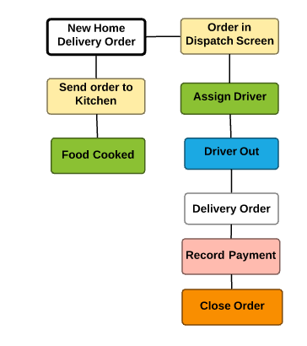

Figure : Home Delivery Order Flowchart

|  |  |
| --- | --- |
|  | **Order Dispatch Screen**  When you log in home delivery system the default screen is known as order dispatch screen. You can track list of orders, assign driver and track status of orders in this screen. |

### 3.1.1 Select Customer

* Press on the Phone number and enter customer information, if the same customer ordered before and information is saved in the system, select the customer from the list; if you are not using a Caller ID, press on New Order which will give you option to select a customer from the list/ enter new customer information/ customer history look up.
* While creating new customer entry, you must provide the customer home address (or delivery address) beside customer name and phone number in order to allow google map to show driving details.
* A new window will pop-up for entering detailed delivery information

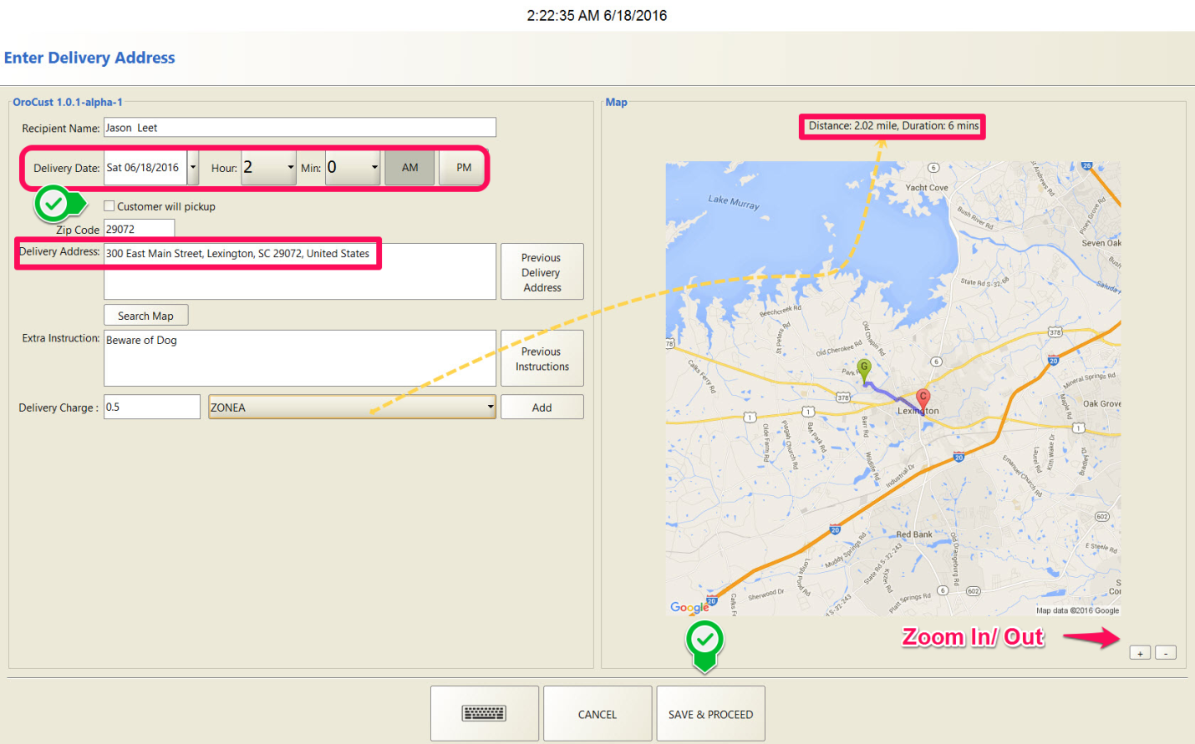

Figure : Delivery Time, Address and Location Setup

### 3.1.2 Add Delivery address & time

* Make sure the Recipient Name (Customer Name who will receive food order at his/ her home) is correct and enter desired Delivery date and time, check the phone number with extension if any, enter apartment/ suite number if any
* Check the box if customer will pick up order by his own which will disable the Delivery Charge option, and no additional charge will be added to the customer food order
* Check the Delivery address again and if there is a new delivery address requested by the same customer, edit and change the delivery address
* Previous Delivery address button will allow to select any previous address for the same customer to deliver the food to
* Press on Search Map which will allow google map to view map from Terminal address to Delivery address with driving duration and the distance, zoom in/ out to see the map more precisely
* Delivery driver can view the map for driving direction or can also enter extra instructions for driving
* Enter Manager’s note if any (available in the new version of orocust plugin), i.e: Deliver pizza at the Back Door of the apartment/ Beware of Dog
* Select the zone depending on the distance to be travelled to the Delivery Address from the to allow the POS system to add delivery charge to the food order
* Once all information is entered properly press ‘Save and Proceed’ which will allow to navigate to the order taking screen, now you are ready to take customer order

## 3.2 Pizza Order

There is a special pizza designer option in the Floreant POS system. Adding pizza item with size, crust and toppings (pizza modifiers) at the Back Office will allow taking pizza order from the main order taking screen.

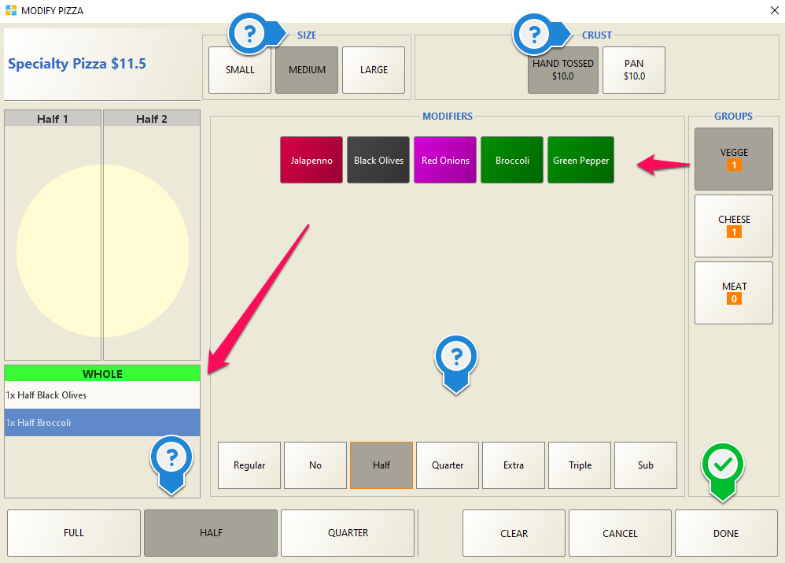

Figure : Pizza Order Taking with Special Pizza Designer

* Select the Pizza Item from the Order Taking screen
* Press on desired size and crust from the top of this screen
* Choose the Pizza Size for modifiers (toppings), Full/ Half/ Quarter?

|  |  |
| --- | --- |
|  | **Pizza Designer**  Pizza designer is not part of the plugin. For more details of how it works check “Floreant POS Pizza Manual” |

* Groups at the right hand side will show all topping groups and their minimum allowance at the bottom; here you must take at last 1 Vegge topping, at least 1 Cheese topping and at least 0 (no) Meat toppings for this specialty pizza that was created in the back office
* Choosing the minimum amount of toppings will take to the next toppings group by default, if needed press back on that group to add more toppings
* You must not choose below the minimum amount of toppings or over the maximum amount of toppings that is set at the Back Office, doing so will give error message; for example here for Specialty pizza you must choose at least 1 vegge topping and at most 2 vegge topping as it was set up at back office accordingly.
* Total price for this pizza order will show at the top left corner with the pizza item name, here this Specialty Pizza price was $11.5 included the price of medium hand tossed pizza+ 2 toppings
* Once everything selected properly, Done button will complete the pizza order and navigate back to the main order taking screen.

## 3.3 Delivery Dispatch

This is the initial screen while logged into the Home Delivery system. Any food order with customer information along with delivery information is viewed in this screen. Home Delivery orders are managed by the buttons at the bottom of this screen.

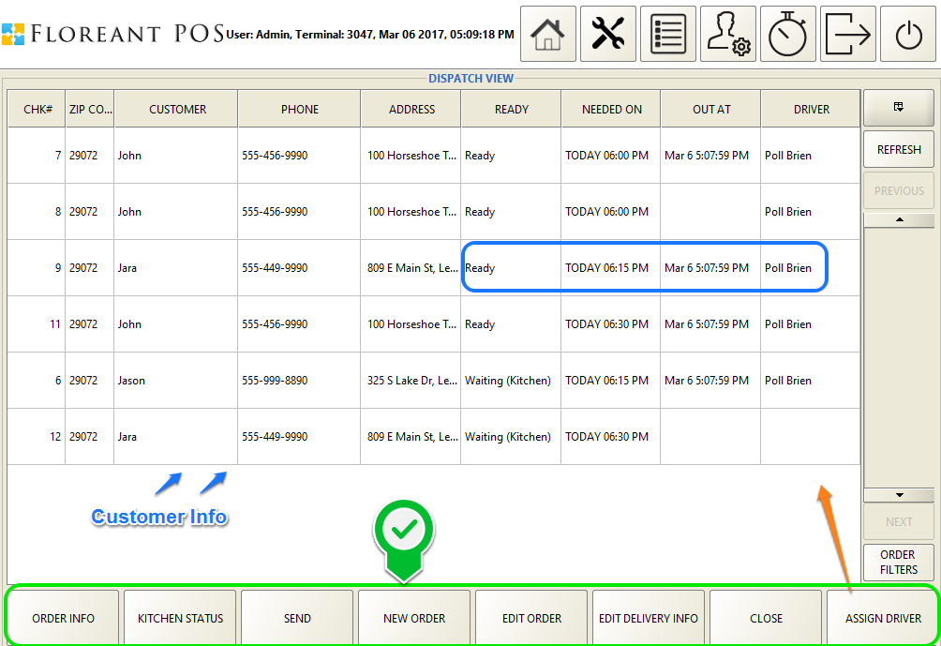

Figure : Delivery Dispatch View containing Customer and Driver Information

Selecting a ticket and pressing any specific button inside the green rectangle will perform different tasks

* Order Info will show the ticket information which looks very similar as it would appear in a ticket receipt. There is option to print a customer copy or a driver copy of this order.
* Kitchen Status will show the food orders in a list, elapsed time since it has been sent to the kitchen, pressing Bump button will change the status of this order from Waiting to Sent; this changes can be observed from the ‘READY’ tab.
* REDAY tab will inform if an order is Not Sent to the kitchen yet. If an order was not sent to the kitchen after it was created, it can be sent to kitchen at any later time by pressing the ‘SEND’ button.
* New Order will allow creating a new order for the specific customer in that order. This also allows Reordering, see Reorder section for details.
* Any existing order can be edited at any later time by pressing Edit Order button; food items can be added or removed from that order.
* In special cases, Delivery Info can be changed as per customer request, such as delivering to a different address or change delivery time or any other delivery info.
* Any specific ticket can be closed by pressing Close button, will pop-up a screen with open orders to choose a ticket from, next will ask if the ticket need to be settled if not settled already.
* Assign Driver will allow a specific ticket to be assigned to a delivery driver that is available for the shift, a list of available driver will appear once prompted.

## 3.4 Reorder

This is a much needed option for Home Delivery orders for the customer’s order from the same store. Any previous customer order is saved into the system and can be processed for Reordering at any later time.

* From the Dispatch View Screen pressing on New Order will take to the Select Customer screen, if the intended customer is already selected, press on Customer History,
* A new window will pop-up to choose from any previous orders for that customer.
* Select the order that you want to Reorder, if you are not sure you may select that order and click on Order Info to check,
* If you want to reorder the same food items, press on Reorder.
* If you need to change some items click on Edit and modify your Order.
* Other options are available in this window are Settle, Close and Void.

# 4. Driver View

Delivery Driver for Home Delivery can log in directly using the Driver View button from initial login screen. Once logged into the system the Delivery Driver can choose which orders are ready to take out for Delivery and mark himself as “Driver Out”. Below is a flowchart for overall Driver activity.

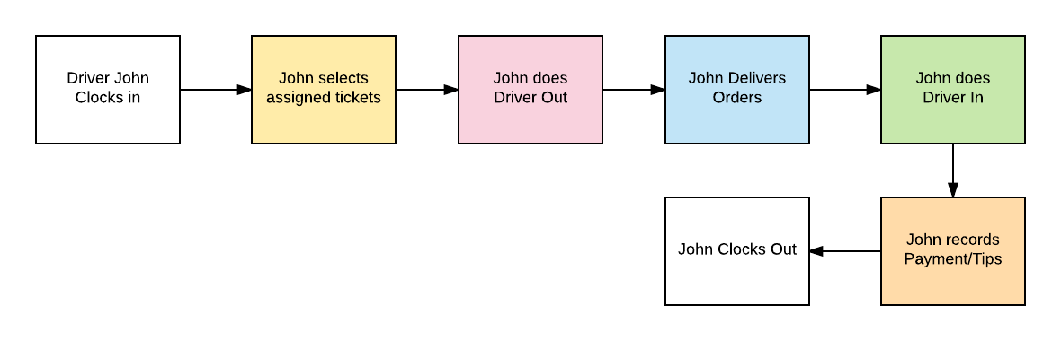

Figure : Delivery Driver Work Flow

The driver must select the orders that he took out which will update information on the Dispatch view screen, it will show “Out At” and the time.

* The ‘Driver Out’ button will be grayed for him meaning he cannot take any more orders at the moment for delivery as he is already out.
* Once the driver returns to the store he can log back in to the Driver View mode and mark himself as ‘Driver In’.
* The Delivery Driver can close any order at any time after the Delivery or after returning to the store. Closing an order will ask to settle that order.

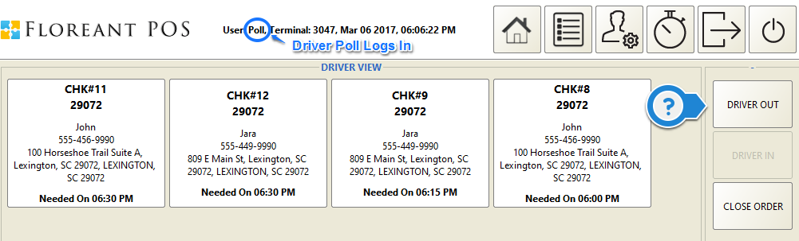

Figure : Delivery Driver View and Activity

# 5. Table of Figures

Figure 1: Plugin License Activation 4

Figure 2: Terminal Key at Back Office 5

Figure 3: Setting Up Terminal Location and Delivery Zones 6

Figure 4: Enabling Driver Permission for Home Delivery 7

Figure 5: Enabling Caller ID Device 9

Figure 6: Caller ID Setup 9

Figure 7: Caller ID Map 10

Figure 8: Caller ID Device Features 10

Figure 9: Home Delivery Order Flowchart 11

Figure 10: Delivery Time, Address and Location Setup 12

Figure 11: Pizza Order Taking with Special Pizza Designer 14

Figure 12: Delivery Dispatch View containing Customer and Driver Information 15

Figure 13: Delivery Driver Work Flow 17

Figure 14: Delivery Driver View and Activity 17