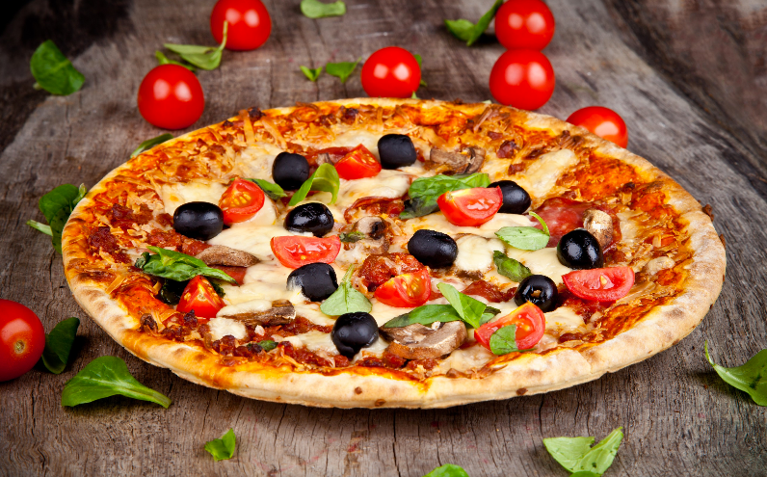

Pizza Designer User manual

Floreant POS version 1.4 build 1600+



[www.orocube.com](http://www.orocube.com)

**Disclaimer:**

Our intent is to provide accurate and up to date content on this document; however, that is not always possible. THEREFORE, ALL CONTENT, SERVICES AND FUNCTIONS ON THIS DOCUMENT ARE PROVIDED "AS IS" AND "AS AVAILABLE" WITHOUT WARRANTY OF ANY KIND, EITHER EXPRESS OR IMPLIED, INCLUDING, BUT NOT LIMITED TO, ANY IMPLIED WARRANTIES OF MERCHANTABILITY, FITNESS FOR A PARTICULAR PURPOSE, OR NONINFRINGEMENT. Some jurisdictions do not allow the exclusion of certain implied warranties in which event any required warranty applies to the minimum extent legally required. Content is provided for informational purposes only and should not be relied on. Although the information on this Document may include statements on various life events and financial, legal or tax concerns, it is provided for informational purposes only, and is not intended and should not be relied upon as legal, tax or personalized advice. Floreant POS is a venture of OROCUBE LLC. However OROCUBE does not warrant or make any representations regarding the suitability, usefulness or expected results of the Content. You should not rely solely upon this information in making any decisions, including any decision to buy a product or service from OROCUBE LLC or any other company. You should consult your financial professional and legal and/or tax advisor for advice about the appropriateness of products and services for you, and the effect of state and federal law on the products, services or issues discussed on this document, or of federal income taxes or any other taxes on amounts held or paid out under any financial products described. Content may contain inaccuracies or errors and may change. No warranty or representation is made that the information on this Site is complete, accurate, up-to-date or error-free or that known defects will be corrected. Contents, services, products or functions available at this document may be changed or updated at any time without notice; but neither Floreant POS Team nor OROCUBE LLC has any obligation to update this document, so information may be out-of-date at any given time.

**Copyright Notice:**

This manual is released under CC license attribute 4. It lets others remix, tweak, and build upon our work even for commercial purposes, as long as they credit us and license their new creations under the identical terms.

Table of Contents

1. Overview 4

2. Back Office Configuration 4

2.1- Multipliers 4

2.2- Pizza Item Entry 5

2.3- Pizza Toppings 5

2.4- Pizza Price, Size and Crust 6

2.5- Single Slice Entry 6

3. Front End- Taking Pizza Order 7

3.1- Whole Pizza 7

3.2- Half Pizza 8

3.3- Quarter Pizza 8

3.4- Single Slice 8

4. Completing Order 9

5. Glossary 9

6. Table of Figures 9

# 1. Overview

This guide will help making Pizza items in the Floreant POS Back office with toppings and pizza builder options; and will elaborate simple ways of taking Pizza Orders. Pizza orders may be taken in Home Delivery/ Pick Up/ Take Out or even Dine In mode. We do have separate plugins to work in integration with Floreant POS system to facilitate these different Order types. Orocust plugin is designed specifically for **Home Delivery/ Pick up Order types**, using Caller ID device is optional there. Floorplan plugin is specifically for Dine in orders. There are separate user manuals for those plugins, here we will only focus on Pizza designer that is in-built in Floreant POS system.

Please review the Orocust Plugin document if your store requires Home Delivery/ Pick Up Order taking.

# 2. Back Office Configuration

## 2.1- Multipliers

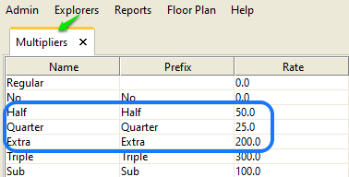How pizza toppings should be added to a pizza need to be specified, i.e. A whole pie of pizza may have same toppings for the whole pie or may have different toppings at the half pie and different at another half. This is an important feature to add toppings easily for 2*half or 4*quarter toppings in a whole pie.

Figure 1: Defining Multipliers

At the Back Office Explorers Tab

* Press the **Multipliers** button at the bottom, list of Multipliers will be shown in the screen
* **Regular** is meant for making a Regular Pizza with full topping
* ‘**No**’ indicates if this topping is added to the Pizza item by default, it will not be added to that pizza item once pressed ‘No’ while taking order.
* **Half** will reduce price of this topping by 50%, you can edit this percentage if you wish to, i.e. changing the rate from 50% to 60%; same idea for Quarter with 25% rate
* **Extra** meant to be double here and will charge 200% for that pizza topping; same follows 300% for **triple**; **Sub** will do full 100%
* Any other denominations may be added/ edited if needed with different name and (%) rate.
* Pressing Set as Default located at the bottom right of the Multipliers screen will make that denomination as main and will calculate for others.

## 2.2- Pizza Item Entry

This is the main Pizza item entry section. Multiple Pizza items can be created in back office with different topping settings from different modifier groups. However just creating one Pizza item with numerous modifier groups may allow taking different Pizza orders.

At the Back Office

* Select the 2nd bottom ‘Pizza’ from the Explorers tab,
* Create Pizza toppings (modifiers); see **section 2.3** for details
* Add or edit size and crust for the pizza item; see **section 2.4** for details
* Press Add to add a new pizza item from the Item tab, this step should be done at last, see Figure 3
* Enter Pizza name, leaving 100% for the **Default Sell Portion** is meant to be used for a whole pie.
* Make sure all the **size and crust** exist for this pizza item in the list below and all those have price
* Add Modifier Group using the tab and provide **minimum and maximum numbers of toppings** allowed from that group.
* Press Ok once everything setup properly and the POS is ready to take Pizza Order now
* To make more Pizza items easily press the duplicate button and specify the changes for this Pizza item than the previous.

Please refer to the Floreant POS main user manual guide book for all other feature details in creating menu item, i.e. assigning the item to a Printer Group or making Shift Pricing

## 2.3- Pizza Toppings

Modifier group must exist prior to making modifiers (toppings); if not create a modifier group first using the Menu Modifier Group option at the Explorers tab.

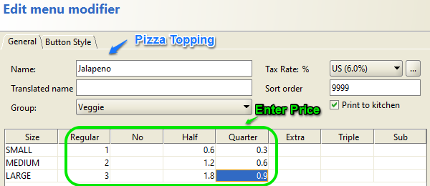Pizza toppings may be referred as modifiers from the Pizza Item. Toppings can be added and then duplicated for multiple modifiers. Each topping should have a modifier group such as Meat/ Veggie; Beef, Chicken modifiers should go under Meat Modifier Group and Jalapeno, Green Pepper modifiers should go under Veggie Modifier Group.

Figure 2: Adding and Editing Pizza Toppings with Multiplier Pricing

Each topping should have its own pricing schema. Multipliers will be shown here as they were created before in the Multipliers tab. Here, **Regular Price** for Jalapeno topping is $1.0 for Small sized pizza, half of this topping is chosen to be priced $0.6 which is not the half price, as mentioned earlier in the Multiplier section, half topping does not necessarily mean half price. Leave empty which will never be used, i.e. Keep blank for Triple and Sub price if they should never be used for your store.

Pressing Ok will take to the Pizza item careen for modifiers. To add more toppings simply press the ‘Duplicate’ button and give a name. Select the ‘Change Group’ button for changing group of a topping; i.e. Beef topping should have the group Meat instead of Veggie.

## 2.4- Pizza Price, Size and Crust

Pizza price for each pizza item is dependent on its size and crust. Small, Medium and Large sizes are there by default, if needed add more size; i.e. add Extra Large. Size dimensions can be provided if desired such as **Small sized pizza 8”,** **Medium sized Pizza 12”** and so on.

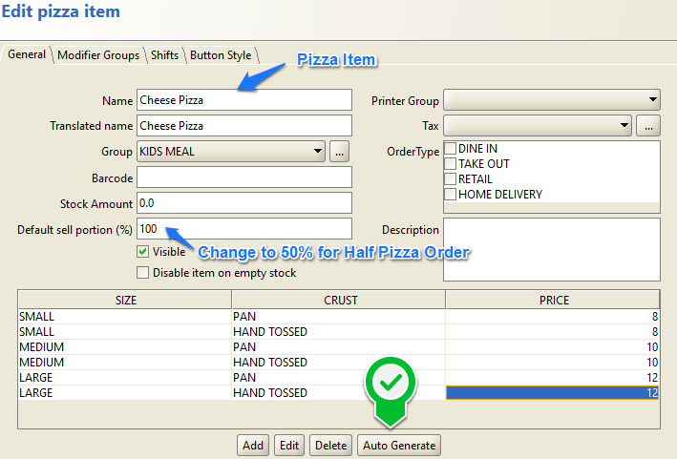Default Pizza crusts(vỏ bánh) are **Pan** and **Handtossed**. Add more if needed by simply pressing duplicate button.

Figure 3: Pizza Item Entry with Pricing based on Size and Crust

If any new size and crust is added for a specific Pizza Item, the price **must be generated** while editing the Pizza Item, pressing Auto Generate button will create 0 price for that size and crust which should be changed to real price.

***Notes:*** <https://recipes.timesofindia.com/articles/features/whats-the-difference-between-pan-pizza-and-hand-tossed-pizza/theres-difference-in-dough-too/photostory/59754913.cms> . Pan nướng chảo(vỏ dày hơn và xốp hơn), hand-tossed pizza nướng tay(vỏ phẳng mỏng hơn và giòn hơn)

## 2.5- Single Slice Entry

For many Pizza stores taking single slice order is necessary. While adding pizza item single slices can be entered by changing the **Default sell Value**( portion ?); i.e. 50% for a Half Pizza- see figure: 3, 12.5% (1/8) for one slice of a pie that has 8 slices. Price must be entered for the slice pizza.

Go back to section 2.1 and select a Multiplier for this Single Slice Item. ‘Sub’ multiplier may be used for this purpose or create a new one, enter rate for the multiplier should be used.

# 3. Front End- Taking Pizza Order

Taking Pizza Orders in Home Delivery/ Pick Up mode will require entering customer and delivery information, please refer to the Orocust manual for details. Once navigated to the main order taking screen, finding the Category and group where the Pizza Items are set up under, will allow taking Pizza order.

Below is a Flowchart illustrating the whole process of taking a Pizza Order.

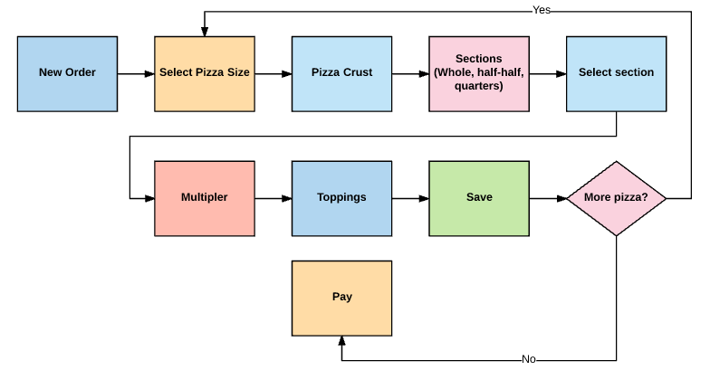

Figure 4: Pizza Designer Workflow

## 3.1- Whole Pizza

Once everything is properly configured in the Back Office you are ready to take orders by logging into the Home Delivery

* After selecting pizza item select size and crust,
* Select topping denomination such as regular/ half/ extra and then select the desired topping
* Choosing the minimum number of toppings allowed will take to the next topping group; however it can be revisited for adding more toppings from that group
* Pressing the arrow button above the pizza pie picture will add the same pizza item as many as wanted
* Done button will complete the order and will also ask for next entry of pizza if needed

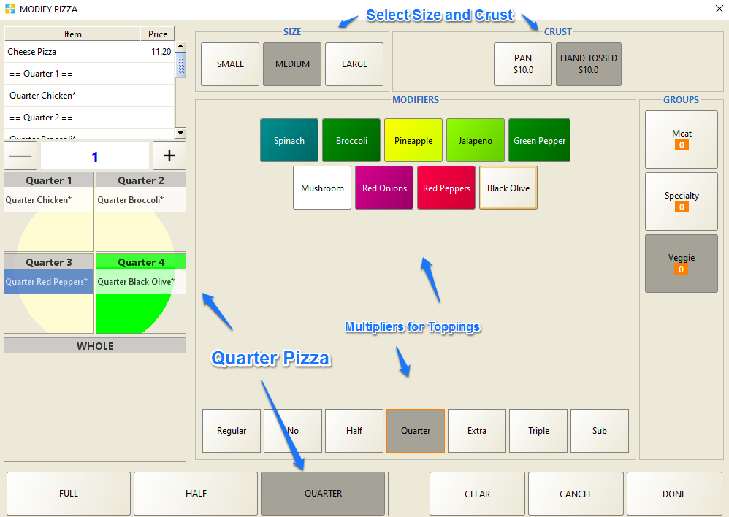

Figure 5: Pizza Order Taking

## 3.2- Half Pizza

Select Half at the bottom left corner of the pizza designer page and then add toppings as needed. Before selecting each topping, select the multiplier, in this case Half. Other details should follow the same as section 3.1.

## 3.3- Quarter Pizza

Select Qaurter at the bottom left corner of the pizza designer page and then add toppings as needed. Before selecting each topping, select the multiplier, in this case Half. Other details should follow the same as section 3.1.

## 3.4- Single Slice

Select single slice pizza item from the order taking screen and add toppings from the pizza designer screen, multiplier must be selected before each time adding a topping.

# 4. Completing Order

Once done taking order for a customer, pressing the Send button will send this order to the kitchen and pressing Total will allow taking payment

Done button can be pressed to save this order to be edited at any later time before sending the order to kitchen.

# 5. Glossary

**Toppings**: Pizza Toppings and Pizza Modifiers both means the same. Same way, Pizza Topping Group and Menu Modifier Group carry the same value.

**Pizza Item**: Menu Item has the similar properties as Pizza Item. However Menu Items do not have Pizza Designer features that are mentioned in this manual.

**Multiplier**: Multiplier is a factor based on which others should be multiplied. If a single multiplier price is $3, a double multiplier price should be $3*2= $6, a half multiplier should be $3*1/2= $1.5 and so on. Multiplier price may be used as default or may be edited to maintain store needs.

# 6. Table of Figures

Figure 1: Defining Multipliers 4

Figure 2: Adding and Editing Pizza Toppings with Multiplier Pricing 5

Figure 3: Pizza Item Entry with Pricing based on Size and Crust 6

Figure 4: Pizza Designer Workflow 7

Figure 5: Pizza Order Taking 8