Synchronous in JavaScript.
Synchronous means the code runs in a particular sequence of instructions given in the program. Each instruction waits for the previous instruction to complete its execution.

Task1 –within 5mins --pending
Task2 – 5mins
Task3
See the following code example of synchronous JavaScript
console.log('First');
console.log('Second');
console.log('Third');
First
Second
Third
In the above JavaScript code snippet, three lines of instructions are given. Every instruction runs once after the previous instruction gets executed. Due to this synchronous nature of javascript, we get the output of console logs in the sequence we provided in the program.
When we say synchronous vs asynchronous JavaScript the execution sequence of instructions in a program is what differentiates them.
Asynchronous in JavaScript.
As we saw in the synchronous code example, all instructions in the program execute one after another, and every instruction waits for its previous instruction to get executed. Due to this nature of synchronous programming, sometimes important instructions get blocked due to some previous instructions, which causes a delay in the user interface. Asynchronous code execution allows to execution next instructions immediately and doesn’t block the flow because of previous instructions.

Task1 ---higher priority
Task 2 –more than task 1
Task 3

See the following coding example to understand how javascript works asynchronously.
console.log('First');
// Set timeout for 2 seconds
setTimeout(() => console.log('Second'), 2000);
console.log('Third');

output
First
Third
Second
As we can see in the output of the above code example, Third gets printed before Second, because of the asynchronous execution of the code. Here setTimeout() function waits for 2 seconds, and in the meantime, the next instruction gets executed without waiting for the previous one to complete the execution.
Conclusion
Javascript is the synchronous single-threaded language but with the help of event-loop and promises, JavaScript is used to do asynchronous programming.
- In this article, we discussed synchronous vs asynchronous javascript with the help of coding examples.
- Synchronous means the code runs in a particular sequence of instructions given in the program, whereas asynchronous code execution allows to execution of the upcoming instructions immediately.
- Because of asynchronous programming we can avoid the blocking of tasks due to the previous instructions.

Synchronous JavaScript – How the Function Execution Stack Works
Stack ---LIFO –
Stack(plate arrangement ) and queue(normal queue) ----
Stack ---5 functions,f1,f2,f3,f4,f5

F5
F4
F3
F2
F1

So what happens when you define a function and then invoke it? The JavaScript engine maintains a stack data structure called function execution stack. The purpose of the stack is to track the current function in execution. It does the following:
- When the JavaScript engine invokes a function, it adds it to the stack, and the execution starts.
- If the currently executed function calls another function, the engine adds the second function to the stack and starts executing it.
- Once it finishes executing the second function, the engine takes it out from the stack.
- The control goes back to resume the execution of the first function from the point it left it last time.
- Once the execution of the first function is over, the engine takes it out of the stack.
- Continue the same way until there is nothing to put into the stack.
The function execution stack is also known as the Call Stack.
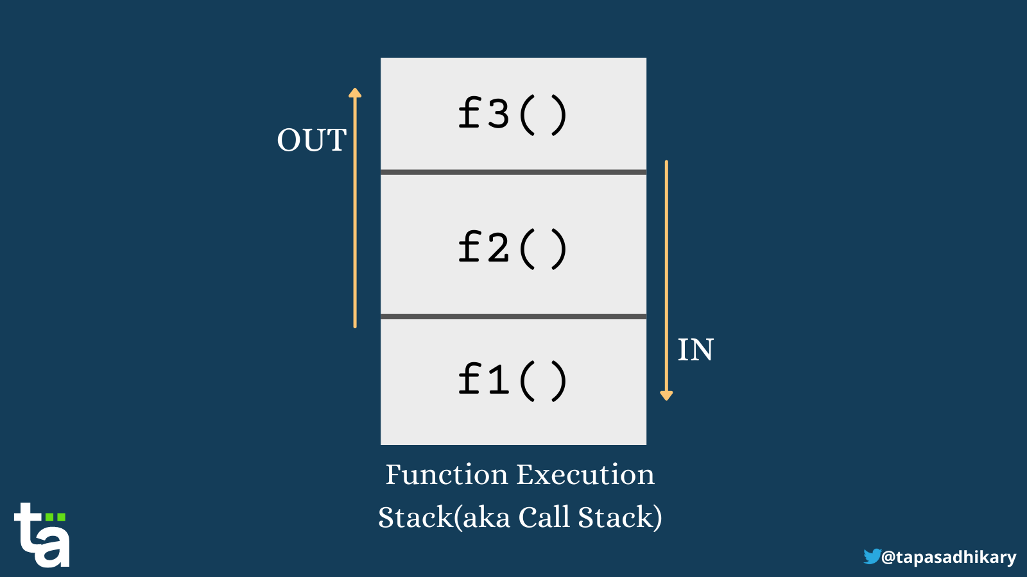Function Execution Stack
Let's look at an example of three functions that execute one by one:
function f1() {
// some code
}
function f2() {
// some code
}
function f3() {
// some code
}

// Invoke the functions one by one
f1();
f2();
f3();
Now let's see what happens with the function execution stack:
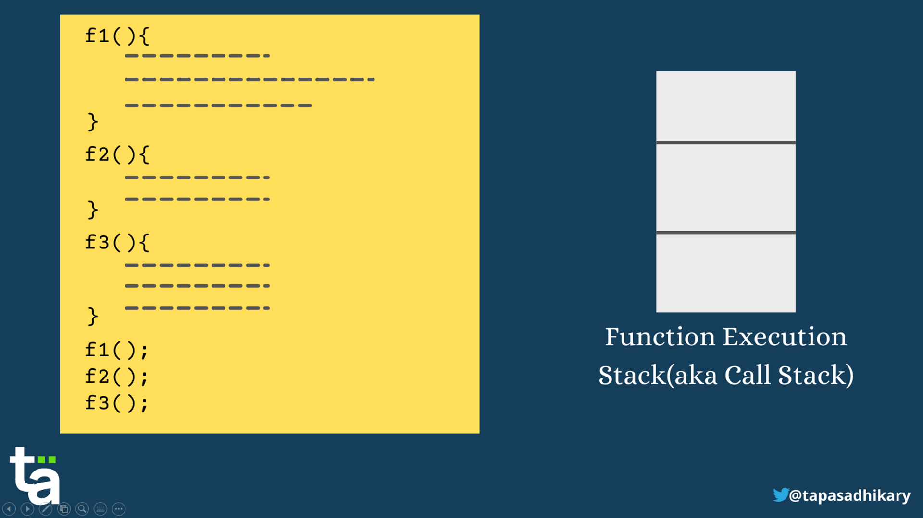A step-by-step flow shows the execution order
Did you see what happened there? First, f1() goes into the stack, executes, and pops out. Then f2() does the same, and finally f3(). After that, the stack is empty, with nothing else to execute.
Ok, let's now work through a more complex example. Here is a function f3() that invokes another function f2() that in turn invokes another function f1().
function f1() {
// Some code
}
function f2() {
f1();
}
function f3() {
f2();
}
f3();
Let's see what's going on with the function execution stack:
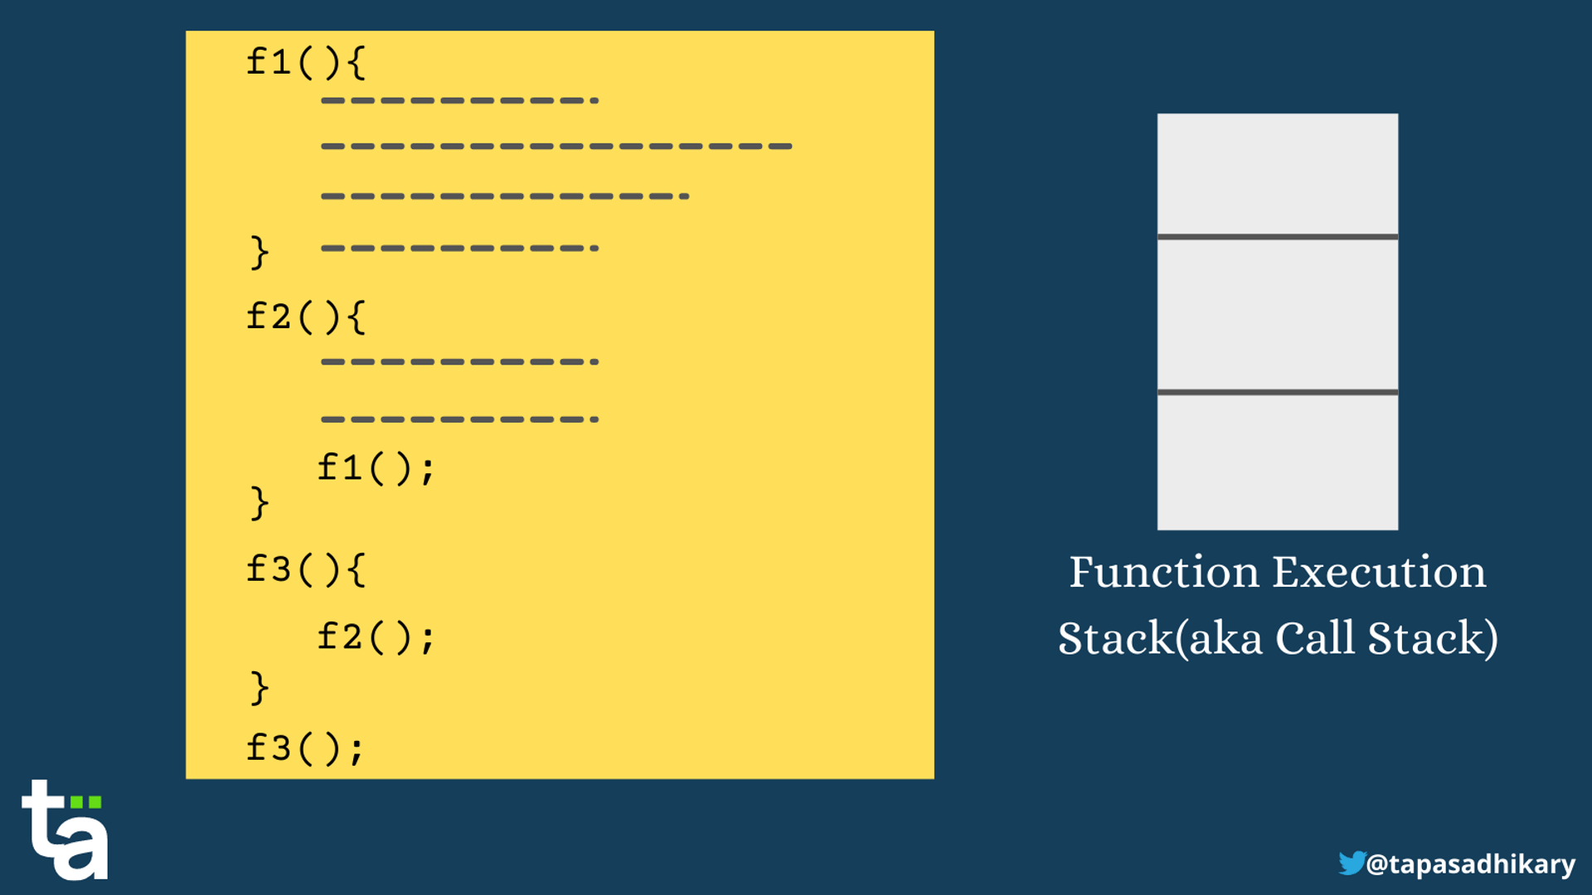A step-by-step flow shows the execution order
Notice that first f3() gets into the stack, invoking another function, f2(). So now f2() gets inside while f3() remains in the stack. The f2() function invokes f1(). So, time for f1() to go inside the stack with both f2() and f3() remaining inside.
First, f1() finishes executing and comes out of the stack. Right after that f2() finishes, and finally f3().
The bottom line is that everything that happens inside the function execution stack is sequential. This is the Synchronous part of JavaScript. JavaScript's main thread makes sure that it takes care of everything in the stack before it starts looking into anything elsewhere.

JSON (JavaScript Object Notation)
- Lightweight data format
- Used to exchange data between client & server
Sprinboot ---endpoint ---access that end point you will ge the response in the form of json …
https://kjhj.com/getdata
[
{
“name”:”Remya”,
“city”:”Chennai”
},
{
“name”:”Remya”,
“city”:”Chennai”
}
]
Api -fetchAPI---json ---manipulate that response in our javascript

{
"name": "Remya",
"age": 25,
"skills": ["JavaScript", "React"]
}
JSON.parse()
- Converts JSON string → JavaScript object
const jsonStr = '{"name":"Remya","age":25}';

const obj = JSON.parse(jsonStr); //json to javascrip object
console.log(obj.name); // Remya
console.log(obj.age);

JSON.stringify()
- Converts JavaScript object → JSON string
const user = {
name: "Remya",
age: 25
};

const json = JSON.stringify(user);
console.log(json);

Callback Hell
- Nested callbacks
- Hard to read & maintain

Callback hell--- pyramid of Doom
setTimeout(() => {
console.log("Step 1");
setTimeout(() => {
console.log("Step 2");
setTimeout(() => {
console.log("Step 3");
}, 1000);
}, 1000);
}, 1000);

In JavaScript, promises are the foundation for managing asynchronous operations, while async/await is modern syntax (syntactic sugar) built on top of promises to make asynchronous code cleaner and easier to read.
Promises
A Promise is an object representing the eventual completion (or failure) of an asynchronous operation and its resulting value. It provides a cleaner alternative to nested callbacks (callback hell) for handling asynchronous flows.
Key Concepts
- States: A promise can be in one of three states:
  - Pending: Initial state, the operation is still ongoing.
  - Fulfilled (Resolved): The operation completed successfully, and a value is available.
  - Rejected: The operation failed, and an error reason is available.
- Handlers: You attach methods to a promise to handle its outcome:
  - .then(): Called when the promise is fulfilled, receiving the success value.
  - .catch(): Called when the promise is rejected, receiving the error reason.
  - .finally(): Always executes when the promise is settled (either fulfilled or rejected).
- Chaining: .then(), .catch(), and .finally() methods each return a new promise, allowing you to chain operations sequentially.
The provided web documents include examples demonstrating promises with .then(), .catch(), and .finally() handlers, as well as the same examples rewritten using async/await syntax.
Summary Comparison
Feature | Promises | Async/Await
Syntax | Chainable .then(), .catch() | Linear, synchronous-like with async and await
Readability | Can become complex with chaining | Generally improves readability
Error Handling | .catch() method | try...catch blocks
Underlying Mechanism | Core async object | Syntactic sugar over promises
Parallel Execution | Promise.all() (can be awaited) | Promise.all() or similar helpers

ES6 Features
1. let and const
Block-scoped variable declarations.
let count = 10;
count = 20; // allowed

const PI = 3.14;
// PI = 3.15 ❌ not allowed
Difference from var:
- var is function-scoped
- let & const are block-scoped
- const cannot be reassigned
2. Arrow Functions (=>)
Shorter syntax and lexical this binding.
// ES5
function add(a, b) {
return a + b;
}

// ES6
const add = (a, b) => a + b;
Lexical this example:
function Timer() {
this.seconds = 0;
setInterval(() => {
this.seconds++;
console.log(this.seconds);
}, 1000);
}
3. Template Literals
String interpolation using backticks `.
let name = "Remya";
let msg = `Hello ${name}, welcome to ES6!`;
console.log(msg);

4. Default Parameters
Provide default values to function parameters.
function greet(name = "Guest") {
console.log(`Hello ${name}`);
}
greet(); // Hello Guest
greet(“Remya”)

5. Destructuring Assignment
Extract values from arrays or objects.
Array Destructuring
const arr = [10, 20, 30];
const [a, b] = arr;
Object Destructuring
const user = { id: 1, name: "John" };
const { name, id } = user;

6. Spread Operator (...)
Expands elements.
const arr1 = [1, 2];
const arr2 = [...arr1, 3, 4];

const obj1 = { a: 1 };
const obj2 = { ...obj1, b: 2 };

7. Rest Parameters (...)
Collect multiple arguments.
function sum(...nums) {
return nums.reduce((a, b) => a + b);
}
sum(1, 2, 3);

8. Enhanced Object Literals
Shorter syntax for object creation.
let name = "Ram";
let age = 25;

const person = {
name,
age,
greet() {
console.log("Hello!");
}
};
9. Classes
Syntactic sugar over prototype-based inheritance.
class Employee {
constructor(name) {
this.name = name;
}

work() {
console.log(`${this.name} is working`);
}
}

const emp = new Employee("Ravi");
10. Modules (import / export)
Split code into reusable files.
// math.js
export function add(a, b) {
return a + b;
}
// app.js
import { add } from "./math.js";
11. Promises
Handle asynchronous operations.
const promise = new Promise((resolve, reject) => {
resolve("Success");
});

promise.then(result => console.log(result));
12. for...of Loop
Iterate over iterable objects.
const arr = [10, 20, 30];

for (let value of arr) {
console.log(value);
}
13. Map and Set
Map
const map = new Map();
map.set("name", "Remya");
Set
const set = new Set([1, 2, 2, 3]);
console.log(set); // {1,2,3}
14. Symbols
Create unique identifiers.
const sym1 = Symbol("id");
const sym2 = Symbol("id");

console.log(sym1 === sym2); // false
15. find() and findIndex()
Array searching methods.
const nums = [5, 12, 8];
nums.find(n => n > 10); // 12
nums.findIndex(n => n > 10); // 1

RestAPI
--communicate between two application (may be in different languages (java,.net)
-- java –ecommerce (Payment gateway -.net ) –endpoint help us to get the response from the application ---without maintaining our information
REST API --reposne in the form of JSON
Springboot –endpoint ---postman ----endpoint –response
Call the endpoint in javascript -----Fetch API
Fetch Api is used to invoke the endpoint ----work along with our promise
(resolve or reject)
Server –down we are not getting --fetch(https://api/getuser)

--
<form method =post/get>

<on submit =”callAPI”>
fetchAPI promise -----resolve /reject

Debugging in JavaScript
Debugging is the process of testing, finding, and reducing bugs (errors) in computer programs. It involves:
- Identifying errors (syntax, runtime, or logical errors).
- Using debugging tools to analyze code execution.
- Implementing fixes and verifying correctness.
Types of Errors in JavaScript
Syntax Errors: Issues with incorrect syntax, preventing execution.
console.log("Hello); // SyntaxError: missing closing quote

Runtime Errors: Errors occurring during execution.
let a = undefined;
console.log(a.length); // TypeError: Cannot read properties of undefined

Logical Errors: Code runs without errors but produces incorrect results.
function add(a, b) {
return a - b; // Logical error: should use + instead of -
}
JavaScript Debuggers
1. Built-in Debugging Tools
Modern browsers provide built-in JavaScript debuggers, accessible via Developer Tools. Debuggers can be turned on and off, forcing errors to be reported. They allow setting breakpoints and examining variables while code executes.
Steps to Activate Debugging:
- Chrome: Open "More tools" → "Developer tools" → Select "Console".
- Firefox: Open "Web Developer" → "Web Console".
- Edge: Open "Developer Tools" → Select "Console".
- Opera: Open "Developer" → "Developer tools" → "Console".
- Safari: Enable "Show Develop menu in menu bar" under Preferences, then select "Show Error Console".
2. Using console.log()
One of the simplest debugging techniques is logging messages to the console.
let x = 10;
console.log("Value of x:", x);
3. Setting Breakpoints
Breakpoints stop execution at specific lines, allowing variable inspection.
- Open DevTools (F12 or Ctrl+Shift+I).
- Navigate to the "Sources" tab.
- Click on line numbers to set breakpoints.
- Resume execution using the play button after analysis.
4. Using the debugger Keyword
The debugger statement stops execution and opens debugging tools.
function test() {
let n = 42;
debugger; // Execution pauses here
console.log(n);
}
test();
If debugging is unavailable, debugger has no effect.
Common Debugging Issues and Fixes
1. Debugging Syntax Errors
Syntax errors occur when code violates JavaScript's syntax rules. These errors are typically caught during compilation.
- Code editors and linters flag syntax errors.
- Fixing syntax mistakes ensures smooth execution.
console.log("Hello);
Fix: Add the missing closing quote.
2. Using console.log() to Track Values
Logging variable values helps debug unexpected outputs.
- Provides real-time feedback on variable states.
- Useful for debugging logical errors.
let x = 5;
console.log("X value:", x);
3. Debugging with Breakpoints in DevTools
Breakpoints allow developers to pause code execution and inspect variable values.
function add(a, b) {
return a + b;
}
let res = add(5, 10);
console.log(res);
Output
- Breakpoints help developers pause and inspect variables during runtime.
- They allow you to step through code line by line.
- Useful for identifying logical errors in complex functions.
4. Identifying undefined Variables
Undefined variables usually indicate scope issues or missing arguments.
- Passing required arguments prevents undefined values.
- Ensures function behavior aligns with expectations.
function greet(name) {
console.log("Hello, " + name);
}
greet(); // Undefined issue
Fix: Call greet("Ajay") to pass a valid argument.
5. Catching Errors with try...catch
- Handling runtime errors prevents crashes.
- Useful for handling JSON parsing errors.
try {
let data = JSON.parse("{invalid}");
} catch (error) {
console.error("Parsing error:", error.message);
}
Fix: Ensure valid JSON input.
6. Debugging Asynchronous Code with Promises
- Handling async operations can be tricky.
- .catch() handles rejected promises.
fetch("invalid-url").catch(error => console.error("Request failed", error));
Fix: Handle network errors gracefully.
7. Debugging Event Listeners
- Event listeners may not trigger as expected.
- Ensure correct event target selection.
document.getElementById("btn").addEventListener("click", function() {
console.log("Button clicked");
});
Fix: Ensure the element ID exists.
8. Memory Leak Detection
- Memory leaks slow down applications.
- Use Chrome DevTools to detect leaks.
- Avoid excessive memory allocations.
let a = [];
setInterval(() => a.push("data"), 1000); // Potential memory leak
Fix: Clear unused data regularly.

