Single Page Application
Single Page Application - GeeksforGeeks

Client-side Routing
Client-side routing means changing views/pages without reloading the browser.
It is commonly used in Single Page Applications (SPA) like Angular, React, etc.
We will implement a pure TypeScript SPA router (no framework).
What is Client-Side Routing?
Instead of:
example.com/home.html
example.com/about.html
We use:
example.com/#/home
example.com/#/about
And dynamically load content using JavaScript/TypeScript.

Webpack
Since you're learning SPA + TypeScript, let's now integrate Webpack properly into your project (production-style setup, similar to Angular build concept).
Console application ---jar ---class,interface
✅ 1️⃣ What is Webpack?
Webpack is a module bundler.
It:
- Bundles multiple .ts / .js files into one file
- Converts TypeScript → JavaScript
- Optimizes for production
- Supports loaders & plugins
Instead of loading many files:
router.ts
routes.ts
home.ts
about.ts
contact.ts
Webpack bundles everything into:
bundle.js

✅ 2️⃣ Why Use Webpack?
Without Webpack:
- Many HTTP requests
- No minification
- No optimization
- No production build
With Webpack:
- Single optimized bundle
- Tree shaking
- Code splitting
- Production ready

What is an Angular Template?
An Angular template is the HTML view of a component.
It:
- Defines UI structure
- Binds data from component (TypeScript class)
- Handles events
- Applies directives
👉 Angular = Component Class (TS) + Template (HTML)

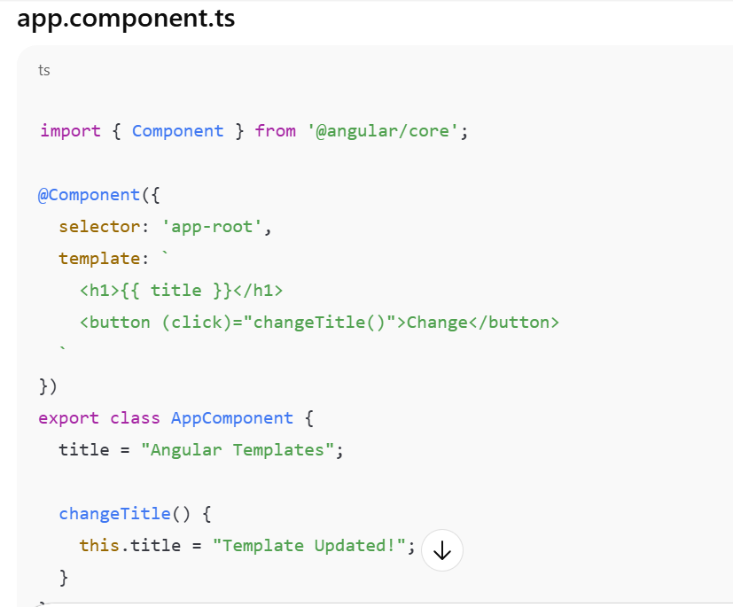

{{ title }} → interpolation
(click) → event binding

Types of Template Syntax
Angular templates support 5 major bindings:
Interpolation
<h1>{{ name }}</h1>
Used for:
- Strings
- Numbers
- Expressions
<p>{{ 10 + 20 }}</p>
<p>{{ user.firstName }}</p>

2️⃣ Property Binding
<img [src]="imageUrl">
<button [disabled]="isDisabled">Click</button>
Difference:
disabled="true" ❌ HTML attribute
[disabled]="true" ✅ Angular property binding

3️⃣ Event Binding
<button (click)="handleClick()">Click Me</button>
With event object:
<input (input)="onInput($event)">
onInput(event: Event) {
console.log((event.target as HTMLInputElement).value);
}

4️⃣ Two-Way Binding
<input [(ngModel)]="username">
<p>{{ username }}</p>
⚠️ Requires:
import { FormsModule } from '@angular/forms';
Two-way binding =
[property] + (event)

5️⃣ Structural Directives
These change DOM structure.

Component Lifecycle
Angular creates, updates, and destroys components in stages.
Each stage has a Lifecycle Hook method.

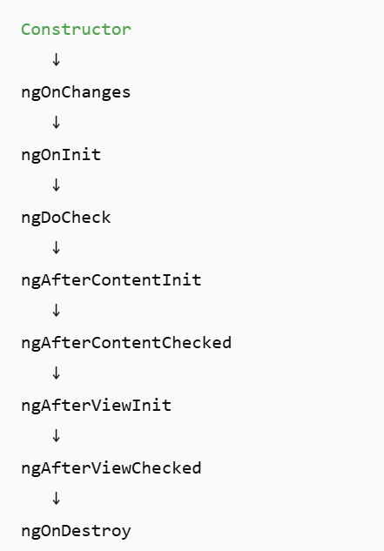

1️⃣ constructor()
- Not an Angular hook
- Called when class is instantiated
- Used for dependency injection
- Avoid heavy logic here
constructor() {
console.log("Constructor called");
}

📌 2️⃣ ngOnChanges()
Called:
- When @Input() property changes
- Before ngOnInit
@Input() name!: string;

ngOnChanges(changes: SimpleChanges) {
console.log("Changes:", changes);
}
Used for:
- Reacting to input updates

📌 3️⃣ ngOnInit()
Called:
- Once
- After first ngOnChanges
Used for:
- API calls
- Initialization logic
ngOnInit() {
console.log("ngOnInit called");
}
Best place for initialization.

📌 4️⃣ ngDoCheck()
Called:
- Every change detection cycle
Used for:
- Custom change detection
ngDoCheck() {
console.log("ngDoCheck called");
}
⚠️ Avoid heavy logic (runs frequently)

📌 5️⃣ ngAfterContentInit()
Called:
- After ng-content is projected
Used for:
- Content projection logic
ngAfterContentInit() {
console.log("Content initialized");
}

📌 6️⃣ ngAfterContentChecked()
Called:
- After every content check

📌 7️⃣ ngAfterViewInit()
Called:
- After component's view is initialized
- After ViewChild is ready
@ViewChild('myDiv') div!: ElementRef;

ngAfterViewInit() {
console.log(this.div.nativeElement);
}
Used for:
- DOM access
- Third-party libraries

📌 8️⃣ ngAfterViewChecked()
Called:
- After every view check

📌 9️⃣ ngOnDestroy()
Called:
- Just before component is destroyed
Used for:
- Unsubscribe Observables
- Clear timers
- Cleanup
ngOnDestroy() {
console.log("Component destroyed");
}

