What is a Monolithic Architecture?
Software is traditionally designed using a monolithic architecture, in which the entire program is constructed as a single, indivisible unit.class(all the methods)---spring
- This means that any changes or updates to the application require modifying and redeploying the entire monolith.
- Monolithic architectures are often characterized by their simplicity and ease of development, especially for small to medium-sized applications.
- However, they can become complex and difficult to maintain as the size and complexity of the application grow.
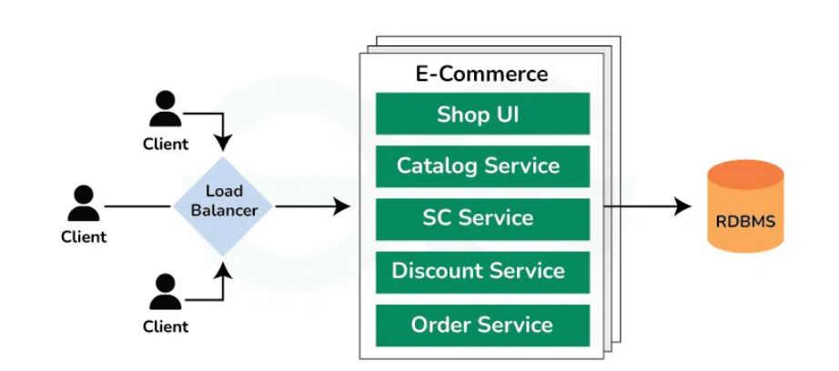
What are Microservices?
Microservices are an architectural approach to developing software applications as a collection of small, independent services that communicate with each other over a network.
- Instead of building a monolithic application where all the functionality is tightly integrated into a single codebase, microservices break down the application into smaller, loosely coupled services.
- Can be written in a variety of programming languages, and frameworks, and each service acts as a mini-application on its own.
- A small, loosely coupled service that is designed to perform a specific business function and each microservice can be developed, deployed, and scaled independently.
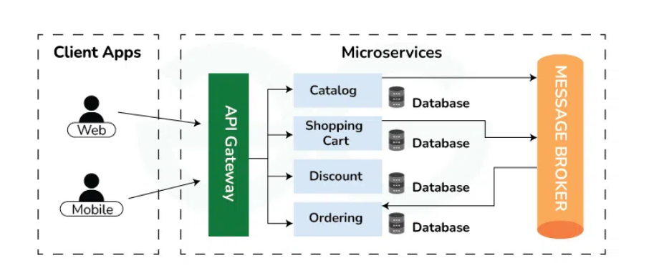
Microservices vs Monoliths
Aspect | Monolithic Architecture | Microservice Architecture
Architecture | Single-tier architecture | Multi-tier architecture
Size | Large, all components tightly coupled | Small, loosely coupled components
Deployment | Deployed as a single unit | Individual services can be deployed independently
Scalability | Horizontal scaling can be challenging | Easier to scale horizontally
Development | Development is simpler initially | Complex due to managing multiple services
Technology | Limited technology choices | Freedom to choose the best technology for each service
Fault Tolerance | Entire application may fail if a part fails | Individual services can fail without affecting others
Maintenance | Easier to maintain due to its simplicity | Requires more effort to manage multiple services
Flexibility | Less flexible as all components are tightly coupled | More flexible as components can be developed, deployed, and scaled independently
Communication | Communication between components is faster | Communication may be slower due to network calls

Characteristics of an MSA
1. Loosely Coupled
Each microservice:
- Runs independently
- Can be developed, deployed, scaled, or updated without affecting others
Benefit: reduces impact of failures and speeds up development.
2. Independently Deployable
You can deploy a single service without deploying the entire application.
Benefit: Faster CI/CD, fewer deployment conflicts.
3. Single Responsibility Principle
Each microservice owns one business capability.
Examples:
- Auth Service → Login, token management
- Payment Service → Billing, refunds
- Inventory Service → managing stock
4. Decentralized Data Management
Each service has its own database.
Example:
- Order-Service → MySQL
- Product-Service → MongoDB
- Search-Service → Elasticsearch
No shared DB schema between services.
5. Technology Agnostic
Teams can choose different:
- Programming languages
- Databases
- Frameworks
Example:
User-service in Java, Product-service in Node.js.
6. Fault Isolation
If one microservice fails, the entire system does not go down.
Techniques: product catalog ---down --- 10
- Circuit breakers
- Timeouts
- Retries
- Bulkheads
7. Distributed Architecture
Services communicate via lightweight protocols:
- REST
- gRPC
- Messaging (Kafka, RabbitMQ)
Leads to:
- Network latency
- Monitoring complexities, etc.
(but scalable)
8. DevOps + CI/CD Friendly
MSA encourages:
- Automated builds
- Automated tests
- Automated deployments
Each microservice has:
- Its own pipeline
- Its own version
- Its own deployment strategy
9. Polyglot Persistence
Different services use different storage technologies.
Reason:
- Best database for business use
(e.g., Payment = SQL, Search = NoSQL)
10. Scalability per Service (Granular Scaling)
You scale only the required service.
Example:
- High traffic → scale Auth-Service
- Low traffic → keep others unchanged
This saves resources and cost.
11. Lightweight Communication
Used protocols:
- HTTP/REST
- gRPC
- Messaging queues
MSA avoids heavy protocols like SOAP.(xml)
12. Autonomy of Teams
Each microservice is owned by one small cross-functional team.
Teams work independently without coordination.
13. Observability
Because MSA is distributed, it needs:
- Centralized logging (ELK)
- Metrics (Prometheus, Grafana)
- Tracing (Zipkin, Jaeger)
This helps monitor failures across services.
14. Resilience & High Availability
MSA supports:
- Multiple instances of services
- Failover
- Load balancing
- Zero downtime deployments

Advantages/Disadvantages of MSA
1. Increased Complexity
MSA introduces:
- Distributed system complexity
- Network latency
- Dependency management
- Service discovery
- API versioning headaches
2. Difficult Testing
Testing becomes harder:
- Contract testing
- Integration testing
- End-to-end testing
Testing a monolith is simpler.
3. More Deployment Overhead
Each service needs:
- CI/CD pipeline
- Docker image
- Monitoring setup
- Logging setup
Infrastructure effort increases.
4. Network Latency
Services communicate over:
- REST
- gRPC
- Message Brokers
This adds latency compared to in-process calls in monolith.
5. Data Consistency Challenges
Each microservice has its own DB →
Complexities arise:
- Eventual consistency
- Distributed transactions
- Saga pattern implementation
6. Operational Complexity
Requires advanced tools:
- Kubernetes
- Service mesh (Istio, Linkerd)
- ELK stack
- Prometheus & Grafana
- API Gateway
Without them, MSA becomes difficult to manage.
7. Higher Resource Usage
Each service needs its own:
- Runtime
- Container
- Memory
- CPU
Total usage increases compared to a single monolith.
8. More Points of Failure
A single failure in:
- Message broker
- Gateway
- Config server
can impact the entire system.
Requires redundancy + failover planning.

Introduction to Messaging Systems
A Messaging System is a communication mechanism that allows different applications or microservices to exchange data asynchronously, without directly depending on each other.
Think of it as a middle layer that passes messages from one service (producer) to another service (consumer).
Why Messaging Systems Are Needed?
In microservices and distributed systems:
- Services may run on different servers
- Services may scale independently
- Services may go offline temporarily
- Services should not block each other
Messaging systems solve these problems by providing:
✔ Loose coupling
Services don’t talk directly.
✔ Asynchronous communication
Service A can send a message and continue its work.
✔ Reliability
Messages are stored until processed.
✔ Scalability
Multiple consumers can process messages in parallel.

Core Concepts
1. Producer
The component that sends messages.
Example: Order Service sends order-created event.
2. Consumer
The component that receives messages.
Example: Notification Service receives the event and sends an email.
3. Message
Data being passed (JSON, string, byte array, event).
4. Queue
Messages are stored and processed in FIFO order (first in, first out).
5. Topic
Messages are broadcast to multiple subscribers.

Types of Messaging Systems
1. Message Queues (Point-to-Point)
- One producer → One consumer
- Each message is processed only once
Examples:
- RabbitMQ
- ActiveMQ
2. Publish–Subscribe Systems (Pub/Sub)
- One producer → Multiple consumers
- Used for event broadcasting
Examples:
- Kafka
- Google Pub/Sub
- AWS SNS

Message Queues
A Message Queue is a FIFO (First-In, First-Out) data structure managed by a message broker.
It ensures:
- Messages are stored safely
- Messages are delivered reliably
- Producers and consumers work independently

Kafka Architecture: Broker, Topic, Partition, Producer, Consumer
Apache Kafka is a distributed streaming platform designed for building real-time data pipelines and streaming applications. It is known for its high throughput, low latency, fault tolerance, and scalability.
Core Components of Kafka Architecture
- Kafka Cluster:
A distributed system of multiple Kafka brokers that ensures fault tolerance, scalability, and high availability for real-time data streaming.
- Brokers:
Kafka servers that handle data storage, and read/write operations, and manage data replication for reliability.
- Topics & Partitions:
Data is organized into topics (logical channels), divided into partitions for parallelism and horizontal scalability.
- Producers:
Client applications that write data to Kafka topics, distributing records across partitions.
- Consumers:
Applications that read data from topics; consumer groups enable load balancing and fault tolerance.
- ZooKeeper:
Manages and coordinates Kafka brokers, handling configuration, synchronization, and leader election.
- Offsets:
Unique IDs for each message in a partition, used by consumers to track read progress.

Kafka Producer and Consumer with Java
Spring Boot Kafka Integration
Implementing Kafka Producer And Consumer In Spring Boot | by Issa Khodadadi | Medium

