Maven

Maven is a powerful *project management tool* that is based on POM (project object model). It is used for projects build, dependency and documentation.

It simplifies the build process like ANT. But it is too much advanced than ANT.

Understanding the problem without Maven

There are many problems that we face during the project development. They are discussed below:

**1) Adding set of Jars in each project:** In case of struts, spring, hibernate frameworks, we need to add set of jar files in each project. It must include all the dependencies of jars also.

**2) Creating the right project structure:** We must create the right project structure in servlet, struts etc, otherwise it will not be executed.

**3) Building and Deploying the project:** We must have to build and deploy the project so that it may work.

What it does?

Maven simplifies the above mentioned problems. It does mainly following tasks.

1. It makes a project easy to build
2. It provides uniform build process (maven project can be shared by all the maven projects)
3. It provides project information (log document, cross referenced sources, mailing list, dependency list, unit test reports etc.)
4. It is easy to migrate for new features of Maven

What is Build Tool

A build tool takes care of everything for building a process. It does following:

* Generates source code (if auto-generated code is used)
* Generates documentation from source code
* Compiles source code
* Packages compiled code into JAR of ZIP file
* Installs the packaged code in local repository, server repository, or central repository

|  |  |
| --- | --- |
| **Ant** | **Maven** |
| Ant **doesn't has formal conventions**, so we need to provide information of the project structure in build.xml file. | Maven **has a convention** to place source code, compiled code etc. So we don't need to provide information about the project structure in pom.xml file. |
| Ant is **procedural**, you need to provide information about what to do and when to do through code. You need to provide s  order. | Maven is **declarative**, everything you define in the pom.xml file. |
| There is **no life cycle** in Ant. | There is **life cycle** in Maven. |
| It is **a tool** box. | It is **a framework**. |
| It is **mainly a build tool**. | It is **mainly a project management tool**. |
| The ant scripts are **not reusable**. | The maven plugins are **reusable**. |
| It is **less preferred** than Maven. | It is **more preferred** than Ant. |

Install maven

Download zip file

Environment variables🡪add system …MAVEN_HOME and path

Path ---bin location

Open cmd

Mvn -version

Maven Repository

A **maven repository** is a directory of packaged JAR file with pom.xml file. Maven searches for dependencies in the repositories. There are 3 types of maven repository:

1. Local Repository
2. Central Repository
3. Remote Repository

Maven searches for the dependencies in the following order:

**Local repository** then **Central repository** then **Remote repository**.

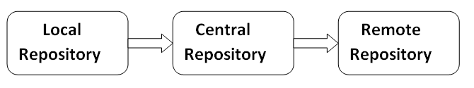

If dependency is not found in these repositories, maven stops processing and throws an error.

Maven pom.xml file

**POM** is an acronym for **Project Object Model**. The pom.xml file contains information of project and configuration information for the maven to build the project such as dependencies, build directory, source directory, test source directory, plugin, goals etc.

Maven reads the pom.xml file, then executes the goal.

Before maven 2, it was named as project.xml file. But, since maven 2 (also in maven 3), it is renamed as pom.xml.

JAVA API

Reflection API

Reflection is an API that is used to examine or modify the behavior of methods, classes, and interfaces at runtime. The required classes for reflection are provided under **java.lang.reflect** package which is essential in order to understand reflection.

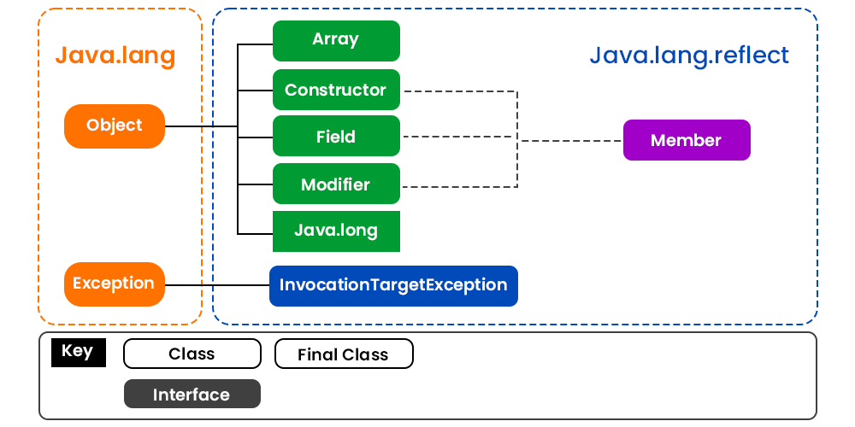

DateTime API

New date-time API is introduced in Java 8 to overcome the following drawbacks of old date-time API :

1. **Not thread safe :**Unlike old java.util.Date which is not thread safe the new date-time API is *immutable* and doesn’t have setter methods.
2. **Less operations :**In old API there are only few date operations but the new API provides us with many date operations.

Java 8 under the package java.time introduced a new date-time API, most important classes among them are :

1. **Local :**Simplified date-time API with no complexity of timezone handling.
2. **Zoned :**Specialized date-time API to deal with various timezones.

* **LocalDate/LocalTime**and **LocalDateTime API :**Use it when time zones are NOT required.