What is CSS?
CSS is the language we use to style a Web page.
- CSS stands for Cascading Style Sheets
- CSS describes how HTML elements are to be displayed on screen, paper, or in other media
- CSS saves a lot of work. It can control the layout of multiple web pages all at once
- External stylesheets are stored in CSS files

Why Use CSS?
CSS is used to define styles for your web pages, including the design, layout and variations in display for different devices and screen sizes.

Css Example
body {
background-color: lightblue;
}
h1 {
color: white;
text-align: center;
}
p {
font-family: verdana;
font-size: 20px;
}

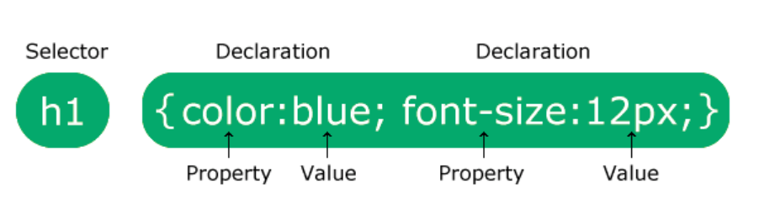

CSS Properties (common groups)
- Text & font: color, font-size, font-family, line-height, text-align.
- Box & spacing: margin, padding, border, width, height.
- Backgrounds: background-color, background-image, background-position, background-size.
- Display & layout: display, position, float, flex, grid.
- Visual: box-shadow, opacity, transform, transition.
- Wordart ---in ur
Example usage:
.card {
width: 320px;
padding: 12px;
border-radius: 8px;
box-shadow: 0 4px 8px rgba(0,0,0,0.08);
transition: transform .15s ease;
}
.card:hover { transform: translateY(-4px); }

Class and ID Selectors
- Class (.my-class) — reusable, many elements can share it. Preferred for styling.
- ID (#my-id) — unique, should appear once per page, higher specificity.
Example:
<div id="hero" class="card highlight">...</div>
<div id="hero1" class="card highlight">...</div>
<div id="hero2" class="card highlight">...</div>

#hero { padding: 40px; } /* applies to the unique element */
.card { border: 1px solid #ddd; } /* reusable across many elements */
.highlight { background: #fff8e6; }
Tip: favor classes for styling; reserve IDs for JS hooks or unique anchors.

CSS Box Model
In CSS, the term "box model" is used when talking about web design and layout.
The CSS box model is essentially a box that wraps around every HTML element.
Every box consists of four parts: content, padding, borders and margins.
The image below illustrates the CSS box model:
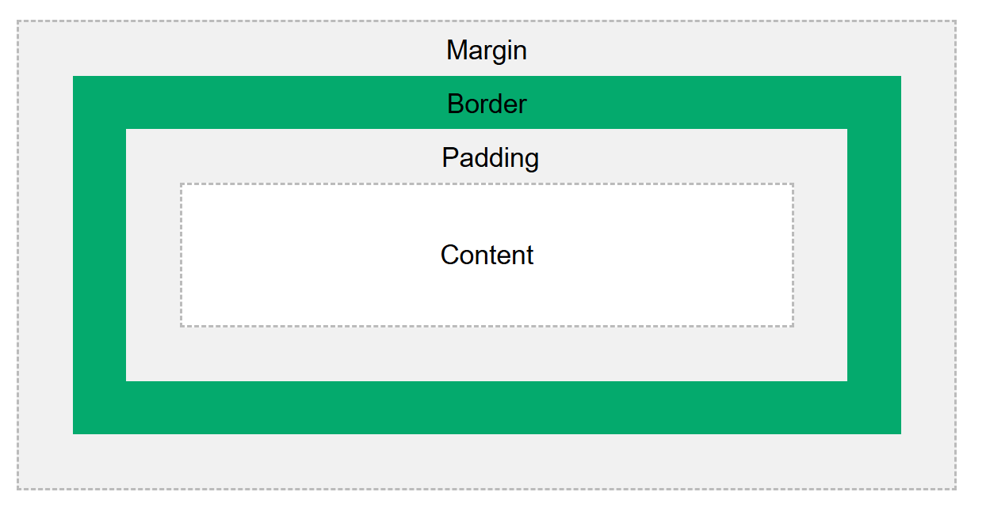
- Content - The content of the box, where text and images appear
- Padding - Clears an area around the content. The padding is transparent
- Border - A border that goes around the padding and content
- Margin - Clears an area outside the border. The margin is transparent

320px (width of content area)
+ 20px (left padding + right padding)
+ 10px (left border + right border)
= 350px (total width)
50px (height of content area)
+ 20px (top padding + bottom padding)
+ 10px (top border + bottom border)
= 80px (total height)
The total width of an element should be calculated like this:
Total element width = width + left padding + right padding + left border + right border
The total height of an element should be calculated like this:
Total element height = height + top padding + bottom padding + top border + bottom border

Form Elements and Implementation
Elements covered: <input> (text, password, checkbox, radio, file, etc.), <textarea>, <button>, <label>, <fieldset>, <legend>. Use <label for="id"> to improve accessibility.
Example:
<form id="signup">
<label for="name">Name</label>
<input id="name" name="name" type="text" placeholder="Full name">

<label for="email">Email</label>
<input id="email" name="email" type="email" placeholder="you@example.com">

<fieldset>
<legend>Subscription</legend>
<label><input type="radio" name="plan" value="free" checked> Free</label>
<label><input type="radio" name="plan" value="pro"> Pro</label>
</fieldset>

<button type="submit">Sign up</button>
</form>
CSS for forms (simple, responsive):
form { max-width: 480px; margin: 0 auto; display: grid; gap: 10px; }
input, textarea { padding: 8px; border: 1px solid #ccc; border-radius: 6px; }
label { font-weight: 600; }
button { padding: 10px 14px; border-radius: 6px; cursor: pointer; }
Accessibility: associate labels, use aria-* where needed, ensure keyboard focus visible (:focus styles).

Select and Multiselect
- Regular single-select: <select><option>...
- Multi-select: <select multiple> (not very friendly on small screens; often replaced by custom UI).
Example:
<label for="country">Country</label>
<select id="country" name="country">
<option value="">Choose...</option>
<option value="in">India</option>
<option value="us">USA</option>
</select>

<label for="skills">Skills (choose multiple)</label>
<select id="skills" name="skills" multiple size="4">
<option value="py">Python</option>
<option value="js">JavaScript</option>
<option value="sql">SQL</option>
<option value="scala">Scala</option>
</select>
Styling tips: native selects are limited; you can style fonts, borders, background but not all parts (for deep customization use custom components/JS).

CSS Box Model: Example demonstrating margin collapse, border-box
<div class="outer">
<div class="inner">Inner box</div>
</div>
*{box-sizing:border-box}
.outer { background:#eef; padding:20px; margin: 20px; }
.inner { background:#cde; margin: 0; padding: 12px; border: 4px solid #89a; }

Complete working example (copy-paste)
<!doctype html>
<html>
<head>
<meta charset="utf-8"/>
<title>CSS Topics Demo</title>
<style>
/* Global recommended box-sizing */
* { box-sizing: border-box; }
body { font-family: system-ui, Arial, sans-serif; line-height: 1.45; padding: 20px; color:#222; }

/* Basic layout */
.container { max-width: 900px; margin: 0 auto; display: grid; gap: 18px; }

/* Card style (properties + transitions) */
.card { padding: 14px; border-radius: 10px; border:1px solid #e0e0e0; box-shadow: 0 6px 18px rgba(0,0,0,0.04); background:#fff; }
.card:hover { transform: translateY(-6px); transition: transform .18s ease; }

/* Class vs ID example */
.highlight { background: #fff7e6; }
#uniqueBanner { padding: 18px; border-left: 4px solid #f09000; }

/* Form styles */
form { display: grid; gap:10px; }
label { font-weight:600; }
input, select, textarea, button { padding:8px 10px; border-radius:8px; border:1px solid #ccc; }
input:focus, select:focus, textarea:focus { outline: 3px solid rgba(100,150,255,0.12); }

/* Flex row for a couple of controls */
.row { display:flex; gap:10px; }
.row .col { flex:1; }

/* Small responsive */
@media (max-width:560px) {
.row { flex-direction: column; }
}
</style>
</head>
<body>
<div class="container">
<div class="card" id="uniqueBanner">
<h1>CSS Foundation / Overview</h1>
<p>Selectors, properties, cascade & specificity. Prefer external CSS for scale.</p>
</div>

<div class="card highlight">
<h2>Box Model demo</h2>
<div style="background:#f2f8ff;padding:18px;border:2px dashed #cfe; margin-top:8px;">
<div style="background:#dfefff;padding:12px;border:3px solid #c9e;">Content area inside padding and border</div>
</div>
</div>

<div class="card">
<h2>Form elements + select</h2>
<form>
<label for="name">Name</label>
<input id="name" type="text" placeholder="Full name">

<div class="row">
<div class="col">
<label for="email">Email</label>
<input id="email" type="email" placeholder="you@example.com">
</div>
<div class="col">
<label for="country">Country</label>
<select id="country">
<option value="">Choose...</option>
<option>India</option>
<option>USA</option>
</select>
</div>
</div>

<label for="skills">Skills (multi)</label>
<select id="skills" multiple size="4">
<option>Python</option>
<option>JavaScript</option>
<option>SQL</option>
<option>Scala</option>
</select>

<button type="submit">Submit</button>
</form>
</div>

<div class="card">
<h2>Selectors, Class vs ID</h2>
<p class="highlight">This uses a <code>.highlight</code> class. IDs are unique and more specific: <code>#uniqueBanner</code>.</p>
</div>
</div>
</body>
</html>

