- OAuth 2.0 Integration
Implementing OAuth in Angular: A Step-by-Step Guide | by Sehban Alam | Medium
Concept
OAuth 2.0 is an authorization framework that lets applications access user data from another service without exposing credentials.
It uses access tokens to allow access to protected resources.
Common Grant Types
- Authorization Code (used for web apps)
- Client Credentials (machine-to-machine)
- Password Grant (legacy, avoid)
- Refresh Token (to renew expired tokens)
Flow Example
- User clicks Login with Google.
- App redirects to Google’s OAuth consent screen.
- User grants access → Google redirects back with an authorization code.
- Backend exchanges code for an access token.
- The access token is used for API requests.
Implementation (Angular + Spring Boot)
- Frontend (Angular):
  - Use OAuth libraries like angular-oauth2-oidc.
  - Redirect user to provider’s login page.
  - Store access token securely (HTTP-only cookie or memory).
- Backend (Spring Boot):
  - Use spring-boot-starter-oauth2-client or spring-security-oauth2-resource-server.
  - Configure provider details in application.yml.
  - Validate tokens automatically via introspection.

2. Social Login Implementation
Concept
Social login uses OAuth 2.0 / OpenID Connect to authenticate via social platforms like Google, GitHub, or Facebook.
Flow
- User clicks Login with Google.
- Redirect to Google OAuth page.
- After consent, the app receives a token and user profile info.
- App creates/updates user in local DB and issues a JWT.
Implementation
- Angular:
Use libraries like @abacritt/angularx-social-login.
Configure providers:
import { GoogleLoginProvider } from '@abacritt/angularx-social-login';
providers: [
{
provide: 'SocialAuthServiceConfig',
useValue: {
autoLogin: false,
providers: [
{
id: GoogleLoginProvider.PROVIDER_ID,
provider: new GoogleLoginProvider('GOOGLE_CLIENT_ID')
}
]
} as SocialAuthServiceConfig,
},
];
- Spring Boot:
Use spring-security-oauth2-client.
Configure:
spring:
security:
oauth2:
client:
registration:
google:
client-id: YOUR_CLIENT_ID
client-secret: YOUR_SECRET
Spring handles token exchange and user mapping automatically.

3. Refresh Token Flow
Concept
Access tokens have short lifetimes (e.g., 15 min).
A refresh token allows getting a new access token without re-login.
Flow
- User logs in → receives access token + refresh token.
- When access token expires → client calls /refresh endpoint with refresh token.
- Server validates and issues a new access token.
Implementation
Spring Boot:
@PostMapping("/refresh")
public ResponseEntity<?> refreshToken(@RequestBody TokenRequest req) {
String refreshToken = req.getRefreshToken();
if (jwtService.validate(refreshToken)) {
String username = jwtService.getUsername(refreshToken);
String newAccessToken = jwtService.generateToken(username);
return ResponseEntity.ok(new TokenResponse(newAccessToken));
}
return ResponseEntity.status(HttpStatus.UNAUTHORIZED).build();
}
Angular:
Use an interceptor to detect 401 errors:
intercept(req, next) {
return next.handle(req).pipe(
catchError(error => {
if (error.status === 401) {
return this.authService.refreshToken().pipe(
switchMap(token => {
const cloned = req.clone({ setHeaders: { Authorization: `Bearer ${token}` }});
return next.handle(cloned);
})
);
}
return throwError(() => error);
})
);
}

4. Role-Based Access Control (RBAC)
Concept
Access to resources is granted based on roles (e.g., ADMIN, USER, MANAGER).
Example
- ADMIN → full access
- USER → read-only access
Implementation
Spring Boot:
@PreAuthorize("hasRole('ADMIN')")
@GetMapping("/admin")
public String adminEndpoint() {
return "Admin Access Granted";
}
Angular:
canActivate(route: ActivatedRouteSnapshot): boolean {
const roles = route.data['roles'] as Array<string>;
return roles.includes(this.authService.userRole);
}
In app-routing.module.ts:
{ path: 'admin', component: AdminComponent, canActivate: [AuthGuard], data: { roles: ['ADMIN'] } }

5. Permission-Based Access Control (PBAC / ABAC)
Concept
More fine-grained than RBAC — based on permissions or attributes, not just roles.
Example:
- Role: USER
- Permission: EDIT_PROFILE, DELETE_COMMENT
Implementation
Spring Boot:
@PreAuthorize("hasAuthority('EDIT_PROFILE')")
public ResponseEntity<?> editProfile(...) { ... }
Angular:
if (this.authService.hasPermission('EDIT_PROFILE')) {
// show edit button
}
Service Example:
hasPermission(permission: string): boolean {
return this.userPermissions.includes(permission);
}

6. Multi-Tenant Security
Concept
Multi-tenancy = One app serving multiple clients (tenants), each with isolated data.
Security ensures a tenant can’t access another tenant’s data.
Types
- Database per tenant
- Schema per tenant
- Shared DB with tenant_id column
Implementation
Spring Boot (Hibernate Multi-Tenancy):
@Configuration
public class MultiTenantConfig {
@Bean
public MultiTenantConnectionProvider multiTenantConnectionProvider() {
return new DataSourceBasedMultiTenantConnectionProviderImpl();
}

@Bean
public CurrentTenantIdentifierResolver tenantResolver() {
return new HeaderTenantIdentifierResolver(); // reads from HTTP header
}
}
Angular:
Add tenant info to each request:
const tenantId = this.authService.getTenantId();
req = req.clone({ setHeaders: { 'X-Tenant-ID': tenantId } });
Spring Controller:
@GetMapping("/data")
public ResponseEntity<?> getData(@RequestHeader("X-Tenant-ID") String tenantId) {
return ResponseEntity.ok(dataService.getDataForTenant(tenantId));
}

Routing
See demo
Forms and Input Validation
Reactive Forms with Security in Mind
What are Reactive Forms?
Reactive Forms are a model-driven approach where form controls are created in the TypeScript class and linked to the template.
They provide:
✔ Strong validation
✔ Better scalability
✔ Immutable form state
✔ Easy testing
Why FormBuilder?
FormBuilder helps reduce the boilerplate code when creating forms.

Input Sanitization and Security
Why sanitization is needed?
To prevent XSS attacks, HTML injection, malicious scripts, etc.
Angular automatically sanitizes values in:
✔ URL
✔ Style
✔ HTML
But sometimes you must sanitize manually.

Custom Validators for Advanced Validation
Why Custom Validators?
Built-in validators cannot handle:
✔ Password strength
✔ Username restrictions
✔ Matching passwords
✔ Custom regex logic
password-strength.validator.ts
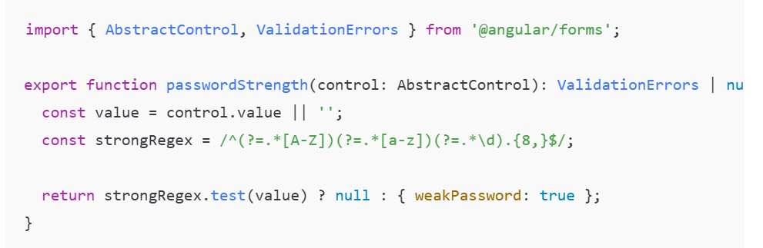
App.component.ts
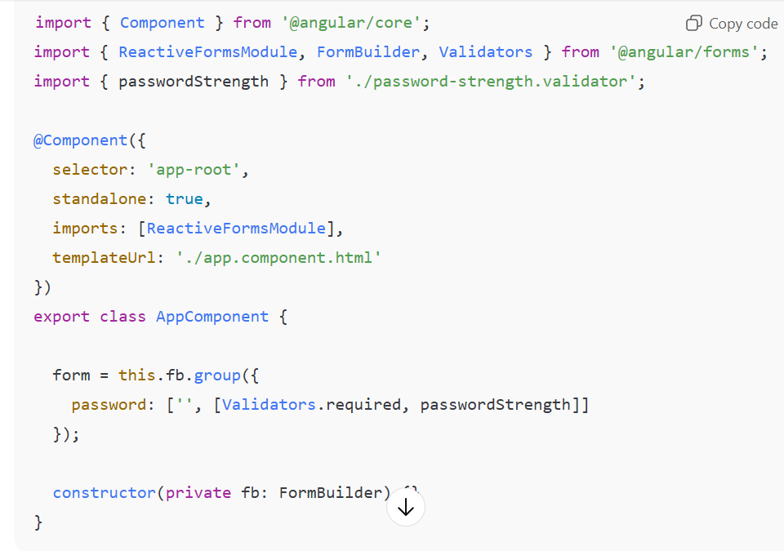

App.component.html
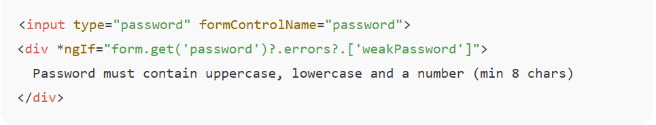

Content Security Policy (CSP)
Purpose
CSP protects web apps from:
✔ Cross-Site Scripting
✔ Data Injection
✔ Clickjacking

Server config
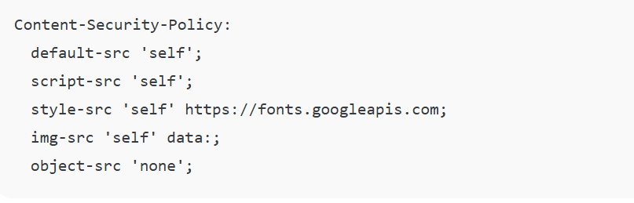
Index.html
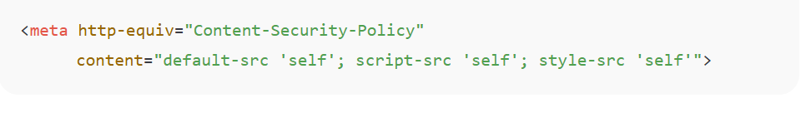

Secure Form Handling and CSRF Protection
What is CSRF?
A malicious website tricks the user’s browser into sending unwanted requests to your server.
How to secure forms?
✔ Add CSRF token
✔ Use SameSite cookies
✔ Validate inputs
✔ Use HTTPS

Auth.interceptor.ts
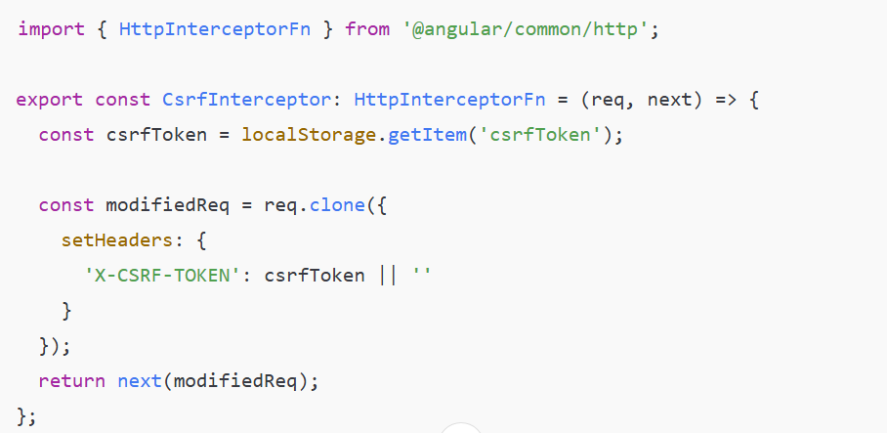

Main.ts
