Introduction to Chrome DevTools
Chrome DevTools is a set of web developer tools built directly into the Google Chrome browser.
It helps you inspect, debug, and optimize websites and web apps.
How to Open DevTools:
- Right-click → Inspect
- Or press:
  - Ctrl + Shift + I (Windows)
  - Cmd + Option + I (Mac)
  - F12
Uses:
- Inspect HTML and CSS
- Edit styles in real-time
- Debug JavaScript
- Analyze performance
- Monitor network requests

2. Console Panel
The Console panel is used to:
- Run JavaScript commands.
- View logs, warnings, and errors.
- Interact directly with your web page.
Example Implementation:
- Open Console (Ctrl + Shift + J).
- Type:
- console.log("Hello, DevTools!");
Output:
Hello, DevTools!
Other Console Functions:
console.warn("This is a warning!");
console.error("This is an error!");
console.table([{ name: "Asha", age: 25 }, { name: "Ravi", age: 30 }]);
Use Case:
Debug JavaScript or check variable values while developing.

3. Elements Panel
The Elements panel lets you inspect and edit HTML and CSS in real-time.
Example:
- Open a webpage.
- Right-click on any element → Inspect.
- You’ll see:
  - The HTML structure (<div>, <p>, <h1>, etc.)
  - The CSS styles applied to it.
Try this:
- Select an element (like a heading).
- In the Styles pane, change:
- color: red;
- font-size: 30px;
- You’ll instantly see changes on the page!
Use Case:
Testing layout, color, font, and margin/padding without editing the source code.

4. Sources Panel
The Sources panel allows you to:
- View and edit website files (HTML, JS, CSS).
- Add breakpoints to debug JavaScript.
- Step through code line-by-line.
Example Implementation:
- Open a webpage with JavaScript.
- Go to Sources → Page → main.js (or script file).
- Add a breakpoint by clicking a line number.
- Refresh the page → execution pauses there.
- Hover over variables to see their values.
Shortcuts:
- F8 → Resume script
- F10 → Step over next function call
- F11 → Step into function
Use Case:
Fix logical or runtime errors in JavaScript.
5. Performance Panel
The Performance panel helps analyze how efficiently your page runs — by recording runtime performance (like CPU, memory, and FPS).
Example:
- Open Performance tab.
- Click Record, then interact with your page (scroll, click, etc.).
- Stop recording.
- DevTools shows:
  - Frames per second (FPS)
  - JS execution time
  - Rendering bottlenecks
Use Case:
To find slow scripts or layout rendering issues.
6. Network Panel
The Network panel monitors network requests — like images, scripts, APIs, and stylesheets — as a page loads.
Example Implementation:
- Open Network tab.
- Reload your page (Ctrl + R).
- You’ll see:
  - All requests made by the browser.
  - Their status codes (200, 404, 500, etc.).
  - Load times and sizes.
Tip:
Filter requests by type:
- JS – to check script files
- XHR / Fetch – to view API calls
Example:
If a request shows 404 (Not Found), it means the file or endpoint doesn’t exist — helping you fix missing resource issues.

HTML DOM
What: The DOM (Document Object Model) is a tree representation of the HTML document. Each element/node is a node in the tree (elements, text nodes, comments).
Why it matters: Knowing the tree model helps you locate, inspect and modify page content programmatically.

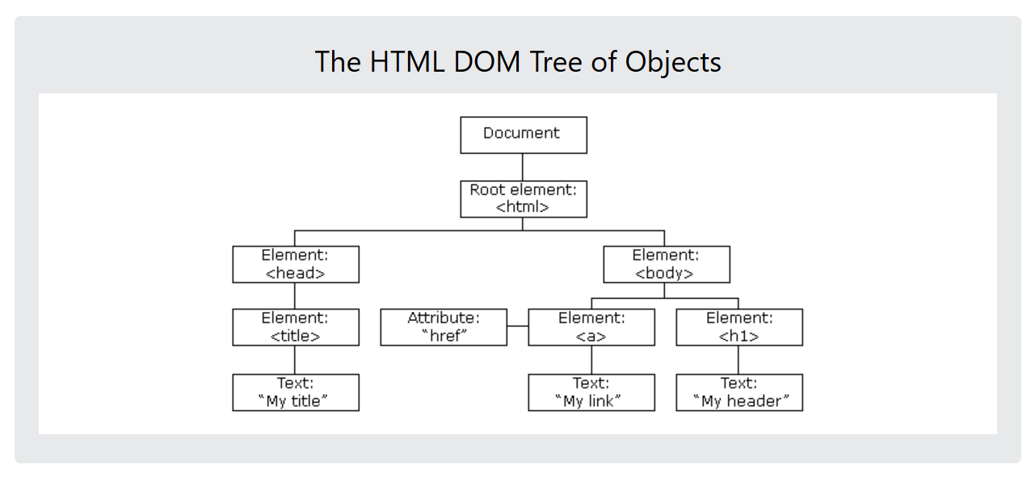

The HTML DOM is a standard object model and programming interface for HTML. It defines:
- The HTML elements as objects
- The properties of all HTML elements
- The methods to access all HTML elements
- The events for all HTML elements

See example

Selecting Elements
What: Methods to get DOM nodes: getElementById, getElementsByClassName, getElementsByTagName, querySelector, querySelectorAll.
When to use: querySelector/querySelectorAll are flexible and often preferred (CSS selectors). getElementById is fastest for single known id.

See example

DOM Manipulation
What: Create, update, remove elements and attributes: createElement, appendChild, insertBefore, remove, innerHTML, textContent, setAttribute, classList.

Events and Listeners
What: Respond to user actions with addEventListener. Events include click, input, submit, keydown, etc.
Syntax: element.addEventListener(eventType, listener, options?). Use named or arrow functions; this behaves differently in arrow functions (lexical this).
Example

Bubbling and Capturing
In JavaScript, event bubbling and event capturing are two phases of event propagation. Event bubbling propagates events from the target element to its ancestors, while event capturing propagates events from the ancestors to the target element.

Errors
Errors in JavaScript are problems that occur during the execution of code. These can be caused by syntax issues, incorrect logic, or runtime exceptions.
Understanding and handling errors properly helps in debugging and improving application stability.

Types of Errors in JavaScript
1. Syntax Error
Occurs when the code violates JavaScript’s grammar/syntax rules.
Example:
// Missing closing parenthesis
console.log("Hello World";
Explanation:
The above code will not execute because the parenthesis ) is missing — a syntax error.
Fix:
console.log("Hello World");

2. Reference Error
Occurs when you try to use a variable that hasn’t been declared.
Example:
console.log(a); // ReferenceError: a is not defined
Fix:
let a = 10;
console.log(a);

3. Type Error
Occurs when a value is not of the expected type (e.g., calling a non-function as a function).
Example:
let num = 10;
num(); // TypeError: num is not a function
Fix:
let num = 10;
console.log(num);

4. Range Error
Occurs when a value is not within an allowed range.
Example:
let num = 1;
num.toPrecision(500); // RangeError: toPrecision() argument must be between 1 and 100
Fix:
num.toPrecision(5);
5. URI Error
Occurs when global URI-handling functions (decodeURI(), encodeURI()) are used incorrectly.
Example:
decodeURI("%"); // URIError: malformed URI sequence
Fix:
decodeURI("%20"); // decodes to space

see example

JSON (JavaScript Object Notation)
What: A text format for representing structured data. Commonly used to send/receive data over HTTP.
Key methods
- JSON.stringify(value) → convert JS value to JSON string
- JSON.parse(jsonString) → parse JSON string back to JS value
Example

Promises
What: Objects representing completion (or failure) of an async operation. They let you attach callbacks with .then() and .catch().
Resolve -success
Reject –failure
Then

A Promise is a placeholder for a value that will be available in the future — either resolved (success) or rejected (failure).

Promise States
A Promise has three states:
State | Meaning
pending | The operation is still running
fulfilled | The operation completed successfully (resolve() called)
rejected | The operation failed (reject() called)

Creating a promise
let myPromise = new Promise(function(resolve, reject) {
let success = true;
if (success) {
resolve(" Operation completed successfully!");
} else {
reject(" Something went wrong!");
}
});
Here:
resolve() → called when operation succeeds
reject() → called when operation fails

let promise = new Promise((resolve, reject) => {
let success = true; // try changing to false
setTimeout(() => {
if (success) {
resolve(" Data fetched successfully!");
} else {
reject(" Error fetching data!");
}
}, 2000);
});
promise
.then((message) => console.log(message)) // success handler
.catch((error) => console.error(error)) // error handler
.finally(() => console.log("Operation completed"));
-----------------------------------------------------------------------------------------------------

function step1() {
return new Promise((resolve) => {
setTimeout(() => resolve("Step 1 complete"), 1000);
});
}

function step2() {
return new Promise((resolve) => {
setTimeout(() => resolve("Step 2 complete"), 1000);
});
}

function step3() {
return new Promise((resolve) => {
setTimeout(() => resolve("Step 3 complete"), 1000);
});
}

step1()
.then((msg) => {
console.log(msg);
return step2();
})
.then((msg) => {
console.log(msg);
return step3();
})
.then((msg) => console.log(msg))
.catch((err) => console.error(err))
.finally(() => console.log("All steps done!"));
// Promise chaining ---chaining mu;tiple .then() calls to to run task sequentially

Async and await
Helps to make asynchronous to looks like synchronous
ES8
Promise ----then and catch ---messy overcome

Async Function step1()
{
Let result = await getdata()
Console.log(result)
}
Await –help to wait for the promise to resolve
The function pause until the promise is done

Notes
In JavaScript, Promise, async, and await are fundamental constructs for handling asynchronous operations, providing a more structured and readable way to manage code that doesn't execute immediately.
Promises:
A Promise represents the eventual completion (or failure) of an asynchronous operation and its resulting value. It can be in one of three states:
- Pending: The initial state; the operation has not yet completed.
- Fulfilled (Resolved): The operation completed successfully, and the promise has a resulting value.
- Rejected: The operation failed, and the promise has a reason for the failure (an error).
You interact with promises using .then() to handle successful outcomes and .catch() to handle errors.
JavaScript
const myPromise = new Promise((resolve, reject) => {
// Simulate an asynchronous operation
setTimeout(() => {
const success = true;
if (success) {
resolve("Data fetched successfully!");
} else {
reject("Error fetching data.");
}
}, 1000);
});
myPromise
.then((message) => {
console.log(message); // Output: Data fetched successfully!
})
.catch((error) => {
console.error(error);
});
Async/Await:
async and await are syntactic sugar built on top of Promises, designed to make asynchronous code look and behave more like synchronous code, improving readability and maintainability.
- async keyword:
Used to define an asynchronous function. An async function always implicitly returns a Promise.
- await keyword:
Can only be used inside an async function. It pauses the execution of the async function until the Promise it's waiting on is resolved or rejected. The await expression then returns the resolved value of the promise.
JavaScript
async function fetchData() {
try {
const response = await new Promise((resolve) => {
setTimeout(() => resolve("Data fetched with async/await!"), 1000);
});
console.log(response); // Output: Data fetched with async/await!
} catch (error) {
console.error(error);
}
}
fetchData();
In essence, async/await provides a cleaner, more linear way to write and reason about asynchronous code that relies on Promises. While Promises offer the underlying mechanism, async/await offers a more elegant syntax for consuming them.

FetchAPI
The Fetch API is a modern interface in JavaScript that allows you to make HTTP requests.
It replaces the older XMLHttpRequest method and provides a cleaner and more flexible way to fetch resources asynchronously. The Fetch API uses Promises, making it easier to work with asynchronous data.

fetch(url, options)
.then(response => response.json())
.then(data => console.log(data))
.catch(error => console.error('Error:', error));
- url: The API endpoint from which data is fetched.
- options (optional): Specifies method, headers, body, etc.
- response.json(): Parses the response as JSON.
- .catch(error): Handles any errors that occur during the request.
How Fetch API Works?
- A request is sent to the specified URL.
- The server processes the request and sends a response.
- The response is converted to JSON (or another format) using .json().
- Errors are handled using .catch() or try-catch blocks.

Jest
Jest is a JavaScript testing framework developed by Facebook (now Meta). It’s primarily used for testing JavaScript and TypeScript applications, especially those built with React, but it can test any JavaScript codebase (Node.js or browser-based).

npm install --save-dev jest

mkdir jest-demo
cd jest-demo
npm init -y

install jest dependency --npm install --save-dev jest

