Introduction to Integration Testing
Integration Testing is a software testing level where individual modules or components are combined and tested as a group to verify:
- They work together correctly (order –deducting number from stock – payment -order confirmation)
- Their interactions (APIs, DB, services) behave as expected
- Data flows correctly across layers
It comes after Unit Testing and before System Testing.
Why Integration Testing Is Needed?
While Unit Tests validate individual components, they don’t check whether components work together.
Integration Testing helps identify issues like:
- Wrong API calls between layers
- Incorrect data mapping (DTO ↔ Entity)
- Mismatched request/response formats
- Database schema mismatches
- Misconfigured beans in Spring Boot
- Failed communication between microservices

Types of Integration Testing
1️⃣ Big Bang Integration
- All modules are integrated at once and tested together.
- Faster, good for small systems.
- Harder to debug.
2️⃣ Incremental Integration
Modules are integrated and tested one by one.
Variants:
- Top-Down (start from controllers → services → repository)
- Bottom-Up (start from repo → services → controllers)
- Sandwich/Hybrid (mix of both)
Functional/Scenario-based Integration
- Tests specific business flows
- Very popular in Spring Boot apps

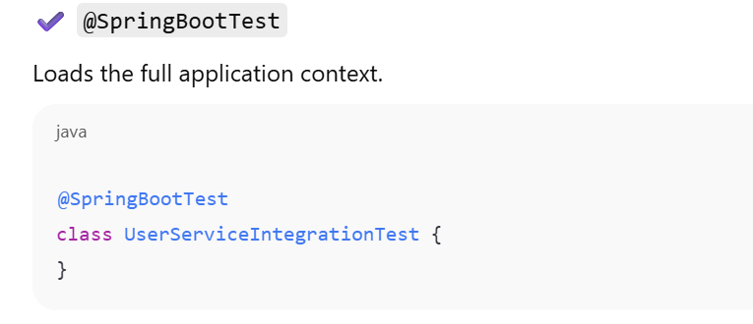
Using web environment
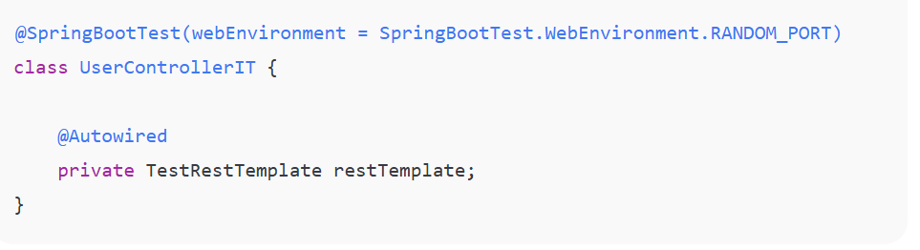
Full example
Controller
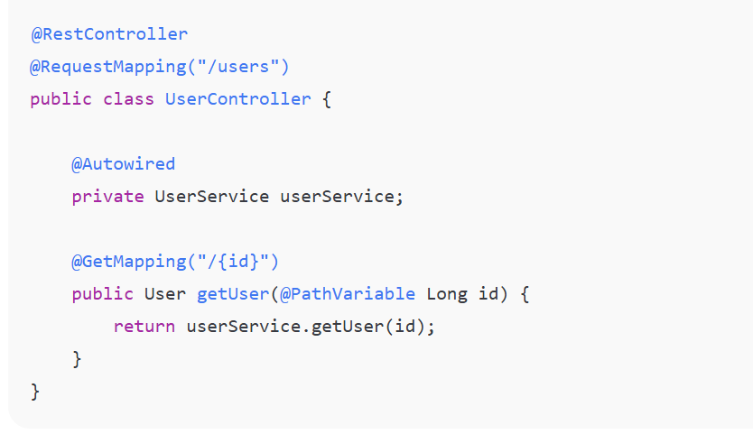
Integration Test
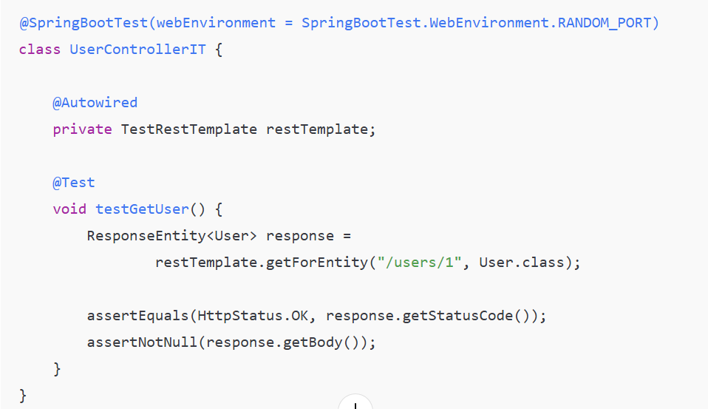

Spring Profiles for Test Environments
Spring Profiles are a powerful feature in Spring Framework that allow you to define environment-specific configurations. They're especially useful for managing different setups across development, testing, and production environments.

What Are Spring Profiles?
Spring Profiles provide a way to segregate parts of your application configuration and make it only available in certain environments. You can activate different bean definitions or property configurations based on which profile is active.

Hitting the real API(Payment ) –Production
Fake Api has to hit(payment -inactive)- development,testing
Defining Profiles
Using @Profile Annotation
You can mark beans to be created only when a specific profile is active:
@Configuration
@Profile("test")
public class TestConfiguration {
@Bean
public DataSource testDataSource() {
return new EmbeddedDatabaseBuilder()
.setType(EmbeddedDatabaseType.H2)
.build();
}
}
Using Properties Files
Create environment-specific property files:
- application.properties (default)
- application-test.properties (test profile) ---testing
- application-dev.properties (dev profile) ----development
- application-prod.properties (prod profile) -----production time
In application-test.properties:
properties
spring.datasource.url=jdbc:h2:mem:testdb
spring.jpa.hibernate.ddl-auto=create-drop
logging.level.root=INFO

Activating Profiles
In Tests
Use the @ActiveProfiles annotation:
@SpringBootTest
@ActiveProfiles("test") --test profile –properties has to be activated
public class UserServiceTest {
@Autowired
private UserService userService;

@Test
public void testUserCreation() {
// test code
}
}
Programmatically
java
@SpringBootTest(properties = "spring.profiles.active=test")
public class MyTest {
// test class
}
Via Environment Variables
Set SPRING_PROFILES_ACTIVE=test before running your application.
In application.properties
properties
spring.profiles.active=test

Practical Test Example
@SpringBootTest
@ActiveProfiles("test")
class ProductServiceTest {
@Autowired
private ProductService productService;

@MockBean
private ExternalApiClient apiClient;

@Test
void shouldReturnProductWithTestProfile() {
// Your test
}
}
With application-test.properties:
properties
spring.datasource.url=jdbc:h2:mem:test
spring.jpa.show-sql=true
app.feature.notifications.enabled=false
Multiple Profiles
You can activate multiple profiles at once:
java
@ActiveProfiles({"test", "h2"})
@SpringBootTest
public class IntegrationTest {
// test code
}

Or via properties:
spring.profiles.active=test,h2

Testing RESTful APIs with MockMvc and RestTemplate
Testing Database Interactions

Overview of Spring Boot Actuator
Spring Boot Actuator is a built-in production-ready monitoring and management tool for Spring Boot applications.
It exposes REST endpoints that help you check the application’s health, metrics, configuration properties, logs, beans, and more.
It is widely used in microservices, cloud deployments, Docker/Kubernetes, and DevOps environments.
Why do we use Actuator?
Because it provides:
✔ Production-ready features
- Health monitoring
- Traffic and performance metrics
- Environment inspection
- Log level management
- Thread dump info
- HTTP tracing
- Integration with Prometheus, Grafana, CloudWatch, ELK, etc.
✔ Helps DevOps & Monitoring teams
- Check service health
- Monitor key metrics (CPU, memory, threads, errors, latency, DB performance)
- Trigger graceful shutdown
- Manage logs dynamically
Add Actuator dependency
<dependency>
<groupId>org.springframework.boot</groupId>
<artifactId>spring-boot-starter-actuator</artifactId>
</dependency>

/getbyID -----Run your application
Check your endpoint ----confirm its working fine
Built-in Actuator Endpoints (health, info, metrics, etc.)

Endpoint | Description
/actuator/health | Shows app health (DB connection, disk space, custom health checks)
/actuator/info | Application information (version, description)
/actuator/metrics | Shows all performance metrics
/actuator/metrics/{metric-name} | Detailed metric (ex: jvm.memory.used)
/actuator/env | Displays environment properties
/actuator/beans | Shows all spring beans
/actuator/mappings | Shows all controller request mappings
/actuator/loggers | View/Change log levels at runtime
/actuator/threaddump | Thread dumps
/actuator/shutdown | Gracefully shutdown (must be enabled manually)
/actuator/httpexchanges | Shows last HTTP request-response exchanges
Enabling endpoints in application
management.endpoints.web.exposure.include=*
management.endpoints.web.exposure.include=health,info,metrics,logger

management.endpoint.health.show-details=always

HTTP Methods (Http Verb): GET, POST, PUT, DELETE, PATCH, etc.
HTTP methods define what action the client wants to perform on the server.
1. GET
- Used to retrieve data from the server.
- No request body.
- Safe, idempotent.
    - Example:
    - GET /users
2. POST
- Used to create new resources.
- Contains a request body (JSON, XML).
- Not idempotent (calling twice creates two records).
    - Example:
    - POST /users
    - { "name": "John" }
3. PUT
- Used to update an existing resource completely.
- Idempotent (same result even if called multiple times).
    - Example:
    - PUT /users/10
    - { "name": "John Doe" }
4. PATCH
- Used to partially update a resource.
- Not always idempotent.
    - Example:
    - PATCH /users/10
    - { "email": "john@example.com" }
5. DELETE
- Deletes a resource.
- Idempotent.
    - Example:
    - DELETE /users/10
6. OPTIONS
- Returns allowed HTTP methods.
- Used in CORS pre-flight.
7. HEAD
- Same as GET but no response body.
- Used for metadata checks.

Spring Session Handling
Spring Session helps manage user sessions, especially useful for distributed systems (microservices).
What Spring Session Does
- Stores session data outside the application.
- Supports session storage in:
  - Redis
  - JDBC DB
  - Hazelcast
  - MongoDB
Why we use it?
- Helps in clustered deployment (load balancers).
- Session remains consistent even if server restarts.
- Avoids in-memory session problems.

How Session Works in Spring MVC
Step 1 — User logs in
Spring creates a Session ID and stores it in:
- Cookie: JSESSIONID
- Or header (for REST APIs)
Step 2 — Server stores user session data
Session may hold:
- Username
- Roles
- Cart items
- Temporary data
Step 3 — Subsequent requests
Client sends the same JSESSIONID, server retrieves session data.
Step 4 — Session Timeout
Configured in application.properties:
server.servlet.session.timeout=30m
Step 5 — Distributed Session with Redis
Add dependency:
<dependency>
<groupId>org.springframework.session</groupId>
<artifactId>spring-session-data-redis</artifactId>
</dependency>
Configure:
spring.session.store-type=redis
This ensures sessions survive:
- Restarts
- Scaling
- Load balancing

3. Request Flow from Browser to Database in Spring Boot
This explains the complete journey of a request in Spring Boot:
Step-by-step Request Flow
1) Browser / Client sends request
Example:
GET /products/1
2) DispatcherServlet receives request
Core component of Spring MVC.
- Works as the front controller.
- Sends request to handler mapping.
3) Handler Mapping
Finds which controller method should handle the request.
4) Controller Layer
Your controller method gets invoked:
@GetMapping("/products/{id}")
public Product getProduct(@PathVariable int id) {
return service.getProduct(id);
}
It delegates to the Service layer.

5) Service Layer
Contains business logic:
public Product getProduct(int id) {
return repository.findById(id).orElseThrow();
}
Delegates to the repository.

6) Repository Layer (DAO)
Interacts with the database.
@Repository
public interface ProductRepository extends JpaRepository<Product, Integer> {}

7) Hibernate / JPA
Steps:
- Convert method into SQL query.
- Use DataSource (HikariCP) for connection.
- Query executed against DB.
- Result converted into entity object. User ---output)

8) Response Returned
Flow:
Repository → Service → Controller → DispatcherServlet → Browser
Example JSON Response:
{
"id": 1,
"name": "Laptop",
"price": 65000
}

Browser → DispatcherServlet → Controller → Service → Repository → Database
Browser ← DispatcherServlet ← Controller ← Service ← Repository ← Database

Core HTTP Concepts — Detailed Explanation
1. Local Storage (Browser Storage)
LocalStorage is a client-side storage mechanism provided by the browser.
It allows web applications to store data locally, inside the user's browser with no expiration time.
Key Characteristics
- Data persists even after the browser is closed.
- Storage limit is usually 5–10 MB (much larger than cookies).
- Data is stored as key–value pairs.
- Only accessible from the client side (JavaScript).
- Not secure for confidential data (never store JWT tokens/passwords).
Example (JavaScript)
localStorage.setItem("username", "john");
let user = localStorage.getItem("username");
localStorage.removeItem("username");
localStorage.clear();

When to Use
- Saving UI preferences (theme, layout).
- Saving temporary app data.
- Caching non-sensitive data.
When not to Use
- Storing tokens
- Sensitive data (email, auth info)
- Financial/user personal data

2. Session Handling
Session is a mechanism to store user-specific data on the server across multiple requests.
HTTP is stateless, so session helps maintain user identity in web applications (login, cart, etc.).
How Sessions Work
- User logs in → server creates a session.
- Server stores data (username, roles, cart info).
- Server issues a session ID (JSESSIONID).
- Browser stores it in cookies.
- Each new request sends JSESSIONID.
- Server uses the ID to retrieve user session data.

Session Example (Spring Boot)
session.setAttribute("user", "john");
String user = (String) session.getAttribute("user");

Session Timeout
server.servlet.session.timeout=30m

Where Sessions Are Stored?
Storage Type | Usage
In-Memory (Default) | Single server apps
Redis Session Storage | Microservices, distributed apps
JDBC session storage | DB-backed persistence

Session Handling in REST APIs
REST is stateless; JWT tokens or API keys are used instead of server sessions.

3. Stateful vs Stateless REST API
Client request ---response from server (not maintaining the details of client )—stateless –(RESTAPI)
Server maintains the details of client

Stateful Applications
Server remembers the client between requests.
✔ How?
Session stored on server (memory/Redis/DB).
✔ Examples:
- Traditional web apps (JSP, PHP)
- Shopping cart with server session
- Banking websites with session timeout
✔ Advantages:
- Easy to implement authentication
- Server manages everything
Disadvantages:
- Harder to scale (load balancing)
- Requires session replication
- Higher memory usage

🟦 Stateless Applications
Server does NOT store client data between requests.
Each request contains all required information.
✔ Examples:
- REST APIs
- JWT authentication
- Microservices
✔ Advantages:
- Simple to scale horizontally
- No session replication needed
- Ideal for cloud/Kubernetes
Disadvantages:
- Client must store auth/token
- Tokens must be validated each time

4. Client-side vs Server-side Storage
Client-side Storage
Stored on user’s browser.
Examples
- Local Storage
- Session Storage
- Cookies
✔ Pros:
- Fast retrieval
- Reduces server load
❌ Cons:
- Limited size
- Not secure
- User can modify data
🟦 Server-side Storage
Stored on the server.
Examples
- Database
- Server sessions
- Redis cache
✔ Pros:
- Secure
- Centralized
- Supports large storage
❌ Cons:
- Slower (network round trip)
- Requires server memory/storage

