Services & DI Essentials
- What: A service holds reusable logic/state. DI (dependency injection) supplies instances where needed.
- Scope: Provide in root for a shared singleton, or provide in a component for isolated instances.
- Use cases: Data fetching, caching, business rules, cross-component state.
- Mental model: DI is like a power outlet: you plug in and Angular gives you a ready instance.
- Decorator: Use @Injectable() on classes that inject other services.

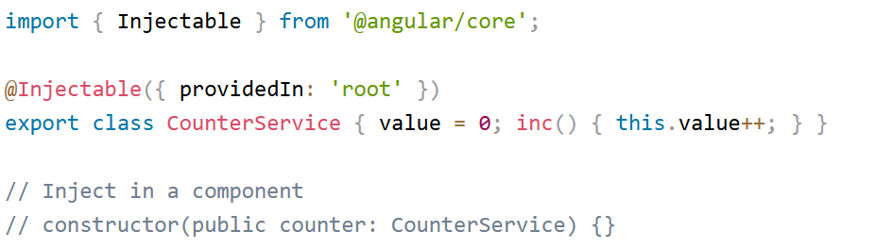

Service Basics
- Decorate classes with @Injectable() (required if they inject other services).
- Inject services into constructors to use them in components.
- Use providedIn: 'root' for a shared singleton.

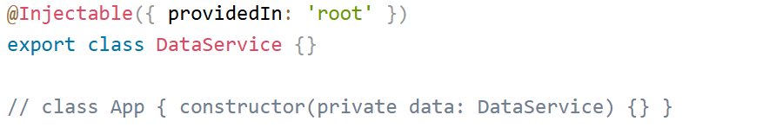

See sample injection demo

Shared Service Across Components
- providedIn: 'root' shares one instance across the app.
- Updating in one component reflects in others using the same service.
<counter-a></counter-a>
<counter-b></counter-b>
<!-- Both use the same service instance -->
See demo
Component-Provided Service (Hierarchical DI)
- Provide a service in a component's providers to create a local instance for its subtree.
- Sibling subtrees receive separate instances.
@Component({ providers: [LocalCounterService] })
export class Panel {}
A B
Aa Ba

see sample

HTTP Client & Communication
Angular HTTP Client
What it is:
The HttpClient module in Angular is a built-in service that allows communication with backend APIs using HTTP methods like GET, POST, PUT, DELETE.
It’s provided by @angular/common/http.
Key Features:
- Simplifies HTTP requests.
- Returns RxJS Observables.
- Supports request/response interceptors.
- Can handle JSON automatically.
2. HTTP Interceptors (Request/Response)
📘 What They Are:
Interceptors allow you to modify or inspect HTTP requests/responses globally — ideal for:
- Adding auth tokens,
- Logging,
- Showing loading spinners,
- Handling errors globally.

Error Handling and Retry Mechanisms
Why Important:
Network requests often fail — proper error handling improves UX and reliability.
Angular + RxJS offers:
- catchError for handling errors.
- retry() for retrying failed requests.

Typed HTTP Responses and Generic Services
Typed HTTP Responses<T>
In Angular (v15+ and now v18), you can define the type of data returned by an HTTP call — so you get compile-time type checking
this.http.get<Product[]>('api/products');
→ Here the response type is Product[], not any.
Generic Service
A generic service lets you reuse CRUD logic for multiple entities:
getAll<T>(url: string): Observable<T[]> { ... }
So instead of writing separate HTTP logic for ProductService, UserService, etc.,
you write one BaseService<T> and extend it.

Authentication vs Authorization
- Authentication = proving who you are (login).
- Authorization = deciding what an authenticated user can do (roles/permissions).
Implementation approach in example:
- Login endpoint issues a short-lived access token (JWT) and a longer-lived refresh token.
- Access token includes user id & roles; middleware verifies token and enforces role-based authorization.

JWT (JSON Web Tokens) Implementation
Best Practices for JWT Authentication in Angular Apps | Syncfusion Blogs

CSRF (Cross-Site Request Forgery) is a type of attack where a malicious site tricks a logged-in user’s browser into sending unauthorized requests to your backend.
⚠️ Example Attack:
- User logs into bank.com (session stored in cookie).
- Without logging out, the user visits evil.com.
- That site silently runs a hidden form or script:
- <form action="https://bank.com/api/transfer" method="POST">
- <input type="hidden" name="amount" value="10000" />
- <input type="hidden" name="to" value="attacker" />
- </form>
- <script>document.forms[0].submit()</script>
- Browser automatically attaches bank.com’s cookies → transfer happens!

Why CSRF Happens
CSRF relies on:
- Automatic cookie attachment (browser sends cookies with every request)
- Lack of an authenticity token verifying request origin
So, CSRF is a concern only when you use cookies for session/authentication — not JWT stored in localStorage (more on this below).

Angular’s Built-in CSRF (XSRF) Protection
Angular provides automatic XSRF protection for apps using cookie-based sessions (not JWTs).
It works via two coordinated elements:
🔹 (a) Server-side:
Your backend must set a cookie with a CSRF token:
Set-Cookie: XSRF-TOKEN=abc123; Path=/
🔹 (b) Client-side:
Angular’s HttpClientXsrfModule automatically:
- Reads the XSRF-TOKEN cookie value
- Adds a custom header on all outgoing mutating requests (POST, PUT, DELETE):
- X-XSRF-TOKEN: abc123
- The backend validates that header matches the cookie

Enabling Angular’s Built-in XSRF Protection
In Angular 18 standalone apps:
import { provideHttpClient, withXsrfConfiguration } from '@angular/common/http';
import { bootstrapApplication } from '@angular/platform-browser';
import { AppComponent } from './app/app.component';

bootstrapApplication(AppComponent, {
providers: [
provideHttpClient(
withXsrfConfiguration({
cookieName: 'XSRF-TOKEN', // default
headerName: 'X-XSRF-TOKEN' // default
})
)
]
});
This setup:
- Automatically sends X-XSRF-TOKEN header when cookie XSRF-TOKEN is present
- Works seamlessly with backend frameworks like Spring Security, Django, Express CSRF middleware, etc.

How Angular’s XSRF Works (Diagram)
Browser ⟶ Login API
↓
Server sets cookie: XSRF-TOKEN=abc123
↓
Angular HttpClient reads cookie
↓
Angular automatically sends header X-XSRF-TOKEN: abc123
↓
Server compares cookie vs header → ✅ valid → proceed

JWT vs CSRF Protection
Auth Method | CSRF Risk | Recommended Protection
JWT in localStorage/sessionStorage | ❌ No automatic cookie → not CSRF vulnerable | Protect with CORS and token signature
JWT in HttpOnly Cookie | ✅ CSRF possible | Use Angular XSRF + SameSite cookies
Traditional Cookie Session | ✅ CSRF possible | Use Angular XSRF protection

1. Authentication vs Authorization
Authentication is verifying who the user is (e.g., login with username and password).
Authorization is determining what the authenticated user can do (e.g., restrict access to certain routes based on roles).
Angular Implementation:
Authentication: Use a login form that calls a REST API for user verification. On success, store a JWT token locally. (JSON web token )
Authorization: Use Angular route guards to restrict access based on user roles, permissions, or authentication status.
User ----jwt ----search ,order
Admin ---jwt ----add new product,updats new , remove ,price…
typescript
// auth.service.ts
login(credentials: {email: string, password: string}) {
return this.http.post('/api/login', credentials)
.pipe(tap((res: any) => localStorage.setItem('token', res.token)));
}

// auth.guard.ts
canActivate(): boolean {
return !!localStorage.getItem('token');
}
Use this guard in your route definitions to protect resources.​

2. JWT (JSON Web Token)
A JWT is a compact token that is signed and optionally encrypted. The server creates and signs it on authentication; the client stores and presents it on each request for authorization.
Angular Implementation:
Save the JWT after login in secure storage (not local/session storage if security is critical—prefer cookies with HttpOnly/secure flags for production).
Add the token to the Authorization header for protected API calls using an HTTP interceptor.
typescript
// token-interceptor.ts
intercept(req: HttpRequest<any>, next: HttpHandler) {
const token = localStorage.getItem('token');
if (token) {
req = req.clone({ setHeaders: { Authorization: `Bearer ${token}` } });
}
return next.handle(req);
}
Register the interceptor in the providers array in your app module.​

3. Token-based Authentication
After a successful login, the backend returns a token (often JWT), which is included in every request for resources that require authentication.
Tokens may have an expiration and can be refreshed using refresh tokens.

Angular Implementation:
Store, manage, and include the access token in requests as shown above.
Handle token expiration in the interceptor; optionally implement automatic token refresh or redirect to login.​

4. HTTP Security Headers
HTTP security headers like Strict-Transport-Security, X-Content-Type-Options, and Content-Security-Policy improve application security.
Angular Implementation:
These headers are set on the backend/server (Node, Java, etc.), not in the Angular frontend.
Ensure the backend API you consume sets these headers to protect your app from common attacks.​

5. Secure Token Storage
Store tokens in secure, XSS-resistant storage. For SPAs, HttpOnly/secure cookies are preferred for critical tokens.
Avoid storing sensitive tokens in localStorage/sessionStorage as they are accessible via JavaScript and susceptible to XSS attacks.
Angular Implementation:
For most tutorials, you’ll see tokens stored in localStorage for simplicity.
For production, use cookie storage with HttpOnly flag (handled server-side), limiting the risk from XSS.
Example for localStorage (for demo only):
typescript
localStorage.setItem('token', response.token);
For advanced security, consult backend docs to use secure cookies instead.​

6. CSRF Protection and Tokens ----cross site request forgery
CSRF tokens are server-generated values unique to the user and session. They protect against unauthorized form submissions from third-party sites.
When using HttpOnly cookies for authentication, a CSRF token is often needed as a hidden field in forms or sent as a custom HTTP header in AJAX requests.
Angular Implementation:
Add the CSRF token to every mutating request’s headers (if your API expects it).
typescript
// Add custom CSRF header in requests (if backend expects 'X-CSRF-Token')
intercept(req: HttpRequest<any>, next: HttpHandler) {
const csrf = localStorage.getItem('csrfToken');
if (csrf) {
req = req.clone({ setHeaders: { 'X-CSRF-Token': csrf } });
}
return next.handle(req);
}
You may need to retrieve the token from a backend API and store it initially after authentication.

