Component Communication (@Input, @Output, EventEmitter)

ViewChild, ViewChildren & Template Reference Variables in angular18
1. Template Reference Variable (#var)
🔹 What it is:
A template reference variable is a local variable declared in the template using #.
It gives you direct access to a DOM element or an Angular component/directive instance.
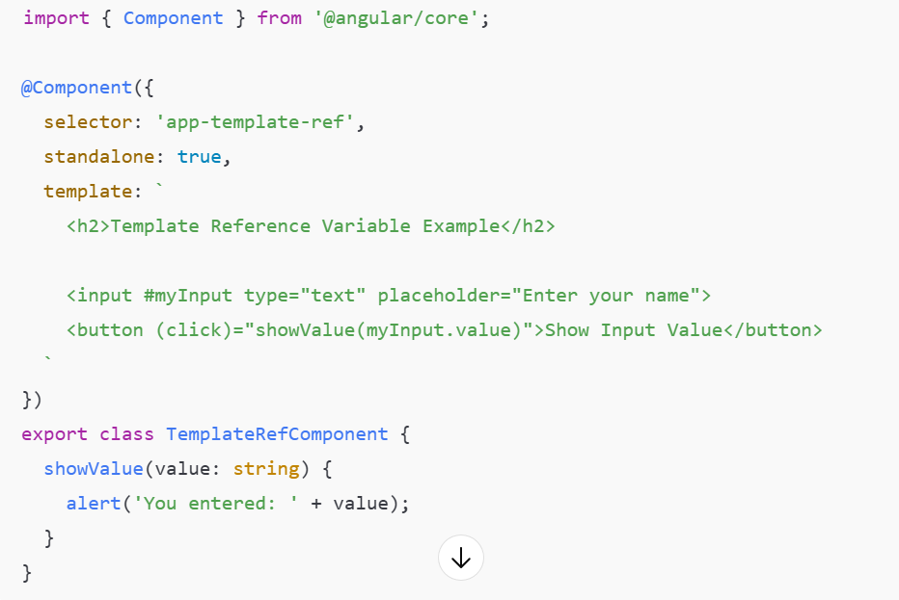

2. @ViewChild — Access a Single Element or Component
🔹 What it is:
@ViewChild is a decorator that allows you to get a reference to:
- A DOM element
- A Directive
- Or a Component instance inside the same template
🔹 When to use:
Use @ViewChild when you want to access or manipulate a single child element/component after the view is initialized.

3. @ViewChildren — Access Multiple Elements or Components
🔹 What it is:
@ViewChildren is used to query multiple elements or components in the template.
It returns a QueryList, which acts like an iterable list of references.
My-angular-application sample
Content Projection (ng-content) and Advanced Patterns
<ng-content><ng-content>
Content Projection lets you insert external content (HTML, components, text) into a child component’s template — while keeping the structure and behavior of that child component.
Basic Example — Single-Slot Projection
Explanation
- <ng-content> is a placeholder where parent content is projected.
- The <app-card> template wraps the projected HTML inside its own layout

Conditional / Dynamic Projection (Advanced Pattern)
You can conditionally project content based on logic inside the component using @ContentChild and Angular’s control flow.
Home About contact ---tabs
Contact page

Advanced Pattern — Projection with @ContentChildren
Use @ContentChildren when you need to access multiple projected child elements or directives inside a component.

Angular Signals (Production Ready in v18)
What Are Angular Signals?
Signals are a reactive primitive in Angular — a new way to manage and track state without relying on RxJS BehaviorSubject or NgRx.
They’re like reactive variables: when their value changes, any computations or components that depend on them automatically update.
Think of a Signal as a "reactive variable with built-in change detection".
Why Signals?
Before Signals, Angular relied heavily on:
- Change Detection Zones (zone.js)
- RxJS Observables
- Immutable data patterns
These are powerful but can cause unnecessary re-renders and complex subscriptions.
Signals solve this by offering fine-grained reactivity, directly controlled by Angular’s rendering engine.
Angular 18: Signals Are Production Ready
In Angular 18:
- Signals are stable and fully supported.
- Zone-less change detection works seamlessly with Signals.
- Angular Material and Router now use Signals internally.
- You can mix Signals + Observables safely.
Core APIs in Signals
Function | Purpose
signal(initialValue) | Creates a writable signal
computed(fn) | Creates a derived signal based on other signals
effect(fn) | Runs a function automatically whenever dependent signals change
toSignal() | Converts an Observable to a Signal
toObservable() | Converts a Signal to an Observable
set(), update() | Mutate signal values safely

Signal-based Reactivity and State Management
Angular Signals: Reactive Programming Simplified | Syncfusion Blogs
See sample signaldemo

View Transitions API Integration
The View Transitions API is a modern browser API (part of the Web Animations standard) that enables smooth page transitions when the DOM changes — for example, when navigating between routes or updating UI elements.
Angular 18 builds on this using:
- provideViewTransitions() (Router-level integration)
- @ViewTransition() (Directive-level control)
- Automatic transitions for route-based changes

Enabling View Transitions in main.ts
In your main.ts, register the view transitions provider in the router configuration.
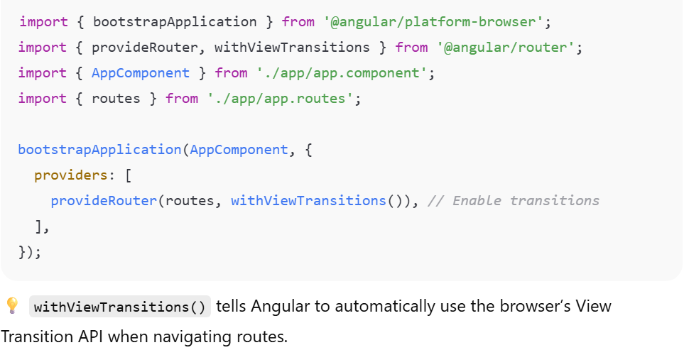

App.routes.ts
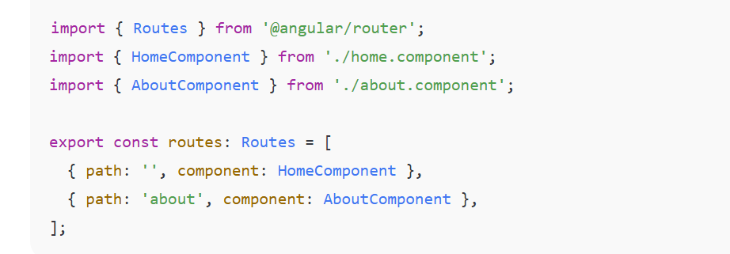

RxJS & Reactive Programming
Observable vs Subject - When to Use Each

Observable ---subscriber getting new random value
Subject –Observable +Observer------all the subscribers will be getting the value
BehaviouralSubject -----need an initial value ---always replays the latest emitted value
to the subscriber …0 1 ---1 is the input tnext subscriber (1+1)=2 ===2 be input
ReplaySubject -----keeps a buffer of last 2 values --- whena a new subscriber it replays the last 2 values 0 1 2 ----(1,2) ---sub2 ----sub2:1 sub2:2
AsyncSubject –emit tonly the last value when its completed
Subscriber (100)
Subscriber(200)
Subscriber(300) ouput after completing my process –300 ---API response ,caluculation---

1. Observable vs Subject
Concept:
- Observable:
→ Unicast (each subscriber gets its own independent stream).
→ Used for data sources like HTTP requests or timer events.
- Subject:
→ Multicast (same data shared to all subscribers).
→ Acts as both Observable (emits data) and Observer (can receive data).
See example ReactiveRxJS

Reactive Communication Pattern
Why Memory Management Matters in Angular
Every time you subscribe to an observable, Angular keeps that subscription active until:
- The observable completes, or
- You manually unsubscribe.
If you forget to unsubscribe from observables that never complete (like interval(), fromEvent(), or subjects that live for the entire app), they keep emitting even after the component is destroyed — causing:
- Memory leaks
- Unwanted API calls or event listeners
- Performance degradation
So, unsubscription is essential in long-lived components.

Common Strategies to Handle Unsubscription
A. Manual Unsubscribe in ngOnDestroy()
See memory.component.ts
Using takeUntil()
This is a clean and scalable method using a special Subject that emits when the component is destroyed.
Using the async Pipe
This is the Angular-recommended and safest way to manage subscriptions in templates.

RxJS Operators: map, filter, switchMap, mergeMap, combineLatest
What Are RxJS Operators?
Operators are like data-processing functions that you apply to observables using .pipe().
They can:
- Transform data (map)
- Filter emissions (filter)
- Chain async calls (switchMap, mergeMap)
- Combine multiple streams (combineLatest)
Think of them as array methods but for data streams.
Key Operators with Explanation & Example
🔹 map() → Transforms each emitted value.
Usage:
Takes the emitted value and applies a function to modify it.
import { of, map } from 'rxjs';
of(1, 2, 3)
.pipe(map(x => x * 10))
.subscribe(console.log);
// Output: 10, 20, 30
In Angular: You might map API responses into models or UI-friendly structures.

🔹 filter() → Filters out unwanted emissions.
Usage:
Emits only values that pass a given condition.
import { of, filter } from 'rxjs';

of(1, 2, 3, 4, 5)
.pipe(filter(x => x % 2 === 0))
.subscribe(console.log);
// Output: 2, 4
In Angular: Useful for filtering user input or events (e.g., only valid form values).

🔹 switchMap() → Cancels previous observable when a new one starts.
Usage:
When you trigger an async operation (like an API call), switchMap() cancels the previous one if a new value comes before completion.
import { fromEvent, switchMap, interval } from 'rxjs';
import { take } from 'rxjs/operators';

// Simulate button clicks triggering a timer
fromEvent(document, 'click')
.pipe(switchMap(() => interval(1000).pipe(take(3))))
.subscribe(console.log);
In Angular: Used for search suggestions — when user types a new query, previous API call is canceled.

🔹 mergeMap() → Runs all inner observables concurrently.
Usage:
Unlike switchMap, it doesn’t cancel previous calls — all run in parallel.
import { of, mergeMap, delay } from 'rxjs';

of('A', 'B')
.pipe(mergeMap(val => of(val + ' done').pipe(delay(1000))))
.subscribe(console.log);
// Output after 1s: A done, B done (both processed)
In Angular: Use it for batch operations — e.g., multiple parallel API requests.

🔹 combineLatest() → Combines multiple observables and emits when any changes.
Usage:
Waits until all observables emit once, then emits the latest values together.
import { combineLatest, interval, map } from 'rxjs';

const obs1 = interval(1000);
const obs2 = interval(1500);

combineLatest([obs1, obs2])
.pipe(map(([a, b]) => `A:${a}, B:${b}`))
.subscribe(console.log);
In Angular: Useful for combining form inputs, filters, or API data streams.

Error Handling in Reactive Streams
Why Error Handling Matters
In reactive programming, everything flows as a stream.
If an error occurs inside that stream (for example, a failed HTTP request), the observable stops emitting unless you handle it properly.
Without handling errors, your UI might stop updating or even crash.

RxJS Error Handling Strategies
RxJS provides operators and techniques to catch, recover from, or rethrow errors gracefully.
catchError()
Use Case: Catches an error and returns a new observable (like a fallback value).
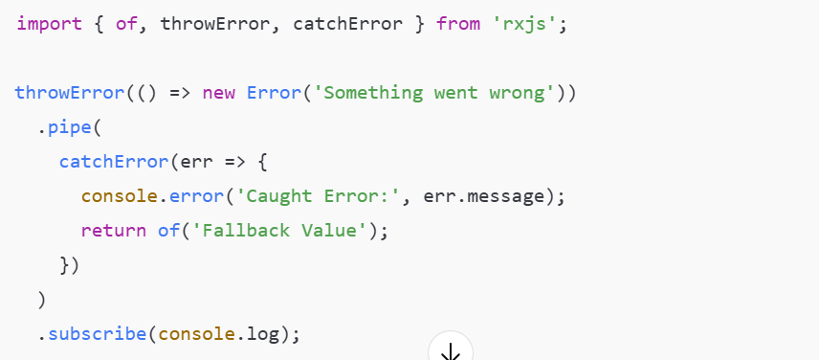

retry()
Use Case: Automatically retries the observable a set number of times before failing.
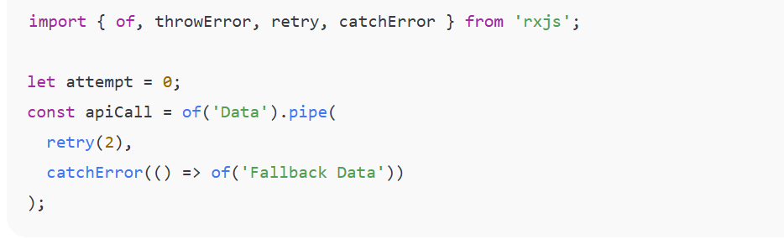
Retrying failed HTTP calls (like temporary network errors).

retryWhen()
Use Case: Allows you to add delay or conditions between retries.
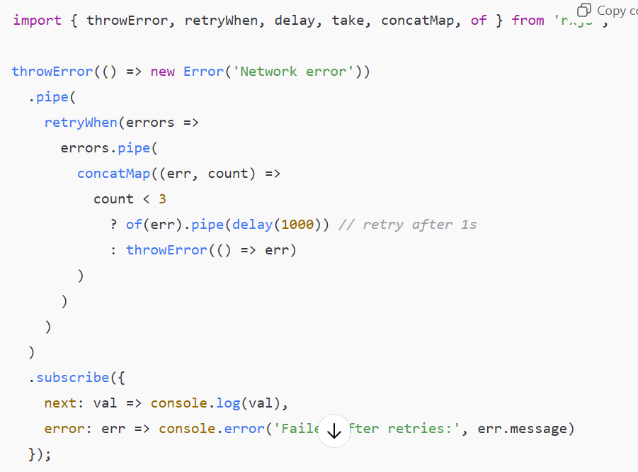

throwError()
Use Case: Manually create an observable that emits an error.
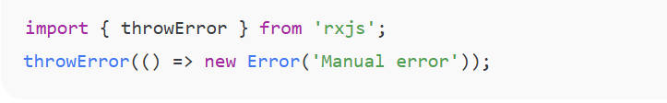
Useful for testing error flows or when manually triggering error conditions.

finalize()
Use Case: Runs cleanup logic after observable completes or errors out.
