# Table of Contents

1. About the Assignment
2. Getting Started
   1. Uploading .ipynb as Kaggle notebook
   2. Running the .ipynb file in Kaggle
   3. Running on Jupyter notebook
3. Contact
4. **About the Assignment**

Toxicity Prediction Challenge is a Kaggle hosted challenge to use machine learning algorithms to predict which chemicals are toxic.

1. **Getting Started**
   1. **Uploading .ipynb as Kaggle notebook**

Follow the below steps to upload and run the .ipynb file in Kaggle

**Step 1:**

Download code as zip file from GitHub link - [**https://github.com/RemyaMurali06/ToxicityPredictionChallenge**](https://github.com/RemyaMurali06/ToxicityPredictionChallenge)

Unzip and extract **XGBClassifierToxicityPrediction.ipynb**

**Step 2:**

Sign-in to Kaggle.com, open **https://www.kaggle.com/c/the-toxicity-prediction-challenge/code** and click on New Notebooks from the menu.

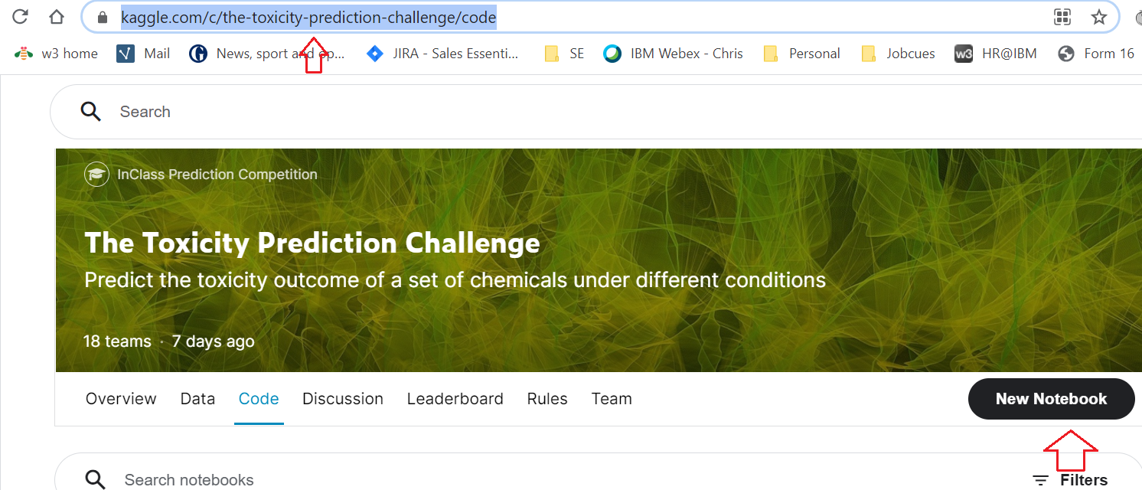

**Step 3:**

When the notebook opens, click on File, and select upload option from the File menu.

Upload the extracted **XGBClassifierToxicityPrediction.ipynb** to Kaggle.

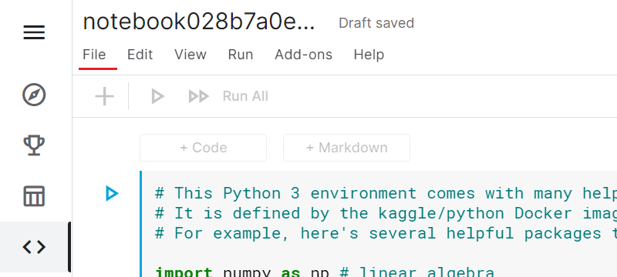

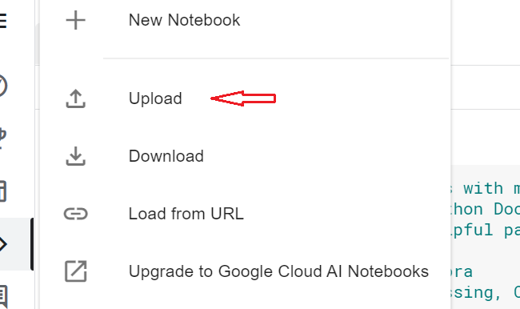

**Note**: open the Kaggle notebook from the competition link [**https://www.kaggle.com/c/the-toxicity-prediction-challenge/code**](https://www.kaggle.com/c/the-toxicity-prediction-challenge/code)**,**

in-order to get the dataset automatically added.

* 1. **Running the .ipynb on Kaggle**

Click anywhere in the code to get the blue run button on the left side. Click on the button and the execution result can be seen in the output section below**.**

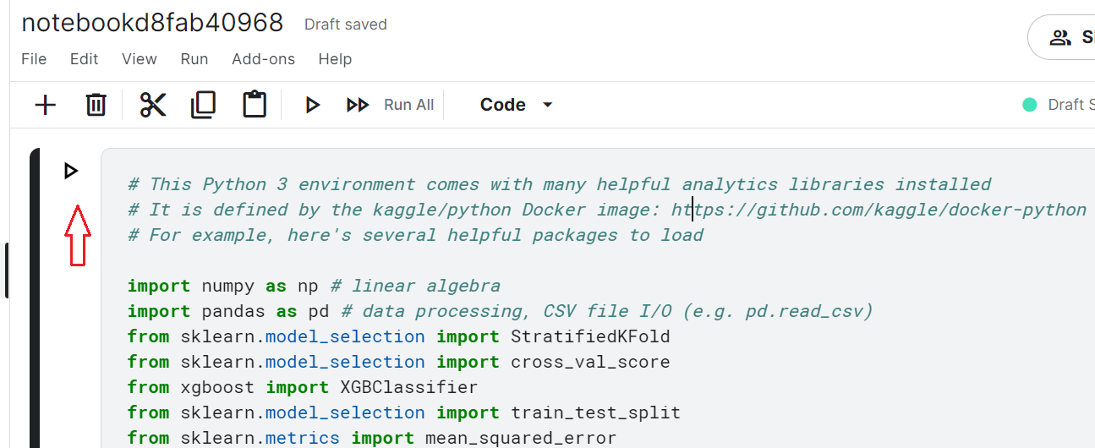

* 1. Running on Jupyter Notebook

1. **Contact**

**Team Scorpio**

**Name**: Remya Murali

**Student ID Number**: 202005986

**StFX email**: [x2020fvq@stfx.ca](mailto:x2020fvq@stfx.ca)

**Kaggle ID**: X2020fvq

**Name**: Jayanth Kottamasu

**Student ID Number**: 202004034

**StFX email**: x2020dxy@stfx.ca

**Kaggle ID**: x2020dxy

**Name**: Chetan Kakollu

**Student ID Number**: 202003785

**StFX email**: x2020dnf@stfx.ca

**Kaggle ID**: x2020dnf