Quizzoid App Project Document

**Online Test Application**

Course : PG FSD Develop a Web Application using frontend stack and part of PG FSD Caltech program

Programmer Details: Remya Pillai

https://github.com/RemyaPillai99/QuizzoidApp.git

Git Hub Link: <https://github.com/RemyaPillai99/QuizzoidApp>

**Project Details:**

Quizzoid is an online Test application platform.

## Website Flow

**Home page**

* Home page displays Registration Page
* Participant can enter name and email address

**Quiz App Flow** –

* After entering Participant name and email address its directed to quiz page
* If user is not logged into the app then user cannot access quiz or result page as proper “**Authentication Guard**” is set in place using Route.canActivate
* Questions are loaded from JSON file using **HTTP client** get in quizservice.
* Timer shows the time elapsed since start of quiz.
* Participant can navigate between questions using the previous and next button.
* Participant can also skip questions if desired.
* Participant can submit quiz using the Submit button
* On submit button a pop up modal Dialog box is displayed to re-confirm if the participant wants to submit quiz or review before final submission
* On Yes submit the result page is shown with the score and time taken.
* Result page also shows all responses selected by user with correct and incorrect option marked.
* Also answer explanation is shown for each question.
* Participant can choose to redo quiz by clicking restart quiz button and redirected to quiz page.
* Participant can log out using navbar Sign Out button and its redirected to welcome page.

## Project Structure

## Technologies Used

* **HTML5**
* **CSS3**
* **BootStrap5**
* **Angular**
* **JSON**
* **TypeScript**
* **VsCode(Editor**

**Json File : The Quiz options and Description are fetched dynamically using JSON data (Containing Questions and Answers) and Angular Framework.**

## Screen Shots

**Screenshots of all Scenarios in the Application:**

1. **Home Page: Shows Online Quiz Registration Page**

**Start Quiz button is disabled.**

**Name field and email Address are required fields**

**Email address Pattern validation is checked If not valid shows red outline and Start Quiz button remains disabled**

**Start Quiz button enabled once valid fields are entered**

1. **Main Quiz Page -TypeScript Quiz**

**Quizzoid navbar logo button takes you to welcome page**

**Participant name entered is displayed**

**Timer shows time taken to solve quiz.**

**Progress bar shows number of questions seen**

**All the questions with their options displayed are rendered from JSON file.**

**Participant can select one of the given options and click the next button**

**The page previous button is disabled as it’s the first page**

**On clicking Submit – Modal dialog box pops up to ask if you want to continue.**

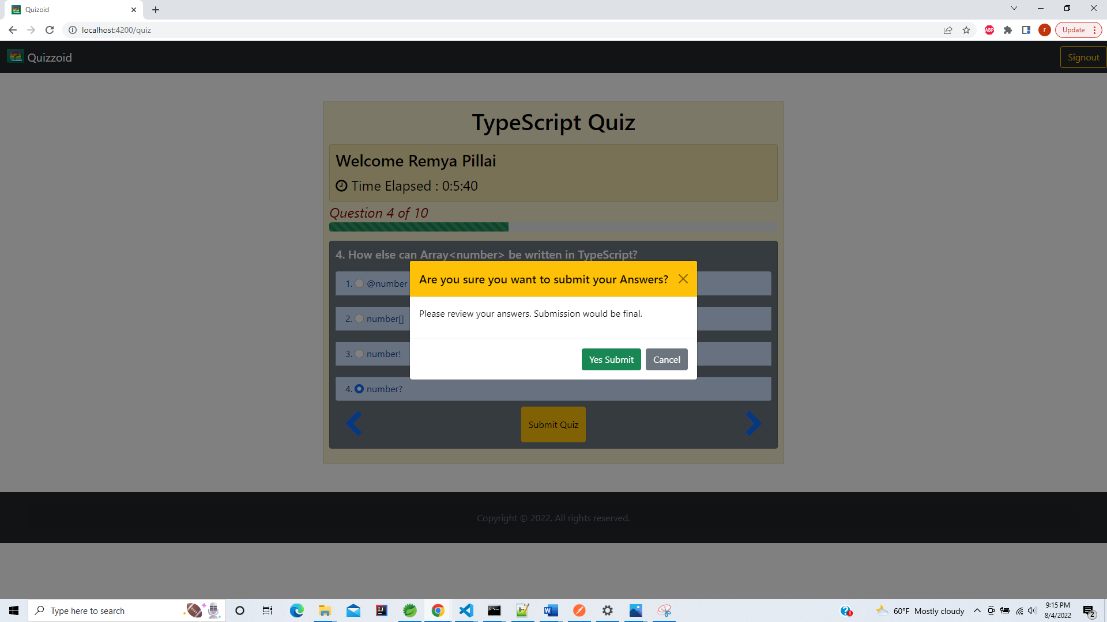

**On selecting cancel you go back to quiz.**

**You can review questions answered previously by clicking back navigation button**

**3.Modal dialog box - On clicking Yes Submit button from modal dialog box Quiz Result page is displayed.**

**3.Quiz Review and Result Page shows the - score , time taken and review page**

**Shows the participant selected answer with ticked check box**

* **Marks it Incorrect in red if response is wrong**
* **Also shows the explanation for correct answer**

**If participant has not attempted the question no check mark is shown.**

**But the correct answer is highlighted**

**After 10 questions the next button is disabled**

**Restart quiz – will take you quiz page to start quiz again**

**On Restart – it redirects to quiz page and starts the timer again and removes previous selections**

**On clicking sign out – it takes you back to home page and all saved data in local storage is destroyed**

**Back to home page**

