**CI/CD Deployment for Springboot Application.**

Course : PG FSD Testing in a DevOps Lifecycle part of PG FSD Caltech program

Programmer Details: Remya Pillai

<https://github.com/RemyaPillai99/RemyaPillai99-Phase5Assessment.git>

Git Hub Link: <https://github.com/RemyaPillai99/RemyaPillai99-Phase5Assessment>

## Assignment - 1: Deploying a project on Amazon EC2

The following are the steps that are involved in the assignment -

1. Create EC2 Instance on AWS
2. Connect to EC2 Instance using SSH
3. Cloning the Repo. on EC2
4. Building the App. Image using Docker
5. Running the Image using Docker
6. Access the Application on Browser using public IPv4 address

### Creating EC2 Instance on AWS

1. Launch AWS Console from the LMS Portal

1. AWS Web Console – AWS Management Console Page

1. Search for EC2

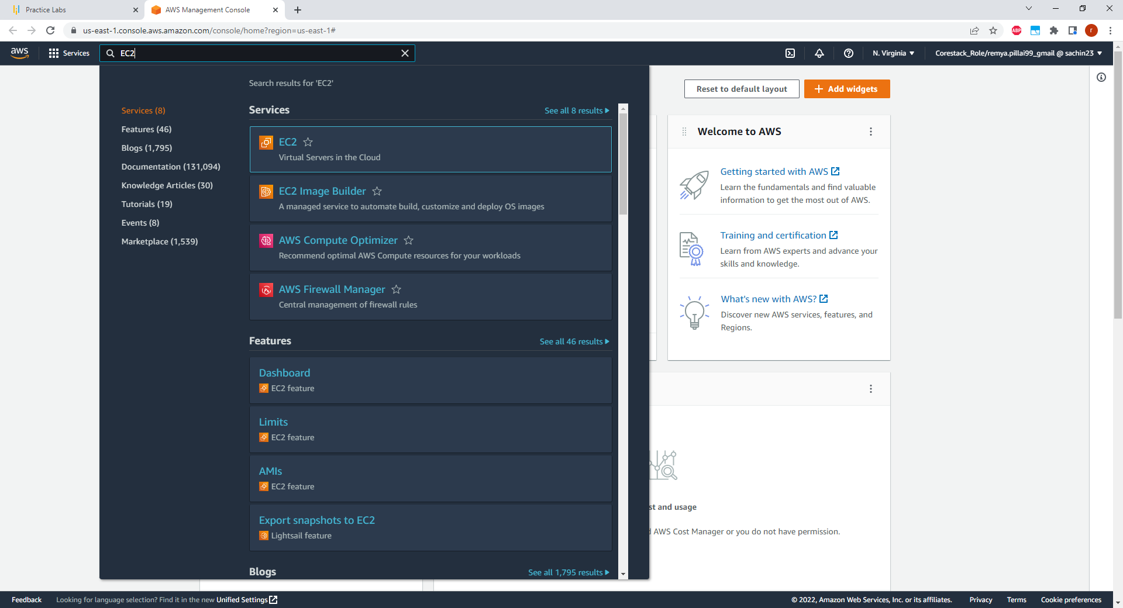

1. Click on “Instances”

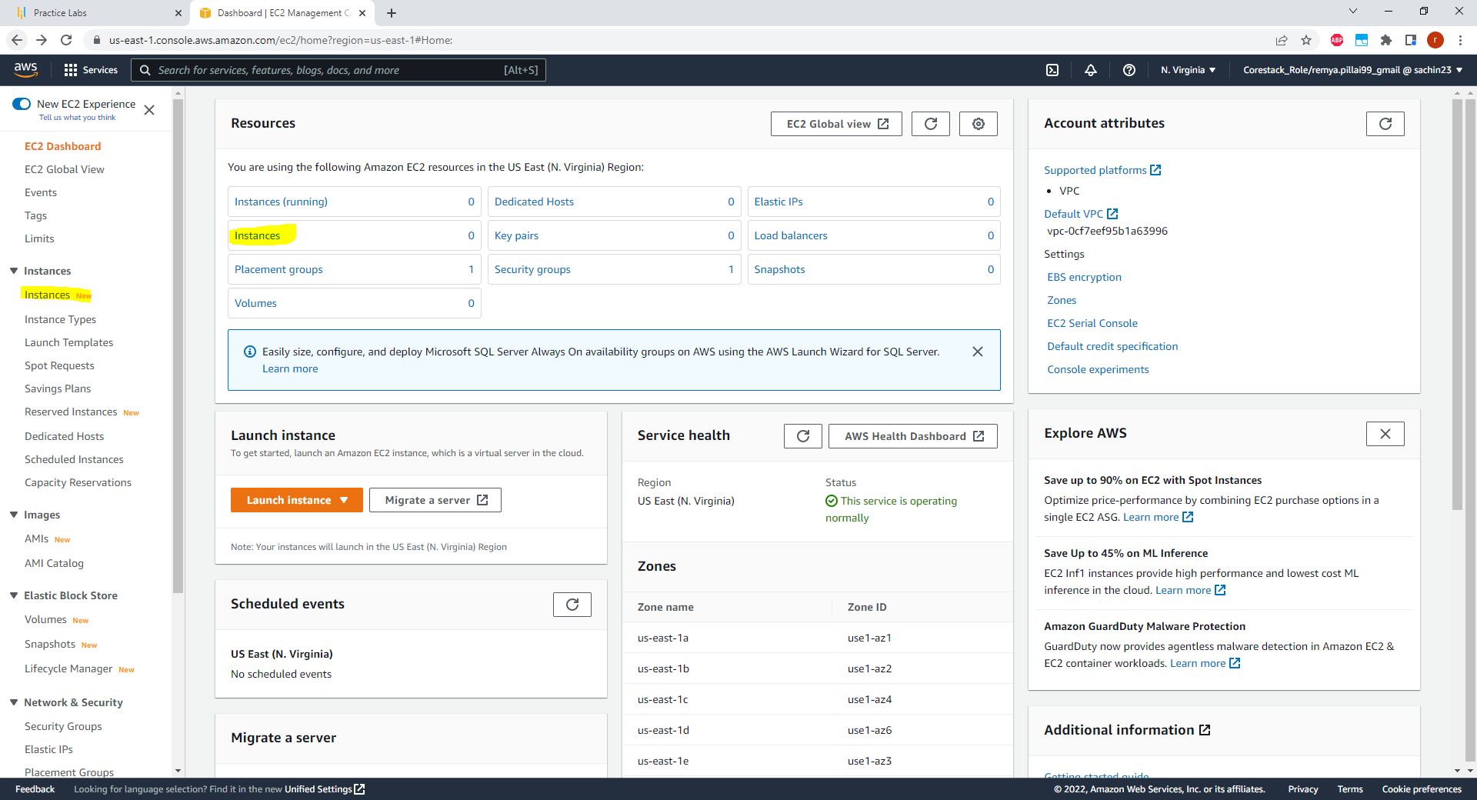

NOTE: We will be creating a New Instance as a part of this exercise

1. Click on Launch Instance - Choose AMI : Select the first option

Select Instance type

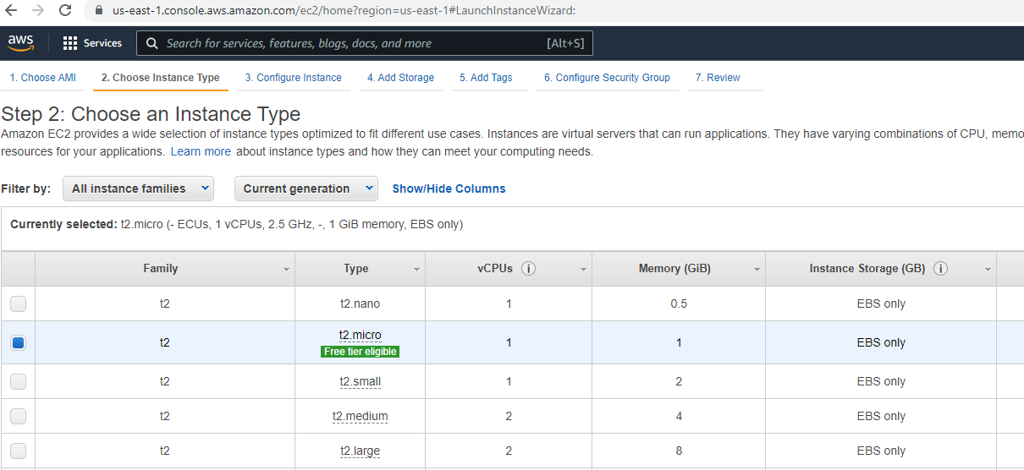

Configure Instance Details: keep the defaults – Click next

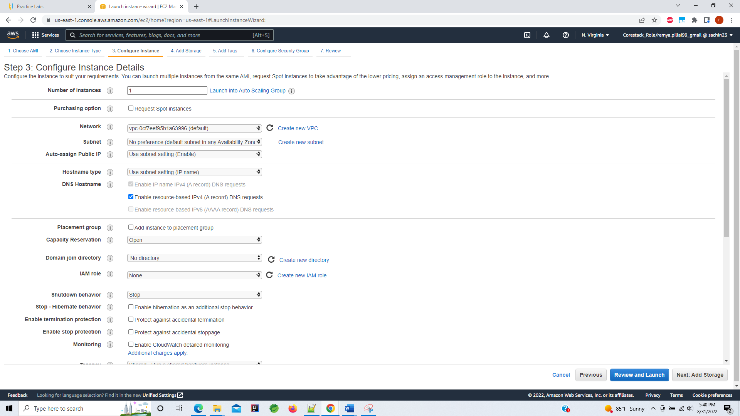

Add Storage – default selection

Add tag – Key value pair

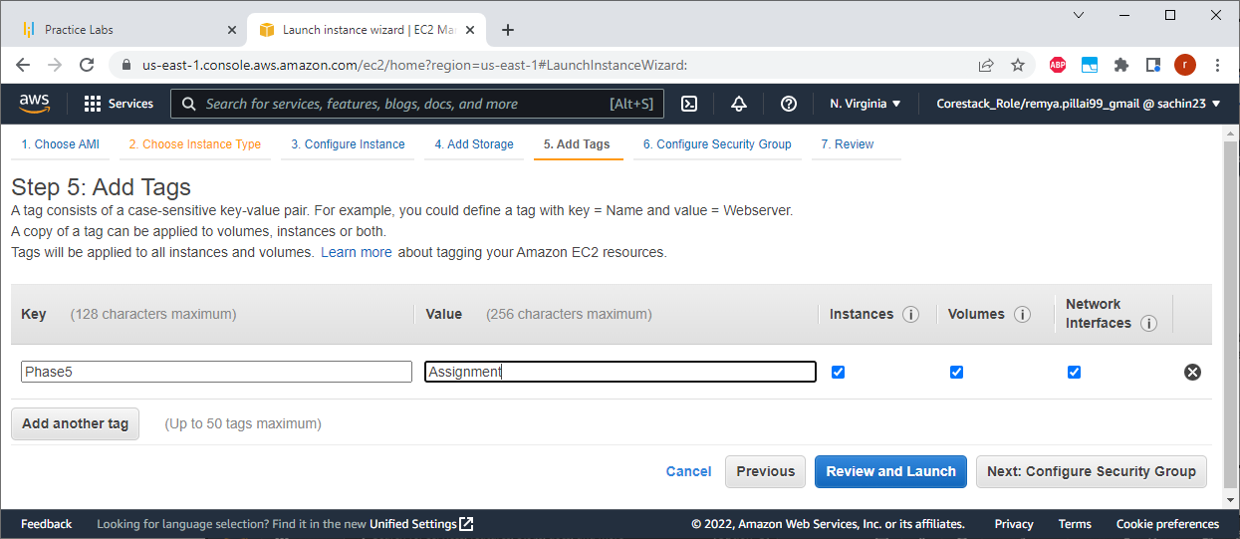

Configure Security Group: Add Type All traffic and Source – Anywhere. Click Review and Launch

Review the details and click on Launch

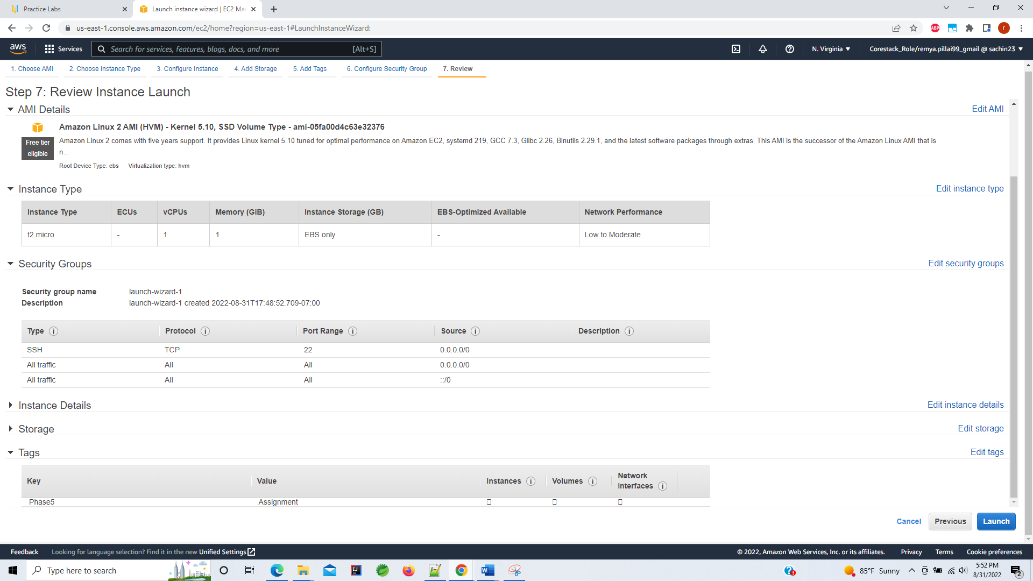

Create a new key pair

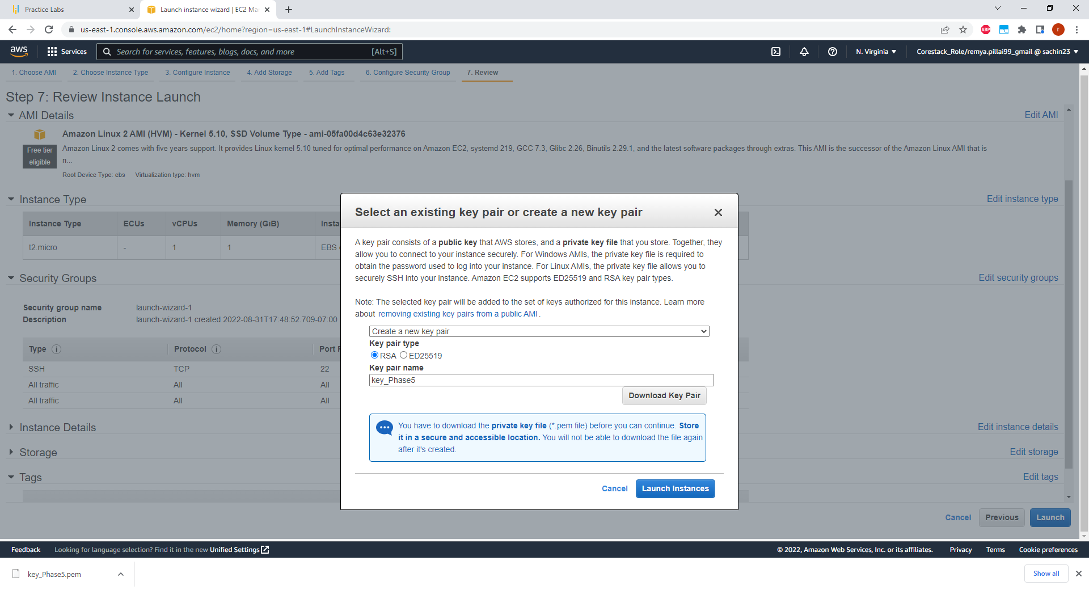

Download the private key and store on your system

Launch instance – Click on View instance to check the status

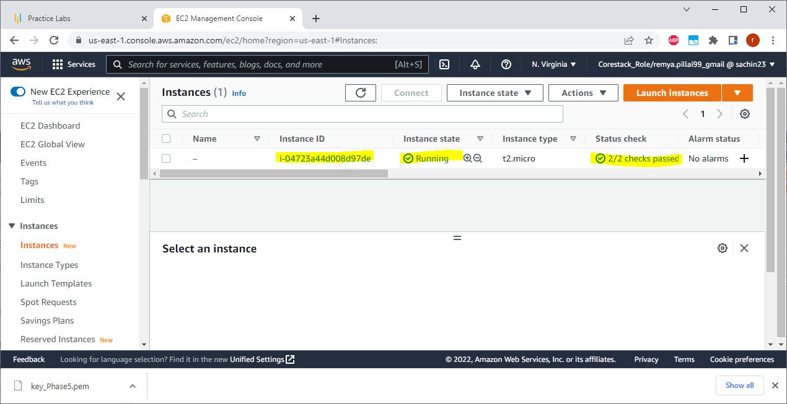

1. Select the instance : Click on Connect

### Connect to EC2 Instance using SSH

1. Connecting to the AWS EC2 Instance from Terminal: Open Command Prompt from the folder where the keypair is stored

1. Click on connect

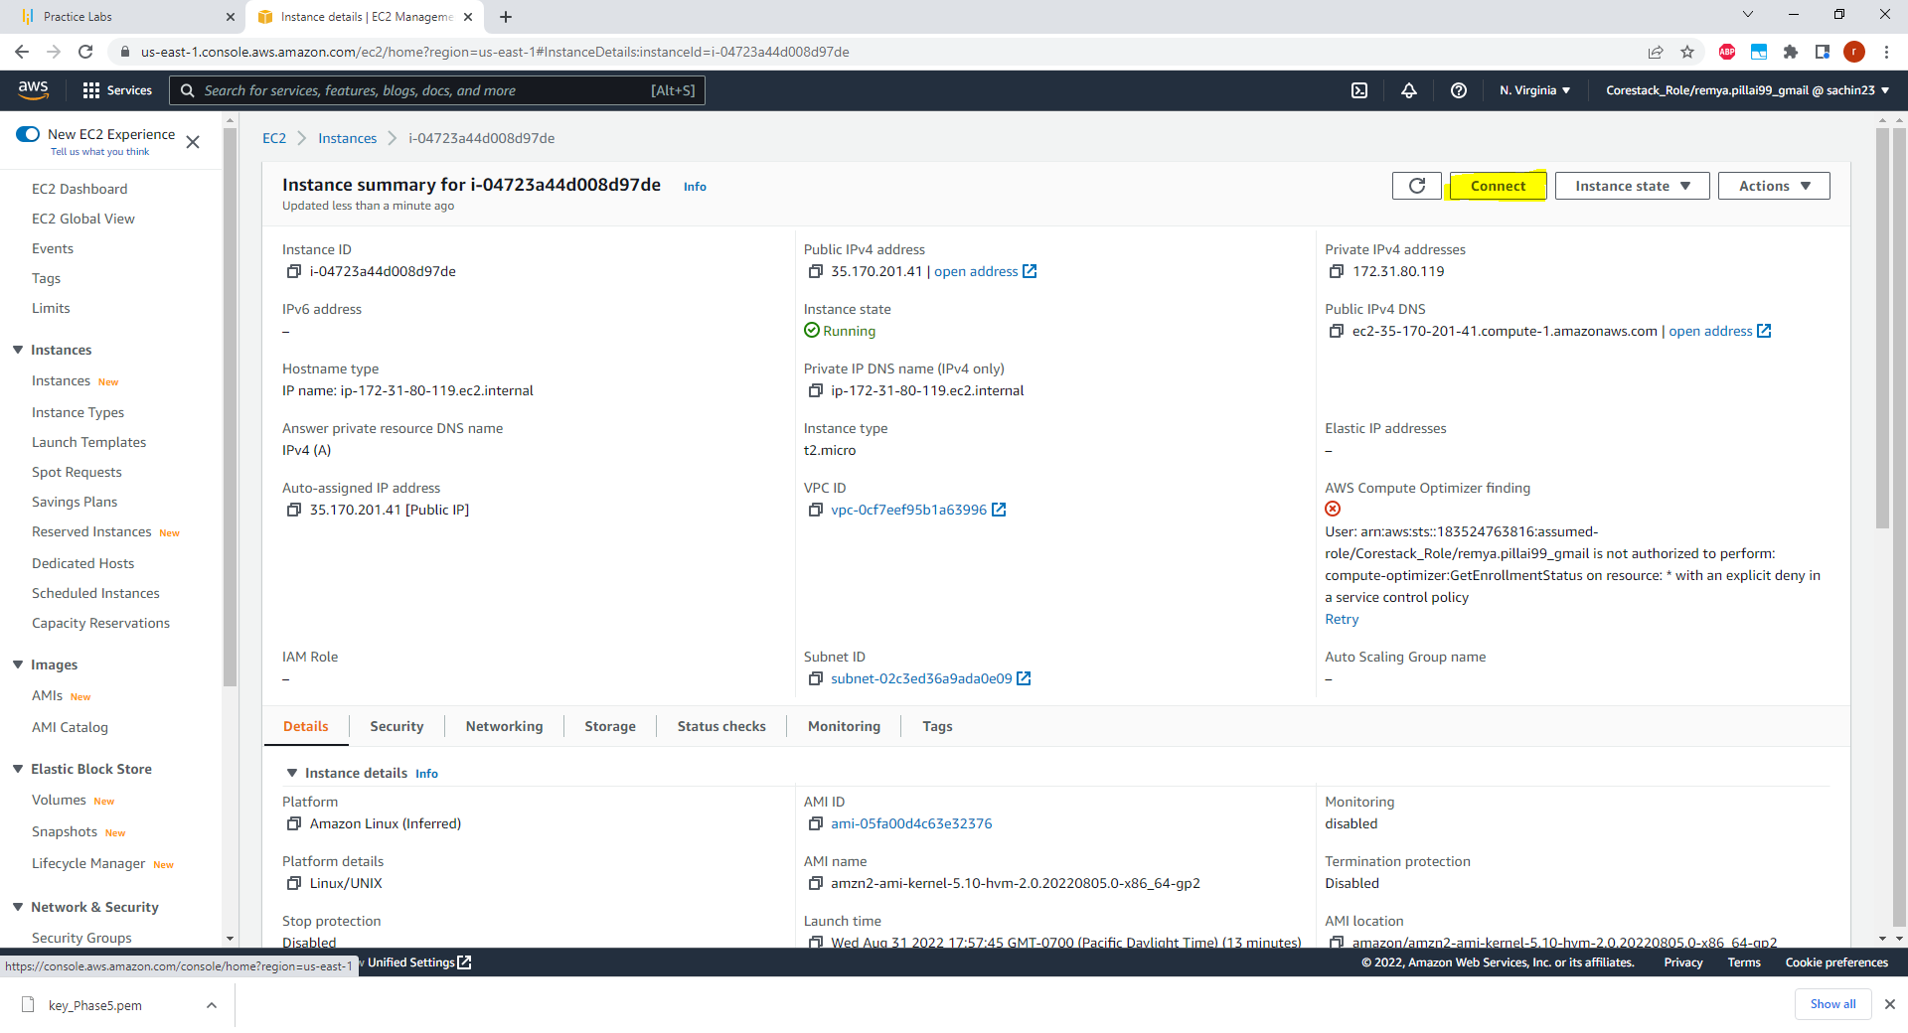

1. Connect using SSH client Copy the highlighted cmd

1. Enter the below command   
    ssh -i "key_Phase5.pem" [ec2-user@ec2-35-170-201-41.compute-1.amazonaws.com](mailto:ec2-user@ec2-35-170-201-41.compute-1.amazonaws.com)

1. Install all updates : sudo yum update -y

1. Install git : sudo yum install git -y

1. Install docker : sudo yum install docker -y

1. Start docker service : sudo service docker start

### Cloning git repository on EC2

1. Clone : git clone <https://github.com/nicks204/Phase5-Project.git>

1. Go to repository folder : See the required files present

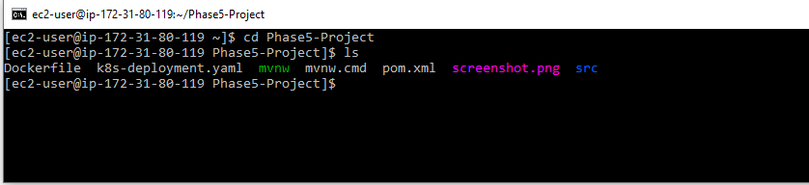

### Building the App Image

1. Run Docker build: sudo docker build -t phase5_projectimage .

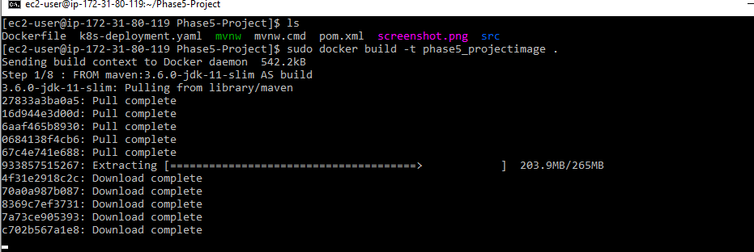

1. List docker images created: sudo docker images – You see the phase5_projectimage

### Running the Image using docker run

1. Run the image: sudo docker run -d --name projectcontainer -p 8080:8080 phase5_projectimage

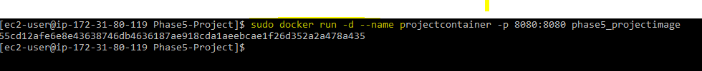

### Access the application using IpV4 address

1. See active process: sudo docker ps -a

1. See logs: sudo docker attach <containerId> 55cd12afe6e8

1. Access the application -Copy the public IPv4 Address

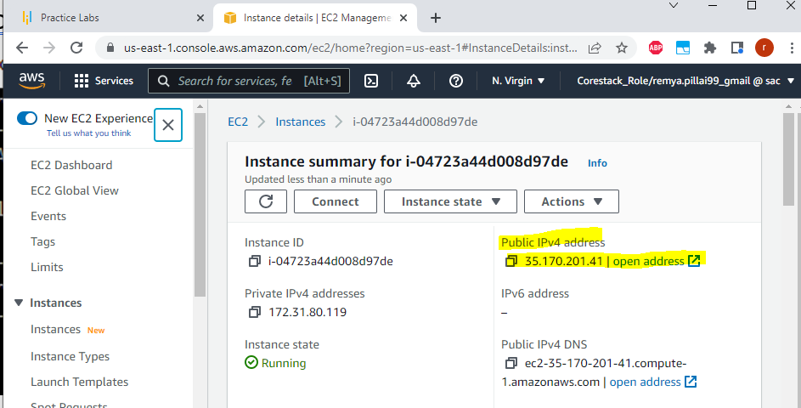

1. Add port number 8080mto address : <http://35.170.201.41:8080/> Application is launched

1. See logs Application was deployed successfully using EC2

