Category Two Narrative
Artifact Description
The artifact is an integrated, full-stack data analytics dashboard and custom Python CRUD (Create, Read, Update, Delete) module interfacing with a MongoDB database, engineered for the animal rescue organization Grazioso Salvare. The application utilizes JupyterDash, Plotly Express, and Dash Leaflet to present a responsive user interface featuring dynamic geographic mapping, statistical visualization, and automated data filtering. The core system was enhanced with a custom algorithmic priority queue framework to rank rescue candidates systematically on suitability metrics.
Justification and Software Development Skills
This item was chosen for the ePortfolio because it represents a complete synthesis of secure database design, advanced algorithmic data structures, and user-centric software engineering. It serves as a direct, empirical demonstration of my ability to build comprehensive computing solutions from the database layer through the algorithmic layer to the interactive client interface.
The artifact was improved across three distinct layers: algorithmic data structures, front-end UI architecture, and system security:
- Algorithmic Upgrades: The backend filtering pipeline was thoroughly re-engineered. I replaced an unoptimized 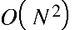 nested loop with a Max-Heap structure. This optimized candidate sorting down to an efficient complexity. The system now computes heuristic suitability score dynamically. I integrated tuple tiebreakers to prevent runtime heap crashes.
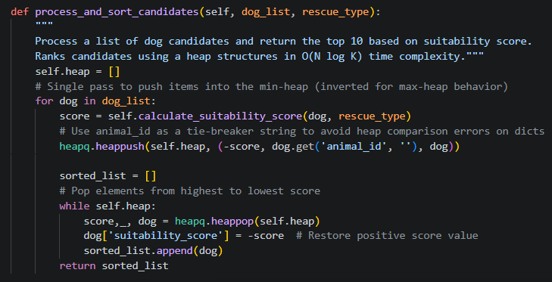
- UI & Component Architecture: The front-end user interface was modernly re-architected. I replaced obsolete HTML formatting with responsive CSS Flexbox grids. The layout structure was isolated into static map containers. This completely resolved asynchronous DOM rendering tree conflicts. Map marker now dynamically synchronize with active data table selections.
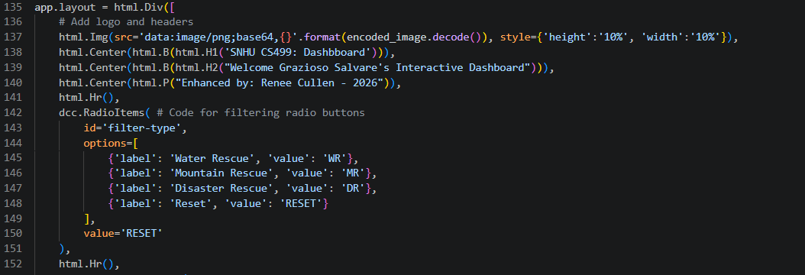
- Security & Defense Design: Robust security enhancements were applied across the entire system. I eliminated hardcoded administrative database credentials entirely from production. The application safely extracts tokens via secure environment variables. A fail-fast guard clause executes script-level termination upon missing keys. Connection handshakes are sanitized user URL-safe cryptographic encoding.
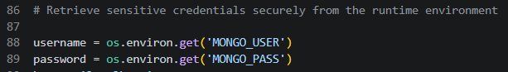
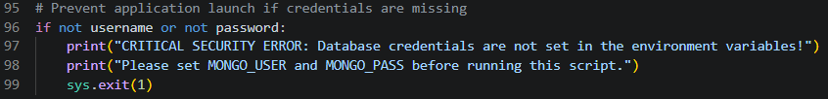

Course Outcomes Tracking
The enhancements implemented during this project directly align with the planned outcomes established in Module One and then some:
- Alignment with Outcome 1 (Collaborative Environments & Organizational Decision Making): The dashboard bridges the gap between raw backend data and non-technical stakeholders at Grazioso Salvare. By translating massive database records into clean interactive radio filters and real-time visualization widgets, the application enables non-technical search-and-rescue decision-makers to rapidly target high-suitability candidates, thereby supporting crucial, fast-paced organizational decisions.
- Alignment with Outcome 2 (Profession-Quality Visual and Coherent Communication): To deliver professional-quality visual communication, I modernized the front-end architecture by replacing outdated styling tags with clean, modern CSS Flexbox grid containers. The visual layout seamlessly unifies tabular data, a Plotly Express breed-distribution pie chart, and an interactive geographic map. Information is presented coherently, and interface components like the dl.Popup bubbles have been styled using clear typographic constraints appropriate for an industry-standard corporate dashboard.
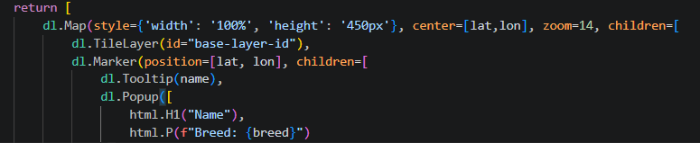
- Alignment with Outcome 3 (Algoritmic Principles and Design Trade-offs): I designed and implemented an in-memory RescueDogPriorityQueue class using Python's heapq library to calculate candidate suitability scores dynamically. I systematically evaluated and resolved a significant architectural trade-off:
  - Rather than relying on computationally heavy database-side aggregations or inefficient linear list sorting or a broken nested loop resulting in 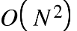, the updated application builds a bounded heap structure. This optimizes top candidate extraction down to an efficient time complexity, balancing local execution speeds against server constraints.
  - I also addressed an inherent limitation in Python's heap structures—where duplicate numerical priority scores cause a crash when comparing unhashable data dictionaries—by introducing a unique string tiebreaker (animal_id) to ensure runtime stability.
- Alignment with outcome 4 (Innovative Techniques, Skills, and Tools): This solution applies a suite of industry-standard development tools and framework methodologies. The data visualization architecture leverages interactive asynchronous callback triggers (@app.callback) to keep data flowing seamlessly between individual DOM nodes. By integrating custom object-oriented Python modules (aac_crud.py) with advanced UI libraries like Dash Leaflet, the artifact demonstrates proficiency in modern web application engineering to accomplish industry-specific wildlife tracking goals.
- Alignment with outcome 5 (Security Mindset and Vulnerability Mitigation): Adopting a proactive security mindset, I systematically eliminated hardcoded authentication credentials from the codebase. The application safely abstracts database handshakes by forcing the runtime environment to source credentials via secure variables (MONGO_USER and MONGO_PASS).
  - To anticipate adversarial exploits or unauthorized system reconnaissance, I established a fail-fast script exit check (sys.exit(1)) that halts application deployment instantly if credentials are omitted.
  - Furthermore, the CRUD constructor implements robust injection defense mechanics by forcing raw string inputs through URL-safe cryptographic sanitization via urllib.parse.quote_plus, shielding the authentication handshake from credential exploitation.

Reflection and Challenges Faced
Refining this artifact highlighted the practical balance required between algorithmic efficiency and code security. Transitioning the sorting pipeline away from simple linear loops to a dedicated heap framework underscored how choice of data structures impacts scalable application behavior.
The greatest challenge encountered centered on state-synchronization within the virtual DOM tree, where dynamically replacing geographic maps on user click events triggered rendering path conflicts. Overcoming this by targeting a static wrapper container element (map-container-id) significantly deepened my mastery of component lifecycle states and state-driven architecture.

