Assignment Kit for
Program 1

Personal Software Process (PSP) for Engineers: Part I

The Software Engineering Institute (SEI)
is a federally funded research and development center
sponsored by the U.S. Department of Defense and
operated by Carnegie Mellon University.

This material is approved for public release.
Distribution limited by the Software Engineering Institute to attendees.

Personal Software Process for Engineers: Part I
Assignment Kit for Program 1
Overview

Overview | This assignment kit covers the following topics.
 | Section | See Page
 | Prerequisites | 2
 | Program 1 requirements | 3
 | Linked lists overview | 4
 | Mean and standard deviation overview | 5
 | Using mean and standard deviation in the PSP | 5
 | Calculating mean and standard deviation | 5
 | A mean and standard deviation example | 6
 | Assignment instructions | 8
 | Guidelines and evaluation criteria | 12

Prerequisites | Reading  • Chapters 1 and 2

Program 1 requirements

Program 1 requirements | Using PSP0, write a program to calculate the mean and standard deviation of a set of n real numbers.  Your program can read the n real numbers from the keyboard, a file, or some other source.  Use a linked list to store the n numbers for the calculations. If necessary, a variable or static array(s), database, or other data structure(s) may be used to hold the data.  Thoroughly test the program. At least two tests should use the data in the columns of Table 1. Expected results are provided in Table 2.

Column 1 | Column 2
Estimate Proxy Size | Development Hours
160 | 15.0
591 | 69.9
114 | 6.5
229 | 22.4
230 | 28.4
270 | 65.9
128 | 19.4
1657 | 198.7
624 | 38.8
1503 | 138.2
Table 1
 |  | Test | Expected Value |  | Actual Value
 |  |  | Mean | Std. Dev | Mean | Std. Dev
 |  | Table 1: Column 1 | 550.6 | 572.03
 |  | Table 1: Column 2 | 60.32 | 62.26
Table 2

Linked lists

Overview | Linked lists are a common abstract data type used to maintain collections of data.  Linked lists are implemented with pointers.  A linked list typically has two components.  • list head  • list node(s)  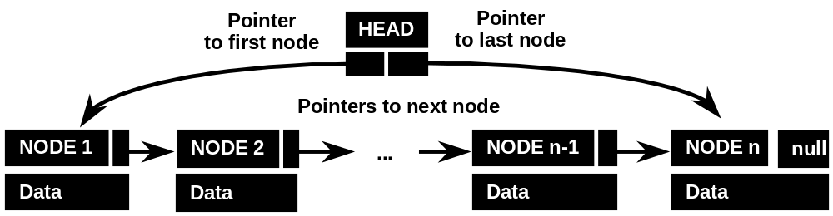  Some of the options for linked list structure are  • the list head can point to the first node, last node, or both  • a list node can point to the next node, prior node, or both  Null pointers are often used to indicate an empty list or the end of the list.  Typical operations on a linked list include  • add node  • remove node  • next node  • prior node

Mean and standard deviation

Overview | The mean is the average of a set of data. The average is the most common measure of location for a set of numbers. The average locates the center of the data.  Standard deviation is a measure of the spread or dispersion of a set of data. The more widely the values are spread out, the larger the standard deviation. For example, say we have two separate lists of exam results from a class of 30 students; one ranges from 31% to 98%, the other from 82% to 93%. The standard deviation would be larger for the results of the first exam.

Using mean and standard deviation in the PSP | Mean and standard deviation are used to divide your historical size data into categories and size ranges. This will be discussed in more detail in Lecture 4 - Estimating with PROBE II.

Calculating mean and standard deviation | The formula for calculating the mean is  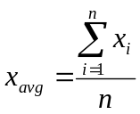  The formula for standard deviation, σ, is  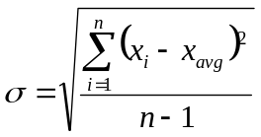  where  • Σ is the symbol for summation  • i is an index to the n numbers  • x is the data in the set  • n is the number of items in the set

A mean and standard deviation example

A mean and standard deviation example |  |  | In this example, we will calculate mean and standard deviation of the data in Table 3.
 | x
 | 186
 | 699
 | 132
 | 272
 | 291
 | 331
 | 199
 | 1890
 | 788
 | 1601
Table 3
- In this example, there are 10 items in the data set. Therefore, we set n = 10.
- We can now solve the summation items in the mean formula.

n | x
1 | 186
2 | 699
3 | 132
4 | 272
5 | 291
6 | 331
7 | 199
8 | 1890
9 | 788
10 | 1601
Total | 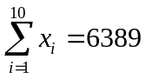

- We can then substitute the intermediate value into the formula.
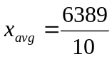

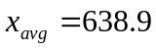
Continued on next page
A mean and standard deviation example, Continued

A mean and standard deviation example, cont. | - We can now substitute 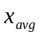 to calculate the intermediate values for the standard deviation formula.

n | x | 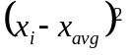
1 | 186 | 205,118.41
2 | 699 | 3,612.01
3 | 132 | 256,947.61
4 | 272 | 134,615.61
5 | 291 | 121,034.41
6 | 331 | 94,802.41
7 | 199 | 193,512.01
8 | 1890 | 1,565,251.21
9 | 788 | 22,230.81
10 | 1601 | 925,636.41
Total |  | 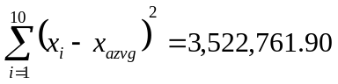

- We can then substitute the intermediate value into the formula.
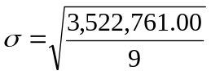

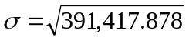

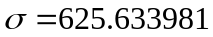

Assignment instructions

Assignment instructions | Before starting program 1, review the top-level PSP0 process script below to ensure that you understand the “big picture” before you begin. Also, ensure that you have all of the required inputs before you begin the planning phase.

PSP0 Process Script

Purpose | To guide the development of module-level programs
Entry Criteria | - Problem description  - PSP0 Project Plan Summary form  - Time and Defect Recording logs  - Defect Type standard  - Stopwatch (optional)

Step | Activities | Description
1 | Planning | - Produce or obtain a requirements statement.  - Estimate the required development time.  - Enter the plan data in the Project Plan Summary form.  - Complete the Time Recording log.
2 | Development | - Design the program.  - Implement the design.  - Compile the program, and fix and log all defects found.  - Test the program, and fix and log all defects found.  - Complete the Time Recording log.
3 | Postmortem | Complete the Project Plan Summary form with actual time, defect, and size data.

Exit Criteria | - A thoroughly tested program  - Completed Project Plan Summary form with estimated and actual data  - Completed Time and Defect Recording logs

Continued on next page
Assignment instructions, Continued

Planning phase | Plan program 1 following the PSP0 planning phase script.

PSP0 Planning Script

Purpose | To guide the PSP planning process
Entry Criteria | - Problem description  - Project Plan Summary form  - Time Recording log

Step | Activities | Description
1 | Program  Requirements | - Produce or obtain a requirements statement for the program.  - Ensure that the requirements statement is clear and unambiguous.  - Resolve any questions.
2 | Resource  Estimate | Make your best estimate of the time required to develop this program.

Exit Criteria | - Documented requirements statement  - Completed Project Plan Summary form with estimated development time data  - Completed Time Recording log

Verify that you have met all of the exit criteria for the planning phase, then have an instructor review your plan. After your plan has been reviewed, proceed to the development phase.
Continued on next page
Assignment instructions, Continued

Development phase | Develop the program following the PSP0 development phase script.

PSP0 Development Script

Purpose | To guide the development of small programs
Entry Criteria | - Requirements statement  - Project Plan Summary form with estimated program development time  - Time and Defect Recording logs  - Defect Type standard

Step | Activities | Description
1 | Design | - Review the requirements and produce a design to meet them.  - Record in the Defect Recording log any requirements defects found.  - Record time in the Time Recording log.
2 | Code | - Implement the design.  - Record in the Defect Recording log any requirements or design defects found.  - Record time in the Time Recording log.
3 | Compile | - Compile the program until error-free.  - Fix all defects found.  - Record defects in the Defect Recording log.  - Record time in the Time Recording log.
4 | Test | - Test until all tests run without error.  - Fix all defects found.  - Record defects in the Defect Recording log.  - Record time in the Time Recording log.

Exit Criteria | - A thoroughly tested program  - Completed Time and Defect Recording logs

Verify that you have met all of the exit criteria for the development phase, then proceed to the postmortem phase.
Continued on next page
Assignment instructions, Continued

Postmortem  phase | Conduct the postmortem following the PSP0 postmortem script.

PSP0 Postmortem Script

Purpose | To guide the PSP postmortem process
Entry Criteria | - Problem description and requirements statement  - Project Plan Summary form with development time data  - Completed Time and Defect Recording logs  - A tested and running program

Step | Activities | Description
1 | Defect Recording | - Review the Project Plan Summary to verify that all of the defects found in each phase were recorded.  - Using your best recollection, record any omitted defects.
2 | Defect Data Consistency | - Check that the data on every defect in the Defect Recording log are accurate and complete.  - Verify that the numbers of defects injected and removed per phase are reasonable and correct.  - Using your best recollection, correct any missing or incorrect defect data.
3 | Time | - Review the completed Time Recording log for errors or omissions.  - Using your best recollection, correct any missing or incomplete time data.

Exit Criteria | - A thoroughly tested program  - Completed Project Plan Summary form  - Completed Time and Defect Recording logs

Verify that you have met all of the exit criteria for the PSP0 postmortem phase, then submit your assignment.

Submitting your assignment | When you’ve completed the postmortem phase, submit your assignment package, source code, and test results to the instructor.  The order for the assignment package is  • PSP0 Project Plan Summary form  • Time Recording log  • Defect Recording log  • source program listing  • test results

Guidelines and evaluation criteria for program 1

Evaluation  criteria | Your process report must be  • complete  • legible  • in the specified order | Your process data must be  • accurate  • precise  • self-consistent

Suggestions | Remember, you should complete this assignment today.  Keep your programs simple. You will learn as much from developing small programs as from large ones.  If you are not sure about something, ask your instructor for clarification.  Software is not a solo business, so you do not have to work alone.  - You must, however, produce your own estimates, designs, code, and completed forms and reports.  - You may have others review your work, and you may change it as a result.  - You should note any help you receive from others in your process report. Log the review time that you and your associates spend, and log the defects found or any changes made.

