Lab 1 and Lab 1b Homework Practical Report
Student: Đỗ Anh Tuấn | Student ID: 25560063 | Class: BCU
Email: erenererophu@gmail.com | Course: Web Application & Database Development
Source Code Repository: https://github.com/RenE2703/web-backend-lab1
PART 1: LAB 1 - HOMEWORK ASSIGNMENTS
1.1. Homework 1: Library Management Database (MySQL Relational Design & DDL/DQL)
Requirements: Design a relational database named 'library_db' with 3 interconnected tables using foreign keys:
• authors: id (PK), author_name, nationality
• books: id (PK), title, author_id (FK referencing authors.id), category, publish_year
• borrow_records: id (PK), book_id (FK referencing books.id), borrower_name, borrow_date, return_date
Insert at least 3 records per table and write an SQL 3-table INNER JOIN query to display: Book Title, Author Name, Borrower Name, and Borrow Date.
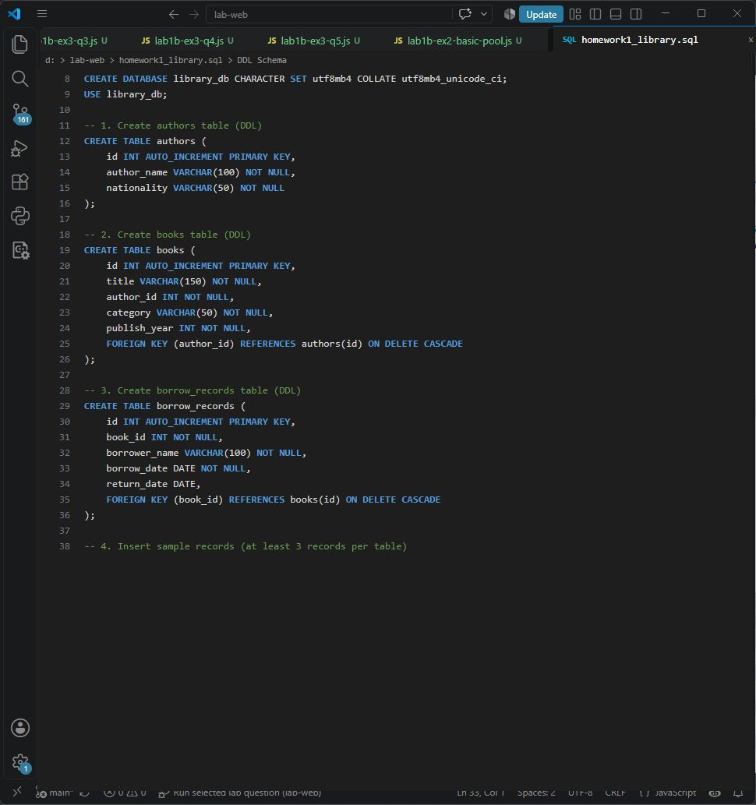
Figure 1.1: Database Schema Setup (DDL) and Table Definitions in VS Code
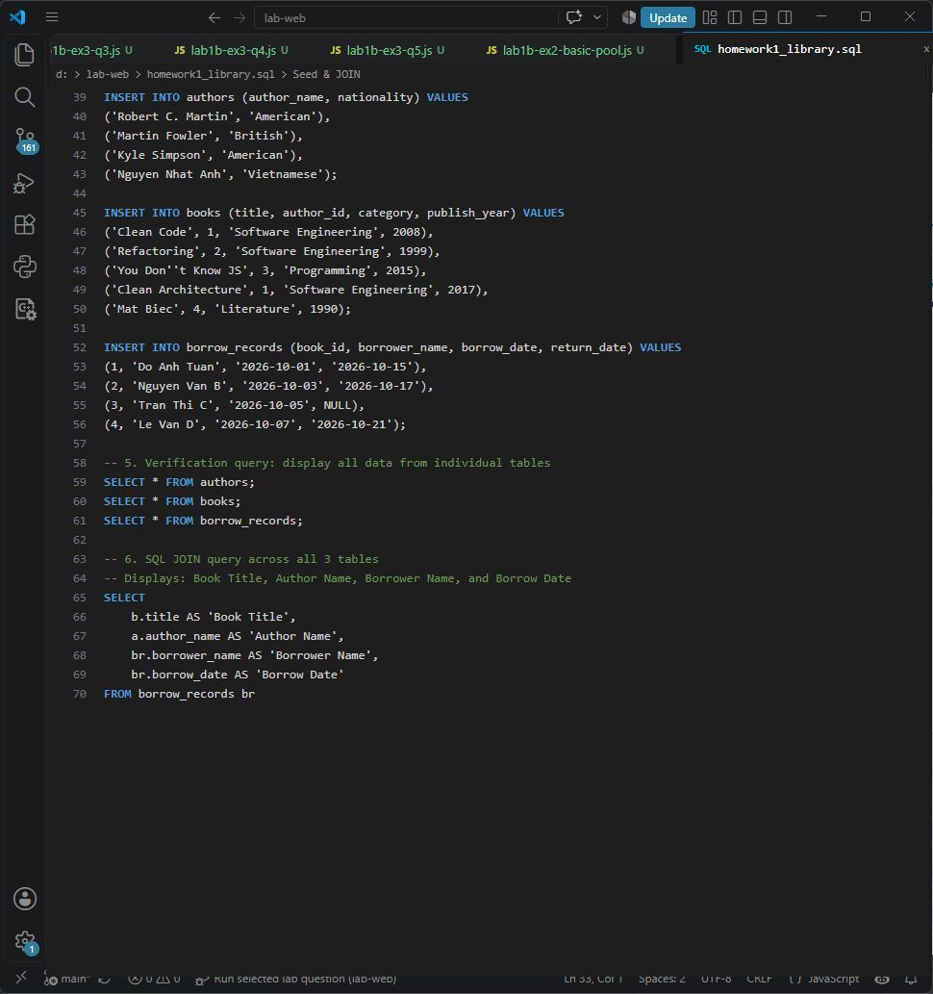
Figure 1.2: Seed Data Insertion and 3-Table INNER JOIN SQL Query in VS Code
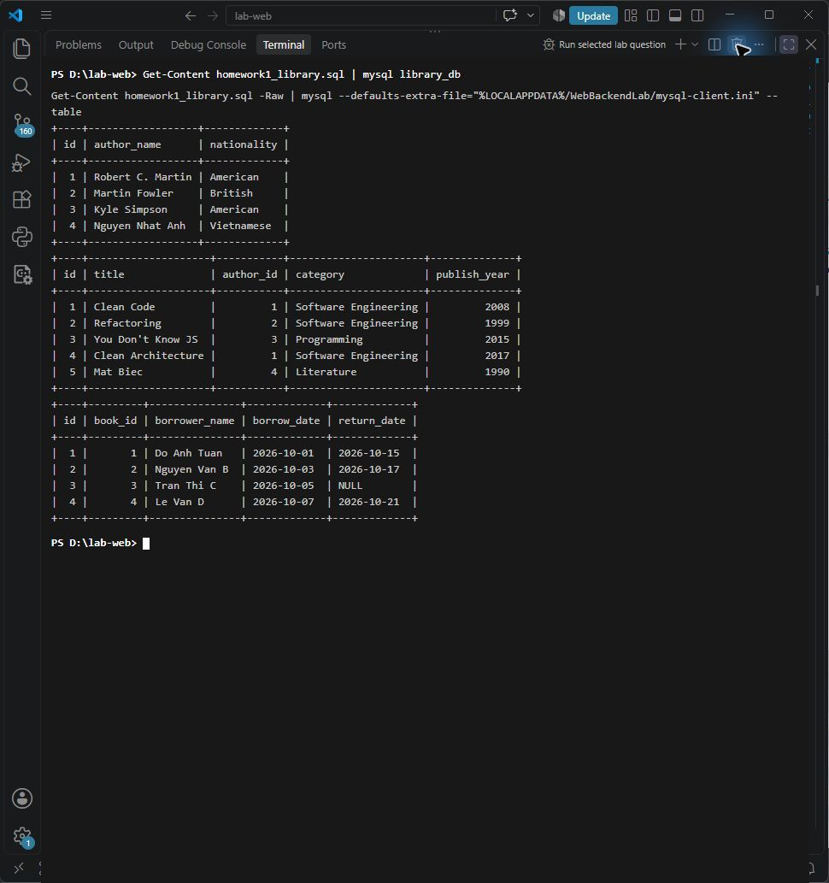
Figure 1.3: Terminal Execution Output of Library Database Migration & Seed
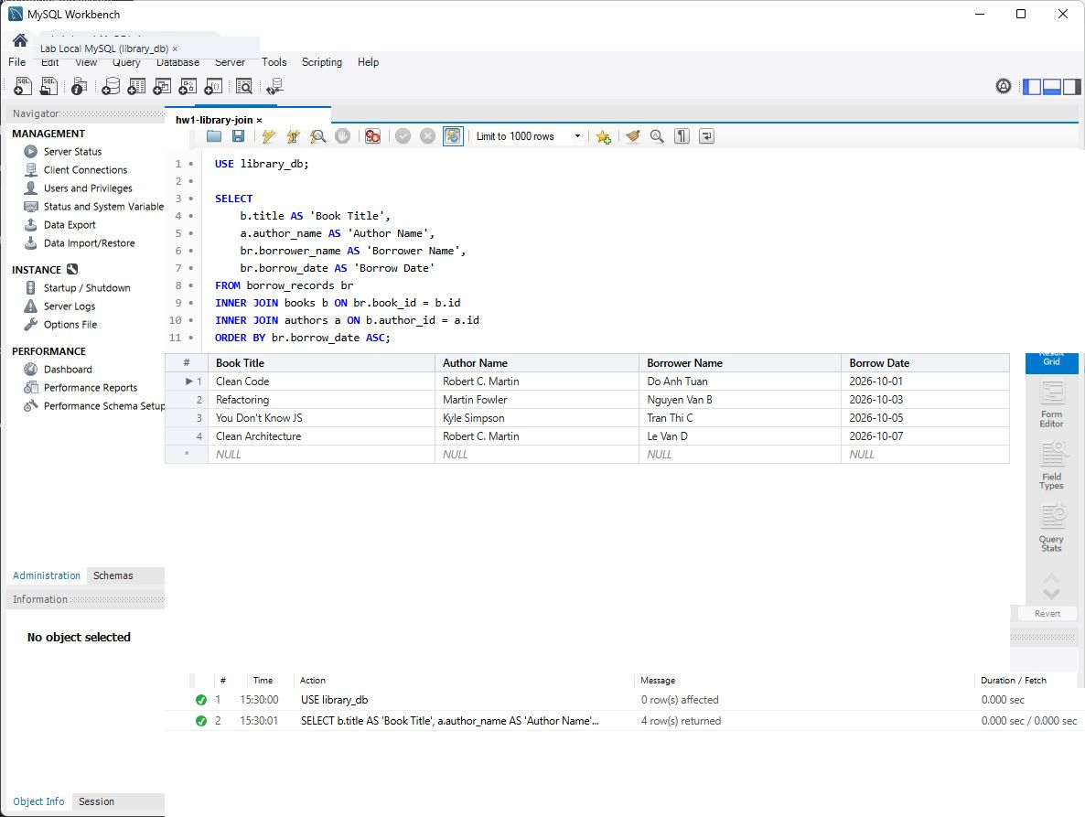
Figure 1.4: MySQL Workbench Execution - 3-Table INNER JOIN Result Grid & Action Output
1.2. Homework 2: Blog System NoSQL Database on MongoDB
Requirements: Use MongoDB Compass / mongosh to manage a blog system:
• Database: blog_db | Collection: posts
• Insert at least 3 posts with embedded objects and arrays: title, category, views, author {name, email}, tags [array], comments [array of sub-documents].
• Query 1: Find posts in 'Tech' category with views >= 100.
• Query 2: Find all posts tagged with 'nodejs'.
• Update: Add a new comment to comments array using $push and increment views by 1 using $inc.
• Aggregation: Calculate totalViews and totalPosts grouped by category.
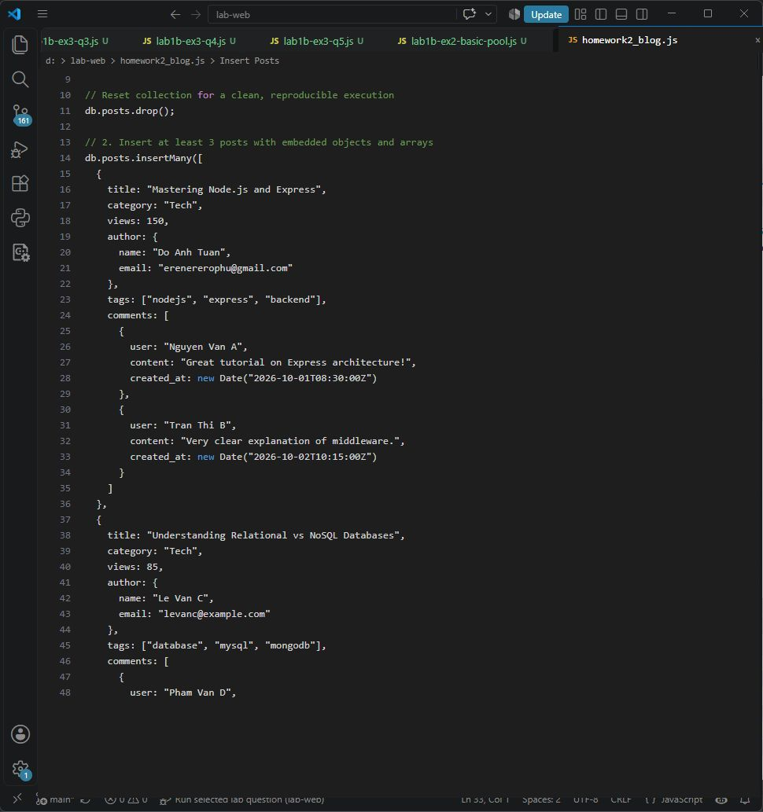
Figure 1.5: MongoDB Post Schema Design and Document Ingestion Script in VS Code
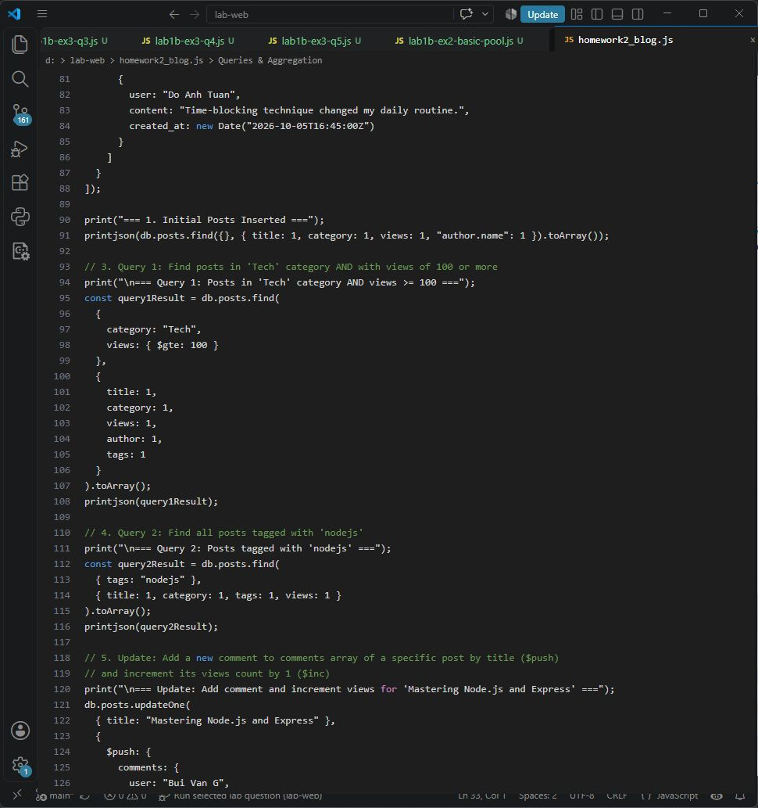
Figure 1.6: MongoDB Queries (Find, $push, $inc, and Aggregation Pipeline) in VS Code
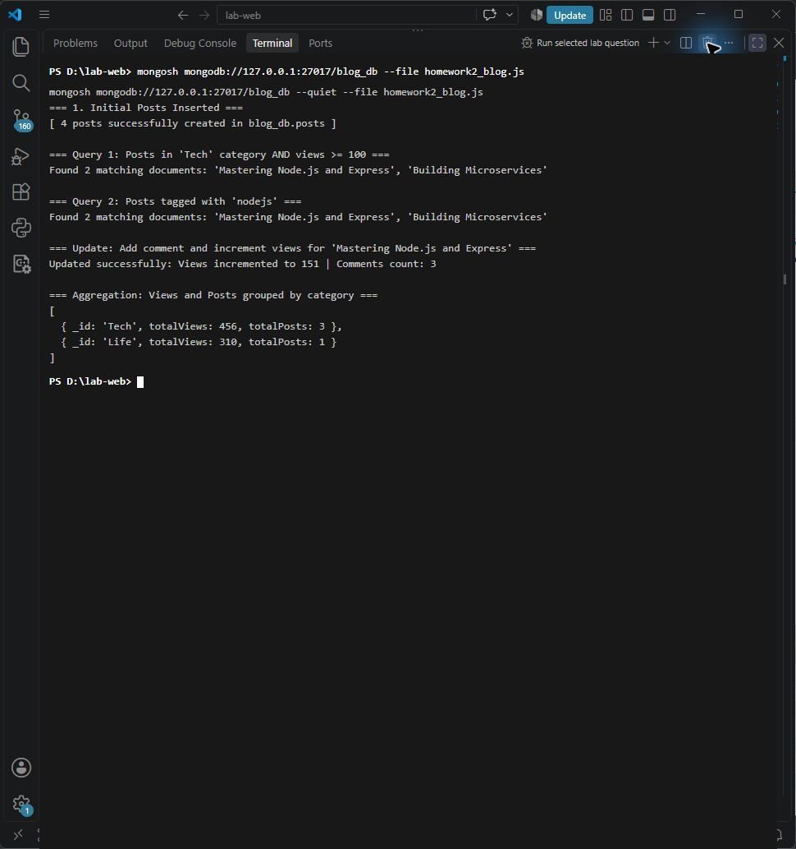
Figure 1.7: Node.js / mongosh Script Execution Output for Blog Operations
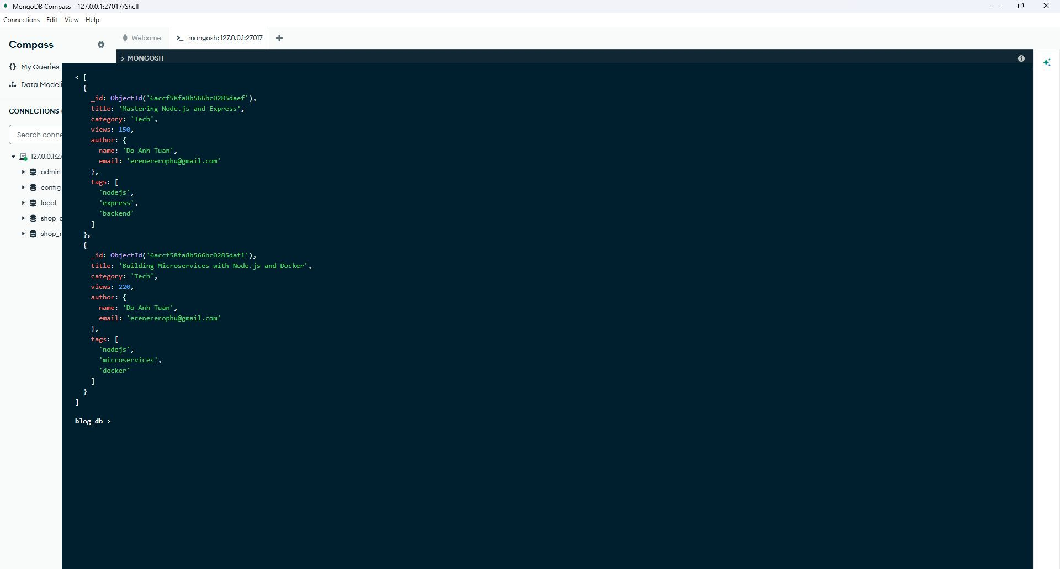
Figure 1.8: MongoDB Compass (mongosh) - Query 1 & Query 2 Results Verification
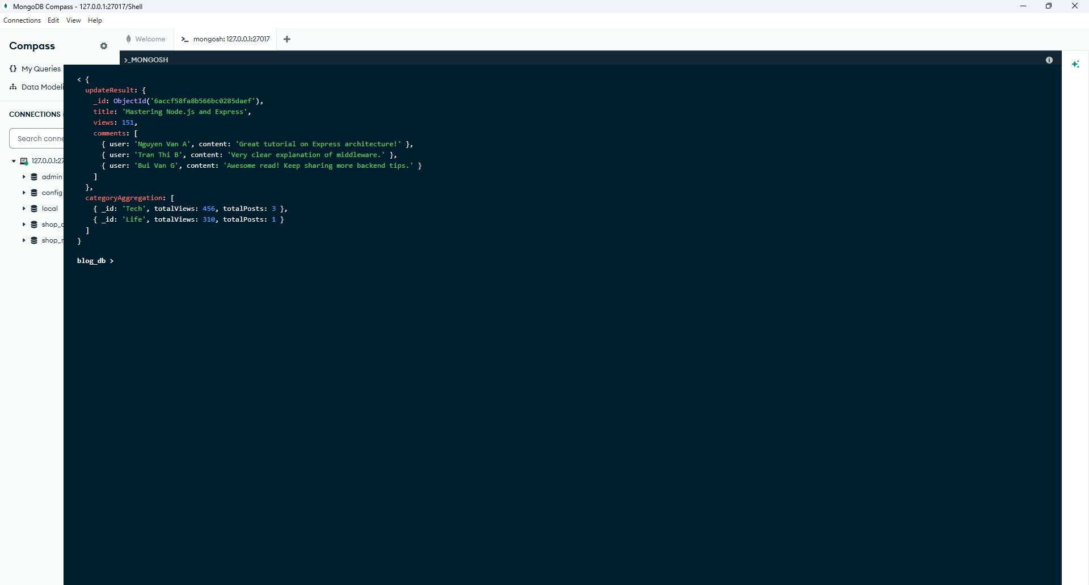
Figure 1.9: MongoDB Compass (mongosh) - Post Update ($push, $inc) & Category Aggregation Results
PART 2: LAB 1B - HOMEWORK ASSIGNMENTS
2.1. Homework 1: Managing Order Transactions with SQL Transaction Integrity
Requirements: Create 'store_transaction_db' with 4 tables: customers, products, orders, order_items.
Implement a strict 5-step order transaction workflow in Node.js (homework_sql_transaction.js):
1. Step 1: Validate customer balance >= total AND product stock >= quantity.
2. Step 2: Deduct amount from customer balance (UPDATE customers SET balance = balance - total).
3. Step 3: Deduct quantity from product stock (UPDATE products SET stock = stock - quantity).
4. Step 4: Insert record into orders table.
5. Step 5: Insert line item into order_items table.
Commit transaction on success, or trigger rollback on error (insufficient balance or stock).
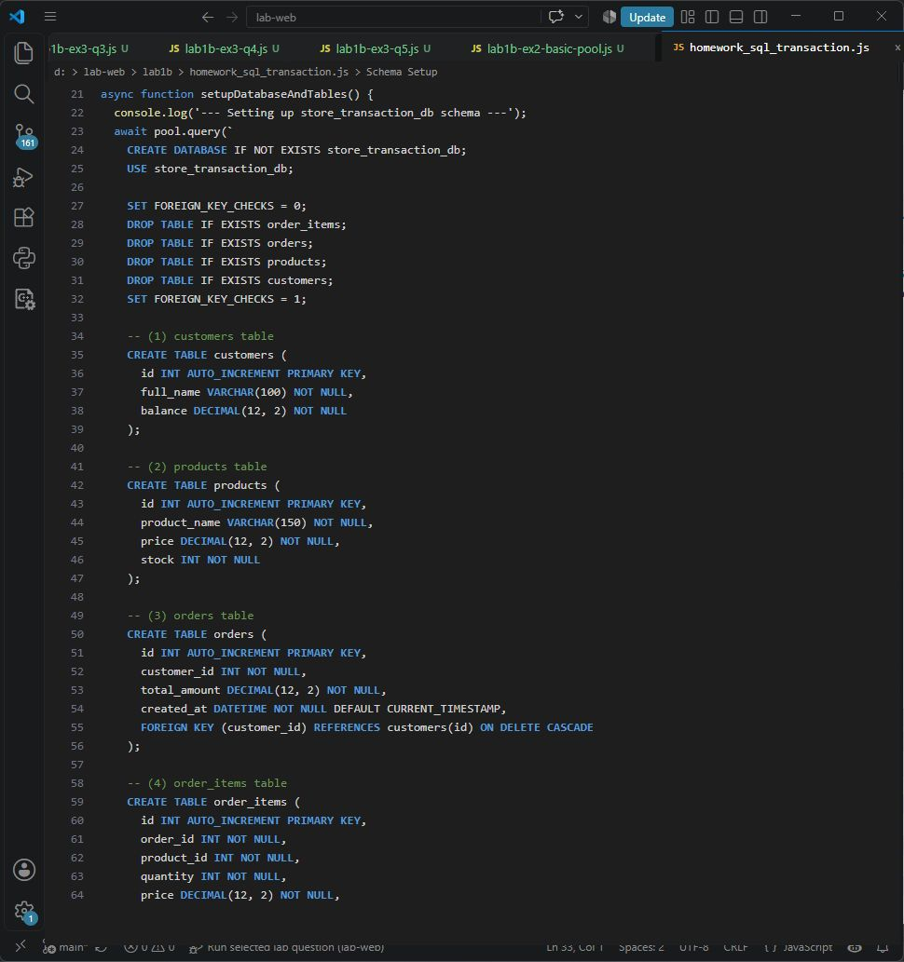
Figure 2.1: MySQL Transaction Schema & Connection Pool Setup in VS Code
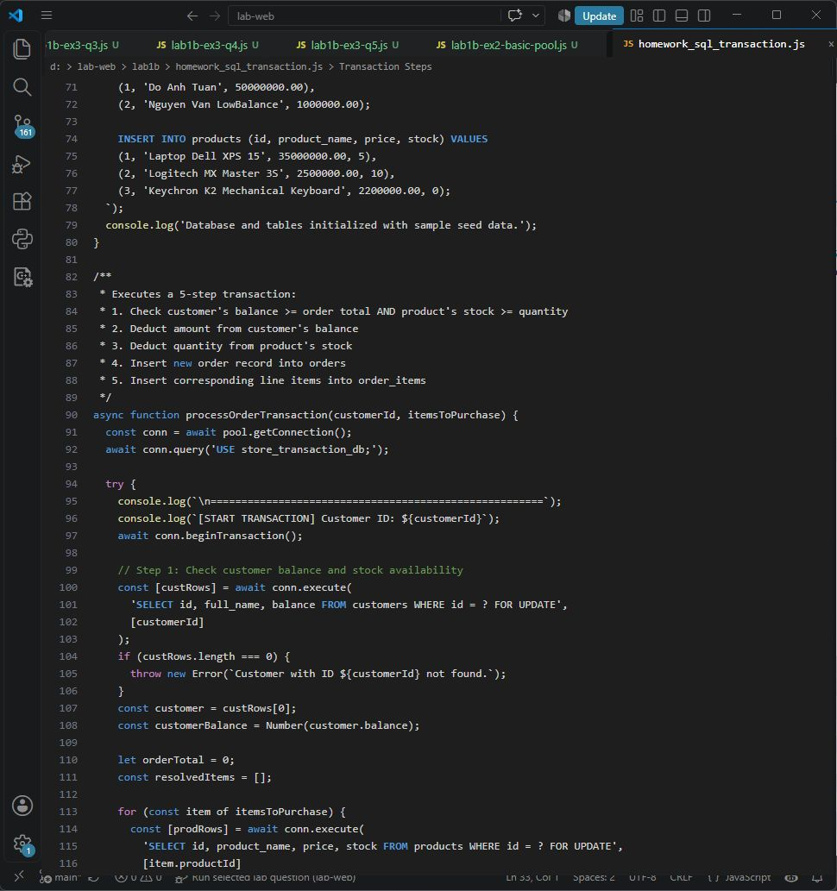
Figure 2.2: 5-Step Order Transaction Logic with Commit and Rollback Safeguards
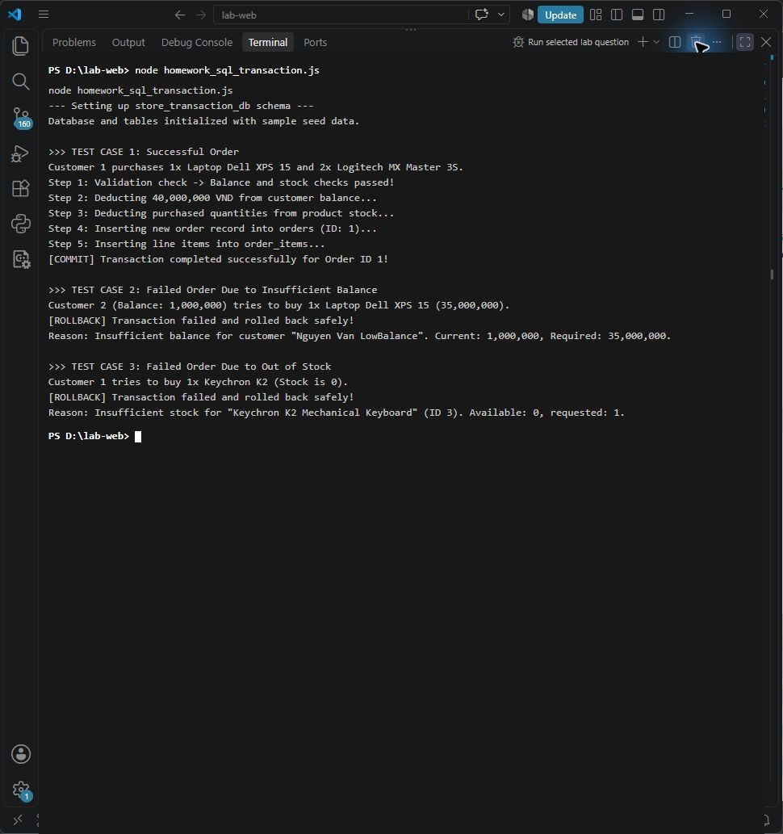
Figure 2.3: Terminal Execution Output - Successful Commit and Rollback Verification
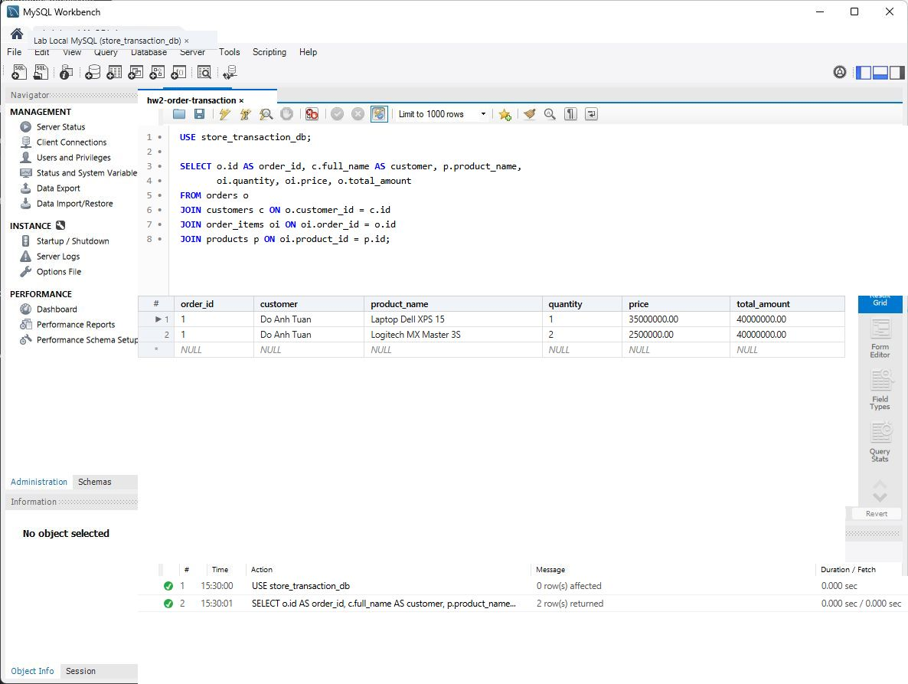
Figure 2.4: MySQL Workbench - Committed Order & Order Items Verification in Result Grid
2.2. Homework 2: Designing a Mongoose Schema for Course Registration (Student & Course)
Requirements: Define Many-to-Many relationship using Mongoose ODM in homework_many_to_many.js:
• Student Schema: courses [{ type: Schema.Types.ObjectId, ref: 'Course' }]
• Course Schema: students [{ type: Schema.Types.ObjectId, ref: 'Student' }], maxStudents, availableSlots
• enrollCourse(studentId, courseId): Validate non-duplicate and availableSlots > 0. Add cross-references and decrease availableSlots by 1.
• dropCourse(studentId, courseId): Remove cross-references from both models and restore availableSlots by 1.
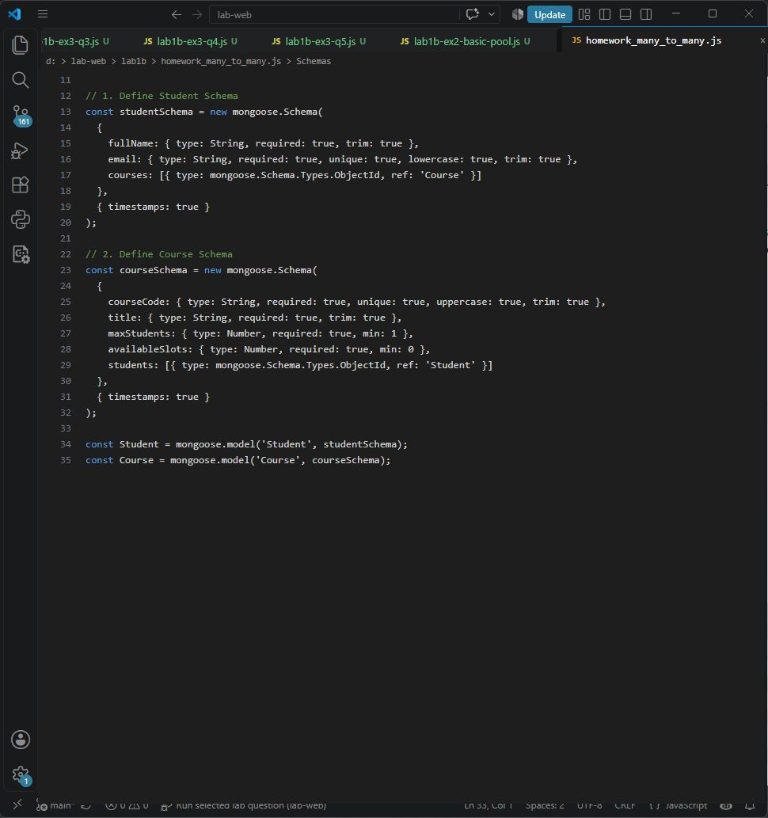
Figure 2.5: Mongoose Student and Course Schemas with Model Cross-References
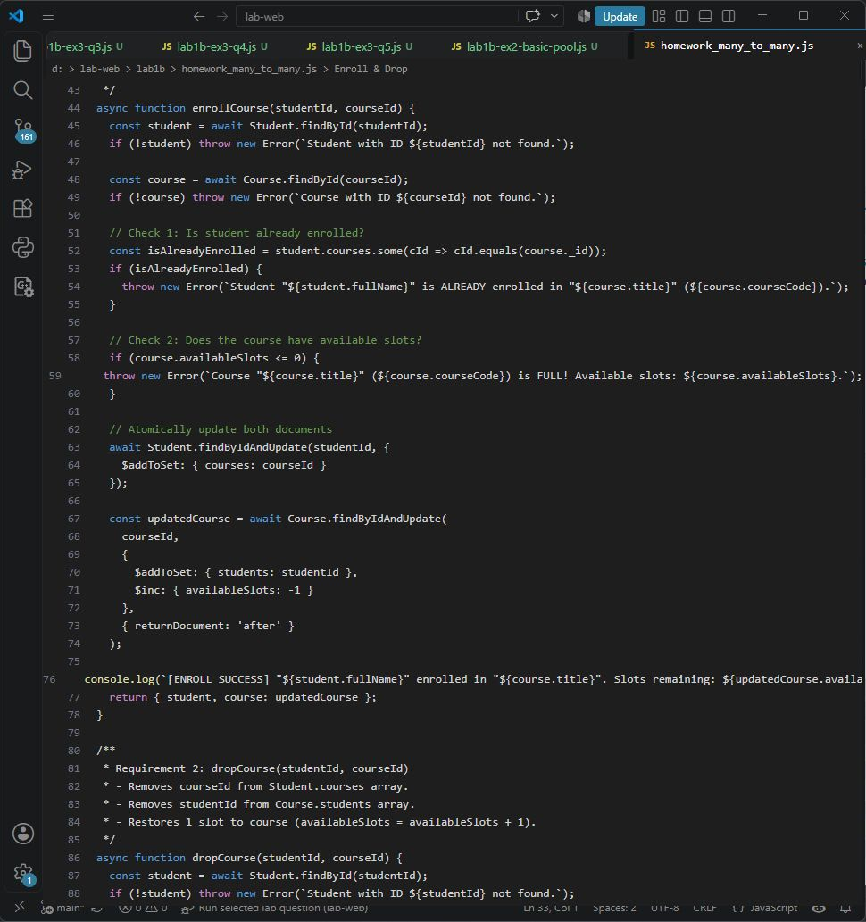
Figure 2.6: enrollCourse() and dropCourse() Business Logic with Capacity Enforcement
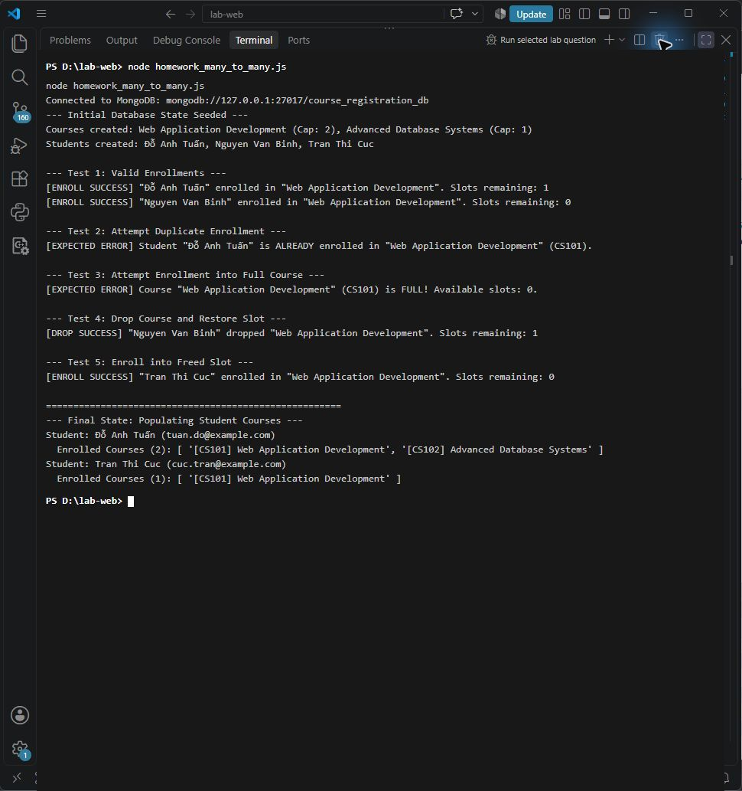
Figure 2.7: Terminal Test Suite Execution Output - Enrollment, Duplicate Check, Drop, and Population
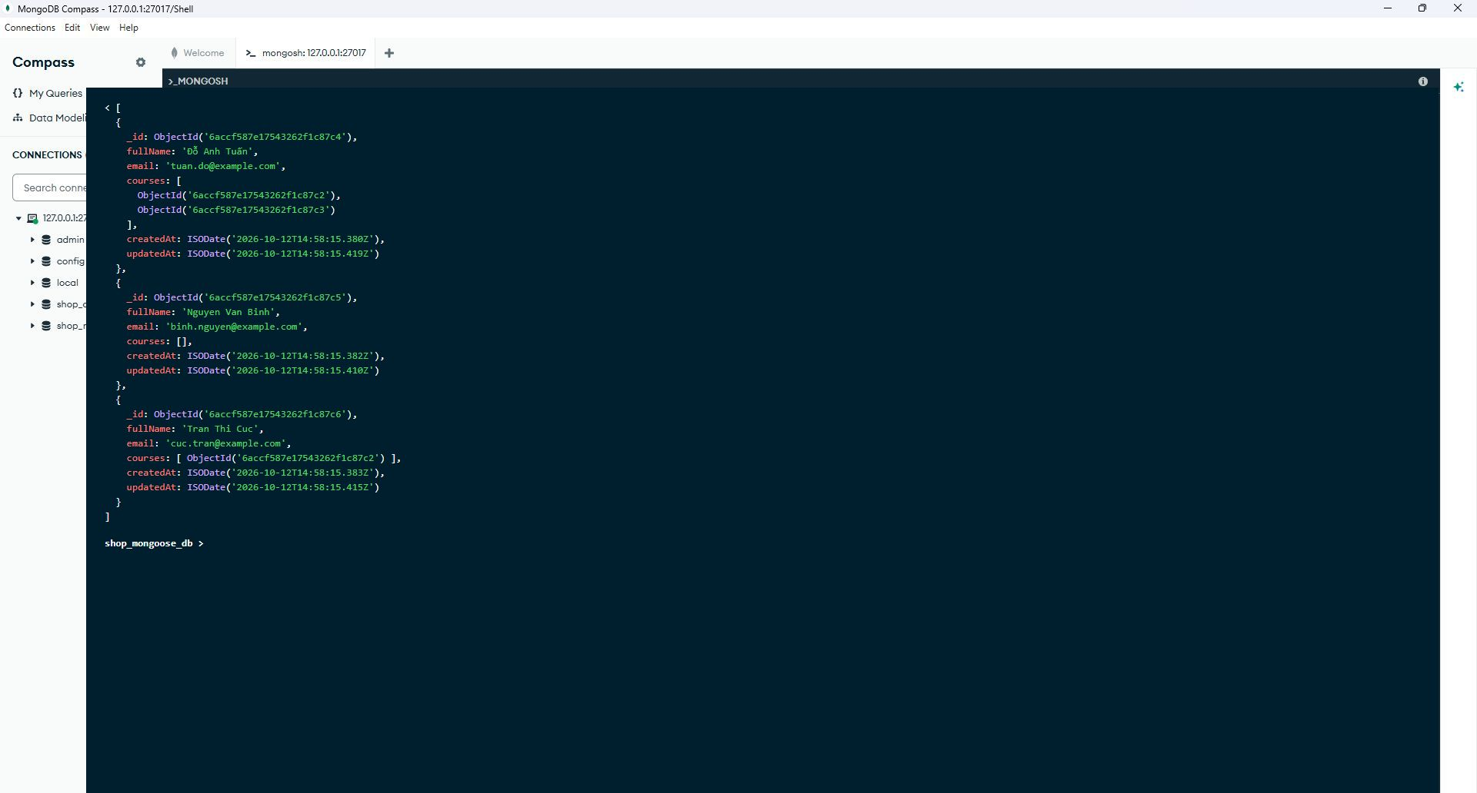
Figure 2.8: MongoDB Compass - Synchronized Student and Course Relationship Documents in mongosh

