THE
QUARTERLYJOURNAL
OFECONOMICS
Vol.CXXIV | November2009 | Issue4
MISALLOCATIONANDMANUFACTURINGTFP
INCHINAANDINDIA∗
CHANG-TAIHSIEHANDPETERJ.KLENOW
Resourcemisallocationcanloweraggregatetotalfactorproductivity(TFP).We usemicrodataonmanufacturingestablishmentstoquantifythepotentialextent ofmisallocationinChinaandIndiaversustheUnitedStates.Wemeasuresizable gapsinmarginalproductsoflaborandcapitalacrossplantswithinnarrowly definedindustriesinChinaandIndiacomparedwiththeUnitedStates.When capitalandlaborarehypotheticallyreallocatedtoequalizemarginalproductsto theextentobservedintheUnitedStates,wecalculatemanufacturingTFPgains of30%–50%inChinaand40%–60%inIndia.
I.INTRODUCTION
Largedifferencesinoutputperworkerbetweenrichand poorcountrieshavebeenattributed,innosmallpart,todiffer-encesintotalfactorproductivity(TFP).1Thenaturalquestion thenis:WhataretheunderlyingcausesoftheselargeTFPdif-ferences?Researchonthisquestionhaslargelyfocusedondif-ferencesintechnologywithinrepresentativefirms.Forexample, Howitt(2000)andKlenowandRodr´ıguez-Clare(2005)showhow largeTFPdifferencescanemergeinaworldwithslowtechnology
∗WeareindebtedtoRyojiHiraguchiandRomansPancsforphenomenal researchassistance,andtoseminarparticipants,referees,andtheeditorsfor comments.WegratefullyacknowledgethefinancialsupportoftheKauffmanFoun-dation.HsiehthankstheAlfredP.SloanFoundationandKlenowthanksSIEPR forfinancialsupport.TheresearchinthispaperonU.S.manufacturingwascon-ductedwhiletheauthorswereSpecialSwornStatusresearchersoftheU.S.Census BureauattheCaliforniaCensusResearchDataCenteratUCBerkeley.Research resultsandconclusionsexpressedarethoseoftheauthorsanddonotnecessarily reflecttheviewsoftheCensusBureau.Thispaperhasbeenscreenedtoensure thatnoconfidentialdataarerevealed.chsieh@chicagobooth.edu,pete@klenow.net. 1.SeeCaselli(2005),HallandJones(1999),andKlenowandRodr´ıguez-Clare (1997).
C⃝2009bythePresidentandFellowsofHarvardCollegeandtheMassachusettsInstituteof Technology.
TheQuarterlyJournalofEconomics,November2009
1403

1404 QUARTERLYJOURNALOFECONOMICS
diffusionfromadvancedcountriestoothercountries.Theseare modelsofwithin-firminefficiency,withtheinefficiencyvarying acrosscountries.
ArecentpaperbyRestucciaandRogerson(2008)takesadif-ferentapproach.Insteadoffocusingontheefficiencyofarepre-sentativefirm,theysuggestthatmisallocationofresourcesacross firmscanhaveimportanteffectsonaggregateTFP.Forexample, imagineaneconomywithtwofirmsthathaveidenticaltechnolo-giesbutinwhichthefirmwithpoliticalconnectionsbenefitsfrom subsidizedcredit(sayfromastate-ownedbank)andtheotherfirm (withoutpoliticalconnections)canonlyborrowathighinterest ratesfrominformalfinancialmarkets.Assumingthatbothfirms equatethemarginalproductofcapitalwiththeinterestrate,the marginalproductofcapitalofthefirmwithaccesstosubsidized creditwillbelowerthanthemarginalproductofthefirmthatonly hasaccesstoinformalfinancialmarkets.Thisisaclearcaseof capitalmisallocation:aggregateoutputwouldbehigherifcapital wasreallocatedfromthefirmwithalowmarginalproducttothe firmwithahighmarginalproduct.Themisallocationofcapital resultsinlowaggregateoutputperworkerandTFP.
Manyinstitutionsandpoliciescanpotentiallyresultinre-sourcemisallocation.Forexample,theMcKinseyGlobalInstitute (1998)arguesthatakeyfactorbehindlowproductivityinBrazil’s retailsectorislabor-marketregulationsdrivingupthecostofla-borforsupermarketsrelativetoinformalretailers.Despitetheir lowproductivity,thelowercostoflaborfacedbyinformal-sector retailersmakesitpossibleforthemtocommandalargeshareof theBrazilianretailsector.Lewis(2004)describesmanysimilar casestudiesfromtheMcKinseyGlobalInstitute.
Ourgoalinthispaperistoprovidequantitativeevidenceon thepotentialimpactofresourcemisallocationonaggregateTFP. Weuseastandardmodelofmonopolisticcompetitionwithhet-erogeneousfirms,essentiallyMelitz(2003)withoutinternational trade,toshowhowdistortionsthatdrivewedgesbetweenthe marginalproductsofcapitalandlaboracrossfirmswilllowerag-gregateTFP.2Akeyresultweexploitisthatrevenueproductivity (theproductofphysicalproductivityandafirm’soutputprice) shouldbeequatedacrossfirmsintheabsenceofdistortions.To theextentrevenueproductivitydiffersacrossfirms,wecanuseit torecoverameasureoffirm-leveldistortions.
2.Intermsoftheresultingsizedistribution,themodelisacousintothe Lucas(1978)span-of-controlmodel.

MISALLOCATIONANDTFPINCHINAANDINDIA 1405
Weusethisframeworktomeasurethecontributionofre-sourcemisallocationtoaggregatemanufacturingproductivityin ChinaandIndiaversustheUnitedStates.ChinaandIndiaare ofparticularinterestnotonlybecauseoftheirsizeandrela-tivepoverty,butbecausetheyhavecarriedoutreformsthatmay havecontributedtotheirrapidgrowthinrecentyears.3Weuse plant-leveldatafromtheChineseIndustrialSurvey(1998–2005), theIndianAnnualSurveyofIndustries(ASI;1987–1994),andthe U.S.CensusofManufacturing(1977,1982,1987,1992,and1997) tomeasuredispersioninthemarginalproductsofcapitaland laborwithinindividualfour-digitmanufacturingsectorsineach country.Wethenmeasurehowmuchaggregatemanufacturing outputinChinaandIndiacouldincreaseifcapitalandlaborwere reallocatedtoequalizemarginalproductsacrossplantswithin eachfour-digitsectortotheextentobservedintheUnitedStates. TheUnitedStatesisacriticalbenchmarkforus,becausethere maybemeasurementerrorandfactorsomittedfromthemodel (suchasadjustmentcostsandmarkupvariation)thatgenerate gapsinmarginalproductseveninacomparativelyundistorted countrysuchastheUnitedStates.
Wefindthatmovingto“U.S.efficiency”wouldincreaseTFP by30%–50%inChinaand40%–60%inIndia.Theoutputgains wouldberoughlytwiceaslargeifcapitalaccumulatedinre-sponsetoaggregateTFPgains.Wefindthatdeterioratingalloca-tiveefficiencymayhaveshaved2%offIndianmanufacturingTFP growthfrom1987to1994,whereasChinamayhaveboostedits TFP2%peryearover1998–2005bywinnowingitsdistortions.In bothIndiaandChina,largerplantswithinindustriesappearto havehighermarginalproducts,suggestingtheyshouldexpandat theexpenseofsmallerplants.Thepatternismuchweakerinthe UnitedStates.
AlthoughRestucciaandRogerson(2008)istheclosestprede-cessortoourinvestigationinmodelandmethod,therearemany others.4InadditiontoRestucciaandRogerson,webuildonthree
3.FordiscussionofChinesereforms,seeYoung(2000,2003)andThe Economist(2006b).ForIndianreforms,seeKocharetal.(2006),TheEconomist (2006a),andAghionetal.(2008).DobsonandKashyap(2006),FarrellandLund (2006),Allenetal.(2007),andDollarandWei(2007)discusshowcapitalcontinues tobemisallocatedinChinaandIndia.
4.Anumberofotherauthorshavefocusedonspecificmechanismsthatcould resultinresourcemisallocation.HopenhaynandRogerson(1993)studiedtheim-pactoflabormarketregulationsonallocativeefficiency;Lagos(2006)isarecent effortinthisvein.CaselliandGennaioli(2003)andBueraandShin(2008)model inefficienciesintheallocationofcapitaltomanagerialtalent,whileGuner,Ven-tura,andXu(2008)modelmisallocationduetosizerestrictions.Parenteand

1406 QUARTERLYJOURNALOFECONOMICS
papersinparticular.First,wefollowtheleadofChari,Kehoe, andMcGrattan(2007)ininferringdistortionsfromtheresidu-alsinfirst-orderconditions.Second,thedistinctionbetweena firm’sphysicalproductivityanditsrevenueproductivity,high-lightedbyFoster,Haltiwanger,andSyverson(2008),iscentral toourestimatesofresourcemisallocation.Third,Banerjeeand Duflo(2005)emphasizetheimportanceofresourcemisallocation inunderstandingaggregateTFPdifferencesacrosscountries,and presentsuggestiveevidencethatgapsinmarginalproductsofcap-italinIndiacouldplayalargeroleinIndia’slowmanufacturing TFPrelativetothatoftheUnitedStates.5
Therestofthepaperproceedsasfollows.Wesketchamodel ofmonopolisticcompetitionwithheterogeneousfirmstoshowhow themisallocationofcapitalandlaborcanloweraggregateTFP. WethentakethismodeltotheChinese,Indian,andU.S.plant datatotrytoquantifythedragonproductivityinChinaandIndia duetomisallocationinmanufacturing.Welayoutthemodelin SectionII,describethedatasetsinSectionIII,andpresentpo-tentialgainsfrombetterallocationinSectionIV.InSectionVwe trytoassesswhethergreatermeasurementerrorinChinaand Indiacouldexplainawayourresults.InSectionVIwemakea firstpassatrelatingobservablepoliciestoallocativeefficiencyin ChinaandIndia.InSectionVIIweexplorealternativeexplana-tionsbesidespolicydistortionsandmeasurementerror.Weoffer someconclusionsinSectionVIII.
II.MISALLOCATIONANDTFP
Thissectionsketchesastandardmodelofmonopolisticcom-petitionwithheterogeneousfirmstoillustratetheeffectofre-sourcemisallocationonaggregateproductivity.Inadditionto differingintheirefficiencylevels(asinMelitz[2003]),weassume thatfirmspotentiallyfacedifferentoutputandcapitaldistortions. WeassumethereisasinglefinalgoodYproducedbyarepre-sentativefirminaperfectlycompetitivefinaloutputmarket.This firmcombinestheoutputYsofSmanufacturingindustriesusing
Prescott(2000)theorizethatlow-TFPcountriesareonesinwhichvestedinterests blockfirmsfromintroducingbettertechnologies.
5.SeeBergoeingetal.(2002),Galindo,Schiantarelli,andWeiss(2007),Alfaro, Charlton,andKanczuk(2008),andBartelsman,Haltiwanger,andScarpetta (2008)forrelatedempiricalevidenceinothercountries.

MISALLOCATIONANDTFPINCHINAANDINDIA 1407
aCobb-Douglasproductiontechnology:
(1) | Y= | S  � | Yθs s,where | S  � | θs=1.
 |  | s=1 |  | s=1
Costminimizationimplies
(2) | PsYs=θsPY.
Here,PsreferstothepriceofindustryoutputYSandP≡�S s=1(Ps/θs)θsrepresentsthepriceofthefinalgood(thefinalgood
isournumeraire,andsoP=1).IndustryoutputYsisitselfaCES aggregateofMsdifferentiatedproducts:
(3) | Ys= | �Ms  � | σ−1  Y σ  si | � | σ  σ−1 | .
 |  | i=1
Theproductionfunctionforeachdifferentiatedproductisgiven byaCobb-DouglasfunctionoffirmTFP,capital,andlabor:
(4) | Ysi=AsiKαs siL1−αs si | .
Notethatcapitalandlaborsharesareallowedtodifferacross industries(butnotacrossfirmswithinanindustry).6
Becausetherearetwofactorsofproduction,wecansepa-ratelyidentifydistortionsthataffectbothcapitalandlaborfrom distortionsthatchangethemarginalproductofoneofthefactors relativetotheotherfactorofproduction.Wedenotedistortions thatincreasethemarginalproductsofcapitalandlaborbythe sameproportionasanoutputdistortionτY.Forexample,τYwould behighforfirmsthatfacegovernmentrestrictionsonsizeorhigh transportationcosts,andlowinfirmsthatbenefitfrompublic outputsubsidies.Inturn,wedenotedistortionsthatraisethe marginalproductofcapitalrelativetolaborasthecapitaldistor-tionτK.Forexample,τKwouldbehighforfirmsthatdonothave accesstocredit,butlowforfirmswithaccesstocheapcredit(by businessgroupsorstate-ownedbanks).
Profitsaregivenby
(5) | πsi=(1−τYsi)PsiYsi−wLsi−(1+τKsi)RKsi.
6.InSectionVII(“AlternativeExplanations”),werelaxthisassumptionby replacingtheplant-specificcapitaldistortionwithplant-specificfactorshares.

1408 QUARTERLYJOURNALOFECONOMICS
Notethatweassumeallfirmsfacethesamewage,anissueto whichwereturnlater.Profitmaximizationyieldsthestandard conditionthatthefirm’soutputpriceisafixedmarkupoverits marginalcost:
(6) | Psi= | σ | �R | �αs� | w | �1−αs(1+τKsi)αs  Asi(1−τYsi).
 |  | σ−1 | αs |  | 1−αs
Thecapital-laborratio,laborallocation,andoutputaregivenby
(7)  (8)  (9) | Ksi Lsi = 1−αs αs ·w R·(1+τKsi),  Lsi∝Aσ−1 si (1−τYsi)σ  (1+τKsi)αs(σ−1),  Ysi∝Aσ si(1−τYsi)σ  (1+τKsi)αsσ.
Theallocationofresourcesacrossfirmsdependsnotonlyonfirm TFPlevels,butalsoontheoutputandcapitaldistortionsthey face.Totheextentresourceallocationisdrivenbydistortions ratherthanfirmTFP,thiswillresultindifferencesinthemarginal revenueproductsoflaborandcapitalacrossfirms.Themarginal revenueproductoflaborisproportionaltorevenueperworker:
(10) | MRPLsi | �=(1−αS)σ−1  σ | PsiYsi | =w | 1 | .
 |  |  | Lsi |  | 1−τYsi
Themarginalrevenueproductofcapitalisproportionaltothe revenue-capitalratio:
(11) | MRPKsi | �=αS | σ−1 | PsiYsi | =R1+τKsi  1−τYsi | .
 |  |  | σ | Ksi
Intuitively,theafter-taxmarginalrevenueproductsofcapitaland laborareequalizedacrossfirms.Thebefore-taxmarginalrevenue productsmustbehigherinfirmsthatfacedisincentives,andcan belowerinfirmsthatbenefitfromsubsidies.
WearenowreadytoderiveanexpressionforaggregateTFP asafunctionofthemisallocationofcapitalandlabor.Wefirst

MISALLOCATIONANDTFPINCHINAANDINDIA 1409
solvefortheequilibriumallocationofresourcesacrosssectors:7
(12) | Ls≡ | Ms  � | Lsi=L | (1−αs)θs/MRPLs  �S s′=1(1−αs′)θs′/MRPLs′ |  | ,
 |  | i=1
(13) | Ks≡ | Ms  � | Ksi=K | αsθs/MRPKs | .
 |  |  |  | �S s′=1αs′θs′/MRPKs′
 |  | i=1
Here,
MRPLs∝ | �Ms  � | 1 | PsiYsi | � | ,
 |  | 1−τYsi | PsYs
 | i=1
MRPKs∝ | �Ms  � | 1+τKsi | PsiYsi | �
 | i=1 | 1−τYsi | PsYs
denotetheweightedaverageofthevalueofthemarginalproduct oflaborandcapitalinasector,andL≡�S s=1LsandK≡�S s=1Ks
representtheaggregatesupplyoflaborandcapital.Wecanthen
expressaggregateoutputasafunctionofKS,LS,andindustry TFP:8
(14) | Y= | S  � | �TFPs·Kαs s·L1−αs | �θs.
 |  | s=1
TodeterminetheformulaforindustryproductivityTFPs,itisuse-fultoshowthatfirm-specificdistortionscanbemeasuredbythe firm’srevenueproductivity.Itistypicalintheproductivityliter-aturetohaveindustrydeflatorsbutnotplant-specificdeflators. Foster,Haltiwanger,andSyverson(2008)stressthat,whenindus-trydeflatorsareused,differencesinplant-specificpricesshowup inthecustomarymeasureofplantTFP.Theystressthedistinc-tionbetween“physicalproductivity,”whichtheydenoteTFPQ, and“revenueproductivity,”whichtheycallTFPR.Theuseofa plant-specificdeflatoryieldsTFPQ,whereasusinganindustry deflatorgivesTFPR.
7.ToderiveKsandLsweproceedasfollows:First,wederivetheaggregate demandforcapitalandlaborinasectorbyaggregatingthefirm-leveldemands forthetwofactorinputs.Wethencombinetheaggregatedemandforthefactor inputsineachsectorwiththeallocationoftotalexpenditureacrosssectors. 8.Wecombinetheaggregatedemandforcapitalandlaborinasector,the expressionforthepriceofaggregateindustryoutput,andtheexpressionforthe priceofaggregateoutput.

1410 QUARTERLYJOURNALOFECONOMICS
Thedistinctionbetweenphysicalandrevenueproductivityis vitalforustoo.Wedefinetheseobjectsasfollows:9
TFPQsi  TFPRsi | �=Asi= | Ysi  Kαs si(wLsi)1−αs
 | �=PsiAsi= |  | PsiYsi  Kαs si(wLsi)1−αs.
Inoursimplemodel,TFPRdoesnotvaryacrossplantswithin anindustryunlessplantsfacecapitaland/oroutputdistortions. Intheabsenceofdistortions,morecapitalandlaborshouldbe allocatedtoplantswithhigherTFPQtothepointwheretheir higheroutputresultsinalowerpriceandtheexactsameTFPRas atsmallerplants.Using(10)and(11),plantTFPRisproportional toageometricaverageoftheplant’smarginalrevenueproducts ofcapitalandlabor:10
TFPRsi∝(MRPKsi)αs(MRPLsi)1−αs∝ | (1+τKsi)αs | .
 | 1−τYsi
HighplantTFPRisasignthattheplantconfrontsbarriersthat raisetheplant’smarginalproductsofcapitalandlabor,rendering theplantsmallerthanoptimal.
WiththeexpressionforTFPRinhand,wecanexpressindus-tryTFPas
(15) | TFPs= | ⎡Ms  �⎣ | � | Asi·TFPRs  TFPRsi | �σ−1⎤ | 1 | ,
 |  |  |  |  |  | σ−1
 |  |  |  |  | ⎦
 |  | i=1
whereTFPRs∝(MRPKs)αs(MRPLs)1−αsisageometricaverageof theaveragemarginalrevenueproductofcapitalandlaborinthe sector.11Ifmarginalproductswereequalizedacrossplants,TFP wouldbe¯As=(�Ms i=1Aσ−1 si ) σ−1.Equation(15)isthekeyequationwe
useforourempiricalestimates.AppendixIshowsthatwewould
arriveatanexpressionsimilarto(15)ifweassumedaLucas span-of-controlmodelratherthanmonopolisticcompetition.
9.Tocrudelycontrolfordifferencesinhumancapitalwemeasurelaborinput asthewagebill,whichwedenoteastheproductofacommonwageperunitof humancapitalwandeffectivelaborinputLsi.
10.TFPRsi= σ−1 σ �MRPKsi αS �αs� w(1−αS) MRPLsi�1−αs=� αS R�αs� 1−αS 1 �1−αs (1+τKsi)αs 1−τYsi .
11.TFPRs= � αS R�Ms i=1 �1+τKsi 1−τYsi � · �PsiYsi PsYs ��αs� 1−αS 1 �Ms i=1 � 1−τYsi 1 ��PsiYsi PsYs��1−αs.

MISALLOCATIONANDTFPINCHINAANDINDIA 1411
WhenA(≡TFPQ)andTFPRarejointlylognormallydis-tributed,thereisasimpleclosed-formexpressionforaggregate TFP:
(16) | logTFPs= | 1  σ−1log | �Ms  � | Aσ−1  si | � | −σ 2var(logTFPRsi).
 |  |  | i=1
Inthisspecialcase,thenegativeeffectofdistortionsonaggregate TFPcanbesummarizedbythevarianceoflogTFPR.Intuitively, theextentofmisallocationisworsewhenthereisgreaterdisper-sionofmarginalproducts.
Wenoteseveralthingsabouttheeffectofmisallocationon aggregateTFPinthismodel.First,from(12)and(13),theshares ofaggregatelaborandcapitalineachsectorareunaffectedbythe extentofmisallocationaslongasaveragemarginalrevenueprod-uctsareunchanged.OurCobb-Douglasaggregator(unitelastic demand)isresponsibleforthisproperty(anindustrythatis1% moreefficienthasa1%lowerpriceindexand1%higherdemand, whichcanbeaccommodatedwithoutaddingorsheddinginputs). WelaterrelaxtheCobb-Douglasassumptiontoseehowmuchit matters.
Second,wehaveconditionedonafixedaggregatestockof capital.BecausetherentalrateriseswithaggregateTFP,we wouldexpectcapitaltorespondtoaggregateTFP(evenwitha fixedsavingandinvestmentrate).IfweendogenizeKbyinvoking aconsumptionEulerequationtopindownthelong-runrental
rateR,theoutputelasticitywithrespecttoaggregateTFPis 1/(1−�S s=1αSθS).Thustheeffectofmisallocationonoutputis
increasingintheaveragecapitalshare.Thispropertyisreminis-
centofaone-sectorneoclassicalgrowthmodel,whereinincreases inTFPareamplifiedbycapitalaccumulationsothattheoutput elasticitywithrespecttoTFPis1/(1−α).
Third,weassumethatthenumberoffirmsineachindustry isnotaffectedbytheextentofmisallocation.InanAppendix availableuponrequest,weshowthatthenumberoffirmswouldbe unaffectedbytheextentofmisallocationinamodelofendogenous entryinwhichentrycoststaketheformofafixedamountof labor.12
12.Weassumeentrantsdonotknowtheirproductivityordistortionsbefore expendingentrycosts,onlythejointdistributionofdistortionsandproductivity fromwhichtheywilldraw.WealsofollowMelitz(2003)andRestucciaandRoger-son(2008)inassumingexogenousexitamongproducers.UnlikeMelitz,however,

1412 QUARTERLYJOURNALOFECONOMICS
III.DATASETSFORINDIA,CHINA,ANDTHEUNITEDSTATES
OurdataforIndiaaredrawnfromIndia’sASIconducted bytheIndiangovernment’sCentralStatisticalOrganisation.The ASIisacensusofallregisteredmanufacturingplantsinIndia withmorethanfiftyworkers(onehundredifwithoutpower)and arandomone-thirdsampleofregisteredplantswithmorethan tenworkers(twentyifwithoutpower)butlessthanfifty(orone hundred)workers.Forallcalculationsweapplyasamplingweight sothatourweightedsamplereflectsthepopulation.Thesurvey providesinformationonplantcharacteristicsoverthefiscalyear (AprilofagivenyearthroughMarchofthefollowingyear).We usetheASIdatafromthe1987–1988through1994–1995fiscal years.Therawdataconsistofaround40,000plantsineachyear. ThevariablesintheASIthatweusearetheplant’sindustry (four-digitISIC),laborcompensation,value-added,age(basedon reportedbirthyear),andbookvalueofthefixedcapitalstock. Specifically,theASIreportstheplant’stotalwagepayments, bonuspayments,andtheimputedvalueofbenefits.Ourmeasure oflaborcompensationisthesumofwages,bonuses,andbenefits. Inaddition,theASIreportsthebookvalueoffixedcapitalatthe beginningandendofthefiscalyearnetofdepreciation.Wetake theaverageofthenetbookvalueoffixedcapitalatthebeginning andendofthefiscalyearasourmeasureoftheplant’scapital.We alsohaveownershipinformationfromtheASI,althoughtheown-ershipclassificationdoesnotdistinguishbetweenforeign-owned anddomesticplants.
OurdataforChinesefirms(notplants)arefromAnnualSur-veysofIndustrialProductionfrom1998through2005conducted bytheChinesegovernment’sNationalBureauofStatistics.The AnnualSurveyofIndustrialProductionisacensusofallnonstate firmswithmorethan5millionyuaninrevenue(about$600,000) plusallstate-ownedfirms.Therawdataconsistofover100,000 firmsin1998andgrowtoover200,000firmsin2005.Hereafter weoftenrefertoChinesefirmsas“plants.”
TheinformationweusefromtheChinesedataaretheplant’s industry(againatthefour-digitlevel),age(againbasedon
wedonothaveoverheadcosts.BecauseoftheoverheadcostsinMelitz,some firmsexitafterspendingentrycostsbutbeforecommencingproduction,thereby creatinganendogenousformofexitthattruncatesthelefttailoftheproductivity distribution.Weleaveitasanimportanttopicforfutureresearchtoinvestigatethe impactofdistortionsonaggregateproductivityandwelfarethroughendogenous entryandexit.

MISALLOCATIONANDTFPINCHINAANDINDIA 1413
reportedbirthyear),ownership,wagepayments,value-added,ex-portrevenues,andcapitalstock.Wedefinethecapitalstockasthe bookvalueoffixedcapitalnetofdepreciation.Asforlaborcom-pensation,theChinesedataonlyreportwagepayments;theydo notprovideinformationonnonwagecompensation.Themedian laborshareinplant-leveldataisroughly30%,whichissignif-icantlylowerthantheaggregatelaborshareinmanufacturing reportedintheChineseinput-outputtablesandthenationalac-counts(roughly50%).Wethereforeassumethatnonwagebenefits areaconstantfractionofaplant’swagecompensation,wherethe adjustmentfactoriscalculatedsuchthatthesumofimputedben-efitsandwagesacrossallplantsequals50%ofaggregatevalue-added.WealsohaveownershipstatusfortheChineseplants. Chinesemanufacturinghadbeenpredominantlystaterunorstate involved,butwasprincipallyprivatebytheendofoursample.13
OurmainsourceforU.S.dataistheCensusofManufactures (CM)from1977,1982,1987,1992,and1997conductedbythe U.S.BureauoftheCensus.Befittingitsname,thecensuscov-ersallmanufacturingplants.Wedropsmallplantswithlimited productiondata(AdministrativeRecords),leavingover160,000 plantsineachyear.TheinformationweusefromtheU.S.Cen-susaretheplant’sindustry(againatthefour-digitlevel),labor compensation(wagesandbenefits),value-added,exportrevenues, andcapitalstock.Wedefinethecapitalstockastheaverageof thebookvalueoftheplant’smachineryandequipmentandstruc-turesatthebeginningandattheendoftheyear.TheU.S.datado notprovideinformationonplantage.Weimputetheplant’sage bydeterminingwhentheplantappearsinthedataforthefirst time.14
Forourcomputationswesetindustrycapitalsharestothose inthecorrespondingU.S.manufacturingindustry.Asaresult,we dropnonmanufacturingplantsandplantsinindustrieswithout aclosecounterpartintheUnitedStates.Wealsotrimthe1% tailsofplantproductivityanddistortionsineachcountry-yearto maketheresultsrobusttooutliers.Laterwecheckrobustnessto adjustingthebookvaluesofcapitalforinflation.
13.Ourdatamayunderstatetheextentofprivatization.DollarandWei(2007) conductedtheirownsurveyofChinesefirmsin2005andfoundthat15%ofall firmswereofficiallyclassifiedasstateownedbuthadinfactbeenprivatized. 14.ForplantsintheAnnualSurveyofManufactures(ASM),weusethe annualdataoftheASM(startingwiththe1963ASM)toidentifytheplant’sbirth year.FortheplantsthatarenotintheASM,weassumethebirthyearistheyear theplantfirstappearsinthequinquennialCMminusthreeyears.

1414 QUARTERLYJOURNALOFECONOMICS
IV.POTENTIALGAINSFROMREALLOCATION
Tocalculatetheeffectsofresourcemisallocation,weneedto backoutkeyparameters(industryoutputshares,industrycap-italshares,andthefirm-specificdistortions)fromthedata.We proceedasfollows:
Wesettherentalpriceofcapital(excludingdistortions)to R=0.10.Wehaveinminda5%realinterestrateanda5% depreciationrate.Theactualcostofcapitalfacedbyplantiin industrysisdenoted(1+τKsi)R,andsoitdiffersfrom10%ifτKsi̸= 0.BecauseourhypotheticalreformscollapseτKsitoitsaveragein eachindustry,theattendantefficiencygainsdonotdependonR. IfwehavesetRincorrectly,itaffectsonlytheaveragecapital distortion,nottheliberalizationexperiment.
Wesettheelasticityofsubstitutionbetweenplantvalue-addedtoσ=3.Thegainsfromliberalizationareincreasingin σ,asisexplicitin(16),andsowemadethischoiceconserva-tively.Estimatesofthesubstitutabilityofcompetingmanufac-turesinthetradeandindustrialorganizationliteraturestypically rangefromthreetoten(e.g.,BrodaandWeinstein[2006],Hendel andNevo[2006]).Laterweentertainthehighervalueof5for σasarobustnesscheck.Ofcourse,theelasticitysurelydiffers acrossgoods(BrodaandWeinsteinreportlowerelasticitiesfor moredifferentiatedgoods),sooursingleσisastrongsimplifying assumption.
Asmentioned,wesettheelasticityofoutputwithrespectto capitalineachindustry(αs)tobe1minusthelaborshareinthe correspondingindustryintheUnitedStates.Wedonotsetthese elasticitiesonthebasisoflaborsharesintheIndianandChi-nesedatapreciselybecausewethinkdistortionsarepotentially importantinChinaandIndia.Wecannotseparatelyidentifythe averagecapitaldistortionandthecapitalproductionelasticityin eachindustry.WeadopttheU.S.sharesasthebenchmarkbecause wepresumetheUnitedStatesiscomparativelyundistorted(both acrossplantsand,moretothepointhere,acrossindustries).Our sourcefortheU.S.sharesistheNBERProductivityDatabase, whichisbasedontheCensusandASM.Onewell-knownissue withthesedataisthatpaymentstolaboromitfringebenefitsand employerSocialSecuritycontributions.TheCM/ASMmanufac-turinglaborshareisabouttwo-thirdswhatitisinmanufacturing accordingtotheNationalIncomeandProductAccounts,which incorporatenonwageformsofcompensation.Wethereforescale

MISALLOCATIONANDTFPINCHINAANDINDIA 1415
upeachindustry’sCM/ASMlaborshareby3/2toarriveatthe laborelasticityweassumeforthecorrespondingU.S.,Indian,and Chineseindustry.
Oneissuethatariseswhentranslatingfactorsharesintopro-ductionelasticitiesisthedivisionofrentsfrommarkupsinthese differentiatedgoodindustries.Becauseweassumeamodestσof 3,theserentsarelarge.Wethereforeassumetheserentsshowup aspaymentstolabor(managers)andcapital(owners)proratain eachindustry.Inthiseventourassumedvalueofσhasnoimpact onourproductionelasticities.
Onthebasisoftheotherparametersandtheplantdata, weinferthedistortionsandproductivityforeachplantineach country-yearasfollows:
(17) | αs wLsi  1+τKsi= ,  1−αs RKsi  σ wLsi  1−τYsi=  σ−1 (1−αs)PsiYsi  σ  (PsiYsi) σ−1  Asi=κs .  Kαs siL1−αs | ,
(18)
(19)
Equation(17)saysweinferthepresenceofacapitaldistortion whentheratiooflaborcompensationtothecapitalstockishigh relativetowhatonewouldexpectfromtheoutputelasticitieswith respecttocapitalandlabor.Recallthatahighlabordistortion wouldshowupasalowcapitaldistortion.Similarly,expression (18)sayswededuceanoutputdistortionwhenlabor’sshareislow comparedwithwhatonewouldthinkfromtheindustryelasticity ofoutputwithrespecttolabor(andtheadjustmentforrents).A criticalassumptionembeddedin(18)isthatobservedvalue-added doesnotincludeanyexplicitoutputsubsidiesortaxes.
TFPin(19)warrantsmoreexplanation.First,thescalaris
1
κs=w1−αs(PsYs)−σ−1/Ps.Althoughwedonotobserveκs,relative
productivities—andhencereallocationgains—areunaffectedby settingκs=1foreachindustrys.Secondandrelated,wedonot observeeachplant’srealoutputYsi,butratheritsnominaloutput PsiYsi.Plantswithhighrealoutput,however,musthavealower pricetoexplainwhybuyerswoulddemandthehigheroutput. WethereforeraisePsiYsitothepowerσ/(σ−1)toarriveatYsi. Thatis,weinferpricevs.quantityfromrevenueandanassumed elasticityofdemand.Equation(19)requiresonlyourassumptions

1416 QUARTERLYJOURNALOFECONOMICS
abouttechnologyanddemandplusprofitmaximization;weneed notassumeanythingabouthowinputsaredetermined.Third,for laborinputweusetheplant’swagebillratherthanitsemploy-menttomeasureLsi.Earningsperworkermayvarymoreacross plantsbecauseofdifferencesinhoursworkedandhumancapital perworkerthanbecauseofworkerrents.Still,asalaterrobust-nesscheckwemeasureLsiasemployment.
Beforecalculatingthegainsfromourhypotheticalliberaliza-tion,wetrimthe1%tailsoflog(TFPRsi/TFPRs)andlog(Asi/¯As) acrossindustries.Thatis,wepoolallindustriesandtrimthetop
andthebottom1%ofplantswithineachofthepools.Wethen
recalculatewLs,Ks,andPsYsaswellasTFPRsand¯As.Atthis
stagewecalculatetheindustrysharesθs=PsYs/Y. 1  FigureIplotsthedistributionofTFPQ,log(AsiM sσ−1 | /¯As),for
thelatestyearineachcountry:Indiain1994,Chinain2005,
andtheUnitedStatesin1997.ThereismanifestlymoreTFPQ dispersioninIndiathaninChina,butthiscouldreflectthediffer-entsamplingframes(smallprivateplantsareunderrepresented intheChinesesurvey).TheU.S.andIndiansamplesaremore comparable.ThelefttailofTFPQisfarthickerinIndiathanthe UnitedStates,consistentwithpoliciesfavoringthesurvivalof inefficientplantsinIndiarelativetotheUnitedStates.TableI showsthatthesepatternsareconsistentacrossyearsandseveral measuresofdispersionoflog(TFPQ):thestandarddeviation,the 75thminusthe25thpercentiles,andthe90thminusthe10th percentiles.Theratioof75thto25thpercentilesofTFPQinthe latestyearare5.0inIndia,3.6inChina,and3.2intheUnited States(exponentialsofthecorrespondingnumbersinTableII). FortheUnitedStates,ourTFPQdifferencesaremuchlargerthan thosedocumentedbyFoster,Haltiwanger,andSyverson(2008), whoreportastandarddeviationofaround0.22comparedtoours ofaround0.80.AswedescribeinAppendixII,ourmeasureof TFPQshouldreflectthequalityandvarietyofaplant’sproducts, notjustitsphysicalproductivity.Andourresultscoverallindus-tries,whereasFoster,Haltiwanger,andSyverson(2008)analyze adozenindustriesspecificallychosenbecausetheirproductsare homogeneous.
Figure | II | plots | the | distribution | of | TFPR | (specifically,
log(TFPRsi/TFPRs))forthelatestyearineachcountry.There isclearlymoredispersionofTFPRinIndiathanintheUnited States.EvenChina,despitenotfullysamplingsmallprivate establishments,exhibitsnotablygreaterTFPRdispersionthan

0.3  0.2  0.1  0  0.3  0.2  0.1  0  0.3  0.2  0.1  0 | MISALLOCATIONANDTFPINCHINAANDINDIA |  |  |  |  | 1417
India
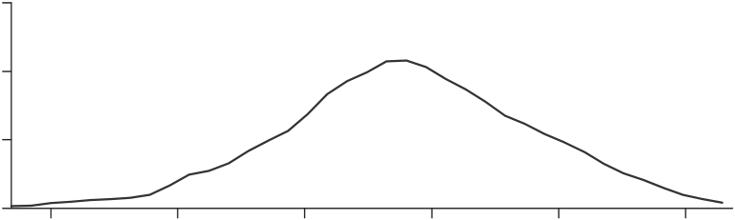
 | 1/256 | 1/64 | 1/16 | 1/4 | 1 | 4
China
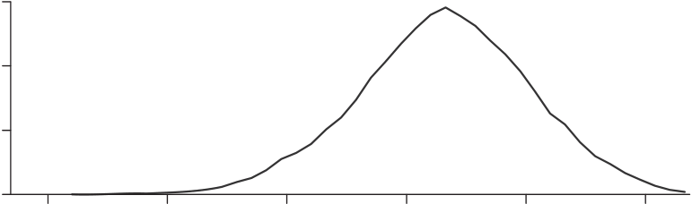
 | 1/256 | 1/64 | 1/16 | 1/4 | 1 | 4
United States
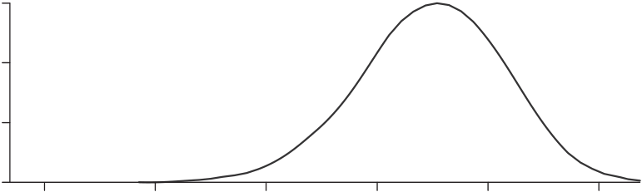
 | 1/256 | 1/64 | 1/16 | 1/4 | 1 | 4
FIGUREI
DistributionofTFPQ
theUnitedStates.TableIIprovidesTFPRdispersionstatisticsfor anumberofcountry-years.Theratioof75thto25thpercentiles ofTFPRinthelatestyearare2.2inIndia,2.3inChina,and 1.7intheUnitedStates.Theratiosof90thto10thpercentilesof TFPRare5.0inIndia,4.9inChina,and3.3intheUnitedStates. ThesenumbersareconsistentwithgreaterdistortionsinChina andIndiathantheUnitedStates.15
15.Hallward-Driemeier,Iarossi,andSokoloff(2002)similarlyreportmore TFPvariationacrossplantsinpoorerEastAsiannations(Indonesiaandthe Philippinesvs.Thailand,Malaysia,andSouthKorea).

1418 QUARTERLYJOURNALOFECONOMICS
TABLEI
DISPERSIONOFTFPQ
China | 1998 | 2001 | 2005
S.D. | 1.06 | 0.99 | 0.95
75−25  90−10  N | 1.41 | 1.34 | 1.28
 | 2.72 | 2.54 | 2.44
 | 95,980 | 108,702 | 211,304
India | 1987 | 1991 | 1994
S.D. | 1.16 | 1.17 | 1.23
75−25  90−10  N | 1.55 | 1.53 | 1.60
 | 2.97 | 3.01 | 3.11
 | 31,602 | 37,520 | 41,006
UnitedStates | 1977 | 1987 | 1997
S.D. | 0.85 | 0.79 | 0.84
75−25  90−10  N | 1.22 | 1.09 | 1.17
 | 2.22 | 2.05 | 2.18
 | 164,971 | 173,651 | 194,669
Ysi
Notes.Forplantiinindustrys,TFPQsi≡Kαs si(wsiLsi)1−αs.Statisticsarefordeviationsoflog(TFPQ)from
industrymeans.S.D.=standarddeviation,75−25isthedifferencebetweenthe75thand25thpercentiles, and90−10the90thvs.10thpercentiles.Industriesareweightedbytheirvalue-addedshares.N=the numberofplants.
TABLEII
DISPERSIONOFTFPR
China | 1998 | 2001 | 2005
S.D. | 0.74 | 0.68 | 0.63
75−25  90−10 | 0.97 | 0.88 | 0.82
 | 1.87 | 1.71 | 1.59
India | 1987 | 1991 | 1994
S.D. | 0.69 | 0.67 | 0.67
75−25  90−10 | 0.79 | 0.81 | 0.81
 | 1.73 | 1.64 | 1.60
UnitedStates | 1977 | 1987 | 1997
S.D. | 0.45 | 0.41 | 0.49
75−25  90−10 | 0.46 | 0.41 | 0.53
 | 1.04 | 1.01 | 1.19
PsiYsi
Notes.Forplantiinindustrys,TFPRsi≡Kαs si(wsiLsi)1−αs.Statisticsarefordeviationsoflog(TFPR)from
industrymeans.S.D.=standarddeviation,75−25isthedifferencebetweenthe75thand25thpercentiles, and90−10the90thvs.10thpercentiles.Industriesareweightedbytheirvalue-addedshares.Numberof plantsisthesameasinTableI.

MISALLOCATIONANDTFPINCHINAANDINDIA |  |  |  |  |  |  |  | 1419
0.6  0.4  0.2  0 | India  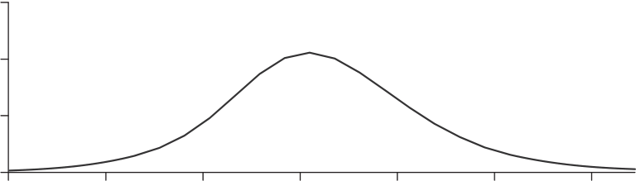
1/8 |  | 1/4 | 1/2 | 1 | 2 | 4 | 8
0.6  0.4  0.2  0 | China  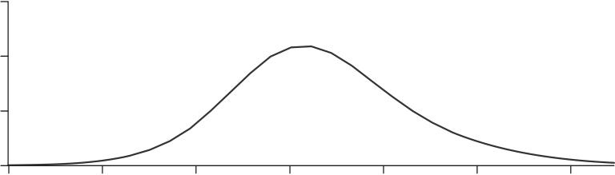
1/8 |  | 1/4 | 1/2 | 1 | 2 | 4 | 8
United States
0.6  0.4  0.2  0 | 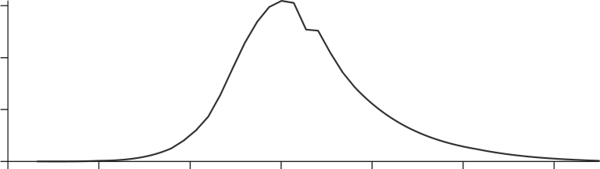
1/8 |  | 1/4 | 1/2 | 1 | 2 | 4 | 8
FIGUREII
DistributionofTFPR
ForIndiaandChina,TableIIIgivesthecumulativepercent-ageofthevarianceofTFPR(withinindustry-years)explainedby dummiesforownership(stateownershipcategories),age(quar-tiles),size(quartiles),andregion(provincesorstates).Theresults arepooledforallyears,andarecumulativeinthat“age”includes dummiesforbothownershipandage,andsoon.Ownershipisless importantforIndia(around0.6%ofthevariance)thaninChina (over5%).Allfoursetsofdummiestogetheraccountforlessthan 5%ofthevarianceofTFPRinIndiaand10%ofthevarianceof TFPRinChina.

1420 QUARTERLYJOURNALOFECONOMICS
TABLEIII
PERCENTSOURCESOFTFPRVARIATIONWITHININDUSTRIES
 | Ownership | Age | Size | Region
India | 0.58 | 1.33 | 3.85 | 4.71
China | 5.25 | 6.23 | 8.44 | 10.01
Notes.Entriesarethecumulativepercentofwithin-industryTFPRvarianceexplainedbydummiesfor ownership(stateownershipcategories),age(quartiles),size(quartiles),andregion(provincesorstates).The resultsarecumulativeinthat“age”includesdummiesforbothownershipandage,andsoon.
Althoughitdoesnotfitwellintoourmonopolisticallycompet-itiveframework,itisusefultoaskhowgovernment-guaranteed monopolypowermightshowupinourmeasuresofTFPQand TFPR.Plantsthatchargehighmarkupsshouldevincehigher TFPRlevels.Iftheyarealsoprotectedfromentryofnearbycom-petitors,theymayalsoexhibithighTFPQlevels.Whereaswe framehighTFPRplantsasbeingheldbackbypolicydistortions, suchplantsmayinfactbehappilyrestrictingtheiroutput.Still, suchvariationinTFPRissociallyinefficient,andaggregateTFP wouldbehigherifsuchplantsexpandedtheiroutput.
Wenextcalculate“efficient”outputineachcountrysowe cancompareitwithactualoutputlevels.Ifmarginalproducts
wereequalizedacrossplantsinagivenindustry,thenindustry TFPwouldbe¯As=(�Ms i=1Aσ−1 si ) σ−1.Foreachindustry,wecalculate
theratioofactualTFP(15)tothisefficientlevelofTFP,and
thenaggregatethisratioacrosssectorsusingourCobb-Douglas aggregator(1):
(20) | Y | = | S  � | ⎡Ms  �  ⎣ | � | Asi | TFPRs | �σ−1⎤ | θs/(σ−1) | .
 |  |  |  |  |  |  |  | ⎦
 | Yefficient |  |  |  |  | As | TFPRsi
 |  |  | s=1 | i=1
Wefreelyadmitthisexerciseheroicallymakesnoallowancefor measurementerrorormodelmisspecification.Sucherrorscould leadustooverstateroomforefficiencygainsfrombetteralloca-tion.Withthesecaveatsfirmlyinmind,TableIVprovidespercent TFPgainsineachcountryfromfullyequalizingTFPRacross plantsineachindustry.Weprovidethreeyearspercountry.Full liberalization,bythiscalculation,wouldboostaggregatemanu-facturingTFPby86%–115%inChina,100%–128%inIndia,and 30%–43%intheUnitedStates.Ifmeasurementandmodeling

MISALLOCATIONANDTFPINCHINAANDINDIA 1421
TABLEIV
TFPGAINSFROMEQUALIZINGTFPRWITHININDUSTRIES
China | 1998 | 2001 | 2005  86.6  1994  127.5  1997  42.9  TFPRsi)σ−1]θs/(σ−1)and TFPRs
% | 115.1 | 95.8
India | 1987 | 1991
% | 100.4 | 102.1
UnitedStates | 1977 | 1987
% | 36.1 | 30.7
Notes.Entriesare100(Yefficient/Y−1)whereY/Yefficient=�S s=1[�Ms i=1(Asi As
PsiYsi
TFPRsi≡Kαs si(wsiLsi)1−αs.
errorsaretoexplaintheseresults,theyclearlyhavetobemuch biggerinChinaandIndiathantheUnitedStates.16
FigureIIIplotsthe“efficient”vs.actualsizedistributionof plantsinthelatestyear.Sizehereismeasuredasplantvalue-added.Inallthreecountriesthehypotheticalefficientdistribu-tionismoredispersedthantheactualone.Inparticular,there shouldbefewermid-sizedplantsandmoresmallandlargeplants. TableVshowshowthesizeofinitiallybigvs.smallplantswould changeifTFPRwereequalizedineachcountry.Theentriesare unweightedsharesofplants.Therowsareinitial(actual)plant sizequartiles,andthecolumnsarebinsofefficientplantsize relativetoactualsize:0%–50%(theplantshouldshrinkbyahalf ormore),50%–100%,100%–200%,and200+%(theplantshould atleastdoubleinsize).InChinaandIndiathemostpopulouscol-umnis0%–50%foreveryinitialsizequartile.Althoughaverage outputrisessubstantially,manyplantsofallsizeswouldshrink. Thusmanystate-favoredbehemothsinChinaandIndiawouldbe downsized.Still,initiallylargeplantsarelesslikelytoshrinkand morelikelytoexpandinbothChinaandIndia(apatternmuch lesspronouncedintheUnitedStates).ThusTFPRincreaseswith sizemorestronglyinChinaandIndiathanintheUnitedStates. Thepositivesize-TFPRrelationinIndiaisconsistentwithBaner-jeeandDuflo’s(2005)contentionthatIndianpoliciesconstrainits mostefficientproducersandcoddleitsleastefficientones.
16.InIndia,thevariationovertimeisnotduetothesmaller,sampledplants movinginandoutofthesample.Whenwelookonlyatlargercensusplantsthe gainsare89%–123%.

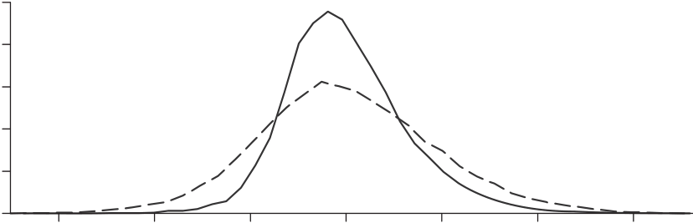
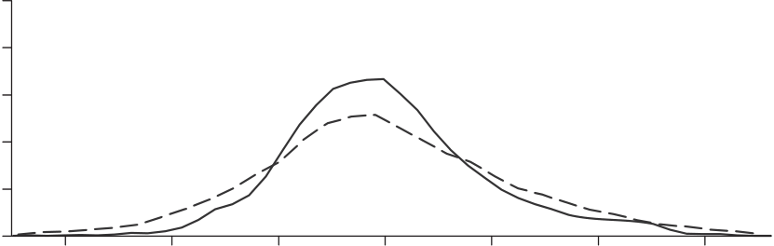
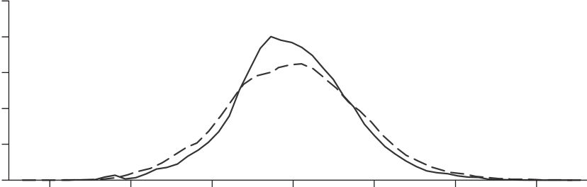
1422  0.25  0.2 | QUARTERLYJOURNALOFECONOMICS  China  Actual
0.15
0.1
0.05 | 1/512 | Efficient | 1/8 | 1 | 8 | 64 | 512
0 |  | 1/64
0.25 |  |  |  | India
0.2
0.15 Actual
0.1
0.05 Efficient
0
0.25 | 1/512 | 1/64 | 1/8 | 1 | 8 | 64 | 512
 |  |  |  | United States
0.2
0.15  0.1 | Actual  Efficient
0.05
0
1/512 | 1/64 | 1/8 | 1 | 8 | 64 | 512
FIGUREIII
DistributionofPlantSize
Althoughweexpressedthedistortionsintermsofoutput (τYsi)andcapitalrelativetolabor(τKsi),inAppendixIII,weshow thattheseareequivalenttoaparticularcombinationoflabor(τ∗Lsi)
andcapital(τ∗Ksi)distortions.InAppendixIII,wealsoreportthat
moreefficient(higherTFPQ)plantsappeartofacebiggerdistor-tionsonbothcapitalandlabor.

MISALLOCATIONANDTFPINCHINAANDINDIA 1423
TABLEV
PERCENTOFPLANTS,ACTUALSIZEVS.EFFICIENTSIZE
China2005 | 0–50 | 50–100 | 100–200 | 200+
Topsizequartile | 7.0 | 6.1 | 5.4 | 6.6
2ndquartile | 7.3 | 5.9 | 5.3 | 6.6
3rdquartile | 8.5 | 6.0 | 5.2 | 5.4
Bottomquartile | 10.5 | 5.9 | 4.5 | 4.2
India1994 | 0–50 | 50–100 | 100–200 | 200+
Topsizequartile | 8.7 | 4.7 | 4.6 | 7.1
2ndquartile | 10.7 | 4.6 | 4.1 | 5.7
3rdquartile | 11.4 | 5.0 | 4.0 | 4.7
Bottomquartile | 13.8 | 3.9 | 3.3 | 3.8
UnitedStates1997 | 0–50 | 50–100 | 100–200 | 200+
Topsizequartile | 4.4 | 10.0 | 6.7 | 3.9
2ndquartile | 4.4 | 9.6 | 5.8 | 5.1
3rdquartile | 4.5 | 9.8 | 5.4 | 5.4
Bottomquartile | 4.7 | 12.0 | 4.3 | 4.1
Notes.Ineachcountry-year,plantsareputintoquartilesbasedontheiractualvalue-added,withanequal numberofplantsineachquartile.Thehypotheticallyefficientlevelofeachplant’soutputisthencalculated, assumingdistortionsareremovedsothatTFPRlevelsareequalizedwithinindustries.Theentriesaboveshow thepercentofplantswithefficient/actualoutputlevelsinthefourbins0%–50%(efficientoutputlessthan halfactualoutput),50%–100%,100%–200%,and200%+(efficientoutputmorethandoubleactualoutput). Therowsaddupto25%,andtherowsandcolumnstogetherto100%.
TABLEVI
TFPGAINSFROMEQUALIZINGTFPRRELATIVETO1997U.S.GAINS
China | 1998 | 2001 | 2005
% | 50.5 | 37.0 | 30.5
India | 1987 | 1991 | 1994
% | 40.2 | 41.4 | 59.2
Notes. For each country-year, we calculated Yefficient/Y using Y/Yefficient=�S s=1 ��Ms i=1(Asi
TFPRsi)σ−1�θs/(σ−1)andTFPRsi≡Kαs si(wsiLsi)1−αs. PsiYsi
WethentooktheratioofYefficient/YtotheU.S.ratioin1997,subtracted1,andmultipliedby100to yieldtheentriesabove.
InTableVIwereportthepercentTFPgainsinChinaand IndiarelativetothoseintheUnitedStatesin1997(aconserva-tivepointofcomparisonbecauseU.S.gainsarelargestin1997). ForChina,hypotheticallymovingto“U.S.efficiency”mighthave boostedTFPby50%in1998,37%in2001,and30%in2005.Com-paredtothe1997U.S.benchmark,Chineseallocativeefficiency improved15%(1.5/1.3)from1998to2005,or2.0%peryear.For

1424 QUARTERLYJOURNALOFECONOMICS
India,meanwhile,hypotheticallymovingtoU.S.efficiencymight haveraisedTFParound40%in1987or1991,and59%in1994. ThuswefindnoevidenceofimprovingallocationsinIndiaover 1987to1994.Theimplieddeclineinallocativeefficiencyof12%, or1.8%peryearfrom1987to1994,issurprisinggiventhatmany Indianreformsbeganinthelate1980s.
HowdotheseimpliedTFPgainsfromreallocationcompare withtheactualTFPgrowthobservedinChinaandIndia?Forthe latter,theclosestestimateswecouldfindarebyBosworthand Collins(2007).TheyreportChineseindustryTFPgrowthof6.2% peryearfrom1993to2004andIndianindustryTFPgrowthof 0.3%peryearfrom1978to1993.Thus,ourpointestimatefor China(2%peryear)wouldsuggestthatperhapsone-thirdofits TFPgrowthcouldbeattributedtobetterallocationofresources. ForIndia,ourevidenceforworseningallocationsmighthelpto explainitsminimalTFPgrowth.
ArelatedquestionishowourestimatesofTFPlossesfrom TFPRdispersioncomparewithactual,observedTFPdifferences betweenChinaorIndiaandtheUnitedStates.Wecrudelyesti-matethatU.S.manufacturingTFPin1997was130%higherthan China’sin1998,and160%higherthanIndia’sin1994.17There-fore,ourestimatessuggestthatresourcemisallocationmightbe responsibleforroughly49%(log(1.5)/log(2.3))oftheTFPgapbe-tweentheUnitedStatesandChinaand35%(log(1.4)/log(2.6))of theTFPgapbetweentheUnitedStatesandIndia.
Sofar,ourcalculationsofhypotheticaloutputgainsfrom TFPRequalizationassumeafixedaggregatecapitalstock.As discussedabove,outputgainsareamplifiedwhencapitalaccu-mulatestokeeptherentalpriceofcapitalconstant.InIndia’s casetheaveragecapitalsharewas50%in1994–1995,andsothe TFPgainsareroughlysquared.ThesamegoesforChina,because itsaveragecapitalsharewas49%in2005.Thusa30%TFPgain inChinacouldyielda67%long-rungaininmanufacturingout-put,whereasa59%TFPgaininIndiacouldultimatelyboostits manufacturingoutputby153%.
17.WeusetheaggregatepriceoftradablegoodsbetweenIndiaandtheUnited Statesin1985(fromthebenchmarkdatainthePennWorldTables)todeflate IndianpricestoU.S.prices.BecausewedonothavepricedeflatorsforChinese manufacturing,weusetheIndianpriceoftradablegoodstoconvertChineseprices atmarketexchangeratestoPPPprices.Inaddition,weassumethatthecapital-outputratioandtheaveragelevelofhumancapitalinthemanufacturingsector isthesameasthatintheaggregateeconomy.Theaggregatecapital-outputratio iscalculatedfromthePennWorldTablesandtheaveragelevelofhumancapitalis calculatedfromaverageyearsofschooling(fromBarroandLee[2000])assuming a10%Mincerianreturn.

MISALLOCATIONANDTFPINCHINAANDINDIA 1425
Wenowprovideanumberofrobustnesschecksonourbase-lineTableVIcalculationsofhypotheticalefficiencygainsfrom liberalizationinChinaandIndiarelativetotheUnitedStates. Wefirstadjustthebookvaluesofcapitalusingacapitaldeflator foreachcountrycombinedwiththeplant’sage.Weassumethata plant’scurrentinvestmentrateappliestoallpreviousyearsofits lifesothatwecaninfertheagedistributionofitscapitalstock. Theresulting“current-market-value”capitalstockssuggestvery similarroomforTFPgainsinChinavs.theUnitedStates(29.8% vs.30.5%baseline)andIndiavs.theUnitedStates(59.9%vs. 59.2%baseline).
Inourbaselinecalculationswealsomeasuredplantlabor inputusingitswagebill.Ourlogicwasthatwagesperworkerad-justforplantdifferencesinhoursworkedperworkerandworker skills.However,wagescouldalsoreflectrentsharingbetweenthe plantanditsworkers.Ifso,wemightbeunderstatingdifferences inTFPRacrossplantsbecausethemostprofitableplantshaveto payhigherwages.Wethereforerecalculatethegainsfromequaliz-ingTFPRinChinaandIndia(relativetotheUnitedStates)using simplyemploymentasourmeasureofplantlaborinput.Surpris-ingly,thereallocationgainsaresmallerinbothChina(25.6%vs. 30.5%baseline)andIndia(57.4%vs.59.2%baseline)whenwe measurelaborinputusingemployment.Thuswagedifferences appeartoamplifyTFPRdifferencesratherthanlimitthem. Wehaveassumedanelasticityofsubstitutionwithinindus-tries(σ)of3,conservativelyatthelowendofempiricalestimates. Ourestimatedgainsarehighlysensitivetothiselasticity.China’s hypotheticalTFPgainin2005soarsfrom87%underσ=3to 184%withσ=5,andIndia’sin1994from128%to230%.These aregainsfromfullyequalizingTFPRlevels.Ourintuitionisas follows:whenσishigher,TFPRgapsareclosedmoreslowlyin responsetoreallocationofinputsfromlow-tohigh-TFPRplants, enablingbiggergainsfromequalizingTFPRlevels.
Ourresultsarenotnearlyassensitivetoourassumptionofa unitaryelasticityofsubstitutionbetweensectors.Cobb-Douglas aggregationacrosssectorsmeansthatTFPRequalizationdoesnot affecttheallocationofinputsacrosssectors;theriseinasector’s productivityisexactlyoffsetbythefallinitspriceindex.Suppose insteadthatfinaloutputisaCESaggregateofsectoroutputs:
Y= | �S  � | φ−1  θsY s φ | � | φ | .
 |  |  |  | φ−1
 | s=1

1426 QUARTERLYJOURNALOFECONOMICS
Firstconsiderthecasewhereinsectoroutputsareclosercom-plements(φ=0.5).Thegainsfromliberalizationaremodestly smallerinChina(82%vs.87%in2005)andappreciablysmaller inIndia(108%vs.128%in1994).Thegainsshrinkbecauseφ<1 meanssectorswithlargerincreasesinproductivityshedinputs. Nextconsideracaseinwhichsectoroutputsaremoresubsti-tutable(φ=2).Inthiscase,thegainsfromliberalizationare modestlylargerinChina(90%vs.87%)andlargerinIndia(142% vs.128%).Whensectoroutputsarebettersubstitutes,inputsare reallocatedtowardsectorswithbiggerproductivitygainssothat aggregateTFPincreasesmore.
V.MEASUREMENTERROR
Ourpotentialefficiencygainscouldbeafigmentofgreater measurementerrorinChineseandIndiandatathanintheU.S. data.Wecannotruleoutarbitrarymeasurementerror,butwecan trytogaugewhetherourresultscanbeattributabletospecific formsofmeasurementerror.Oneformissimplyrecordingerrors thatcreateextremeoutliers.Forourbaselineestimates(TableVI) wetrimmedthe1%tailsofTFPR(actually,intheoutputandcap-italdistortionsseparately)andTFPQ—upto6%ofobservations. Whenwetrim2%tails(upto12%ofobservations)thehypothet-icalTFPgainsfallfrom87%to69%forChinain2005,andfrom 128%to106%forIndiain1994.Thus,measurementerrorinthe remaining1%tailscouldwellbeimportant,butdoesnotcome closetoaccountingforthebiggainsfromequalizingTFPR. Ofcourse,measurementerrorcouldbeimportantinthein-terioroftheTFPRdistribution,too.Supposemeasurementerror isclassicalinthesenseofbeingorthogonaltothetruthandto otherreportedvariables.ThenwewouldnotexpectplantTFPR toberelatedtoplantownership.TableVIIshowsthat,infact, TFPRissystematicallyrelatedtoownershipinmostlyreassuring waysinChinaandIndia.Thetablepresentsresultsofregressing TFPRandTFPQ(relativetoindustrymeans)onownershiptype inChinaandIndia.Allyearsarepooledandyearfixedeffectsare included.TheomittedgroupforChinaisprivatelyowneddomestic plants,whereasinIndiaitisprivatelyownedplantsbecausewe lackinformationonforeignownershipinIndia.InChina,state-ownedplantsexhibit41%lowerTFPR,asiftheyreceivedsub-sidiestocontinueoperatingdespitelowprofitability.18Perhaps
18.DollarandWei(2007)likewisefindlowerproductivityatstate-owned firmsinChina.

MISALLOCATIONANDTFPINCHINAANDINDIA 1427
TABLEVII
TFPBYOWNERSHIP
TFPR | TFPQ
China
State | −0.415  (0.023) | −0.144  (0.090)
Collective | 0.114 | 0.047
Foreign | (0.010) | (0.013)
 | −0.129  (0.024) | 0.228
 |  | (0.040)
India
State(central) | −0.285  (0.082) | 0.717
 |  | (0.295)
State(local) | −0.081  (0.063) | 0.425
 |  | (0.103)
Jointpublic/private | −0.162  (0.037) | 0.671
 |  | (0.085)
Notes.ThedependentvariableisthedeviationoflogTFPRorlogTFPQfromtheindustrymean.The independentvariablesforChinaaredummiesforstate-ownedplants,collective-ownedplants(plantsjointly ownedbylocalgovernmentsandprivateparties),andforeign-ownedplants.Theomittedgroupisdomestic privateplants.TheindependentvariablesforIndiaaredummiesforaplantownedbythecentralgovernment, aplantownedbyalocalgovernment,andaplantjointlyownedbythegovernment(eithercentralorlocal)and byprivateindividuals.Theomittedgroupisaprivatelyownedplant(bothdomesticandforeign).Regressions areweightedleastsquareswithindustryvalue-addedsharesasweights.Entriesarethedummycoefficients, withstandarderrorsinparentheses.Resultsarepooledforallyears.
surprisingly,collectivelyowned(partprivate,partlocalgovern-ment)plantshave11%higherTFPR.Foreign-ownedplantshave 23%higherTFPQonaverage,but13%lowerTFPR.Thelatter couldreflectbetteraccesstocreditorpreferentialtreatmentin exportprocessingzones.Consistentwiththisinterpretation,ex-portingplantshave46%higherTFPQbut14%lowerTFPR.Inthe UnitedStates,exportershaveasimilarTFPQadvantage(50%) butdisplayhigherratherthanlowerTFPR(+6%onaverage).19
InIndia,alltypesofplantswithpublicinvolvementexhibit lowerTFPR:29%lowerforplantsownedbythecentralgovern-ment,8%lowerforthoseownedbylocalgovernments,and16% lowerforjointpublic-privateplants.Publicinvolvementalsogoes alongwith40%–70%higherTFPQ,althoughthismightreflect monopolyrightsthatguaranteedemand.
WenextlookatthecorrelationofTFPRwithplantexit.One wouldexpecttrueTFPRtobelowerforexiters.IfTFPRismea-suredwithmoreerrorinChinaandIndia,thecoefficientfrom aregressionofplantexitonTFPRshouldbebiaseddownward.
19.ThehighTFPQofexporterscouldreflectthe“demandshock”comingfrom accessingforeignmarkets,ratherthanjustphysicalproductivity.

1428 QUARTERLYJOURNALOFECONOMICS
TABLEVIII
REGRESSIONSOFEXITONTFPR,TFPQ
China
ExitonTFPR  ExitonTFPQ | −0.011  (0.003)  −0.050  (0.002)
India
ExitonTFPR  ExitonTFPQ | −0.019  (0.005)  −0.027  (0.004)
UnitedStates
ExitonTFPR  ExitonTFPQ | −0.011  (0.003)  −0.039  (0.002)
Notes.Thedependentvariablesaredummiesforexitingplants.Theindependentvariablesarethe deviationoflog(TFPR)orlog(TFPQ)fromtheindustrymean.Regressionsareweightedleastsquareswith theweightsbeingindustryvalue-addedshares.Entriesabovearethecoefficientsonlog(TFPR)orlog(TFPQ), withstandarderrorsshowninparentheses.Regressionsalsoincludeaquarticfunctionofplantage.Results arepooledforallyears.
TableVIIIshowsthatlowerTFPRisassociatedwithahigher probabilityofplantexitinallthreecountries.A1-log-pointde-creaseinTFPRisassociatedwitha1.1%higherexitprobability inChinaanda1.9%higherexitprobabilityinIndia,compared to1.1%higherexitprobabilityintheUnitedStates.LowTFPR firmsdisproportionatelyexitinChinaandIndia,suggestingTFPR isastrongsignalofprofitability.Ofcourse,governmentsubsidies mightallowmanyunprofitableplantstocontinueratherthan exit.However,thatisnotwhatTableVIIIshows,perhapsbecause ofthereformsunderwayinbothcountries.TheChineseresults partlyreflectthatstate-ownedplantsarelessprofitableandare morelikelytoexit.However,therelationshipbetweenexitand TFPRisstillsignificantlynegative(−0.8%withastandarderror of0.3%)whenadummyforSOEsisincluded.
WecanalsolookatthecorrelationofTFPQwithexit,because measurementerrorinTFPRshouldalsoshowupasmeasurement errorinTFPQ.(RecallthatlogTFPRislogrevenues–loginputs, andlogTFPQisσ/(σ−1)logrevenues–loginputs.)TableVIII showsthatlowerTFPQisassociatedwithhigherexitprobabili-ties,withastrongerrelationshipinChinaandaweakerrelation-shipinIndiawhencomparedwiththeUnitedStates.Ifthetrue

MISALLOCATIONANDTFPINCHINAANDINDIA 1429
TABLEIX
REGRESSIONSOFINPUTSONREVENUE,REVENUEONINPUTS
 | China | India | UnitedStates
Inputsonrevenue | 0.98 | 0.96 | 1.01
Revenueoninputs | 0.82 | 0.90 | 0.82
Notes.EntriesarethecoefficientsfromregressionsoflogPsiYsionlogKαs si(wLsi)1−αs(revenueoninputs)
andlogKαs si(wLsi)1−αsonlogPsiYsi(inputsonrevenue).Allvariablesaremeasuredrelativetotheindustry
mean,withindustriesweightedbyvalue-addedshares.Resultsarepooledforallyears.
relationshipbetweenTFPQandplantexitisthesameinthethree countries,thenthisevidencesuggestslessmeasurementerrorin China,butmoremeasurementerrorinIndiawhencomparedwith theUnitedStates.
Wecanalsodirectlyassesstheextentofclassicalmeasure-menterrorinplantrevenueandinputs.Ifthepercenterrorsin revenueandinputsareuncorrelatedwitheachother,andtrue elasticitiesarethesameinallcountries,thenweexpectlower coefficientsinChinaandIndiawhenweregresslogrevenueon loginputsorviceversa.WepresentsuchregressionsinTableIX, poolingallyearsforagivencountryandmeasuringvariables relativetoindustrymeans.Theelasticityofinputswithrespect torevenueis0.96inIndiaand0.98inChina,vs.1.01intheUnited States.Thesecoefficientssuggestgreaterclassicalmeasurement errormightbeadding5%tothevarianceoflogrevenueinIndia and3%tothevarianceinChina.Theelasticityofrevenuewith respecttoinputsis0.82inChina,0.90inIndia,and0.82inthe UnitedStates.Thesecoefficientssuggestclassicalmeasurement errorhasthesameeffectonthevarianceofloginputsinChina asintheUnitedStates,butactuallylowersthevarianceinIndia by10%relativetotheUnitedStates.Puttingthetwo-wayregres-sionstogether,greaterclassicalmeasurementcouldcontributeto thehighervarianceofTFPRinChina,butnotinIndia.Thisevi-denceisnotconclusivebecausethetrueelasticitiescouldbelower inChinaandIndiathantheUnitedStates,butitdoesprovide mixedevidenceonwhetherthereisgreatermeasurementerror inChinaandIndiarelativetotheUnitedStates.
Supposefurtherthat,foragivenplant,measurementerror islessseriallycorrelatedthantruerevenueandinputs,andthat thetrueserialcorrelationsarethesameforallcountries.Then wewouldexpectthegrowthratesofrevenueandinputstovary moreacrossplantsinChinaandIndiathantheUnitedStates.

1430 QUARTERLYJOURNALOFECONOMICS
TABLEX
DISPERSIONOFINPUTANDREVENUEGROWTH
Inputs | Revenue
China
S.D. | 0.45 | 1.00
75−25 | 0.34 | 0.93
India
S.D. | 0.28 | 0.70
75−25 | 0.24 | 0.60
UnitedStates
S.D. | 0.68 | 0.43
75−25 | 0.43 | 0.32
Notes.Entriesarethestandarddeviation(S.D.)andinterquartilerange(75−25)ofdlogPsiYsiand dlogKαs si(wsiLsi)1−αs.Allvariablesaremeasuredrelativetotheindustrymean,andwithindustriesweighted
bytheirvalue-addedshares.Entriesarepooledforallyears.
TableXpresentstherelevantstatistics.20Inputgrowthactually variesmuchlessacrossplantsinChinaandIndiathantheUnited States.Revenuegrowth,however,variesalotmoreinChinaand IndiathantheUnitedStates.Sothegrowthrates,too,provide mixedevidenceonwhetherTFPRisnoisierinChinaandIndia. Ofcourse,truedispersionofinputgrowthcouldbelowerinChina andIndia.
Finally,ifmeasurementerrorislesspersistentthantruevari-ables,then“instrumenting”withlaggedvariablesshouldshrink efficiencygainsmoreinChinaandIndiathanintheUnitedStates. TheTFPgainfromfullyequalizingTFPRlevelsfallsfrom87% under“OLS”to72%under“IV”in2005China,from127%to108% in1994India,andfrom43%to26%inthe1997UnitedStates.By thismetric,measurementerroraccountsforabiggerfractionof thegainsintheUnitedStatesthaninChinaorIndia.Ofcourse,it couldinsteadbethatmeasurementerrorismorepersistentthan trueTFPR.
Torecap,thestatisticsinthissubsectionareinconclusive. Theydonotprovideclearevidencethatthesignal-to-noiseratio forTFPRishigherintheUnitedStatesthaninChinaandIndia, butneitherdotheyentirelyruleoutthepossibility.Inaddition, wecannotruleoutnonclassicalmeasurementerroracrossplants asthesourceofgreaterTFPRdispersioninChinaandIndia.
20.ForthisandallotherU.S.calculationsrequiringapanel,weusetheASM
ratherthanjusttheCM.WemeasureinputgrowthasthegrowthrateofKαs siL1−αs si | .

MISALLOCATIONANDTFPINCHINAANDINDIA 1431
TABLEXI
OWNERSHIPOFINDIANANDCHINESEPLANTS
China | 1998 | 2001 | 2005
Privatedomestic | 15.9 | 37.4 | 62.5
Privateforeign | 20.0 | 21.7 | 21.9
State | 29.0 | 18.5 | 8.1
Collective | 35.1 | 22.4 | 7.5
India | 1987 | 1991 | 2004
Private | 87.7 | 88.4 | 92.4
State(centralgov.) | 3.3 | 3.3 | 2.4
State(localgov.) | 3.9 | 3.0 | 2.8
Jointpublic/private | 5.1 | 5.4 | 2.4
Notes.Entriesarethepercentofplantsineachownershipcategoryinthesector,whereeachsectoris weightedbythevalue-addedshareofthesector.Eachcolumnaddsto100.
TABLEXII
REGRESSIONSOFSECTORTFPRDISPERSIONONSTATEOWNERSHIPINCHINA
 | 1998 | 2001 | 2005 | 1998–2005
Stateownership | 0.766 | 0.659 | 0.025 | 0.300
share | (0.165) | (0.153) | (0.213) | (0.080)
YearF.E. | NO | NO | NO | YES
SectorF.E. | NO | NO | NO | YES
N | 406 | 403 | 407 | 3,237
Note.EntriesarecoefficientsfromregressionsofthevarianceoflogTFPRinsectorsonthevariance insectorsofanindicatorvariableforastate-ownedplant.Allregressionsareweightedbythevalue-added weightsofthesector.Standarderrorsareclusteredbysectorinthelastcolumn.
VI.POLICIESANDMISALLOCATION
IfTFPRdispersionisrealratherthanaby-productofmea-surementerror,thenweshouldbeabletorelateTFPRgapsto explicitgovernmentpolicies.InthissectionwerelateTFPRdis-persioninChinatostateownershipofplants,andTFPRdisper-sioninIndiatolicensingandsizerestrictions.
TableXIgivesthepercentageofplantsthatarestateowned inChina:29%in1998,19%in2001,and8%in2005.(InIndiathe shareofstate-affiliatedplantsfelllessdramatically,from12%of plantsin1987to8%in1994.)Now,inTableVIIwedocumented roughly40%lowerTFPRatstate-ownedplantsvs.privatedo-mesticplantsinChina.Thisraisesthequestionofhowmuchof China’sTFPRdispersioncanbeaccountedforbystateowner-ship.InTableXII,weexaminethisrelationshipacrossthe400or

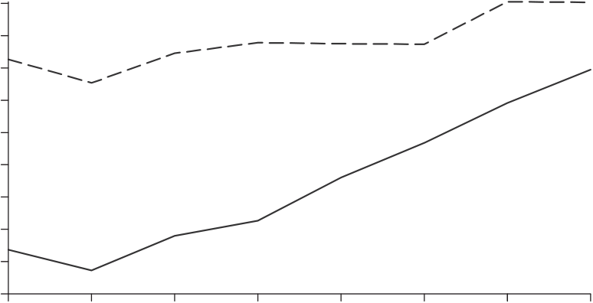
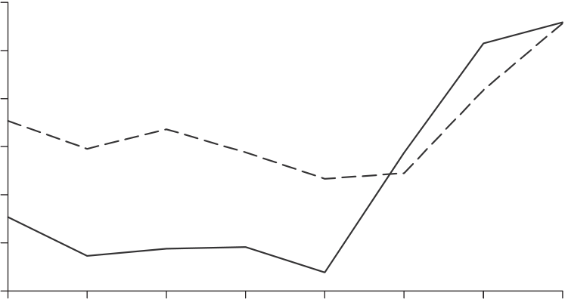
1432  −0.3  −0.325  −0.35 | QUARTERLYJOURNALOFECONOMICS  TFPR  All SOEs  Surviving SOEs
−0.375
−0.4
−0.425
−0.45 | 1999 | 2000 | 2001 | 2002 | 2003 | 2004 | 2005
1998
0.5 |  |  | TFPQ
0.4
0.3
0.2 Surviving SOEs
0.1
0
−0.1
−0.2 All SOEs
−0.3
−0.4 | 1999 | 2000 | 2001 | 2002 | 2003 | 2004 | 2005
1998
FIGUREIV
TFPRandTFPQofChineseState-OwnedFirms
sofour-digitindustriesinChina.Weregresstheindustryvariance oflogTFPRontheindustryshareofplantsownedbythestate. Therelationshipispositiveandsignificantinboth1998and2001, witha1%higherstateshareofplantsassociatedwithabout0.7% higherTFPRdispersion.Therelationshipisnolongersignificant by2005,andFigureIVshowswhy.State-ownedplantshavemuch higherrelativeTFPRin2005thanin2001;someofthisisdueto exitoftheleastproductivestateplants,butthefigureshowsasiz-ableincreaseintherelativeTFPRofsurvivingplantsaswell.21
21.Amongstate-ownedplantsin1998,thoseprivatizedby2005had11% higherTFPR(and26%higherTFPQ)thanstate-ownedplantsexitingby2005.

MISALLOCATIONANDTFPINCHINAANDINDIA 1433
TABLEXIII
REGRESSIONOFSECTORTFPRDISPERSIONONDELICENSINGANDSIZERESTRICTIONS
ININDIA
 | (1) | (2) | (3)
Delicensed1991 | −0.298  (0.117) | 0.368 | −0.298  (0.117)
Delicensed1991×post-1991 | 0.032 |  | −0.056  (0.040)
 | (0.036)
Sizerestriction
(0.173)
Delicensed1991×  post1991×sizerestriction | 0.415  (0.120)
Notes.ThedependentvariableisthevarianceoflogTFPRinsectorsinyeart.Entriesarecoefficients onthefollowingindependentvariables:(1)delicensed1991:indicatorforwhetherindustrywasdelicensed in1991;(2)delicensed1991×post1991:productofanindicatorforanindustrydelicensedin1991and anindicatorforobservationsafter1991;(3)sizerestriction:%ofvalue-addedofanindustrysubjectto reservationsforsmallfirmsand;(4)delicensed1991×post1991×sizerestriction:productofsizerestriction, indicatorvariableforobservationsafter1991,andadummyvariableforindustriesdelicensedafter1991.All regressionsincludeindicatorvariablesforyear(1987through1994)andareweightedbythevalue-added shareofthesector.Regressions(1)and(3)alsoincludeadummyforindustriesdelicensedin1985.Theomitted groupconsistsofindustriesnotdelicensedineither1985or1991.Standarderrorsareclusteredbysector. Numberofobservations=2,644.
WhenweequalizeTFPRonlywithinownershipcategories,the gainsare8.2%lowerin1998and2.4%lowerin2005.Therefore, ofthe15%reductioninpotentialgainsfromreallocationinChina from1998to2005,wecalculatethat39%(5.8/15.0)comesfrom theshrinkingTFPRgapbetweenSOEsandotherplants.
InIndia,misallocationwithinindustrieshasoftenbeenat-tributedtolicensingandsizerestrictions,amongothergovern-mentpolicies(see,e.g.,Kocharetal.[2006]).Thesedistortions maypreventefficientplantsfromachievingoptimalscaleand keepinefficientplantsfromcontractingorexiting.TheIndian governmentdelicensedmanyindustriesin1985(about40%of industriesbyvalue-addedshare)andin1991(about42%ofin-dustriesbyvalue-addedshare).22Indialifteditssizerestrictions muchmorerecently(1997–2005),whichunfortunatelyweareun-abletoanalyzebecauseourdataendin1994–1995.Acrossindus-triesduringoursample,themeanshareofindustryvalue-added subjecttosizerestrictionswas21%withastandarddeviationof 16%.23
InTableXIIIwerelatethedispersionofindustryTFPRto whethertheindustrywasdelicensedin1991andtowhetherthe
22.Basedonthree-digitdatainAghionetal.(2008).
23.ThelistofindustriessubjecttosizerestrictionsisfromMohan(2002).

1434 QUARTERLYJOURNALOFECONOMICS
industryfacedsizerestrictions.(Wealsoincludeadummyfor industriesdelicensedin1985;theomittedgroupconsistsofin-dustriesnotdelicensedineither1985or1991.)Thefirstcolumn showsthatindustriesdelicensedin1991exhibitedlessdisper-sionofTFPR,butnotinparticularfor1991onward.Itisasif licensedindustrieshadlowerTFPRdispersiondespitetheirli-censingrestrictions,andthedelicensingdidnotaffectthis.The reasonmaybethatmanyofthedelicensedindustrieswerestill subjecttosizerestrictions.ThesecondcolumnofTableXIIIindi-catesthatthevarianceoflogTFPRisgreaterwithinindustries subjecttosizerestrictions.Weinteractdelicensingwithsizere-strictionsandyearsafter1991inthethirdcolumn,andfindthat industriesdelicensedin1991whofacesizerestrictionsdoindeed displaymoreTFPRdispersionfrom1991onward.Delicensedin-dustriesnotfacingsizerestrictionsdidexhibitlowerTFPRfrom 1991,butnotsignificantlyso.
India’slicensingrestrictionsmightparticularlyrestrictthe abilityofplantstoacquireinputswhentheirefficiencyrises. Ifso,thenwewouldexpectplantswithrisingTFPQtohave higherTFPR,butmoresobeforedelicensingthanafterward. ForIndianindustriesdelicensedin1991,FigureVplotsaver-agelogTFPRagainstpercentilesofplantTFPQgrowth,with bothvariablesrelativetoindustrymeans.Aspredicted,therela-tionshipispositivebutnotablyflatterafterdelicensing.Whereas TFPRdifferedby1.2logpointsacrossthe90thvs.10thpercentile TFPQgrowthbeforedelicensing,itdifferedby0.6logpointsafter delicensing.
WefindlittleevidencethatTFPRdispersioniscorrelated withmeasuresofgeography,industryconcentration,and(inIn-dia)labor-marketregulation.AverageTFPRlevelsdiffermodestly (within10%)acrossChineseprovincesandIndianstates,sothat theoverwhelmingmajorityofourTFPRdifferencesarewithin industryregions.Withinindustryregionswetriedwithoutsuc-cesstorelateTFPRdispersiontoindustryconcentrationusing aHerfindahlindex.ForIndiaweexperimentedwithanindexof laborregulationforeachindustry,calculatedasaweightedav-erageofthecumulativeindexoflaborregulationinBesleyand Burgess(2004)ineachstate,withweightsequaltovalue-added sharesofeachindustryineachstate.Thisindexwasnotsig-nificantlyrelatedtothevarianceoflogTFPRacrossindustries, whetherinteractingwithorcontrollingfordelicensingand1991 onward.

MISALLOCATIONANDTFPINCHINAANDINDIA 1435
Before delicensing
log TFPR | 0.8 | 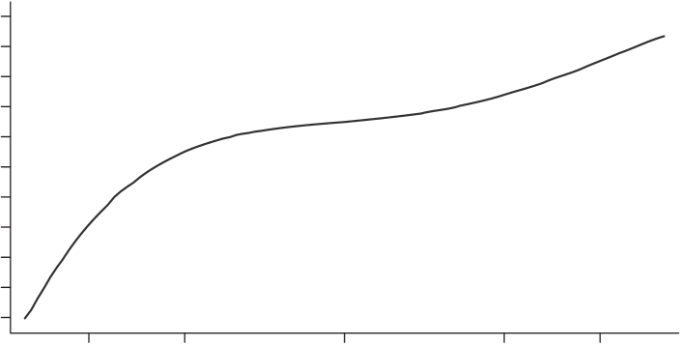
 | 0.6
 | 0.4
 | 0.2
 | 0
 | −0.2
 | −0.4
 | −0.6
 | −0.8
 | −1
 | −1.2
 |  | 10 | 25 | 50 | 75 | 90
 | 0.8 | After delicensing
 |  | 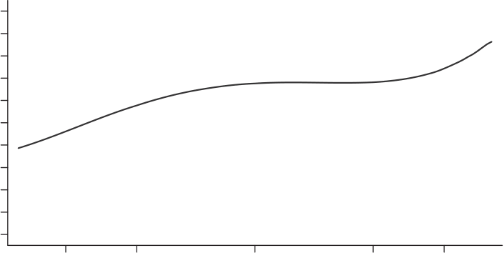
 | 0.6
 | 0.4
 | 0.2
 | 0
 | −0.2
 | −0.4
 | −0.6
 | −0.8
 | −1
 | −1.2
 |  | 10 | 25 | 50 | 75 | 90
TFPQ growth (percentile)
FIGUREV
TFPRandTFPQGrowthinDelicensedSectorsinIndia
VII.ALTERNATIVEEXPLANATIONS
WenowentertainalternativeexplanationsforTFPRdisper-sionbesidespolicydistortionsandmeasurementerror.Specif-ically,webrieflyexaminevaryingmarkupswithplantsize, adjustmentcosts,unobservedinvestments(suchasR&D),and varyingcapitalelasticitieswithinindustries.Allofthesesurely contributetoTFPRdispersioninallthreecountries,butourques-tioniswhethertheymightexplainthewiderTFPRdispersionin ChinaandIndiathanintheUnitedStates.

1436 QUARTERLYJOURNALOFECONOMICS
VII.A.VaryingMarkupswithPlantSize
OurCESaggregationofplantvalue-addedwithinindustries impliesthatallgoodshavethesamemarkupwithinindustries (nottomentionacrossindustries).Yetmarkupsmightbehigher forbiggerplants,andtheremaybegreatersizedispersioninour ChineseandIndiandatathanintheU.S.data.Markupsaredis-tortionstoo,ofcourse,buttheirdispersionmaynotwhollyreflect policydifferencesbetweenthecountries.MelitzandOttaviano (2008)analyzethecaseoflineardemand,underwhichtheelas-ticityofdemandisfalling(andthemarkupincreasing)withsize. FigureVIshowswhywedidnotgothisroute.WhereasTFPRis stronglyincreasinginpercentilesofplantsize(valueadded)inIn-diaandmostlyincreasinginplantsizeinChina,ifanythingTFPR decreaseswithplantsizeintheUnitedStates.Iflineardemand appliedeverywhere,thenTFPRshouldincreasewithsizeinthe UnitedStates,too.ThefactthatChinaandIndiadiffernotonly quantitativelybutqualitativelyfromtheUnitedStatessuggests morethanjustamplificationofusualU.S.forces.
VII.B.AdjustmentCosts
YoungplantsmighthavehigherTFPRonaveragedueto adjustmentcosts.IfChineseandIndianplantsalsodifferinage morethanU.S.plantsdo,differencesinadjustmentcostsbyage couldcontributetowiderTFPRdispersioninChinaandIndia. FigureVIIplotsaveragelogTFPR(relativetoindustrymeans)by percentileofplantageineachcountry.TFPRsteadilyincreases withplantageinIndia,contrarytothisstory.InChina,TFPR risesthroughtheyoungestdecile,thenisflatormildlydecreasing intheinterdecilerangebeforefallingfortheoldestdecile.Only theUnitedStatesexhibitsthepredictedpatternofsteadilyfalling TFPRwithage.
Moregenerally,growingplantsmighthavehigherTFPRthan shrinkingplantsbecauseofadjustmentcosts.Andinputgrowth ratesmayvarymoreinChinaandIndia,becauseoftheirreforms, thanintheUnitedStateswithitsmorestablepolicyenviron-ment.FigureVIIIplotsaverageTFPRbypercentileofplantinput growth.TFPRisincreasingininputgrowthinallthreecoun-tries,aspredicted,buttheUnitedStatesexhibitsmorevariation inTFPRassociatedwithinputgrowththandoChinaandIndia. Related,recallfromTableXthatinputgrowthactuallyvaries moreacrossU.S.plantsthanacrossplantsinChinaorIndia.The UnitedStatesdisplaysmorechurning,andso,ifanything,should

MISALLOCATIONANDTFPINCHINAANDINDIA 1437
India
0.4  0.2  0  −0.2  −0.4  −0.6 | 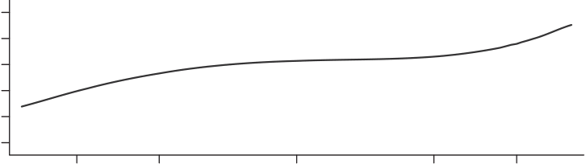
 | 10 | 25 | 50 | 75 | 90
China
log TFPR | 0.4 | 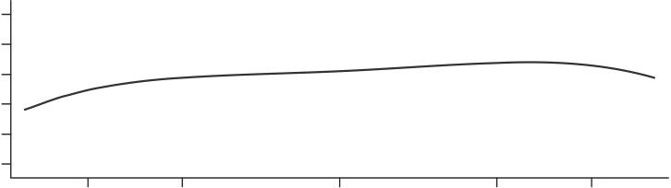
 | 0.2
 | −0.2
 | −0.4
 | −0.6
 |  | 10 | 25 | 50 | 75 | 90
United States
0.4  0.2  0  −0.2  −0.4  −0.6 | 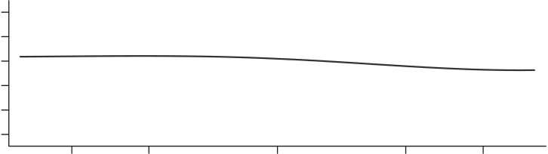
 | 10 | 25 | 50 | 75 | 90
Plant size (percentile)
FIGUREVI
TFPRandSize
havemoreTFPRvariationbecauseofconvexadjustmentcostsin inputgrowth.24
InputgrowthmayvarylessinChinaandIndiabecausetheir plantsarehitwithlessvolatileidiosyncraticshocksand/orbe-causetheyfacehigheradjustmentcosts.CooperandHaltiwanger (2006)estimateidiosyncraticprofitabilityshocksinapanelofU.S.
24.AnotherinterpretationofFigureVIIIisintermsofwhetherinputsare beingreallocatedtoplantswithhigherTFPR.Theanswerisyesinallthree countries,butmoresointheUnitedStates.Thisisconsistentwithmoreefficient resourceallocationintheUnitedStates.

1438 QUARTERLYJOURNALOFECONOMICS
India
0.02  0  −0.2  −0.4 | 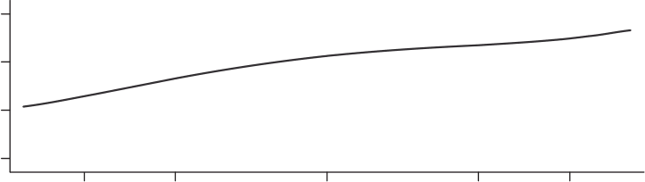
 | 10 | 25 | 50 | 75 | 90
China
log TFPR | 0.2 | 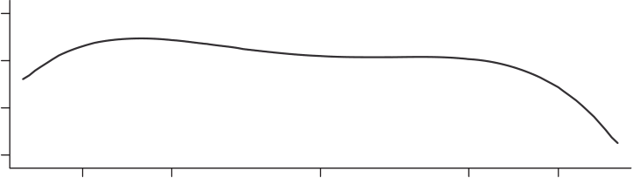
 | −0.2
 | −0.4
 |  | 10 | 25 | 50 | 75 | 90
United States
0.2  0  −0.2  −0.4 | 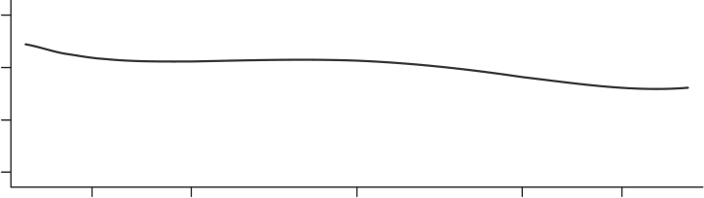
 | 10 | 25 | 50 | 75 | 90
Age (percentile)
FIGUREVII
TFPRandAge
plantsbasedonregressionsoflogprofits(actuallylogrevenue minus(roughly)0.5logcapital)onitslaggedvalueandyeardum-mies.Whenwerepeattheirestimationforallthreecountries,we obtainsimilarestimatesfortheUnitedStates(serialcorrelation 0.81,innovationstandarddeviation0.56),China(0.79and0.59) andIndia(0.84and0.57).Theoverallstandarddeviationis1% higherforChinathantheUnitedStatesand10%higherforIndia thantheUnitedStates.Bycomparison,inTableIIthestandard deviationsofTFPRareover50%higherforChinaandIndiathan theUnitedStates.ThusitwouldseemthatplantsinChinaand

MISALLOCATIONANDTFPINCHINAANDINDIA 1439
India
0.6  0.4  0.2  0  −0.2 | 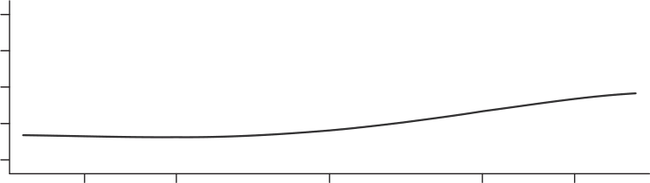
 | 10 | 25 | 50 | 75 | 90
China
log TFPR | 0.6 | 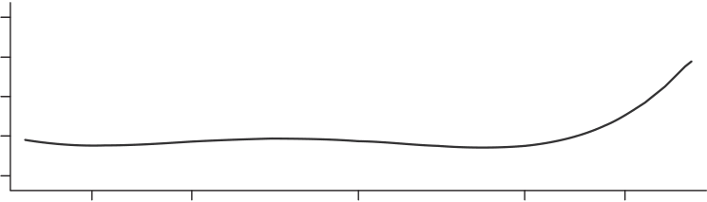
 | 0.4
 | 0.2
 | −0.2
 |  | 10 | 25 | 50 | 75 | 90
United States
0.6  0.4  0.2  0  −0.2 | 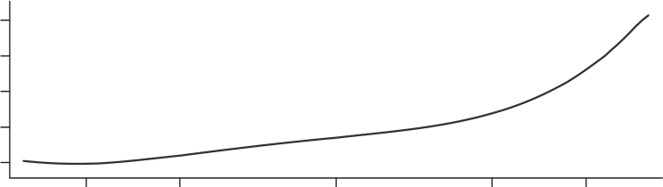
 | 10 | 25 | 50 | 75 | 90
Input growth (percentile)
FIGUREVIII
TFPRandInputGrowth
Indiafacegreaterbarrierstoreallocationasopposedtobigger shockswiththesamecostsofreallocation.
FigureVIIrelatedaverageTFPRtoplantage.Arelatedhy-pothesisisthatyoung(orsmall)plantsdisplaygreaterdisper-sionofTFPR.IfplantsinChinaorIndiaareyoungerorsmaller thanU.S.plants,therefore,thenonemightexpectthemtodis-playmorevariableTFPR.TableXIVprovidestheageofthe25th, 50th,and75thpercentileplantsineachcountry.Chineseplants

1440 QUARTERLYJOURNALOFECONOMICS
TABLEXIV
DISTRIBUTIONOFPLANTAGE(PERCENTILES)
 | 25th | 50th | 75th
China | 2 | 5 | 22
India | 6 | 12 | 22
UnitedStates | 5 | 10 | 25
Notes.Entriesarethe25th,50th,and75thpercentiledistributionofplantageinasector,whereeach sectorisweightedbythevalue-addedshareofthesector.
(medianagefiveyears)areyoungerthanU.S.plants(medianage tenyears),butIndianplantsareolder(medianagetwelveyears). FigureIXplotsthesize(employment)distributionofplantsin allthreecountries.Indianplants(mediansize33employees)are smallerthanU.S.plants(mediansize47employees),butChi-neseplants(mediansize160employees)aremuchlargerthan U.S.plants.Whenwesplitplantsintoquartilesofsizeandage (respectively)andequalizeTFPRonlywithinquartiles,thegains areabout5%lowerforbothChinaandIndia.Thusvariationin TFPRbysizeandageexplainsonlyamodestamountoftheoverall dispersioninTFPR(seeTableIII).
VII.C.UnobservedInvestments
LowTFPRmightreflectlearningbydoingorotherunob-servedinvestments(R&D,buildingacustomerbase)ratherthan distortions.Ifso,thenweexpectlow-TFPRplantstoexhibithigh subsequentTFPQgrowth.FigureXdisplayspreciselythispat-ternintheUnitedStates,buttheoppositepatterninChinaand India.Thusitisfarfromobviousthatunobservedplantinvest-mentsvarymoreinChinaandIndiathanintheUnitedStates.If TFPQgrowthdoesproxyforunobservedinvestments,thenFigure XsuggeststhatsuchinvestmentsmaymitigateTFPRdifferences inChinaandIndia.
Perhapsrelated,TFPRdifferencesaremoretransitoryinthe UnitedStatesthaninChinaandIndia(seethe“IV”resultsdis-cussedneartheendofSectionV).U.S.TFPRdifferencesmay largelyreflecttemporarydifferencesininvestmentsandadjust-mentcosts,whereasTFPRdifferencesinChinaandIndiamay reflectmorepersistent,perhapspolicy-relatedgapsthatarenot asreliablyclosedwithsubsequentinputreallocationandTFPQ growth.

0.25  0.2  0.15  0.1  0.05  0  0.25  0.2  0.15  0.1  0.05  0  0.25  0.2  0.15  0.1  0.05  0 | MISALLOCATIONANDTFPINCHINAANDINDIA |  |  |  |  |  |  |  | 1441
India
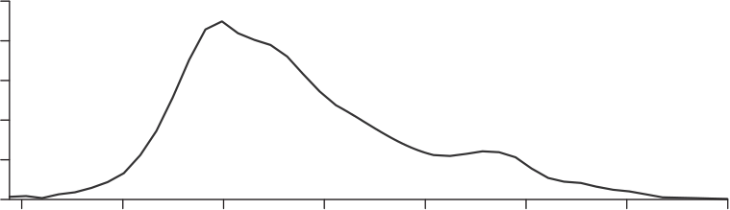
 | 1 | 4 | 16 | 64 | 256 | 1,024 | 4,096 |  | 16,384
China
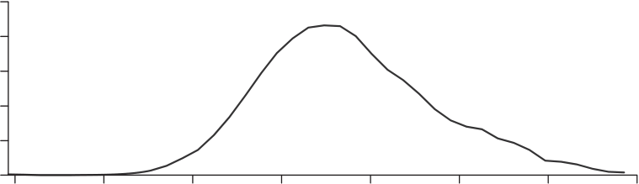
 | 1 | 4 | 16 | 64 | 256 | 1,024 | 4,096 |  | 16,384
United States
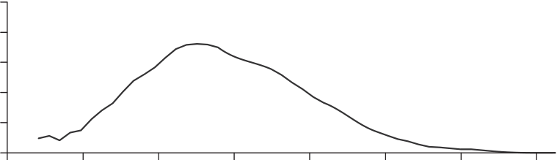
 | 1 | 4 | 16 | 64 | 256 | 1,024 | 4,096 | 16,384
FIGUREIX
DistributionofNumberofWorkers
VII.D.VaryingCapitalShareswithinIndustries
OurbaselineestimatesinTableVIassumedthesamecapital elasticityforallplantswithinafour-digitindustry.Weinferred relativedistortionsfromvariationincapital-laborratioswithin industries.Attheotherextreme,onecouldattributeallvariation intheseratioswithinindustriestoplant-specificcapitalshares. DoingsoandrecalculatingtheTFPgains,wefindthemajorityof thegainsinChinaandIndiarelativetotheUnitedStatesstem fromoutputdistortions.Withplant-specificcapitalshares,TFP

1442 QUARTERLYJOURNALOFECONOMICS
India
0.6  0.4  0.2  0  −0.2  −0.4 | 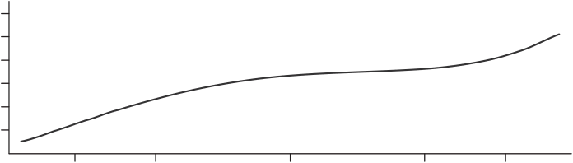
 | 10 | 25 | 50 | 75 | 90
China
log TFPR | 0.6 | 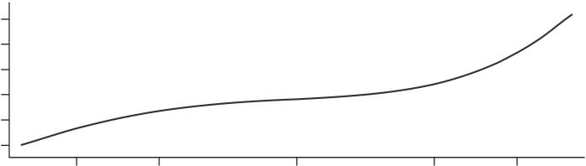
 | 0.4
 | 0.2
 | −0.2
 | −0.4
 |  | 10 | 25 | 50 | 75 | 90
United States
0.6  0.4  0.2  0  −0.2  −0.4 | 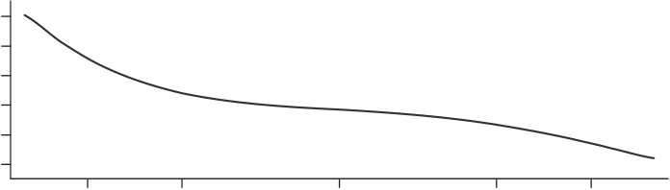
 | 10 | 25 | 50 | 75 | 90
TFPQ growth (percentile)
FIGUREX
TFPRandTFPQGrowth
gainsarestill23%–45%(vs.30%–50%baseline)forChinaand 32%–39%(vs.40%–60%baseline)forIndia.
VIII.CONCLUSION
Alongstreamofpapershasstressedthatmisallocationof inputsacrossfirmscanreduceaggregateTFPinacountry.We usedmicrodataonmanufacturingplantstoinvestigatethepos-sibleroleofsuchmisallocationinChina(1998–2005)andIndia (1987–1994)comparedwiththeUnitedStates(1977,1987,1997).

MISALLOCATIONANDTFPINCHINAANDINDIA 1443
Viewingthedatathroughtheprismofastandardmonopolistic competitionmodel,weestimateddifferencesinmarginalprod-uctsoflaborandcapitalacrossplantswithinnarrowlydefined industries.WefoundmuchbiggergapsinChinaandIndiathan intheUnitedStates.Wethenentertainedacounterfactualmove byChinaandIndiatotheU.S.dispersionofmarginalproducts. WefoundthatthiswouldboostTFPby30%–50%inChinaand by40%–60%inIndia.Roomforreallocationgainsshrankabout 2%peryearfrom1998–2005inChina,asifreformstherereaped someofthegains.InIndia,despitereformsintheearly1990s,we reportevidenceofrisingmisallocationfrom1991to1994.
Ourresultsrequiremanycaveats.Therecouldwellbegreater measurementerrorintheChineseandIndiandatathaninthe U.S.data.Thestaticmonopolisticcompetitionmodelwedeploy couldbeapoorapproximationofallthreecountries.Althoughwe providedreassuringevidenceontheseconcerns,ourinvestigation wasverymuchafirstpass.Inadditiontoinvestigatingtheseis-suesmorefully,futureworkcouldtrytorelatedifferencesinplant productivitytoobservablepolicydistortionsmuchmorethanwe have.Finally,weneglectedthepotentialimpactofdistortionson plantentryandexit,animportanttopicforfutureresearch.
APPENDIXI:LUCASSPAN-OF-CONTROLVERSION
Inthemaintextwemodeledmanufacturingplantsasmo-nopolisticcompetitors,andrelatedtheelasticityofsubstitution betweenvarietiestoalargeempiricalliterature.However,many modelers,suchasRestucciaandRogerson(2008),followLucas (1978)inpositingdiminishingreturnsinproductionratherthan utility.Hereweshowhowthetwoformulationsareisomorphicfor aggregateTFPforagivennumberofplantsandaggregatelabor input.
Supposelaboristhesoleinputandthereisasinglesector. Theequationsforaggregateoutput,firmoutput,andfirmprofits foreachvarietyare
M
Y=�Yi,
i=1
Yi=AiLγ i,
πi=(1−τi)PYi−wLi.

1444 QUARTERLYJOURNALOFECONOMICS
Returnstoscaleequalγ,andPisthepriceofhomogeneousoutput. TFP(=Y/Lhere)is
TFP= | ⎡M  �  ⎣ | � | � | TFPR | �� | 1−γ⎤ | 1−γ� | L1−γ.
 |  | TFPQi |  |  |  | ⎦
 |  |  |  | TFPRi
 | i=1
HereTFPQi=AiandTFPRi=1/(1−τi).Thisisthesameas ourexpressioninthemaintext,exceptfortwodifferences.First, 1/(1−γ)takestheplaceof(σ−1).Diminishingreturnsinpro-duction(γ<1)playthesameroleasdiminishingreturnsinutility (σ<∞).Second,aggregateTFPisnowdecreasinginaggregate laborinput.Ifthenumberofplantsisproportionaltolaborinput, thensuchaggregatedecreasingreturnsdisappear.Ofcourse,a varietybenefitwouldthenexistintheCESformulation.Interms ofourcalibration,ourconservativechoiceofσ=3correspondsto γ=0.5.Thisisquitelow,evencomparedtostudiessuchasAtke-sonandKehoe(2005),whochoseγ≥0.8basedondiminishing returnsinbothproductionandutility.
APPENDIXII:GENERALIZINGTFPQFORQUALITYANDVARIETY
HerewesketchhowourmeasureofTFPQshouldcapture notonlyprocessefficiencybutalsofirmdifferencesinquality andvariety(equivalently,idiosyncraticdemand).Forsimplicity, supposelaboristhesoleinputandthereisasinglesector.The equationsforaggregateoutput,firmoutput,andfirmprofitsfor eachvarietyare
Y= | �M  � | Ni(QiYi/Ni) | σ−1  σ | � | σ  σ−1 | ,
i=1
Yi=AiLi,
πi=(1−τi)PiYi−wLi.
HereNiisthenumberofsymmetricvarietiesthefirmproduces,Qi
isthesymmetricqualityofeachofitsvarieties,Aiisitsprocess efficiency,Yi/Niisthesymmetricquantityitproducesofeach variety,andPiisthesymmetricpriceofeachvariety.Forthis economy,ourmethodofmeasuringTFPQyields
σ  TFPQi=(PiYi) σ−1/Li  Y σ−1P σ−1 | =AiQiN iσ−1 | .

MISALLOCATIONANDTFPINCHINAANDINDIA 1445
MeasuredTFPQisacompositeofprocessefficiencyandidiosyn-craticdemandtermscomingfromqualityandvariety.Aggregate TFP(=Y/Lhere)isidenticaltothecaseinwhichfirmsvaryonly inprocessefficiency,onlywiththeabovemeasureofTFPQ:
TFP=TFPQ= | ⎧M  ⎨� |  | � | � | TFPR | ��σ−1⎫  ⎬ | 1 | .
 |  |  |  |  |  |  | σ−1
 |  |  | TFPQi
 |  |  |  |  | TFPRi
 | ⎩ | i=1 |  |  |  | ⎭
TFPRisasinthemaintext,onlyhereitreducestothesingle distortion,TFPRi=1/(1−τi).NotethataggregateTFP(effective outputperworker)isalsosynonymouswithwelfare.
APPENDIXIII:LABORANDCAPITALDISTORTIONS
Inthemaintextweestimateddistortionstooutput(τYsi) andtocapitalrelativetolabor(τKsi),respectively.Anobserva-tionallyequivalentcharacterizationisintermsofdistortionsto theabsolutelevelsofcapitalandlabor.Denoteleveldistortions asτ∗Lsiandτ∗Ksi,andprofitsasπsi=PsiYsi−(1+τ∗Lsi)wLsi−(1+
τ∗Ksi)RKsi.Thefirm’sfirst-orderconditionsareidenticaltothose
with{τYsi,τKsi}assuming1−τYsi=1/(1+τ∗Lsi)and1+τKsi=
(1+τ∗Ksi)/(1+τ∗Lsi).SectoralTFPisidenticalunderthesecondi-
tionsaswell.
Wedenotedeviationsofplantvariablesfromindustry-weightedmeansas
�Asi=lnAsi  ¯As |  | ,�τ∗Lsi=ln1+τ∗Lsi  1+¯τ∗Ls |  | ,�τ∗Ksi=ln1+τ∗Ksi  1+¯τ∗Ks | ,
�Lsi=ln | wLsi |  | .
 | �Ms i=1wLsi/Ms
ForthelatestyearsinChinaandIndia,thecorrelationma-tricesofthesevariablesareshowninTableA.1.Notsurprisingly, plantswithhighTFPQtendtohavehighlaborinput.Morein-teresting,plantswithhighTFPQtypicallyfacehigher“taxes”on bothcapitalandlabor.Thedistortionsdiscouragelaborinput,but notstrongly,because,again,thedistortionstendtobehighwhen TFPQwoulddictatehighlaborinput.Laborandcapitalwedges arepositivelycorrelatedacrossplants,butonlymodestlyso. Herewecanentertainthethoughtexperimentofeliminating variationinthecapitalorlabordistortionindividually.Forthe latestyearinChina,theTFPgainsfromeliminatingthecapital

1446 QUARTERLYJOURNALOFECONOMICS
TABLEA.1
 |  | China2005 |  |  | India1994
 | �Asi | �τ∗  Lsi | �τ∗  Ksi | �Asi | �τ∗  Lsi | �τ∗  Ksi
�Lsi | 0.518 | −0.202  1 | −0.074  0.201 | 0.690 | 0.010 | −0.038  0.004
�τ∗  Lsi | 0.532 |  |  | 0.538 | 1
�τ∗  Ksi | 0.592 | 0.201 | 1 | 0.398 | 0.004 | 1
(labor)distortionaloneare60%(24%)comparedto87%fromelim-inatingbothdistortions.InIndia,thegainsfromeliminatingthe capital(labor)distortionaloneare78%(33%)comparedto128% fromeliminatingbothdistortions.
UNIVERSITYOFCHICAGOBOOTHSCHOOLOFBUSINESSANDNBER STANFORDUNIVERSITY,SIEPR,SCID,ANDNBER
REFERENCES
Aghion,Philippe,RobinBurgess,StephenRedding,andFabrizioZilibotti,“The UnequalEffectsofLiberalization:EvidencefromDismantlingtheLicense RajinIndia,”AmericanEconomicReview,98(2008),1397–1412.
Alfaro,Laura,AndrewCharlton,andFabioKanczuk,“Plant-SizeDistribution andCross-CountryIncomeDifferences,”NBERWorkingPaperNo.w14060, 2008.
Allen,Franklin,RajeshChakrabarti,SankarDe,Jun“QJ”Qian,andMeijunQian, FinancingFirmsinIndia,manuscript,UniversityofPennsylvania,2007. Atkeson,AndrewG.,andPatrickJ.Kehoe,“ModelingandMeasuringOrganiza- tionalCapital,”JournalofPoliticalEconomy,113(2005),1026–1053. Banerjee,Abhijit,andEstherDuflo,“GrowthTheorythroughtheLensofDevelop- mentEconomics,”inHandbookofEconomicGrowth,Vol.1A,P.Aghionand S.Durlauf,eds.(Amsterdam:Elsevier,2005,Chap.7).
Barro,Robert,J.,andJong-WhaLee,“InternationalDataonEducationalAttain- ment:UpdatesandImplications,”NBERWorkingPaperNo.w7911,2000. Bartelsman,Eric,JohnHaltiwanger,andStefanoScarpetta,Cross-CountryDiffer- encesinProductivity:TheRoleofAllocativeEfficiency,manuscript,University ofMaryland,2008.
Bergoeing,Raphael,PatrickJ.Kehoe,TimothyJ.Kehoe,andRaimundoSoto, ReviewofEconomicDynamics,5(2002),166–205.
Besley,Timothy,andRobinBurgess,“CanLaborRegulationHinderEconomicPer- formance?EvidencefromIndia,”QuarterlyJournalofEconomics,119(2004), 91–134.
Bosworth,Barry,andSusanM.Collins,“AccountingforGrowth:ComparingChina andIndia,”NBERWorkingPaperNo.w12943,2007.
Broda,Christian,andDavidE.Weinstein,“GlobalizationandtheGainsfrom Variety,”QuarterlyJournalofEconomics,121(2006),541–585.
Buera,Francisco,andYongseokShin,FinancialFrictionsandthePersistenceof History:AQuantitativeExploration,manuscript,UniversityofCalifornia, LosAngeles,2008.
Caselli,Francesco,“AccountingforIncomeDifferencesacrossCountries,”inHand- bookofEconomicGrowth,Vol.1A,P.AghionandS.Durlauf,eds.(Amsterdam: Elsevier,2005,Chap.9).

MISALLOCATIONANDTFPINCHINAANDINDIA 1447
Caselli,Francesco,andNicolaGennaioli,“DynasticManagement,”NBERWorking PaperNo.w9442,2003.
Chari,V.V.,PatrickJ.Kehoe,andEllenC.McGrattan,“BusinessCycleAccount- ing,”Econometrica,75(2007),781–836.
Cooper,RussellW.,andJohnC.Haltiwanger,“OntheNatureofCapitalAdjust- mentCosts,”ReviewofEconomicStudies,73(2006),611–633.
Dobson,Wendy,andAnilK.Kashyap,“TheContradictioninChina’sGradual- istBankingReforms,”BrookingPapersonEconomicActivity,2(2006),103– 148.
Dollar,David,andShang-jinWei,“Das(Wasted)Kapital:FirmOwnershipand InvestmentEfficiencyinChina,”NBERWorkingPaperNo.w13103,2007. TheEconomist,“Survey:BusinessinIndia,”June3,2006a.Availableonlineat http://www.economist.com/surveys/displayStory.cfm?storyid=6969740.——,“Survey:China,”May23,2006b.Availableonlineathttp://www.economist .com/surveys/displayStory.cfm?storyid=5623226.
Farrell,Diana,andSusanLund,“China’sandIndia’sFinancialSystems:ABarrier toGrowth,”McKinseyQuarterly,November(2006),1–12.
Foster,Lucia,JohnHaltiwanger,andChadSyverson,“Reallocation,Firm Turnover,andEfficiency:SelectiononProductivityorProfitability?”Amer- icanEconomicReview,98(2008),394–425.
Galindo,Arturo,FabioSchiantarelli,andAndrewWeiss,“DoesFinancialLiberal- izationImprovetheAllocationofInvestment?Micro-EvidencefromDevelop- ingCountries,”JournalofDevelopmentEconomics,83(2007),562–587. Guner,Nezih,GustavoVentura,andYiXu,“MacroeconomicImplicationsofSize- DependentPolicies,”ReviewofEconomicDynamics,11(2008),721–744. Hall,RobertE.,andCharlesI.Jones,“WhyDoSomeCountriesProduceSoMuch MoreOutputperWorkerThanOthers?”QuarterlyJournalofEconomics,114 (1999),83–116.
Hallward-Driemeier,Mary,GiuseppeIarossi,andKennethL.Sokoloff,“Exports andManufacturingProductivityinEastAsia:AComparativeAnalysiswith Firm-LevelData,”NBERWorkingPaperNo.w8894,2002.
Hendel,Igal,andAvivNevo,“MeasuringtheImplicationsofConsumerInventory Behavior,”Econometrica,74(2006),1637–1673.
Hopenhayn,Hugo,andRichardRogerson,“JobTurnoverandPolicyEvaluation: AGeneralEquilibriumAnalysis,”JournalofPoliticalEconomy,101(1993), 915–938.
Howitt,Peter,“EndogenousGrowthandCross-CountryIncomeDifferences,”Amer- icanEconomicReview,90(2000),829–846.
Klenow,PeterJ.,andAndr´esRodr´ıguez-Clare,“TheNeoclassicalRevivalin GrowthEconomics:HasItGoneTooFar?”inNBERMacroeconomicsAnnual, B.BernankeandJ.Rotemberg,eds.(Cambridge,MA:MITPress,1997).——,“ExternalitiesandEconomicGrowth,”inHandbookofEconomicGrowth,Vol. 1A,P.AghionandS.Durlauf,eds.(Amsterdam:Elsevier,2005,Chap.11). Kochar,Kalpana,UtsavKumar,RaghuramRajan,ArvindSubramanian,andIoan- nisTokatlidis,“India’sPatternofDevelopment:WhatHappened,WhatFol- lows,”NBERWorkingPaperNo.w12023,2006.
Lagos,Ricardo,“AModelofTFP,”ReviewofEconomicStudies,73(2006),983–1007. Lewis,WilliamW.,ThePowerofProductivity:Wealth,Poverty,andtheThreatto GlobalStability(Chicago:UniversityofChicagoPress,2004).
Lucas,RobertE.,Jr.,“OntheSizeDistributionofBusinessFirms,”BellJournal ofEconomics,9(1978),508–523.
McKinseyGlobalInstitute,Productivity:TheKeytoanAcceleratedDevelopment PathforBrazil(Washington,DC:McKinseyGlobalInstitute,1998).
Melitz,MarcJ.,“TheImpactofTradeonIntra-IndustryReallocationsandAggre- gateIndustryProductivity,”Econometrica,71(2003),1695–1725.
Melitz,MarcJ.,andGianmarcoI.P.Ottaviano,“MarketSize,Trade,andProduc- tivity,”ReviewofEconomicStudies,75(2008),295–316.
Mohan,Rakesh,“SmallScaleIndustryinIndia:ACriticalEvaluation,”inEco- nomicPolicyReformsandtheIndianEconomy,AnneKrueger,ed.(Chicago: UniversityofChicagoPress,2002).
Parente,StephenL.,andEdwardC.Prescott,BarrierstoRiches(Cambridge,MA: MITPress,2000).

1448 QUARTERLYJOURNALOFECONOMICS
Restuccia,Diego,andRichardRogerson,“PolicyDistortionsandAggregatePro- ductivitywithHeterogeneousPlants,”ReviewofEconomicDynamics,11 (2008),707–720.
Young,Alwyn,“TheRazor’sEdge:DistortionsandIncrementalReforminthe People’sRepublicofChina,”QuarterlyJournalofEconomics,115(2000),1091– 1135.
——,“GoldintoBaseMetals:ProductivityGrowthinthePeople’sRepublicof ChinaduringtheReformPeriod,”JournalofPoliticalEconomy,111(2003), 1220–1261.

