Ren Junyan (NUID: 001529948)
INFO 6205
Program Structures & Algorithms
Fall 2020
Assignment No2

Note: I’m so sorry that I cannot run the sort method normally in InsertionSort.java. So, to ensure I can still complete part3 task, I write another class named InsertionSort included in package RealTest in my project, which can run normally with data of time of random array sorted by insertion sort. So this report is based on that file’s data.
- Task:
Measure the running times of this sort, using four different initial array ordering situations: random, ordered, partially-ordered and reverse-ordered. Use the doubling method for choosing n and test for at least five values of n. Draw any conclusions from your observations regarding the order of growth.

- Output:
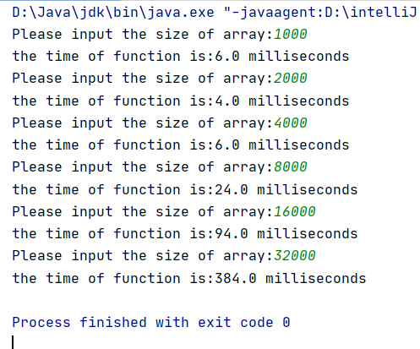

- Relationship conclusion:
It can be observed that running time(T) will surge while input size(N) grows doubly. And also their log-log plot shows their positive relationship based on a line.

- Evidence to support relationship:
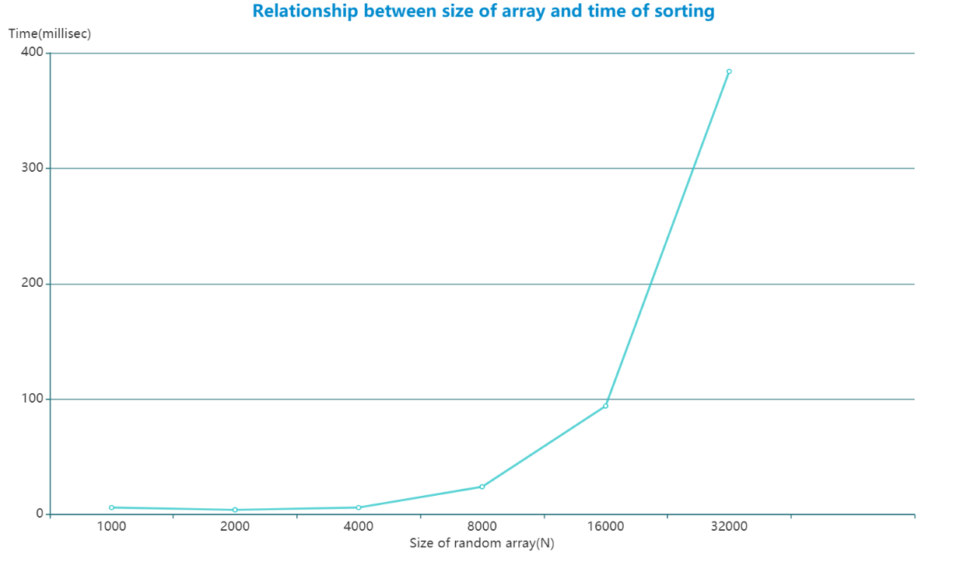
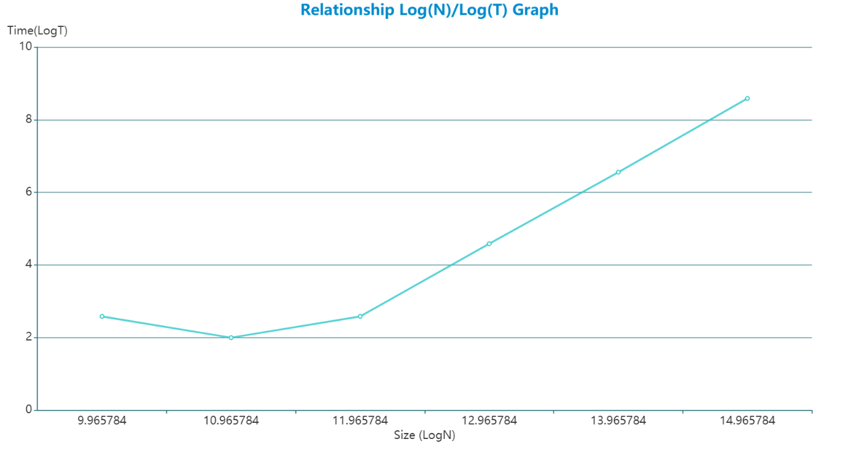

- Screenshot of Unit test passing:
