|  |  |
| --- | --- |
| **DOCUMENT RULES:** | |
| **Task Number / Name:** | **Task 7 / Building docker images (Building your own app in Docker) - Building Containers** |
| **Task name & column name should be written:** | **Bold (CTRL+B)** |
| **Commands should be written in the after # sign:** | *Italic (CTRL+I) #hostname* |
| **Output photo should be cropped or compressed:**  **Photo could be more than one:**  **If you need extra lines, add the line next after it:** | ***Description photo should be with title bar (CTRL + I + B)*** |
| **All other text should be written:** | Standard |
| **Font name and text size:** | Calibri and 9 |
| **Group name:** | Dev_ops_ |
| **Student name and surname:** | Rəna İsgəndərova |
| **E-mail:** | Rena.isgenderova27@gmail.com |
| **WhatsApp number:** |  |

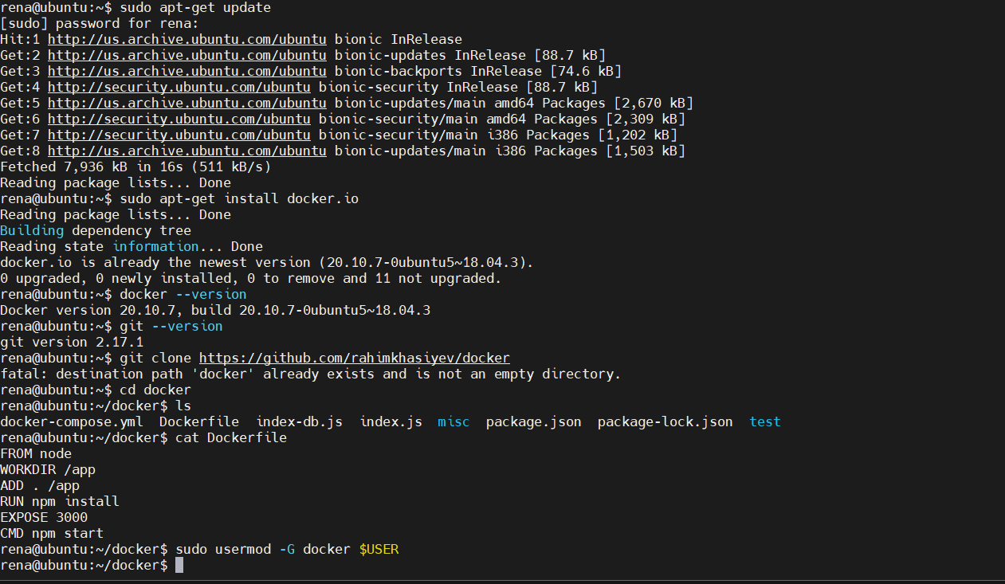

|  |  |  |
| --- | --- | --- |
| **#** | **Task names** | **Command steps and outputs** |
| **1** | 1. **Lab requirements:**   **-We need Ubuntu VM on Desktop Hypervisor with Snapshoot**  **- MobaXterm terminal Client software should access to guest VM** | Ubuntu 18.04 Bionic Beaver mini.iso |
| **2** | 1. **Check status of firewall and take screenshot of the CLI output.** 2. **If firewall is not installed left it as have.** 3. **Give permanent SSH access from.** 4. **SSH virtual port is 22. If SSH server is not installed, please install it.** 5. **To be check connectivity use commands.** 6. **Update the system and application.** | **For instance: start**, **stop**, **enable**, **disable, status**  *# firewall-cmd –state*  #*ping x.x.x.x*  *#telnet x.x.x.x 22*  *#sudo apt-get update* |
|  | 1. **First install docker** | *#sudo apt-get install docker.io* |
|  | 1. **Check Docker version** | *#Docker --version* |
|  | 1. **Check git version if not installed it** | **#git --version** |
|  | 1. **Download file from gihub web site use this command** | **#git clone https://github.com/rahimkhasiyev/docker -> hit enter** |
|  | 1. **Go to the directory** | **#cd docker -> hit enter** |
|  | 1. **List file names** | **# ls -> hit enter** |
|  | 1. **Look at the Dockerfile** | **#cat Dockerfile** |
|  | 1. **Please add current user to docker group.** | *#sudo usermod -G docker $USER -> hit enter*  *Log out and login please #logout ->hit enter*  *And #cd docker ->hit enter* |
|  | 1. **For Execute docker build command** | *#Docker build .* |
|  |  |  |
|  |  |  |
|  |  |  |

