

Assessing Speaking Performance – Level B2

# Examiners and speaking assessment in the B2 First exam

Speaking tests are conducted by trained examiners. The quality assurance of Speaking Examiners (SEs) is managed by Team Leaders (TLs) who are in turn responsible to a Professional Support Leader (PSL), who is the professional representative of Cambridge English Language Assessment for the Speaking tests in a given country or region.

All of the examiners (PSLs, TLs and SEs) must prove each year, through a certification process, that they are competent to assess. In addition, they are regularly monitored during live testing sessions.

Although candidates take the test in pairs or groups of three, throughout the test they are assessed on their individual performance and not in relation to each other. They are awarded marks by two examiners: an *assessor* and an *interlocutor*.

The *interlocutor* awards a mark for the performance as a whole, using the Global Achievement scale.

The *assessor* awards marks for four individual criteria:

* Grammar and Vocabulary
* Discourse Management
* Pronunciation
* Interactive Communication.

# How can I use the Assessment Scales?

Examiners use the B2 Level Assessment Scales to decide which marks to give candidates taking the B2 First Speaking test. Using the scales yourself during classroom speaking practice tasks will help you to:

* analyse your students’ strengths and weaknesses when they do B2 First Speaking tasks
* form an impression of how ready your students are to take the Speaking test.

# The Assessment Scales

The B2 First Assessment Scales are divided into six bands from 0 to 5, with 0 being the lowest and 5 the highest. Descriptors for each criterion are provided for bands 1, 3 and 5 and indicate what a candidate is expected to demonstrate at each band. B2 First is at Level B2 of the Common European Framework of Reference (CEFR), and the descriptors for band 3 and above generally indicate performance of at least B2 level.

© UCLES 2008. This material may be photocopied (without alteration) and distributed for classroom use provided no charge is made. For f urther information see ou[r **Terms and Conditions**](http://www.cambridgeenglish.org/footer/terms-and-conditions/).

1

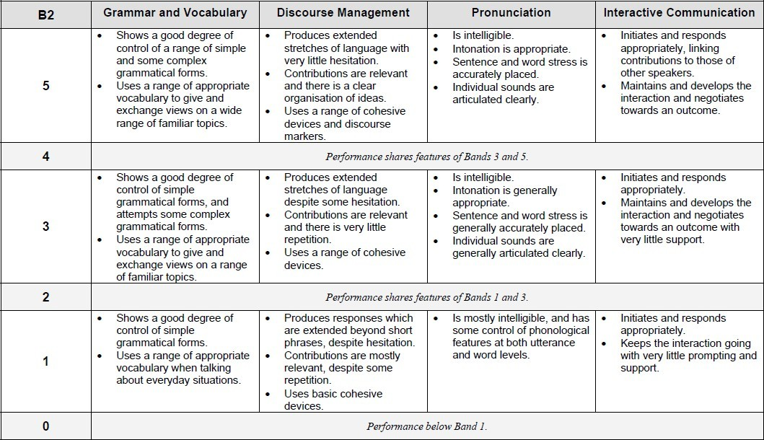

As you look through the scales, it may help to highlight words which make one band different from another.

For example, under Grammar and Vocabulary, half of the first descriptor at Band 3 is the same as at Band 1 – *Shows a good degree of control of simple grammatical forms.* Band 3, however, has an additional element: *… and attempts some complex grammatical forms.* At Band 5, the new elements are: *a range of simple grammatical forms*, and *control of … some complex grammatical forms.*

Don’t worry if a lot of the terms used in the scales are new to you – in the Handbook for Teachers you will find a Glossary of Terms for Speaking.

Although all four analytical criteria are assessed across the whole test, Part 2 (the long turn) is the main opportunity for examiners to assess Discourse Management, and Part 3 tends to be when they focus most on Interactive Communication.

# How can I use the Assessment Scales with students?

You could:

1. Refer to the scales as you observe students carrying out a B2 First speaking task.
2. Note down examples of performance in terms of the listed criteria.
3. Give students feedback on their strengths and weaknesses.
4. Think about whether your students are ready for the exam and how they could improve.

However, it can be difficult for a teacher to manage a speaking practice task (i.e. be the interlocutor), make notes of what the students say and refer to the Assessment Scales, all at the same time. The following activities are designed to help you get started.

On the Cambridge English TV YouTube channel there is a video recording of two candidates called Camilla and Johanna taking the B2 First Speaking test. Please note that this example is for the pre-January 2015 version of B2 First exam.

You can click on this link to watch the test:

[***https://www.youtube.com/watch?v=nIp8FVs8-f0***](https://www.youtube.com/watch?v=nIp8FVs8-f0)

*The four activities use this recording to practise using the Assessment Scales.*

## Activity 1

1. Make a copy of the blank **Grammar and Vocabulary** table on page 4. You will see that statements from the Assessment Scales have been turned into questions.
2. Watch the B2 First Speaking video part 1 (about 3½ minutes)*.*
3. Note down examples of what Camilla does well and not so well for each of the questions in the Comments box on the assessment sheet.
4. Compare the notes you have made with a completed example on page 8.

## Activity 2:

1. Make a copy of the blank **Discourse Management** table on page 5.
2. Watch the B2 First Speaking video part 2 (from about 3 mins 25 to 7 mins)*.*
3. Note down examples of what Johanna does well and not so well for each of the questions in the Comments box on the assessment sheet.
4. Compare the notes you have made with a completed example on page 9.

## Activity 3:

1. Make a copy of the blank **Pronunciation** table on page 6.
2. Watch the B2 First Speaking video (from about 10 mins 30 to the end)*.*
3. Note down examples of what Camilla does well and not so well for each of the questions in the Comments box on the assessment sheet.
4. Compare the notes you have made with a completed example on page 10.

## Activity 4:

1. Make a copy of the blank **Interactive Communication** table on page 7.
2. Watch the B2 First Speaking video (from about 7 mins to 10 mins 30)*.*
3. Note down examples of what Johanna does well and not so well for each of the questions in the Comments box on the assessment sheet.
4. Compare the notes you have made with a completed example on page 11.

# Remember:

* In a real B2 First Speaking test the marks awarded reflect a candidate’s performance across the whole exam and not just in one part of it. As you become more familiar with the assessment criteria and gain more experience in analysing your students, you will find it easier to focus on all of the criteria during classroom practice tasks.
* Being able to refer to the Assessment Scales will help you to analyse your students’ strengths and weaknesses and to estimate whether they are ready for the Speaking

test. However, it won’t necessarily give you an accurate prediction of the marks that your students will achieve in a real test, as the candidate may be affected by other factors such as nervousness.

|  |  |
| --- | --- |
| **B2 First (LEVEL B2) SPEAKING**  **GRAM MAR & VOCABULARY** | |
| **Name of student** | |
| **Does the speaker use simple grammatical forms with control?** | |
| **Good** | **Not so good** |
| **Does the speaker use complex grammatical forms?** | |
| **Good** | **Not so good** |
| **Does the speaker use a range of appropriate vocabulary? (everyday situations / familiar topics / wide range of familiar topics?)** | |
| **Good** | **Not so good** |
| **Comments** | |

|  |  |
| --- | --- |
| **B2 First (LEVEL B2) SPEAKING**  **DISCOURSE MANAGEM ENT** | |
| **Name of student** | |
| **Are the answers of an appropriate length for the task? Is there much hesitation?** | |
| **Good** | **Not so good** |
| **Are the contributions relevant? Is there much repetition? Is it well organised?** | |
| **Good** | **Not so good** |
| **Does the speaker use a range of cohesive devices? And discourse markers?** | |
| **Good** | **Not so good** |
| **Comments** | |

|  |  |
| --- | --- |
| **B2 First (LEVEL B2) SPEAKING**  **PRONUNCIATION** | |
| **Name of student** | |
| **Are the answers clear? Can the speaker be generally understood?** | |
| **Good** | **Not so good** |
| **Is the speaker’s intonation appropriate?** | |
| **Good** | **Not so good** |
| **Does the speaker use sentence stress correctly? Is word stress correct?** | |
| **Good** | **Not so good** |
| **Are individual sounds clear? Are they correctly produced?** | |
| **Good** | **Not so good** |
| **Comments** | |

|  |  |
| --- | --- |
| **B2 First (LEVEL B2) SPEAKING**  **INTERACTIVE COMM UNICATION** | |
| **Name of student** | |
| **Does the speaker start discussions? Does the speaker introduce new ideas?** | |
| **Good** | **Not so good** |
| **Does the speaker react appropriately to what the interlocutor or other candidate says?** | |
| **Good** | **Not so good** |
| **Does the speaker try to move the interaction in an appropriate direction? (‘develop the interaction and negotiate towards an outcome’) Does the speaker need support?** | |
| **Good** | **Not so good** |
| **Comments** | |

|  |  |
| --- | --- |
| **B2 First (LEVEL B2) SPEAKING**  **Active Listening** | |
| **Name of student** | |
| **Does the speaker respond actively? Does the speaker give feedback as the listener?** | |
| **Good** | **Not so good** |
| **Does the speaker have the ability of conducting collaborative finishes or reactive tokens?** | |
| **Good** | **Not so good** |
| **Does the speaker could take the turn at suitable time in the conversation?** | |
| **Good** | **Not so good** |
| **Does the speaker try to move the interaction in an appropriate direction? (‘develop the interaction and negotiate towards an outcome’) Does the speaker need support?** | |
| **Good** | **Not so good** |
| **Comments** | |