Lab Activities:
Part 1: Capturing HTTP Traffic.
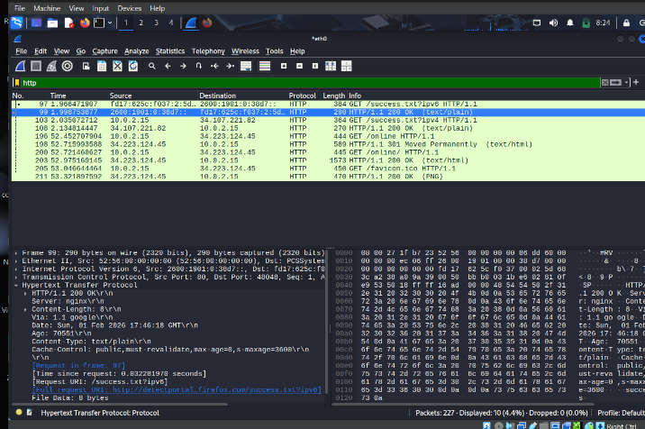
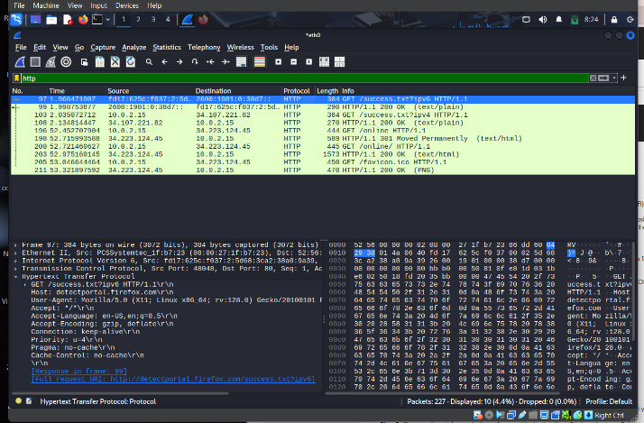

Part 2: Analyzing TCP/IP Traffic.
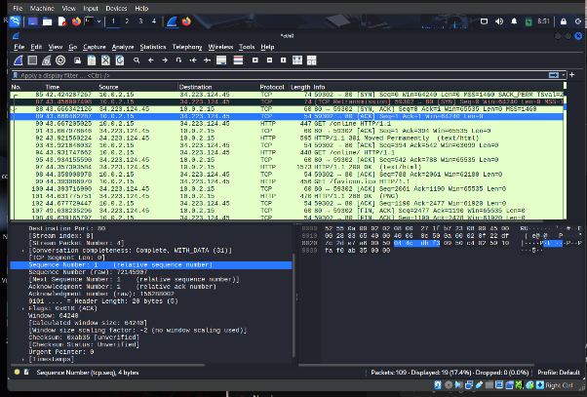
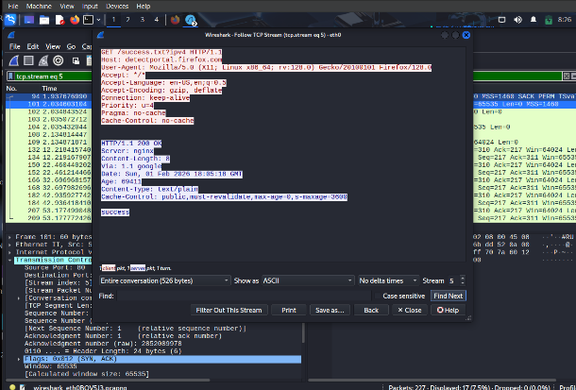

Part 3: Capturing and Analyzing UDP Traffic
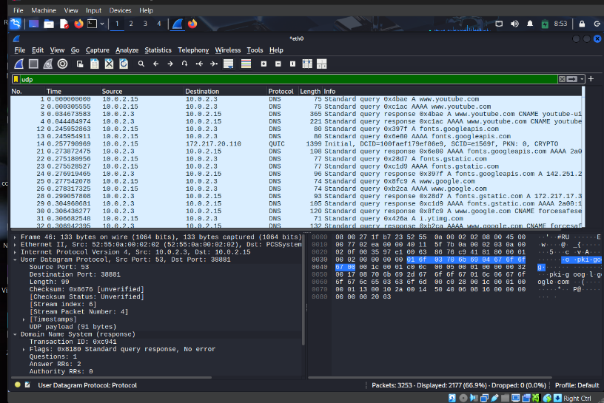

Part 4: Comparing TCP and UDP by filling in the following tables. Save your work (e.g., in an MS Word document), and upload it to your online git repo.
Task 1: Fill in the following table and provide reasons.

 | TCP or UDP | Reasons
Reliability and Connection Establishment | TCP | TCP is connection-oriented and establishes a connection using a three-way handshake. It ensures reliable data delivery by retransmitting lost packets.
Data Integrity and Ordering | TCP | TCP guarantees data integrity and ensures packets are delivered in the correct order using sequence numbers and error checking.

Task 2: Identify the use Cases and Performance of TCP and UDP.

 | TCP | UDP
Use cases | Web browsing (HTTP/HTTPS), Email (SMTP), File transfer (FTP), Remote login (SSH) | Video streaming, Online gaming, Voice calls (VoIP), DNS
Performance | Slower than UDP due to connection setup, error checking, and retransmissions, but very reliable | Faster and more efficient with lower latency, but less reliable since it does not guarantee delivery

