**Task #1**

**Create a repository on GitHub called “web development training” and please add me and Nadeem, then download web storm to push your code on your repository**

[**amsalam@asaltech.com**](mailto:amsalam@asaltech.com) **and nalherbawi@asaltech.com**

**Design a web page as shown below you can use any online tools to know the specific colour of each part to use it on hexadecimal format**

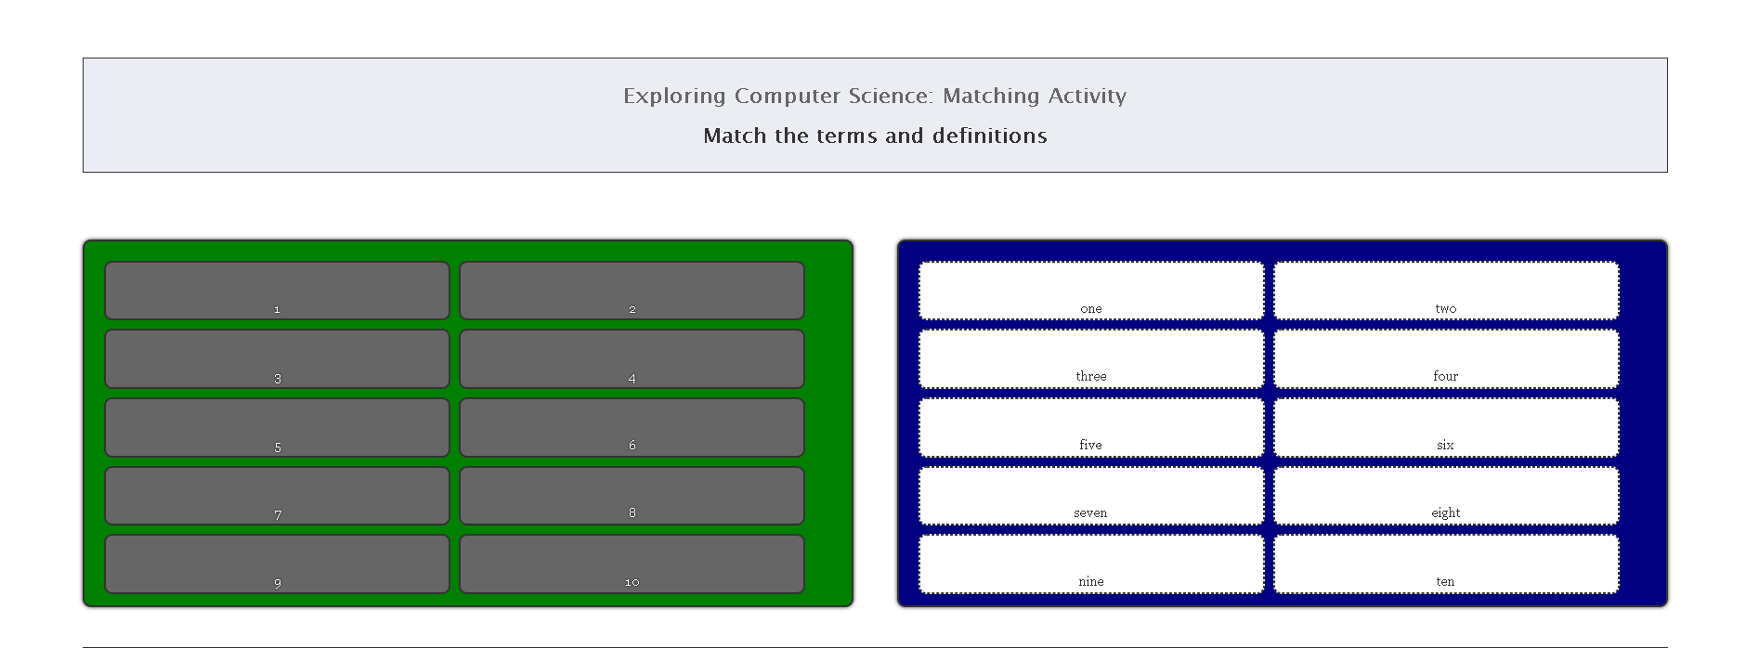

**The user must match all numbers correctly as shown on the second image**

