COE233 – HW2
Student Name: Renad Sultan Alqahtani
ID: 202169930

- A single multi input XOR
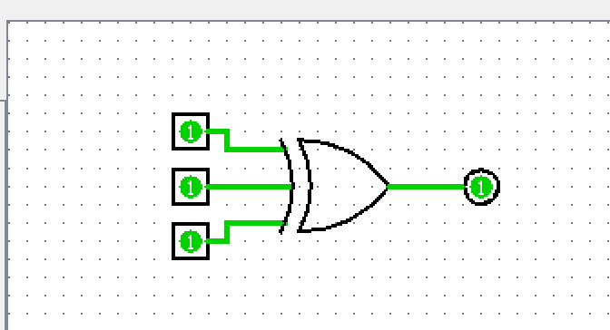
- Cascaded 2-inputs XORs
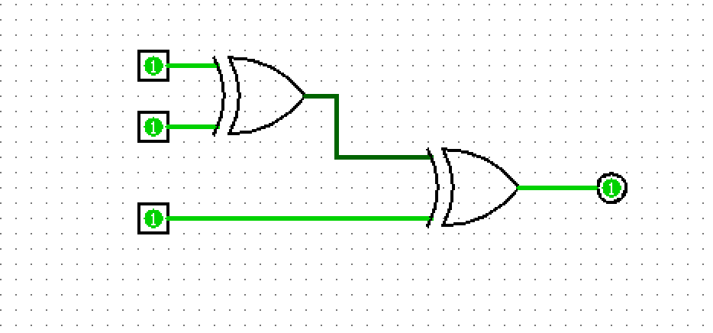
- Two level And-OR circuit.
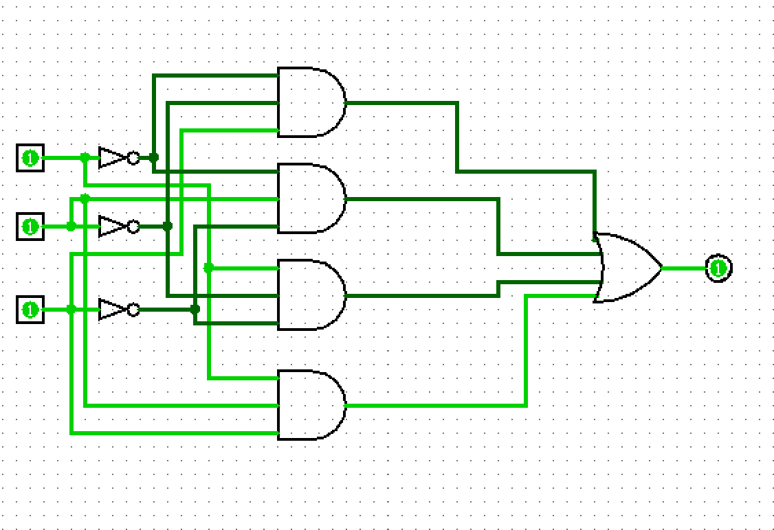
- Two level Nand-Nand circuit.
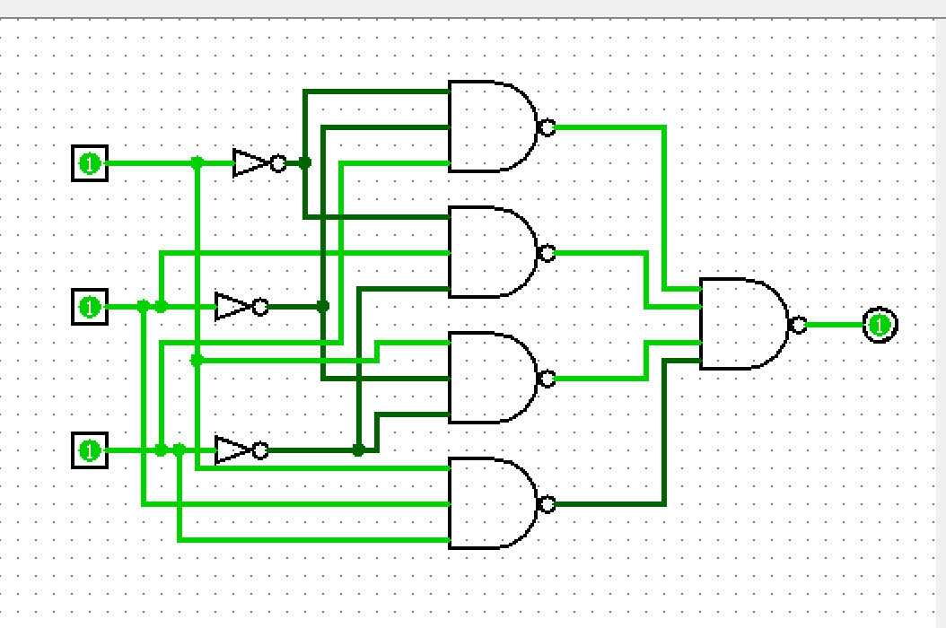
- A decoder and a single gate using minterms
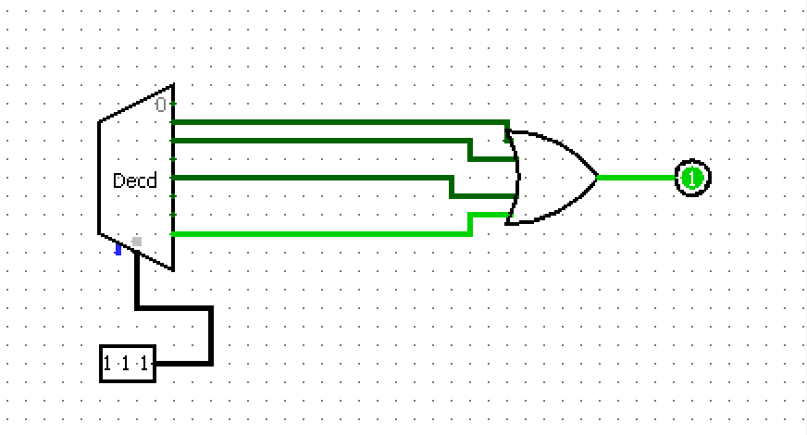
- A decoder and a single gate using Maxterms
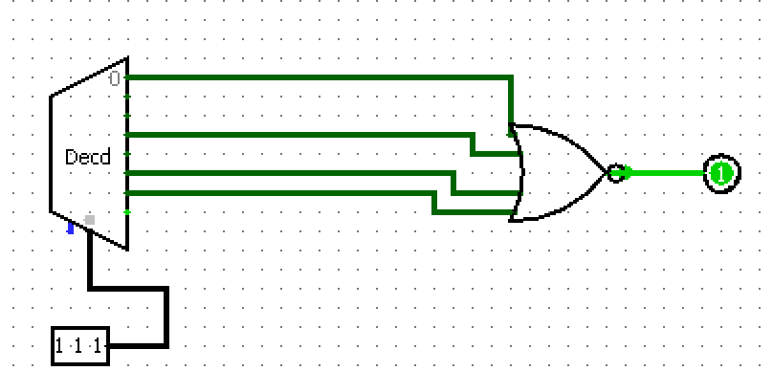

For all circuits:
When inputs 1 1 1:
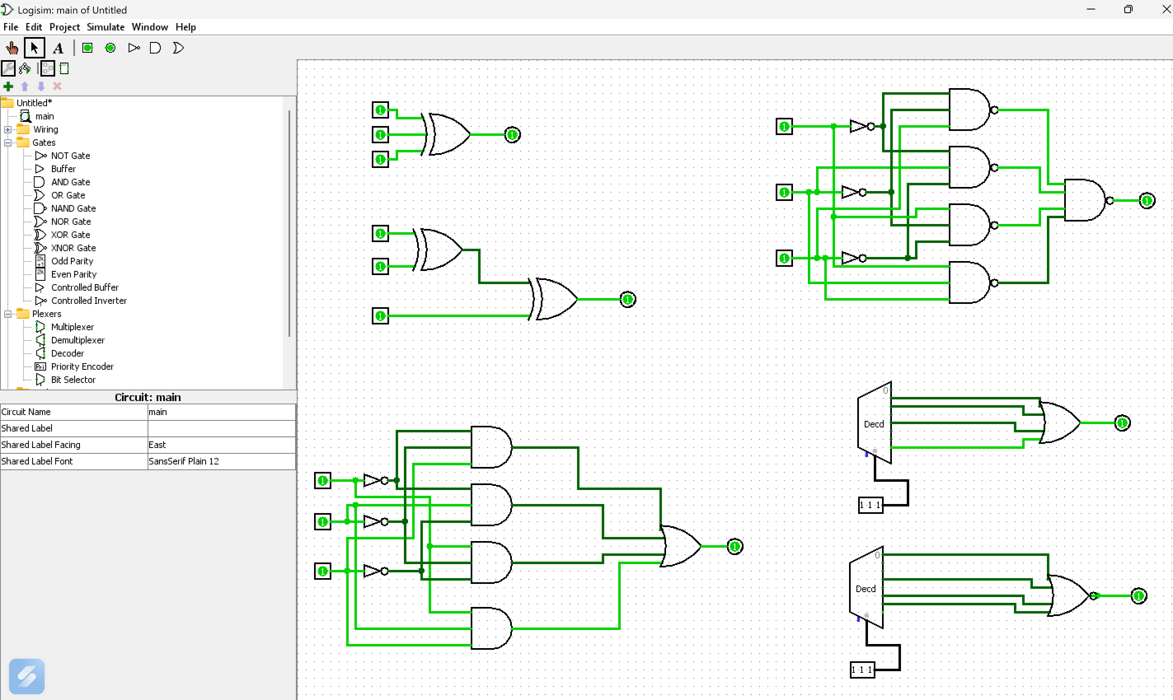

When inputs 0 0 0:
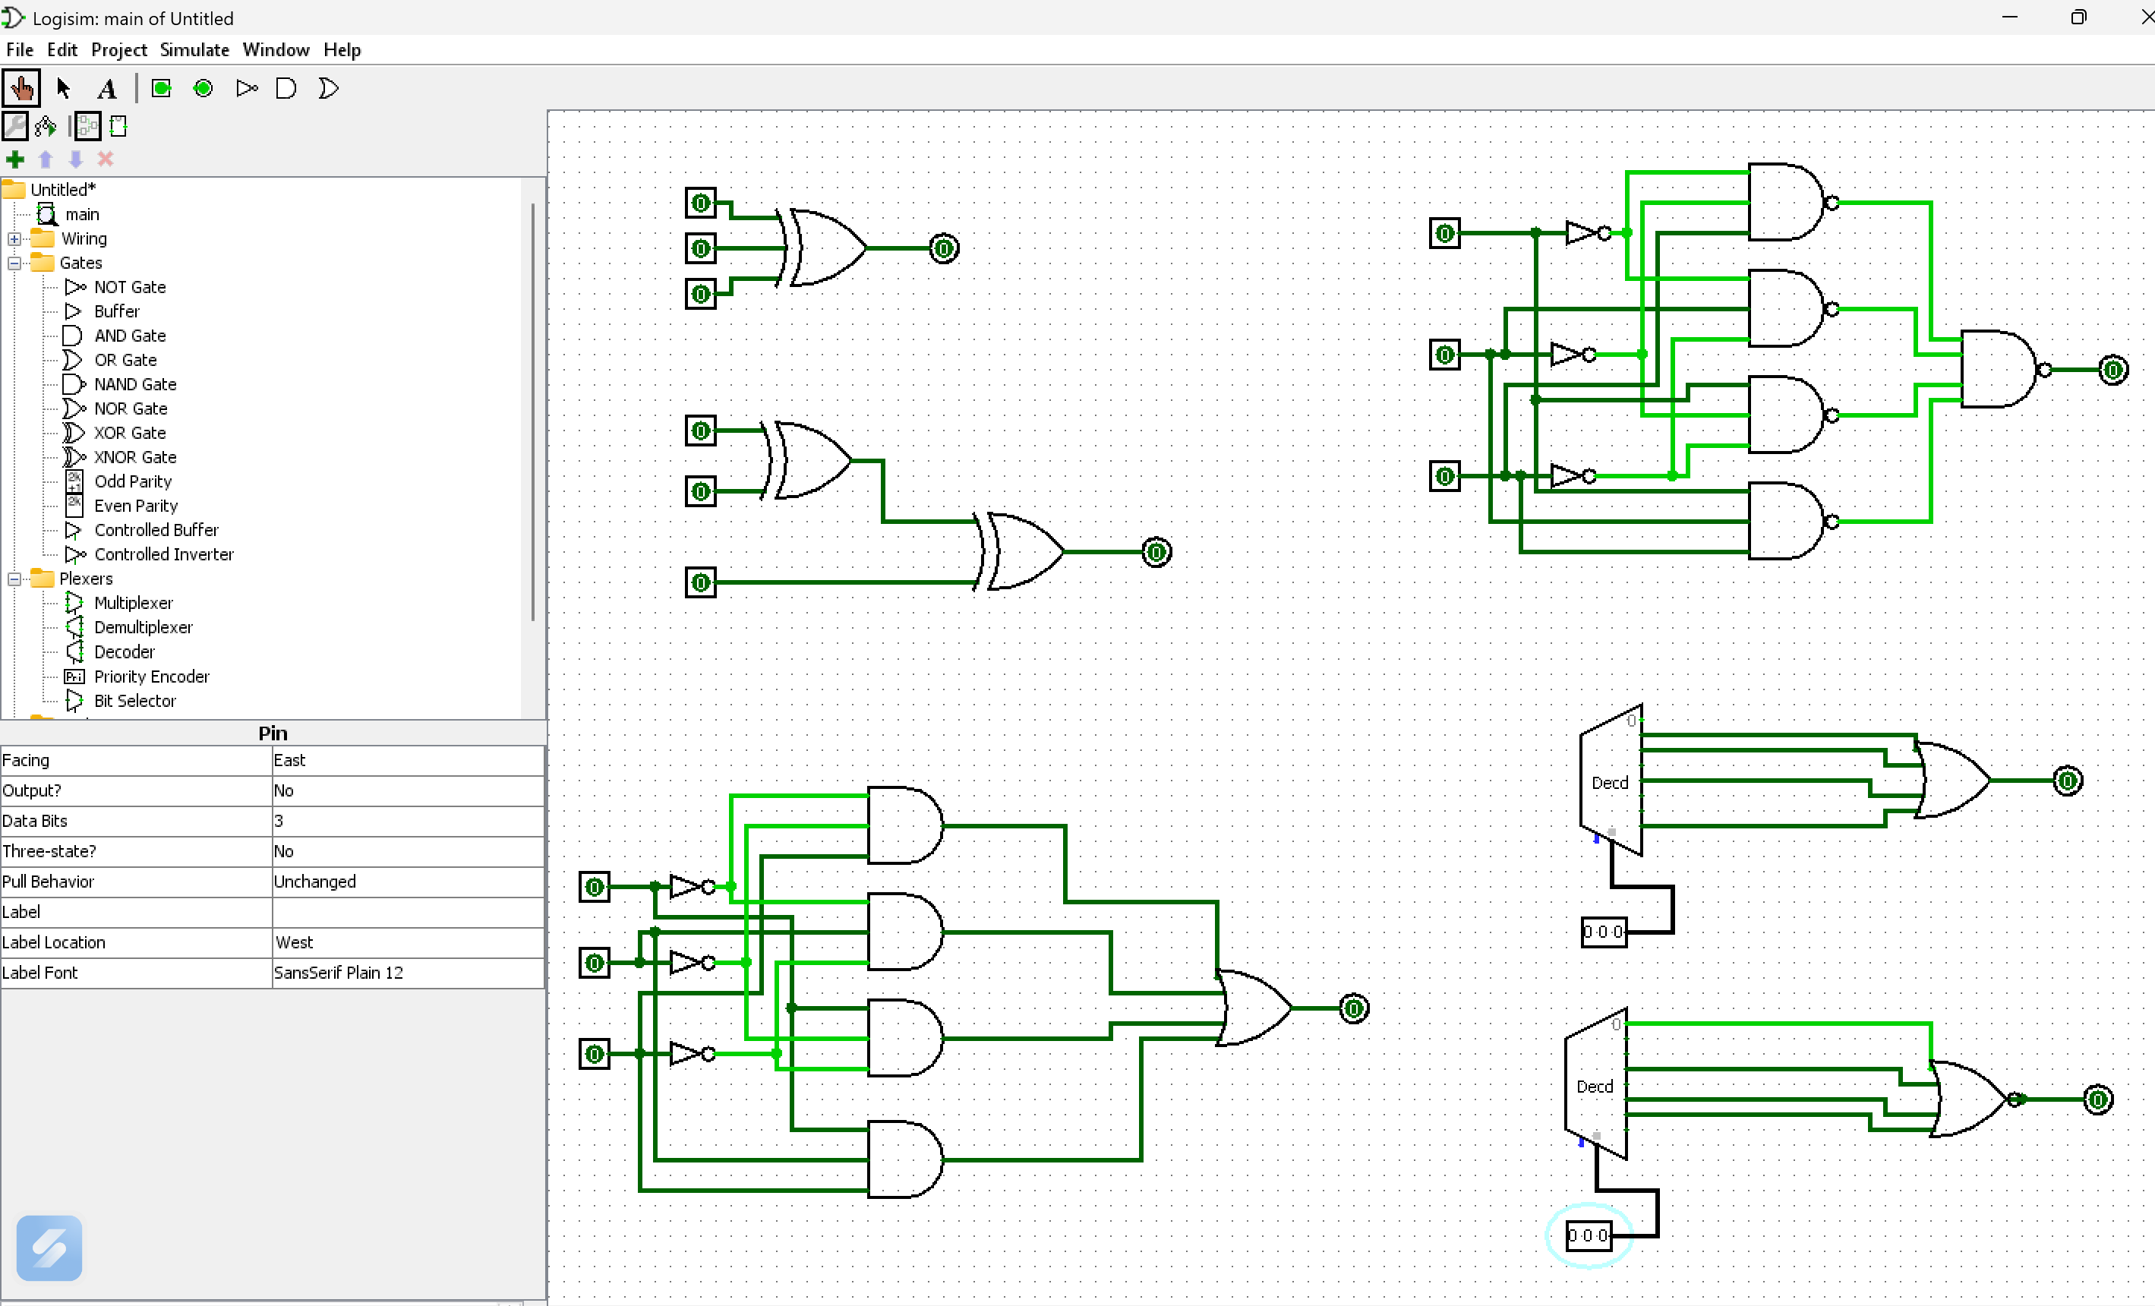
When inputs 1 0 0:
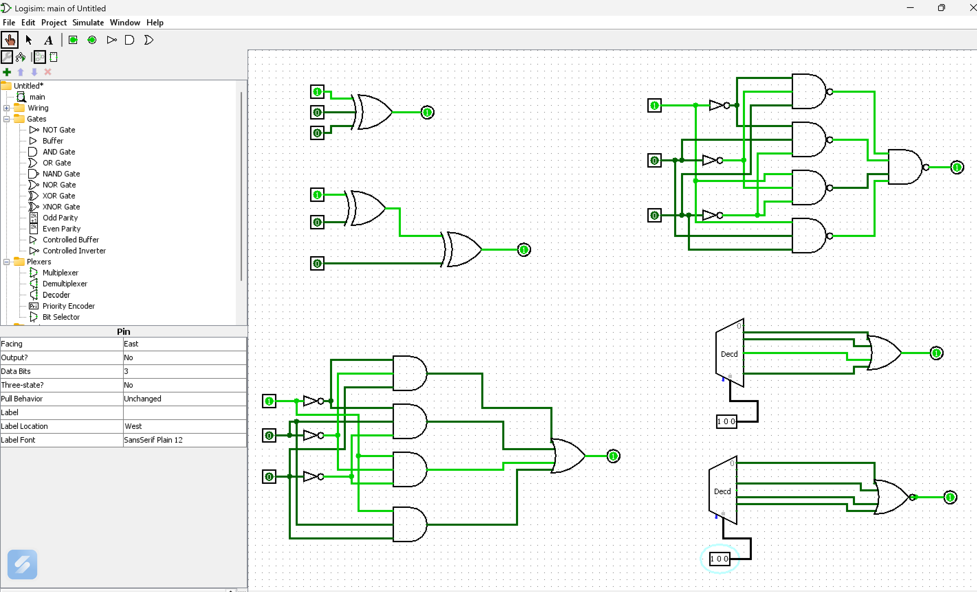
When inputs 0 1 0:
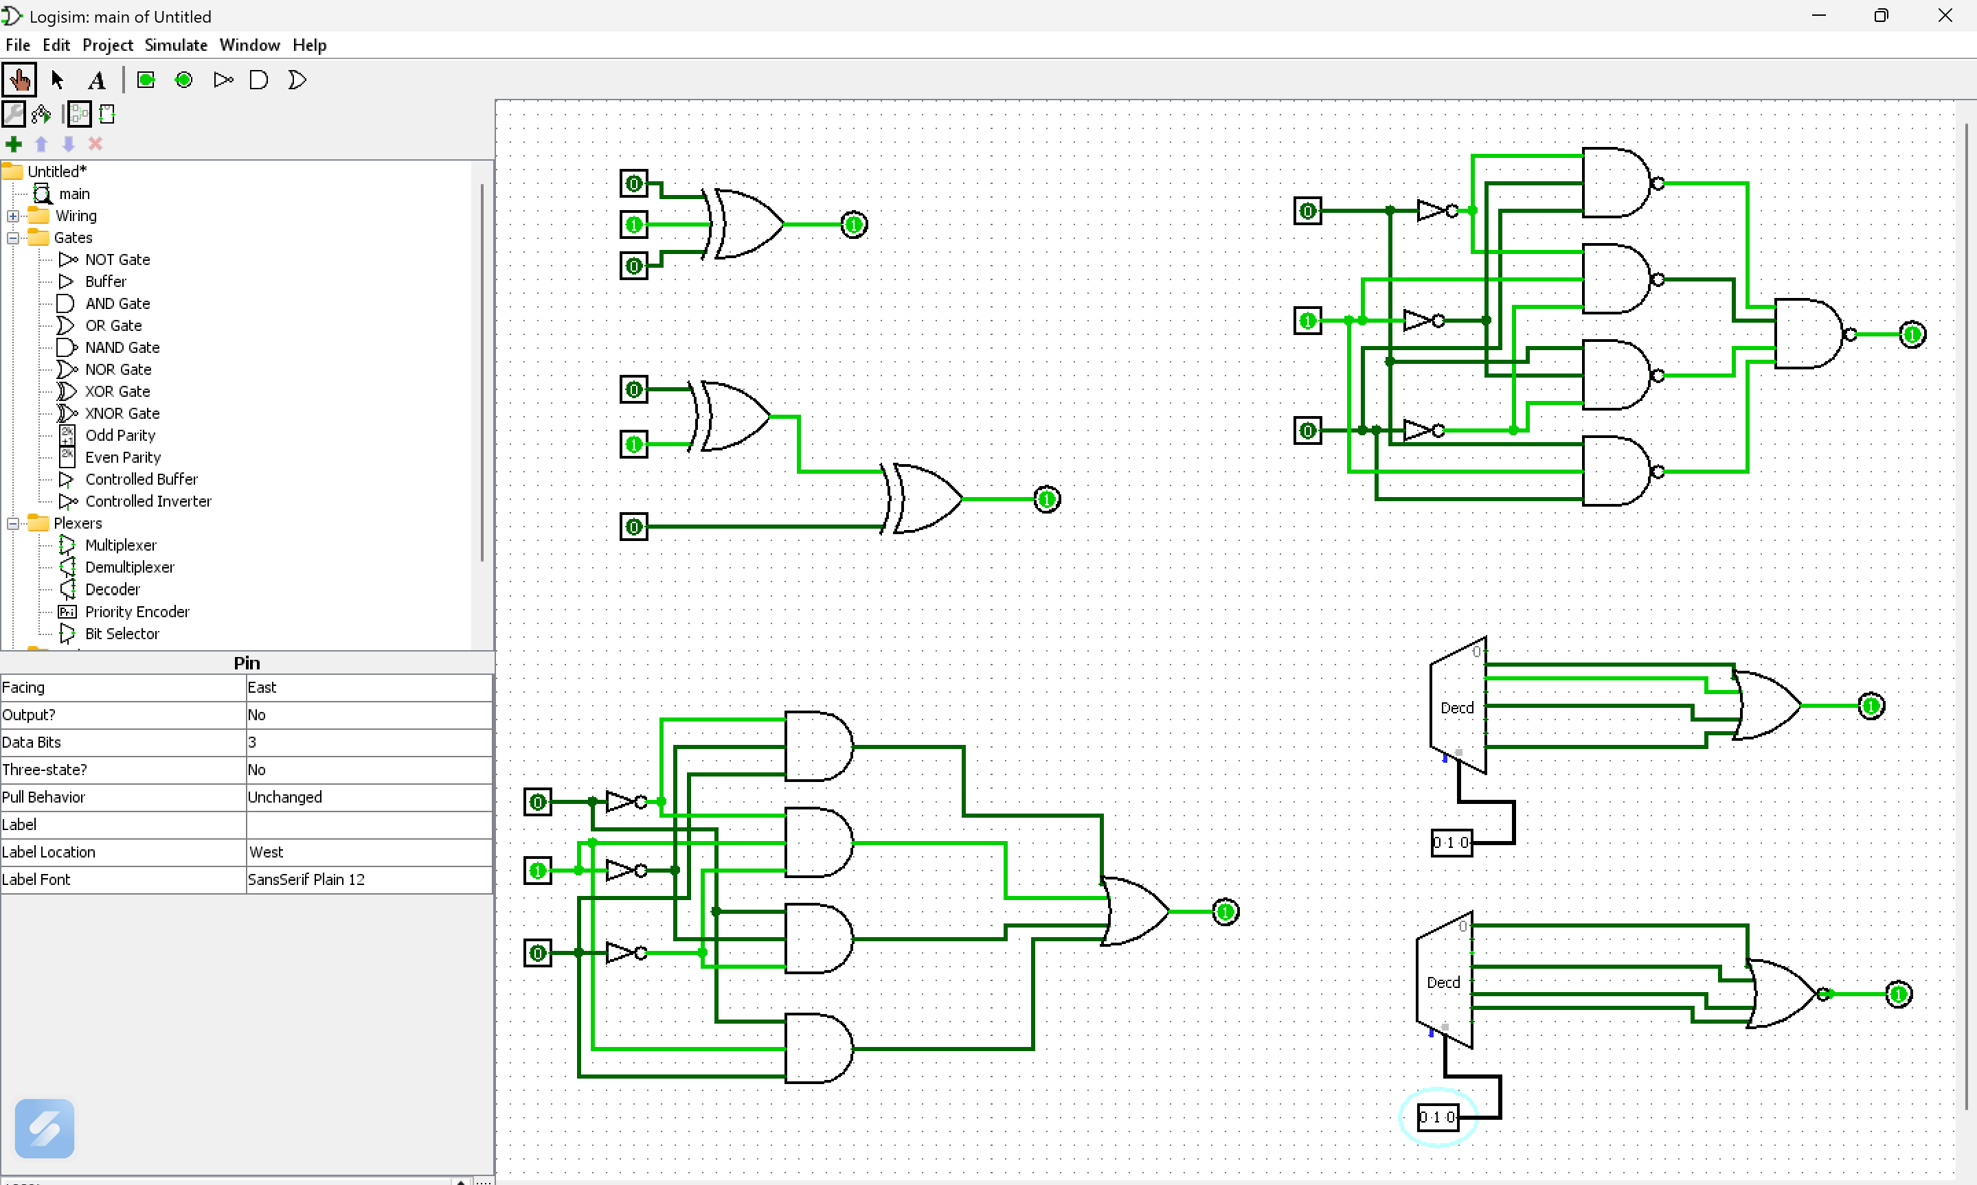
When inputs 0 0 1:
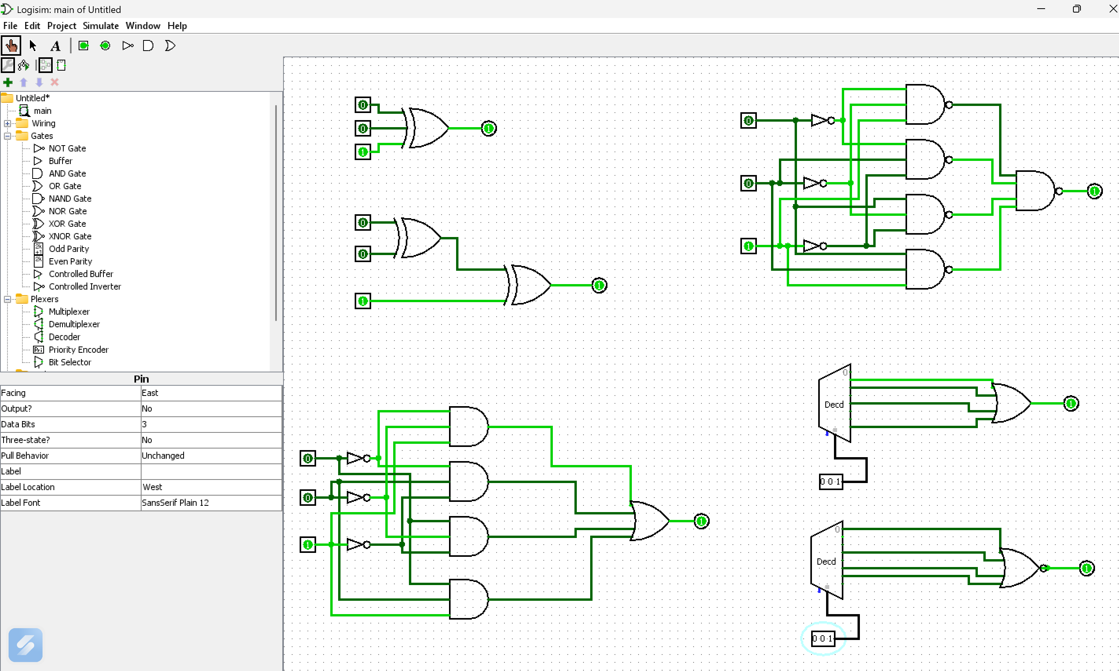

When inputs 0 1 1:
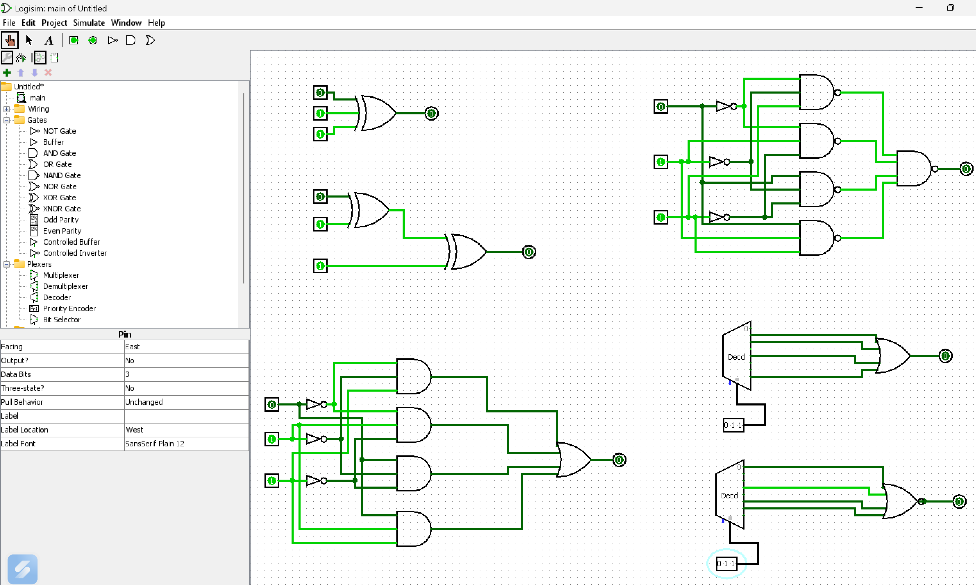
When inputs 1 1 0:
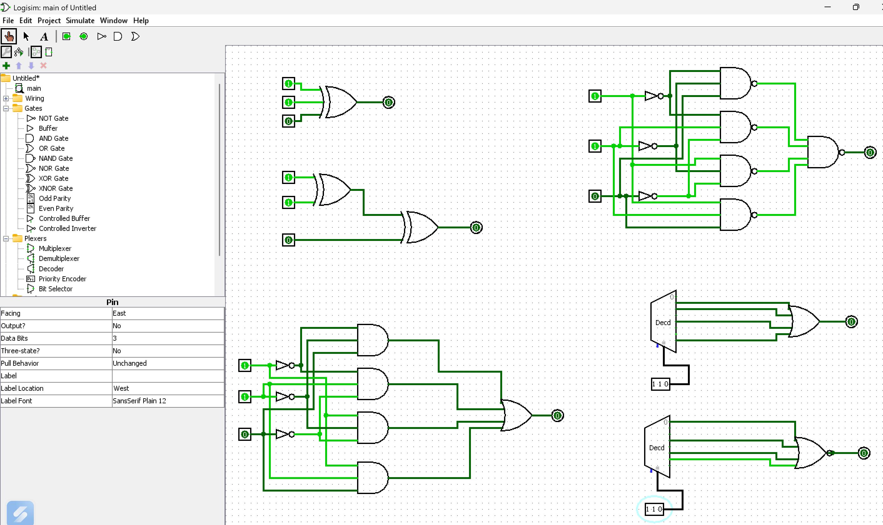
When inputs 1 0 1:
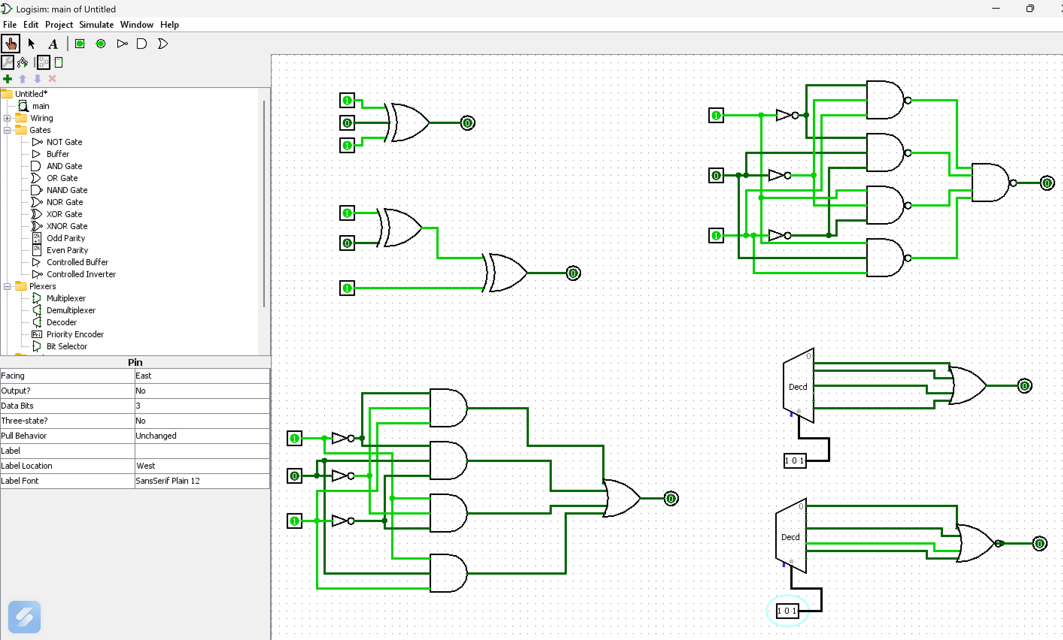

Truth Table:
