Module A: Planning

**Required Information to Upload to the Repository**

**Project Name**: Drone Assembling: develop a retractable landing gear for a UAS

**Description of the Project**

* **Goal**: Designing a set of landing gear for an undisclosed project. The landing gear is required to comply with pre-defined specifications, coordinate systems, and overall landing gear performance. The purpose of this project is to document the conceptual and embodiment design process and also prototype manufacturing for an articulated main landing gear system.
* **Main Functions**:

To ensure the safe takeoff and landing of UAVs in various environments, the landing gear plays a crucial role as an important mechanism to support the UAV fuselage.

* **Benefits**:

landing gear design for UAVs will mainly focus on lightweight, multi-environment adaptability and modular replaceability. Modularized and replaceable landing gear design ideas will provide UAVs with more abundant and flexible options, reducing maintenance and replacement costs.

* **Problem Solved**:

To develop a retractable landing gear for UAS with a take-off weight of up to 7 kg with specified contours Tasks:

• Choose the layout of the chassis.

• Determine the installation location, taking into account the placement of other nodes.

• Determine the kinematic scheme of cleaning-release

• Select wheels from the presented range

• Simulate mounting points, cleaning-release rods (using the provided servos), struts and shock absorbers

• Print chassis parts on a 3D printer

• Assemble and work out the cleaning/release mechanism

• Demonstrate the safety of landing according to the criteria of NLG UAS.

* **Target User Group**:

Some companies that incorporate retractable landing gears in their fixed-wing UAV designs:

1. **DJI**:
   * Known for advanced aerial platforms like the Matrice series, which often features retractable landing gear for improved aerodynamics and stability.
2. **Parrot**:
   * Their fixed-wing UAVs, such as the Parrot Disco, use retractable landing gear to enhance flight performance and streamline design.
3. **AeroVironment**:
   * Models like the Raven and Wasp feature retractable landing gear to facilitate better takeoff and landing dynamics in various terrains.
4. **Northrop Grumman**:
   * Their Global Hawk UAV is equipped with retractable landing gear, emphasizing aerodynamic efficiency and long-range capabilities.
5. **Insitu**:
   * The ScanEagle and other models utilize retractable landing gear, providing operational flexibility and enhancing performance during flight.
6. **Textron Systems**:
   * The RQ-7 Shadow series employs retractable landing gear to optimize its flight characteristics and operational versatility.

These companies represent a mix of commercial and military applications, showcasing the advantages of retractable landing gear in fixed-wing UAVs.

**Team Member Roles**:

|  |  |  |
| --- | --- | --- |
| **Full Name of Participant** | **Role** | **Responsibilities** |
| Mehrdad Daghagh | Mechatronics Engineer | Design and simulation |
| Ali Farshad | Mechanical engineer | Design and documentation |

|  |  |  |  |  |
| --- | --- | --- | --- | --- |
| **Description of the task** | **Responsible** | **Due Date** | **Status** | **Indicate what technologies/tools/software were used to solve the problem** |
| Planning for retractable landing gear, Design clamp for fuselage reinforcement bars | Daghagh & Farshad | 23 - 09 - 2024 | Completed | Planning for Product, manuals, documentations, components and device,  Polygon X, CATIA |
| Choosing wheel, landing simulation of suspension(calculating the maximum dynamic load and minimizing static load) , locating wheels’ position(optimization problem to minimize static load in dimensional limitations) , Documentation | Daghagh & Farshad | 24 - 09 - 2024 | Completed | MapleSim, MATLAB, |
| Design retracting mechanism, mechanism simulation & kinematic pivot points, Detail design of main gear components & 3D printing and assembling parts, completing suspension system & verifying whole system design in simulation, Documentation | Daghagh & Farshad | 25 - 09 - 2024 | Completed | CATIA, Polygon X, MapleSim |
| Design retracting nose gear, simulation & kinematic pivot points, Detail design of nose gear components & 3D printing and assembling parts, Documentation | Daghagh & Farshad | 26 - 09 - 2024 | Yet to be performed | CATIA, Polygon X, MapleSim |
| Assembling landing gear & nose gear, wiring electrical actuators, preparing layouts, diagrams and simulations, Documentation | Daghagh & Farshad | 27 - 09 - 2024 | Yet to be performed | CATIA |

For a UAV with a take-off weight of 7 kg a few chassis layouts can be applicable:

1. Tricycle Configuration: One nose wheel and two main wheels. It provides good stability during takeoff and landing, which is beneficial for smaller UAVs.

2. Taildragger Configuration: two main wheels at the front and a smaller wheel or skid at the tail. It can be lighter and simpler but may require more skill to land smoothly.

3. Quad Configuration: four landing gear points can distribute weight evenly, providing extra stability, especially for larger UAVs.

4. Skid Gear: If weight savings are critical, consider using skids instead of wheels. This design is lighter but may be less versatile on uneven terrain.

Tricycle layouts often provide better stability during takeoff and landing.

As for the retraction system, hydraulic systems are commonly used for reliability and efficiency, but electric actuators are becoming more popular for their simplicity and lower maintenance needs.

Shock absorption is crucial for landing gear performance. it might consider using oleo-pneumatic struts, which combine air and hydraulic fluid to provide excellent dampening. Additionally, incorporating progressive spring rates can help manage different landing conditions. For passive shock absorption, you might look into using rubber or elastomeric components for the landing gear. These materials can effectively absorb and dissipate energy during landing without the complexity of active systems. Progressive coil springs can also help manage varying loads.

**Technical steps (Conceptual Design)**:

1. **Chassis Layout**: A tricycle configuration provides balance during takeoff and landing.
2. **Installation Location**: Place the landing gear near the center of gravity to ensure stability and also considering clearance for any payloads.
3. **Kinematic Scheme**: A simple link-and-lever mechanism can be effective for the cleaning/release system, using servos (electric actuators) to retract the gear.
4. **Wheels**: Choosing lightweight wheels with appropriate tread for landing surface can handle the UAV's weight.
5. **Simulation**: For the mounting points and rods, the stress points during landing must be considered to ensure they can handle the load without failure.
6. **3D Printing**: Using durable, lightweight materials like PLA for the chassis parts.
7. **Assembly**: Making sure to test the cleaning/release mechanism multiple times to ensure reliability.
8. **Safety Demonstration**: NLG UAS criteria by conducting controlled tests to validate performance under different landing conditions.

**Technical steps (Detailed Design)**:

* Parametric simulation suspension
* Optimization of parameter (Dimensions)
* Retractable mechanism design simulation
* 3D Printing of parts

**Design Considerations**

Aircraft landing gear mechanism serves several design purposes such as supporting the weight of aircraft, providing rolling chassis/taxiing and shock absorption function especially during takeoff and landing etc. The present project carried out to layout design of landing gear system for unmanned aerial vehicle (UAV) at conceptual design stage. The nose wheel tricycle landing gear has been the preferred configuration for UAV. The most attractive feature of this type of undercarriages is the improved stability during braking and ground maneuvers. The results of the simulation study indicated that landing gear stability could be improved by longer wheel axle, stiffer damping mechanism and smaller wheel mass and lower aircraft sinking velocity.

It is important to incorporate green technologies in the manufacturing of UAVs. One such concept is to use 3D printing using the recyclable plastic material to make them environmentally friendly, lighter and hence consume less power for higher endurance.

Being a prime emerging technology, 3D printing has evolved rapidly over the past decade and is predicted to evolve into a 30-billion-dollar industry by 2019. In this project, the attempt made with respect to design, develop and build 3D printable landing gear is presented for a Fixed wing type UAV lying in the weight class of 3-7 kilograms and using tricycle landing gear configuration. This design is unique due to its placement of damping elements within the primary struts of the landing gears. Smart connections have been provided to enable ease of assembly and disassembly of the landing gear.

Since the design is suited for 3-D printing, the manufacturing time is reduced drastically. Modular nature of the Landing gear allows for ease of maintenance and diverse functionality. Validation is carried out using numerical methods and 3D printing followed by operational testing on a functioning UAV.

Topological Optimization of the landing gear structure allows us to significantly reduce the weight of the landing gear and make the structure more efficient. This optimization is performed by providing limiting values on parameters like space limitation from dimensions while the objective function is the minimization of mass. Optimization performed on the components will yield a weight reduction of the main landing gear and the nose landing gear.

The clever placement of shock absorbers within both nose and landing gear structure itself saves a large amount of space within the fuselage of the UAV. Aside from improving the payload capacity of the plane, by simple dynamics, it can be shown that there is a minimal loss in transmission of torque from servo motor to the wheel. Such a feature is unique to this arrangement, as the loss of torque is a common phenomenon observed in other UAV landing gear designs.

The main landing gear, suitable for a tricycle configuration incorporates simple components which are capable of handling impact loads of up to 3g. The dimensions of the current model have been chosen to accommodate the given UAV fuselage which is one of the common types for fixed-wing UAV.

A functioning prototype of the design has been generated using 3-D printing within a short duration of 2 days. Simplicity in design allows us to vary the dimensions at any point of time to suit specific requirements, like wheelbase and height. With an efficient design and simple concept, the landing gear thus designed is modular in nature, sturdy and adaptable. This design incorporates simple shock absorbers to give a smooth landing for the tactical unmanned aerial vehicle.

**Landing Gear Layout Design Parameters**

This report represents a typical step by step approach that would be taken by the landing gear layout designer during conceptual design phase.

**Main landing gear location**

In the landing gear layout, the aircraft center of gravity (c.g) location used to position the main landing gear such that ground stability, maneuverability and clearance requirements are met. In this project, the c.g location was pre-defined as UAV technical characteristic.

**Load calculation on nose wheel and main wheel**

The calculation of nose wheel and main wheel load are based on the diagram shown in the below figure and the following as given relations and their constraints in the equation. The nose gear should be placed as far forward as to minimize its load, maximize flotation and maximize stability. Conversely, to allow for adequate nose wheel steering, a minimum normal force must act on the nose gear so that the appropriate level friction forces needed for steering can be generated. Nose gear loads in the static condition generally vary about 6-20%, but these should be considered as extremes. A preferable range would be 8% with the c.g aft, increasing to 15% with the c.g. forward has been considering in present design calculations.

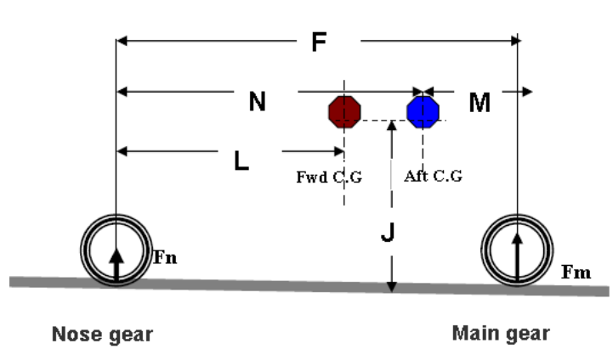 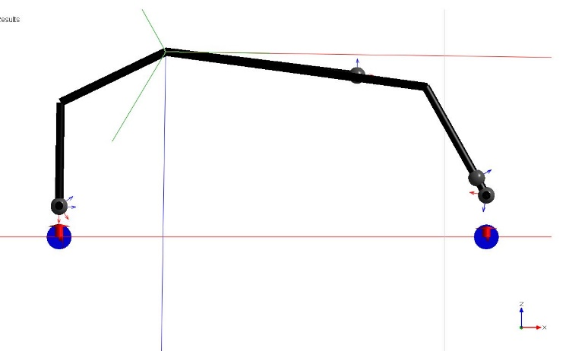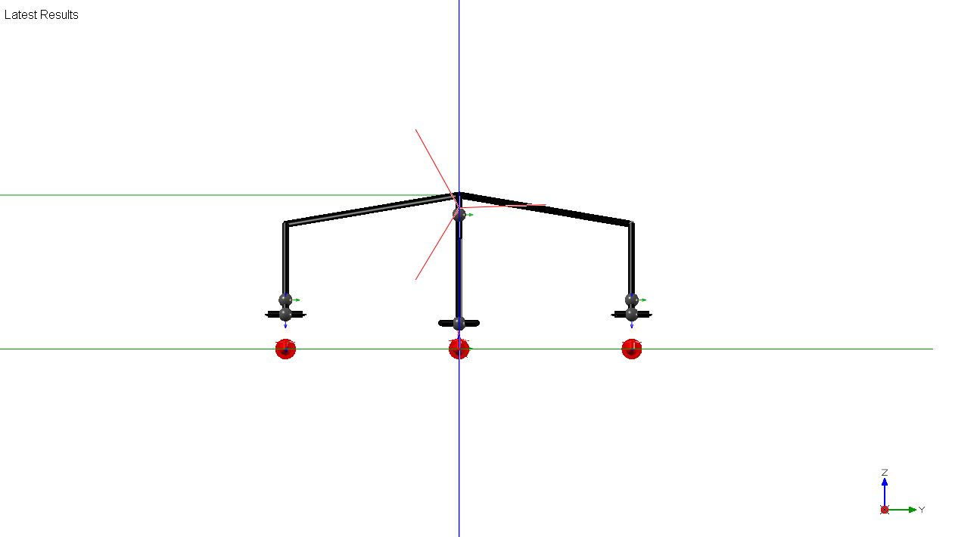

Where W is the Take-off weight of aerial vehicle and other quantities are defined in figure.

**Shock absorber stroke length calculation**

The landing gears in most unmanned aircraft today are those making use of the solid steel spring or rubber and those making use of a fluid acting as spring with gas or oil, commonly known as the oleo-pneumatic landing gears. This project has focused for conceptual design of rubber type shock absorber for both the main landing gears and the nose landing gear which has been selected because it has the highest energy-dissipating efficiency and simplicity in comparison with other various types of shock absorbers currently in use in the UAVs industry.

Based upon the required speeds and load factors, the vertical wheel travel must be determined. Normal design in which the wheel and strut travel the same distance. The first step is to determine the maximum loads accept able in the shock strut. This load comprises the static load plus the dynamic reaction load. When that load divided by the static load, the reaction factor N obtained. This is some time called to landing gear load factor or merely landing load factor. Its valued ranges from 2.0–3.0 for small utility aircraft or UAVs. Its permissible magnitude is determined by the airframe to accommodate those factors during landing impact.

Initially, the aircraft is assumed a rigid body with no relative acceleration between the c.g. and gear attachment point. Thus, the load factor at the c.g. is the same as the attachment. To understand fully the relationship between the load factor at the center of gravity Nc.g and the landing gear load factor N, consider a free body being acted upon by shock strut forces and lift, as Shown in figure, where Fs is the shock strut force and L, the lift. Thus

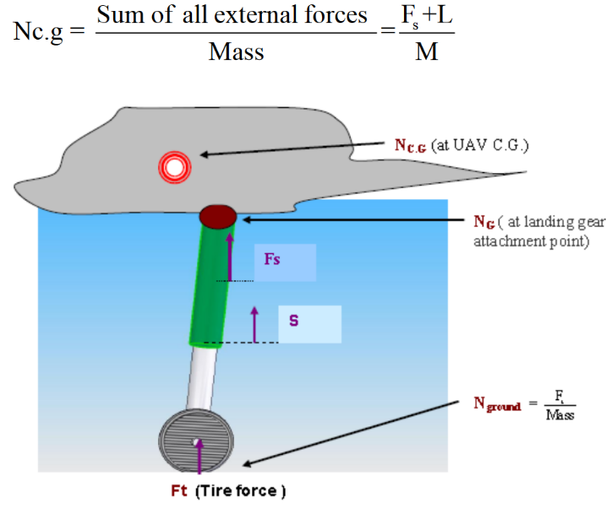 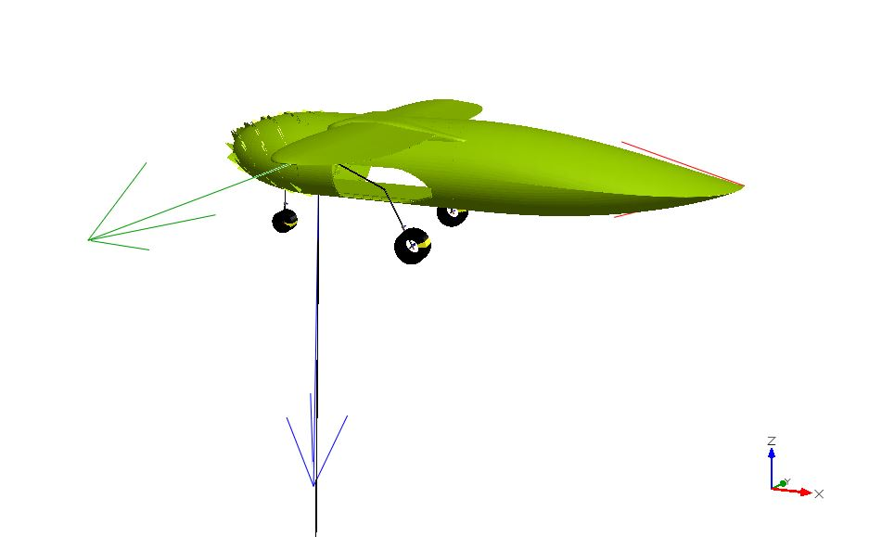

If, for convenience, the landing gear load factor N is defined as being equal to Fs/Mass, the gear load factor

determine how much load, the gear passes to the air frame, which affects the airframe structural weight as

well as strength.

Then



The shock absorbers and tire act together to decelerate the UAVs from landing vertical velocity to zero vertical velocity. Therefore, shock absorber and tire must also absorb the sum of the kinetic energy and potential energy of the aircraft; thus,

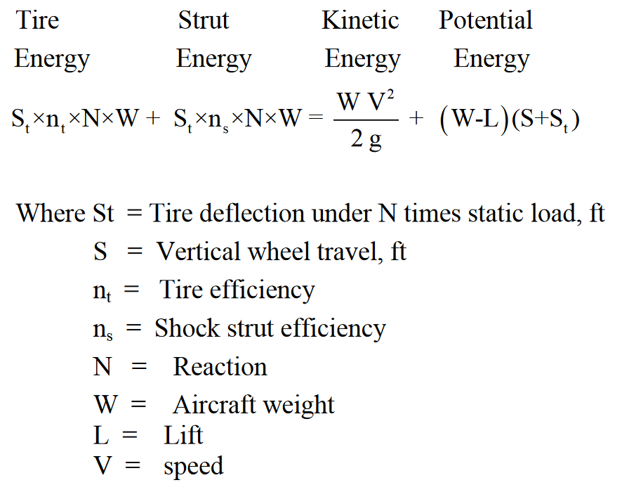

**Lateral location of main gear**

The tread and wheelbase should be determined. The relationship between the tread and wheelbase is dictated by the turnover angle, which is determined as follows in the figure.

(1) Draw a top view showing the desired nose most forward C.G location

(2) Draw a side view showing the landing gear with shock absorbers and tire statically deflected and the C.G position

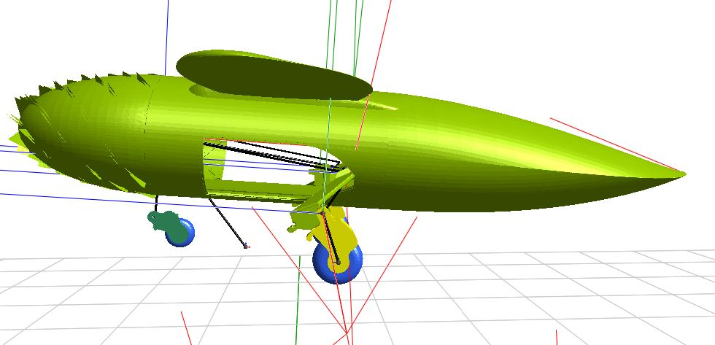 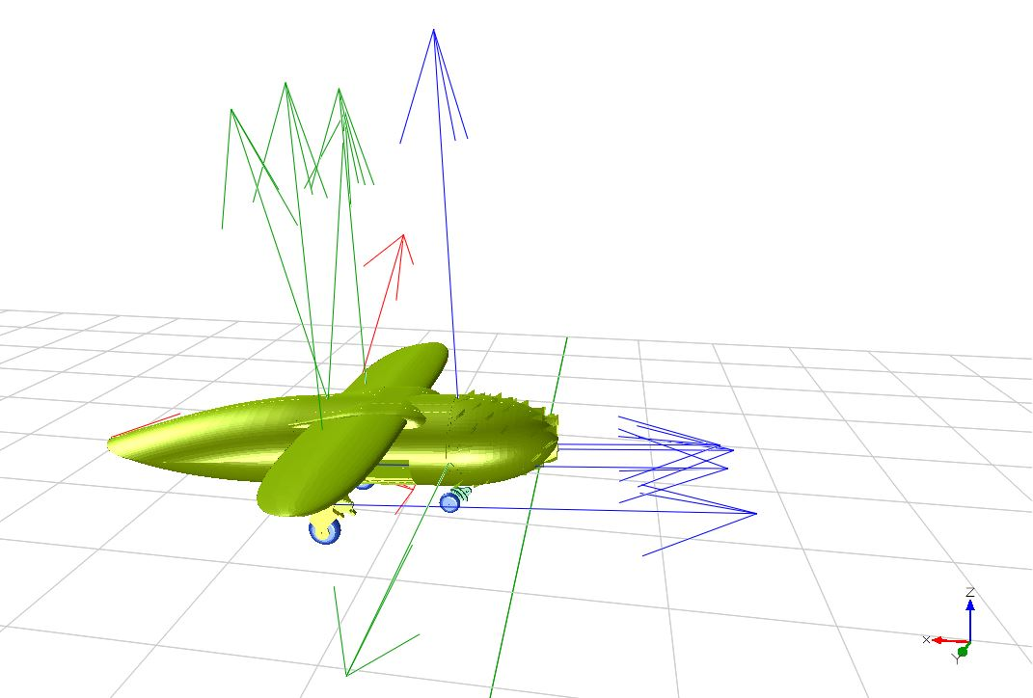

(3) Establish line A-B Extend the line to a point “C”.

(4) Through point, “C” draws a perpendicular to line A-B.

(5) Through the c.g. (in the plane view draw a line parallel to A-B and obtain point “D”.

(6) From point “D” measure height of the c.g. (H) obtained from the side view and obtain point “E”.

**Tire selection**

The tires are sized to be carried out the weight of the aircraft. Typically, the main tires are carry about 90% of the total weight of the aircraft weight. Nose tires carry only about 10 % of the static load but experience higher dynamic loads during landing. In conceptual design stage we can find a tire size by using a statistical approach. By assuming that main tire carries about 90% of aircraft weight, calculated values for diameter and width should increase about 30% if the aircraft is to operate from rough unpaved runways. Nose tires can be assumed to be about 60- 100% the size of main tire.

Choosing wheels for landing gear involves several considerations to ensure performance and compatibility with the UAV. Key factors to consider are:

1. **Weight Capacity**:
   * Ensure the wheels can support the UAS's take-off weight (up to 7 kg). Check the manufacturer’s specifications for load ratings.
2. **Diameter:**
   * A larger diameter wheel (e.g., 5-10 cm) helps with shock absorption and smoother roll over rough terrain. Smaller wheels may be lighter but can increase landing impact.
3. **Material:**
   * **Rubber**: Provides good grip and shock absorption.
   * **Plastic**: Lightweight and cost-effective but may not provide as much cushioning.
   * **Foam**: Lightweight and shock-absorbent, suitable for softer landings.
4. **Tread Pattern:**
   * Choosing a tread pattern based on the expected landing surface. A deeper tread offers better grip on rough or uneven surfaces.
5. **Axle Compatibility:**
   * Ensuring the wheel fits the axle size and type used in your landing gear. Verify that the wheel hub can accommodate the axle securely.
6. **Weight:**
   * Selecting lightweight wheels to minimize the overall weight of the UAS, as every gram counts in flight performance.
7. **Rolling Resistance:**
   * Consider wheels with low rolling resistance for better efficiency during taxiing and takeoff.

Sample wheel material options are:

* **Aerofoam Wheels**: Lightweight and shock-absorbing, great for soft landings.
* **Rubber Tread Wheels**: Provide excellent grip and durability, suitable for various surfaces.
* **Plastic Wheels**: Ideal for lightweight applications but ensure they have a suitable tread.

Always prototype and test different wheel options to evaluate performance during landing and takeoff is recommended. Making adjustments, usually done based on pre-defined specific operational environment. In the project, we had to use 60mm aero foam wheel for nose and 80mm rubber wheels for main landing gear. Specifications for wheels with a diameter of approximately 60 mm and 80 mm suitable for small UAVs are mentioned in the below table.

Usually, there must be differences between front and rear wheel diameters, especially in a tricycle landing gear configuration. To choose front vs. rear wheel diameter, there are some criteria to be considered too:

|  |  |  |  |  |  |  |
| --- | --- | --- | --- | --- | --- | --- |
| Wheel Type | Diameter (cm) | Material | Load Capacity (kg) | Weight (g) | Tread Type | Notes |
| Aerofoam Wheel | 6-8 | Foam | 3 – 10 | 10 - 40 | Smooth or knobby | Very lightweight, good for soft landings |
| Rubber Tread Wheel | 6-8 | Rubber | 4 – 8 | 12 - 30 | Varies  (deep tread) | Good grip and moderate durability |
| Plastic Wheel | 6-8 | Plastic | 2 – 12 | 8 – 30 | Smooth | Lightweight, less durable |
| Composite Wheel | 6-8 | Composite materials | 3 – 8 | 12 - 30 | Smooth | Strong and lightweight |

In many designs, front wheels are often slightly larger than rear wheels, but this depends on the specific requirements of the UAS. Ultimately, the choice should align with the overall design goals, stability needs, and operational environment.

1. **Stability**:
   * Larger front wheels can enhance stability during takeoff and landing, as they provide better roll characteristics and help in steering.
2. **Weight Distribution**:
   * If the UAS has a heavier front, slightly larger front wheels can help balance the weight distribution and improve handling.
3. **Shock Absorption**:
   * Larger wheels generally offer better shock absorption, which can be beneficial for front wheels that encounter initial impact forces.
4. **Ground Clearance**:
   * Front wheels might be designed to allow for greater ground clearance, especially if the nose of the aircraft tends to pitch up during takeoff.
5. **Maneuverability**:
   * Smaller rear wheels can aid in turning and maneuverability on the ground, especially in tight spaces.

**Mounting points**

Simulating mounting points, cleaning release rods, struts, and shock absorbers is crucial for ensuring the reliability and effectiveness of your retractable landing gear system. Here’s how we can approach this simulation:

**1. Define Parameters**

* **Mounting Points**: Identify where the landing gear will attach to the airframe. Consider the center of gravity and load distribution.
* **Cleaning Release Rods**: Determine the length and angle of these rods based on the kinematic scheme you’ve designed.
* **Struts**: Define the length and material of the struts, considering load and stiffness.
* **Shock Absorbers**: Choose the type (oleo-pneumatic, coil spring, etc.) and define their damping characteristics.

**2. Use Simulation Software**

* **CAD Software**: Use programs like SolidWorks, AutoCAD, or CATIA to model the landing gear components. This will allow you to create 3D representations and define relationships between parts.
* **Finite Element Analysis (FEA)**: Use tools like ANSYS or COMSOL Multiphysics to analyze the stresses and strains on mounting points, rods, and struts under load.
* **Dynamic Simulation**: If your software supports it, simulate the retraction mechanism and landing impacts to see how the components behave in real scenarios (MapleSim).

**3. Set Up Simulation**

* **Input Parameters**: Enter the physical properties (dimensions, materials, etc.) and boundary conditions (fixed points, loads) into your simulation.
* **Run Simulations**: Start with static load tests to analyze stress distribution, then move to dynamic simulations for retraction and landing.

**4. Analyze Results**

* **Check Stress Concentrations**: Look for areas with high stress that could lead to failure.
* **Evaluate Movement**: Ensure the cleaning release rods and struts allow smooth motion without binding or excessive friction.
* **Optimize Design**: Based on the results, adjust dimensions, materials, or configurations to improve performance.

**5. Prototyping and Testing**

Once simulations indicate satisfactory performance, create prototypes of our components for physical testing. Use the results to make further refinements before finalizing the design (3D printing).

**kinematic scheme for a retractable landing gear system**

The main components of a common landing gear system consist of:

* + **Landing Gear**: The main structure that supports the wheels.
  + **Retracting Arm**: Connects the landing gear to the actuating mechanism.
  + **Servo Motor**: Responsible for the retraction and deployment of the landing gear.
  + **Linkages**: Mechanical connections that transmit motion from the servo to the landing gear.

Also the kinematic scheme Steps are:

1. **Initial Position**:
   * The landing gear is extended, resting on the ground.
2. **Retracting Action**:
   * When the servo motor is activated, it rotates a crank or pulls a linkage.
   * This movement pulls the retracting arm, causing it to rotate about a pivot point.
3. **Landing Gear Movement**:
   * The movement of the retracting arm raises the landing gear into the fuselage.
   * As the gear moves upward, it locks into place using a latch mechanism or a secondary linkage.
4. **Deployment Action**:
   * To deploy, the servo motor reverses direction, allowing the linkage to extend.
   * Gravity or a spring mechanism can help lower the landing gear back to its operational position.

You can find a simple diagram representation of the whole system in the below picture:

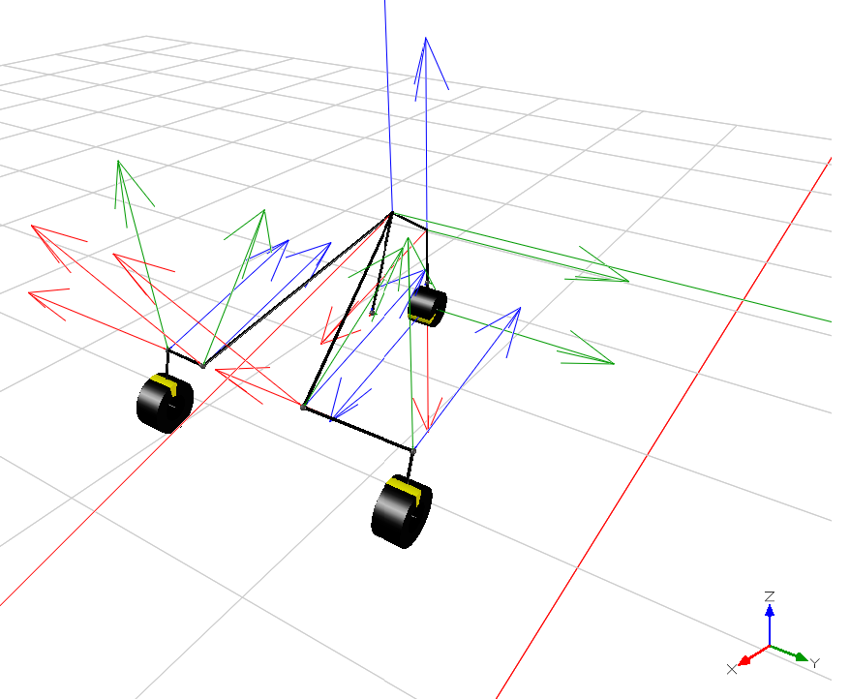

Key design considerations that must be taken in attention are:

* **Pivot Points**: Ensuring the pivot points allow smooth rotation without excessive friction.
* **Locking Mechanism**: Designing a reliable locking mechanism to secure the landing gear when retracted.
* **Weight Distribution**: Positioning components to minimize impact on the UAS's balance.
* **Linkage Lengths**: Ensuring that the lengths of arms are calculated to provide the desired movement range.
* **Servo Specifications**: Choosing a servo with adequate torque to handle the loads during retraction and deployment.
* **Material Selection**: Using lightweight yet strong materials for the landing gear and linkages to minimize weight.

This scheme provides a basic understanding of how a retractable landing gear system operates.

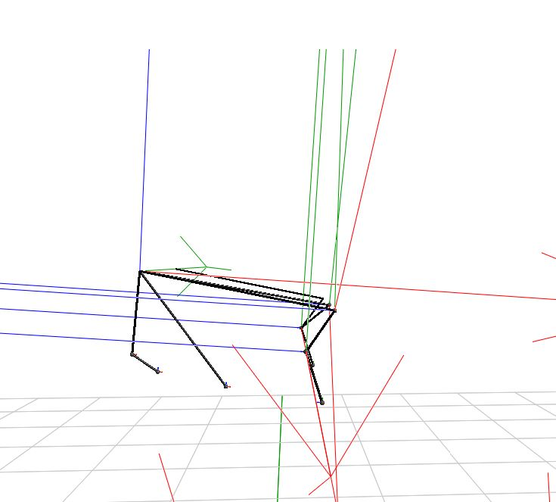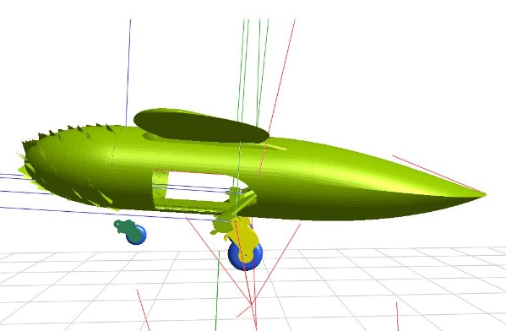 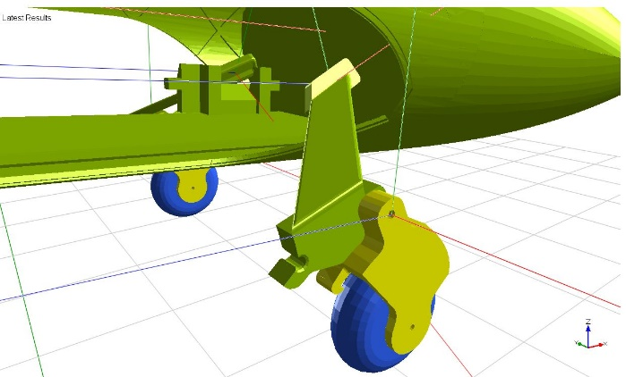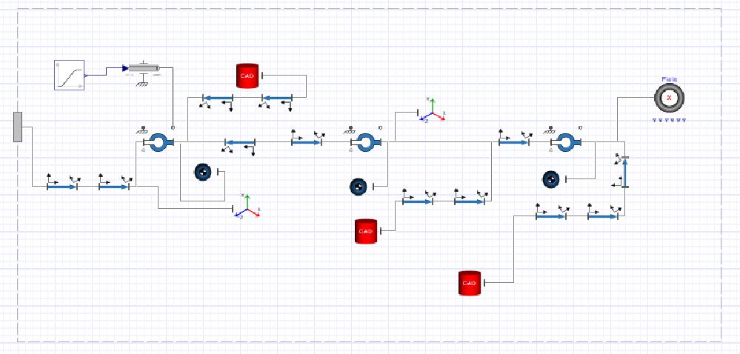

Additional mechanisms should be designed too in order to complete the system design:

* **Anti-Sway Mechanism**: To prevent lateral movement during operation, consider adding additional linkages or a guiding track.
* **Sensor Feedback**: Implement limit switches or sensors to provide feedback on the position of the landing gear for automation.

**Electrical actuator**

Since servo motors are recommended as electrical actuator in this project, for a retractable landing gear system on a UAS with a take-off weight of around 7 kg, here are some recommended servo specifications:

1. **Torque Rating**:
   * Aim for a torque rating of at least **10-15 kg-cm** (approximately **10-15 N-m**) to ensure the servo can handle the loads during retraction and deployment.
2. **Speed**:
   * A speed of around **0.1 to 0.2 seconds** per 60 degrees is generally sufficient for smooth operation without being too quick, which could stress the mechanism.
3. **Voltage**:
   * Use servos compatible with a **6-7.4V** supply, common for RC applications. High-voltage servos can offer better performance but check compatibility with your system.
4. **Type**:
   * Consider **digital servos** for better precision and responsiveness, especially under varying loads.
5. **Weight**:
   * Choose lightweight servos to minimize the overall weight of the UAS. Look for servos weighing around **30-50 grams**.
6. **Gear Material**:
   * Metal gears are preferred for durability, especially under heavy loads, but consider the trade-off in weight and cost.



**Retractable Landing Gear Main Gear Mechanism:**

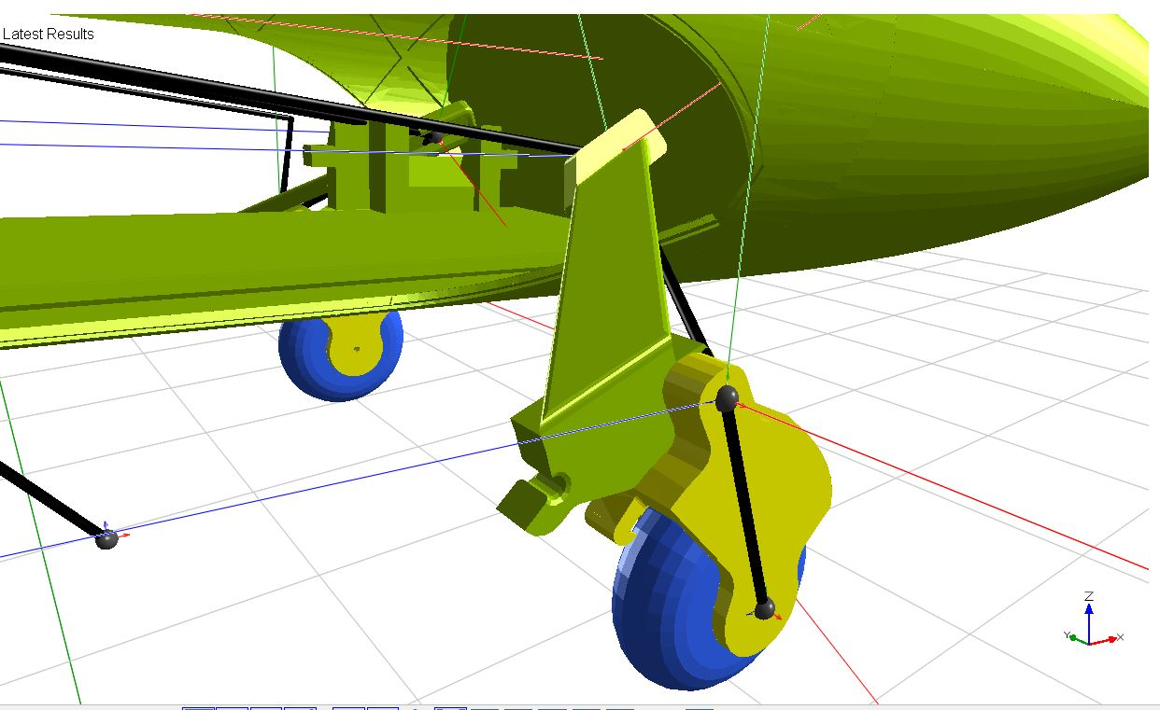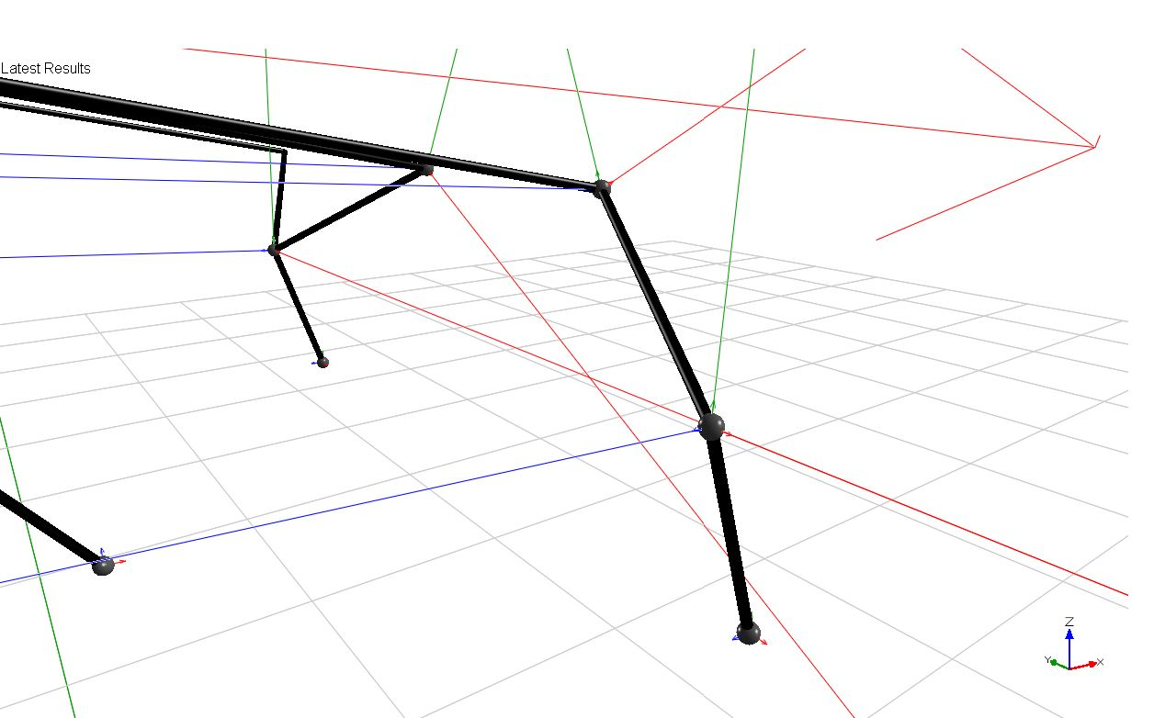

**Retractable Landing Gear Main Gear Mechanism Finite Element Meshing for Stress Analysis:**

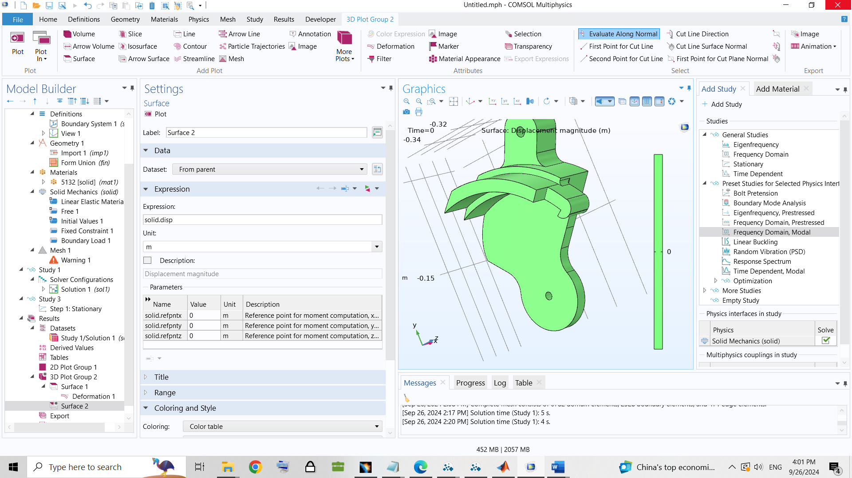

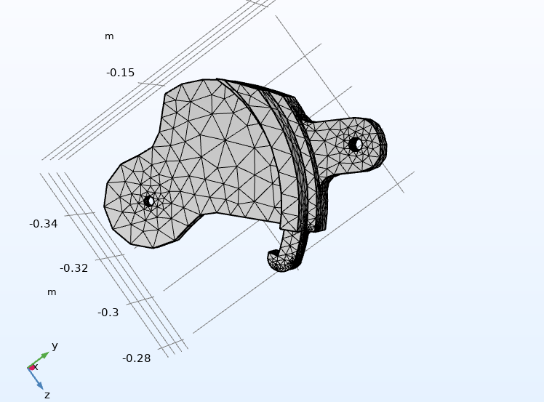

In the follwing diagrams you can find the relation between time and lateral and vertical position of the UAV during landing :

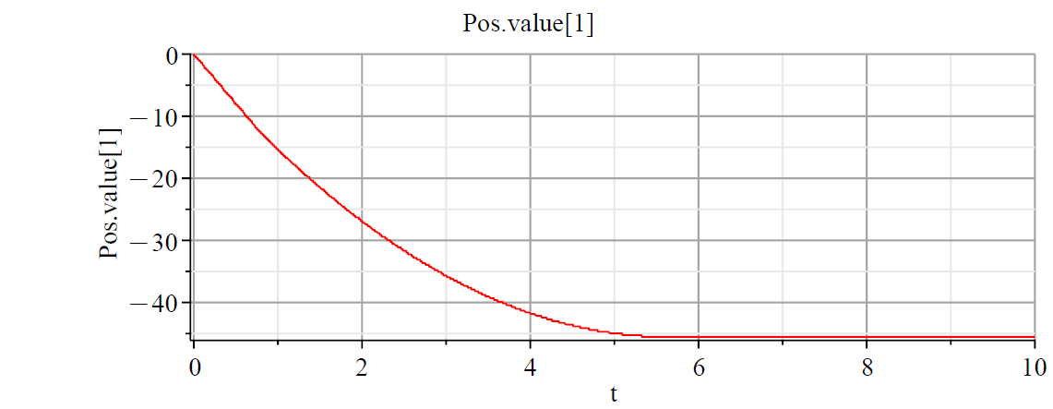 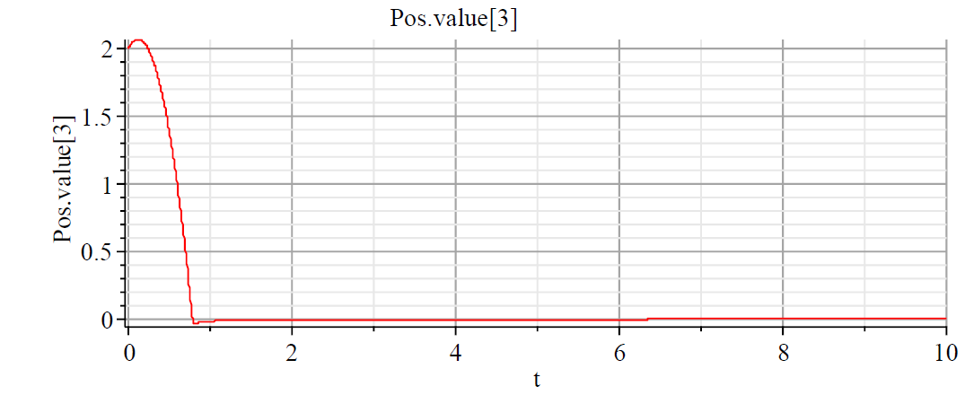

In the follwing diagrams you can find the relation between time and longitudinal and vertical of the UAV during landing :

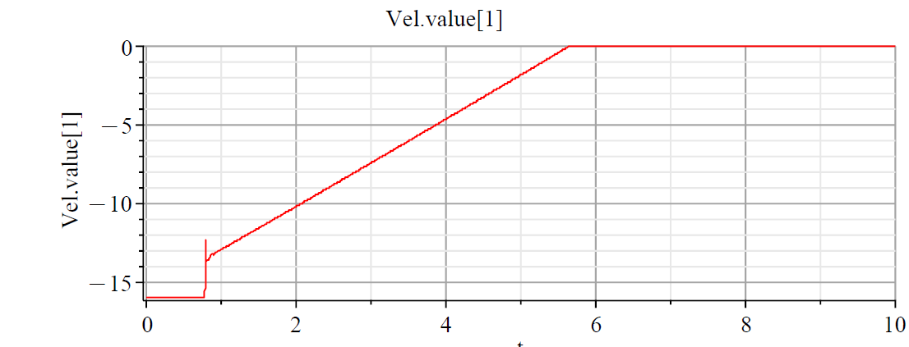

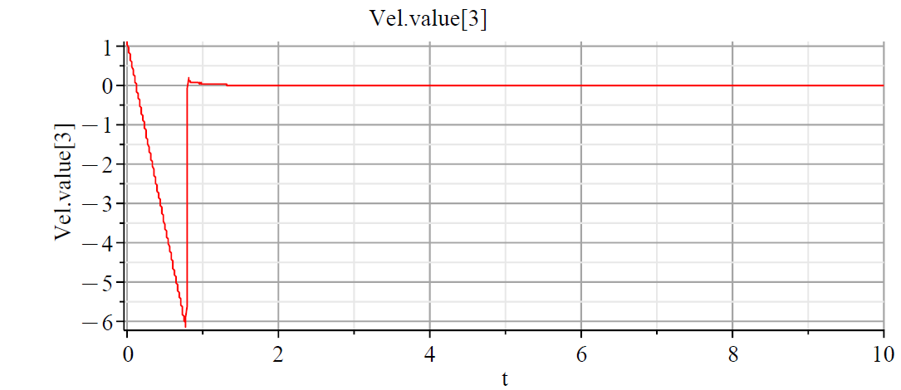

In the follwing diagrams you can find the relation between time and pitch angle of the UAV during landing :

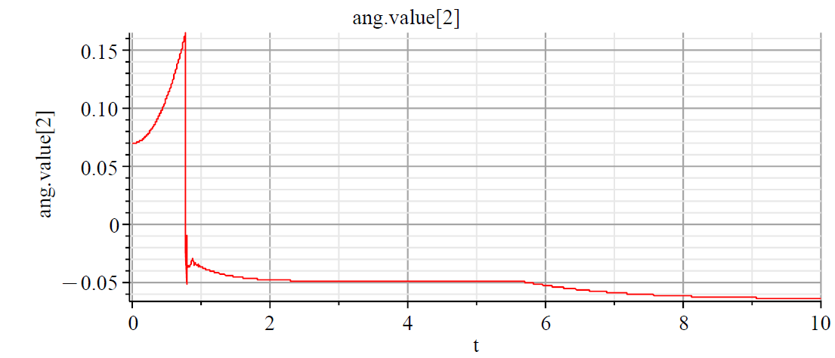

In the following images, the 3D printed subscaled model of the UAV fuselage and the located landing gear mechanism inside it has been shown:

