Predicting Marital Infidelity

Rene Solis

Bellevue University

Author Note

I would like to express my gratitude to Professor Williams for providing her support

towards the progress of this project.

**Abstract**

Couples therapists view extramarital affairs as one of the most damaging relationship events and

one of the most difficult problems to treat in couples therapy. Furthermore, a review of

ethnographic accounts of conjugal dissolution across 160 societies found that infidelity was the

single most common cause of marital dissolution. Rather than seeking couple therapy when

extramarital affairs happen, can we predict the factors of extramarital affairs? If so, we may help

prevent marital affairs from happening. The aim of the current project is to determine the

predictors of extramarital affairs. To tackle this project, I utilized Fair’s Affair data set. It

featured 10 columns and 601 rows. Some notable features were frequency of affairs, gender, age,

years married, and religiousness. After running a correlation matrix, the significant predictors

for my model were years married, religiousness, and happiness rating. Both in training and

testing, the model did not perform well with the predictors chosen from the correlation matrix.

*Keywords*: extramarital affair predictors, infidelity,

**Predicting Marital Infidelity**

The majority of couples come in for counseling when the relationship is on the edge of

falling apart. It comes as no surprise then that couples therapists view extramarital affairs as one

of the most damaging relationship events and one of the most difficult problems to treat in

couples therapy (Whisman, Gordon, & Chatav, 2007). It is with good reason. Research has

shown that marital infidelity can have lasting negative effects on the marriage and can lead to

divorce (Jeanfreau, Jurich, & Mong, 2014).

The increased coverage of marital infidelity within the media highlights the prevalence of

marital infidelity within our society. It is estimated between 30-60 % of men and 20-50 % of

women have been involved in some type of marital infidelity. Some researchers even estimate

that percentage to be higher.

To help explain the complexity of marital infidelity, it is important to understand what

occurs within the marriage. To do this, I utilized Fair’s data set to peek into respondents’ answers

about their relationship. The data set contained attributes known for being predictors of divorce.

Notable attributes were happiness rating of the relationship, religiousness, years of marriage, and

age of spouse. The aim of this project was to determine the predictors of infidelity.

**Methods**

**Data Preparation**

For the present project, I utilized Fair’s Affair data set. The data comprised from two

magazine surveys. The first survey was conducted in 1969 by *Psychology Today*. A

questionnaire on sexual activity was published in the July 1969 issue of *Psychology Today*, and

readers were asked to mail in their answers. They received about 20,000 replies. However, 2,000

replies were coded for the survey (Fair, 2002). The second survey was only for women. It was

conducted in 1974 by *Redbook*. A questionnaire on sexual activity was published in the October

1974 issue of *Redbook*, and readers were asked to mail in their answers. They received about

100,000 replies, and about 18,000 replies were coded for the survey. The questionnaire included

questions about extramarital affairs as well as about many other aspects of sexual behavior and

about various demographic and economic characteristics of the individual (Fair, 2002).

**Results**

Executing some exploratory analysis, we looked at happiness rating and number of

affairs (Figure 1). Happiness rating was categorized as 1 = very unhappy, 2 = somewhat

unhappy, 3 = average, 4 = happier than average, and 5 = very happy. Looking at the bar plot,

most affairs occurred with respondents whom answered in the 1 and 2 categories. The least

affairs occurred with respondents in the 5 category. The mean for happiness rating was *M* = 3.93

and a *SD* = 1.10.

**Figure 1**

*Happiness rating and number of affairs*

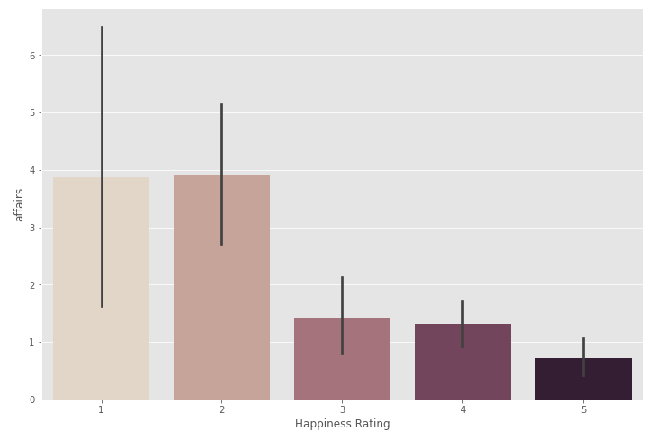

Affair by sex did not appear to be statistically significant between the sexes. Males had a

mean of *M* = 1.50 affairs in the past year with a *SD* = 3.29. Females had a mean of *M* = 1.42

affairs in the past year with a *SD* = 3.31.

How often did the sexes engage in extramarital affairs during the past year varied

between categories. Respondents’ answers were categorized as 0 = none, 1 = once, 2 = twice, 3 =

3 times, 7 = 4-10 times, 12 = weekly or daily. Most respondents answered the 0 category with

males answering 208 while females answering 243. For category 1, males answered 19 while

females answered 15. In category 3, males answered 11 while females answered 8. For category

7, males answered 20 while females answered 22. In category 12, males answered 18 while

females answered 20. Overall, both sexes appeared to engage in extramarital affairs just about

equally.

To determine the best predictors for my model, I ran a matrix correlation on the data set

(Figure 2). For the most part, the attributes had a small correlation with my target variable,

affairs. Years married had a correlation of *r* = 0.17. Religiousness had a correlation of *r* = -0.14.

Happiness rating had a correlation of *r* = -0.28. Since religiousness and happiness rating’s

correlation was closer to a medium size correlation, I included them in my model as predictors.

Thus, my predictors for my regression model were years married, religiousness, and happiness

rating.

**Figure 2**

*Marital infidelity matrix correlation*

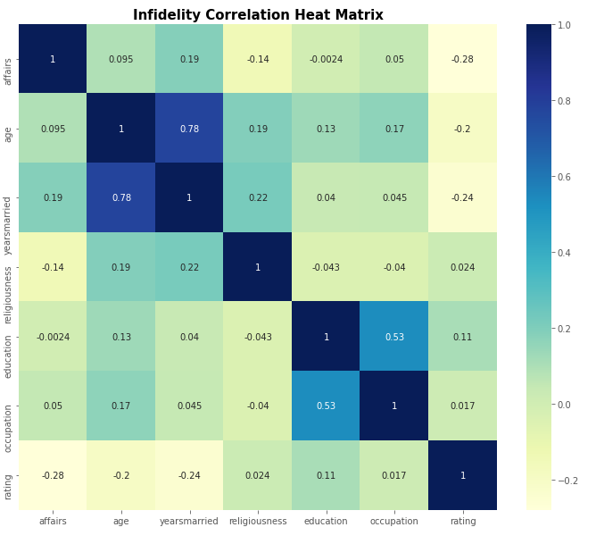

For my project, I used a regression model. My predictors were years married,

religiousness, and happiness. My target variable was affairs. I used a split validation to partition

the data set for my model. The training model utilized a data set with 417 instances while my test

model used 178 instances. According to my model, the predictor for affairs is years married

(Table 1). It had a p value of *p* = 0.00. Surprisingly, happiness rating did not appear to have a

statistically significant effect on my model. It had a p value of *p* = 0.95. The attribute

religiousness did not appear to have a statistically significant effect neither. It had a p value of *p*

= 0.75. In the testing model too, religiousness and happiness rating did not appear as significant

predictors of infidelity (Appendix). However, years of marriage did appear as a predictor. It had

a p value of *p* = 0.00.

**Table 1**

*Marital infidelity model*

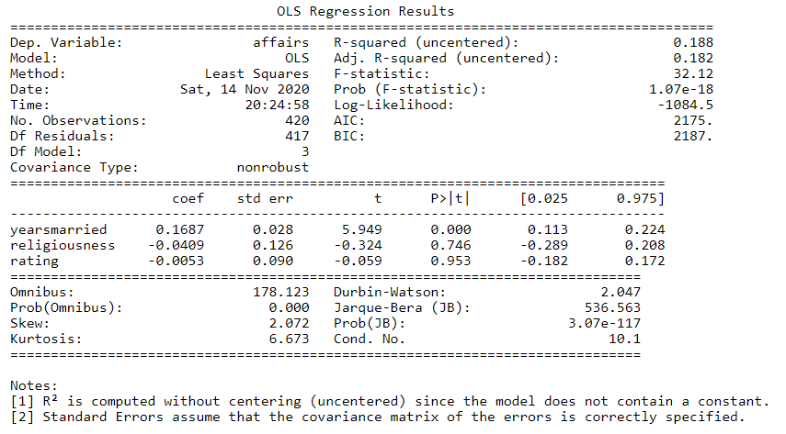

**Discussion**

In spite of unhappy spouses committing most of marital infidelity, happiness rating did

not appear to be a predictor of affair. I was not able to reproduce similar results other researchers

have noted about marital happiness and religiousness being predictors of marital affair

(Whisman, Gordon, & Chatav, 2007). Even if the sample from *Psychology Today* and *Redbook*

was not bias in their selection, it does raise a question in regards to generational subjects. For

instance, the survey from *Psychology Today* dates from 1969. The survey from *Redbook* dates

from 1974. A lot has changed both in terms how people few marriages and its purpose. Perhaps

recent studies that predict happiness rating and religiousness as predictors of infidelity used a

sample from a more recent generation than the one used by Fair. More research is needed to

determine if a more recent generation plays a role in predicting marital infidelity predictors.

References

Fair, R. C. (2002). *Predicting presidential elections and other things.* Stanford, CA: Stanford

University Press.

Jeanfreau, M., Jurich, A., & Mong, M. (2014). Risk Factors Associated with Women’s Marital

Infidelity. *Contemporary Family Therapy: An International Journal*, *36*(3), 327–332.

<https://doi-org.ezproxy.bellevue.edu/10.1007/s10591-014-9309-3>

Whisman, M. A., Gordon, K. C., & Chatav, Y. (2007). Predicting sexual infidelity in a

population-based sample of married individuals. *Journal of Family Psychology*, *21*(2), 320–324.

<https://doi-org.ezproxy.bellevue.edu/10.1037/0893-3200.21.2.320>

**Appendix**

*Regression test model of predicting marital infidelity*

