|  |  |  |  |  |
| --- | --- | --- | --- | --- |
|  | **a** | **b** | **c** | **B** |
| **0** | 1,B,R | 2,B,R | 3,B,R | F,B,L |
| **1** | 1,a,R | 1,b,R | 1,C,R | 4,B,L |
| **2** | 2,a,R | 2,b,R | 2,C,R | 5,B,L |
| **3** | 3,a,r | 3,b,R | 3,C,R | 6,B,L |
| **4** | 7,B,L |  |  | F,B,L |
| **5** |  | 7,B,L |  | F,B,L |
| **6** |  |  | 7,b,L | F,B,L |
| **7** | 7,A,L | 7,b,L | 7,c,L | F,B,L |
| **F** |  |  |  |  |

**Palíndromo**

M={(0,1,2,3,4,5,6,7,F), (a,b,c,d),β,0,B,F}

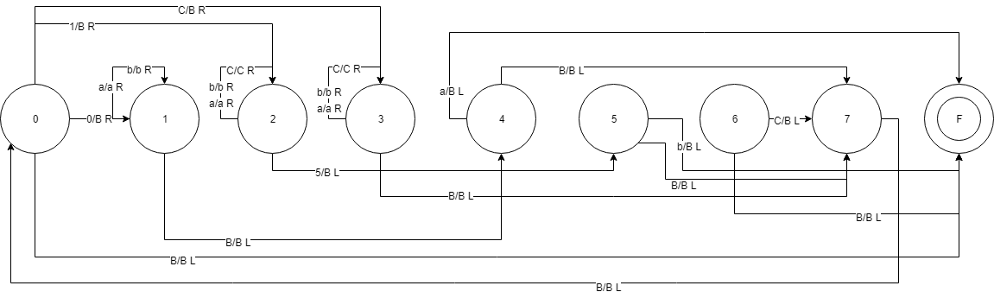

**Copia cadena**

M={(0,1,2,3,4,5,6,7,F), (a,b,c,d),β,0,B,F}

|  |  |  |  |  |  |  |  |
| --- | --- | --- | --- | --- | --- | --- | --- |
|  | **a** | **b** | **c** | **B** | **X** | **Y** | **Z** |
| **0** | 1,X,R | 2,Y,R | 3,Z,R | F,B,L |  |  |  |
| **1** | 1,a,R | 1,b,R | 1,C,R | 4,B,R |  |  |  |
| **2** | 2,a,R | 2,b,R | 2,C,R | 6,B,R |  |  |  |
| **3** | 3,a,R | 3,b,R | 3,C,R | 6,B,R |  |  |  |
| **4** | 4,a,R | 4,b,R | 4,C,R | 7,a,L |  |  |  |
| **5** | 5,a,R | 5,b,R | 5,C,R | 7,b,L |  |  |  |
| **6** | 6,a,R | 6,b,R | 6,b.R | 7,c,L |  |  |  |
| **7** | 7,a,L | 7,b,L | 7,c,L | 7,c,L | 0,X,R | 0,Y,R | 0,Z,R |
| **T** |  |  |  | F | T,a,L | T,b,L | T,c,L |

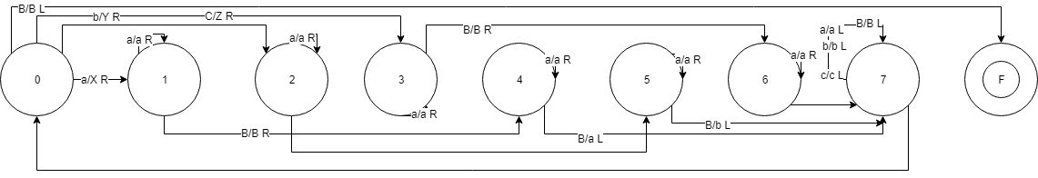

**Multiplicación**

M={(0,1,2,3,4,5,6,7,F), (a,b,c,d),β,0,B,F}

|  |  |  |  |  |  |
| --- | --- | --- | --- | --- | --- |
|  | **1** | **X** | **F** | **B** | **0** |
| **0** | 1,B,R | 7,B,R |  |  |  |
| **1** | 1,1,R | 4,X,R | 2,=,R |  |  |
| **2** | 2,1,R |  |  | 3,1,L |  |
| **3** | 3,1,L | 3,X,L | 5,=,L | 0,B,R | 3,1,L |
| **4** | 1,0,R |  |  |  |  |
| **5** | 6,1,L |  |  |  | 3,1,L |
| **6** | 6,1,L |  |  |  | 4,0,R |
| **7** | 7,B,R |  | F,B,R | T,B,R | T,B,R |
| **F** |  |  |  |  |  |

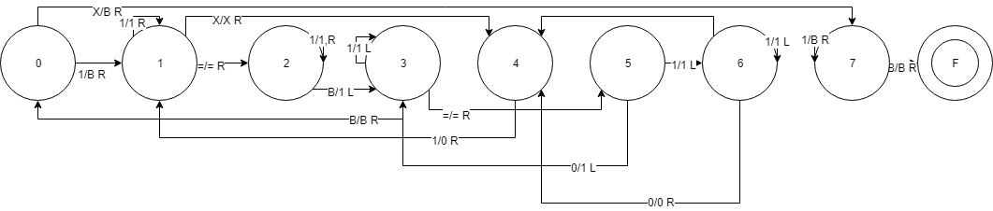

**Suma**

M={(0,1,2,3,4,5,6,7,F), (a,b,c,d),β,0,B,F}

|  |  |  |  |  |
| --- | --- | --- | --- | --- |
|  | **1** | **+** | **=** | **B** |
| **0** | 1,B,R | 0,B,R | F,B,R |  |
| **1** | 1,1,R | 1,+,R | 1,=,R | 2,1,L |
| **2** | 2,1,L | 2,+,L | 2,=,L | 0,B,R |
| **F** |  |  |  |  |

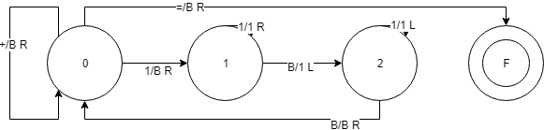

**Resta**

M={(0,1,2,3,4,5,6,7,F), (a,b,c,d),β,0,B,F}

|  |  |  |  |  |
| --- | --- | --- | --- | --- |
|  | **1** | **-** | **=** | **B** |
| **0** | 1,B,R | 6,B,R |  |  |
| **1** | 1,1,R | 1,-,R | 1,=,R | 2,1,L |
| **2** | 2,1,L | 2,-,L | 2,=,L | 0,B,L |
| **3** | 3,1,R |  | 3,=,R | 4,B,L |
| **4** | 5,1,L |  | 7,1,L |  |
| **5** | 5,B,L |  | 5,=,L | 6,B,R |
| **6** | 3,B,R |  | F,B,R |  |
| **7** | 7,1,L |  |  | F,0,L |
| **F** |  |  |  |  |

