**Analysis and Modelling of Locomotion**

Report on kinematic and kinetic gait analysis – Spring 2021

Student name: Titouan Renard Student name: _________________

Section: Robotics Section: _________________

Sciper number: 272257 Sciper number: __________________

**General information:**

This project will lead you through a series of exercises to familiarize you with the course content and to give you through computing experience some of the main analysis techniques involved in human motion analysis. Students will be divided into groups of two or three by the TAs. Each group of students will receive a dataset which is different from other groups and should provide one report per group.

The results must be handled back by completing the underlying report’s template. It should then be saved as pdf and sent back through the Moodle webpage of the class in due time for grading. Each lab session will be dedicated to a specific assignment and queries from that assignment will be given priority by the teaching assistants.

In case of problems related to this project, please contact the teaching assistants:

* Arash Atrsaei [atrsaei.arash@epfl.ch](mailto:atrsaei.arash@epfl.ch)
* Mahdi Hamidi Rad [mahdi.hamidirad@epfl.ch](mailto:mahdi.hamidirad@epfl.ch)
* Mina Baniasad [mina.baniasad@epfl.ch](mailto:mina.baniasad@epfl.ch)

# Setting up

## Install MATLAB

If not already available on your machine, please install MATLAB from the EPFL repository:  
<https://soft-epfl.epfl.ch/students/matlab/tah_en.cgi>

## Find your group and download the data

Go on the Moodle page of the course (Aminian part, first week, Datasets folder) and download the dataset file which is assigned to you. To find which dataset you should use, go on Moodle, open the file “Assigned Dataset” listed in Week 1 documents and find your Sciper number in the list of the groups. Then download the dataset number which correspond to your group and provide the name of data file here:

Data file name: amlWalkingDataStruct29.mat

## Structure of the data

To load the dataset from section ‎B into MATLAB environment, you can either double click on the dataset file “amlWalkingDataStructX.mat” (where X is your dataset number) or use the MATLAB command load(‘path_to_amlWalkingDataStructX.mat’). Here is the structure of the dataset file:

Each matrix is expressed as $[row×column]$

* data
  + imu.[left/right]
    - gyro: $N×3$ *matrix where N is the total number of samples and where the columns represent the 3 technical frame axis [X, Y, Z] of the gyroscope. Data are expressed in deg/s.*
    - accel: $N×3$*matrix where N is the total number of samples and where the columns represent the 3 technical frame axis [X, Y, Z] of the accelerometer. Data are expressed in g.*
    - accelstatic: $J×3$ *matrix where J is the total number of samples and where the columns represent the 3 technical frame axis [X, Y, Z] of the accelerometer. Data are expressed in g. accelstatic corresponds to a motion less period.*
    - midswings: $K×1$ *vector where K is the total number of midswings and where the ith sample correspond to the index of the ith midswing event.*
    - calibmatrix*: $3×3$ rotation matrix which aligns the technical frame [X, Y, Z] of the IMU’s sensors with the anatomical frame of the foot. Such a vector DT (3x1) in technical frame is expressed in anatomical frame by DA= calibmatrix*DT.*
    - fs: *gyroscope and accelerometer sampling frequency in Hz.*
    - time: $N×1$ *vector that stores the timestamps of each sample. Data are expressed in seconds.*
  + insoles
    - [left/right].pressure: $M×99$ *matrix where M is the total number of samples and where the columns represent the pressure measured by the each ith pressure cells in the insole ($i∈[1,99])$. Data are expressed in kPa.*
    - [left/right].area: $1×99$ *matrix where the columns represent the area of the ith pressure cell in the insole $i∈[1,99])$. Data are expressed in mm2.*
    - fs: *pressure insole sampling frequency in Hz.*
    - time: $M×1$ *vector that stores the timestamps of each sample. Data are expressed in seconds.*
  + *motioncameras*
    - static:
      * time: $Q×1$ *vector that stores the timestamps of each sample. Data are expressed in seconds.*
      * fs: *the motion cameras sampling frequency in Hz.*
      * [left/right]CenterFoot: $Q×3$ *matrix where Q is the total number of samples and where the columns represent the position of the marker in the [X,Y,Z] general frame. Data are expressed in mm. Figure 2 shows the position of this marker on the foot.*
      * [left/right]MedialFoot: $Q×3$ *matrix where Q is the total number of samples and where the columns represent the position of the marker in the [X,Y,Z] general frame. Data are expressed in mm. Figure 2 shows the position of this marker on the foot.*
      * [left/right]LateralFoot: $Q×3$ *matrix where Q is the total number of samples and where the columns represent the position of the marker in the [X,Y,Z] general frame. Data are expressed in mm. Figure 2 shows the position (1) of this marker on the foot.*
      * [left/right]LateralMalleolus: $Q×3$ *matrix where Q is the total number of samples and where the columns represent the position of the marker in the [X,Y,Z] general frame. Data are expressed in mm. Figure 2 shows the position (2) of this marker on the foot.*
      * [left/right]MedialMalleolus: $Q×3$ *matrix where Q is the total number of samples and where the columns represent the position of the marker in the [X,Y,Z] general frame. Data are expressed in mm. Figure 2 shows the position (3) of this marker on the foot.*
    - walking*:*
      * *Same content as in* static *but without the malleolus markers.*

You can access any of these fields using the “.” connector. For example, if you want to access the accelerometer data of the IMU on the left foot, you can type: data.imu.left.accel.MATLAB script.

Please download the file named “*amlMATLABScript.m*” under Week 1 in Moodle. Save this file in the same directory as the dataset you downloaded in ‎B and rename it in the following way “*<last name1>_<last name2>_AML.m*” where you must replace *<last name>* by your last names (e.g. Zola_Smith_AML.m). **This file must contain all the MATLAB code that you wrote for this report**.

## Structure of the script

Please respect the structure of the MATLAB script we provided and add your code where “<<< ENTER YOUR CODE HERE >>>” is written. Also, for some exercises we ask you to provide the detailed results of your algorithms. This is done through the use of an output structure named “scriptOutResults” which you will have to fill in at the end of some exercises. Please do not change the name of the fields of this output structure. Finally, note that we introduced four functions (alignGyroscopeTF2AF, get3DRotationMatrixA2B, applyLowpassFilter , fft_plot at the end of the script to help you with the assignments.

## MATLAB tips

Below is a list of MATLAB functions you may need for this project:

* Figure()
* Plot()
* Subplot()
* Norm()
* Diff()
* Sum()
* Min()
* Max()
* Mean()
* Trapz()
* Linspace()

We strongly recommend that you use the official MATLAB webpage for help, or use the helpcommand before the function of interest. For example, if you want to have more information about the plot() function, you can type help plot in the MATLAB console.

## Submit your project

Before submitting your project, please create a .zip file which contains:

1. This document completed with your results.
2. Your MATLAB script named *“<last name1>_<last name2>_AML.m”* where you must replace *<last name>* by your last names.
3. The output structure automatically saved in the same directory as your MATLAB script. This file should have to following name: *“<last name1>_<last name2>_outStruct.mat”.*

Please name your .zip file as such: *“<last name 1>_<last name 2>_AMLProject.zip”* where you must replace *<last name>* by your last names. You can then go under Week 4 of the class Moodle page and submit this .zip file using the link “Electronical submission for projects”.

Your project should be submitted before March 26, 2021.

# Assignement 1: Temporal and spatial gait analysis (27 Pts + 4 pts Bonus)

As seen during the lectures, gait temporal events detection plays an important role in walking analysis. There are several systems for measuring such events, each have their own advantages and drawbacks. In the literature, force plates are often used as reference system as they provide direct information about the ground reaction forces applied on the foot and, therefore, allow an accurate detection of initial contact and toe-off. However, force plates are limited to laboratory usage as their setup requires an environment dependent and time-consuming calibration of the force sensors.

The goal of this assignment is to introduce two other methods that are used outdoor using wearable sensors. Before starting, we recommend that you read the publication by Mariani et al. (2013) [1] on « Quantitative estimation of foot-flat and stance phase of gait using foot-worn inertial sensors ».

The objective of this assignment is to be familiar with temporal gait analysis through two measurement techniques: foot-worn Inertial Measurement Units (IMU) and plantar pressure measurement insole. In addition, body segment angles estimation from gyroscope is introduced.

## 1.A Temporal gait analysis with gyroscope (24 pts + 2 Bonus)

1) From the MATLAB data structure you downloaded in SETTING UP section ‎B, plot the three components of the gyroscope sensors, **in the anatomical frame**, using the MATLAB function plot. Note that you need to align the technical frame of the IMU with the anatomical frame of the foot. You can do this by using the function alignGyroscopeTF2AF that we provided with the script. Observe the signal and provide the label of the column corresponding to the pitch angular velocity, _pitch (justify your answer). (3 points)

2) Apply a lowpass filter with cut-off frequency of 12 Hz to the first column of the accelerometer in the technical frame of the sensor data for one foot (left/right) and then compare with the raw signal. You can apply the filter using the function *applyLowpassFilter* that we provided in the script. Change the cut-off frequency to 5 Hz and describe what happen by decreasing the cut-off frequency. Plot the raw signal in technical frame, its filtered version with 12 Hz cut-off, and the version with 5 Hz cut-off frequency for a two second window that you can better observe the effect of filtering. What are the advantages/ drawbacks of such a filtering process? (2 points)

|  |
| --- |
|  |

3) Consider the content of data.imu.[left/right].midswings to segment the _pitch (i.e. pitch angular velocity) in midswing-to-midswing cycles. Write a script to detect for both feet all initial contacts (IC), terminal contacts (TC) and the middle of the foot-flats based on the gyroscope data as in chapter 2 of the course and in reference [1]. Once again, use the alignGyroscopeTF2AF function to align the technical frame of the gyroscope with the anatomical frame of the foot. You can save the results of IC and TC for each foot in a mat file. Explain why _pitch is always negative during the stance. Do you get expected results for foot-flat, IC and TC? If not, discuss a possible solution to improve your result. (6 points)

4) Add in the frame below a graph showing four gait cycles against time, from the right foot with the results of your IC and TC events detection, middle of the foot flat (FF) phase and the mid-swing (MS). Do not forget to add the labels on each axis of the graph and a legend for all the signals. (2 points)

5) Complete your script to estimate, for each foot, the parameters in the table below. Compute the mean and standard deviation (STD) over all gait cycles and fill the blanks in the table. (6 points)

|  |  |  |  |  |  |
| --- | --- | --- | --- | --- | --- |
| **Parameter** | | **Left leg** | | **Right leg** | |
| **Label** | **Units** | **Mean** | **STD** | **Mean** | **STD** |
| Gait cycle time | ms |  |  |  |  |
| Cadence | steps/min |  |  |  |  |
| Stance Percentage | % |  |  |  |  |

6) In the above table, compare the values obtained for the right and the left leg and discuss the difference. (1 point)

7) Estimate the coefficient of variation (in %) of the gait cycle time obtained from of the right foot. (1 point)

8) What gait behavior is expressed by CV and how do you judge the value you obtained in the previous question? (1 point)

9) Plot the single-sided amplitude spectrum of the vertical acceleration and gyroscope signal using *fft_plot* function in the end of the code. Remove the mean value of vertical acceleration before computing its Fourier transform. What does the frequency of the peak represent and how does this value relate to the value of cadence obtained in 1.A.5? Note that you might observe several peaks. Which one is related to cadence and why? (2 points)

10) Bonus question (2 points): propose a method to detect right and left stride time from recorded signals

|  |
| --- |
|  |

## 1.B Foot angle estimation with gyroscope (3 pts + 2 Bonus)

1) Consider _pitch at a gait cycle *i* starting at foot_flat(*i*) and ending at foot_flat(*i+1*). Estimate the foot rotation in sagittal plane (pitch_angle) by integration _pitch (e.g. the trapezoidal integration rule using the script trapz()). You should obtain a signal similar to the one below:

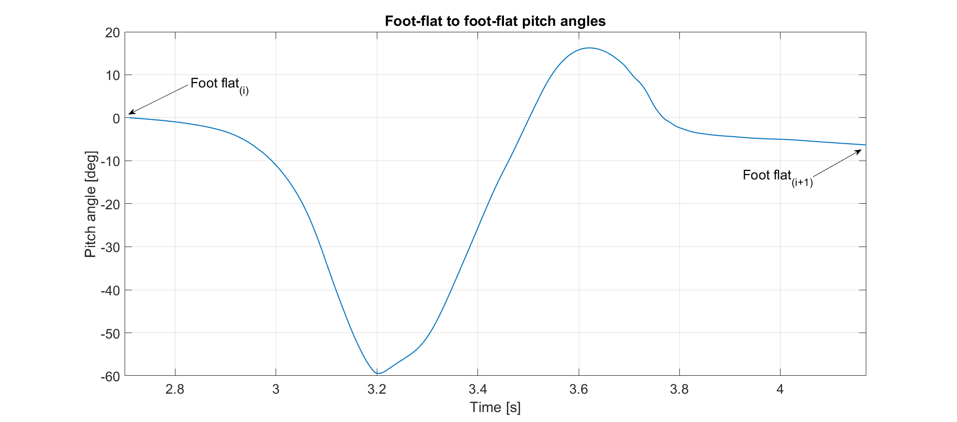

Figure 1: Foot-flat to foot-flat pitch angle

2) Considering gait as periodic, we expect same pitch_angle at the beginning of each cycle. Estimate the difference of pitch_angle at foot_flat (i+1) and foot_flat(i). Explain the source of error for this difference and propose a model to this error and correct the pitch_angle(t).

3) Plot the estimated pitch_angle (for ten gait cycles) before and after correction of error in the following box.

4) Bonus question (2 points) : Estimate the average and STD of the pitch foot angle at IC by averaging values over ten cycles.

|  |
| --- |
|  |

# ASSIGNEMENT 2: FRAME & ORIENTATIONS (26 Pts)

In addition to temporal analysis, information about the foot’s position and orientation in space is relevant for clinicians [2]. In the literature, the gold standard for 3D motion analysis are stereo photogrammetry-based motion capture and reflective markers.

The goal of this assignment is to understand some of the basic steps required when performing 3D motion analysis with cameras-based motion capture. We will address issues such as alignment of the marker based technical frame (TF) with the anatomical frame (AF). Moreover, meaningful angles for the spatial analysis of gait will be studied.

## 2.A Anatomical calibration of foot-worn sensor (9 pts)

As explained during the Chapter 3 lectures, IMUs measure 3D kinematics (i.e. angular velocity, acceleration) in their own technical frame. If this technical frame is not aligned with the anatomical frame of the segment it is affixed to (in this case the foot), it becomes very complicated to understand the meaning of each individual IMU axis. Moreover, if we remove the IMU from the foot and place it again, it is very likely that the orientation of the technical frame with respect to the segment anatomical frame will be different than for the previous trial. Therefore we need to estimate the rotation matrix, which aligns the IMU technical frame with the foot anatomical frame. **We use static phase (i.e. motionless period) for this alignment**.

In this part, you need to complete your MATLAB script to align only the y-axis of the IMU technical frame (Y_IMU_TF) with the anatomical y-axis of the foot (Y_AF). We assume that the gravity vector measured by the accelerometer during standing still phase (subject not moving and standing on a flat ground) should be aligned with the vertical axis Y_AF, since Earth’s gravitational acceleration is perpendicular to the ground. The data in data.imu.[left/right].accelstatic represent the foot-worn accelerometer measurements while the subject was standing still on the treadmill. Figure 2 gives an example of the aforementioned static situation.

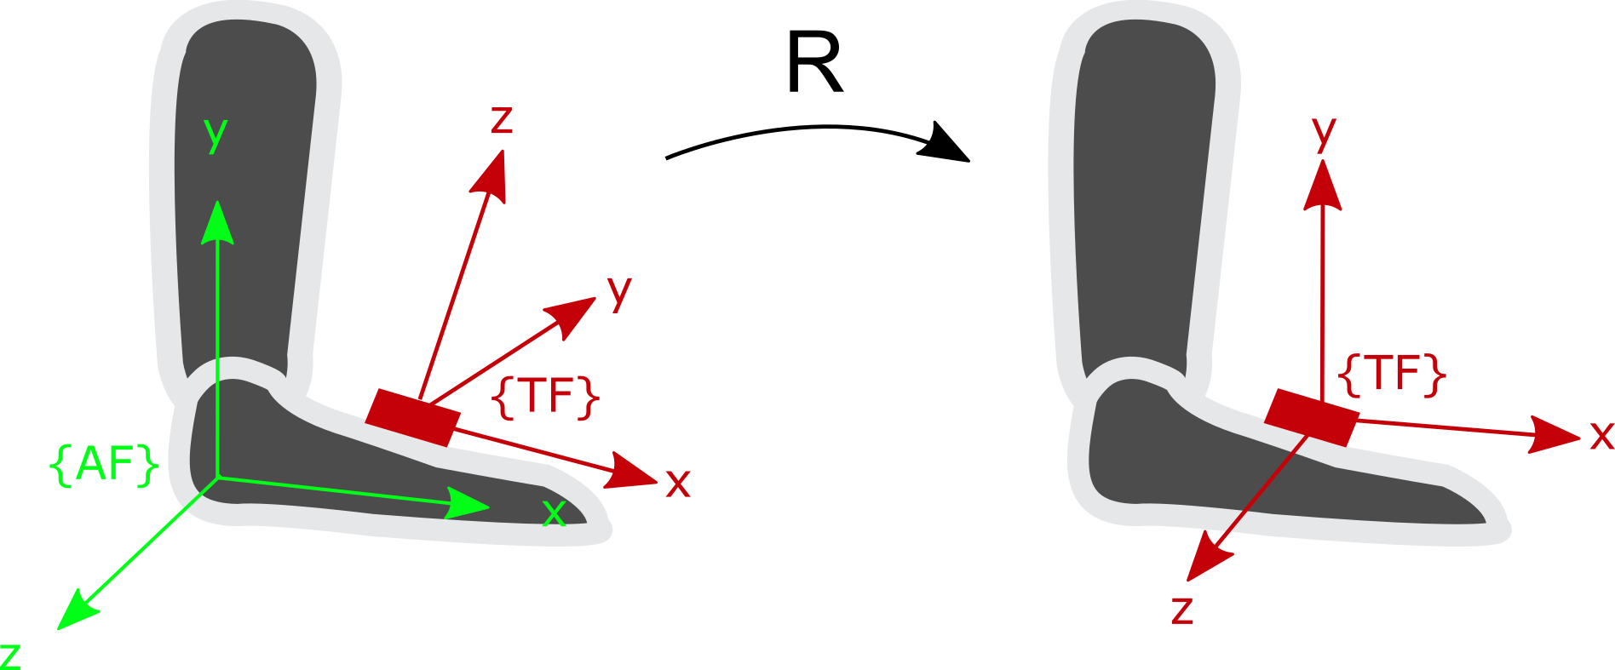

* {AF}: The **anatomical frame** of the foot
* {TF}: The **technical frame** of the IMU.
* **g**: Acceleration due to **Earth gravity**.

**g**

Figure 2 - The anatomical frame {AF} of the right foot, technical frame {TF} of the IMU and gravity vector (g). R express the rotation matrix that align {TF} with {AF}.

1) Express the gravity vector in the {TF} of the right foot IMU, by considering the average value of the static measurements represented by a $j×3$ matrix in data.imu.right.accelstatic. (1 point)

*TFg = [ , , ] g*

2) Express the gravity vector **g**, **measured by the accelerometer**, in the anatomical frame of the foot during a static period (i.e. the foot is flat on the ground) and obtain the anatomical y-axis of the foot (Y_AF). (1 point)

*Y_AF=[ , , ] g*

3) The provided script get3DRotationMatrixA2B(A,B)compute the rotation matrix between two $1×3$ vectors A and B. Find the rotation matrix R_TFg_Y_AF between TFg and Y_AF. (2 points)

|  |  |  |
| --- | --- | --- |
|  |  |  |
|  |  |  |
|  |  |  |

*R_TFg_Y_AF =*

4) Using subplot() command in MATLAB, plot the two graphs: the static acceleration signal before and after applying the rotation matrix. Discuss the difference (3 points)

5) The above calibration align only one axis of the TF to AF. Do you have any suggestion to align the three axes of TF? Describe your idea in few sentences. (2 points)

## 2.B Anatomical calibration of camera-based motion capture (12 pts)

The goal of this part is to construct the technical frame of the foot using reflective markers attached to the foot by assuming the foot as one rigid segment. Then we perform a 3D anatomical calibration using some anatomical landmarks of the foot. The static measurements recorded with the subject standing still with foot flat will be used for calibration. Figure 3 shows the marker configuration on the foot. Each marker in Figure 3 is expressed in the global frame of the camera-based motion capture system. You can find the data in the MATLAB structure we provided under data.motioncameras.static.<marker_name>*.* The global frame is defined by [XO,YO,ZO]: the x-axis is in the direction of length of the treadmill, the y-axis is perpendicular to the ground pointing towards the ceiling (upward) and the z-axis is in the direction of the width of the treadmill.



5

4

3

1

2

{GF}

{AF}

**Markers for TF** :

1 leftCenterFoot

2 leftLateralFoot

3 leftMedialFoot

**Landmark Markers :**

4 leftLateralMalleolus

5 leftMedialMalleolus

**YAF**

**XAF**

**ZAF**

**YO**

**XO**

**ZO**

Figure 3 - Left foot markers configuration for the technical frame {TF} and the global frame {GF}.

1. Plot the three components of the *leftCenterFoot* marker versus time. Observe the signal and provide the label of the column corresponding to the anterior posterior (direction of walking) and vertical direction. Justify your choice for both columns. Label the legend in the plot accordingly. The motion data was captured at 100 Hz and note that the subject was walking on a treadmill. (2 points)

|  |
| --- |
|  |

1. Complete your script to construct the technical frame (TF) for the left foot with the help of the skin markers 1, 2, 3 and using the average values of their coordinates during static period (use data in data.motioncameras.static.<marker_name>*).* Fix the origin of TF on marker 1 with Y_TF pointing upward. Compute the axes of TF: (2 points)

*X_TF = [ , , ]*

*Y_TF = [ , , ]*

*Z_TF = [ , , ]*

1. Compute the rotation matrix ${}_{TF}^{GF}R$. (1 point)

|  |  |  |
| --- | --- | --- |
|  |  |  |
|  |  |  |
|  |  |  |

$${}_{TF}^{GF}R=$$

1. The anatomical frame AF for left foot is defined with Y_AF parallel to YO pointing upward. Using an auxiliary axis Z’_AF, from marker 4 to 5, pointing to the right (medial side). Complete your script to compute the axes of AF. Set the origin of AF at marker 1. (3 points)

*X_AF = [ , , ]*

*Y_AF = [ , , ]*

*Z_AF = [ , , ]*

1. Propose a method to check whether the AF you computed is orthogonal. If it is non-orthogonal, correct your computation of the frame to ensure orthogonality. (1 point)

|  |
| --- |
|  |

6) Compute the rotation matrix . (1 point)

|  |  |  |
| --- | --- | --- |
|  |  |  |
|  |  |  |
|  |  |  |

7) Complete your script to compute the rotation matrix that align TF with AF, i.e. ${}_{TF}^{AF}R$ (2 points)

|  |  |  |
| --- | --- | --- |
|  |  |  |
|  |  |  |
|  |  |  |

$${}_{TF}^{AF}R=$$

## 2.C Foot angle computation (5 pts)

Now that the calibration matrix has been computed in static conditions, we can apply it to the data measured while walking on a treadmill. This is possible because we assume that the markers’ position on the foot have not changed between the static measure and the walking measure. After you applied the rotation matrix, the axes of your technical frame are aligned with the anatomical frame while the data are expressed in the global reference frame.

1) Complete your script by computing the TF during walking for each frame.

2) Complete your script by computing the AF during walking for each frame.

3) Compute the pitch angle of the foot (rotation around the medio-lateral axis) during walking

Here are some tips to help you:

* The formula to find the angle **α** between a 3D vector **u**  and a plane with normal vector **n** is:

$α= arcsin⁡(\frac{|n×u|}{\left|n\right||u|})$.

* The plane of interest as defined by the treadmill is the plane spanned by XO and ZO axes of the global frame (i.e. x = [1 0 0] and z = [0 0 1]). You need to define the anatomical axis of the foot and then estimate the angle  (pitch angle).
* Please also check the MATLAB documentation when using the arcsin function and pay attention to the argument and output of this function in MATLAB.

4) Add in the frame below the graph of the pitch angles over two strides and show on the graph where the approximate stance phases, swing phases and foot-flat phases are (no need for precise answer). Can you make use of the results from question 1.A.3 to deduce the location of these phases and how?

# Assignement 3: Kinetic analysis (22 Pts)

In many cases, kinetic analysis is a good complement to kinematic analysis. It allows computing some temporal parameters and an estimate the forces acting on a segment or joint. Reliable measurement or estimation of these forces can be very helpful, especially because force excess or imbalance could lead to joint disease (e.g. arthrosis).

The main problem to estimate the joint forces remains in the difficulty to measure internal force. To tackle this issue, a commonly used approach consists in measuring the force at the extremities, and to use inverse dynamics in order to compute the net force on the more proximal joints. More detailed information on this approach is available in Whittlesey 2004 [3].

In gait analysis, we usually start with a force-plate which is considered as gold standard for ground reaction force measurement. Nonetheless, the size of the force plate is limited, and in most cases, it is only possible to record a single step. Another approach consists to measure ground reaction force with a plantar pressure insole placed in the shoe. This allows to record an arbitrary number of steps, even beyond the lab setup, however only the vertical component of the force can be measured, and some additional artifacts will be present, mainly due to the shoes movements around the foot.

In this exercise, you will get familiar with the use of plantar pressure insoles for the computation of temporal parameters, ground reaction and internal ankle forces, and get a more concrete idea of the advantages and limits of this method.

## 3.A Ground reaction force during foot-flat phase (10 pts)

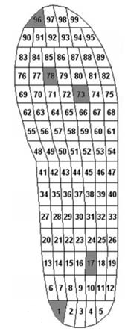The plantar pressure insole (as from now on, the insole) measures the plantar pressure distribution using 99 cells. The signals in data.insoles.[left/right].pressure are expressed in kPa, therefore, you will have to use the content of data.insoles.[left/right].areato transform the data into the Newton units. Use Figure 3 to segment the insole data. You can select a portion of the insole data by doing data.insoles.[left/right].pressure(:, p:q) where p and q are integers corresponding to pressure cell. This command will return an M by (q-p+1) matrix that contains all that data of the pressure cells between p and q (p and q are included)*.*

Figure 4 - Pressure cells position within the insole.

1) Split the insole in two parts: the rear-foot (cells 1 to 33) and fore-foot (cells 55 to 99) and estimated the total force acting under each part: *F_rear, F_fore*. Using the two force signals and appropriate thresholds. Complete your script by writing a rule to detect the four gait events described in Mariani et al. (2013) [1], namely: initial contact or heel strike(HS), toe-strike (TS), heel-off (HO) and terminal contact or toe-off (TO). Justify the values of your thresholds. (5 points)

2) Add in the frame below a graph showing *F_rear* and *F_Fore* for two gait cycles of the right foot where *HS*, *TS*, *HO* and *TO* events are correctly detected and show these events in your plot. Do not forget to add labels on each axis and a legend for all signals. (3 points)

3) For the two cycles above, estimate the foot-flat duration. (2 points)

*Foot_flat_1 = ... ms Foot_flat_2 = ... ms*

## 3.B Net force and net moment at ankle joint (12 pts)

Here we aim to estimate the net force (*FA, FF*) and moment (*MA, FF* ) at ankle joint during the foot-flat phase.

1) During foot-flat period estimate the mean vertical ground reaction force signal recorded by all the pressure sensors of the insole during this period, *GRFFF*. (1 point)

*GRF_FF = .... N*

2) Complete the free body diagram (assume that the foot is in the foot-flat phase) and indicate *GRFFF* on the diagram. (2 points)

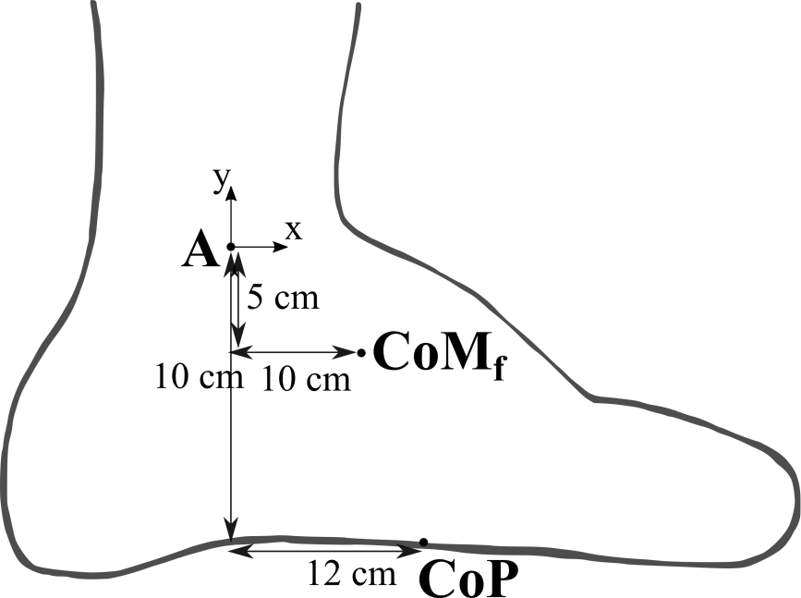

3) Compute the net force (*FA, FF*) and moment (*MA, FF* ) on the ankle for every time sample of foot-flat phase. We assume that the mass of the foot is 1 kg, and the mediolateral component of the ground reaction force is zero while the forward component of ground reaction force during foot-flat is parallel to the ground and equal to +10% of *GRFFF*. We consider the *CoP*, *CoM* and *A* movement are negligible during this interval. Compute the value of *FA, FF and MA, FF* in the middle of foot flat and report it in the table. (4 points)

*FA, FF=*  *... N* *MA, FF=*  *... N.m*

4) Given a choice between using a pressure insole or a foot-worn IMU, which one would you choose for estimating the gait events and why? (Hint: Think about their advantages/limitations in terms of accuracy and suitability for all gait phases). (3 points)

|  |
| --- |
|  |

1. Plot the ground reaction force obtained from left and right insoles separately in one graph. Does this plot represent a M-shape? Assuming that body weight is equal to *GRFFF* estimated in 3.B.1, explain why the magnitude of the peak is higher than the bodyweight? (2 points)

|  |
| --- |
|  |

# References

[1] Mariani, B., Rouhani, H., Crevoisier, X., & Aminian, K. (2013). Quantitative estimation of foot-flat and stance phase of gait using foot-worn inertial sensors. Gait & posture, 37(2), 229-234.

[2] Barrett, R. S., Mills, P. M., & Begg, R. K. (2010). A systematic review of the effect of ageing and falls history on minimum foot clearance characteristics during level walking. Gait & posture, 32(4), 429-435.

[3] S. N. Whittlesey, D. G. E. Robertson, G. Caldwell, J. Hamill, and G. Kamen, “Two-Dimensional Inverse Dynamics,” in *Research Methods in Biomechanics*, 2004, pp. 103–124.