Renat Norderhaug

CS 477

9/24/19

Homework Assignment #3

1.

1. The algorithm is running 2 loops. The outer loop is from 0 to n-2 and the the inner loop is from i + 1 to n-1. It is checking if the elements are equal. The algorithm is calculating for the existence of duplicate elements and returns false if there is a duplicate element, else it returns true.
2. Time complexity: 0(N^2)

2.

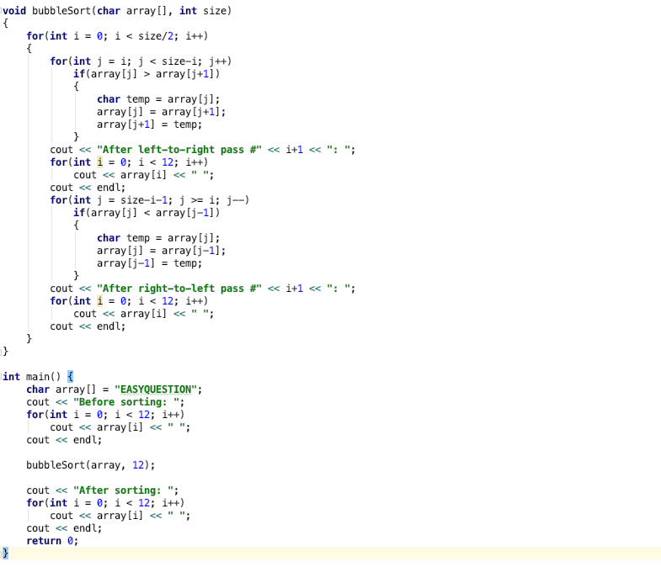

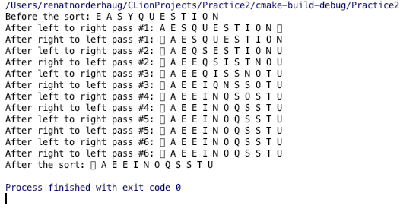

b)

12 comparisons

3.

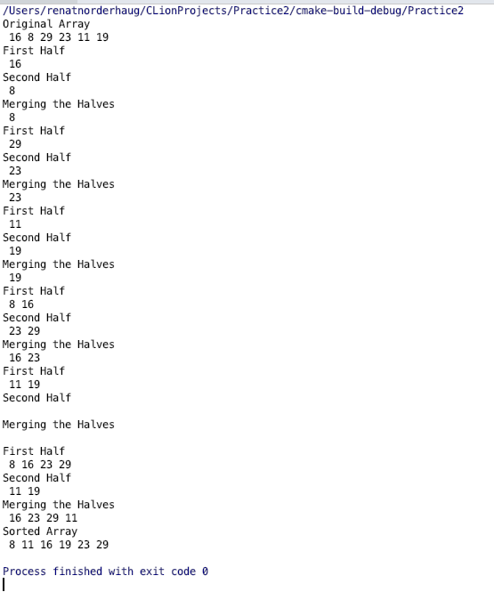

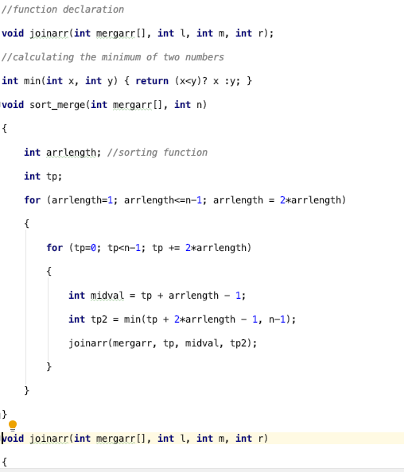

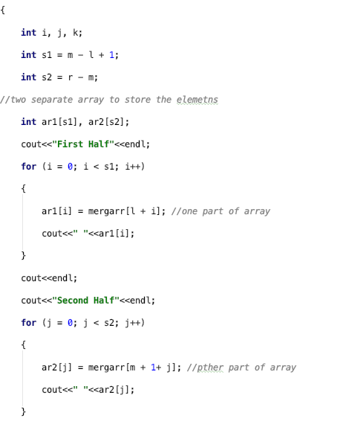

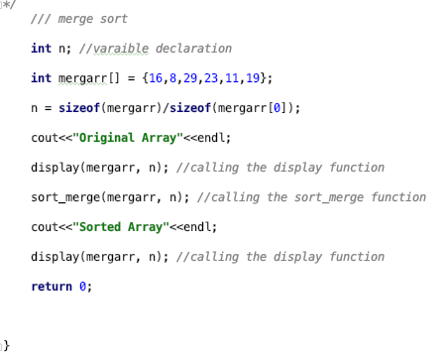

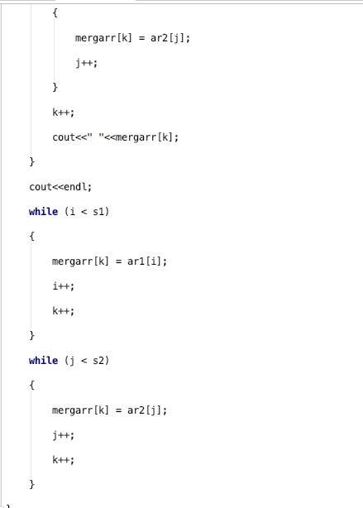

5.

1. The algorithm finds the minimum value of an array, the algorithm splits an array into 2 halves and finds the minimum value of each and then compares the minimum values and outputs the final minimum value