Software Engineering Project

Code Smells

By: Madalena Plácido 63001 (team_member4)

Table of Contents
Software Engineering Project 1
Code Smells 1
Introduction 1
Code Smell 1 2
Code Smell 2 3
Code Smell 3 4
References 4

Introduction
The aim of this report is to identify three code smells present in the code provided of the open-source game Freecol, the subject of our Software Engineering Project.
Code smells are characteristics which indicate that there may be some issues in the implementation or design of a program.

Code Smell 1
Type: Long Method
Location: Game.src.net.sf.freecol.server.model.ServerPlayer.csCombat(…)
I found this method while analyzing my metric Lines of Code. This is the longest method in the whole program with 495 lines.
Solution: To remove the smell, I suggest the addition of smaller auxiliar methods, the main method can call, making it easier to understand what the method does.
Code:
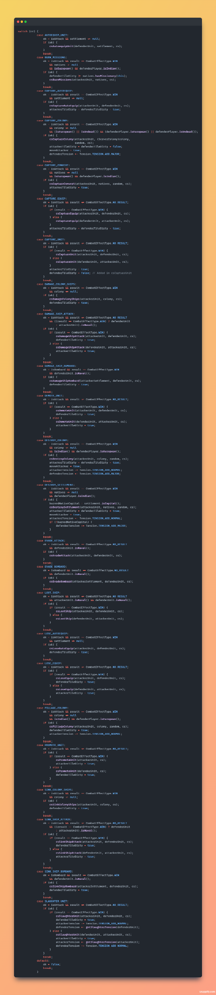

Code Smell 2
Type: Data Class
Location: Game.src.net.st.freecol.common.option.RangeOption
This class has nothing but getter and setter methods. I found it while exploring the code.
Solution: To remove the smell, I suggest adding other methods to give the class functionality.
Code:
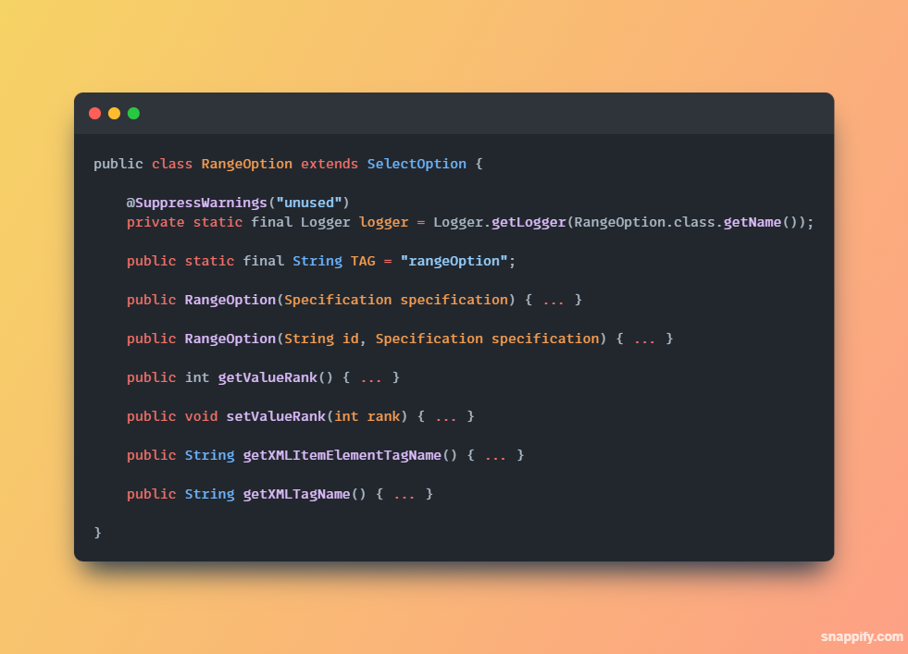

Code Smell 3
Type: Long Parameter List
Location: Game.src.net.sf.freecol.common.model.Map.searchMap(…)
I found this method while analyzing my metric Lines of Code. This is the fourth longest method in the program, but what brought my attention was the 8 parameters.
Solution: To remove the smell, I suggest the introduction of parameter objects or the creation of global variables.
Code:
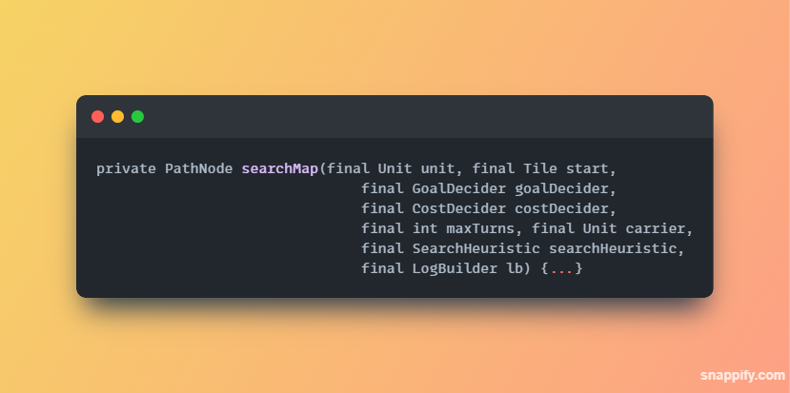

References
ES2324 Lecture 11 – Code Smells.pdf

