Software Engineering Project

Design Patterns

By: Madalena Plácido 63001 (team_member4)

Table of Contents
Software Engineering Project 1
Design Patterns 1
Introduction 1
Design Pattern 1 2
Design Pattern 2 3
Design Pattern 3 4
References 4

Introduction
The aim of this report is to identify three design patterns present in the code provided of the open-source game Freecol, the subject of our Software Engineering Project.
Design patterns are models of common problems in the software design and their respective solutions. They can be creational (deals with creating new objects), structural (deals with the relations between objects) or behavioral patterns (deals with how objects interact between them).

Design Pattern 1
Type: Composite
Location:
Game.src.net.sf.freecol.common.model.mission.AbstractMission.java
Game.src.net.sf.freecol.common.model.mission.CompoundMission.java
Game.src.net.sf.freecol.common.model.mission.GoToMission.java
Game.src.net.sf.freecol.common.model.mission.ImprovementMission.java
Game.src.net.sf.freecol.common.model.mission.Mission.java
This structural design pattern allows objects to be composed in trees and work with the structures as individual objects. I found it because the CompoundMission class (the container) can have elements like the leaves (ImprovementMission and GoToMission classes) or other containers.

Code snippet:
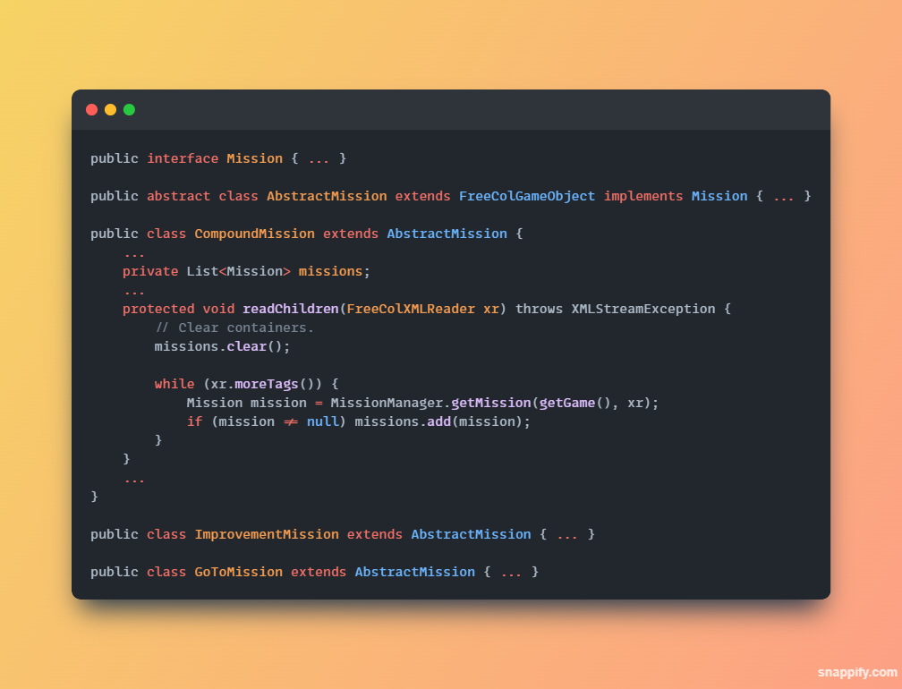

Class Diagram:
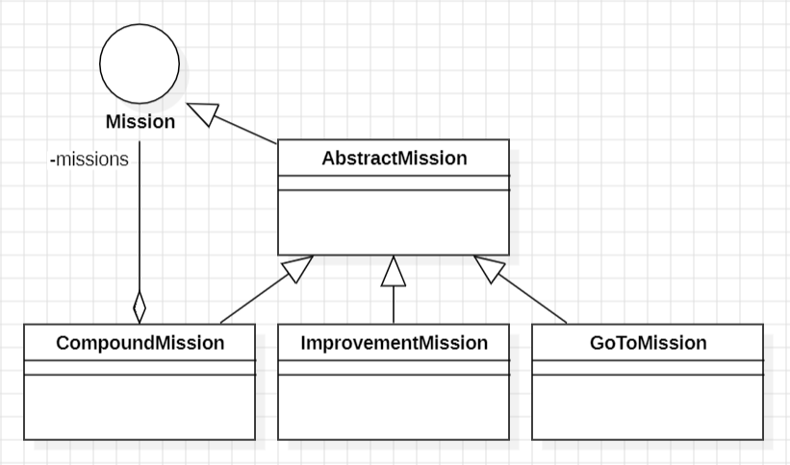

Design Pattern 2
Type: Template Method
Location:
Game.scr.net.sf.freecol.common.networking.TrivialMessage.java
Game.scr.net.sf.freecol.common.networking.AttributeMessage.java
Game.scr.net.sf.freecol.common.networking.ReconnectMessage.java
Game.scr.net.sf.freecol.common.networking.StartGameMessage.java
Game.scr.net.sf.freecol.common.networking.RequestLaunchMessage.java
Game.scr.net.sf.freecol.common.networking.ContinueMessage.java
Game.scr.net.sf.freecol.common.networking.RetireMessage.java
Game.scr.net.sf.freecol.common.networking.DisconnectMessage.java
Game.scr.net.sf.freecol.common.networking.EnterRevengeModeMessage.java
Game.scr.net.sf.freecol.common.networking.EndTurnMessage.java
This behavioral design pattern defines an outline of an algorithm in the superclass and lets the subclasses redefine the implementation of those methods. I found it when analyzing the class diagram of the whole project.

Code snippet:
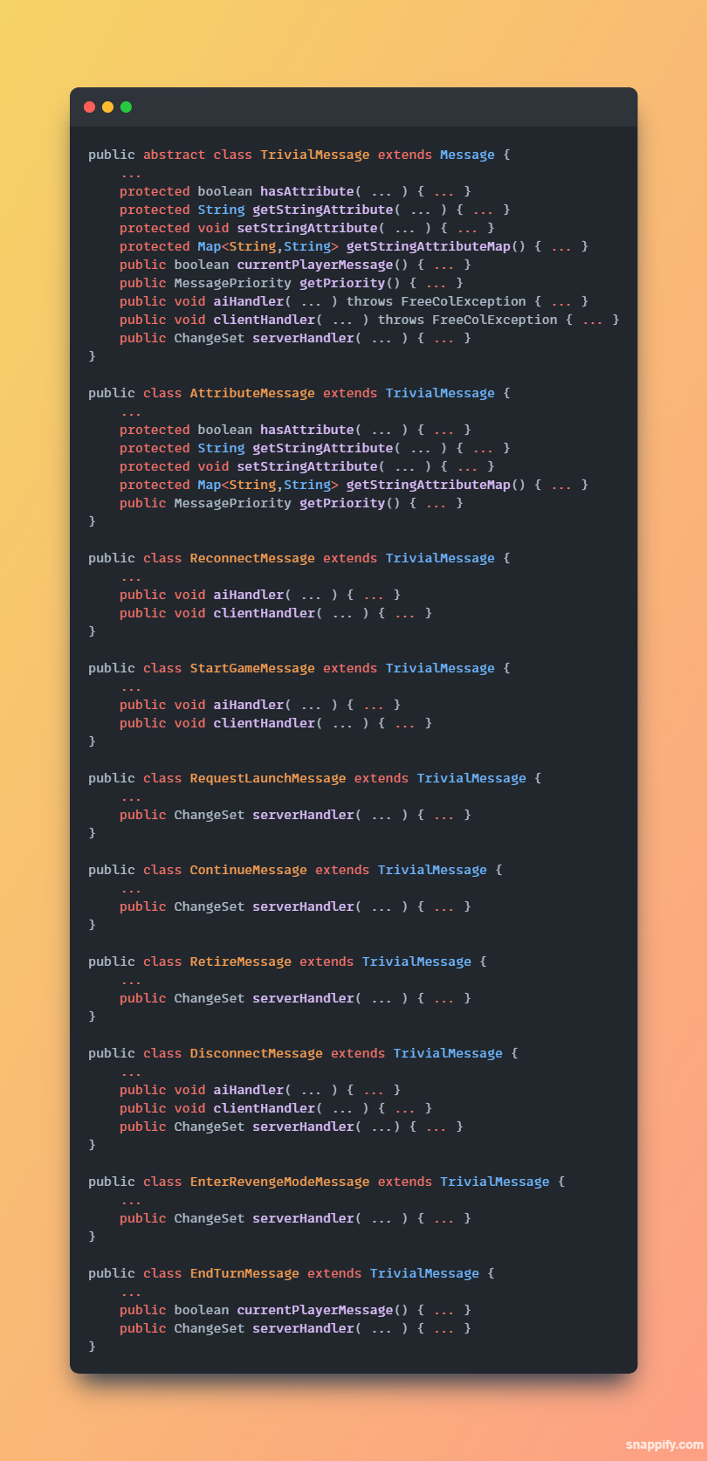

Class Diagram:
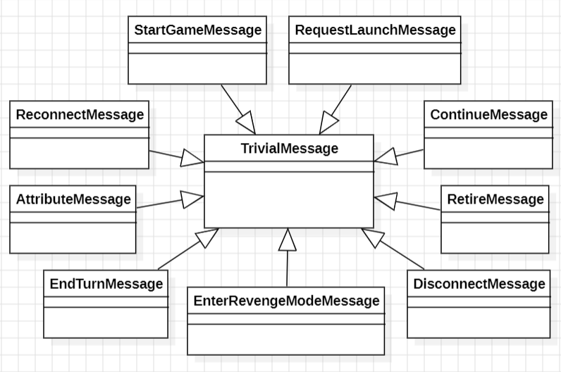

Design Pattern 3
Type: Memento
Location:
Game.src.net.sf.freecol.common.model.Unit
Game.src.net.sf.freecol.common.model.UnitWas
Game.src.net.sf.client.control.InGameController
This behavioral design pattern allows the process of saving and restoring the previous state of objects. The class InGameController needs the previous unit state which is stored in the class UnitWas.

Code snippet:
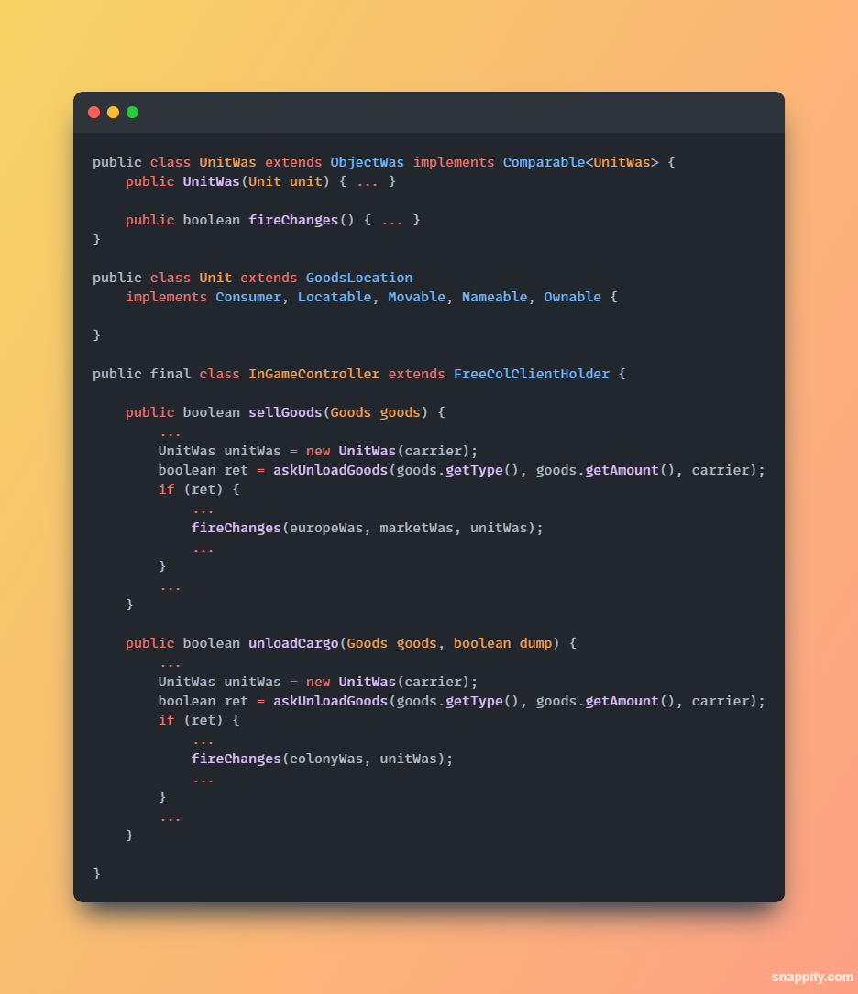

Class Diagram:
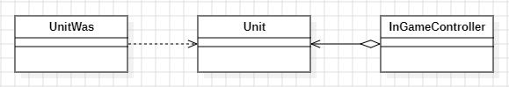

References
ES – Lecture 8, 9, and 10 – Design Patterns.pdf
https://refactoring.guru/design-patterns, consulted at 8/11/2023

