Software Engineering Project
Martin Packaging Metrics
Code Metrics

Renata Henriques (63215) - team_member6

The Martin Packaging Metrics were introduced by Robert “Uncle Bob” Martin in 1994. This metrics only focus on the relationship between packages in the project.
Martin’s metrics include:
- Efferent Coupling (Ce)
- Afferent Coupling (Ca)
- Instability (I)
- Abstractness (A)
- Normalized Distance from Main Sequence (D)

Efferent Coupling (Ce):
This metric is used to measure the total number of classes inside a package that depend on classes outside this package.
Packages with a high CE (>20) are considered problematic because they have a negative impact on package reusability and maintainability.
In the FreeCol code, most classes have a CE greater than 20, indicating that these classes have strong dependencies on classes from other packages.
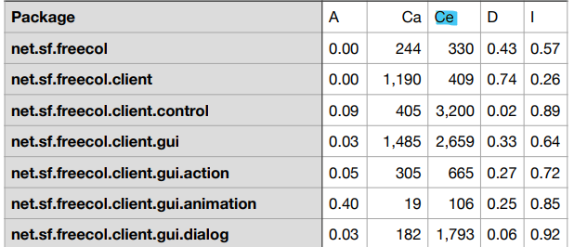

Afferent Coupling (Ca):
This metric measure the total number of classes outside a package depend on classes within that package, directly related to portability.
Packages with a high CA (>500) are bad packages because it means that class depends on many other classes and they are harder to be replaced since they have a lot of other packages that depend on them.

In the FreeCol code, there are some classes with a good CA (Afferent Coupling) and others with a poor CA:
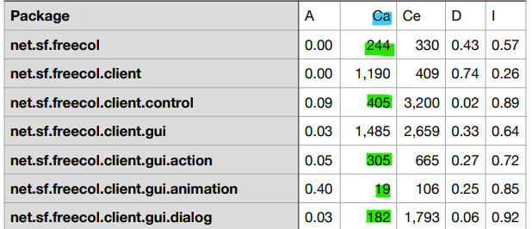

Instability (I):
This metric measures the instability of packages, by calculating the effort to change a package without impacting other packages within the application. Measures the ratio between CE and CE+CA. Values between 0 and 1 are acceptable.
In the FreeCol code, all classes have an I value between 0 and 1.
If the value is near 0, it means that the ones having many incoming dependencies and not many of outgoing
If the value is near 1, it means that the ones having many outgoing dependencies and not many of incoming ones
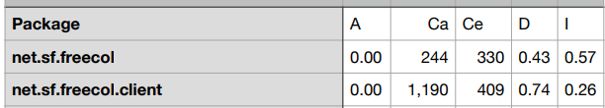

Abstractness (A):
This metric measures how abstract a package is, calculating the ratio between the number of abstract classes or interfaces and the total number of classes inside a package (A = Na / Nc).
If the value is near 0, means that all classes in this package are non-abstract while the value near 1 shows a package that only consists of abstract classes and interfaces.
Exemple of a abstract package and one non-abastract:
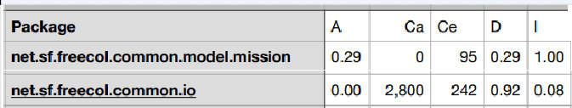

Normalized Distance from Main Sequence (D):
This metric measures the balance between stability and abstractness and is calculated using the following formula D = | (A + I) – 1|.
Two extremely unfavourable cases are considered:
- A = 0 and I = 0: package is extremely stable and concrete.
- A = 1 and I = 1: rather impossible situation because a completely abstract package must have some connection to the outside.
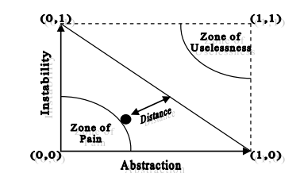

References:
https://gvpress.com/journals/IJHIT/vol8_no12/15.pdf
https://www.codeproject.com/Articles/1007524/Object-oriented-metrics-by-Robert-Martin

