Software Engineering Project

Code Metrics

By: Madalena Plácido 63001 (team_member4)

Lines of Code Metrics
The metric “Lines of Code” counts the number of lines in a program’s source code. It’s a simplistic measure used to assess the dimension and complexity of a project. When used exclusively, it may not accurately reflect reality and can be misleading, as its value is significantly influenced by external factors such as the language used. The number of lines is not directly related to the program’s quality. Therefore, it is best used with other metrics for a more accurate analysis.
For our project, the levels worth considering are the class and method level.
At the class level, the following fields can be analysed:
- CLOC – comment lines of code
- JLOC – javadoc lines of code
- LOC – lines of code
In addition to the ones above, at the method level, exist the following fields:
- NCLOC – non-comment lines of code
- RLOG – relative lines of code. It calculates the ratio between the lines of code in the method and the lines of code in its class.
At the class level, the field LOC indicates evidence towards the code smell large class. Examples follow:
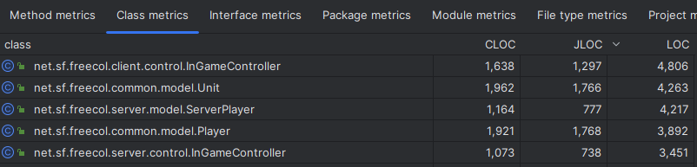

At the method level, the field LOC indicates evidence towards the code smell long method. Examples follow:

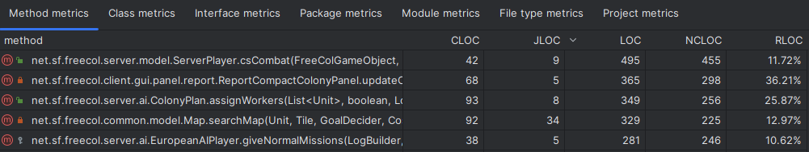

References
https://www.aivosto.com/project/help/pm-loc.html, consulted on 8/11/2023

