Design Patterns

Template Method Pattern:

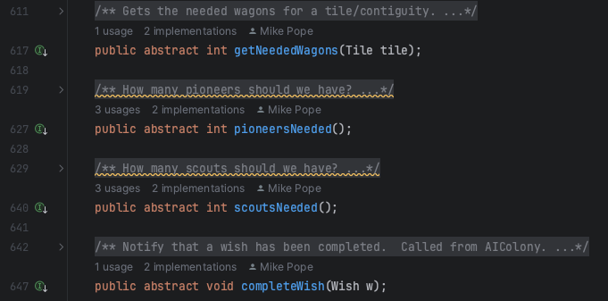
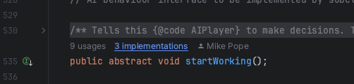
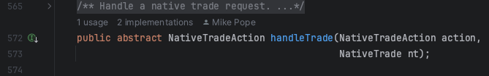
src/net/sf/freecol/server/ai/AIPlayer.java

src/net/sf/freecol/server/ai/MissionAIPlayer.java

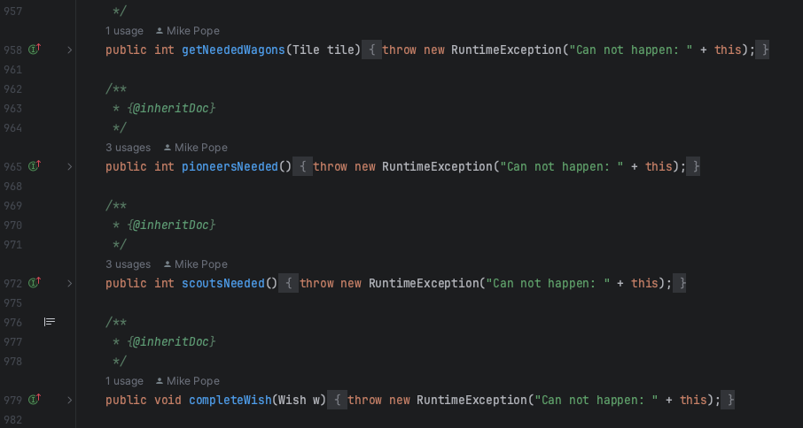
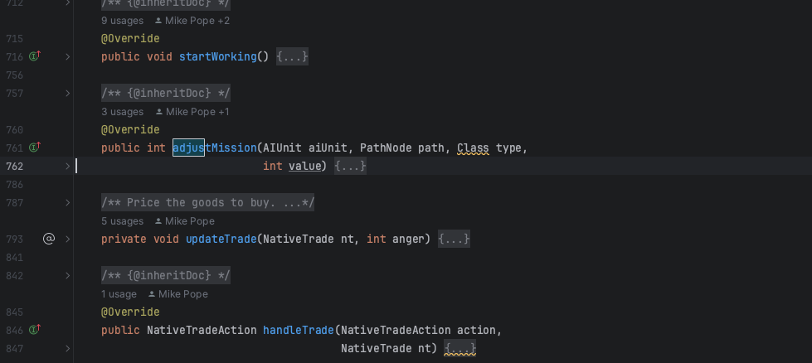
src/net/sf/freecol/server/ai/NativeAIPlayer.java

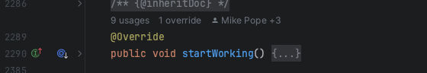
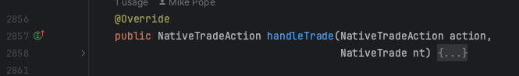
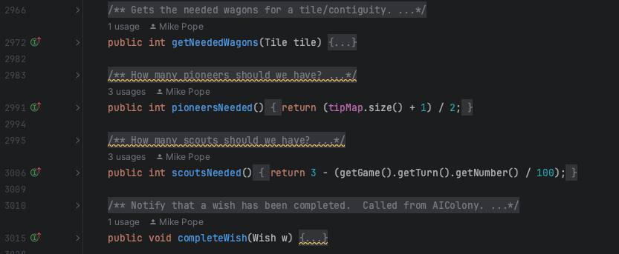
src/net/sf/freecol/server/ai/EuropeanAIPlayer.java

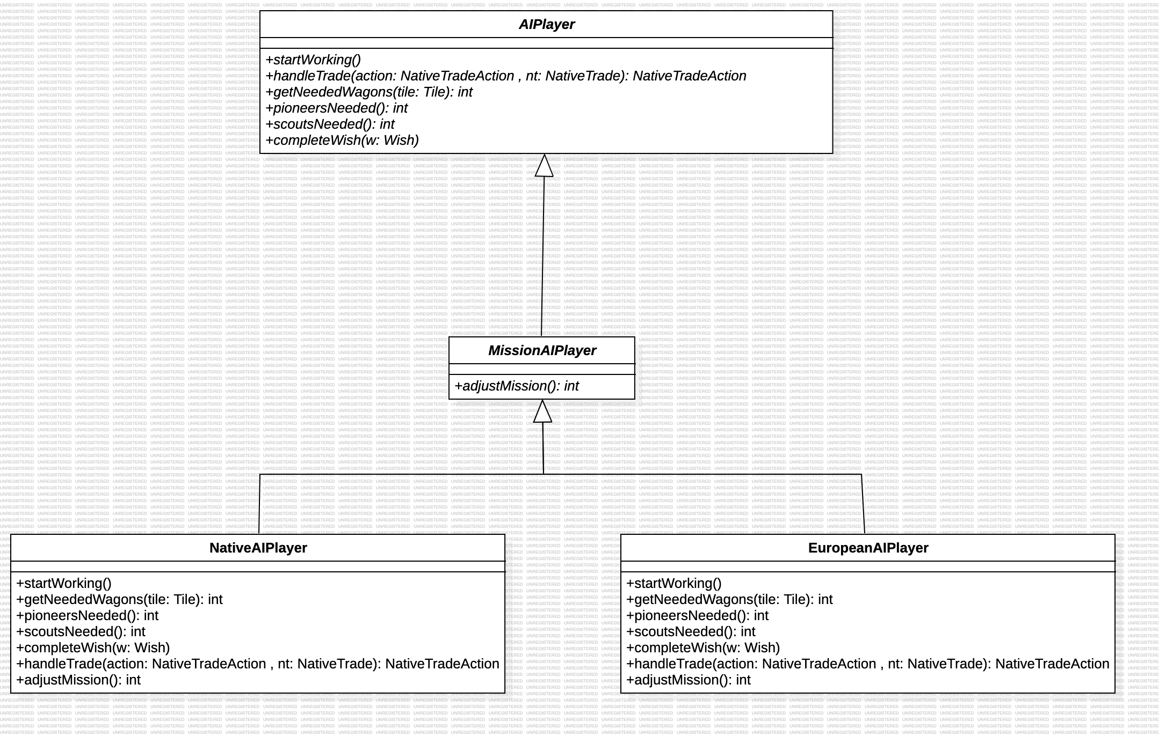

The Template Method Pattern is a behavioral design pattern, where the overall structure is defined in the abstract class and methods from this class are then defined in its subclasses, allowing customization. In this case, some methods from the abstract class MissionAIPlayer, which extends the abstract class AIPlayer and inherits its methods, are being inherited by the subclasses NativeAIPlayer and EuropeanAIPlayer. Consequently, these subclasses override the abstract methods.

Observer:

Location - src/net/sf/freecol/common/model/Market.java
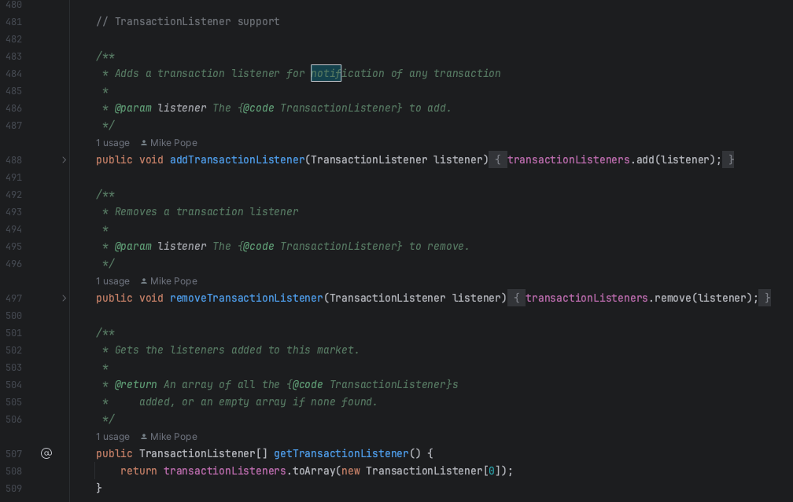
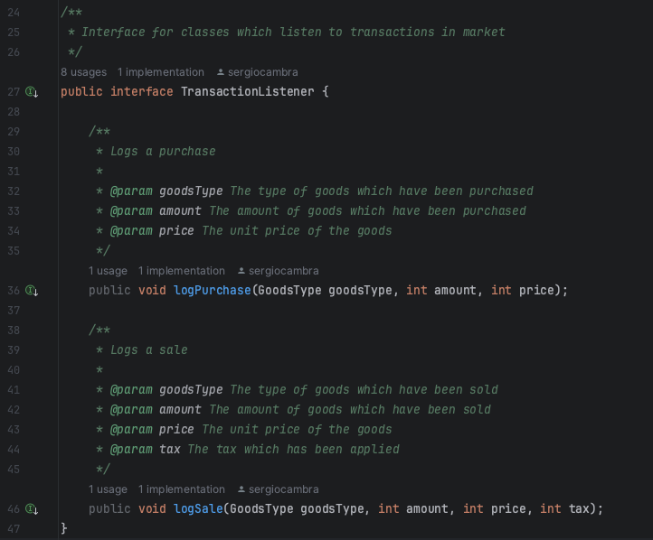
Location - src/net/sf/freecol/common/model/TransactionListener.java

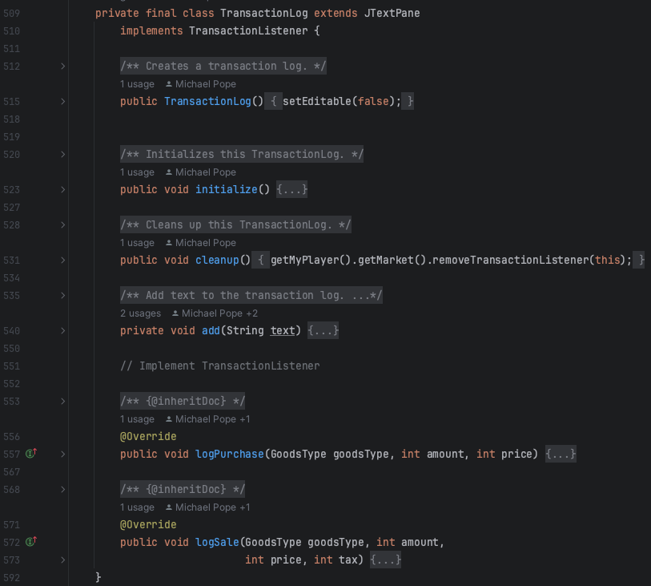
Location - src/net/sf/freecol/client/gui/panel/EuropePanel. java
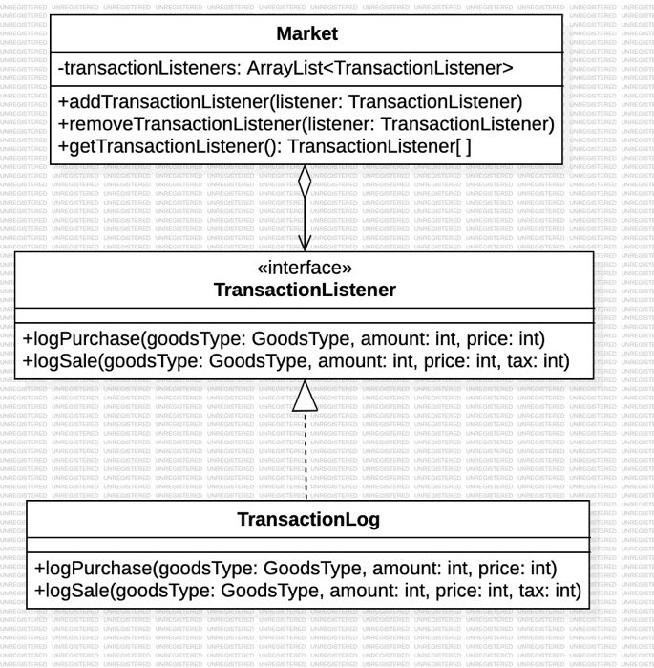

The Observer design pattern has a subject, which is being observed, and observers that are notified when the subject’s state changes. In this case, we have the TransactionListener interface as the observer. This interface includes the methods logPurchse and logscale, which are then implemented by the class, in this case the TransactionLog, that listens and reacts to the transactions. In addition, we also have the Market class that acts as the subject. This class has a collection of TransactionListener objects and methods that allows adding and removing observers. When a transaction occurs, the Market class may iterate trough the collection of registered listeners and notified them.
Facade pattern

Facade Pattern:
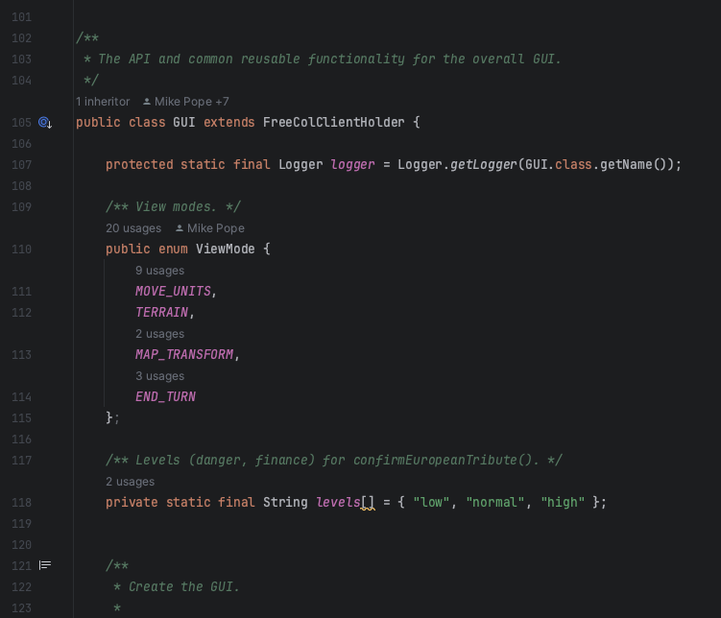
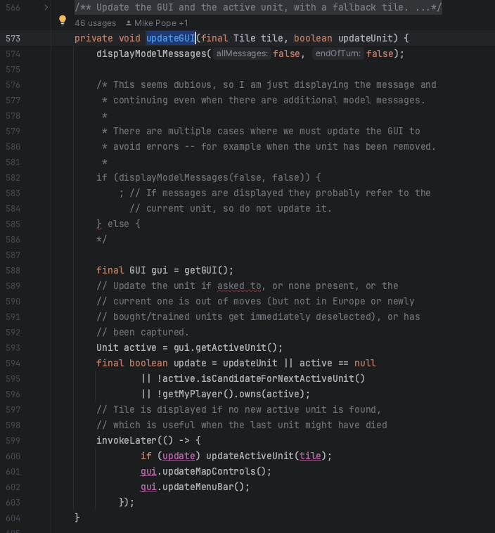

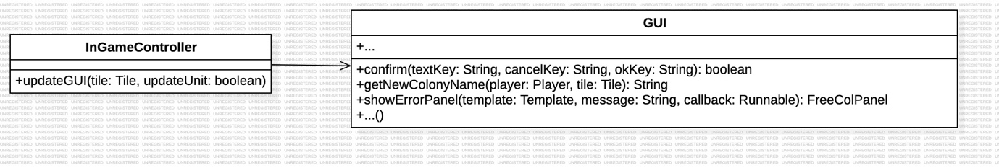
The Facade pattern is used to encapsulate and hide the complexities from the client code, making it easier to manage. In this case, the class GUI has multiple methods that allow other parts of the code to interact with the simplified interface. For example, the methods confirm(…, getNewColonyName(…), showErrorPanel(…), and many others in this class, are all called by the InGameController, which interacts with this Facade to perform actions or update the graphic user interface based on game state changes.

