Code Smells
Catarina Pedroso 61675 member1

Duplicated Code:
Location - src/net/sf/freecol/client/gui/menu/DebugMenu.java

In this snippet, we can identify duplicated code when we are adding menu items. It creates a JMenuItem and sets its properties, such as label, opacity and mnemonic. After that, adds an action listener and invokes the method from DebugUtils with the argument freeColClient. When any of this code needs to be updated or fixed, it must be done in multiple locations, which can introduce inconsistencies. Moreover, it violates de DRY principle.
To improve this code, we could create a method to construct this JMenuItem, where the proprieties of the different menu item would be given in the parameters, and it would follow the structure described previously.
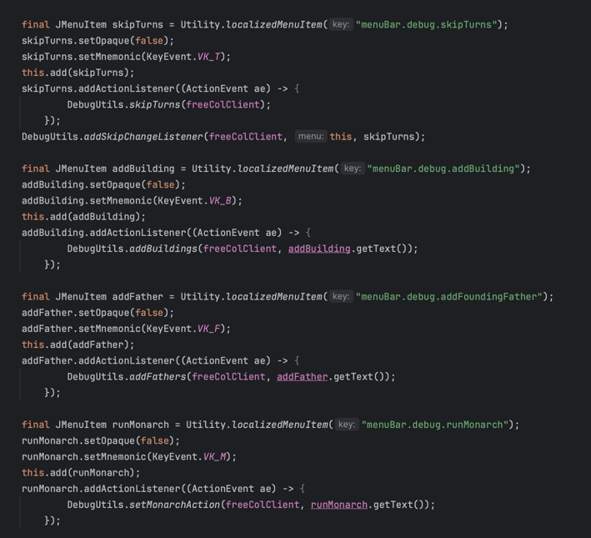
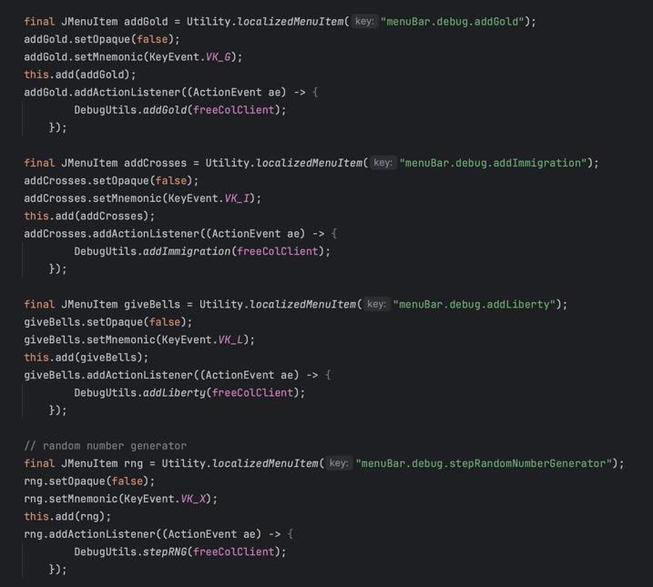

Message Chain:
Location - src/net/sf/freecol/common/model/BuildingType.java

In this snippet, each method call depends on the result of the previous call, so this high coupling makes the code less flexible and difficult to maintain. If it were an error to happen, it makes it harder to find and fix the issue.
One way of refactoring the code is by breaking the chain into multiple lines, using variables, for example, for the stream, in which the filtering and mapping would be done, and other for the rest of the methods (findFirst().orElse(0)).
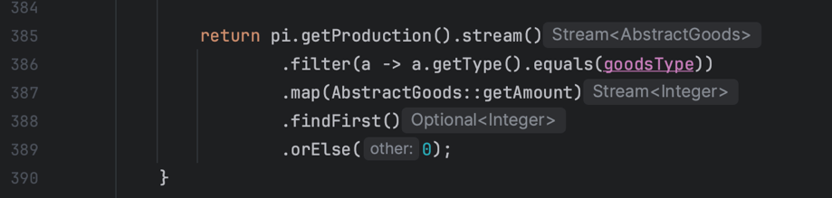

Long Method:

Location - src/net/sf/freecol/server/ai/EuropeanAIPlayer.java

The method giveNormalMissions(LogBuilder lb, List<AIUnit> aiUnits) starts at the line 1682 and ends in the line 1976. This long method makes it harder to understand and to maintain. It also increases the complexity, which can lead to errors.
In this case, we could reactor the code by break it down into smaller methods, such as one that would deal with the different types of missions (PioneeringMission, ScoutingMission and TransportMission). This can improve readability and each method can now be maintained independently.

