Assignment 3: Workflows with Airflow
INFO-H420 Process Modeling, Data Pipelines, and Responsible AI
Group members: [Name 1], [Name 2], [Name 3]
Code repository: https://github.com/Renata1214/AirflowPDFProcessor
Submitted: 9 November 2026

1. Overview
We built a small local pipeline that turns research PDFs into a searchable study library. A scheduled Apache Airflow 3 DAG looks for new PDFs in a Google Drive-synced folder, converts each one to Markdown, asks a locally served LLM (Llama 3.2 3B through Ollama's OpenAI-compatible API) for a title, summary, keywords and category as JSON, stores that metadata in a local SQLite database, rebuilds a static HTML catalogue with search and category filtering, and posts a Discord message for every new paper.
Everything runs on one laptop: Airflow in standalone mode, Ollama for the model, and SQLite for storage. Only the PDFs and the generated HTML live in synced folders; the database stays local, as the assignment requires.

2. Architecture
Concern | Tool | Where in the code
Orchestration | Apache Airflow 3.4 (airflow standalone) | dags/paper_pipeline.py
PDF to Markdown | PyMuPDF4LLM 2.1 | src/PDFtoMarkdown.py
Local LLM | Ollama, llama3.2:3b, OpenAI-compatible /v1 endpoint | src/llm_client.py (Python openai client)
Metadata storage | Python sqlite3 | src/database.py, file data/papers.db
Static HTML | Single self-contained index.html | src/catalog.py
Notification | Discord webhook via requests | src/notify.py
Configuration | .env loaded with python-dotenv | src/config.py

The DAG file only wires tasks together. The work itself lives in src/pipeline.py (find_new_pdf_paths, process_one_pdf, rebuild_catalog), so each step can also be run and tested outside Airflow. Paths, the model name and the webhook URL come from .env, so the same code runs on any machine.

Folder layout
Google Drive (synced from the laptop)
├── airflowpapers/ ← PAPERS_DIR: PDFs dropped here
└── airflowpapers_output/ ← OUTPUT_DIR: <paper>.md files and index.html

Local project (AirflowPDFProcessor/)
├── dags/paper_pipeline.py ← the DAG
├── src/ ← pipeline steps
├── data/papers.db ← SQLite, not synced
└── .env ← paths, model, webhook (git-ignored)

3. Airflow DAG and task dependencies
The DAG paper_pipeline is written with the TaskFlow API and has three tasks:
find_new_pdfs → process_pdf.expand(pdf_path=found) → rebuild_html

@dag(dag_id="paper_pipeline", schedule="*/5 * * * *", # normally "*/30 * * * *"
start_date=datetime(2026, 11, 5), catchup=False, max_active_runs=1,
default_args={"retries": 1, "retry_delay": timedelta(minutes=5)})
def paper_pipeline():
@task
def find_new_pdfs() -> list[str]: ...
@task(max_active_tis_per_dag=1)
def process_pdf(pdf_path: str) -> str: ...
@task(trigger_rule=TriggerRule.ALL_DONE)
def rebuild_html() -> str: ...
- find_new_pdfs lists the PDFs in the papers folder whose filename is not yet in papers.db and returns their paths through XCom.
- process_pdf uses dynamic task mapping (.expand): Airflow creates one task instance per new PDF, so each paper succeeds, fails and retries on its own and has its own log. max_active_tis_per_dag=1 runs them one at a time, because a laptop-hosted Ollama serves one request at a time and parallel requests only queue up and time out.
- rebuild_html depends on all mapped instances and uses TriggerRule.ALL_DONE, so the catalogue is rebuilt even when there are no new PDFs (the mapped task is then skipped) or when one paper failed.
- max_active_runs=1 stops two runs from processing the same PDF at once; catchup=False avoids replaying every missed interval since the start date; each task retries once after five minutes.
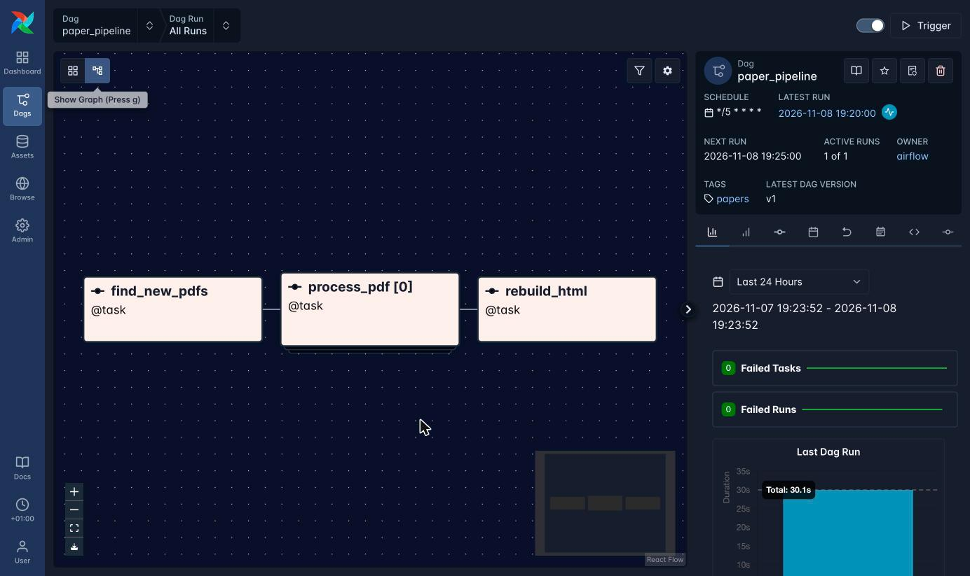
Figure 1. Graph view of paper_pipeline: find_new_pdfs → process_pdf (mapped) → rebuild_html

4. PDF conversion and local LLM integration

PDF to Markdown
pymupdf4llm.to_markdown() converts each PDF to Markdown, which is written next to the HTML as <paper>.md. Text-based PDFs convert without OCR; the RapidOCR warning in the logs only matters for scanned PDFs.

Calling the LLM
The openai Python package is pointed at Ollama's OpenAI-compatible endpoint (http://127.0.0.1:11434/v1). The request uses JSON mode (response_format={"type": "json_object"}) and a low temperature of 0.1. The prompt gives the exact JSON structure from the assignment and a fixed list of categories with a one-line description each.
The reply is parsed with json.loads() and checked: title, summary and category must be non-empty strings and keywords must be a list of strings. If parsing or the check fails, the request is retried once; a second failure fails the task, and Airflow's own task retry applies after that.

Two problems we hit and how we solved them
- Context window. Ollama serves llama3.2:3b with a 4,096-token context, but a full paper is 20,000–45,000 tokens. Ollama silently drops the beginning of a prompt that is too long, which removed our instructions: the model then returned JSON without a title and each call took about three minutes. We now send only the first 8,000 characters (title, abstract and introduction), which is all the metadata needs. Each paper now takes 12–23 seconds.
- Category quality. With a free-text category, the 3B model copied the example ("Research category") or answered "Research" for every paper, and sometimes prefixed titles with "Paper title:". A fixed list of seven categories with short descriptions, placed after the paper text, gave meaningful categories (Table 2).

5. SQLite storage, static HTML and Discord

SQLite
One table holds one record per paper. filename is the primary key, which is also how the DAG decides what is new; keywords are stored as a JSON string.
CREATE TABLE IF NOT EXISTS papers (
filename TEXT PRIMARY KEY,
title TEXT NOT NULL,
summary TEXT NOT NULL,
keywords TEXT NOT NULL, -- JSON list, e.g. ["text-to-SQL", "LLM"]
category TEXT NOT NULL
);

Static HTML
rebuild_html reads the whole table and writes one self-contained index.html with the papers embedded as JSON. A few lines of JavaScript provide a search box over title, summary, keywords and filename, and a category drop-down built from the categories in the data. The page needs no server, so it opens straight from the synced folder.

Discord
After a paper is stored, notify_new_paper() posts "New paper processed: <title> (<category>)" with the filename to a Discord webhook. Errors are reported without the webhook URL so the secret never reaches the Airflow logs.

6. Showing that the workflow runs correctly

Schedule change for the demonstration
The DAG normally runs every 30 minutes*/30 * * * *). To record several scheduled runs for this report in a short time, we temporarily changed the schedule to every 5 minutes (*/5 * * * *).** The DAG file marks this with a comment; the 30-minute schedule should be restored after grading.

Test scenario
We started from an empty papers table and output folder, put 8 of our 10 test papers (2026 arXiv papers on databases and AI) in the papers folder, and turned the DAG on. All three runs below were started by the scheduler, not triggered by hand:
Scheduled run | Duration | New PDFs | What happened
19:20 | 2 min 34 s | 8 | 8 mapped process_pdf instances ran one after another (12–23 s each); 8 rows stored, catalogue built, 8 Discord messages.
19:25 | 5 s | 0 | No new PDFs: process_pdf was skipped, rebuild_html still ran. No duplicate rows, no Discord messages.
19:30 | 51 s | 2 | We had added the 2 remaining PDFs (NousDB, Uber-Join) to the folder. Only these 2 were processed.
Table 1. Scheduled runs during the demonstration.
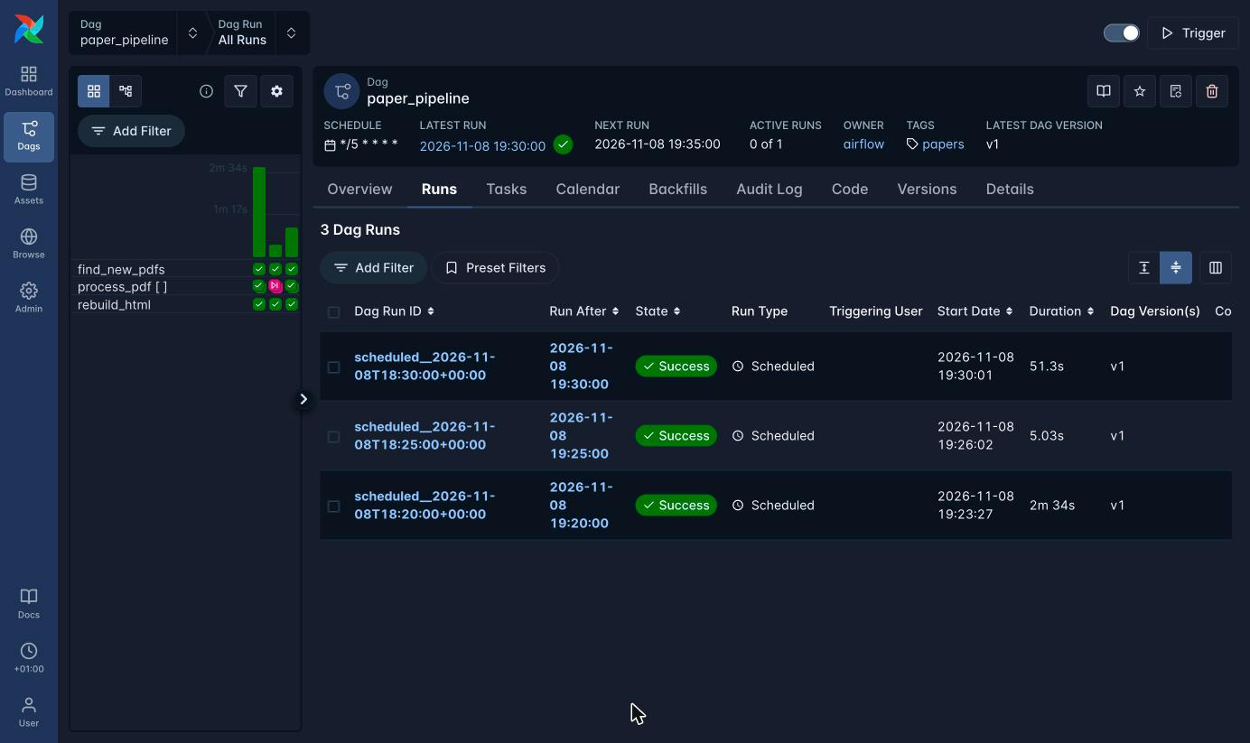
Figure 2. Three scheduled runs: 8 papers, then nothing new (process_pdf skipped, pink), then 2 new papers
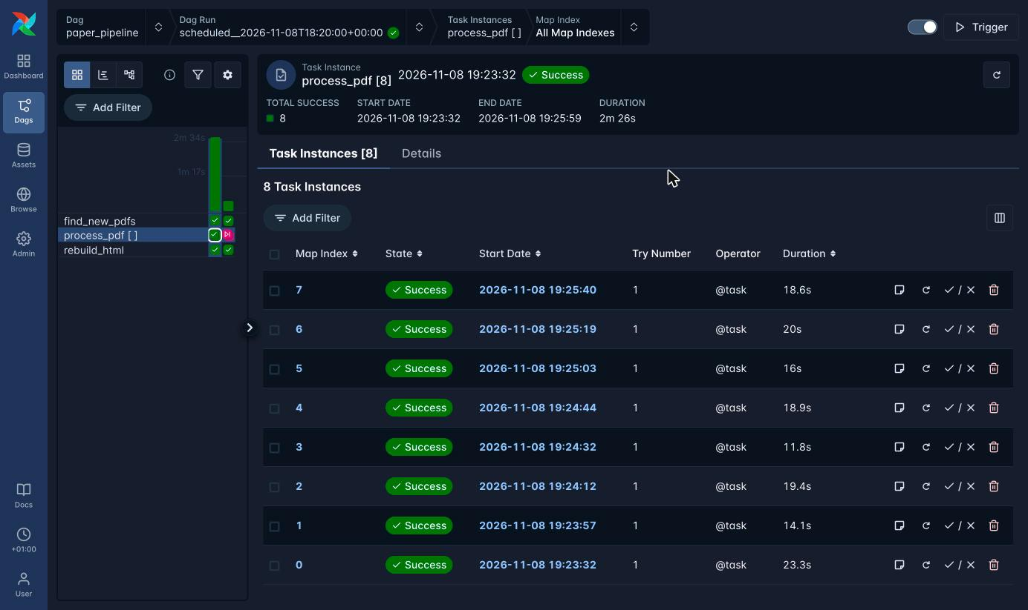
Figure 3. The 8 mapped process_pdf instances of the first run, all successful on the first try
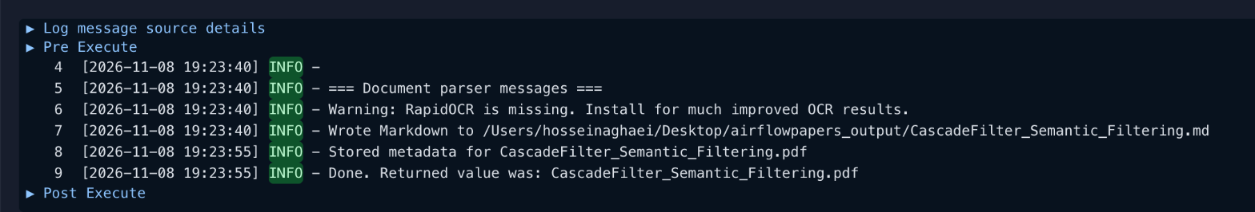
Figure 4. Log of one process_pdf instance: Markdown written, metadata stored
Paper (file) | Category from the LLM
SQLoom_Text_to_SQL.pdf | Text-to-SQL
LLM_based_Data_Cleaning.pdf | Data Cleaning and Integration
Uber_Join_LLM_Table_Joins.pdf | Data Cleaning and Integration
GenDB_V_AI_Generated_Database_Systems.pdf | Database Systems
DiagDBench_Agentic_Database_Diagnosis.pdf | Database Diagnosis (not in the list, see Section 8)
GraphRAGProv_GraphRAG_Provenance.pdf | Knowledge Graphs and RAG
LLM_Augmented_Cardinality_Estimation.pdf | Knowledge Graphs and RAG
RT_J_Relational_Transformers.pdf | Machine Learning for Data
CascadeFilter_Semantic_Filtering.pdf | Query Processing
NousDB_Semantic_Analytics_Engine.pdf | Query Processing
Table 2. Contents of the papers table after the three runs.
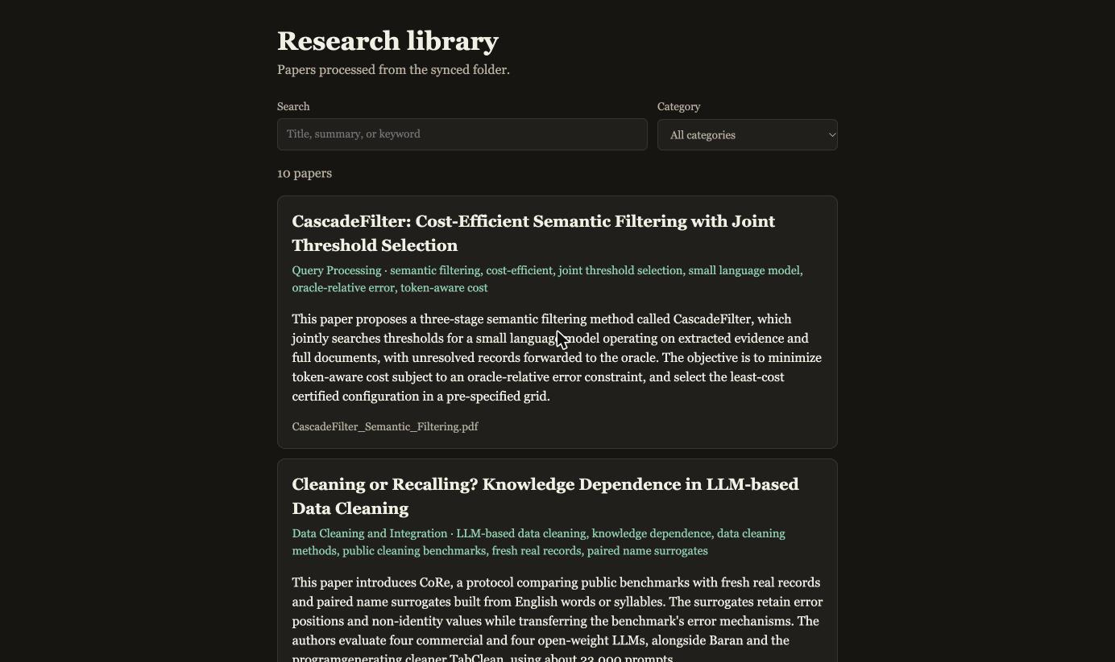
Figure 5. Generated index.html listing all 10 papers
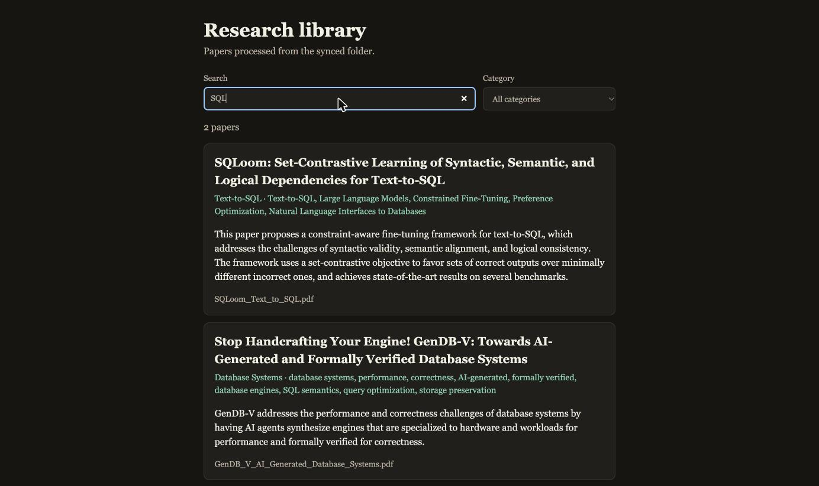
Figure 6. Search box: "SQL" narrows the list to 2 papers
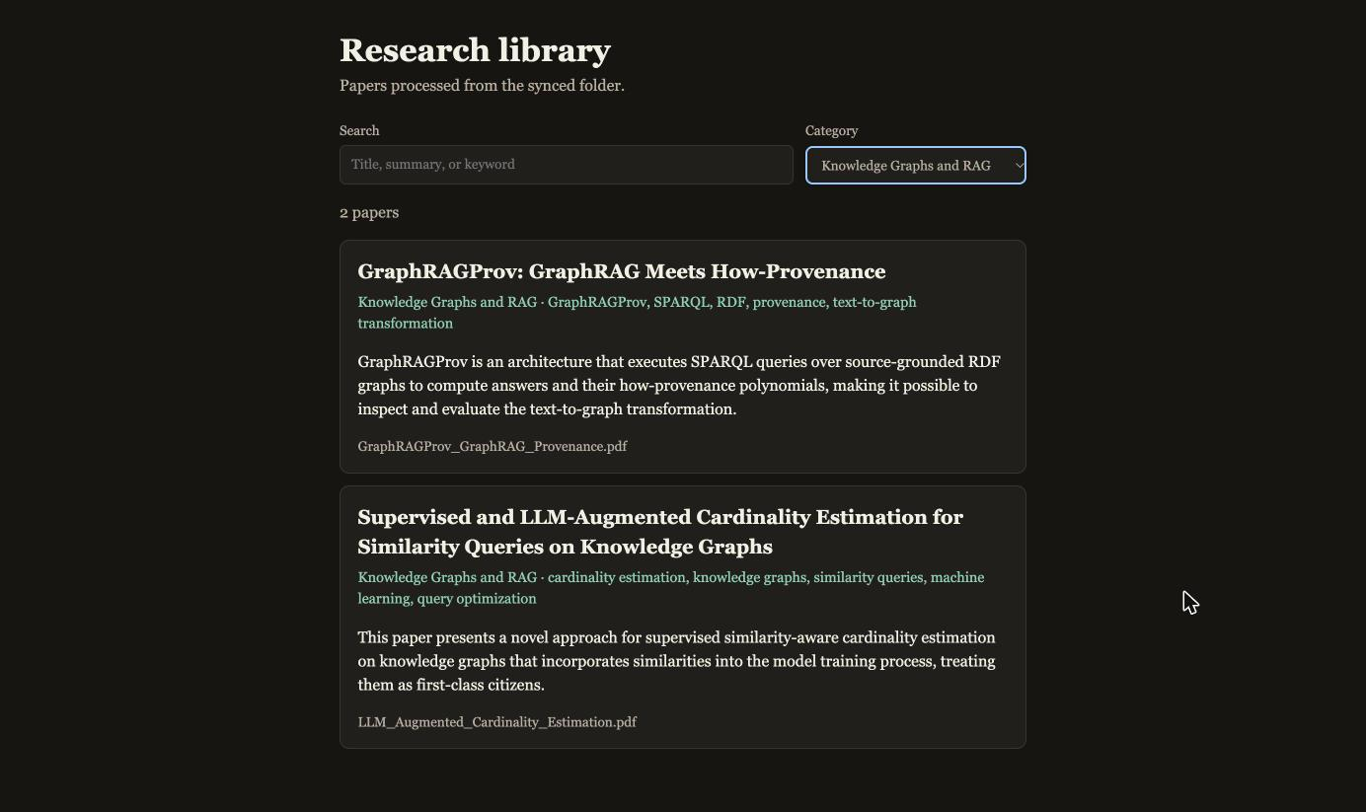
Figure 7. Category filter: "Knowledge Graphs and RAG"
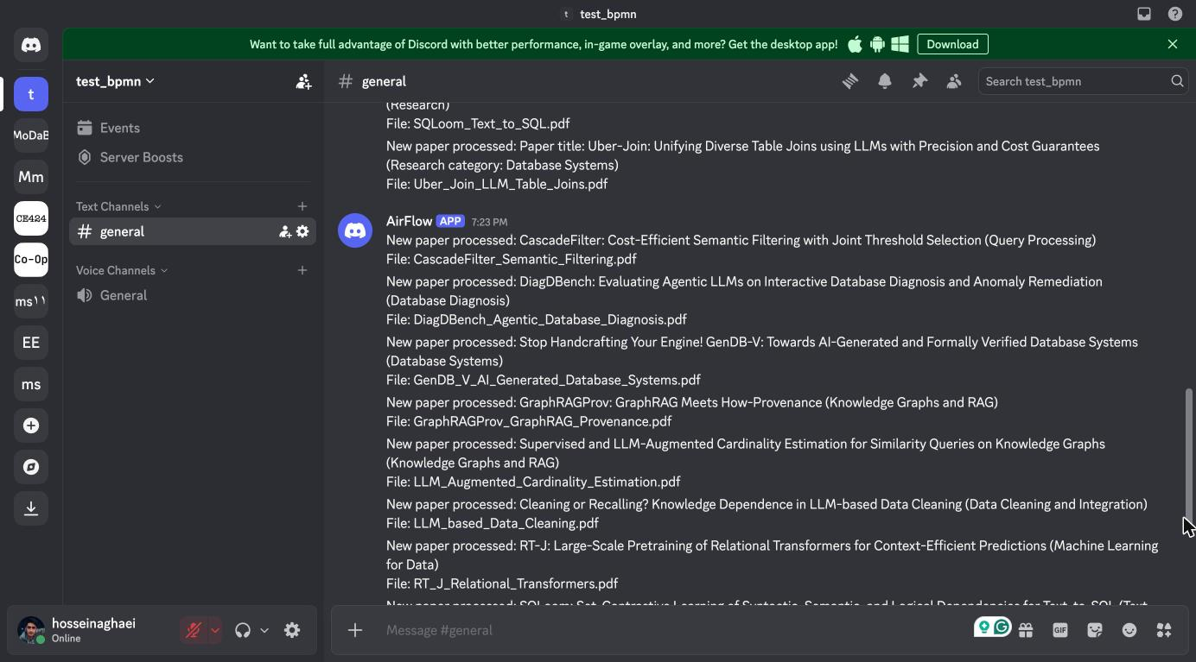
Figure 8. Discord messages posted by the AirFlow webhook, one per processed paper (7:23 PM, first demo run). The messages above it come from an earlier test run, before the prompt fix, and show the old "Paper title:" prefix and "Research" categories
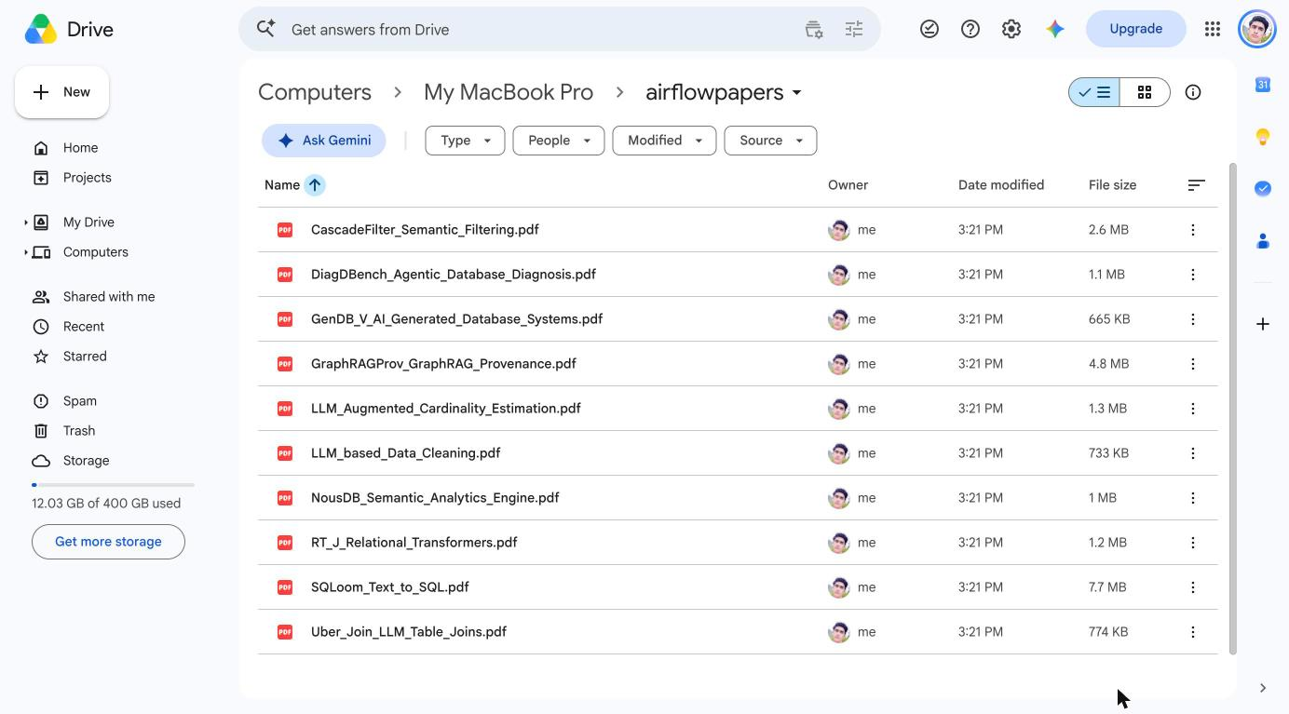
Figure 9. The papers folder synced to Google Drive (Computers → My MacBook Pro)
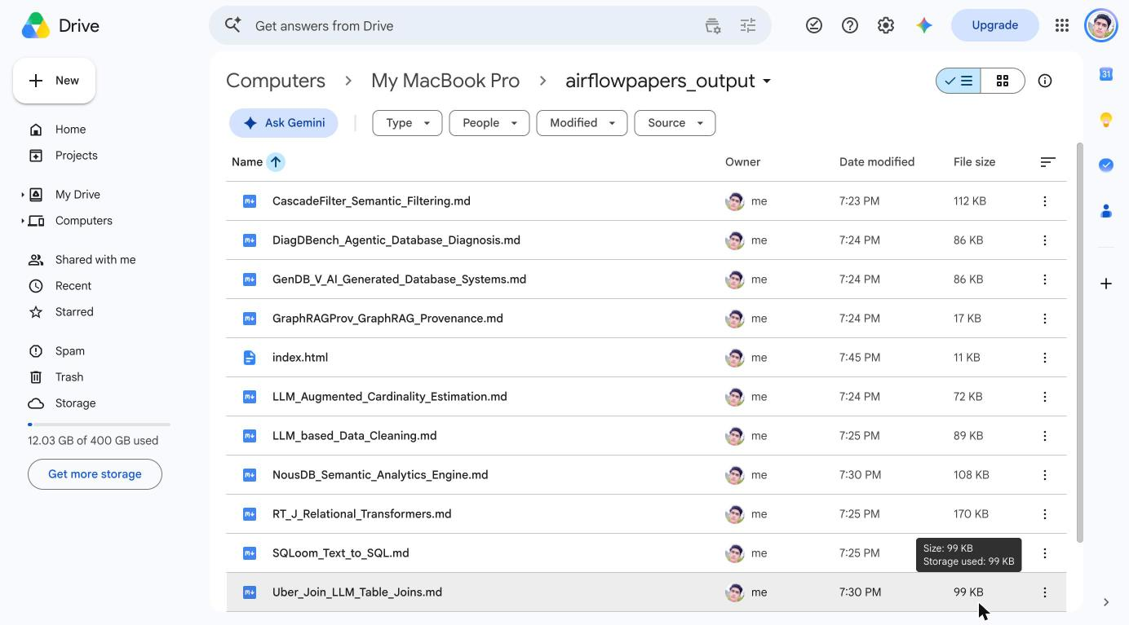
Figure 10. The output folder synced to Google Drive: one Markdown file per paper and index.html

7. How to run it
Full instructions are in the repository README. In short:
- Install Ollama and pull the model: ollama pull llama3.2:3b.
- Create a virtual environment and install the dependencies: python -m venv venv, source venv/bin/activate, pip install -r requirements.txt.
- Copy .env.example to .env and set PAPERS_DIR and OUTPUT_DIR to the Google Drive-synced folders, plus DISCORD_WEBHOOK_URL.
- Start Airflow from the project folder with an absolute DAGs path:
export AIRFLOW_HOME=$HOME/airflow
export AIRFLOW__CORE__DAGS_FOLDER=$PWD/dags
export AIRFLOW__CORE__LOAD_EXAMPLES=False
airflow standalone
- Open http://localhost:8080 (user admin, password in $AIRFLOW_HOME/simple_auth_manager_passwords.json.generated), turn on paper_pipeline, and drop PDFs in the papers folder.

8. Limitations
- A 3B model is fast on a laptop but not perfectly reliable: one paper was given a category outside the list ("Database Diagnosis"). The page still filters on it correctly; a larger model or a validation-and-retry on the category would fix it.
- Only the first 8,000 characters of each paper reach the model. This is enough for the title, abstract and introduction, but a summary of the full paper would need chunking or a model with a larger context.
- A paper is identified by its filename, as the assignment allows: renaming a PDF makes it look new, and replacing a PDF under the same name is not picked up.
- Scanned PDFs would need OCR (RapidOCR is not installed).

