SUBMISSION TYPE

Poster

TITLE

O*Net Demands and Resources: Associations with Stress, Burnout, and Engagement

ABSTRACT

We examine job resources as well as both challenge and hindrance demands as they relate to organizational outcomes of engagement, stress, and burnout. 568 workers rated O*Net job characteristics in terms of relevance and perceptions as challenges, hindrances and resources. The findings are generally aligned with the job demands resource theory regarding associations between perceived resources, demands, and organizational outcomes of engagement, stress, and burnout.

WORD COUNT

3,000

O*Net Demands and Resources: Associations with Stress, Burnout, and Engagement

Research on the job demands-resources model (Demerouti et al., 2001) and later job demands-resources theory (Bakker & Demerouti, 2017) highlight the importance of work characteristics on the experience of motivation and strain, which in turn have an impact on job performance. We further extend these perspectives to include challenge and hindrance demands. This study explores how these work experiences empirically relate to engagement, stress, and burnout. Prior to presenting the current study in detail, we provide a brief overview of the relevant theoretical and empirical work on these topics.

**The Job Demands-Resources Theory**

The underlying framework for this study is the job demands-resources theory, which is an expansion of the well-studied job demands-resources model (Demerouti et al., 2001). One of the major advantages of the job demands-resources theory is that it allows us to model both work environment and job characteristics via job resources and demands. *Resources* include physical, psychological, social, or organizational aspects of the job that may help an employee achieve work goals, reduce job demands, or promote personal growth and development (Demerouti et al., 2001). In contrast, demands include components of a job that require sustained effort, and as such, produce psychological or physiological strain (e.g., high work pressure is frequently cited as a common demand; Demerouti et al., 2001).

Cognitively, the perception of an element of one’s job as a resource or demand activates one of two distinct processes: health impairment (resulting from demands) or motivation (resulting from resources; Bakker & Demerouti, 2014). Pertinent to the current study, demanding job characteristics are frequently associated with negative outcomes (e.g., Bakker et al., 2003), whereas job characteristics deemed resources have been associated with positive organizational outcomes like engagement and motivation (Bakker et al., 2007).

## The Essential Role of Appraisal

Although some research on job demands in particular is based on *a priori* classifications of demands (Searle & Auton, 2015), the classification of any work characteristic as a demand or resource is largely subjective (e.g., two different employees could most certainly perceive being a public figure differently - perhaps one as a resource and the other as a demand). The stress process speaks to how such individual differences in appraisal are possible. Lazarus and Folkman (1984) presented a transactional theory of stress and coping, which states that people cognitively appraise stimuli in their environments on a continuous basis. Via this process, meaning is assigned to stimuli – if appraised as threatening, challenging, or possibly harmful, the resulting emotional distress initiates coping. The cycle of appraisal then continues based on the action to cope with the stressor (Lazarus & Folkman, 1984).

## The Challenge-Hindrance Framework

Although there is a tendency to attach a negative connotation to the word “stress”, Selye (1936) defined stress as a response to change, which is quite non-specific. We return to the employed public figure for this next section. It is quite probable that two employees would be called upon to serve as a spokesperson for their organization in a time of need. One may appraise the circumstance as an opportunity to positively influence others, while the other may plausibly feel paralyzed by the task. Cavanaugh et al. (2000) delineated between two forms of demands – that of *challenge* and *hindrance* demands. Challenge demands promote mastery, personal growth, and future gains. Hindrance demands, in contrast, inhibit growth, learning and goal achievement. This particular distinction has been valuable in determining what demands are related to various outcomes, whereby challenge stressors are typically associated with positive outcomes, whereas hindrance stressors are associated with more negative outcomes (e.g., Cavanaugh et al., 2000).

We next consider the empirical evidence on this topic. First - research suggests that employees do, in fact, distinguish between challenge and hindrance stressors (e.g., Bakker & Sanz-Vergel, 2013; Gerich, 2017; Webster et al., 2011). For example, Bakker and Sanz-Vergel (2013) found that perceived work pressure can be classified as a hindrance demand, and emotional demands as more of a challenge. Webster et al. (2011) approached this question with three common workplace demands: workload, role ambiguity, and role conflict. They found that while each could be appraised primarily as challenges or hindrances, they could also simultaneously be perceived as being both a challenge and hindrance to different degrees.

The challenge-hindrance framework has been associated with a wide variety of organizational outcomes ranging from affective variables like job satisfaction, to motivation, performance, and well-being. A sampling of variables and relationships are described below to provide a sense of scope of the work done on this topic. For example, Cavanaugh et al. (2000), in a study of managers, found that challenge demands were positively related to job satisfaction and negatively related to job search behaviors, while hindrance demands demonstrated the opposite pattern. In contrast, Abbas and Raja (2019) found that challenge and hindrance stressors were *both* positively related to strain and turnover intentions. We also have some evidence that challenge-hinderance appraisals are related to engagement in the expected direction whereby hindrance appraisals are negatively associated with engagement and challenge appraisals are positively associated with it (Crawford et al., 2010). Lastly, Gerich (2017) concluded that employee well-being was also, in part, explained by appraised challenge or hindrance demands such that working conditions of time pressure, qualitative demands, responsibility, and interruptions, were partially mediated by challenge and hindrance demands. We even have sufficient evidence to explore outcomes associated with challenge and hindrance stressors meta-analytically at this point. Podsakoff et al. (2007) supported the original assertion of Cavanaugh et al. (2000) with regard to work outcomes such that challenge stressors were positively related to job satisfaction and organizational commitment, and negatively related to both turnover intentions and actual turnover. The opposite pattern of relationship was observed for hindrance stressors.

## Current Study and Hypotheses

Given the abundance of theoretical and empirical support for the connection between resources and positive organizational outcomes, and between demands and negative outcomes, we sought to explore whether or not the appraisal of a demand as a challenge or hindrance would be related *differently* to three organizational outcomes: engagement (“a positive affective experience defined as a fulfilling, work-related state of mind characterized by vigor, dedication, and absorption”, Schaufeli et al., 2002), workplace stress (“an individual state characterized by a combination of high arousal and displeasure”, p. 15, Pejtersen et al., 2010) and burnout (“the degree of physical and psychological fatigue and exhaustion that is perceived by the person as related to his/her work”, p. 197; Kristensen et al., 2005). Drawing on the job demands-resources theory and the challenge-hindrance framework, we propose that job elements appraised as “challenge demands” (i.e., promote mastery, personal growth, and future gains) would activate a positive state – that of engagement. In contrast, elements of one’s job appraised as a hindrance demand (i.e., inhibit growth, learning and goal achievement) would activate a negative state – here, stress.

*Hypothesis 1*: Job characteristics appraised as resources will be positively associated with engagement, and negatively associated with stress and burnout.

*Hypothesis 2*: Job characteristics appraised as challenge demands will be positively associated with engagement, and negatively associated with stress and burnout.

*Hypothesis 3*: Job characteristics appraised as hindrance demands will be negatively associated with engagement, and positively associated with stress and burnout.

**Method**

We evaluate associations between the antecedents and proximal outcomes of the Job Demands-Resources model (Bakker & Demerouti, 2017; Bakker et al., 2003; Demerouti et al., 2001), but from within the unifying framework of O*Net. Specifically, we focus on the relationship between O*Net delineated job components and employee levels of job engagement, job stress, and burnout with a U.S. workforce representative sample.

## Participants

We utilized Prolific panels for our respondent sample. Of the 785 individuals who initially accessed the survey link, 112 indicated that they were not interested, had more than 200 missing responses, or had 20 or more identical consecutive sequential responses (Yentes & Wilhelm, 2021). Applying a further screen regarding attention checks (there were four attention checks embedded throughout) resulted in the retention of 568 respondents who constitute the current SIOP sample. 13.57% had been in their referent job less than 6 months, 19.20% between 6 months and a year, 49.12% between one and five years, 13.27% between 5 and 10 years, and 4.87% more than 10 years.

Ages ranged from 18 to 65 with an average of 28.18 years old (SD = 7.53). The survey offered a free-field gender identity category, although the sample predominantly self-identified as female (52.58%) or male (46.83%). Jobs were classified into the International Standard Classification of Occupations (ISCO) via the package labourR (Kouretsis et al., 2020). We further grossly categorized these classifications into “knowledge” (*n* = 320) versus “skill” (*n* = 214) occupations with knowledge workers being defined as having ISCO classifications of: 1) Professionals, and 2) Managers.

## Materials

**Characteristics, Demands, and Resources.** Our analyses are organized by O*Net’s classifications of “work activity”: 1) Information Input (5 statements), 2) Interacting with Others (17 statements), 3) Mental Processes (10 statements), and 4) Work Output (9 statements) and “work context”: 5) Interpersonal Relationships (14 statements), 6) Physical Work Conditions (30 statements)1, and 7) Structural Job Characteristics (13 statements).

Other than minor grammatical editing (for example, changing “the” to “you”), we retained the O*Net wording for our item stems. We also administered O*Net’s response scales, several of which were unique across items, but universally shared the same 1 to 5 scaling convention. Subsequent to providing ratings of whether or not an O*Net characteristic was relevant for the respondent’s work, each respondent who agreed that an element had at least some relevance to their job was also asked to rate that element in terms of, 1) . . . this aspect of your job is a resource that can be functional in achieving work goals, reduce job demands, or stimulate personal growth/development, 2) . . . this aspect of your job is a challenge that can promote mastery, personal growth, or future gains, and 3) . . . this aspect of your job is a hindrance that can inhibit personal growth, learning, and work goal attainment.

**Burnout and Stress.** Were taken from the Copenhagen Psychosocial Questionnaire (Burr et al., 2019). There were 4 burnout items and 3 stress items with current sample α’s of 0.85 (burnout) and 0.85 (stress).

**Engagement.** The 18-item engagement measure was recently developed (Russell et al., 2022), with the authors specifying three subscales which yielded current sample α’s of 0.68 (Absorption) and 0.80 (Vigor), and 0.90 (Dedication). For the purposes of the current study, we focused on an overall engagement score (18 item aggregate, α = 0.91).

## Procedure

The data for this study were collected through Prolific, a data collection platform. An email was sent to a random subset of all eligible participants in the Prolific respondent pool, notifying them about their eligibility for the study based on demographic information. The requirements to participate in this study included being 18 or older and holding either a full-time or part-time job. Participants then voluntarily chose to respond to the survey, and were informed that their responses were anonymous and confidential. The survey was conducted online via Qualtrics with an estimated completion time of 40-45 minutes. Participants were asked to think about their primary job while answering the survey, and the items they were presented with depended on the specific job characteristics they initially specified. Participants were compensated for their participation in this study in the amount of six dollars through Prolific.

**Results**

We used R (Version 4.0.3; R Core Team, 2020) and the R-packages *careless* (Version 1.1.3; Yentes & Wilhelm, 2021), *labourR* (Version 1.0.0; Kouretsis et al., 2020), *papaja* (Version 0.1.0.9997; Aust & Barth, 2020), and *tinylabels* (Barth, 2021) for all analyses. Our analyses are presented by characteristics of work that are rated in terms of being resources, challenge demands, and hindrance demands. Pearson correlation coefficients between characteristics classified as resources, challenges, and hindrances were obtained to investigate the associations among these characteristics.

**Resources.** Across all items, the average perception that an O*Net job element could be considered a resource was 3.77 with a standard deviation of 0.48. Table 1 shows relationships among resource dimensions (O*Net categories) as well as our three focal outcome variables[1]. Regression analyses reveal that the more a work characteristic is perceived as a resource, the more engaged is the respondent (R2 = .15, *F*(7, 528) = 12.82, *p* < .001). There was a only a trivial effect between being viewed as a resource and stress (R2 = .03, *F*(7, 528) = 2.20, *p* = .032) and no significant association between being viewed as a resource and burnout (R2 = .01, *F*(7, 528) = 1.12, *p* = .348). Note that this is consistent with the predictions of the JD-R. lending partial support to H1.

**Challenges.** Across all items, the average perception that an O*Net job element could be considered a challenge was 3.75 with a standard deviation of 0.50. Table 2 shows relationships among challenges and the three focal outcome variables. Regressions reveal that the impact of challenging demands on engagement was similar in direction and magnitude to that of resources, as consistent with JD-R predictions (R2 = .13, *F*(7, 528) = 11.03, *p* < .001), with null effects for both stress (R2 = .01, *F*(7, 528) = 0.88, *p* = .520) and burnout (R2 = .02, *F*(7, 528) = 1.21, *p* = .295). That is, workplace challenges were predictive of engagement but not self-reported stress or burnout, partially supporting H2.

**Hindrances.** Across all items, the average perception that an O*Net job element could be considered a hindrance was 2.39 with a standard deviation of 0.78. Table 3 shows relationships among categories of hindrance and the three outcome variables. There was a marginal association between a work characteristic being perceived as a greater hindrance and lower levels of engagement (R2 = .07, *F*(7, 528) = 5.84, *p* < .001), with similar effects both between being viewed as a hindrance and increased stress (R2 = .06, *F*(7, 528) = 4.88, *p* < .001) as well as increased levels of burnout (R2 = .06, *F*(7, 528) = 4.90, *p* < .001), also providing partial support for H3.

We further highlight two example regression analyses below to provide a better sense of how two different job experiences predicted one of our outcomes: 1) the relationships between the engagement criterion and resource ratings as predictors (Table 4) and 2) engagement with challenge demand ratings as predictors (Table 5). Beginning with resources: four of the resource categories predicted engagement: structural job characteristics (β = .31), interpersonal relationships (β = .11), interacting with others (β = .12), and information input (β = -.12). Next, two challenge ratings of the following categories predicted engagement: structural job characteristics (β = .34) and mental processes (β = -.17).

**Discussion**

The primary aim of this paper was to further explore the relationships between demands (challenge and hindrance demands) and resources and outcomes of engagement, stress, and burnout. Largely aligning with the job-demands resources theory (Demerouti et al., 2001), our results indicated that work characteristics perceived as resources were associated with greater engagement, and similarly, job characteristics perceived as challenge demands were also associated with higher engagement. Further, job characteristics deemed hindrance demands were associated with lower engagement, higher stress, and greater burnout. These results support prior research on the potential impact of challenge stressors on work outcomes (e.g., Cavanaugh et al., 2000; Podsakoff et al., 2007).

One work characteristic that stood out from the regression analyses as particularly impactful was structural work characteristics, which includes elements such as regularity of work schedules, the structure of work, the extent to which being accurate or exact is important (O*Net, 2021). These work characteristics were implicated as serving as both resources and challenges, and in both instances, these were predictive of engagement (and in the same direction). Perhaps not surprisingly, interpersonal elements were also strong predictors of engagement.

These findings provide evidence for moving away from a rigid *a priori* classification of job characteristics as either demands or resources and toward an individual appraisal and categorization of job characteristics. Specifically, our results highlight the importance in noting the distinction between *types of demands* in future research and practice. The overall experience of an element as a challenge or demand had very little overlap, whereas the same element was much more likely to be viewed as both a resource and a challenge. Employers would benefit from understanding what work demands may be perceived as challenges, and leveraging them to increase desired work outcomes (e.g., engagement).

**Limitations and Future Directions**

This study contributed to our understanding of the relationships between demands and resources (challenge and hindrance demands, and resources) and outcomes of engagement, stress, and burnout using O*Net defined job characteristics. The findings are generally aligned with the job demands resource theory regarding the associations between perceived resources, demands, and organizational outcomes. Furthermore, we attempt an integration of O*Net specifications with JD-R informed concepts of demand and resource.

There are several directions for additional research given the above findings. First, while we argue the predictor groupings of items is a meaningful way to summarize these data, there was also variability in ratings for the items within each category. Future study could explore job characteristics at a more granular/individual level. Next, our study was limited to three outcomes of interest. A fruitful direction for future study would be consideration of additional outcomes (e.g., job satisfaction) as well. It would also be of interest to consider moderators of these relationships (e.g., industry type, personality).

References

Abbas, M., & Raja, U. (2019). Challenge-hindrance stressors and job outcomes: The moderating role of conscientiousness. *Journal of Business and Psychology*, *34*(2), 189–201.

Aust, F., & Barth, M. (2020). *papaja: Create APA manuscripts with R Markdown*. Retrieved from https://github.com/crsh/papaja

Bakker, A. B., & Demerouti, E. (2014). Job demands–resources theory. *Wellbeing: A Complete Reference Guide*, 1–28.

Bakker, A. B., & Demerouti, E. (2017). Job demands–resources theory: Taking stock and looking forward. *Journal of Occupational Health Psychology*, *22*(3), 273.

Bakker, A. B., Hakanen, J. J., Demerouti, E., & Xanthopoulou, D. (2007). Job resources boost work engagement, particularly when job demands are high. *Journal of Educational Psychology*, *99*(2), 274.

Bakker, A. B., & Sanz-Vergel, A. I. (2013). Weekly work engagement and flourishing: The role of hindrance and challenge job demands. *Journal of Vocational Behavior*, *83*(3), 397–409.

Bakker, A., Demerouti, E., & Schaufeli, W. (2003). Dual processes at work in a call centre: An application of the job demands–resources model. *European Journal of Work and Organizational Psychology*, *12*(4), 393–417.

Barth, M. (2021). *tinylabels: Lightweight variable labels*. Retrieved from https://github.com/mariusbarth/tinylabels

Burr, H., Berthelsen, H., Moncada, S., Nübling, M., Dupret, E., Demiral, Y., … Pohrt, A. (2019). The Third Version of the Copenhagen Psychosocial Questionnaire. *Safety and Health at Work*, *10*(4), 482–503. https://doi.org/10.1016/j.shaw.2019.10.002

Cavanaugh, M. A., Boswell, W. R., Roehling, M. V., & Boudreau, J. W. (2000). An empirical examination of self-reported work stress among us managers. *Journal of Applied Psychology*, *85*(1), 65.

Crawford, E. R., LePine, J. A., & Rich, B. L. (2010). Linking job demands and resources to employee engagement and burnout: A theoretical extension and meta-analytic test. *Journal of Applied Psychology*, *95*(5), 834.

Demerouti, E., Bakker, A. B., Nachreiner, F., & Schaufeli, W. B. (2001). The job demands-resources model of burnout. *Journal of Applied Psychology*, *86*(3), 499.

Gerich, J. (2017). The relevance of challenge and hindrance appraisals of working conditions for employees’ health. *International Journal of Stress Management*, *24*(3), 270.

Kouretsis, A., Bampouris, A., Morfiris, P., & Papageorgiou, K. (2020). *LabourR: Classify multilingual labour market free-text to standardized hierarchical occupations*. Retrieved from https://CRAN.R-project.org/package=labourR

Kristensen, T. S., Borritz, M., Villadsen, E., & Christensen, K. B. (2005). The Copenhagen Burnout Inventory: A new tool for the assessment of burnout. *Work & Stress*, *19*(3), 192–207.

Lazarus, R. S., & Folkman, S. (1984). *Stress, appraisal, and coping*. Springer publishing company.

Pejtersen, J. H., Kristensen, T. S., Borg, V., & Bjorner, J. B. (2010). The second version of the Copenhagen psychosocial questionnaire. *Scandinavian Journal of Public Health*, *38*(3_suppl), 8–24.

Podsakoff, N. P., LePine, J. A., & LePine, M. A. (2007). Differential challenge stressor-hindrance stressor relationships with job attitudes, turnover intentions, turnover, and withdrawal behavior: A meta-analysis. *Journal of Applied Psychology*, *92*(2), 438.

R Core Team. (2020). *R: A language and environment for statistical computing*. Vienna, Austria: R Foundation for Statistical Computing. Retrieved from https://www.R-project.org/

Rodell, J. B., & Judge, T. A. (2009). Can “good” stressors spark “bad” behaviors? The mediating role of emotions in links of challenge and hindrance stressors with citizenship and counterproductive behaviors. *Journal of Applied Psychology*, *94*(6), 1438.

Russell, M., Ossorio Duffoo, C., Garcia Prieto Palacios Roji, R., & Kulas, J. (2022). Development of an intentional bifactor measure of engagement. In The Seattle edition of siop (pp. 1–14). SIOP.

Schaufeli, W. B., Salanova, M., González-Romá, V., & Bakker, A. B. (2002). The measurement of engagement and burnout: A two sample confirmatory factor analytic approach. *Journal of Happiness studies, 3*(1), 71-92. https://doi.org/10.1023/A:1015630930326

Searle, B. J., & Auton, J. C. (2015). The merits of measuring challenge and hindrance appraisals. *Anxiety, Stress, & Coping*, *28*(2), 121–143. https://doi.org/10.1080/10615806.2014.931378

Selye, H. (1936). A syndrome produced by diverse nocuous agents. *Nature*, *138*(3479), 32–32.

Webster, J. R., Beehr, T. A., & Love, K. (2011). Extending the challenge-hindrance model of occupational stress: The role of appraisal. *Journal of Vocational Behavior*, *79*(2), 505–516.

Yentes, R. D., & Wilhelm, F. (2021). *Careless: Procedures for computing indices of careless responding*.

**Table 1**

**Scale Intercorrelations (Resources)**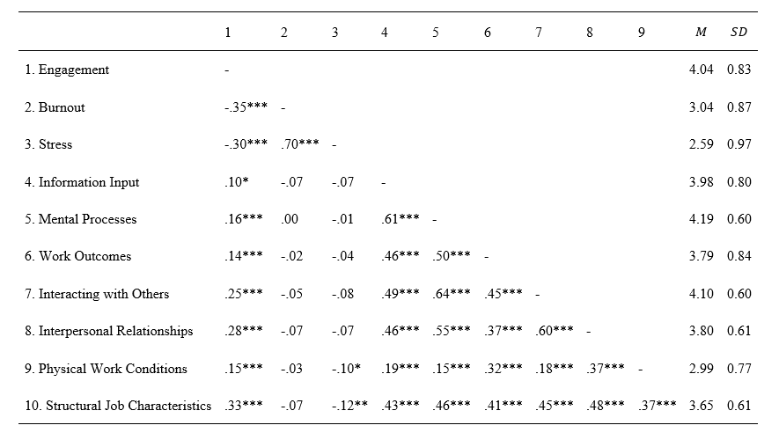

*Note.* * *p* < 0.05; ** *p* < 0.01; *** *p* < 0.001

**Table 2**

**Scale Intercorrelations (Challenge Demands)**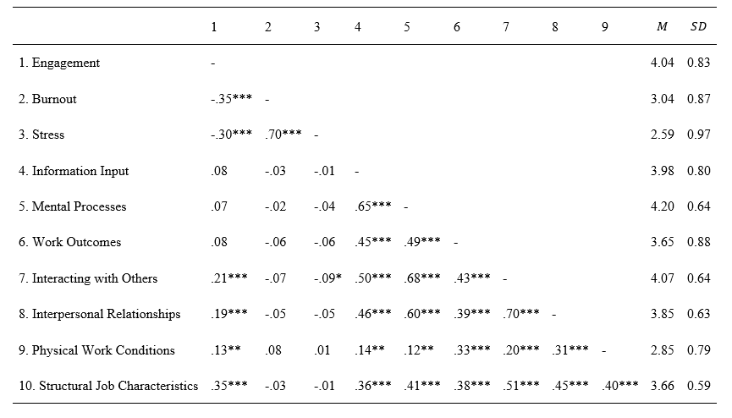

*Note.* * *p* < 0.05; ** *p* < 0.01; *** *p* < 0.001

**Table 3**

**Scale Intercorrelations (Hindrance Demands)**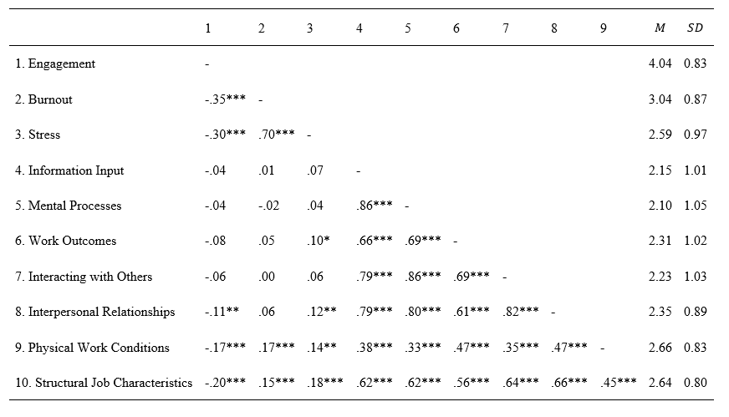

*Note.* * *p* < 0.05; ** *p* < 0.01; *** *p* < 0.001

**Table 4**

**Regression Results Using Engagement as the Criterion and Resources as Predictors**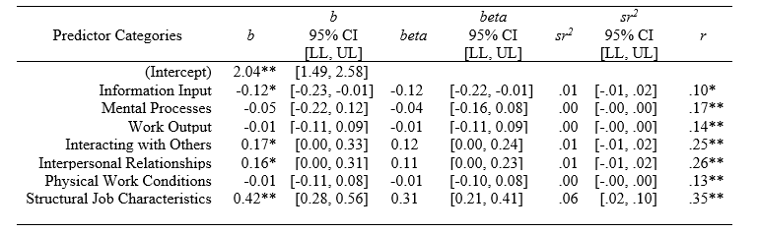

*Note.* A significant *b*-weight indicates the beta-weight and semi-partial correlation are also significant. *b* represents unstandardized regression weights. *beta* indicates the standard regression weights. *sr²* represents the semi-partial correlation squared. r represents the zero-order correlation. *LL* and *UL* indicate the lower and upper limits of a confidence interval, respectively. * indicates *p* < .05. ** indicates *p* < .01.

**Table 5**

**Regression Results Using Engagement as the Criterion and Challenge Demands as Predictors**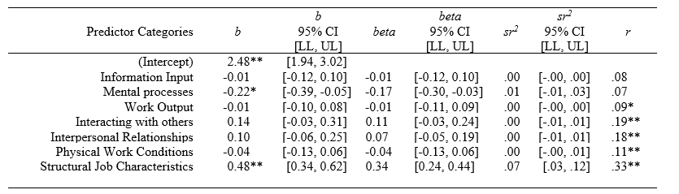

*Note.* A significant *b*-weight indicates the beta-weight and semi-partial correlation are also significant. *b* represents unstandardized regression weights. *beta* indicates the standard regression weights. *sr²* represents the semi-partial correlation squared. r represents the zero-order correlation. *LL* and *UL* indicate the lower and upper limits of a confidence interval, respectively. * indicates *p* < .05. ** indicates *p* < .01.

1. We also investigated the associations among all classifications (e.g., challenges, hindrances, and resources), noting that the average correlation among resources and challenges was .37 (*SD* = 0.16), among resources and hindrances was -.16 (*SD* = 0.08), and among challenges and hindrances was -.13 (*SD* = 0.09).