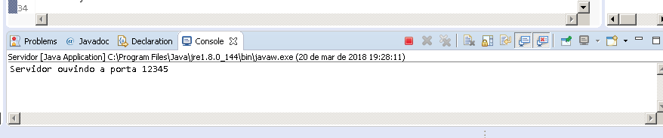

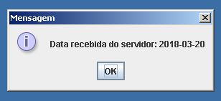

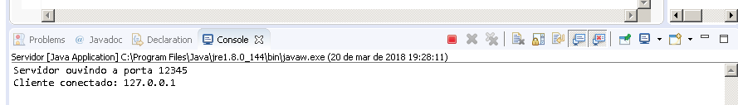

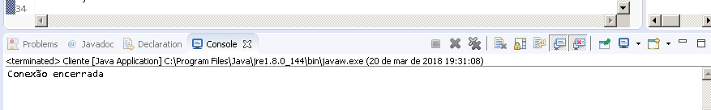

**package** TCPBasico;

**import** java.io.ObjectInputStream;

**import** java.net.Socket;

**import** java.sql.Date;

**import** javax.swing.JOptionPane;

**public** **class** Cliente {

**public** **static** **void** main(String[] args) {

**try** {

Socket cliente = **new** Socket("localhost",12345);

ObjectInputStream entrada = **new** ObjectInputStream(cliente.getInputStream());

Date data_atual = (Date)entrada.readObject();

//Date data_atual = (Date)entrada.readObject();

JOptionPane.*showMessageDialog*(**null**,"Data recebida do servidor: " + data_atual.toString());

entrada.close();

System.***out***.println("Conexão encerrada");

}

**catch**(Exception e) {

System.***out***.println("Erro: " + e.getMessage());

}

}

}

**package** TCPBasico;

**import** java.io.ObjectOutputStream;

**import** java.net.ServerSocket;

**import** java.net.Socket;

**import** java.sql.Date;

**public** **class** Servidor {

**public** **static** **void** main(String[] args) {

**try** {

// Instancia o ServerSocket ouvindo a porta 12345

ServerSocket servidor = **new** ServerSocket(12345);

System.***out***.println("Servidor ouvindo a porta 12345");

**while**(**true**) {

// o método accept() bloqueia a execução até que

// o servidor receba um pedido de conexão

Socket cliente = servidor.accept();

System.***out***.println("Cliente conectado: " + cliente.getInetAddress().getHostAddress());

ObjectOutputStream saida = **new** ObjectOutputStream(cliente.getOutputStream());

saida.flush();

saida.writeObject(**new** Date(System.*currentTimeMillis*()));

saida.close();

cliente.close();

}

}

**catch**(Exception e) {

System.***out***.println("Erro: " + e.getMessage());

}

}

}