Feature selection results for big_dataset and Nmin = 10

1. result: (signal_strength, peak_frequency, max_frequency)
Estimated Epsilon: 0.0062405, Picked Epsilon: 0.018741, MinNumPoints: 10
DBCV index value: 0.66925
cluster -1 had 1.4754% single peaks
cluster 1 had 97.0492% single peaks
cluster 2 had 1.1475% single peaks
cluster 3 had 0% single peaks
cluster 4 had 0% single peaks
cluster 5 had 0.32787% single peaks
cluster 6 had 0% single peaks
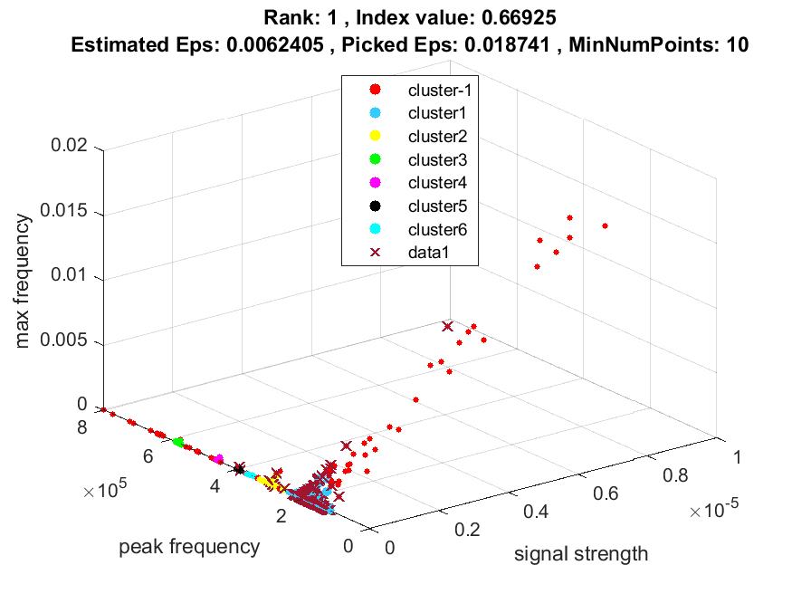
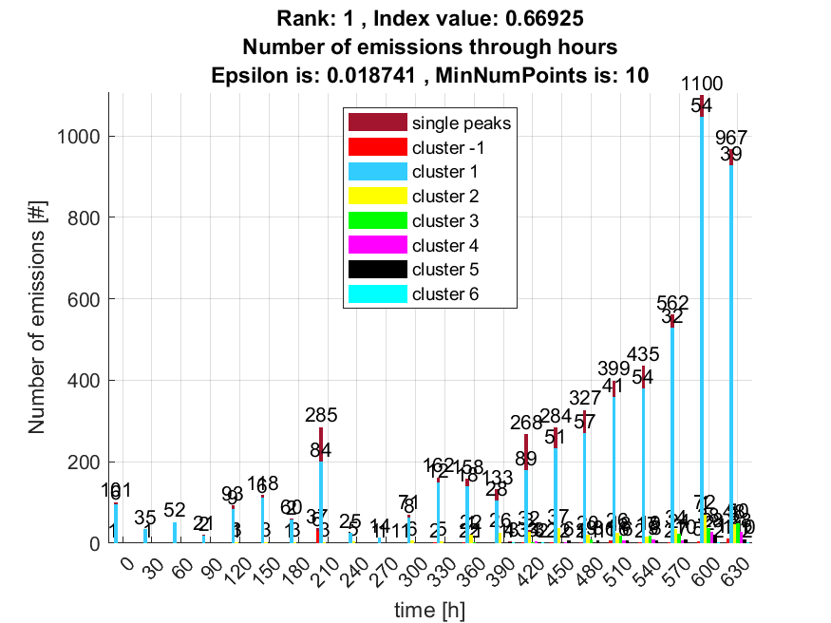

2. result: (peak_amplitude, peak_frequency, max_frequency)
Estimated Epsilon: 0.0085671, Picked Epsilon: 0.021067, MinNumPoints: 10
DBCV index value: 0.66481
cluster -1 had 1.6393% single peaks
cluster 1 had 96.8852% single peaks
cluster 2 had 1.1475% single peaks
cluster 3 had 0% single peaks
cluster 4 had 0% single peaks
cluster 5 had 0.32787% single peaks
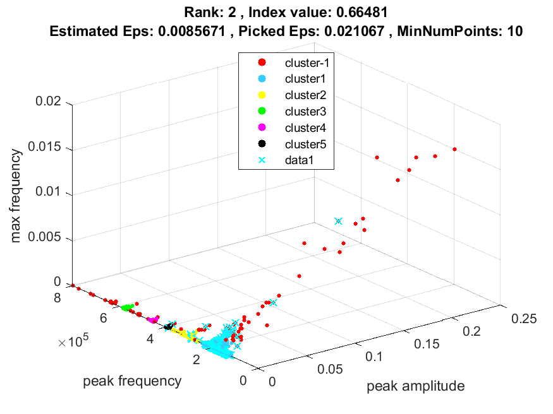
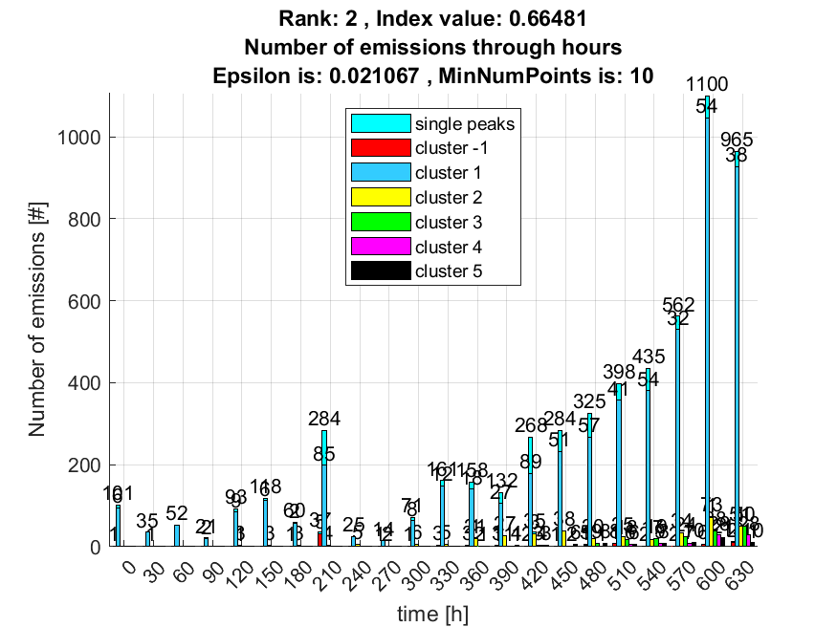

3. result: (peak_amplitude, pp3, peak_frequency)
Estimated Epsilon: 0.018447, Picked Epsilon: 0.040947, MinNumPoints: 10
DBCV index value: 0.65286
cluster -1 had 1.3115% single peaks
cluster 1 had 98.0328% single peaks
cluster 2 had 0.32787% single peaks
cluster 3 had 0% single peaks
cluster 4 had 0% single peaks
cluster 5 had 0.16393% single peaks
cluster 6 had 0.16393% single peaks
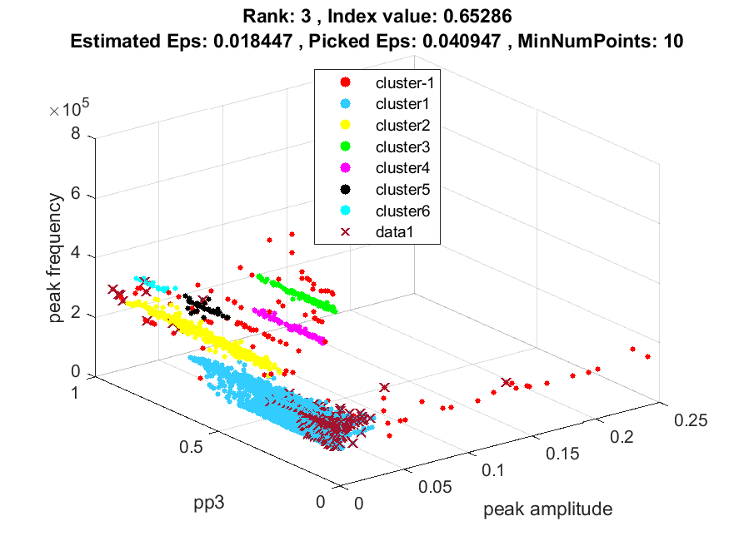
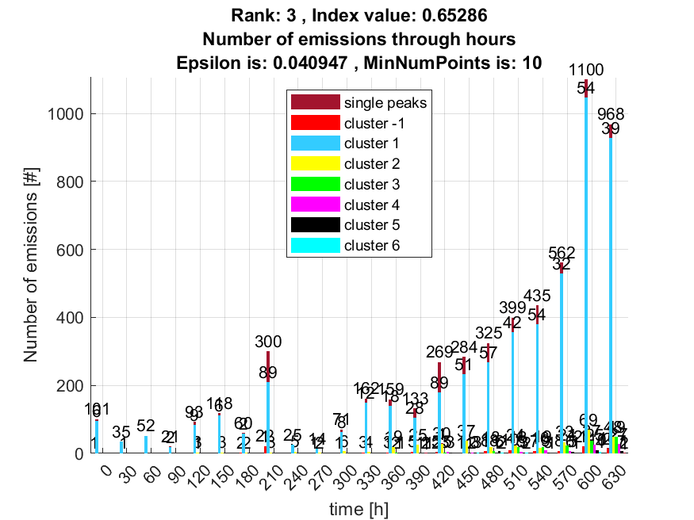

4. result: (pp3, peak_frequency, max_frequency)
Estimated Epsilon: 0.014342, Picked Epsilon: 0.039342, MinNumPoints: 10
DBCV index value: 0.65251
cluster -1 had 1.3115% single peaks
cluster 1 had 98.0328% single peaks
cluster 2 had 0.32787% single peaks
cluster 3 had 0% single peaks
cluster 4 had 0% single peaks
cluster 5 had 0.16393% single peaks
cluster 6 had 0.16393% single peaks
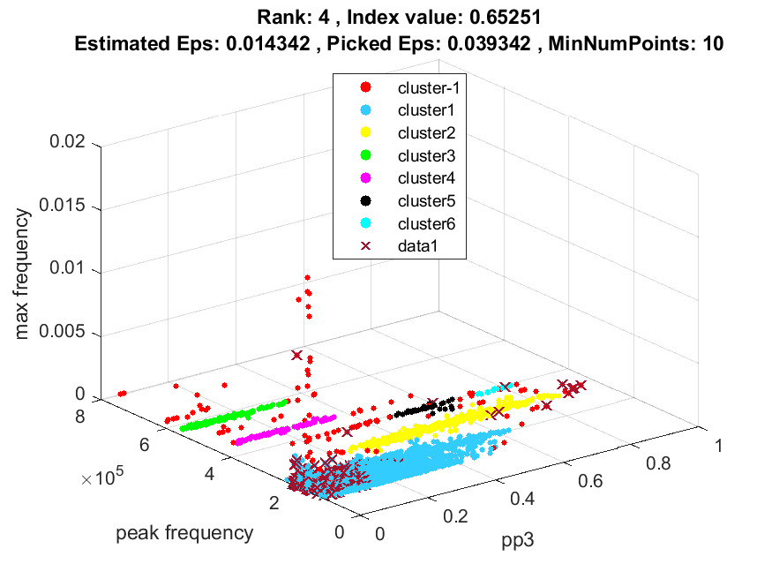
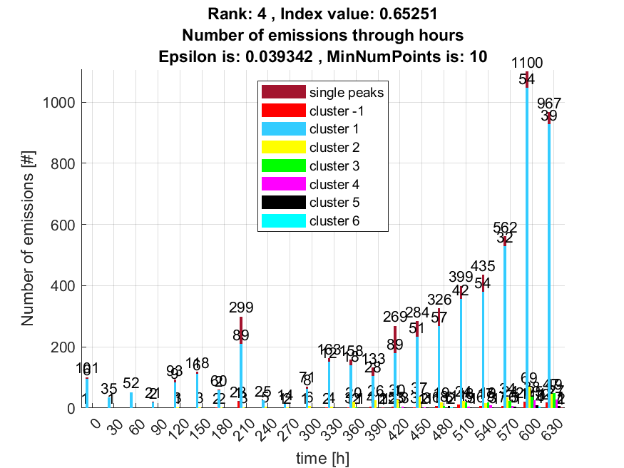

5. result: (signal_strength, pp3, peak_frequency)
Estimated Epsilon: 0.017417, Picked Epsilon: 0.039917, MinNumPoints: 10
DBCV index value: 0.65191
cluster -1 had 1.3115% single peaks
cluster 1 had 98.0328% single peaks
cluster 2 had 0.32787% single peaks
cluster 3 had 0% single peaks
cluster 4 had 0% single peaks
cluster 5 had 0.16393% single peaks
cluster 6 had 0.16393% single peaks
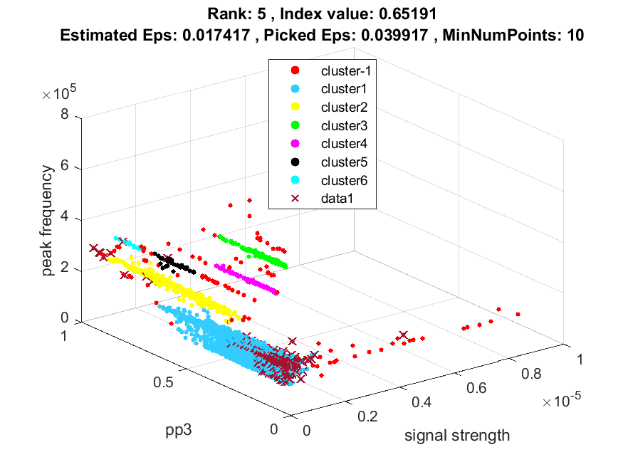
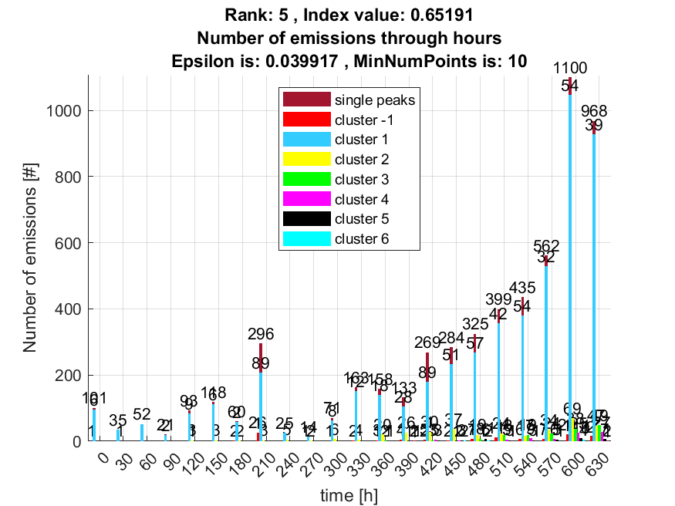

6. result: (pp2, peak_frequency, max_frequency)
Estimated Epsilon: 0.01633, Picked Epsilon: 0.04383, MinNumPoints: 10
DBCV index value: 0.64942
cluster -1 had 0.65574% single peaks
cluster 1 had 98.0328% single peaks
cluster 2 had 1.1475% single peaks
cluster 3 had 0% single peaks
cluster 4 had 0% single peaks
cluster 5 had 0.16393% single peaks
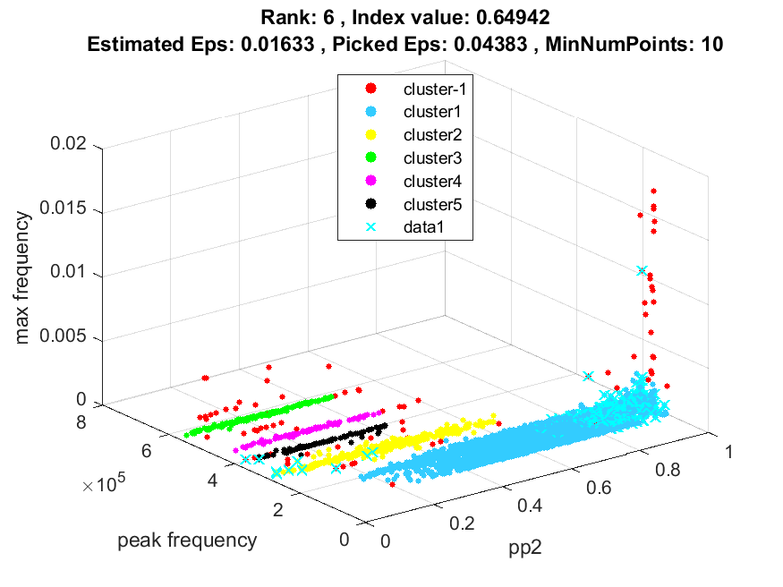
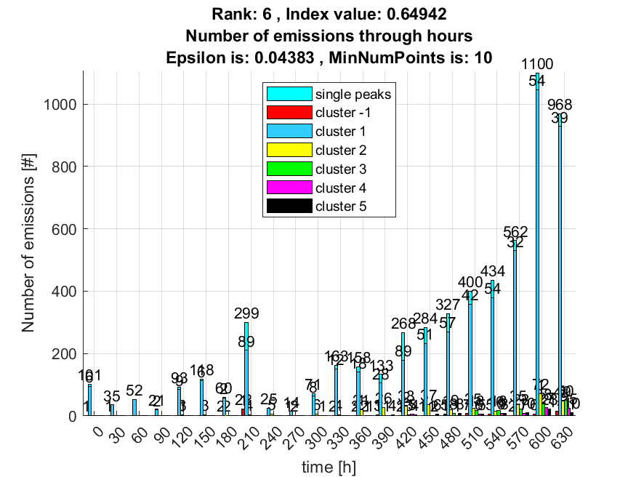

7. result: (signal_strength, centroid_frequency, peak_frequency)
Estimated Epsilon: 0.01697, Picked Epsilon: 0.04197, MinNumPoints: 10
DBCV index value: 0.64873
cluster -1 had 0.4918% single peaks
cluster 1 had 98.0328% single peaks
cluster 2 had 1.1475% single peaks
cluster 3 had 0% single peaks
cluster 4 had 0% single peaks
cluster 5 had 0.32787% single peaks
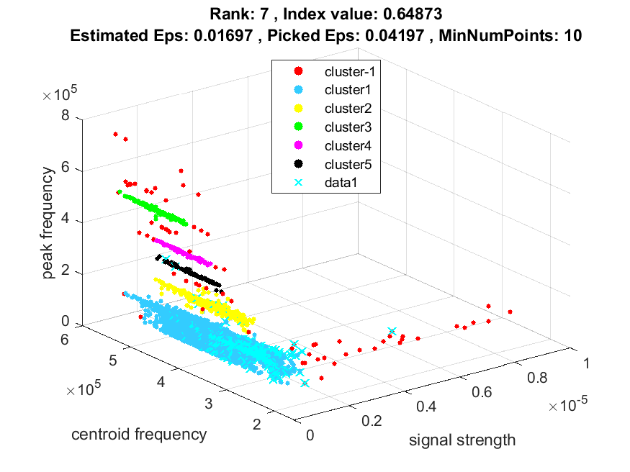
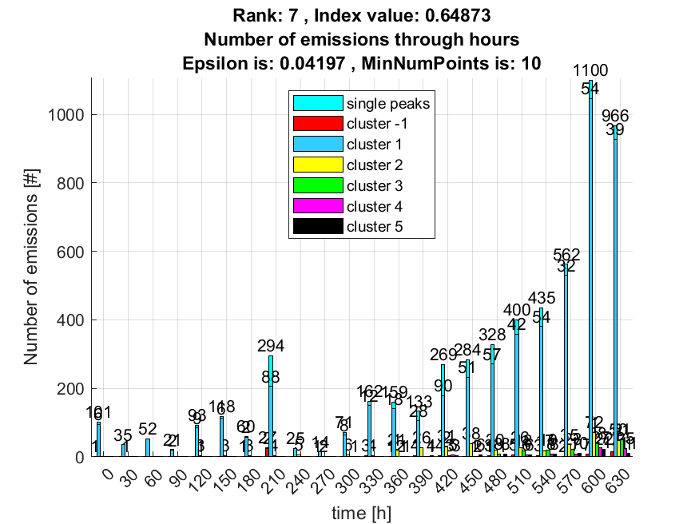

8. result: (peak_amplitude, pp2, peak_frequency)
Estimated Epsilon: 0.018288, Picked Epsilon: 0.043288, MinNumPoints: 10
DBCV index value: 0.64832
cluster -1 had 0.98361% single peaks
cluster 1 had 98.0328% single peaks
cluster 2 had 0.98361% single peaks
cluster 3 had 0% single peaks
cluster 4 had 0% single peaks
cluster 5 had 0% single peaks
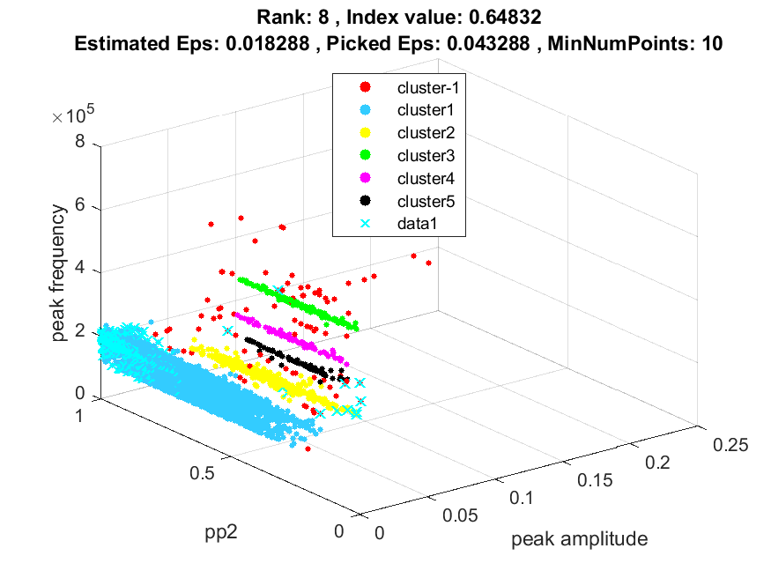
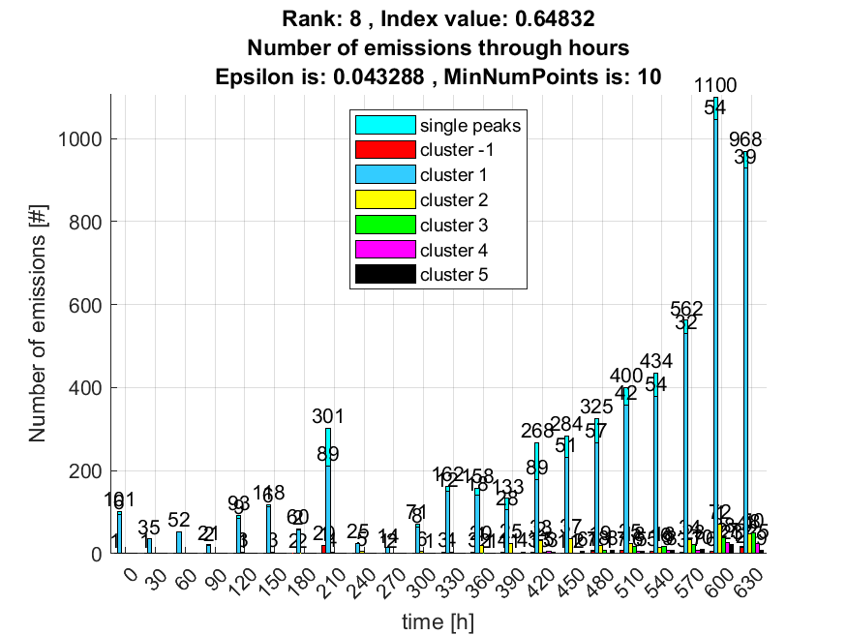

9. result: (centroid_frequency, peak_frequency, max_frequency)
Estimated Epsilon: 0.016101, Picked Epsilon: 0.041101, MinNumPoints: 10
DBCV index value: 0.64811
cluster -1 had 0.4918% single peaks
cluster 1 had 98.0328% single peaks
cluster 2 had 1.1475% single peaks
cluster 3 had 0% single peaks
cluster 4 had 0% single peaks
cluster 5 had 0.32787% single peaks
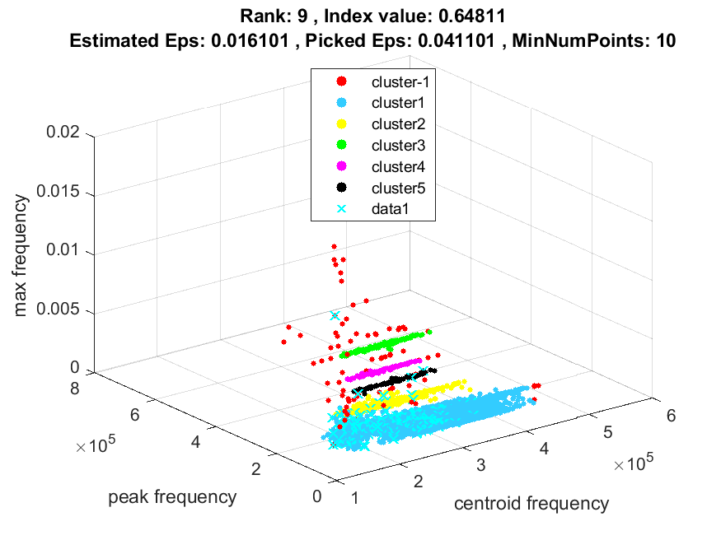
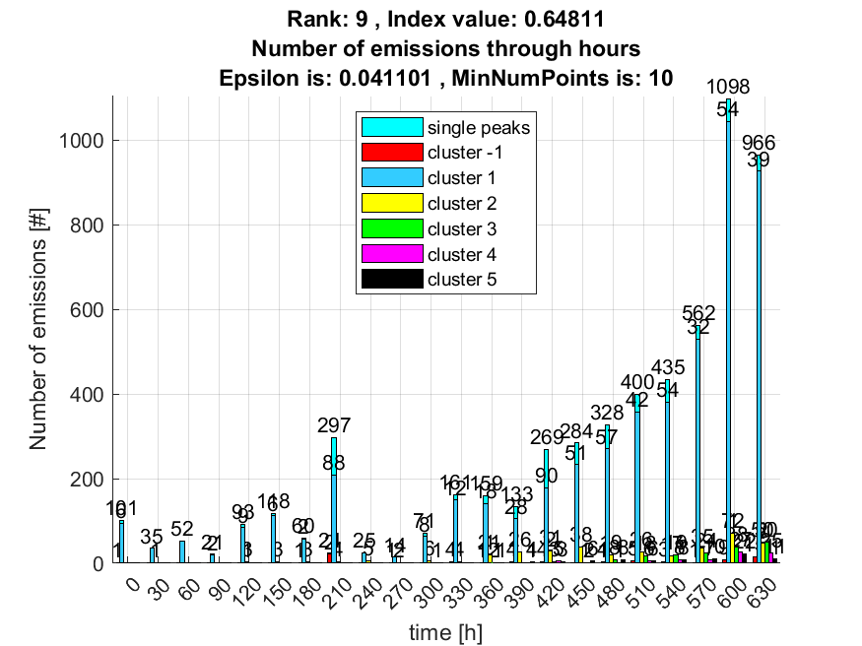

10. result: (signal_strength, pp2, peak_frequency)
Estimated Epsilon: 0.016969, Picked Epsilon: 0.041969, MinNumPoints: 10
DBCV index value: 0.6467
cluster -1 had 0.98361% single peaks
cluster 1 had 97.8689% single peaks
cluster 2 had 1.1475% single peaks
cluster 3 had 0% single peaks
cluster 4 had 0% single peaks
cluster 5 had 0% single peaks
