Feature selection results for big_dataset and Nmin = 10

1. result: (pp4, peak_frequency, total_counts)
Estimated Epsilon: 0.034676, Picked Epsilon: 0.052176, MinNumPoints: 10
DBCV index value: 0.75789
cluster -1 had 0.16393% single peaks
cluster 1 had 99.6721% single peaks
cluster 2 had 0% single peaks
cluster 3 had 0% single peaks
cluster 4 had 0.16393% single peaks
cluster 5 had 0% single peaks
cluster 6 had 0% single peaks
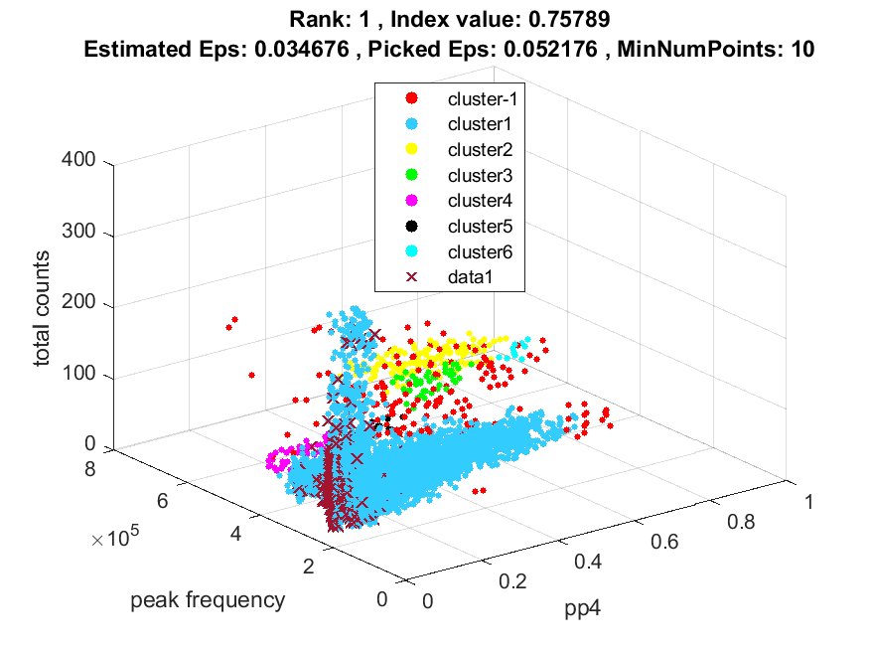
Jer ne prepoznaje najveću rupu koja ima start node s jednim stupnjem! Zbog toga smanjujemo drvo za sve čvorove s jednim stupnjom.
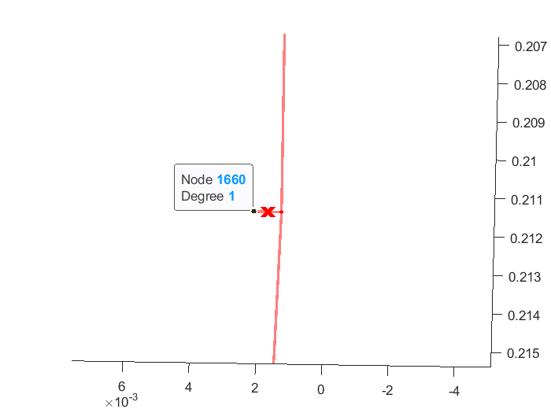
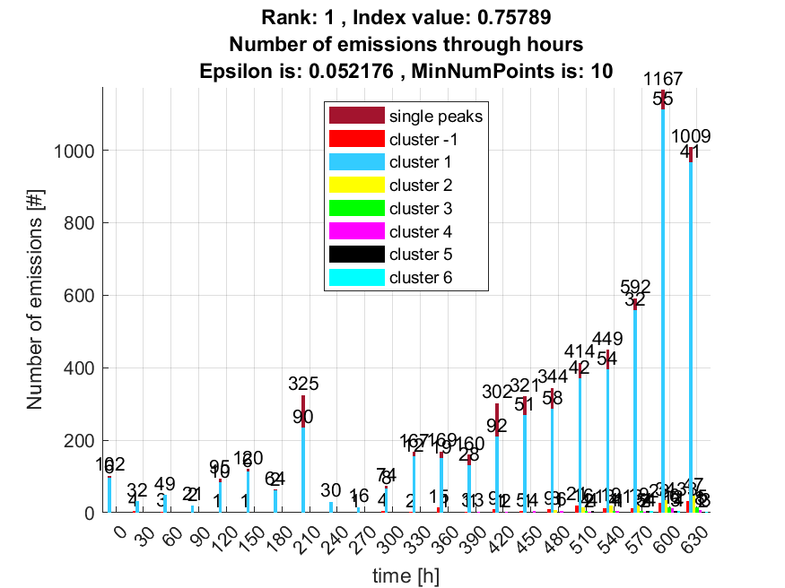

2. result: (pp4, peak_frequency, fall_time)
Estimated Epsilon: 0.028047, Picked Epsilon: 0.058047, MinNumPoints: 10
DBCV index value: 0.73393
cluster -1 had 0% single peaks
cluster 1 had 100% single peaks
cluster 2 had 0% single peaks
cluster 3 had 0% single peaks
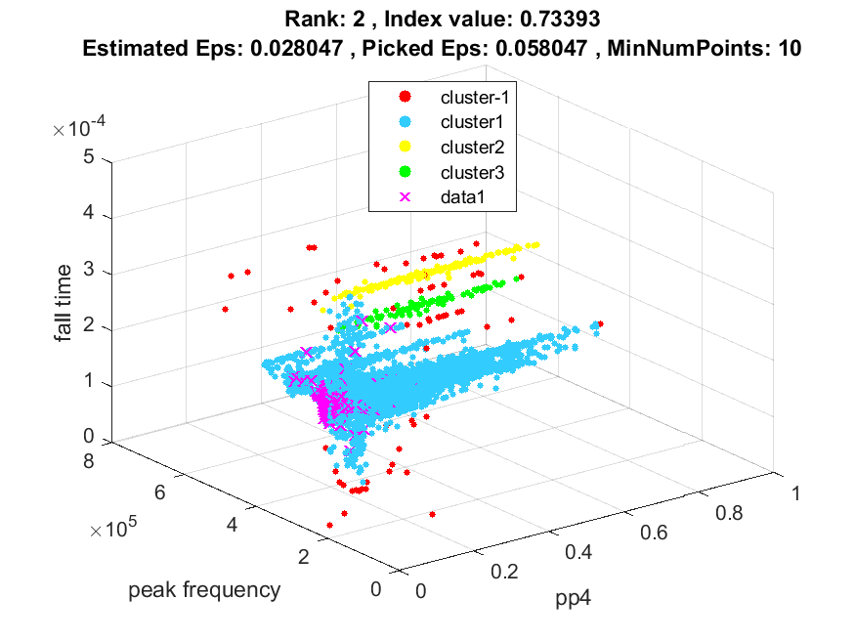
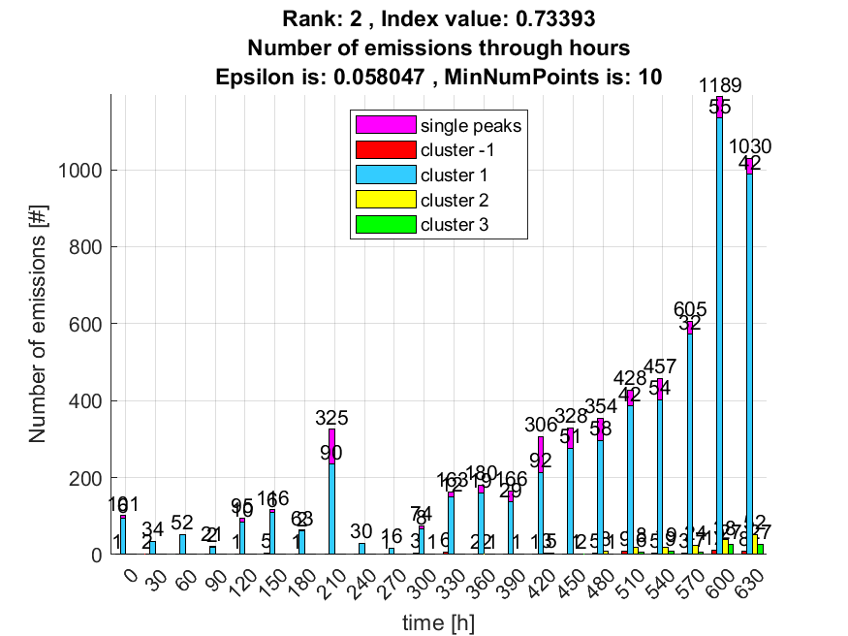

3. result: (peak_amplitude, peak_frequency, max_frequency)
Estimated Epsilon: 0.0085671, Picked Epsilon: 0.018567, MinNumPoints: 10
DBCV index value: 0.66027
cluster -1 had 2.2951% single peaks
cluster 1 had 96.2295% single peaks
cluster 2 had 1.1475% single peaks
cluster 3 had 0% single peaks
cluster 4 had 0% single peaks
cluster 5 had 0.32787% single peaks
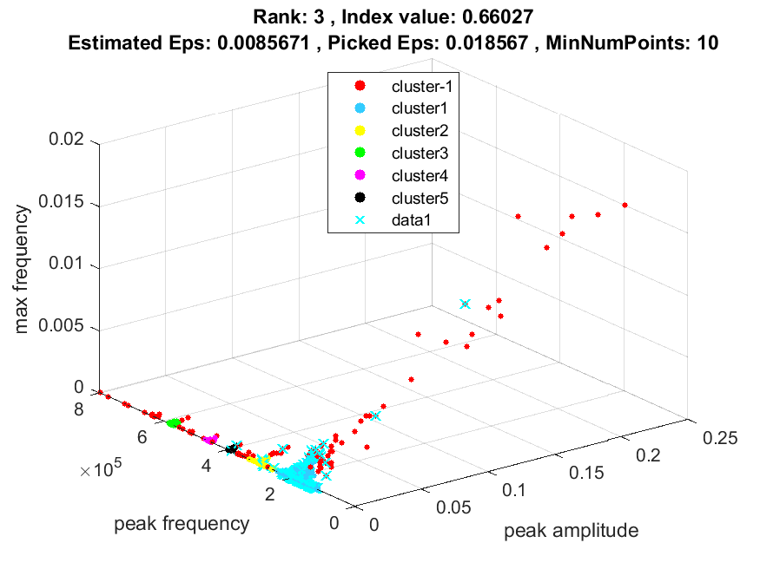
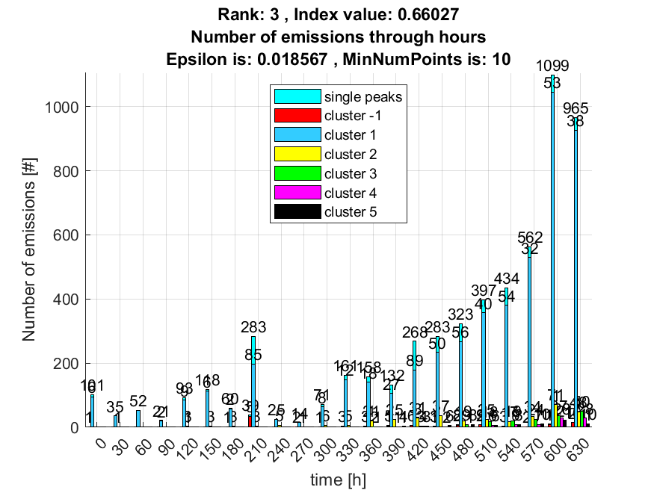

4. result: (signal_strength, peak_frequency, max_frequency)
Estimated Epsilon: 0.0062405, Picked Epsilon: 0.018741, MinNumPoints: 10
DBCV index value: 0.64818
cluster -1 had 1.4754% single peaks
cluster 1 had 97.0492% single peaks
cluster 2 had 1.1475% single peaks
cluster 3 had 0% single peaks
cluster 4 had 0% single peaks
cluster 5 had 0.32787% single peaks
cluster 6 had 0% single peaks
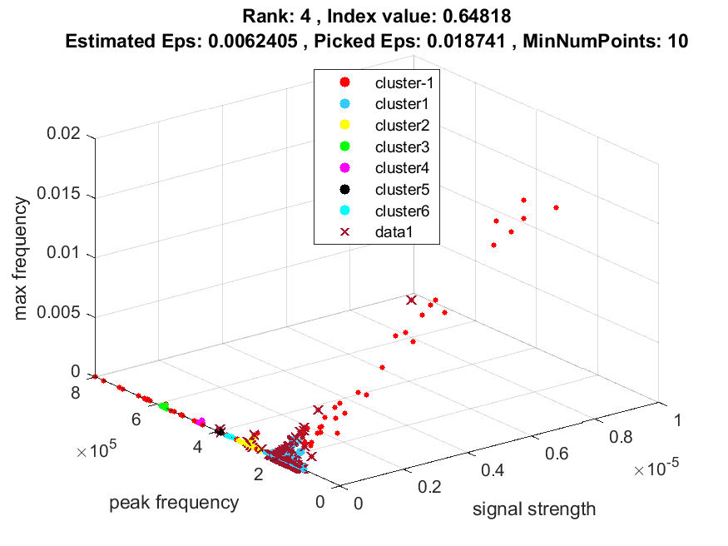
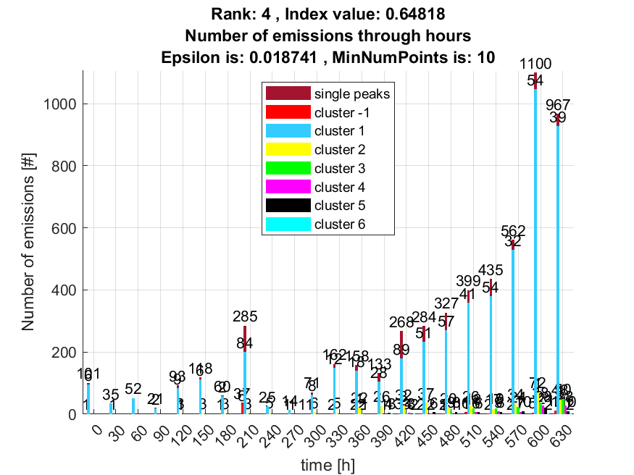

5. result: (pp1, peak_frequency, max_frequency)
Estimated Epsilon: 0.012715, Picked Epsilon: 0.030215, MinNumPoints: 10
DBCV index value: 0.64082
cluster -1 had 0.4918% single peaks
cluster 1 had 97.8689% single peaks
cluster 2 had 1.6393% single peaks
cluster 3 had 0% single peaks
cluster 4 had 0% single peaks
cluster 5 had 0% single peaks
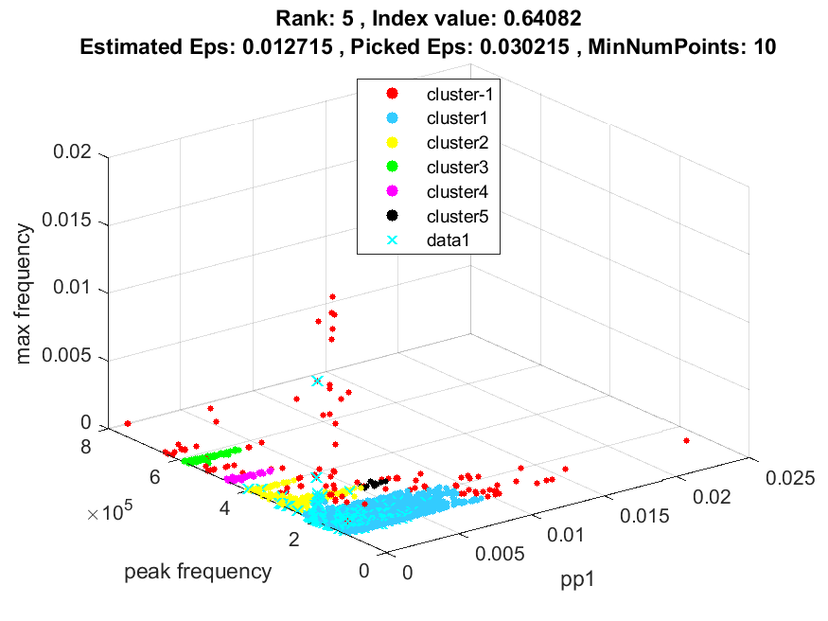
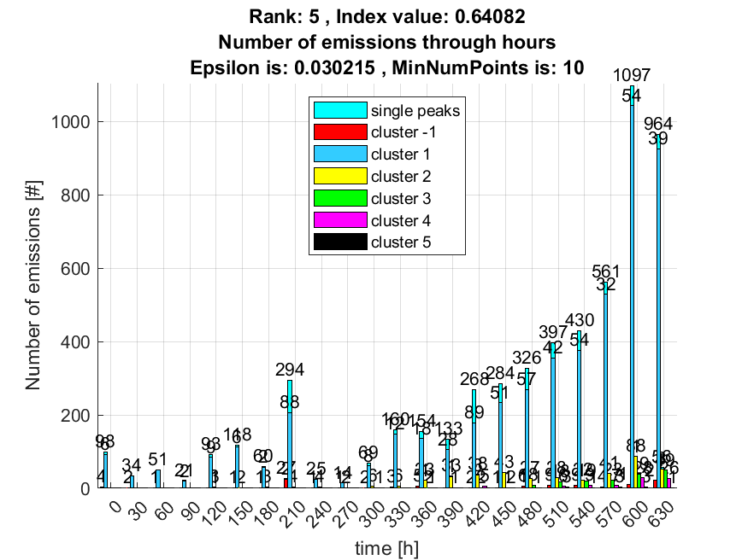

6. result: (signal_strength, pp1, peak_frequency)
Estimated Epsilon: 0.012862, Picked Epsilon: 0.027862, MinNumPoints: 10
DBCV index value: 0.6373
cluster -1 had 0.81967% single peaks
cluster 1 had 97.7049% single peaks
cluster 2 had 1.1475% single peaks
cluster 3 had 0% single peaks
cluster 4 had 0% single peaks
cluster 5 had 0.32787% single peaks
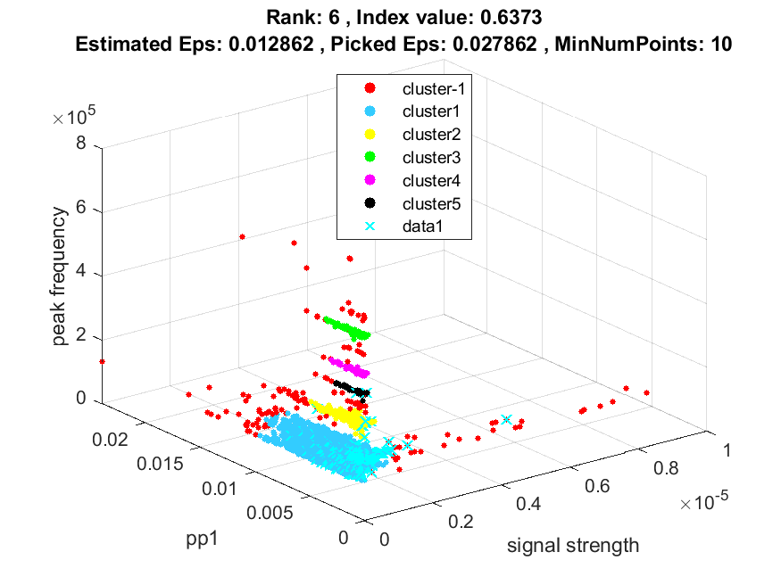
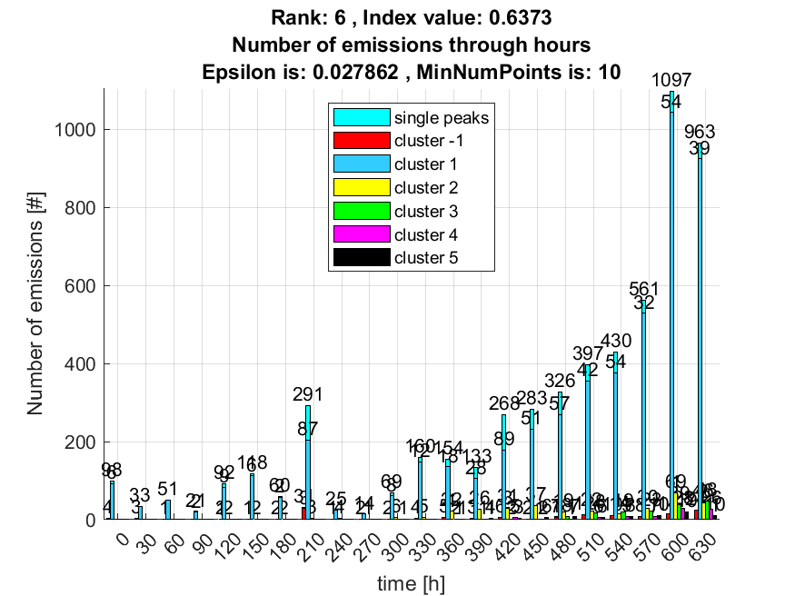

7. result: (peak_amplitude, pp1, peak_frequency)
Estimated Epsilon: 0.012862, Picked Epsilon: 0.027862, MinNumPoints: 10
DBCV index value: 0.63681
cluster -1 had 0.81967% single peaks
cluster 1 had 97.8689% single peaks
cluster 2 had 0.98361% single peaks
cluster 3 had 0% single peaks
cluster 4 had 0% single peaks
cluster 5 had 0.32787% single peaks
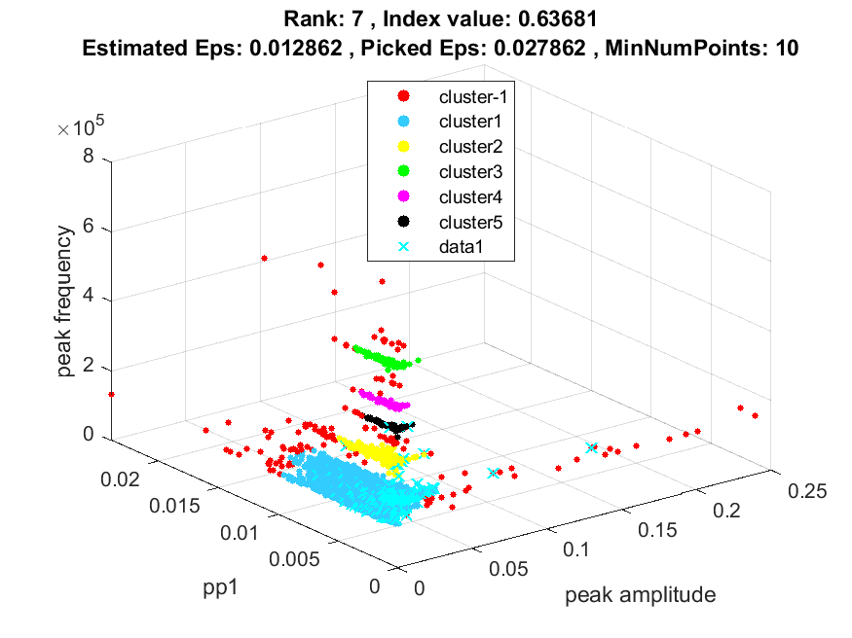
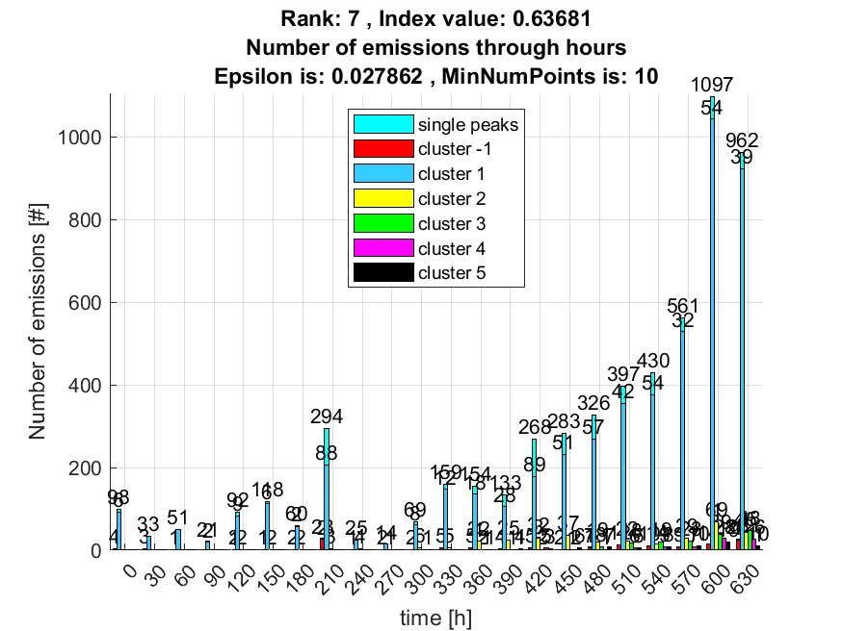

8. result: (pp4, peak_frequency, max_frequency)
Estimated Epsilon: 0.014652, Picked Epsilon: 0.032152, MinNumPoints: 10
DBCV index value: 0.63181
cluster -1 had 0.4918% single peaks
cluster 1 had 98.0328% single peaks
cluster 2 had 1.3115% single peaks
cluster 3 had 0% single peaks
cluster 4 had 0% single peaks
cluster 5 had 0.16393% single peaks
cluster 6 had 0% single peaks
cluster 7 had 0% single peaks
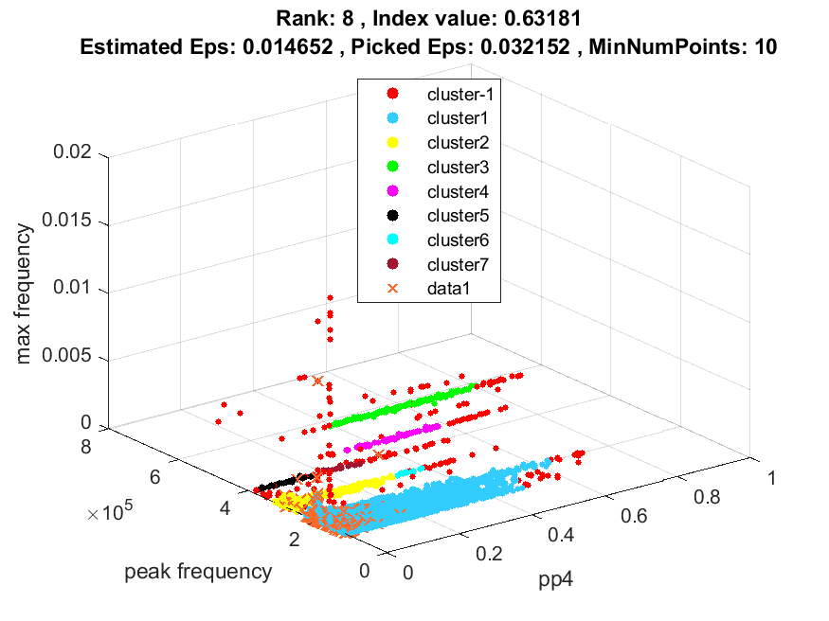
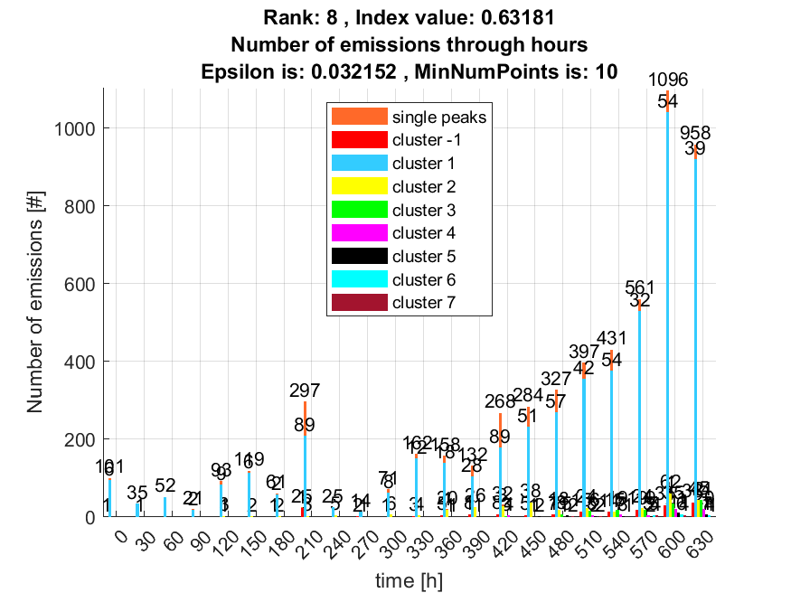

9. result: (signal_strength, pp4, peak_frequency)
Estimated Epsilon: 0.014811, Picked Epsilon: 0.032311, MinNumPoints: 10
DBCV index value: 0.63131
cluster -1 had 0.81967% single peaks
cluster 1 had 97.7049% single peaks
cluster 2 had 1.3115% single peaks
cluster 3 had 0% single peaks
cluster 4 had 0% single peaks
cluster 5 had 0.16393% single peaks
cluster 6 had 0% single peaks
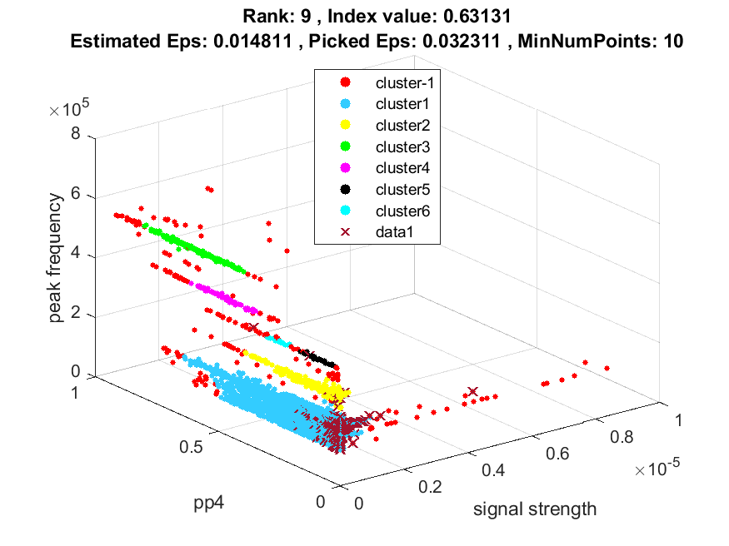
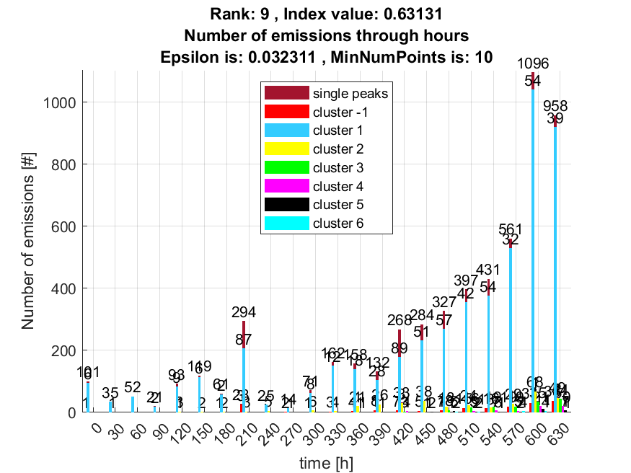

10. result: (peak_amplitude, pp4, peak_frequency)
Estimated Epsilon: 0.016855, Picked Epsilon: 0.031855, MinNumPoints: 10
DBCV index value: 0.63033
cluster -1 had 0.65574% single peaks
cluster 1 had 97.8689% single peaks
cluster 2 had 1.3115% single peaks
cluster 3 had 0% single peaks
cluster 4 had 0% single peaks
cluster 5 had 0.16393% single peaks
cluster 6 had 0% single peaks
cluster 7 had 0% single peaks
