Feature selection results for big_dataset and Nmin = 15

Histogrami su teško uočivi pa je bolje gledati figure unutar matlaba. Prikazuje se broj emisija po 30 h zbog veličine dataseta.
1. result: (peak_amplitude, peak_frequency, max_frequency)
Estimated Epsilon: 0.010077, Picked Epsilon: 0.010077, MinNumPoints: 15
DBCV index value: 0.90835
cluster -1 had 3.9344% single peaks
cluster 1 had 94.918% single peaks
cluster 2 had 0.98361% single peaks
cluster 3 had 0% single peaks
cluster 4 had 0% single peaks
cluster 5 had 0.16393% single peaks
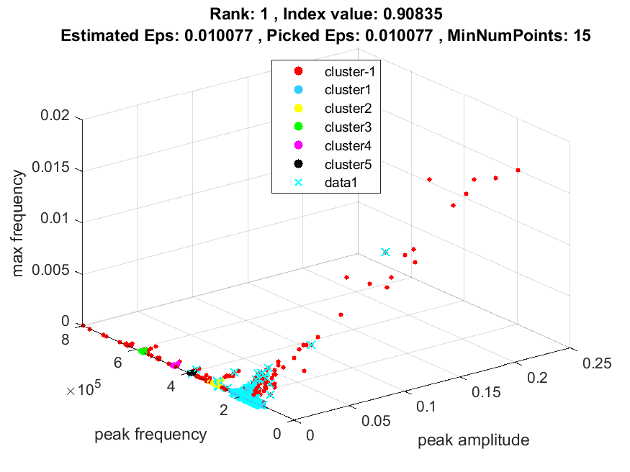

Prikazano bez označenih single peakova:
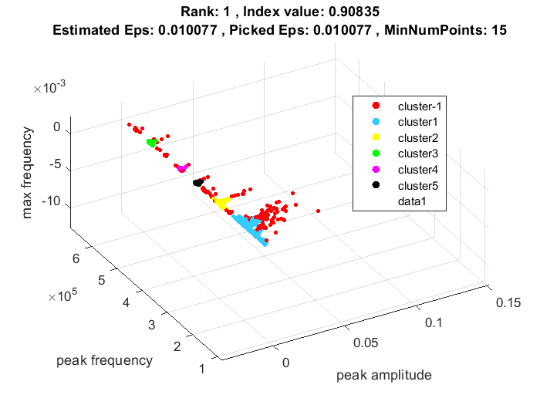

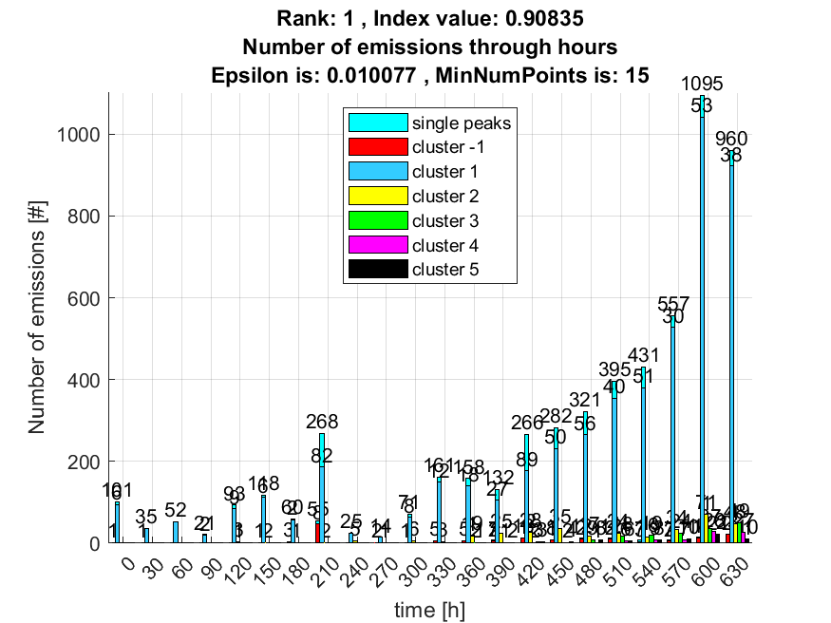

2. result: (signal_strength, peak_frequency, max_frequency)
Estimated Epsilon: 0.0079026, Picked Epsilon: 0.0079026, MinNumPoints: 15
DBCV index value: 0.90719
cluster -1 had 3.9344% single peaks
cluster 1 had 94.918% single peaks
cluster 2 had 0.81967% single peaks
cluster 3 had 0% single peaks
cluster 4 had 0% single peaks
cluster 5 had 0.32787% single peaks
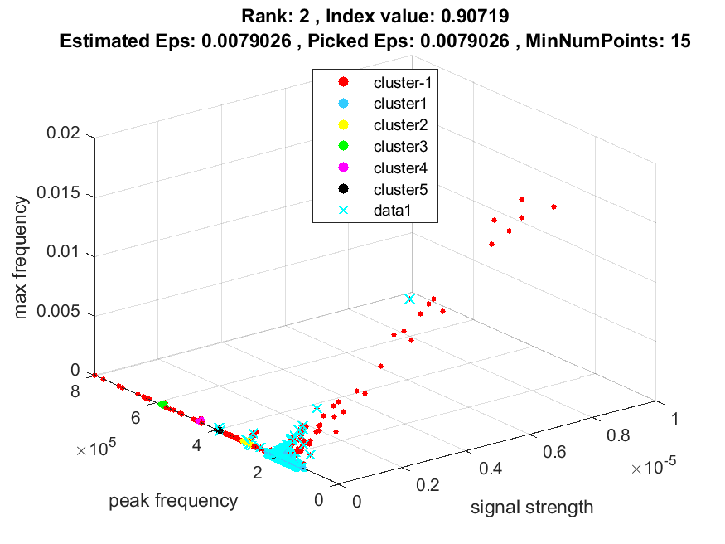
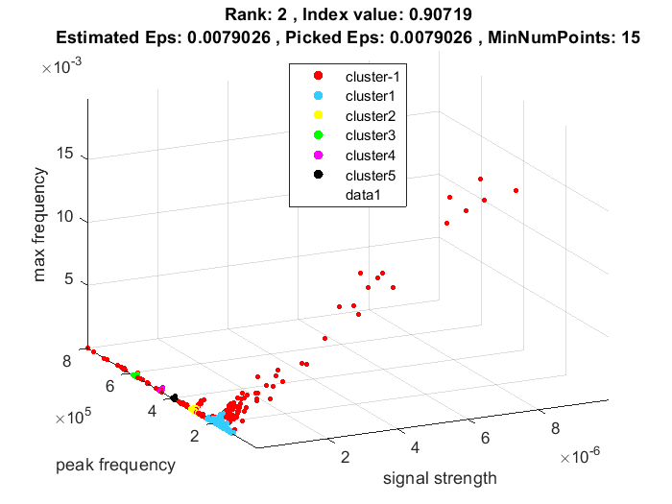
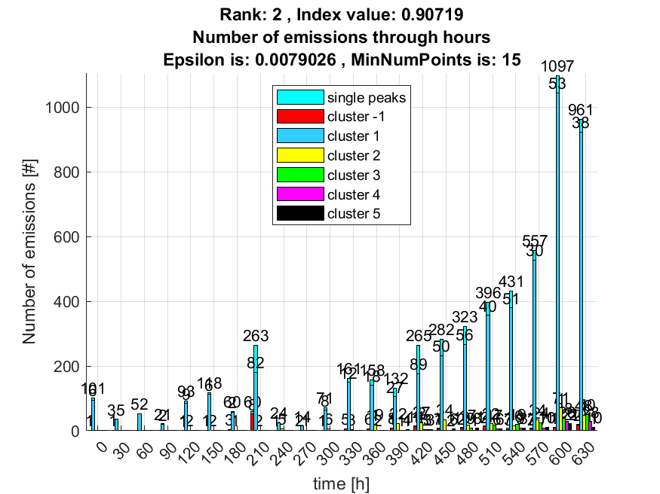

3. result: (pp3, pp4, peak_frequency)
Estimated Epsilon: 0.046333, Picked Epsilon: 0.086333, MinNumPoints: 15
DBCV index value: 0.86189
cluster -1 had 0.16393% single peaks
cluster 1 had 99.8361% single peaks
cluster 2 had 0% single peaks
cluster 3 had 0% single peaks
Vidimo algoritam nije najbolje podjelio clustere zbog velike raspršenosti većeg clustera pa nam daje prikaz prva 3 rezultat za ovaj podskup značajki:
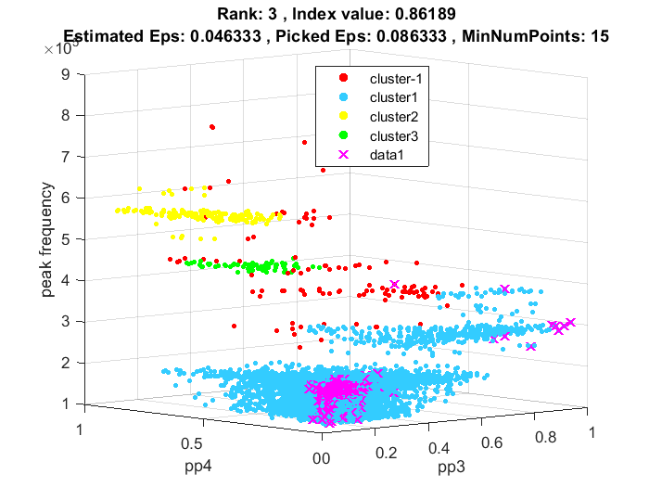
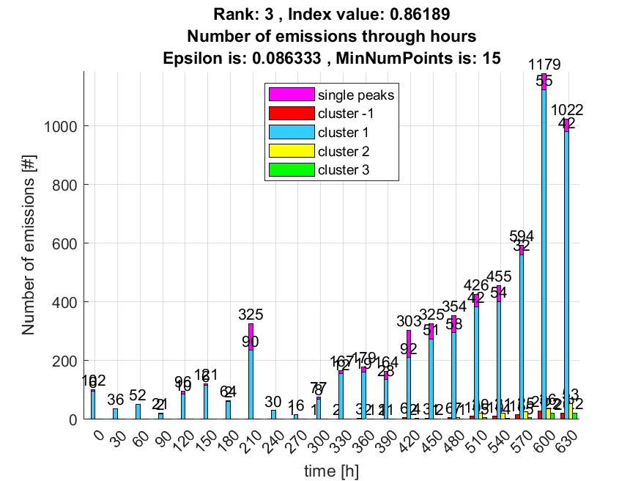

4. result: (counts_from, pp4, peak_frequency)
Estimated Epsilon: 0.038981, Picked Epsilon: 0.078981, MinNumPoints: 15
DBCV index value: 0.85124
cluster -1 had 0% single peaks
cluster 1 had 100% single peaks
cluster 2 had 0% single peaks
cluster 3 had 0% single peaks
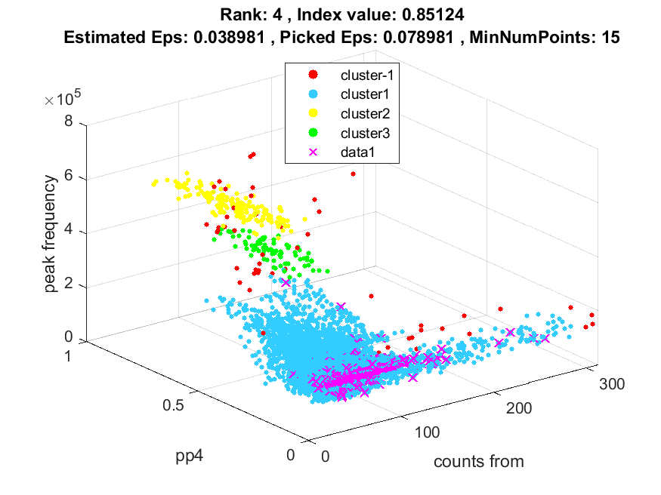
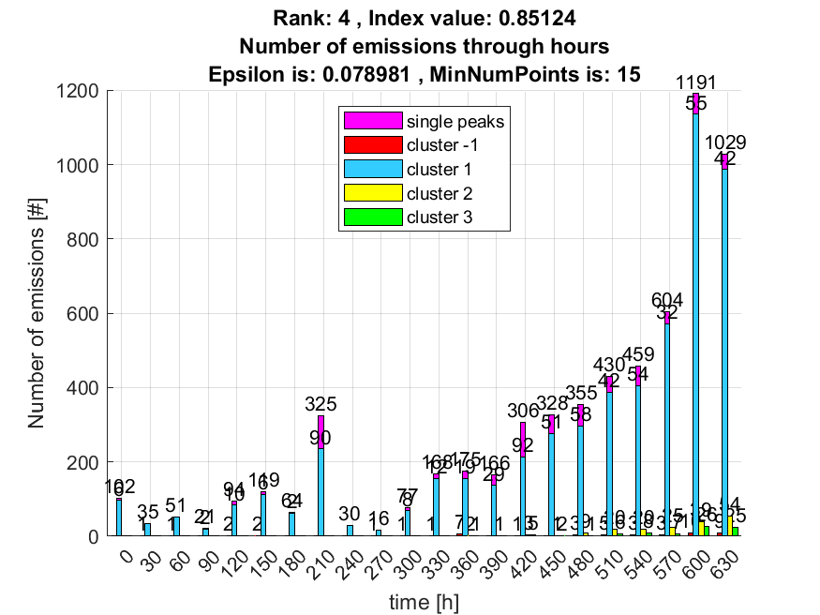

5. result: (peak_amplitude, pp2, peak_frequency)
Estimated Epsilon: 0.024758, Picked Epsilon: 0.044758, MinNumPoints: 15
DBCV index value: 0.8362
cluster -1 had 1.3115% single peaks
cluster 1 had 98.0328% single peaks
cluster 2 had 0.65574% single peaks
cluster 3 had 0% single peaks
cluster 4 had 0% single peaks
cluster 5 had 0% single peaks
DBCV je dobro izabrao.
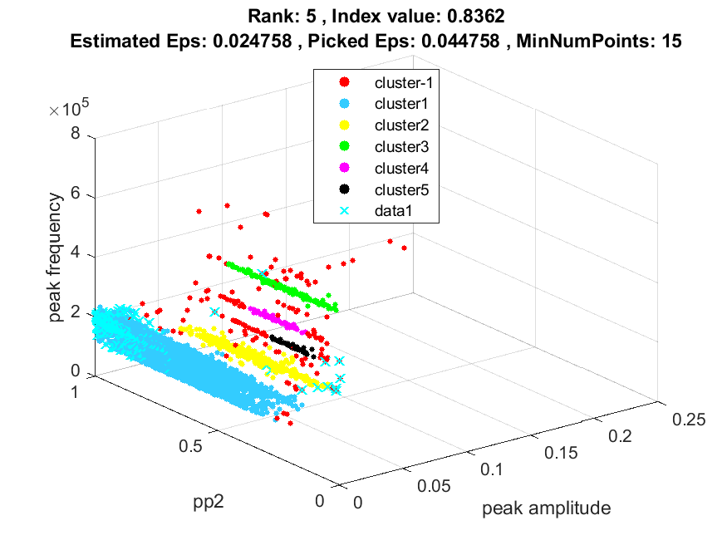
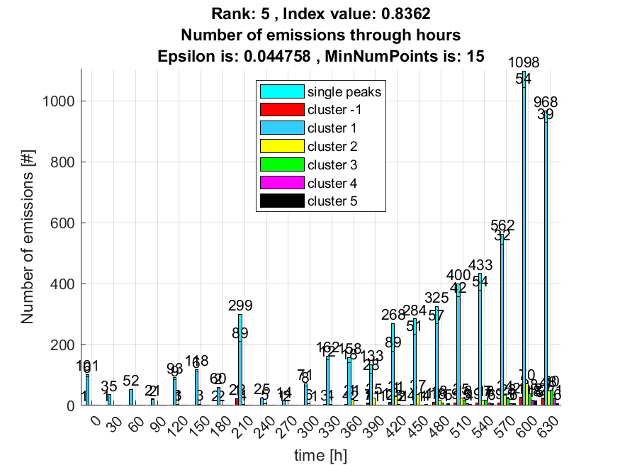

6. result: (pp4, centroid_frequency, peak_frequency)
Estimated Epsilon: 0.042613, Picked Epsilon: 0.052613, MinNumPoints: 15
DBCV index value: 0.83012
cluster -1 had 0.4918% single peaks
cluster 1 had 99.5082% single peaks
cluster 2 had 0% single peaks
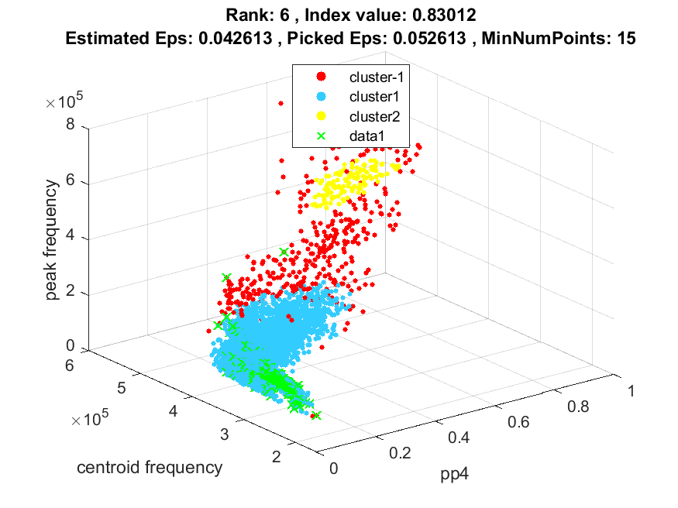
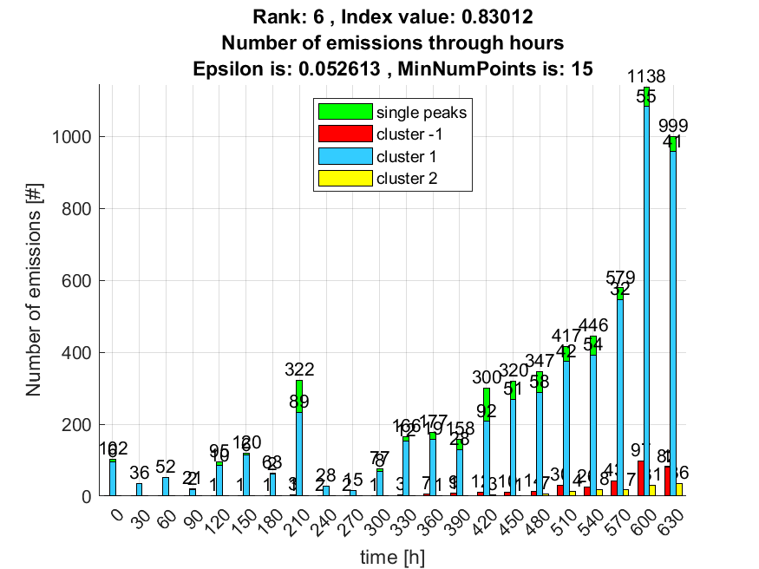

7. result: (pp2, pp4, peak_frequency)
Estimated Epsilon: 0.043803, Picked Epsilon: 0.073803, MinNumPoints: 15
DBCV index value: 0.82504
cluster -1 had 0.4918% single peaks
cluster 1 had 99.5082% single peaks
cluster 2 had 0% single peaks
cluster 3 had 0% single peaks
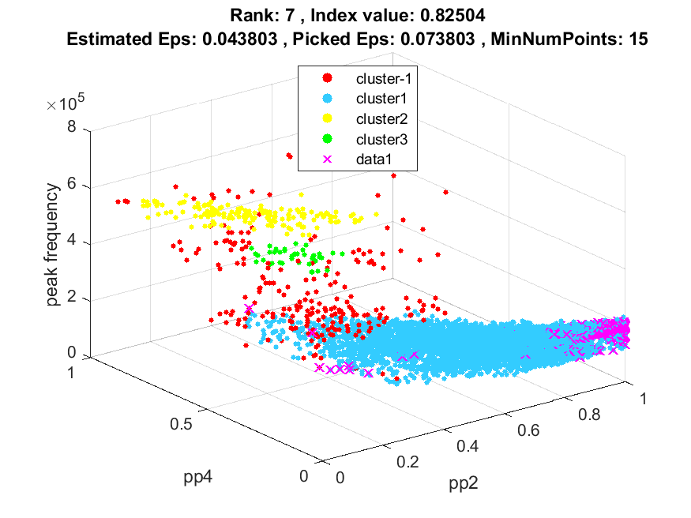
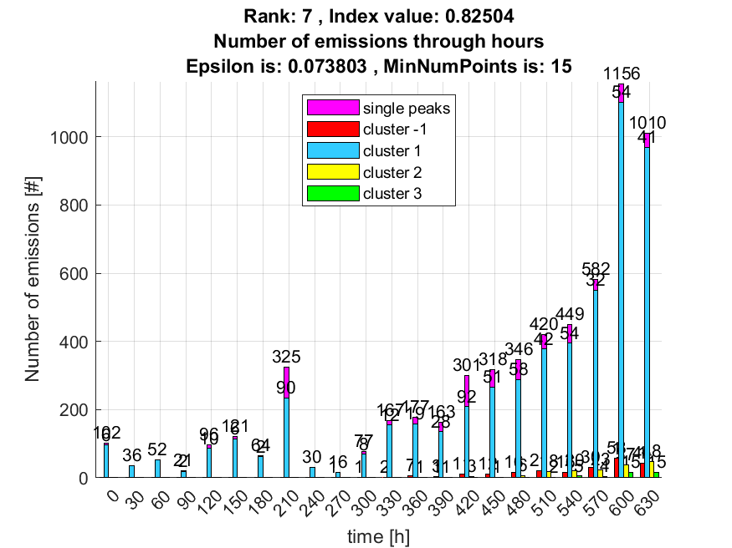

8. result: (pp3, peak_frequency, fall_time)
Estimated Epsilon: 0.027217, Picked Epsilon: 0.077217, MinNumPoints: 15
DBCV index value: 0.81761
cluster -1 had 0% single peaks
cluster 1 had 100% single peaks
cluster 2 had 0% single peaks
cluster 3 had 0% single peaks
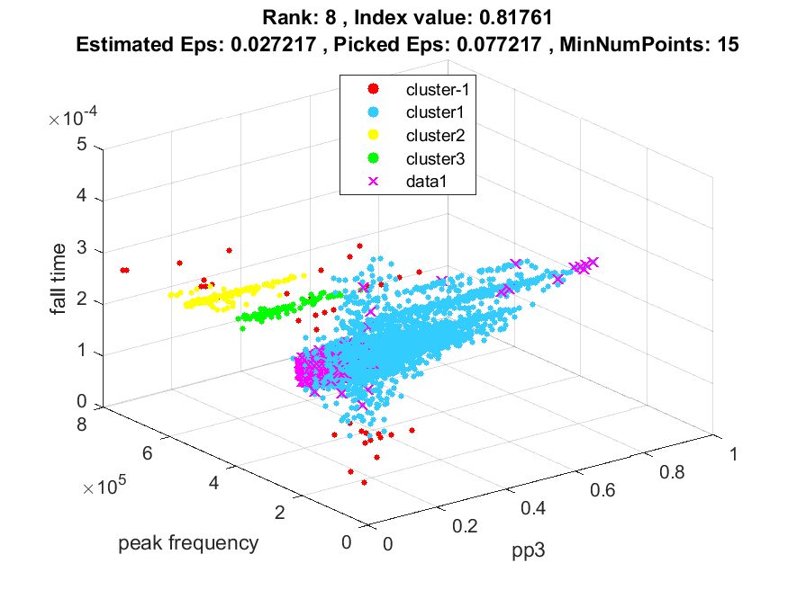
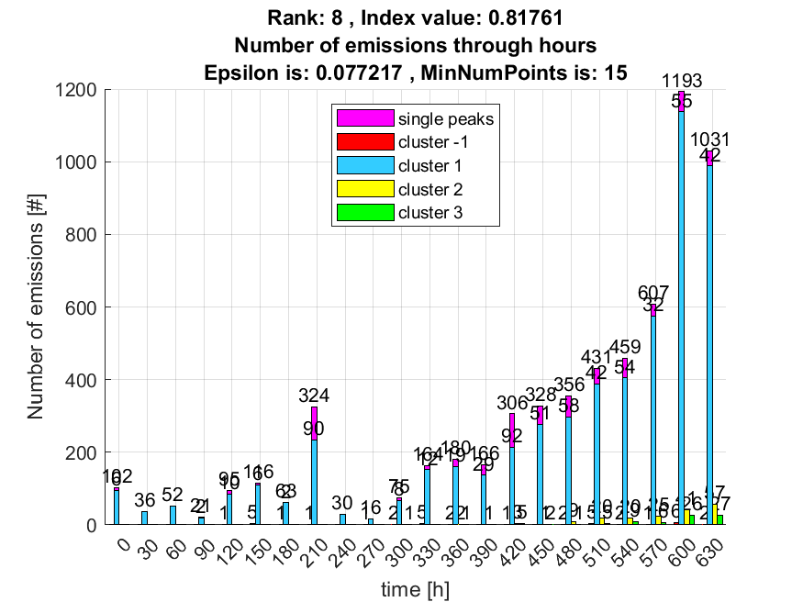

9. result: (signal_strength, pp1, peak_frequency)
Estimated Epsilon: 0.01598, Picked Epsilon: 0.02598, MinNumPoints: 15
DBCV index value: 0.81663
cluster -1 had 0.98361% single peaks
cluster 1 had 97.541% single peaks
cluster 2 had 1.1475% single peaks
cluster 3 had 0% single peaks
cluster 4 had 0% single peaks
cluster 5 had 0.32787% single peaks
DBCV je dobro izabrao.
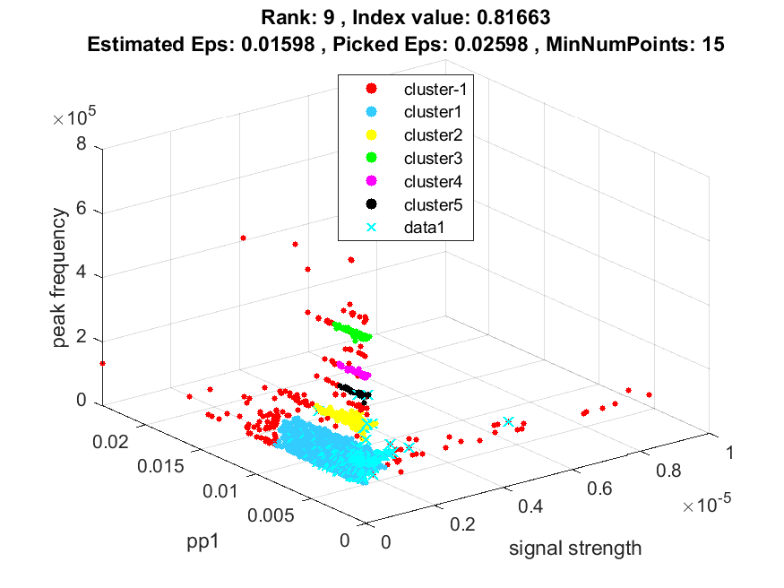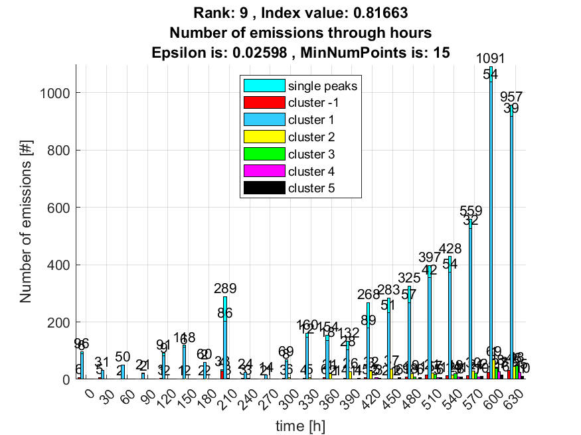

10. result: (peak_amplitude, pp1, peak_frequency)
Estimated Epsilon: 0.016395, Picked Epsilon: 0.016395, MinNumPoints: 15
DBCV index value: 0.81417
cluster -1 had 1.8033% single peaks
cluster 1 had 97.2131% single peaks
cluster 2 had 0.81967% single peaks
cluster 3 had 0% single peaks
cluster 4 had 0% single peaks
cluster 5 had 0.16393% single peaks
DBCV mali problem s izborom.
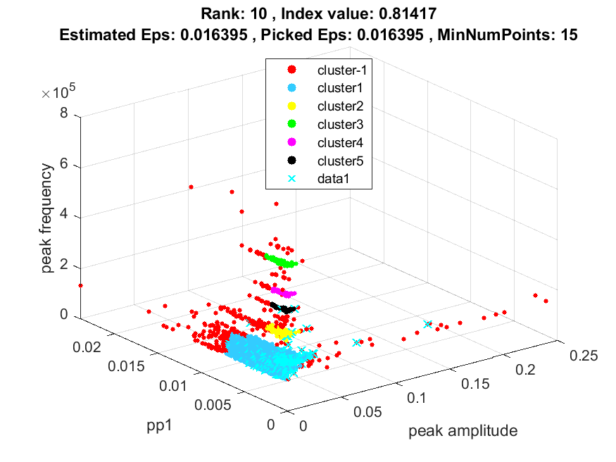
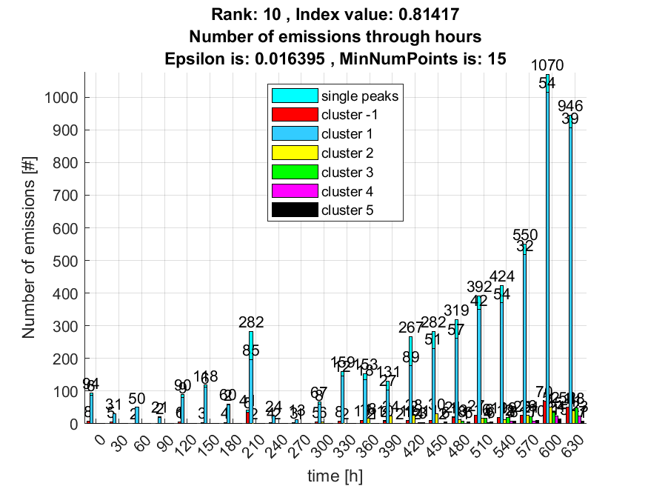

Ovo treba biti najbolji rezultat:
